A Simple Technique for Preventing Vortex
With Some Aspects of Flow under Inclined Sluice Gates
Mowafaq Y. Mohammed⁽¹⁾ | Ahmed Y. Mohammed⁽²⁾ | Inam A. Kasem⁽³⁾
⁽¹⁾Univ. Of Mosul, Coll. Of Eng., Dept. of Dams and Water Resources, Eng
⁽²⁾Univ. Of Mosul, Coll. Of Eng., Dept. of Dams and Water Resources, Eng. P. O. Box 11244, Mosul, Iraq;
⁽³⁾ Univ. Of Mosul, Coll. Of Eng., Dept. of Dams and Water Resources, Eng
Received: D 14.03.2018; Accepted: 05.06.2018; Published: D 05.06.2018
Tur. J. Hyd. Vol: 2 No: 1 Page: 1-7 (2018) ISSN: XXXX-YYYY
SLOI: http://www.dergipark.gov.tr
*Correspondence e-mail: ahmedymaltaee@gmail.com
ABSTRACT: In this paper the effect of vortex formation upstream inclined sluice gate, discharge coefficient as well as predicted discharge equation have been studied for several gate openings (3,4&4.5) cm, five discharges and three different gate cases, vertical and inclined opposite flow direction in (30 and 45)° angles. It was found that there is no vortex at vertical sluice gate but observed at gate inclined opposite flow direction. There are tow corner vortices in high discharges and one central vortex in low discharges. Vortex decay elements have studied the reduction of these vortices. The average discharge coefficient for the vertical gate was 0.645 while these values reduced to 0.59 and 0.564 for gate inclined (30 and 45)° opposite flow direction respectively
Keywords: Vortex, Sluice gate, Hydraulic, Discharge coefficient, Vortices decay

1. Introduction
Sluice gates are widely used for controlling discharge and flow depth in many irrigational structural systems. Due to the practical importance of the sluice gate as a control and metering device, the prediction of the flow characteristics upstream and downstream gates was one of the classical problems of hydraulics and prevent scouring downstream. One of the important phenomena occurred upstream sluice gate is vortex motion which is a movement of liquid in a circular path about an axis.
Many studies have been made to study free and submerged low discharged through the sluice gate.
Some of these studies are deals with the discharge characteristics of the sluice gate Rajaratnam & Subramanya [1], others deal with characteristics of the stream emerging from under the gate, concentrating on the coefficients of contraction, discharge and velocity of this stream of flow Fangmeier & Strelkoff [2]; Isaacs [3]; Rajaratnam [4]; Cheng et al. [5].
Rajaratnam & Humphries [6] studied the characteristics of flow upstream vertical sluice gate experimentally.

Nago [7] and Montes [8] deals with attributes of underflow for inclined sluice gate.
Swamee [9] presented equations for free and submerged flows. Hager [10] submitted project describes new findings on standard gate flow, involving scale effects, the coefficient of discharge. Jung et al. [11] Investigated various characteristics of a vertical sluice gate in a rectangular flatbed channel. Equations for discharge coefficient, dimensionless discharge, submerged water depth, maximum allowable gate opening, and the different condition separating free flow and submerged flow were derived and plotted with consideration of flow contraction at the gate. Dwi et al. [12] objected to predict the properties of flow beneath a sluice gate using a physical model to analyse the profile of water surface around the sluice gate. Sepulveda et al. [13] studied different calibration methods for the discharge coefficient of submerged sluice gates. They found that the value 0.611, gives good results within the practical range. The contraction coefficient under free and submerged sluice gates was studied by Belaud et al. [14].
Using the energy-momentum balance (EMB), the method leads to an analytic determination of Cc, both in free flows and submerged flows and then to a discharge coefficient, Cd. Lozano et al. [15] studied sluice gates in irrigation canals under submerged conditions. The effect of the contraction coefficient was studied, and the energy loss was found to be insignificant for large submergences. The study included an assessment of the accuracy of the discharge determinations and the sources of measurement error. Habibzadeh et al. [16] predicted the discharge coefficient by a theoretical approach that allows for the energy loss by introducing an energy-loss factor, k. The new equations can be used to predict the performance of sluice gates with different edge shapes under free and submerged flow situations.
To this end on this paper was studied phenomena of the corner and central vortices, its side effect on sluice gate performance and a novel of vortex decay to prevent its formation upstream sluice gate. In the end of as well as predicted a theoretical discharge equation for inclined and vertical sluice gate and characteristics of discharge coefficient.
2. Experimental Works
According to Ahmed [17] experiments were conducted in the hydraulic laboratory of the Dams and Water Resources Department, University of Mosul, Iraq.
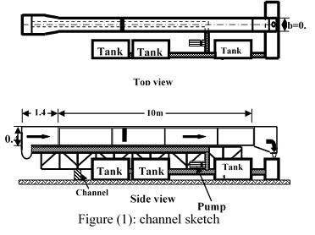
Figure 1. Channel Sketch
The rectangular hydraulic flume was (10) m long, (30) cm wide and (45) cm depth, Fig. 1.
The discharge measurements were made using a rectangular sharp crested weir installed at the channel end with dimensions (30*15*1) cm. The gate was (30) cm wide (40) cm height and (6) mm thickness installed vertically and inclined (30, 45)° opposite flow direction at a distance (2.9)m from the channel entrance, Fig.2.
Three gate openings (3, 4&4.5) cm and five upstream water levels (18.9, 21, 24, 26, 28.9) cm have been used, with more than (60) experiments. The variables measured in experiments are; head of water upstream sluice gate H, gate opening a concentration depth under sluice gate yo, vortex distance from the side wall and sluice gate yv and xv, water head over sharp crested weir Hw, so, actual discharge Qact can be calculated from volumetric calibration.
The volumetric calculations using container (20.2) L volume were done. Then, on the main channel timer to calculate the time when the container full, using the equation (Q= volume/time) to fined discharge at several stages of head of water above the standard weir the downstream, the equation (1) from the data shown in Table (1) using the Microsoft office excel were calculated.
Qact = 0.64 H^{1.5} (1)

Table (1): discharge volumetric calculation

Q(l/s) | Time(s) | Volume(l) | H(cm)
1.690 | 12.0 | 20.2 | 1.910
3.873 | 5.2 | 20.2 | 3.321
6.051 | 3.3 | 20.2 | 4.471
7.570 | 2.7 | 20.2 | 5.191
9.600 | 2.1 | 20.2 | 6.082
15.000 | 1.4 | 20.2 | 8.190
15.737 | 1.3 | 20.2 | 8.456
17.778 | 1.2 | 20.2 | 9.172
18.500 | 1.0 | 20.2 | 9.419

3. Dimensional Analysis
Flow under a sluice gate was influenced by:
Q: Discharge of channel (L3T-1); H: Total head upstream sluice gate (L); a: Sluice gate opening (L); b: Channel width (L); yo: Concentration depth under sluice gate (L); g: Acceleration due to gravity (LT-2); ρ: Density of water (ML-3); μ: Dynamic viscosity (ML-1T-1); α: Vertical angle of sluice gate, thus dimensional vortex equation parameters can be written:
Q=ƒ(H,a,b,yo,μ,g,ρ,α) (2)
Dimensional analysis of the given parameter gives:
(3)
Where:
R: Reynold number ()
F: Froud number ()
Cc: Coefficient of contraction ()
by multiplying and dividing pi-variables and neglected Reynolds number because of little affected in open channel flow so that the following equation can be described
)4)
Where
k 1, k2 : constant
Eq. (4) can be calculated statistically using Statistical Package for the Social Sciences programming (SPSS, V.17) the following equations wereobtained:
(5)
The correlation coefficient is 0.98
The values calculated using Eq (5) compared with experimental data shown in Fig. 3 with average error 11.5%.
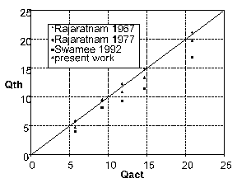
Figure 3. Comparison between discharges calculated using Eq (5) and experimental data
4. Coefficient of Discharge
The values of (Cd) are changed from (0.60 to 0.675) for a vertical gate with average value (0.645) while these values decrease from (0.59 to 0.564) for gate inclined opposite flow direction. The values of (Cd) with (H/a) for all cases have been drawn in Fig. (4), it could be seen that the values of (Cd) decrease when gate slope increase opposite flow direction. The lowest amount of Cd happened at gate inclined in (45o) opposite flow direction because of flow resisting under sluice gate in the inclined gate.

Fig.4. Variation of (Cd) with (H/a) for all cases
5. Central and Corner Vortices
The volume of water accumulated and low velocity (subcritical flow) at upstream of inclined sluice gate while flow has high velocity (supercritical flow) downstream gate, this lead to forming circulation movement (vortex upstream direction).
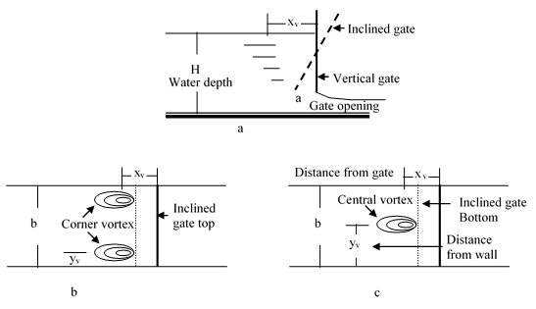
Figure 5. The corner vortex upstream sluice gate
(a)Section (b) two corner vortex plan (c) one central vortex plan
Therefore, the flow under sluice gate was characterized by the appearance of one central vortex in low water levels and two corner vortices in high water levels upstream gate structure
The volume of water accumulated and low velocity (subcritical flow) at upstream of inclined sluice gate while flow has high velocity (supercritical flow) downstream gate, this lead to forming circulation movement (vortex upstream direction). Therefore, the flow under sluice gate was characterized by the appearance of one central vortex in low water levels and two corner vortices in high water levels upstream gate structure.

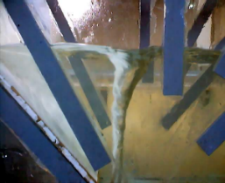
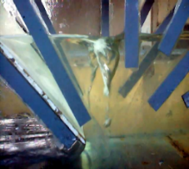
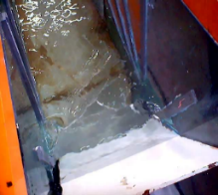
a
b
c

Figure 6. Vortex formation upstream sluice gate.
(a) central vortex.(b)corner vortices.
(c) Top view of corner vortices

Fig. (5) Shows a sketch of sluice gate with vortices upstream. The distance of vortex centre from the gate is (xv) and from the wall is (yv), Fig. (6) shows the vortex photo in inclined sluice gate.
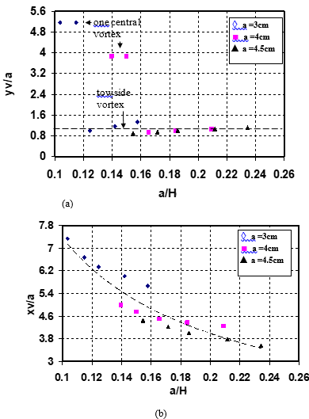Fig. 7. Vortex location upstream inclined sluice gate
(a) Distance from side walls
(b) Distance from sluice gate

Fig. 7 (a & b) refers to the location of the vortex concerning side walls and gate respectively, from figs. It was found that for small values of discharge there is one central vortex and its distance from side wall was constant; it can be written as:
yv/a=1.2(a/H)0.001 (6)
Where;
yv= distance of vortex centre from side wall
a=gate opening
H=upstream water depth
The values of (a/H)0.001 was small and can be neglect, then eq.(6) can be written;
yv/a=1.2 (7)
For high values of discharge, there are two corner vortex, and their distance from sluice gate decreases when discharge increased, this expression can be written as;
xv/a=0.96*(a/H)-0.88 (8)
The correlation coefficient was 0.93
Where; xv= distance of vortex centre from the gate.
6. Froud Number and Vortex
The relationship between Froud number F and vortex location from side walls yv and sluice gate xv were shown in Fig.8 (a & b) respectively. As depicted in these figures, the vortex distance from wall yv remain constant at channel centre for all values of Froud number F and gate opening a, the expression can be wrtten as;
yv/a=1 (9)
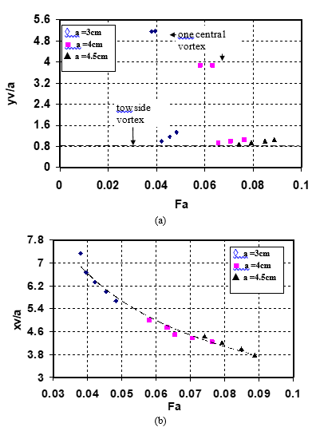
Figure 8. Relationship between Froud number and vortex location upstream inclined sluice gate
(a) Relation of Froud number with respect to vortex distance from side walls
(b) Relation of Froud number with respect to vortex distance from sluice gate

When Froud number between 0.039 and 0.062 for gate opening 3 and 4 cm observed one central vortex then disappeared to form two corner vortices. Vortex distance from gate xv decreases when Froud number F increased and can be expressed as;
xv/a=0.695*(F)-0.7 (10)
The correlation coefficient was 0.98
7. Coefficient of Contraction and Vortex
Fig. 9 (a & b) shows the relationship between coefficient of contraction Cc and vortex location from side walls yv and sluice gate xv respectively, From figures it can be seen that the vortex distance from wall remain constant for all gate opening and all values of coefficient of contraction Cc, the expression can be written as;
yv/a=0.9 (11)
When the coefficient of contraction Cc values between 0.625 and 0.635 for gate opening 3 and 4 cm observed one central vortex then disappeared to form two corner vortices.
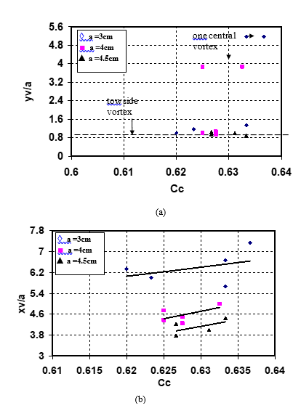
Figure 9. Relationship between Coefficient of contraction and vortex location upstream inclined sluice gate
(a) Relation of Coefficient of contraction with respect to vortex distance from side walls
(b) Relation of Coefficient of contraction with respect to vortex distance from sluice gate

The vortex distance from gate xv decrease when coefficient of contraction Cc increased and these values not constant depending on gate opining, these relations can be expressed as;
When gate opining a= 3 cm
Xv/a=31.827Cc3.472 (12)
When gate opining a= 4 cm
Xv/a=167.75Cc7.73 (13)
When gate opining a= 4.5 cm
Xv/a=158.74Cc7.89 (14)
8. Vortex Decay Element
The vortex upstream sluice gates including many disadvantages such as scour and vibrations …etc., and to reduce it suggested used vertical plates located close to the side walls to cut the transverse stagnation currents from the channel axis to the side walls.
Fig. 10 (a & b) Shown the vortex decay element located upstream from the gate. These consist of two vertical plates of distances (xe) from the gate, with (ye) wide and (ze) height. These sheets can be made from plates or wood installed either at side walls or sluice gate, the dimensions of these sheets must be used carefully depending on sluice gate operation to know observed one or two corner vortex.
b
b
x_{e}
a
H
a
x_{e}
z_{e}
y_{e}
Vortex decay distance from gate

Vortex decay hieght

Vortex decay distance from wall

Figure 10. The vortex decay (a) section (b) plan
The lateral element position was optimum when it was located at the core of the vortex when (ye = yv), ( xe = xv) and (ze) at the upper edge of the gate opening.
Small deviations from (xe) were insignificant because the vortex is a highly dynamic phenomenon that is subject to temporal oscillation.
6. Conclusion
The vortex was taken place when the gate inclined opposite the flow direction, and when the upstream water depth was shallow, there is one central vortex, but there are two corner vortices appeared when water increased. Locations of the vortex centre relative to the side wall and the gate have been determined so that it can be reduced with the anti-vortex element. The average discharge coefficient for the vertical gate was 0.645 while these values decreased to 0.59 and 0.564 for gate inclined (30 and 45)° opposite flow direction respectively. A discharge equation have been predicted and compared with discharge computed experimentally
List Of Notation
A | Sluice gate opening | cm
B | Channel width | cm
Cc | Coefficient of contraction | -
F | Froud number | -
G | Gravitational acceleration | m/sec2
H | Water depth upstream sluice gate | cm
Hw | Water depth upstream sharp crested weir | cm
Q | Discharge of flow | m3/sec
Qact | Actual discharge of the flow | m3/sec
V | Vortex formation upstream sluice gate | 1/sec
xe | The distance of sheet plates from the sluice gate | cm
xv | Vortex distance from the sluice gate | cm
ye | The distance of sheet plates from the side walls | cm
yo | Concentration depth under a sluice gate | cm
yv | Vortex distance from the wall | cm
ze | The depth of sheet plates | cm
Α | The angle of the inclined sluice gate | -
Μ | Dynamic viscosity | Kg/m. sec
Ρ | Density of water | Kg/m3

7. References
- Rajaratnam N. and Subramanya K. "Flow Equation for the Sluice Gate." J. Irr. & Dra. Div., ASCE, 93(9), 167-186 (1967).
- Fangmeier D.D.and Strelkoff T.S. "Solution for Gravity Flow Under a Sluice Gate." J.eng.Mech. Div., ASCE, 94(2), 153-176 (1967).
- Isaacs L.T. "Numerical Solution for Flow under Sluice Gates." J.Hydra. Div., ASCE, 103(5), 473-481 (1977).
- Rajaratnam N. "Free Flow Immediately Below Sluice Gates." J. Hydra. Div., ASCE, 103(4), 345-351 (1977).
- Cheng A.H-D. , Liggett J.A.and Liu P.L-F. "Boundary Calculations of Sluice and Spillway Flows." J. Hydra. Div., ASCE, 107(10), 1163-1178 (1981).
- Rajaratnam N. and Humphries J. A. "Free Flow Upstream of Vertical Sluice Gates." J. Hydra. Res., IAHR, 20(5), 427-437 (1982).
- Nago H. "Influence of Gate Shapes on Discharge Coefficients." Proc. fJSCE, 10(2), 59-71 (1978).
- Montes J.S. "Irrotational Flow and Real Fluid Effects under Planar Sluice Gates." J. Hydra. Eng., ASCE, 123(3), 219-232 (1997).
- Swamee, P. K. “Sluice-gate discharge equations.” J. Irrig. Drain. Eng., 118(1), 56–60 (1992).
- [10] Hager W.H. "Underflow of Standard Sluice Gate." Experiments in Fluids,27(4), 339-350 (1999).
- Jung-Fu, Yen Chih-Han and Lin Chang-Tai Tsai "Hydraulic Characteristics And Discharge Control Of Sluice Gates." Jour. of the Chinese Inst. Of Eng., 24(3), 301-310 (2001).
- Dwi Tjahjanto, Mohd Adib Mohd Razi, Wan Afnizan Wan Mohamed and Nur Bazilah Ishak, "Investigation of the Properties of Flow beneath a Sluice Gate.", International Conference On Civil Engineering, Kuantan, Pahang, Malaysia, 12-14th May 2008, 1-9 (2008).
- Sepulveda, C., Gomez, M., and Rodellar, J. “Benchmark of discharge calibration methods for submerged sluice gates.” J. Irrig. Drain Eng., 135(5), 676–682 (2009).
- Belaud, G., Cassan, L., and Baume, J.-P. "Calculation of contraction coefficient under sluice gates and application to discharge measurement.” J. Hydraul. Eng., 135(12), 1086–1091 (2009).
- Lozano, D., Mateos, L., Merkley, G. P., and Clemmens, A. J. "Field calibration of submerged sluice gates in irrigation Canals.” J. Irrig. Drain. Eng., 135(6), 763–772 (2009).
- Habibzadeh A, Vatankhah R and Rajaratnam N. "Role of Energy Loss on Discharge Characteristics of Sluice Gates." Jour. of Hydra. Eng., 137(9), 1079-1084 (2011).
- Ahmed Y. Mohammed "Hydraulic Study for Performance of the Vertical and Inclined Gates and Compound on Weir" M.Sc. Thesis Submitted to Mosul University, p110. (2002).

Turkish Journal of Hydraulic TM © All rights reserved.

