Determination of Some Biological Activities and Elemental Content of Methanol Extracts of Psylliostachys spicata (Willd.) Nevskis’ Specimens Collected from Two Different Locations

1Abdul Vahap Korkmaz****ORCID, Hasan Hacıfazlıoğlu[1]

‎1Istanbul University-Cerrahpaşa, Mining Engineering Depart., Istanbul, Turkey.‎

Corresponding author, e-mail: av.karkmaz@hotmail.com ,

Submission Date: xx.xx.20xx Acceptation Date: xx.xx.20xx

**Abstract (Times New Roman, 10 Punto, Bold) -** Times New Roman, 10-point Abstract should be 100-250 words. A line space should be left to the key words that will consist of at least 3 and maximum 5 words. Mathematical expressions should not be included in essence.

**Keywords:** Consist of minimum 3 and maximum 5 words

[Psylliostachys spicata (Willd.) Nevski](https://www.google.com.tr/search?q=Phyllostachys+spicata+(Wild.)+Nevski&spell=1&sa=X&ved=0ahUKEwjL37q5pbrfAhVC3qQKHSZqD7oQBQgpKAA)’nin İki Farklı Lokasyondan Toplanan Örneklerinin Metanol Ekstraktlarının Bazı Biyolojik Aktiviteleri ve Element İçeriğinin Belirlenmesi

**Öz (Times New Roman, 12 Punto, Kalın) -** Times New Roman, 12 punto olan Öz’ün uzunluğu 100-250 kelime olmalıdır. En az 3 en fazla 5 kelimeden oluşacak anahtar kelimeler ile öz arasında bir satır boşluk bırakılmalıdır. Matematiksel ifadeler öz’e dâhil edilmemelidir.

Anahtar kelimeler: En az 3 en fazla 5 kelimeden oluşacaktır

**GRAPHICAL ABSTRACT**

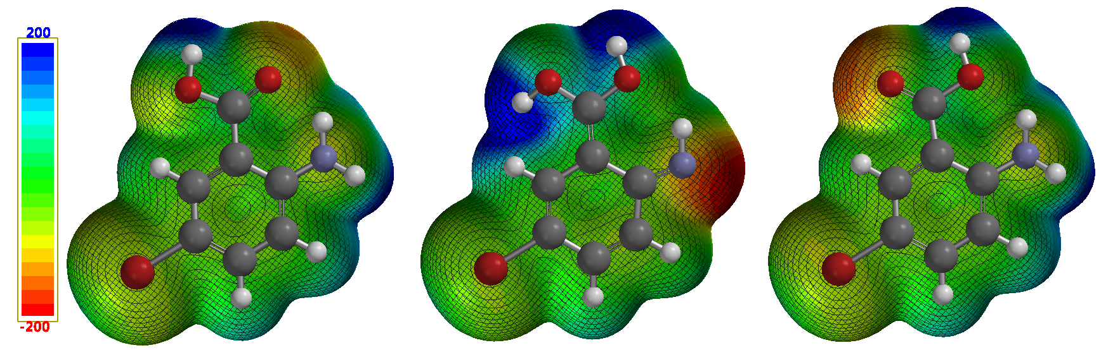

1. **Introduction**

In many different industries today, such as, plastics, ceramics, cement, metallurgy, paint, food, cosmetics and energy, there is a growing need for materials identified as nano-sized. Nanomaterials fabrication methods can be classified according to whether their assembly followed either the so called “*bottom-up*” approach or the “*top-down*” approach. The bottom-up approach is one where smaller components of atomic or molecular dimensions self-assemble together, according to a natural physical principle or an externally applied driving force, to give rise to larger and more organized systems. The top-down approach is where a process starts from a large piece and subsequently uses finer and finer tools for creating correspondingly smaller structures [1]. Namely, nano-sized grains are produced by physical processes such as grinding. In the top-down approach there are two options such as wet and dry grinding. In this study, dry grinding was preferred to eliminate the cost of drying. The general flow diagram of the nano-calcite fabrication using an industrial scale ball mill is given in Figure 1.

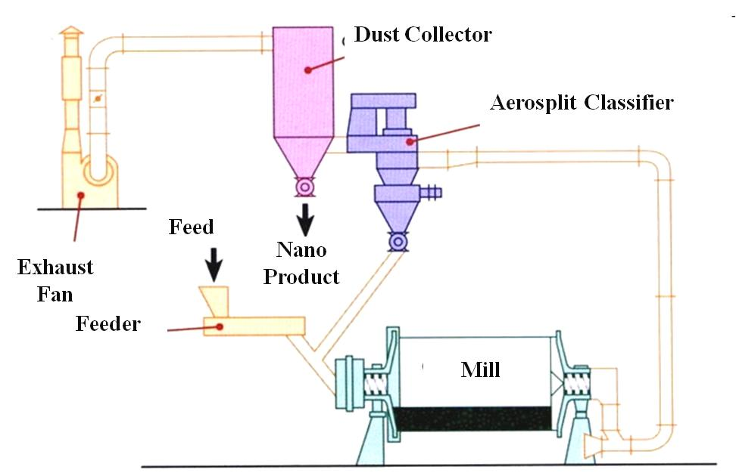

Figure 1. Nano calcite fabrication flow diagram [“top-down” approach]

The primary function of grinding media is to crush and grind ore particles inside rotating mills, such as ball, rod, and semi-autogenous mills, and sometimes in stirred mills such as Vertimill, SVM mills, Sala Agitated Mill, HIGMill, Tower Mill, and ISAMill [2]. In recent years, grinding charges with unconventional shapes have appeared on the market. One example is the cylindrically shaped media called Cylpebs. Cylpebs have greater surface area and higher bulk den-sity than balls of similar mass and size, due to their shape. Cylpebs of the same diameter and length have 50% greater surface area, and 45% greater weight, than balls of thesame material. In addition, they have 9% higher bulk density than steel balls, and 12% higher than cast balls. The objective of this paper is to compare Cylpebs and ball grinding media in terms of grinding efficiency for fabrication of nano sized calcite [3-4]. Calcite (CaCO3 ) was chosen as test material for this study. It is a salt, widely used in the ground nano-form, in paints, food or pharmaceuticals industries and as filler in the paper making process (Garsia et al., 2002).

**2. Materials and Methods**

Experimental studies were carried out in an industrial-scale ball mill shown in Figure 2. The diameter of the mill is 3 m in length and 7 m in length. The total internal volume of the mill is 49 m3. The mill capacity for the production of d90 ~ 60-100 microns calcite is 20 tph. The Cylpebs and spherical balls shown in Figure 3 were separately charged and their grinding performances tested. The charging rates of Cylpebs and spherical balls are given in Table 1. The material (calcite) which is grinded to the nano size is taken with the Alphine type air separator. The calcite mineral was broken to -8 mm by impact crusher before feeding to the mill. The grain size (d90) of the calcite feed to the mill is ~ 4 mm.

[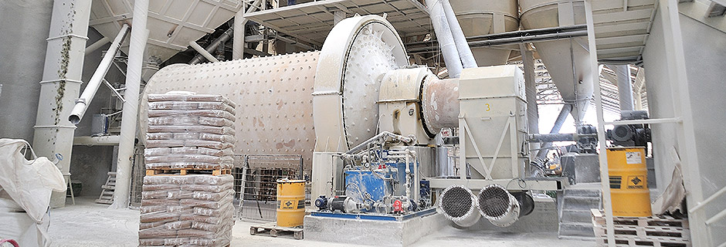](http://www.google.com/url?sa=i&rct=j&q=&esrc=s&source=images&cd=&cad=rja&uact=8&ved=2ahUKEwj358jmhu3fAhXNy6QKHQy2B8IQjRx6BAgBEAU&url=http://www.mikrokal.com.tr/uretim.php&psig=AOvVaw1gJ3XAa6UFG5SdjdDPqBgT&ust=1547547753877646)

Figure 2. Image of calcite grinding mill (Classic ball mill)

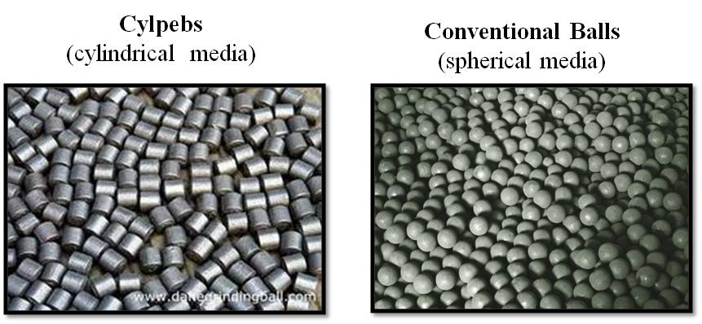

Figure 3. Image of different types of grinding media

Table 1. Grinding media features and charging rates

|  |  |  |  |  |  |  |
| --- | --- | --- | --- | --- | --- | --- |
| Grinding Media  Types | Sizes and Weights  of  Grinding Media | | | | Total Media Weight | Media Charge Rate |
| Conventional Balls | 15-20mm  14520 kg | 20-30mm  14700 kg | 30-40mm  14700 kg | 40-55mm  14700 kg | 70630 | 37% |
| Cylpebs | 14x17x16mm  28000 kg | 21x25x26mm  2100 kg | 29x35x34mm  2100 kg | -  - | 7000 | 31% |

**3. Results and Discussions**

Table 2 shows the d90 dimensions of the products obtained depending on the capacity of the mills. Accordingly, when the capacity of the mill was reduced from 20 tph to 5 tph, the fineness of the product was reduced from 60 microns to 3.9 microns (Figure 4). Reducing the capacity means increasing the contact time of the material (calcite) with the grinding media. The same applies if Cylpebs are used. When the capacity was reduced from 20 tph to 5 tph, the fineness of the product obtained decreased from 30 microns to 1.3 microns. Cylpebs grinder media has more efficient grinding than conventional balls. For example, if the mill is operated with a capacity of 10 tons per hour, the products obtained are 10 microns with cylpebs balls and 20 microns with conventional balls.

Table 2. d90 sizes vs mill capacity of products using with Balls and Cylpeps

|  |  |  |  |
| --- | --- | --- | --- |
| Conventional Spherical Balls | | Cylpebs | |
| Mill Capacity | d90 sizes of product | Mill Capacity | d90 sizes of product |
| 20 tph | 60 µm | 20 tph | 30 µm |
| 10 tph | 20 µm | 10 tph | 10 µm |
| 5 tph | 3.8 µm | 5 tph | 1.3 µm |



Figure 4. Particle size distribution in grinding with Spherical Balls (5 tph capacity)



Figure 5. Particle size distribution in grinding with Cylpebs (5 tph capacity)

**4. Conclusions**

In this study, industrial scale grinding tests were carried out for the fabrication of nano calcite. The normal capacity of the mill used in the tests is 20 tph. However, it was not possible to produce nano-sized calcite with this capacity. Therefore, the capacity of the mill has been reduced. In other words, the amount of calcite feed is reduced. This increases the contact time between the calcite and the balls. When the residence time of Calcite in the mill was increased by 4 times, the fineness (d90) of the products obtained fell below 4 microns. When the mill capacity was 20, 10 and 5 tph, respectively, the fineness of the products were 60, 20, and 3.8 microns, respectively. These results were obtained in case of grinding with conventional balls. In case of using Cylpebs instead of conventional balls, the product fineness was 30, 10 and 1.3 microns, respectively. According to these results; the fineness of the products is inversely proportional to the mill capacity. As the mill capacity is reduced, finer products are obtained. This is due to increased grinding time and material-to-ball contact.

As a result, mill capacity is an important operating parameter in the fabrication of nano-sized calcite. It is not possible to fabricate nano-sized material with a conventional ball mill operated with normal capacity (20 tph). If the capacity is reduced by 75%, it is possible to produce nano-sized material. Furthermore, cylpebs should be used instead of conventional balls in this grinding process. Cylpebs gives finer products than conventional spherical balls.

**Peer-review:** Externally peer - reviewed.

**Author contributions:** Concept – A.V.K., İ. H.; Data Collection &/or Processing - A.V.K.; Literature Search - İ.H.,; Writing - A.V.K.

**Conflict of Interest:** No conflict of interest was declared by the authors. (or This study was produced from the YL / DR thesis entitled "Comparison of EEG signals after rowing sport and EEG signals after rowing sport" by Ahmet HARMANCI, which was accepted in 2020.) (or This paper has been presented at the ICENTE'20 (5th International Conference on Engineering Technologies) held in Konya (Turkey), November 17-19, 2020.)

**Financial Disclosure:** The authors declared that this study has received no financial support (If there is financial support, please specify the grant organization and support number).

**References**

[1] Arole, M.V. and Munde, S.V. (2014). Fabrication of nanomaterials by top-down and bottom-up approaches-An Overview, JAAST:Material Science (Special Issue), 1, 2, 89-93.

[2] Hacıfazlıoğlu, H. 2018. Ultrafine Grinding of Kokaksu Bauxite ore via Stirred Mill and Ball Mill, Open Journal of Nano, Vol.3, no.1. p.1-4.

[3] Shi, F., 2004. Comparison of grinding media-Cylpebs versus balls.Miner. Eng. 17, 1259–1268.

[4] Ipek, H. 2006. The eﬀects of grinding media shape on breakage rate,Minerals Engineering, Technical Note, Minerals Engineering 19 (2006) 91–93

[5] Garcia, F., Bolay, N. Le., Frances, C. 2002. Changes of surface and volume properties of calcite during a batch wet grinding process, Chemical Engineering Journal 85, 177–187

1. Corresponding author: Tel: 0 xxx xxx xx xx

   E-mail: [txxxx@xxx.edu.tr](mailto:txxxx@xxx.edu.tr)