Streetscape Perception: Interaction of Perceived Legibility   
and Sense of Security in the Streets of Hasköy, Beyoğlu

|  |  |
| --- | --- |
| **C:\Users\Abra A7 V5.3\AppData\Local\Microsoft\Windows\INetCache\Content.Word\fdghjklş.jpgC:\Users\Abra A7 V5.3\AppData\Local\Microsoft\Windows\INetCache\Content.Word\Instasize1632016-10-17-06-19-09pm.jpg** | Asst.Prof.Dr. Emine Koseoglu¹, Vildan Mengi Camas²  ¹Fatih Sultan Mehmet Waqf University, Faculty of Architecture and Design, Department of Interior Architecture; ²Fatih Sultan Mehmet Waqf University, Faculty of Architecture and Design, Department of Architecture  [koseogluemine@gmail.com](mailto:koseogluemine@gmail.com), vildan_mengi@hotmail.com |

***Abstract:*** *Streets are one of the major public spaces in an urban environment. Sense of security to environment increases the level of liveability of an urban space in an ongoing structure of the city. People get used to a legible environment easily and legibility of space increases the sense of security and the familiarity. In this study, the interaction of legibility of city and sense of security is examined via streets. Hasköy area, which belongs to Istanbul Beyoglu District that is an old settlement, is chosen as the investigation field. A questionnaire is performed with 80 first and third grade psychology students in total. The relationship between legibility of streets and sense of security is evaluated through correlation tests.* *In addition, the differences or similarities in the spatial evaluation of participants are measured over photographs of the 6 streetscapes which are classified in terms of landmarks, greenery, enclosure, mystery, and coherence. The study tested the differences / similarities between street perceptions of two student groups using Independent Samples t-test*. *The results reveal that the relationship between the perceived legibility and sense of security is linear which means if spaces become more legible, sense of security and naturally quality of life increase.*

***Keywords:*** *Urban space, streetscape, legibility, sense of security, Hasköy*

**Sokak-görünümü Algısı: Beyoğlu Hasköy’de Algılanan Okunabilirlik ile Güvenlik Hissinin Etkileşimi Sokaklar Üzerinden Ölçülmesi**

***Özet:*** *Sokaklar, bir kentsel çevredeki kamusal mekânların başında gelir. Sürekli değişen kent içinde çevreye duyulan güvenlik hissi yaşanabilirlik düzeyini belirler. Kişi okunabilir bir çevreye kolaylıkla aşina olur ve aşinalık güvenlik hissini arttırır. Bu çalışmada kentin okunabilirliği ile güvenlik hissinin etkileşimi sokaklar üzerinden incelenmiştir. İnceleme alanı olarak eski bir yerleşim olan İstanbul Beyoğlu ilçesine bağlı Hasköy semti seçilmiştir. Araştırma tekniği olarak anket kullanılmıştır. Anket toplamda 80 adet birinci ve üçüncü sınıf psikoloji öğrencileri arasında uygulanmış ve sokaklara dair olan algılamalar karşılaştırılmıştır. Sokakların algılanabilir okunabilirliği ile güvenlik hissi arasındaki ilişki, korelasyon testleri aracılığıyla değerlendirilmiştir. Katılımcıların mekânsal değerlendirmedeki farklılık ve benzerlikleri işaret ögeleri, yeşil doku, kapalılık, gizemlilik ve tutarlılık açılarından sınıflandırılmış 6 sokak fotoğrafı üzerinden ölçülmüştür. Birinci sınıf ve üçüncü sınıf psikoloji öğrencilerinin çevreyi algılayışlarında anlamlı farklılık olup olmadığını ölçmek amacıyla Bağımsız İki Grup t-testi uygulanmıştır. Araştırma sonuçları, belirlenen sokaklara dair algılanan okunabilirlik ile güvenlik hissi arasında doğrusal bir ilişkinin olduğunu kanıtlamıştır. Bu sonuç, mekânın okunabilirliği arttıkça güvenlik hissinin arttığı anlamına gelmektedir. Bunun sonucunda yaşam kalitesinin artacağı açıktır.*

***Anahtar Kelimeler:*** *Kentsel mekân, sokak-görünümü, okunabilirlik, güvenlik hissi, Hasköy*

**1. INTRODUCTION**

Cities have a heterogeneous structure with the coexistence of many cultures. This cultural variety brings a complex spatial perception of urban life. When we consider that more than half of the world population live in cities, a chaotic urban life becomes a real problem for humanity. Therefore, the concept of quality of urban life has gained importance in the research literature recently. Although every culture and city has different needs, the quality of life has emerged as a phenomenon that supplies the basic needs of people living in cities such as living in a healthy environment, nutrition, shelter, safety, etc. Urban liveability includes the collection of some or all basic human needs in city structure.

The human has needed a secure area to live in and has tried to control his/her own built environment. Thus security is one of the most important criteria for human to choose his built environment among crowded societies. According to Veleshani and his colleagues [1], a healthy society considers the sense of security of citizens as the most important aim. Refer to Maslow's hierarchy of needs [2], security is one of the main needs for human together with food, shelter, and health. Physical environment has a great role to give people a feeling of security. Security and therefore physical environment has real effect on quality of life that is naturally related with quality of urban space and their architectural components. In this point, the importance of physical environment comes forward to get secure life. Kevin Lynch [3] investigated urban spaces and quality of life and according to him, a good environment gives its possessor an important sense of emotional security. Kevin Lynch describes the legibility of a city in his book The Image of the City as: “…*the ease with which its parts may be recognized and can be organized into coherent pattern…” (p.2)*

Urban space is an organic and live structure. Living spaces have many ongoing changes in the process of their evolutions. Under the ongoing structure, legibility of an area has importance to increase the sense of security [4, 5]. This study examines the relationship between perceived legibility and sense of security via streets. It is aimed to reveal whether the features of the streets affect the perceived legibility and perceived security and whether there is a relationship between the perceived legibility and sense of security. In addition, more specifically, it is aimed to measure whether there is a difference between the perceptions of first-grade psychology students and third-grade psychology students towards the given streetscapes in terms of perceived legibility and perceived security.

**2. LEGIBILITY, PERCEIVED LEGIBILITY, SECURITY, AND SENSE OF SECURITY IN URBAN SPACE**

A desire to investigate and to get familiar with the environment is one of the most basic instincts of human and a legible environment provides familiarity easily [3]. According to Lynch [3], if a city is legible, its parts can be recognized into a coherent pattern and it is easily imageable. In this sense, legibility is seen as the key of understanding the city [6]. Legibility of urban space differs from reading space, as reading an urban space may include any dimensions of the city it has such as visual, morphological, historical, cultural, social, and economical. On the other hand, legibility should be understood as a “term” related to architectural space. It stands for the memorisable, learnable, orientable, and imageable dimensions of an architectural space.

In an urban space, urban spatial configuration in two dimensional considerations and landmarks in three dimensional considerations define the degree of urban legibility (Figure 1) [7]. Several researches emphasized the importance of spatial configuration in spatial legibility [8, 9, 10], whereas some others focused on the three dimensional landmarks [8, 11, 12]. These studies defined the spatial factors that affect the degree of spatial legibility. On the other hand, spatial legibility is also affected by the characteristics of the user or observer [7]. Thus perceived legibility constitutes the subjective part of this duality. For instance, a research conducted by Herzog and Leverich [11] in field/forest areas is one of the heading recent and basic studies that directly measured perceived legibility. Herzog and Leverich [11] showed several pictures of field/forest settings that represent several levels of having coherency and landmarks to the participants asking them to evaluate the pictures in terms of coherency, complexity, mystery, legibility, landmarks, and openness. They found that legibility is an independent predictor of preference.

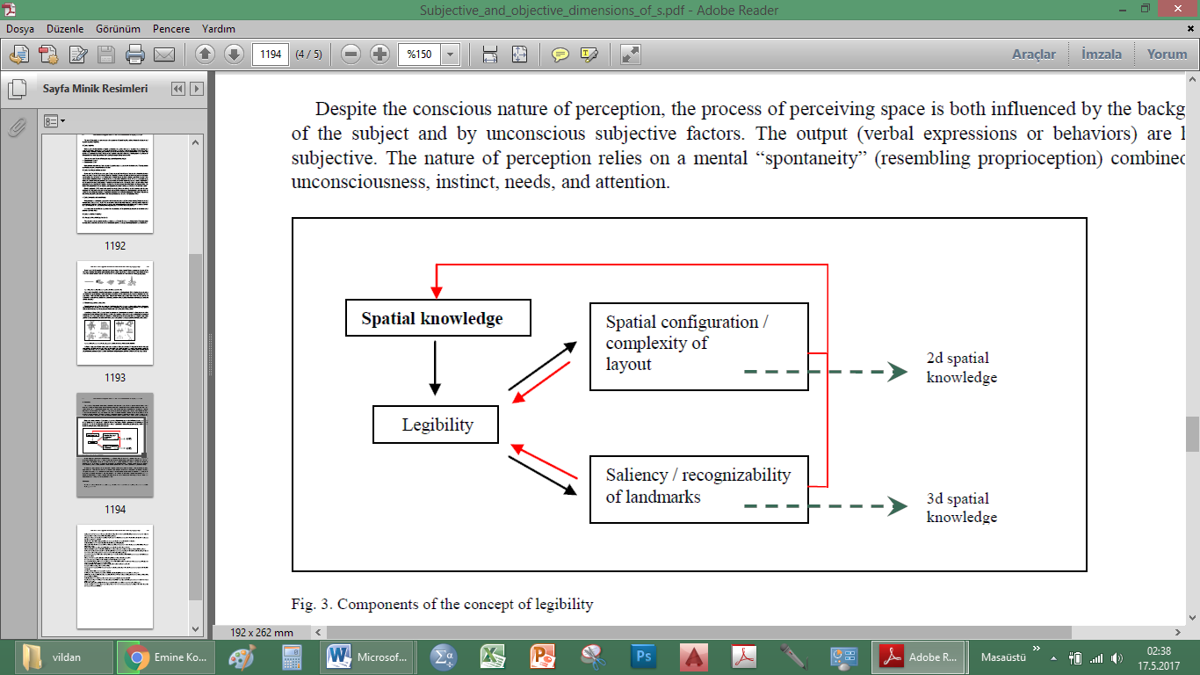

*Figure 1. Components of Spatial Legibility [7]*

Legibility is listed in urban design guides prepared by city councils as one of the urban design principles that enhance quality of urban life together with security (Url 1, Url 2). Moreover, Vanda Felbab-Brown, a senior fellow in Center for 21st Century Security and Intelligence, Security, asserts in her article that urban spaces are the new frontier for international security (Url 3). Defining the term of security, Carmona and his colleagues [13] mention a variety of threads such as crime, terrorism, fast-moving vehicles, air pollution, water contamination, and so on. Lack of security or lack of sense of security causing perceptions of danger, fear of victimisation, affect public realm negatively [13]. Several studies focused on the relationship between the physical and visual characteristics of streets and sense of security [14, 15]. Some studies concentrate specifically for instance, on the effects of greenery in urban space on the sense of security and they revealed that in greenery areas, people feel safer [16, 17], others examined the effect of being legible for spaces on the perceived security [18] [19].

In research literature, urban security is frequently associated with the phenomenon of the amount of people-on-the-streets [4, 5, 20, 21, 22]. Urban spaces tend to have a potential to become secure when they promote some degree of user movement [9]. For instance, space syntax theory suggests that if the spaces integrate to eachother in an urban setting, the users get encouragement to move through it [23]. Kevin Lynch [3], seemed not mentioning the importance of pedestrian movement directly, concentrated on a related concept: imageability of a safe urban space. He notes that: *“A good environmental image gives its possessor an important sense of emotional security”* [3:4]. Imageability is one of the related concepts to legibility as indicated by Lynch [3]. Thus it is possible to conclude that legibility affects the sense of security (emotional security).

In a streetscape level, legibility related features of a street can be considered together with walkability or a desire to walk in a certain street. Thus sense of security through a street and the factors that make a street preferable by a user to walk through it may be determined by the capacity of being spatially legible [24]. The metaphor in “broken window theory” developed by James Q. Wilson and George Kelling in 1982 (Url 4) indicates the importance of well-designed and sustained urban space in reducing the rates of crime in a setting. As one of the urban design principles, imageability and legibility may reduce the potential of crime in an urban space reviving a sense of security.

**3. METHODOLOGY**

**3.1. Research Area**

The aim of this research is investigating relationship between city legibility and sense of security via streets of Hasköy District, İstanbul (Figure 2). The area was famous with its gardens during the Byzantine and Ottoman Period. By the 1980s, industrialization and rapid urbanization brought many problems to the area. Therefore, the study field selected in Hasköy that includes ongoing changes, historical structures, industrial and residential usages, and good view of Golden Horn of İstanbul (Figure 3, 4, 5). Therefore, streets of the area have several views for investigation.

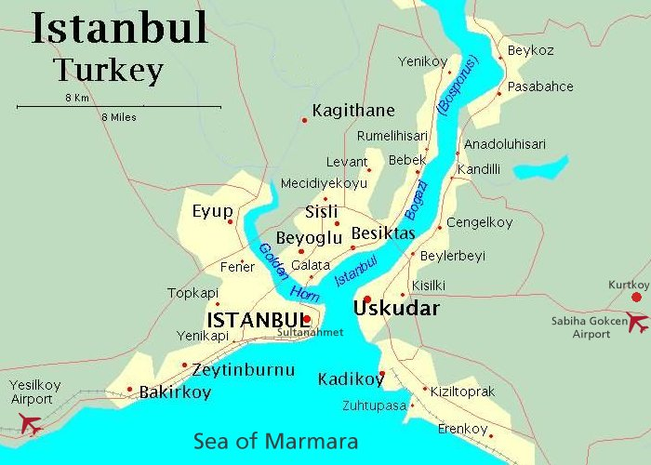

*Figure 2. Research Area Location in Haskoy District [Url 5]*

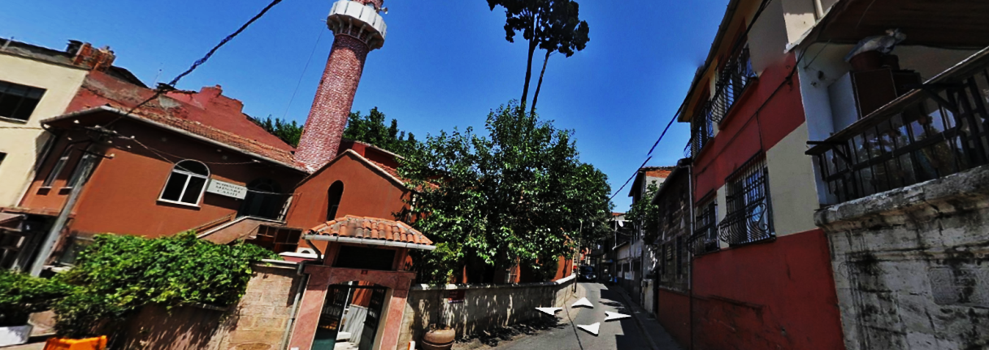

*Figure 3. A view from Kalaycibahce Street in Haskoy District [6]*

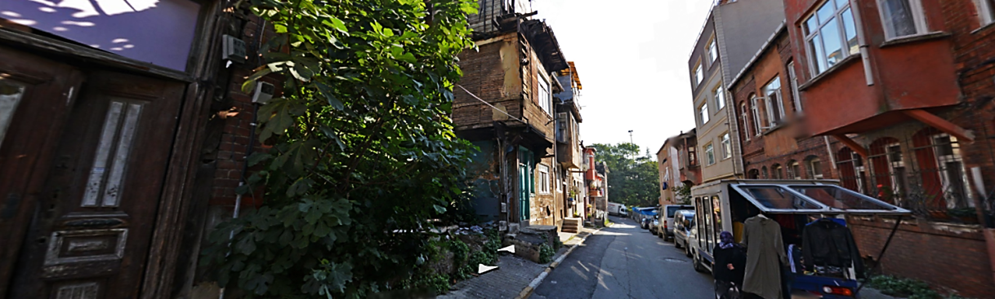

*Figure 4. A view from Basmaci Rusen Street in Haskoy District [7]*

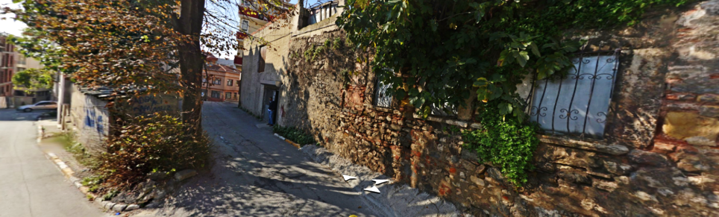

*Figure 5. A view from Aziz Street in Haskoy District [8]*

**3.2. Material**

6 different images from the streets of Hasköy have chosen for the research. Name of the streets are Aziz Street, Basmaci Rusen Street, 2 different views from Kalayci Bahce Street, and 2 different views from Tursucu Cesme Street (Figure 6, 7). The differences or similarities in the spatial evaluation of participants are measured over the chosen photographs of these 6 streets that are classified in terms of landmarks, greenery, enclosure, mystery, and coherence that are the determinants of the legibility level of the streets. Landmarks, enclosure, mystery and coherence are defined as legibility related parameters in literature [11]. Greenery as a perceived security related concept is suggested as landmark elements in a streetscape image in this study. Table 1 shows classification of streets.

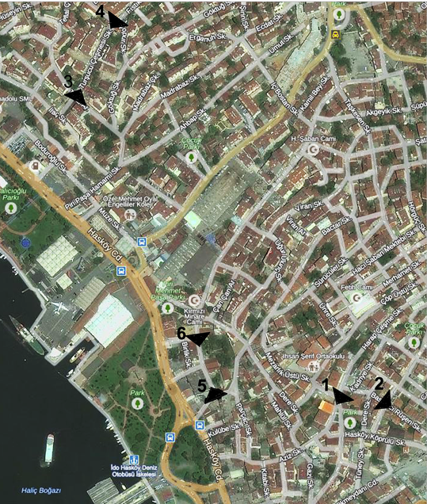

*Figure 6. Street Locations and Images Directions of Research Field [Url 9]*

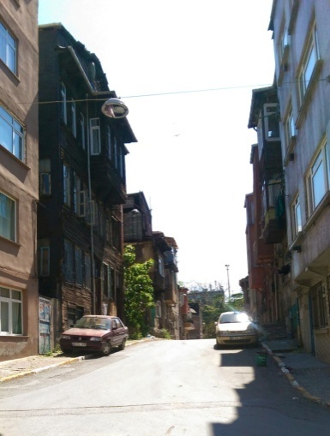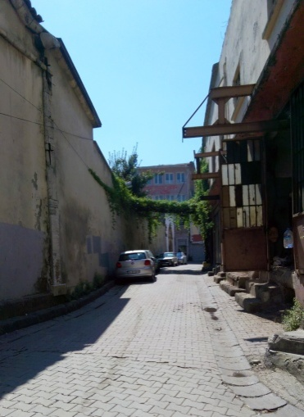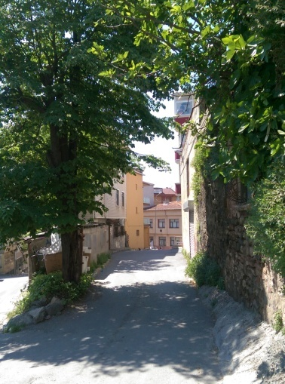

2

1

3

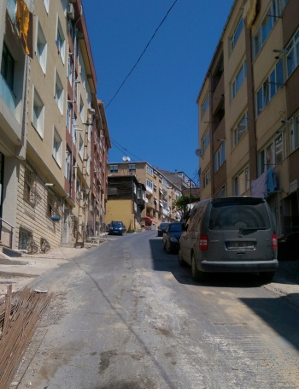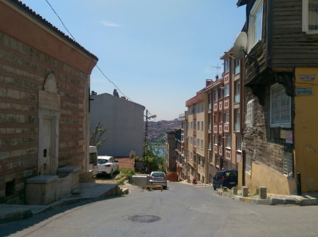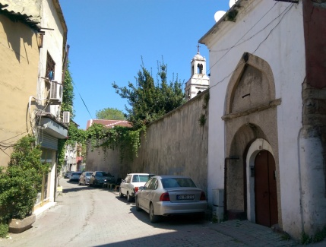

5

4

6

*Figure 7. 1 -Aziz Street, 2-Basmaci Rusen Street, 3/4- Kalaycı Bahce, 5/6-Tursucu Cesmesi Street (Photographed by authors)*

*Table 1. Classification of street images in the research*



**3.3. The Participants**

Psychology students are determined as the main group of participants. First and third grade students are designated as sub-groups. The reason for choosing different grades’ students is to determine the role of psychology education on their urban space perception and critical thinking. Psychologists, more specifically social and environmental psychologist may collaborate with architects in environmental researches, and / or majoring in the area of psychology may help gain a more sensitive point of view towards the built environment. Thus it is important to understand the perceptions of psychology students in terms of legibility and security. Within this scope psychology students are chosen as the participant group. 27 female and 13 male students of each first class and third class, totally 80 students, participated to the investigation. The ages of participants are centred between 20-22 ages.

**3.4. The Questionnaire: Semantic Differential Scale**

Osgood's Semantic Differential Scale is used to get data for the study. Semantic differential technique is preferred as by this way comparative results are received easily. In this technique, a questionnaire is formed which includes a rating scale of two bipolar adjectives. Thus, opinions, attitudes, and values also can be measured. Participants evaluated legibility and sense of security of 5 different aspects of streets according to given adjective list. These adjectives are chosen based on legibility and security (Figure 8).

*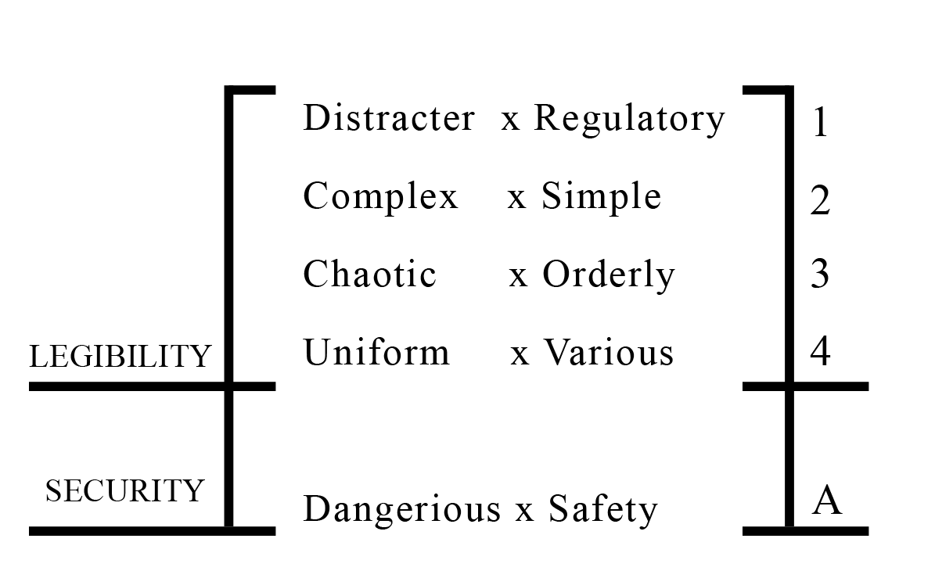Figure 8. The adjective pairs.*

**3.5. Hypotheses**

The main hypothesis of the study is: **H1:** The degree of sense of security increases together with the degree of perceived legibility in a street.

The sub-hypotheses of the study are: **H2:** There is a significant difference between the legibility perceptions on streets of first-grade and third-grade psychology students. **H3:** There is a significant difference between the security perceptions on streets of first-grade and third-grade psychology students.

**4. FINDINGS**

4 adjectives based on legibility are marked as “1-2-3-4” and 1 adjective based on safety is marked as “A” had determined. The data from survey is coded into SPSS software for descriptive statistical analysis and correlation statistical analysis. By this way, evaluations of the street conditions are accepted as “dependent variables”.

In SPSS, -2 is defined for very negative, -1 for negative, 0 for neutral, 1 for positive, and 2 for very positive. The weighted mean values are determined for each question and Street 2 (Basmacı Ruşen Street) (m for first-grade is=0.28, m for third-grade is=0.35) and Street 6 (Tursucu Cesmesi Street 2) (m for first-grade is=0.05, m for third-grade is=0.33) are determined as safe by both sub-groups. Street 4 (second view of Kalaycı Bahce Street) and Street 5 (first view of Tursucu Rusen Street) are determined as dangerous (Table 2).

*Table 2. Mean Values of Adjectives*

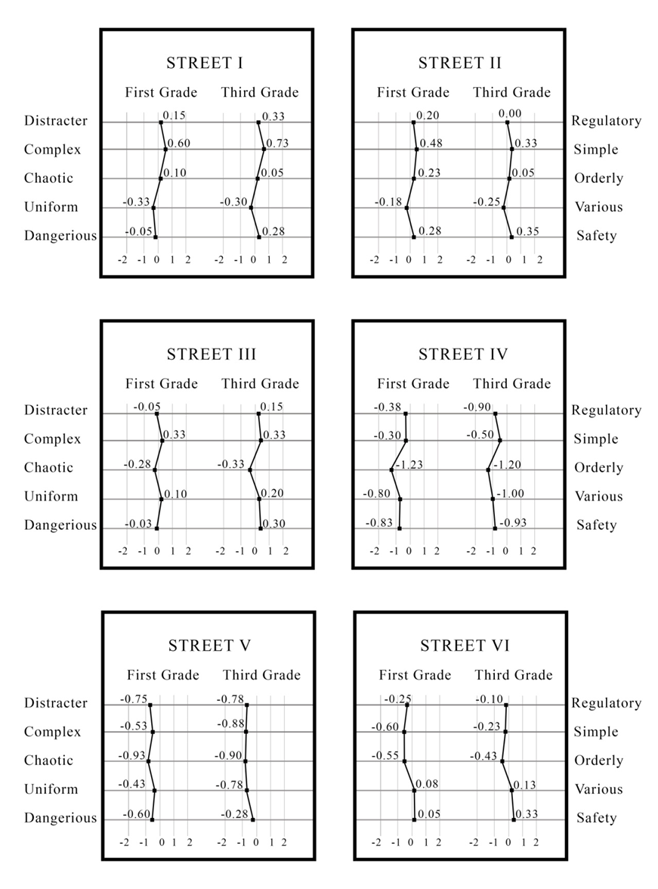

The next step of the evaluation is to analyse the correlation between legibility and sense of security variables. The value of a correlation coefficient ranges (r) between -1 and 1(-1 < r > 1). Correlations show a significant and a moderate relationship between legibility and security, especially at the results of third class students. Although the correlations are generally upper than 0 at the Table 3 (First Grade Students), less than half of values are not significant. On the other hand, the correlations of Table 4 (Third Grade Students) are significant except four points.

|  |  |
| --- | --- |
| *Table 3. Correlation results of first grade students* | *Table 4. Correlation results of third grade students* |



* Correlation is significant at the 0.05 level. (2-tailed) *Correlation is significant at the 0.05 level. (2-tailed)

** Correlation is significant at the 0.01 level. (2-tailed) ** Correlation is significant at the 0.01 level. (2-tailed)

Independent Samples t-test is implemented to compare the perceptions of first-grade psychology students and third-grade psychology students. The results revealed that there is a significant difference between the legibility perceptions of two groups for Street 5 for distractor-regularity parameter. Third-grade students revealed a more negative attitude compared to first-grade students (Table 5).

*Table 5. Independent Samples T-test results*

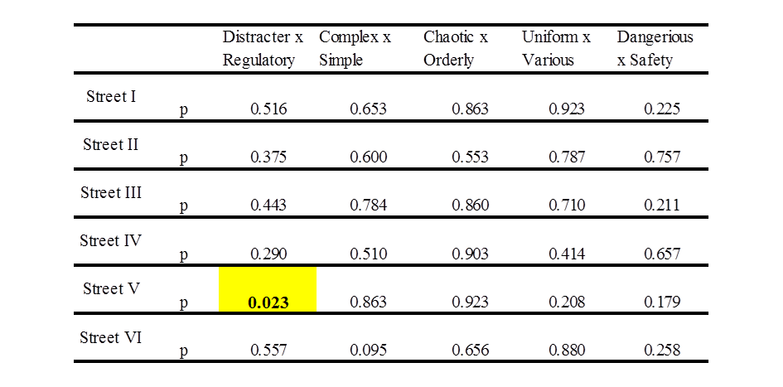

p<0.05, significant difference

**5. CONCLUSION**

According to Lynch, a legible environment can be organized in a coherent and recognizable pattern. A built environment includes several buildings, green zones, public spaces and streets. Streets surround the built environment and if a street is recognized easily, it becomes more liveable. Landmarks, coherent spaces, green zones, permeability, etc. make the streets legible.

This study measured the relationship between perceived legibility and sense of security for two participant groups constituting of first-grade psychology students and third-grade psychology students. Results showed that, Street 2 (Basmacı Rusen Street) and Street 6 (Tursucu Cesmesi Street) are perceived as safe by both sub-groups. Street 4 (second view of Kalaycı Bahce Street) and Street 5 (first view of Tursucu Rusen Street) are evaluated as dangerous. The interesting point is that one side of Turşucu Cesmesi Street is perceived as safe and the second side of it is perceived as dangerous. Probably the slope and the length of street are efficient on this result. In terms of correlations of legibility and security parameters, although the correlations are generally upper than zero for the first grade students, less than half of values are not significant. On the other hand, the correlations of third grade students are significant except four points. This shows us that the psychology education has the role on reading the environment in terms of legibility and security parameters. Another interesting result of the study is Street 2 (Basmaci Rusen Street). Although it includes regular, light, and wide view, it has not revealed a significant correlation in both sub-groups of participants. The historical and old facades it includes may cause this result; students sense old as insecure.

Security is a fundamental need of life. People need a secure environment, and the streets are very important for security and the reading environment easily when moving in it provides sense of security. This research examined the relationship between spatial legibility and sense of security via streets. Research proved that this relationship is linear, that means if spaces become more legible, sense of security and naturally quality of life increase. Therefore, this investigation can help designers to figure out why legibility has great importance for urban design.

**REFERENCES**

**[1] Veleshani, S.T., Madani I., Azeri A.R.K., & Hosseini S.B. 2015.** Effect of Physical Factors on the Sense of Security of the People in Isfahan's Traditional Bazaar. Procedia – Social and Behavioural Sciences 201, 165-174.

**[2] Maslow, A. H. 1943.** A Theory of Human Motivation. Psychological Review, 50 (4), 430-437.

**[3] Lynch, K. 1960.** The Image of The City. The MIT Press.

**[4] Jacobs, J. 1961.** The Death and Life of Great American Cities. Vintage Books, A Division of Random House, Inc., New York.

**[5] Newman, O. 1996.** Defensible Space – Crime Prevention through Urban Design. The Macmillan Company, New York.

**[7] Koseoglu, E. and Onder, D. E. 2011.** Subjective and Objective Dimensions of Spatial Legibility. Procedia - Social and Behavioral Sciences Journal, 30, 1191-1195.

**[8] Abu-Obeid, N. 1998.** Abstract and Scenographic Imagery: The Effect of Environmental Form on Wayfinding. Journal of Environmental Psychology, 18, 159-173.

**[9] O’Neill, M. J. 1991.** Evaluation of a Conceptual Model of Architectural Legibility. Environment and Behavior, 23:3, 259.

**[10] Hunt, M. 1984.** Environmental Learning Without Being There. Environment and Behavior, 16:3, 307.

**[11] Herzog, T. R. & Leverich, O. L. 2003.** Searching for Legibility. Environment and Behavior, 35, 459.

**[12] Başkaya, A., Wilson, C. and Özcan, Y. Z. 2004.** Wayfinding in an Unfamiliar Environment: Different Spatial Settings of Two Polyclinics. Environment and Behavior, 36, 839.

**[13] Carmona, M., Heath, T., Oc, T. and Tiesdell, S. 2003.** Public Places, Urban Spaces: The Dimensions of Urban Design. Architecural Press.

**[14] Muderrisoglu, H. and Demir, Z. 2004.** The Relationship Between Perceived Beauty and Safety in Urban Recreation Parks. Journal of Applied Sciences, 4: 72-77.

**[15] Shehata, W. 2012.** Perceived Attractiveness and Security of Design Features in Urban Parking Lots Case study: Stationsplein, Enschede, the Netherlands. 2nd International Conference Quality of Life.

**[16] Hami, A. and Emami, F. 2015.** Spatial Quality of Natural Elements and Safety Perception in Urban Parks. International Conference on Agricultural, Ecological and Medical Sciences (AEMS-2015) Feb. 10-11, 2015 Penang (Malaysia).

**[17] Lorenzo, A.B., and D. Wims. 2004.** Do Designed Landscapes Deter Crime? Proceedings of the Florida State Horticultural Society, 117:297-300.

**[18] Bielik, M., Schneider, S., Kuliga, S., Valášek, M. and Donath, D. 2015.** Investigating the effect of urban form on the environmental appraisal of streetscapes, SSS10 Proceedings of the 10th International Space Syntax Symposium, London.

**[19] Lay, M. C. D., Reis, A., Dreux, V. and Becker, D. 2007.** Urban Security and Spatial Behavior: Syntactic and Perceptual Analysis of the Central Area of Porto Alegre. 6th International Space Syntax Symposium, İstanbul.

**[21] Gehl, J. 1987.** Life Between Buildings: Using Public Space. Van Nostrand Reinhold Company, New York.

**[22] Kanigel, R. 2016.** Eyes on the Street: The Life of Jane Jacobs. Alfred A. Knopf, 1st edition.

**[23] Hillier, B. and Hanson, J. 1984.** The Social Logic of Space. Cambridge University Pres, UK.

**[24] Kuo, F. E. and Sullivan, W. C. 2001.** Environment and Crime in the Inner City: Does Vegetation Reduce Crime? Environment and Behavior 33, 3:343-367.

**ONLINE REFERENCES**

**URL-l.**ttp://www.wiltshire.gov.uk/gillespies_report_land_use_framework_and_urban_design_codes_-_best_practice_approach.pdf, last accessed on 17 May 2017.

**URL-2.** <http://www.designcouncil.org.uk/sites/default/files/asset/document/councillors-guide-to-urban-design.pdf>, last accessed on 17 May 2017.

**URL-3.** <https://www.brookings.edu/blog/order-from-chaos/2016/02/18/safe-in-the-city-urban-spaces-are-the-new-frontier-for-international-security/>, last accessed on 17 May 2017.

**URL-4.** <https://www.manhattan-institute.org/pdf/_atlantic_monthly-broken_windows.pdf>, last accessed on 17 Mayl 2017.

**URL-5.** <http://www.mappery.com/map-of/Istanbul-Bosphorus-Map-2>, last accessed on 17 May 2017.

**URL-6.** https://yandex.com.tr/harita/115695/beyo%C4%9Flu/?ll=28.948260%2C41.042281&z=17&l=stv%2Csta&panorama%5Bpoint%5D=28.950854%2C41.041800&panorama%5Bdirection%5D=11.395574%2C19.401147&panorama%5Bspan%5D=118.812635%2C54.279379

**URL-7.** https://yandex.com.tr/harita/115695/beyo%C4%9Flu/?ll=28.952503%2C41.041221&z=17&l=stv%2Csta&panorama%5Bpoint%5D=28.954410%2C41.040491&panorama%5Bdirection%5D=102.249400%2C9.473701&panorama%5Bspan%5D=120.000000%2C55.393621

**URL-8.** https://yandex.com.tr/harita/115695/beyo%C4%9Flu/?ll=28.952503%2C41.041221&z=17&l=stv%2Csta&panorama%5Bpoint%5D=28.953367%2C41.040634&panorama%5Bdirection%5D=223.171022%2C0.000000&panorama%5Bspan%5D=120.000000%2C55.393621

**URL-9.** https://yandex.com.tr/harita/115695/beyo%C4%9Flu/?ll=28.949933%2C41.043343&z=16&l=sat%2Cskl

**EMINE KOSEOGLU,** Assistant Professor, PhD,

She is an Assistant Professor in the Department of Interior Architecture at Fatih Sultan Waqf University, Istanbul. She graduated from Trakya University, Department of Architecture, in 2002. She has received Master of Architecture degree (Yildiz Technical University, Department of Architecture, 2004) with her thesis about spatial perception in hotel lobbies. Her PhD research (2005-2012, Yildiz Technical University, Department of Architecture) is formal, syntactical, and subjective aspects of urban legibility. Her research areas are architectural design, environmental psychology, spatial perception, spatial cognition, spatial legibility, culture-environment-behaviour relations, consumer behaviour, spatial image, architectural education, space syntax.

**VILDAN MENGI CAMAS,** Master of Arch. Candidate,

She is a student in the Architecture Master Programme of Fatih Sultan Waqf University. She graduated from International University of Sarajevo, Department of Architecture, in 2012. Her research interests are architectural design, spatial perception, spatial legibility, futuristic architecture, cinematic architecture, phenomenology- media- architecture relations.