Case Report/ Olgu Sunumu
A Three-Stage Assessment of a Case of Polycystic Liver Disease, Based on the Principles of Family Medicine
Polikistik Karaciğer Hastalığı olan Olgunun, Aile Hekimliği İlkelerine göre Üç Aşamalı Değerlendirilmesi
Sanjay Kini*
ABSTRACT

Background:Nowadays there is an increasing trend of diagnosis of hepatic cysts due to widespread use of ultrasound examination. However, the vast majority of these cysts are benign and have an indolent course during the lifespan of the patient. Secondary to enlarging cyst size and hepatomegaly, the minority of patients develop clinical symptoms. Aim: Applying the consultation model of three-stage assessment (ie, Clinical, individual and contextual assessment) based on the principles of family medicine, in the evaluation of a patient with polycystic liver disease. Method: We present a case of polycystic liver disease, with clinical manifestations like palpable liver, shifting dullness, elevated bilirubin levels and evaluated using three-stage-assessment model. Result: Patient had a positive attitude towards her health, but suffered neglect from family members. Conclusion: Positive attitude towards health and disease, emotional support of family members, regular follow-up with the consulting physician and genetic counseling of couples who are planning to conceive and have a family history of polycystic liver disease are some of the key facts emphasized when we applied the three-stage-assessment model in this particular case.

Key words: Polycystic liver disease, three stage assessment, family medicine

ÖZET

Giriş: Günümüzde, ultrason incelemesinin yaygın kullanımı nedeniyle hepatik kistlerin teşhisinde artış eğilimi vardır. Bununla birlikte, bu kistlerin büyük çoğunluğu iyi huyludur ve hastanın yaşamı boyunca yavaş ilerleyen bir seyre sahiptir. Büyüyen kist büyüklüğü ve hepatomegaliye ikincil olarak, az sayıda hastada klinik semptomlar geliştirir. Amaç: Polikistik karaciğer hastalığı olan bir hastanın değerlendirilmesinde Aile Hekimliği İlkelerini temel alan üç aşamalı değerlendirme modelinin (örneğin; klinik, bireysel ve bağlamsal değerlendirme) uygulanması. Yöntem: Klinik olarak palpe edilebilir karaciğer, yer değiştiren matite, artan bilirubin düzeyleri ile sunduğumuz polikistik karaciğer olgusu, üç aşamalı değerlendirme modeli kullanılarak incelendi. Bulgular: Hastanın sağlığı konusunda olumlu bir tutumu vardı, fakat aile üyeleri tarafından ihmal ediliyordu. Sonuç: Üç aşamalı değerlendirme modelini uyguladığımız bu özel olguda; sağlık ve hastalığa karşı olumlu tutum, aile üyelerinin duygusal desteği, danışılan hekimin düzenli izlemi ve çocuk sahibi olmayı planlayan ve ailede polikistik karaciğer hastalığı öyküsü olan çiftlerin genetik danışmanlığı kilit noktalar olarak vurgulanmıştır.
Anahtar kelimeler: Polikistik karaciğer hastalığı, üç aşamalı değerlendirme, aile hekimliği

Received Date: 18.03.2019, Accepted Date: 14.05.2019
*¹Dept. Of Community Medicine, KS Hegde Medical Academy, Deralakatte, Mangalore 575018, India
*Address for Correspondence / Yazışma Adresi: Sanjay Kini, Dept. Of Community Medicine, KS Hegde Medical Academy, Deralakatte, Mangalore-575018, India
E-mail: sanjaykini2010@gmail.com
Kini S. A Three-Stage Assessment of a Case of Polycystic Liver Disease, Based on the Principles of Family Medicine. TJFMPC, 2019;13 (3): 396-401.
DOI:

Background
It has been observed that polycystic liver disease (PLCD) cases, less than 5% of the patients have significant clinical symptoms and it’s a relatively benign condition. The mass effect of cysts within the liver, causing abdominal pain and distension, obstructive jaundice, portal hypertension, and recurrent ascites are the most common presentations necessitating surgical intervention.¹⁻⁵ PCLD can greatly affect the quality of life, though it’s a benign condition and in some cases, it can also be lethal. These patients should not be neglected and must be followed closely in order to act at the right time due to the fact that there is no effective medical therapy that can cure the condition. Several surgical approaches are available such as partial hepatectomy but liver transplantation is the only curative treatment available. Different approaches such as prevention, surveillance or even therapeutics are important, in order to decrease the volume of cysts and prevent their growth and consequently the hepatic failure.⁶ Complications pertaining to polycystic liver disease are well described in literature.⁷
Approach of a family physician, differs very much from that of a specialist physician while evaluating a particular case. While the approach and diagnosis of a specialist is based on “systems thinking”, the approach of a family physician will be holistic which includes the internal and external environment of a patient⁸. When a patient comes to a family physician it’s important that the physician not only tries to find out what is wrong at the level of the organ systems but also at the level of the person and the family. The three-stage-assessment model is one of such models to evaluate a patient holistically⁹.
Aım
Applying the consultation model of three stage assessment (ie, Clinical, individual and contextual assessment) based on the principles of family medicine, in the evaluation of a patient with polycystic liver disease.
Methods
We had a 48-year-old female patient in the out-patient department (OPD) at Kowdoor Srinivasa Hegde Memorial Health Centre, Bailur [a primary care rural satellite hospital of KS Hegde Medical College (KSHEMA) Hospital in Mangalore, India] with multiple ailments. We applied the three-stage-assessment model to evaluate the patient and come to a holistic conclusion.
Three stage assessment is a consultation model developed by Fehrsen and Henbest, who took the 3 - stage diagnosis published by McWhinney and developed it into a 3-stage assessment model⁹. The 3-stage assessment model consists of coming to a comprehensive, holistic (1) clinical assessment, (2) individual assessment, and (3) contextual assessment. The clinical assessment refers to the usual bio-medical physical (clinical) assessment. The individual assessment refers to the patient's personality and the ''R.I.C.E.S.'‘- the reason for the person's coming, as well as his/her relationship with God; his/her ideas and thoughts about this symptoms and illness; the concerns, fears, questions or worries they may have; their expectations and emotions, and their spirituality. It focuses much on the subjective aspect of the assessment (in other words the patient's agenda). The contextual assessment refers to the patient's family and work and community contexts and it influences his/her well-being (and vice versa).
Results
Patient presentation with three stage assessment:
A 48-year-old female patient presented to the OPD at Kowdoor Srinivasa Hegde Memorial Health Centre, Bailur with abdominal distention and pain in the right hypochondrium. On examination, the liver was palpable, shifting dullness was present and mild icterus was present. Liver function test result (LFT) showed total bilirubin- 2.1 mg/dl, direct bilirubin- 0.5 mg/dl, indirect bilirubin- 0.6 mg/dl, Serum Glutamic-Oxaloacetic Transaminase (SGOT)- 35 U/L, Serum Glutamate-Pyruvate Transaminase (SGPT)- 50 U/L, alkaline phosphatase- - 92 U/L, total protein- 6.4 g/Dl, , albumin- 4.7 g/dl. She was treated symptomatically with diuretics and then she was referred to Nitte Gajria Hospital, Karkala (Secondary care center of Nitte Deemed-to-be University). Ultrasonography (USG) scan of abdomen was done and the results showed- multiple cysts in both lobes of the liver (1-5cm size). She was then referred to Justice KS Hegde Charitable Hospital (Tertiary care medical college hospital of Nitte University). Computed Tomography (CT) scan was done there which showed- Hepatomegaly, multiple non-enhancing hypodense foci of varying sizes with well-defined margins. Impression- Multiple hepatic cysts- likely autosomal dominant polycystic liver disease. Complete blood count revealed- haemoglobin- 11.1 g/dL, total leucocyte count- 9900 cells/mm³, differential count- polymorphs-61 %, lymphocytes-35 %, eosinophils-03 %, monocytes - 01 %. LFT- total bilirubin- 0.7 mg/dL, direct bilirubin- 0.2 mg/dL, indirect bilirubin- 0.5 mg/dL, SGOT-20 U/L, SGPT- 45 U/L, alkaline phosphatase- 114 U/L, total protein- 6.2 g/dL, albumin- 4.5 g/dL. RBS-108 mg/dL, urea- 34 mg/dL, creatinine- 0.94 mg/dL, Sodium- 140.8, Potassium- 4.2, Chloride- 100.8. Urine routine- pus cells- 4-6/hpf, calcium oxalate crystals. Electrocardiogram (ECG)- normal, chest X-ray- no abnormality detected. Treatment is given during hospital stay- intra-venous fluids, Tab. Metronidazole TID, Tab. Pantoprazole, Tab. B-Complex. Surgery reference was given and she was prescribed Tab. Cinmove TID (content- Cintapride). She was then discharged with tablets for symptomatic treatment.
Patient later used to come for follow up at Kowdoor Srinivasa Memorial Health Centre, Bailur as it was closer to her home. She had neck pain and was initially treated with pain killers. Then she was referred to an orthopedic surgeon who used to visit the health center daily for 1 hour. The orthopedic surgeon treated her with Tab. Ultracet (Contents- tramadol hydrochloride/acetaminophen), Tab. Myoril (content- thiocolchicoside) and Diclofenac gel.
She also came for regular follow-ups for complaints of pain abdomen for which she was treated symptomatically with Tab. Pantoprazole and antacid gel. Figure 1 shows an ultrasound scan of the liver showing polycystic liver disease.
Figure 2 shows per abdomen examination of the patient to palpate the liver.
Figure 3 shows straight leg raising test in the patient to examine regarding the patients backache.

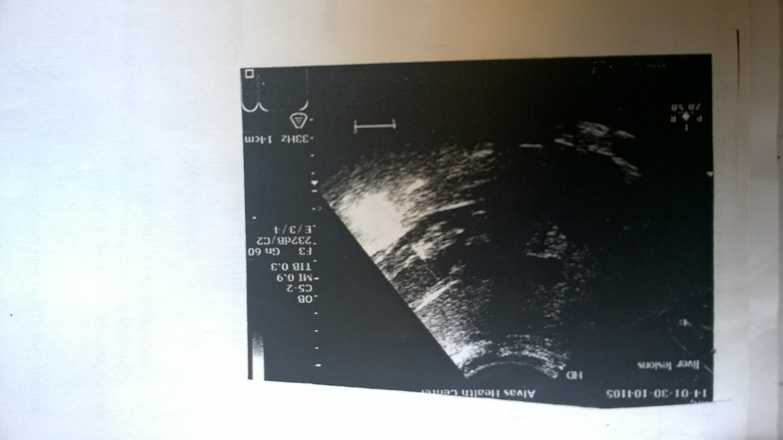

Figure 1. An ultrasound scan of the liver showing polycystic liver disease

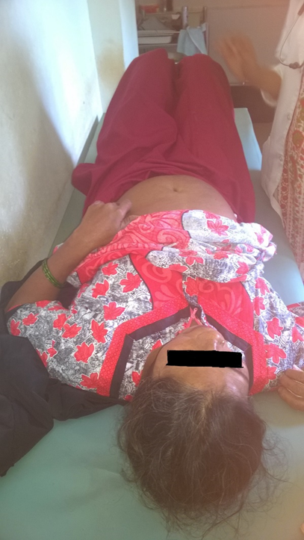
Figure 2. Per abdomen examination of the patient to palpate the liver

Three stage assessment:
Clinical assessment: As mentioned above the patient was regularly followed up. Her reports were seen periodically and she was advised to come for follow up regularly. She was given health advice to combat gastritis which she had always. She was given the following advices: 1. Do not eat spicy food. 2. Take medications for gastritis- pantoprazole/omeprazole/ranitidine. 3. Take little food at frequent intervals. Breakfast around 8 am, a small snack at 11 am, lunch at 1 pm, a small snack at 4 pm and dinner at 8 pm. 4. Drink plenty of water. 5. Do not take excess of coffee and tea. 6. Do not take much stress. Stress aggravates gastritis 7. Do regular exercise. Brisk walk half an hour per day.
She also had some orthopedic problem for which she was referred to the orthopedist and she was suggested some exercises.
The patient had attained menarche at the age of 14, married at 19 years of age. She had 5 children. Age of the last child 12 years. She had attained menopause 5 years back. She has not taken any hormone replacement therapy. This history is important because exposure to female hormones like estrogen and hormone replacement therapy increases the chances of the polycystic liver disease.
Individual assessment:
Personality: The patient was moderately built and nourished. But she had central obesity owing to her disease of polycystic liver. The patient was educated only till 3rd and had poor knowledge about her disease condition. She had a good attitude towards health and disease condition where she believed that disease occurs due to unhygienic surroundings and improper dietary practices. But she admitted the fact that there is a lot of unclean surroundings around her house where there are dirt and water stagnation, dumping of garbage and breeding of vectors around her house. When asked about the housing conditions it was found that there was overcrowding. She was given elaborate health advice where she was shown pictures and videos and was made to understand the importance of clean surroundings and educated about various vector-borne diseases.
Real reasoning for coming: The patient had a constant feeling of indigestion and burning sensation in the stomach. The patient also developed irregular bowel habits where she had on and off diarrhea.
Ideas and thoughts: The patient did not have an idea about her disease condition. She felt that there was constant bloating sensation in the abdomen and that she could feel some mass in the right hypochondriac region. After the disease of the polycystic liver was diagnosed she knew that there was some mass in the abdomen.
Concerns fears and worries: Though the doctors assured her that her condition was benign, still she had concerns whether the disease is lifethreatening. She was given proper counseling and was assured that her disease is not life-threatening but she has to follow proper dietary advice where she has to avoid fatty, oily food and take more of fibers. She also has to do regular exercise to decrease her central obesity.
Expectations and emotions: The patient was happy the way we followed her up regularly and gave health advice. She had a lot of expectations from us as we were addressing all her concerns and fears whereas at the higher centers the doctors hardly had time to speak to her and many of her doubts and concerns were not addressed properly. Though she was symptomatically better after treatment at higher centers she had the fear that the disease could be life-threatening and it was at our primary health care center we could give her a lot of time and answer all her questions. She was quite relieved to know that she could lead a normal life like others.
Spirituality: She was a very religious person and had strong faith in God. She used to do namaz daily at home and attended all the religious gatherings with her family, and that she used to read the Quran daily. She felt that the disease may be due to some of her sins but that God was merciful and that she was relieved soon.

Contextual assessment: Since she lived in a joint family and the overcrowded house she felt that she lacked care from her family members. Though they were attending to her health needs by taking her to various higher centers, but due to some financial constraints and apathy from her husband and children towards emotional support she was a bit disheartened. We called her husband and provided counseling to him also saying that his wife did not have any serious disease and she can lead a normal life, do all the household works and will not be a financial burden to him.

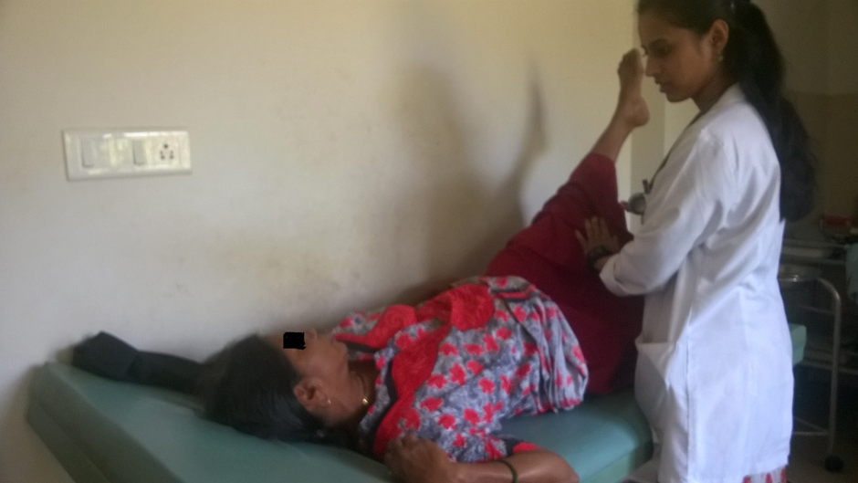

Figure 3. Straight leg raising test in the patient to examine regarding the patients backache

Dıscussıon
My personal reflections about the patient and my learning:
The patient was from a traditional family with a lot of restrictions. She was not educated well and the emotional support from family members were dismal. Hence the family members felt that they have spent enough money on her treatment and that she was becoming a financial burden to them. We had to counsel the husband of the patient and demystify a lot of myths regarding the disease of the patient and patient care. In this context, I stress the fact that education is very important for women

and that they should be financially independent and should be able to take care of themselves. The positive aspect of the patient was that she had strong faith in God and that she believed that God will provide her all the help.
Emotional support of all family members is very important in the speedy recovery of any patient. So in any complicated disease condition it’s important for family physicians to do family counseling. Hence three-stage assessment plays a very important role for family physicians to judiciously help the patients and ensure a good doctor-patient relationship.
Currently the following aspects should be borne in mind when it comes to prevention of polycystic liver disease
- Currently, there are no specific methods or guidelines to prevent polycystic liver disease since it is a genetic condition.
- Genetic testing of the expecting parents (and related family members) and prenatal diagnosis (molecular testing of the fetus during pregnancy) may help in understanding the risks better during pregnancy.
- If there is a family history of the condition, then genetic counseling will help assess risks, before planning for a child.
- Active research is currently being performed to explore the possibilities for treatment and prevention of inherited and acquired genetic disorders.
- The growth rate of the cysts may be slowed through dietary measures (avoiding caffeine, having a low-salt diet, etc.).
Prognosis of patients with polycystic liver disease
- Most individuals diagnosed with polycystic liver disease are asymptomatic and lead a normal quality of life.
- In some individuals, who may require an appropriate surgery to reduce the liver size, the prognosis is good.
- Typically, polycystic liver disease does not lead to liver failure. However, in the case of liver failure, individuals may still cope with the condition and have a better quality of life after a liver transplant.
- The prognosis of polycystic liver disease with associated autosomal dominant polycystic kidney disease can be highly variable, due to the possibility of kidney failure.
CONCLUSION
The three-stage assessment in this particular case depicts the fact that- positive attitude towards health and disease, emotional support of family members, regular follow-up with the consulting physician and genetic counseling of couples who are planning to conceive and have a family history of PCLD are the key factors in management and prevention of the condition.

References
- Bistritz L, Tamboli C, Bigam D, Bain VG: Polycystic liver disease: experience at a teaching hospital. Am J Gastroenterol 2005, 100(10):2212-2217.
- Turnage RH, Eckhauser FE, Knol JA, Thompson : Therapeutic dilemmas in patients with symptomatic polycystic liver disease. Am Surg 1988, 54(6):365-372.
- Russell RT, Pinson CW: Surgical management of polycystic liver disease. World J Gastroenterol 2007, 13(38):5052-5059.
- Van Erpecum KJ, Janssens AR, Terpstra JL, Tjon A, Tham RJ: Highly symptomatic adult polycystic disease of the liver. A report of fifteen cases. J Hepatol 1987, 5(1):109-117.
- Woolnough et al.: Polycystic liver disease presenting with an exudative pleural effusion: a case report. Journal of Medical Case Reports 2012 6:107.
- Salustio R, Ribeiro JV. Polycystic liver disease. BMJ Case Rep 2014; 1-3
- Arnold HL, Harrisson SA: New advances in evaluation and management of patients with polycystic liver disease. Am J Gastroenterol 2005, 100(11):2569-2582
- Doctor-Patient Communication: A Review. Jennifer Fong Ha, and Nancy Longnecker, Ochsner J. 2010 Spring; 10(1): 38–43 http://www.ncbi.nlm.nih.gov/pmc/articles/PMC3096184/
- Fehrsen GS and Henbest RJ. In Search of Excellence. Expanding the patient-centred clinical method: a three-stage assessment. Family Practice 1993; 10-49-54.

