 | Bozok  Tarım ve Doğa Bilimleri Dergisi  (Bozok Journal of Agriculture and Natural Sciences)  https://dergipark.org.tr/en/pub/bojans |  |  | 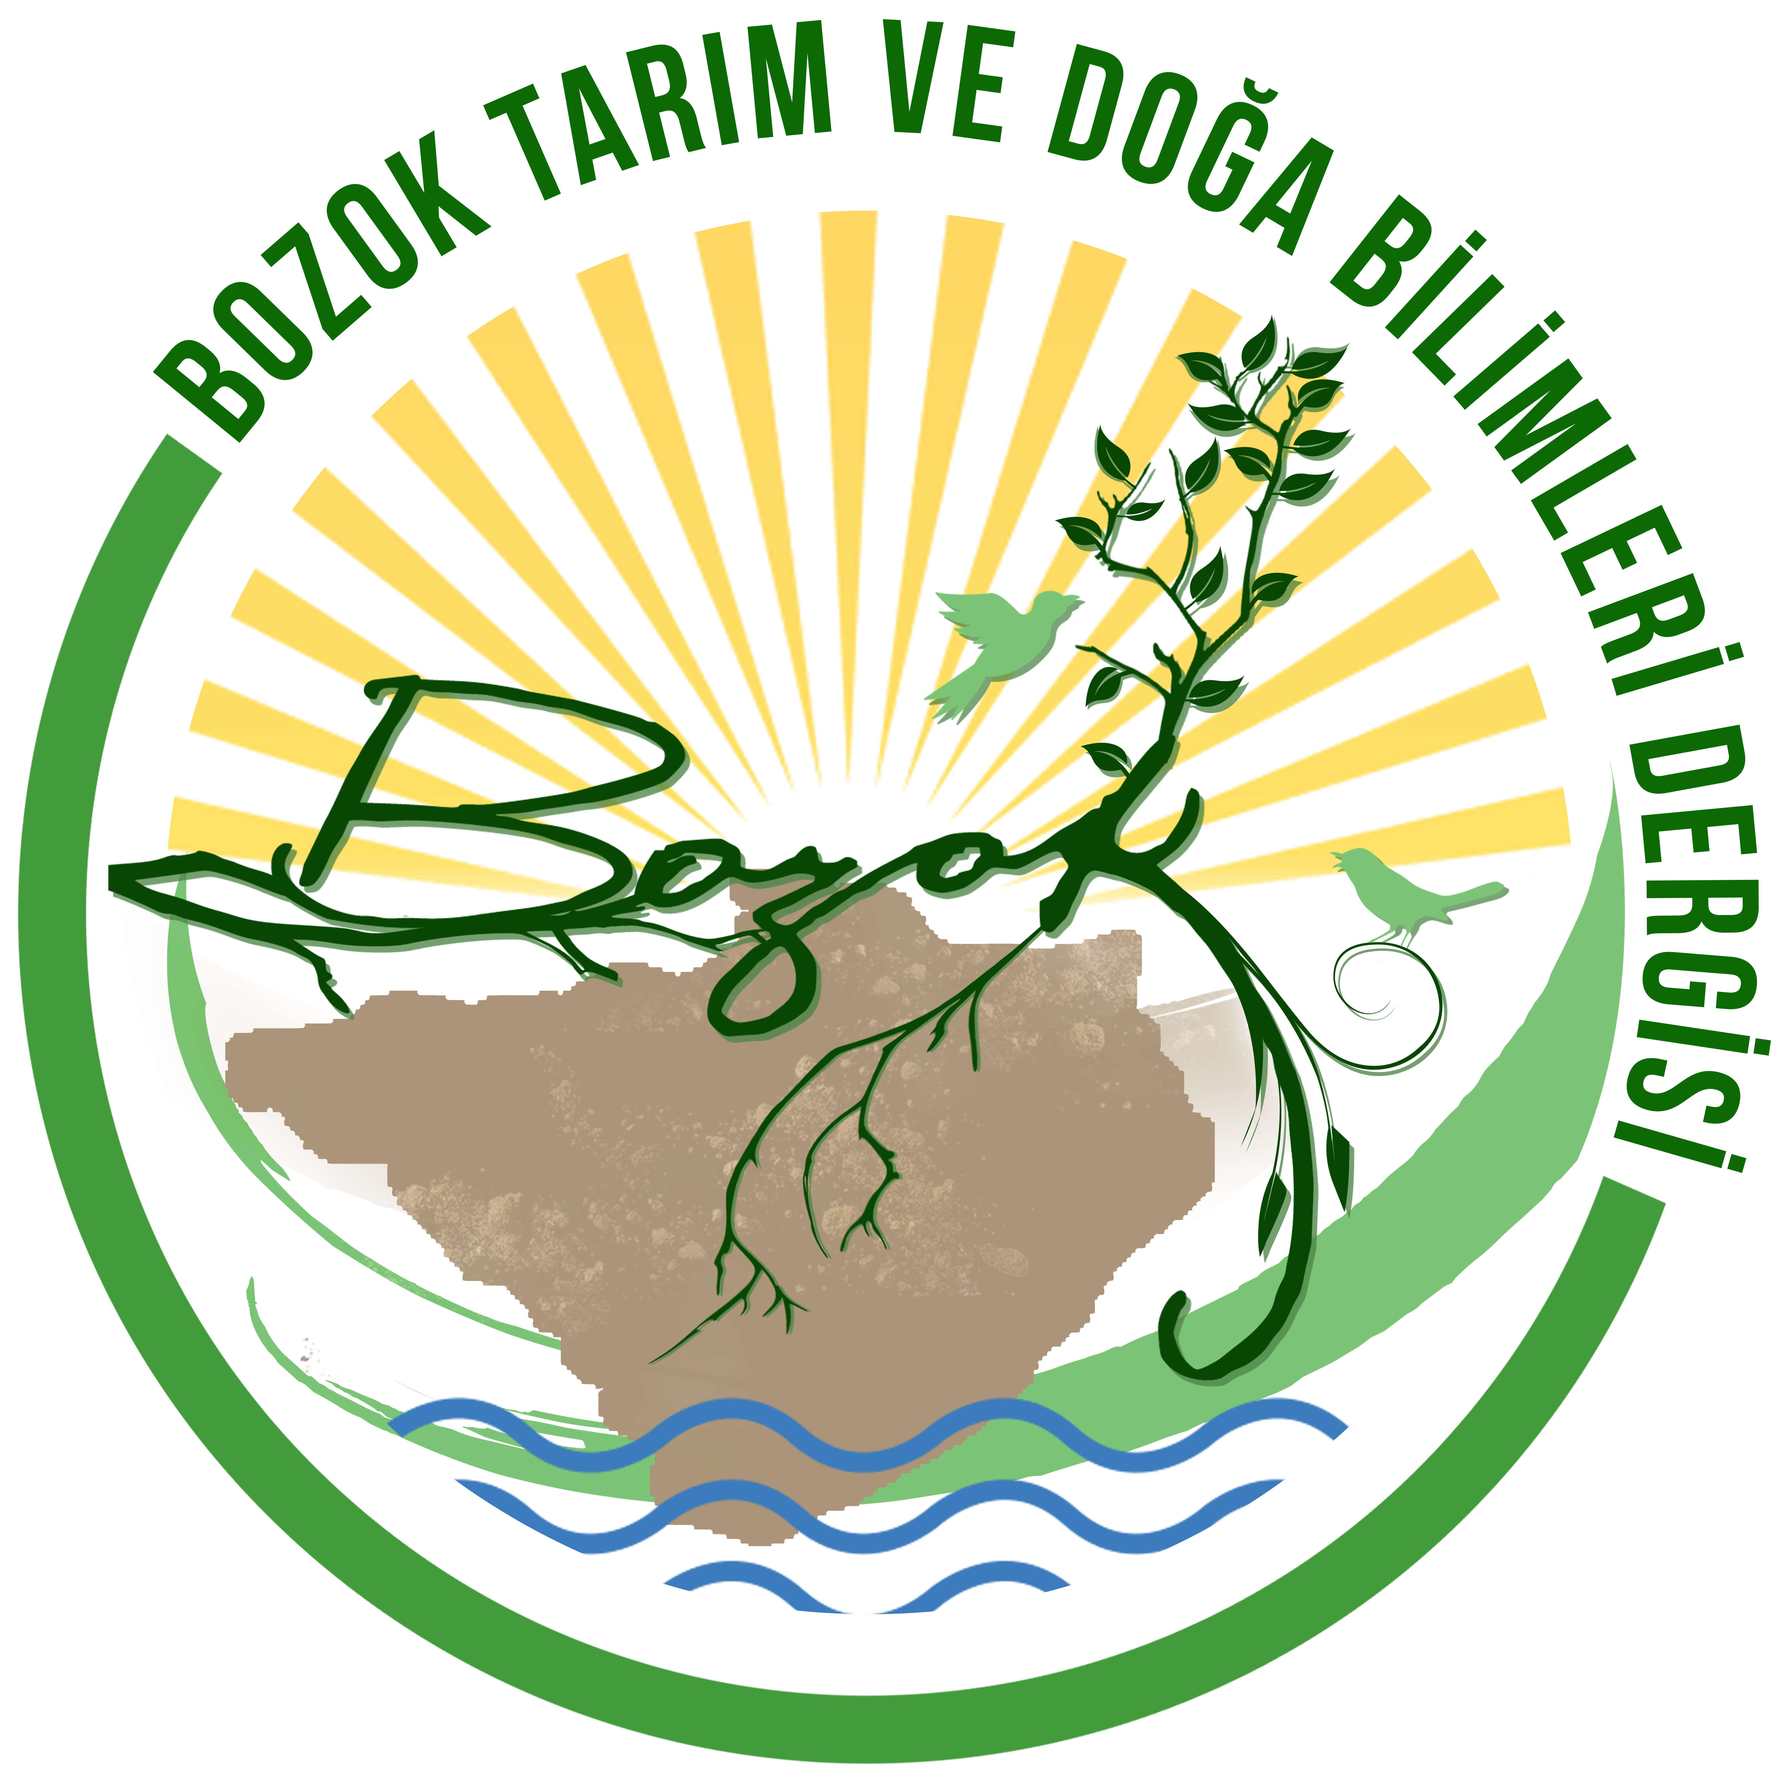
 |  |  | e-ISSN: 2822-4604
Araştırma Makalesi
Sürdürülebilir Peyzaj Kapsamında Milli Parkların Rekreasyonel Potansiyeli
Kübra YAZİCİ^{*1}, Atakan PİRLİ ²
¹ Yozgat Bozok Üniversitesi, Ziraat Fakültesi, Peyzaj Mimarlığı, Bölümü, 66100, Yozgat, Türkiye
²Ege Üniversitesi Ziraat Fakültesi Peyzaj Mimarlığı Bölümü, 35100, İzmir, Türkiye
¹https://orcid.org/0000-0002-6046-1648 - ²https://orcid.org/0000-0002-2208-6306
*Sorumlu Yazar e-mail:k-yazici-karaman@hotmail.com
Makale Bilgileri |  | Öz: Rekreasyonel alanlar; hızlı nüfus artışı, sanayileşme, kentleşme ve teknoloji alanındaki gelişmelerden dolayı sürekli genişlemiş ve doğal kaynaklar üzerindeki baskı da buna paralel olarak artmıştır. Özellikle geçtiğimiz ve yaşadığımız yüzyılda insanoğlunun doğal kaynakları aşırı ve plansız kullanmaya devam etmesi ile birlikte; ciddi çevre problemlerinin ortaya çıkması, canlı türlerinin yok olmaya başlaması, doğal dengenin değişmesi, başta insan olmak üzere birçok canlının yaşadığı ekosistemlerin bozulmaya başlaması, “milli park” kavramının ortaya çıkmasına neden olmuştur. Turizm ve açık hava rekreasyon faaliyetlerine olan ilginin artmasıyla birlikte milli park alanlarına olan talep de artış göstermektedir.  Bu araştırmada, Yozgat ilinde bulunan ve 1958 yılında ilk milli park olarak ilan edilen Yozgat Çamlığı Milli Parkı’nın rekreasyonel potansiyelinin belirlenmesi amaçlanmıştır. Çalışmada; meteorolojik verilerden yararlanılmış, Yöntem olarak, Yunanistan’ın Samos adasında Rekreasyon potansiyelinin saptanmasında ilk defa Kiemsted tarafından ortaya konan ve daha sonra Buchwald ve arkadaşlarının (1973) uyguladığı ve Gülez (1990) tarafından çeşitli değişikliklerle kullanılan “Açıkhava rekreasyon potansiyelinin saptanması” yöntemi uygulanmıştır. Elde edilen veriler ile alanın rekreasyonel potansiyeli belirlenmiştir. Çalışma sonucunda, iklim faktörü ve alanın eğimi gibi özellikler yüksek puan almamıştır. Buna rağmen alanının rekreasyonel potansiyeli ‘Yüksek’ çıkmıştır. Sonuçlara göre alanın peyzaj değerinin yanı sıra beşeri özellikleri, kullanıcılara yönelik hizmetler yüksek puan almıştır.
Geliş: 10.05.2022
Kabul: 01.06.2022
Online yayınlanma: 10.06.2022

Anahtar Kelimeler
Orman içi rekreasyon,
Milli park,
Yozgat,
Kent ekolojisi,

Atıf Künyesi: Yazici K. and Pirli, A. (2022). Yozgat Çamlığı Milli Parkı’nın Rekreasyonel Potansiyelinin Belirlenmesi, Bozok Tarım ve Doğa Bilimleri Dergisi, 1(1), 11-23 How to Cite: Yazici K. and Pirli, A. (2022). A Research on Determination of Recreational Potential of Yozgat Çamlığı National Park, Bozok Journal of Agriculture and Natural Sciences, 1(1), 11-23
The Recreational Potential of National Parks in the Scope of Sustainable Landscape
Article Info |  | Abstract: Recreational areas have increased due to rapid population growth, industrialization, urbanization and developments in technology. These areas have continuously expanded and the pressure on natural resources has increased in parallel. Especially in the last century and in the century we live in, with the continuation of human beings to use natural resources excessively and unplanned; The emergence of serious environmental problems, the extinction of living species, the change in the natural balance, the deterioration of ecosystems in which many living things, especially human beings, started to deteriorate, led to the emergence of the concept of "national park". With the increasing interest in tourism and outdoor recreation activities, the demand for national park areas is also increasing. This study was aimed to determine the recreational potential of Yozgat Çamlığı National Park, which is located in Yozgat and declared as the first national park in 1958. As method, the method of "Determination of outdoor recreation potential", which was first introduced by Kiemsted and later applied by Buchwald et al. (1973) and used with various modifications by Gülez (1990), was used to determine the recreational potential on the Greek island of Samos. The recreational potential of the area was determined with the data obtained. As a result of the study, features such as the climate factor and the slope of the area did not receive high scores. Despite this, the recreational potential of the area has been found to be 'High'. According to the results, in addition to the landscape value of the area, human characteristics and services for users received high scores.
Received: 10.05.2022
Accepted: 01.06.2022
Online published: xx.xx.202x

Keywords

Forest recreation,
National Park,
Yozgat,
Urban ecology,

1. Introduction
Today, unplanned and rapid urbanization due to technological developments, together with intense work tempo and stress, adversely affect the physiological and psychological health of people living in cities. For this reason, recreation is seen as an important element for people to regain their physiological and psychological health, which is deteriorated for various reasons, to get rid of the pressures of daily life, and to regulate their relations with each other and with their environment (Gülgün et al., 2014; Yazici and Arslantas Saglamer, 2019; Yazici and Gülgün, 2021;Çolak et al., 2021). Today's society, especially with the disappearance of natural and green areas, has felt the need for these areas more and has started to prefer natural and green areas in order to spend their free time (Çavuş and Aker, 2021; Unal et al. 2018). Reading landscape or understanding landscape emphasizes that human is a part of landscape. Different land uses are explained through temporally and spatially different meanings or values (culture, history, tradition, law, etc.) that affect how landscapes are understood and used (Hansen, 2020). Therefore, recreational qualities should be included in the physical planning of the landscape (Raumer, et al. 2019). In this direction, a healthy recreation planning can only be possible by determining the recreational habits and recreational needs of the citizens in a rational way. In the study, the recreational potential of Yozgat Çamlığı National Park was evaluated in line with the increasing recreational demands in the city of Yozgat.

What is recreation
Recreation is a concept that has been the subject of research by many disciplines in recent years and many definitions have been made. One of the most efficient ways to get rid of the pressures that we have to face in the daily busy and monotonous urban life has emerged as turning to recreational areas (Bayramoğlu and Yurdakul, 2020). According to Boman (2013), recreation; It defines it as “the cultural and economic activities that people do voluntarily, at any time they want”. There is no financial gain and expectation in recreation, and it includes physical or mental mobility. Joyful activities that are individually or collectively planned or decided on the spot (Sağcan 1986; Pehlivanoğlu 1987). In other words, recreational activities in leisure time are not made for the purpose of making money (Orel and Yavuz, 2003). According to Hacioglu et al. (2003), recreation activities that people participate voluntarily in their spare time for the purpose of entertainment, relaxation and satisfaction. People can spend their spare time with different activities that they participate in voluntarily, in their spare time and outside of their work environment, and they can renew themselves with the behaviors they gain from these activities. Moreover, recreational activities that bring about change, innovation and interestingness can be eliminated from the monotony of human life (Karakuş, 2005). Recreation includes all kinds of pleasure and joyful activities that the participants choose voluntarily in their spare time, alone or with a group, with or without a vehicle, in open or closed areas, in the city or outside the city, affiliated with an organization or independently (Serarslan and Bakır , 1988; Gunay, 2012; Yazici and Aşur, 2020). These activities are; It can be grouped under general headings as various arts, music and sports-based activities, activities in nature, activities that require talent, social and cultural activities, and various games.

National Parks, Recreational Facilities and Conservation Status
Today, national park areas have an important place among protected areas. These areas attract attention from many visitors due to their tourism potential and recreational activities (Bingöl and Arslan, 2021). Areas such as national parks and nature parks, which are considered as recreational areas, are also in high demand. For this reason, it is extremely important for nature protection to prevent the destruction of protected areas, to protect nature and natural resources, and to ensure sustainable land use. Protected area according to the definition of "International Union for Conservation of Nature" (IUCN); It is “land, water or sea areas with protection status, managed in accordance with the relevant legislation for the purpose of protecting and maintaining biological diversity, natural and related cultural resources”. Today, according to the data of the "World Database on Protected Areas" (WDPA), protected areas constitute 9.60% of the earth's surface. Protected areas cover 15.01% of land areas and 7.59% of marine areas (WDPA, 2020). Protected areas according to the management objectives of the "International Union for Conservation of Nature" (IUCN); It is divided into six categories: absolute nature reserve, wildlife area, national park, natural monument or feature, habitat/species management area, protected landscape/marine area, and protected areas managed for the sustainable use of natural resources (Dudley, 2008). These classifications are classified as nature protection area, national park, natural monument, wildlife protection area, nature park and wetland in Turkey. As in the whole world, "National Parks" are the most prominent of the concepts in "Protected Areas" in our country. IUCN's definition of a national park is: "The species and ecosystems it hosts, together with large-scale ecological processes, environmental and cultural values are protected; It is largely natural or near-natural areas that provide opportunities for scientific research, educational work, recreational activities and visitors”. Many studies were available on the recreational evaluation of nature parks and other nature conservation areas (Akten and Gül 2014; Altunöz et al. 2014, Dal and Karayılmazlar 2019; Gül et al. 2005; Kaptan Ayhan; 2019; Özçalık and Kumru 2019; Yazici and Aşur ,2019; Öztürk and Gül 2020, Gülgün et al., 2020; Polat and Aktaş Polat 2016, Sezer and Bekdemir, 2017; Surat et al. 2014; Şahbaz and Altınay 2015; Yener, 2021; Yazici and Akça, 2019). These studies were carried out to determine the potential for recreational activities in general and focused on the recreational suitability of the areas.
Recreation activities that meet the needs of urban people in this direction in their daily life and urban recreation areas that provide this are of great importance. Yozgat Çamlık National Park, located in the central district of Yozgat province, is Turkey's first national park, and is preferred by many visitors for tourism and recreation activities. Therefore, Çamlık National Park stands out with its recreational activities as well as its natural and cultural features. In this research, Çamlık National Park, which has rich natural and cultural resources and is one of the valuable national parks in Turkey, is considered as a study area. By analyzing the values of the study area, the recreational potential was tried to be determined and various suggestions were presented to increase the recreational potential.

2. Material and Method
In this study, Yozgat Çamlık National Park, which is located in the city of Yozgat, is very rich in terms of natural values and was declared as a national park in Turkey in 1958, was evaluated. Yozgat Çamlığı National Park is located in the Central Anatolia Region and is in the Central district of Yozgat province. Its area was reported to be 264 hectares. It consists of rare examples of the forest cover that once covered a large part of Central Anatolia. The tree species of the forest is mainly larch. There are also oak and juniper.
Yozgat Çamlık National Park, which is a piece of forest surrounded by steppes; fox, rabbit, vole, marten, squirrel etc. mammals; hawk, magpie, dove, weevil , lark , starling , yellow vine , mountain crow , falcon , falcon , golden eagle etc. It is home to birds and reptiles such as turtles, lizards and snakes. There was an American origin white eagle in Yozgat Çamlığı National Park, and two of them were last seen in 1996. Its distance from the city center is 1.5 km. The national park, which is a national park, is an important recreation area for the people of Yozgat (General Directorate of Nature Conservation and National Parks, 2021). In the research process, which started with the literature review, information about the source values of the study area was obtained by revealing the theoretical information that guided the study. In this framework, tourism, recreation, etc., which directs the whole of the study. Documents were provided for the use of such concepts in recreation areas, and studies were carried out to determine the data of the research area and the recreational resource values of the area in order to transfer the obtained information into practice.

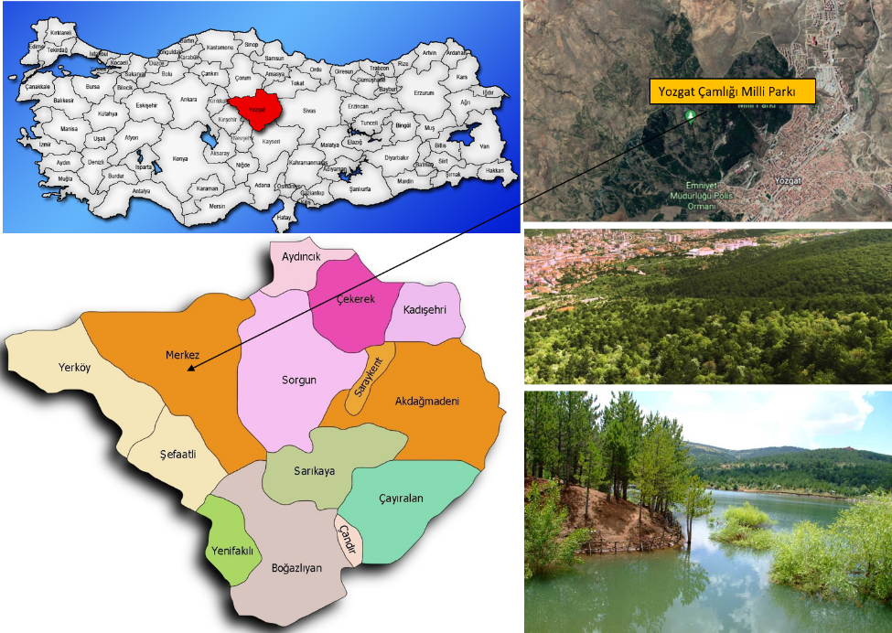

Figure 1. The Study Area, Yozgat/Turkey
Meteorological data were used in the study process. As a method, the "Determination of outdoor recreation potential" method, which was first introduced by Kiemsted and later applied by Buchwald et al. (1973) and used with various modifications by Gülez (1990), was used to determine the recreational potential in the island of Samos, Greece. This method; It was an evaluation method based on the principle of giving weighted points to the five existing elements of the area, namely landscape value, climate value, accessibility, recreational convenience and negative factors. The method, which was based on scoring the information in a form and providing a result with a simple mathematical operation, was a method that does not require user surveys and statistical evaluations since it was based on expert observations and evaluations (Altunöz et al., 2014). This method, based on this study, was adapted to the study area and tried to determine the recreational potential of the area (Equation 1).
LV+CV+A+RE+NF=%RP (1)
The meaning of the abbreviations in the equation and the percentage distribution of the values they can take predominantly are given in Table 1.

Table 1. Meanings and score distribution in the recreation potential formula

Symbol | Meaning | Maximum Points (Item Weight Points)
LV | Landscape Value | 35
CV | Climate Value | 25
A | Accessibility | 20
RE | Recreational Equipment | 20
NF | Negative Factors | 0 (Minimum-10)
% RP | Recreation Potential | 100

3. Result and Discussion
Many factors were taken into consideration while determining the recreational potential of the study area. These factors, which were classified as landscape value, climate value, accessibility, recreational equipment and negative factors of the study area, were handled separately, and the recreational potential of the area was tried to be determined. Landscape Value, expressed with the "LV" symbol: The most important factor to be taken into account in calculating the recreation potential was the landscape value of that area. For this reason, it was expressed as 35% in weighted scoring. While determining the landscape value of the study area, element properties were examined in 6 groups. These; The size of the area, vegetation, sea, lake and rivers, land structure, visual quality and human environmental value are the elements (Table 2).

Table 2. Landscape value of the study area, Yozgat Çamlığı National Park

Elements in the Formula | Characteristic of the elements | Maximum points | Instructions
Landscape value | Size of the area | 3 | Larger than 50.000 hectares | 4
 |  |  | 20.000-50.000 hectares | 3
 |  |  | 1.000-20.000 hectares | 2
 |  |  | 0-1.000 hectares | 1
 | Vegetation cover | 8 | Trees, scrub, meadow | 7-8
 |  |  | Trees, scrub | 6-7
 |  |  | Scrub, meadow, rare | 5-6
 |  |  | Meadow, rare trees | 4-5
 |  |  | Scrub, meadow | 3-4
 |  |  | Scrub, rare trees | 3-4
 |  |  | Meadow, Rare scrub | 2-3
 |  |  | Meadow | 1-3
 | Open water | 8 | Seaside | 7-8
 |  |  | Lakeside | 6-7
 |  |  | Riverside | 4-5
 |  |  | Streams | 1-4
 | Land Form | 4 | Flat land | 5
 |  |  | Gently rolling | 4
 |  |  | Undulating | 3
 |  |  | Little hilly | 2
 |  |  | Hilly | 1
 | Visual Quality | 4 | Panoramic Views | 3-4
 |  |  | Landscapes | 2-3
 |  |  | General Visual Aesthetic Value of the Area | 1-3
 | Human Environmental Value | 6 | Ruins | 1
 |  |  | Natural Plants and Animals | 1
 |  |  | Wetlands | 1
 |  |  | Geological Structure | 1
 |  |  | Education, Tourism | 1-1

Climate Value, expressed with the symbol “CV”: Another important factor in calculating the recreation potential is the climate factor. For this reason, the climate value was expressed as 25% in the weighted scoring. “Temperature”, “Rainfall”, “Sun Time” and “Windness” states that were included in the value of climate contribute to the climate value with certain weights (Equation 2 and Equation 3).
Climate Value = Temperature + Precipitation + Sunshine + Windiness (Equation 2)
25=10+8+5+2 (Equation 3)
In the temperature element included in the climate value, it was evaluated by taking the average temperature of the summer months (June, July and August) where recreational activities were more common. In terms of suitability for recreational activities, the mean temperature was evaluated with 10 points at 25°C, and between 16°C and 34°C with 1 point (Table 3).
Precipitation, another element in the climate value, was included in the calculation with 8 weight points. Considering that precipitation adversely affects recreational activities, places where the total precipitation amount is 0-50 mm in summer months are evaluated with 8 points, and places with high precipitation are evaluated with 1 point (Table 3).
The sunshine duration, which was included in the climate value, was included in the calculation with 5 weight points. The duration of sunbathing was evaluated between 2-12 hours. Here, as the number increases, the sunshine duration also increases (Table 3).
The last element of the climate value was the windiness. In the calculation, areas with an average wind speed of 1-3 m/sec in summer months and areas lower than 1.1m/sec were evaluated with 2 points (Table 3).

Table 3. Climatic value of the study area

Climate Value | Temperature | 7 | Average of summer months (June, July, August) (ºC)  16-17-18-19-20-21-22-23-24-25  34-33-32-31-30-29-28-27-26-25  P: 1, 2, 3, 4, 5, 6, 7, 8, 9, 10
 | Precipitation | 8 | Average of summer months (June, July, August) (mm)  50-100-150-200-250-300-350-400  P: 8, 7, 6, 5, 4, 3, 2, 1
 | Sunshine | 5 | Average of summer months (June, July, August) (hour)  ↓ 2-4 ,4-6, 6-8, 8-10, 10-12↑  P: 1, 2, 3, 4, 5
 | Windiness | 0 | Average wind speed in summer (m/sec)
 |  |  | less than 1 m/sec less than 1 m/sec, 2 | 1-3 m/sec, 1

Landscape Value, expressed with the "A" symbol, Accessibility: Another factor in determining the recreation potential was the accessibility factor. The easier it was to reach the area where recreational activities will be held, the higher the recreational potential of that area. Therefore, the accessibility factor was included in the calculation of the recreation potential with a weight of 20% (Table 4).

Table 4. Accessibility value of the study area

Accessibility: (A) | Touristic Importance of the Region | Black Sea, Marmara, Aegean, Mediterranean Coastline | 3-4
 |  | Important Highway Routes | 2-3
 |  | Priority Regions in Tourism | 1-3
 | Having a City with a Population of At least 100,000 in the Region | Distance away 20 km | 4-5
 |  | Distance away 50 km | 3-4
 |  | Distance away 100 km | 2-3
 |  | Distance away 200 km | 1-2
 | Travel time (From Nearby town with minimum 5,000 Population) | One hour walk’s or 0-1 hour’s driving | 4
 |  | 0-1/2 hour’s driving | 3
 |  | 1-2 hour’s driving | 2
 |  | 2-3 hour’s driving | 1
 | Transportation (Except Taxi and Private Car) | Regular public transport | 3-4
 |  | Occasional public transport | 1-3
 | Other Conveniences in Transportation | For example, there is a cable car, it can be reached from the sea | 1-3

Landscape Value Recreational Facilities expressed with the symbol "RF": Existing recreational facilities in the area increase the recreational potential. The area's having the necessary equipment and the ability of these equipment to meet the expectations and needs of the visitors increases the recreational potential of the area. Recreational equipment was included in the calculation with a weight of 20% (Table 5).

Table 5. Recreational equipment in the study area

Recreational Facilities r (RF) | Picnic Facilities | 2 | Fixed picnic tables,grilles etc.. | 1-3
 | Water Supply | 3 | Supply potable and other water (According to their qual) | 1-3
 | Information Center, Museum | 1 | By Visitor Center Availability | 1-3
 | Accommodation facilities | 0 | Fixed Accommodation Facilities | 2
 |  |  | Tent and Tent less Camping Facilities | 1
 |  |  | Areas where accommodation is prohibited | 0
 | WCs | 1 | According to their qualities | 1-2
 | Car park | 1 | According to their qualities | 1-2
 | Refreshment | 1 | According to their qualities | 1-2
 | Wardens | 2 | Payment wardens | 2
 |  |  | Temporary wardens | 1
 | Other facilities | 2 | For example, Beach, Cabin and Shower Facilities, Rental Sandal Facilities, Playgrounds and Sports Areas, Facilities etc. | 1-3

“NF” Negative Factors: In calculating the recreational potential, it is necessary to calculate the negative factors as well as the positive ones. Negative factors are scored between 0-10 and are given a (-) value (Table 6).
Table 6. Negative Factors of study areas

Negative Factors (NF) | Air pollution | - | According to Air Pollution Condition | -1
 | Water pollution | - | For Sea, Lake and Streams | -1
 | Noise | - | Traffic Crowded Etc. Noises | -1
 | Lack of security | - | By Assurance Status | -1
 | Exceeding Facility Capacity | -1 | According to Capacity Status | -1
 | Neglect | -1 | Inadequate Maintenance in the Field | -1
 | Insufficient Recreation Areas | - | According to Recreation Activities | -1
 | Referral and Promotion Shortcomings | - | Sign, Promotional Signs, Brochure etc. | -1
 | Harvest | -1 | Gathering, Poaching etc. | -1
 | Rising Inflation in Prices | -1 | High Prices in Uses | -1

Obtained results were evaluated as follows:
• National Park recreation potential “Very Low” (below 30%)
• National Park recreation potential “Low” (30%-45%)
• National Park recreation potential “Medium” (46%-60%)
• National Park recreation potential “High” (61%-75%)
• The recreation potential of the National Park is “Very High” (above 75%) According to this evaluation, the result of the analysis of the study area is given in Table 7.

As a result of the evaluation, the score of the study area was found to be 76% and according to the national park recreation potential evaluation criteria, the study area was classified as "Very High" in terms of recreation potential. The chart below shows the comparison of the scoring values related to the study area with the values of the Gulez Method.

Figure 2. The recreational potential of Yozgat Çamlığı National Park
Table 7. Study area recreation potential evaluation form

Elements in  the Formula | Characteristic of the elements | Maximum points
Landscape value (LV) | Size of the area | 4
 | Vegetation cover | 6
 | Open water | 6
 | Land Form | 1
 | Visual Quality | 4
 | Human Environmental Value | 5
Climatic Value (CV) | Temperature | 3
 | Precipitation | 8
 | Sunshine | 4
 | Windiness | 1
Accessibility:(A) | Touristic Importance of the Region | 2
 | Having a city in the region with a population of at least 100,000 people | 5
 | Time Traveled (From a nearby city of at least 5,000 people) | 4
 | Transportation (Except Taxi and Private Car) | 3
 | Other Conveniences in Transportation | 1
Recreational Facilities r (RF) | Picnic Facilities | 4
 | Water Supply | 3
 | Information Center, Museum | 1
 | Accommodation facilities | 2
 | Otopark | 2
 | WCs | 2
 | Car park | 2
 | Refreshment | 2
Negative Factors (NF) | Exceeding Facility Capacity | -1
Total Score or Recreation Potential in the National Park (%) |  | 76

In the research process, which started with the literature review, information about the source values of the study area was obtained by revealing the theoretical information that guided the study. The framework of study was tourism, recreation, etc., which direct the whole of the study. Documents were provided for the use of such concepts in recreation areas, and studies were carried out to determine the data of the research area and the recreational resource values of the area in order to transfer the obtained information into practice.

4. Conclusion
Yozgat Çamlık National Park, which forms the study area, has a rich structure in terms of forest area and vegetation. Therefore, it is possible to see intense recreation and tourism activities here. Especially Yozgat city center and nearby settlements such as Sorgun, Çekerek, Yerköy, Çorum (Sungurlu) were also affected by these developments. The advantage of accessibility to the National Park is that the National Park is located in the city center of Yozgat. In addition, two entrances were provided for the use of visitors in order to avoid long vehicle queues at the entrance of the National Park, thus enabling visitors to enter without waiting. In addition, there are many facilities in the National Park. Since these facilities are put into use by tender method, they are open to the public. Activities are picnic, trekking, photography, wildlife watching, orienteering, bird watching, botanical excursion, mountain biking, cultural tourism, accommodation, nature tourism, ecological tours, scenic cruising, daily use, scientific tour nature education in general (Figure 3). In addition, snow wells, which have cultural value and were used by the people in ancient times, were also identified in the area.

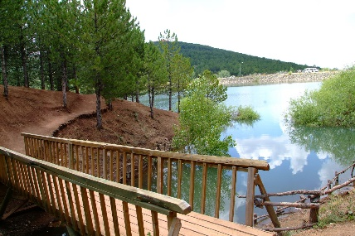 | 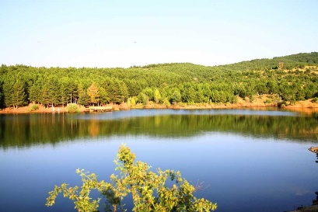 | 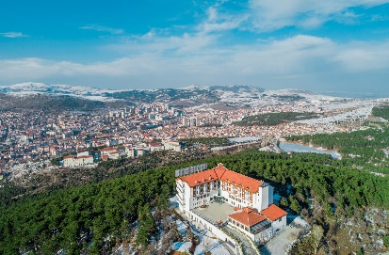
Walking track | Pond | Çamlık Hotel-Accommodation facility
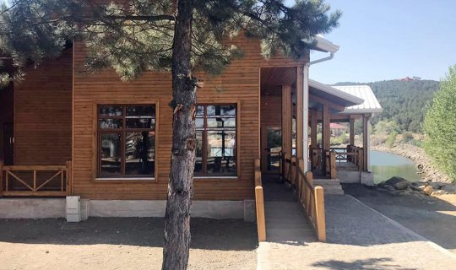 | 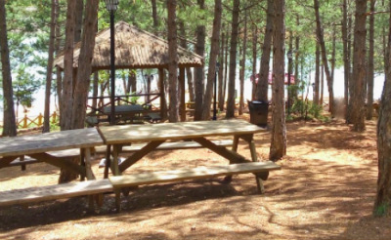 | 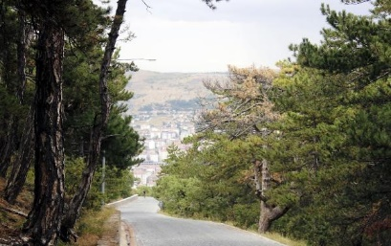
Cafeteria | Picnic area | Road landscape
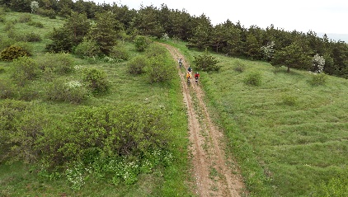 | 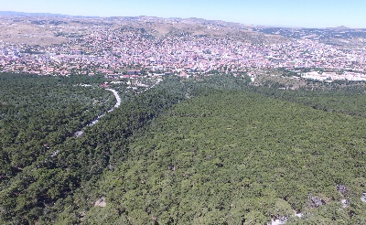 | 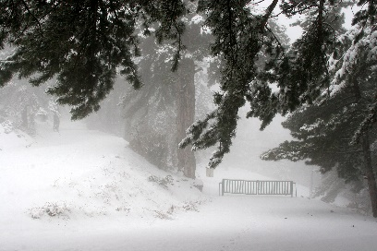
Cycling tour | General view | Winter view
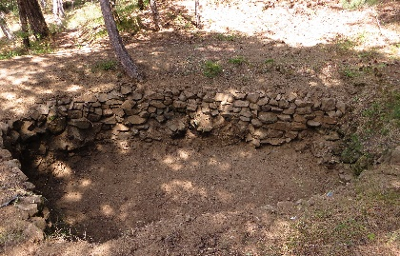 | 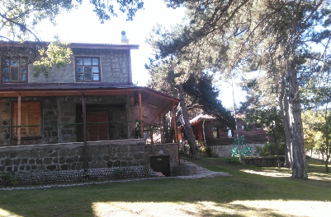 | 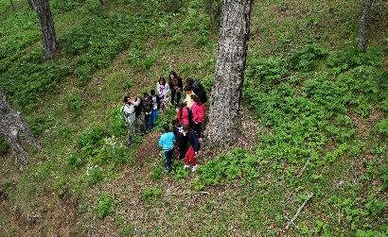
Snow well / tree well | Cottage | Nature education
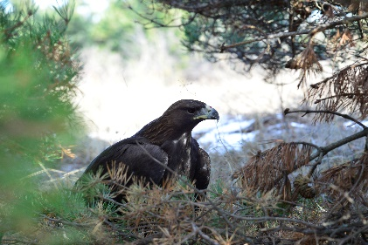 | 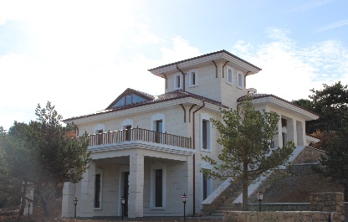 | 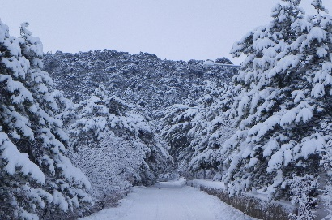
Golden eagle (Aquila chrysaetos) | Forest Lodge | Winter view
Figure 3. Yozgat Çamlık National Park (Culture Portal; General Directorate of Nature Conservation and National Parks)
In addition, there is a fountain, parking area, activity area, accommodation facility, buffet, picnic areas, WC, prayer room, country house, children's playground, sports field, jogging track, forest roads, sightseeing route, walking path, conference hall, arbours, security points, bicycle path, viewing point, forest lodge, rain shelter, administrative service building, guard house, country restaurant, basketball court, volleyball court, barbecue, access control point, cafe management, track, picnic table, İn Yozgat Çamlığı National Park. There is also an administrative-visitor promotion centre, a nature museum and a chairlift. However, despite all these existing formations, the demand that was formed above the capacity leads to the emergence of human pressure on the natural environment. During the summer months, the carrying capacity of the National Park is exceeded due to the high demand, especially on weekends. In addition, as the entrance is uncontrolled around the walking and vehicle roads, unforeseen recreational activities are encountered in this section and this situation is prohibited by the National Park administration. The visitor and promotion center in the National Park area is located in the Police School Street section. The General Directorate of Nature Conservation and National Parks (DKMP) provided the release of approximately 100 thousand pheasants and partridges produced in 2019 in order to support natural life. In the study area, lichenicol fungus was found by researchers in 2021. Small mammals, birds, reptiles, invertebrates and rare herbaceous plants also live in this forest part surrounded by steppes (Yazici and Temizel, 2020).
Agricultural activities should be strictly controlled, tourism and housing investments should be prevented. The National Park is open to the public as a union. However, the demand over capacity reveals human pressure on the natural environment. For this reason, the carrying capacity of the National Park is exceeded due to the high demand during the summer months, especially on weekends. For this reason, vehicle limitation is introduced in order to protect the environment.
As a result, when all evaluations are made, it is seen that the recreational good criteria that need to be developed for national parks are provided at a high rate (for example, lengthy process and more detailed studies are required in the recreational area to be built around a dam). In this direction, Yozgat Çamlığı National Park, which is considered within the scope of the study, has a high value in terms of recreational potential. As stated within the scope of the study, Yozgat Çamlığı National Park is an extremely important value both in the country and in the world. When it is considered from various aspects such as its natural structure, the ecosystem it hosts, and the recreational opportunities it provides to people, it is an important value that should not be lost and protected. For this reason, to provide healthy and sustainable benefits, it should be evaluated within this framework, especially taking into account the national and international frameworks related to the Conservation status, and this green value should be preserved and transferred to the next generations in the best possible way without being deteriorated.

References
Akten, S. ve Gül, A. (2014). Korunan Doğal Alanlarda Ziyaretçilerin Olası Etki Düzeyleri Önlem ve Standartların Belirlenmesi (Gölcük Tabiat Parkı Örneği), SDÜ Orman Fakültesi Dergisi, 15: 130-139.
Altunöz, Ö., Tırıl, A. ve Arslan, Ö.E. (2014). Hamsilos Tabiat Parkı’nın Rekreasyon Potansiyelini Belirlemeye Yönelik Bir Araştırma, Journal of Recreation and Tourism Research (JRTR) 2014, 1 (1) 20-38.
Bayramoğlu, E. ve Yurdakul, N. M. (2020). Trabzon 100.Yıl Parkı ve Çevresinin Rekreasyon Potansiyelinin Saptanması. Bartın Orman Fakültesi Dergisi, 22 (1) , 38-46.
Bingöl, B. ve Arslan, M. (2021). Dilek Yarımadası Büyük Menderes Deltası Milli Parkı’nın Rekreasyon Potansiyelinin Belirlenmesine Yönelik Bir Araştırma. Humanities Sciences, 16(3):177-186.
Boman, M., Fredman, P., Lundmark ,L. ve Ericsson, G. (2013). Outdoor recreation – A necessity or a luxury? Estimation of engel curves for Sweden. Journal Of Outdoor Recreation And Tourism. 3 (4): 49–56.
Buchwald, K., Harfst, W. and Kraus, E. (1973). Gutachen für einen Landschaftsrahmen-plan, Bodensee Baden-Württemberg Ein Beitrag zur regionalen Entwicklung im BadenWürttembergischen Bodensegebiet. Ministerium für Ernahrung Landwirtschaft und Umwelt Baden-Württemberg, Stuttgart.
Çavuş, A. ve Aker, P. (2021). Turgut Özal Tabiat Parkı’nın Rekreasyon Potansiyelinin Belirlenmesi. Turizm Akademik Dergisi, 8 (1) , 193-212 .
Çolak, S., Akça, Ş. B. and Yazici, K. (2021). Toprak Kirliliğinin Zenginleştirme Transfer ve Birikim Faktörleri ile Değerlendirilmesi Zonguldak Çaycuma Örneği. Ziraat Mühendisliği, (371), 59–73.
Dal, İ. ve Karayılmazlar, S.A. (2019). Balamba Tabiat Parkı Açık Hava Rekreasyon Potansiyelinin Değerlendirilmesi, UBAK Uulslararası Bilimler Akademisi, 55-68.
Dudley, N. (2008). Guidelines for applying protected area management categories. Gland, Switzerland, IUCN, 86pp. ISBN:978- 2-8317-1086-0.Stuttgart, 206 s.
General Directorate of Nature Conservation and National Parks (2021). http://yozgatcamligi.tabiat.gov.tr
Gül, A., Örücü, K. ve Karaca, Ö. (2005). Korunan Alanlarda Rekreasyon Uygunluk Analizi ile Potansiyel Alanlarının Belirlenmesi (Gölcük Tabiat Parkı Örneği), Korunan Doğal Alanlar Sempozyumu, 8-10 Eylül, SDÜ Isparta.
Gülez, S. (1990). Orman İçi Rekreasyon Potansiyelinin Saptanması İçin Geliştirilen Bir Değerlendirme Yöntemi. İstanbul Üniversitesi Orman Fak. Dergisi, 40, 2, İstanbul. Erişim adresi: https://forestist.org/Content/files/sayilar/ 390/7.pdf
Gülgün B., Yetişen, A. ve Yazici K. (2020). Theory and Research in Agriculture, Forestry and Aquaculture Sciences, Bölüm Adı:The Prelımınary Examınatıon of Recreatıonal Potentıal In Mesır Nature Park In Manısa/Turkey, Yayın Yeri:Gece Akademi, Editör:Prof. Dr. Ali Musa BozdoğanAssoc. Prof. Dr. Mehmet Fırat Baran, Basım sayısı:1, Sayfa sayısı:125, ISBN:978-625-7243-80-3, Bölüm Sayfaları:29 -44.
Gülgün, B., Güney, M. A., Aktaş, E. ve Yazici, K. (2014). Role Of The Landscape Architecture İn Interdisciplinary Planning Of Sustainable Cities. Journal Of Environmental Protection And Ecology, 15(4), 1877–1880.
Hansen A. S. (2020). Understanding recreational landscapes–a review and discussion. Landscape Research, 46(1), 128-141
Kaptan Ayhan, Ç. (2019). Ayazmapınarı Tabiat Parkı’nın (Bayramiç, Çanakkale) Rekreasyonel Potansiyelinin Belirlenmesi Üzerine Bir Araştırma, Cilt 7, Sayı 1, 219 – 228.
Orel D., F. ve Yavuz M., C. (2013). Rekreasyonel Turizmde Müşteri Potansiyelinin Belirlenmesine Yönelik Bir Pilot Çalışma, Çukurova Üniversitesi Sosyal Bilimler Dergisi, 11(11):61-76.
Ministry of Culture and Tourism (Turkey), https://www.kulturportali.gov.tr/turkiye/yozgat/gezilecekyer/camlik-milli-parki
Ministry of Environment, Urbanisation and Climate Change (Turkey), Meteroloji Genel Müdürlüğü (2021), https://www.mgm.gov.tr/veridegerlendirme/il-ve-ilceler-istatistik.aspx?m=YOZGAT
Özçalık, M. ve Kumru, S.N. (2019). Kapiçam tabı̇at parkı’nın gülez yöntemı̇ne göre rekreasyon potansı̇yelı̇nı̇n belı̇rlenmesı̇. Turkish Journal of Forest Science, 3(2): 129-141.
Öztürk, B.Ö. ve Gül, A. (2020). Başpınar Tabiat Parkı’nın Rekreasyonel Planlama Açısından İrdelenmesi, Mimarlık Bilimleri ve Uygulamaları Dergisi, 5(1): 11-34.
Pehlivanoğlu, M.T. (1987). Belgrad ormanının rekreasyon potansiyeli ve planlama planlamasının önemi. Peyzaj mimarlığı dergisi, (3): 45-49 20.
Polat, S. ve Aktaş Polat, S. (2016). Rekreasyonel tabiat parklarının korunan alanlar kapsamında incelenmesi: Mersin ili örneği, Social Sciences.
Raumer, H. G., Borsdorff, M., Roser, F., Roth, M. ve Hildebrandt S. (2019) Recreational Quality and Importance of Landscape: An Approach Beyond Scenic Aspects. Journal of Digital Landscape Architecture, 4-2019, pp. 57-65. doi:10.14627/537663006.
Sağcan, M. (1986). Rekreasyon ve turizm. 380s, Ankara
Sezer, İ., Bekdemir, Ü. (2017). Kuzalan Şelalesi Tabiat Parkı’nın Coğrafi Özellikleri ile Ekoturizm ve Rekreasyon Olanakları Bakımından İncelenmesi, Turkish Studies, Vol 12/29, 505-544.
Surat, H., Surat, B.Z. and Özdemir, M. (2014). Korunan Alanların Rekreasyonel Kullanımı ve Yerel Halkın Farkındalığı: Borçka Karagöl Tabiat Parkı Örneği, II. Ulusal Akdeniz Orman ve Çevre Sempozyumu, 22-24 Ekim, Isparta.
Şahbaz, R.P. and Altınay, M. 2015. Türkiye’deki Milli Parkların Rekreasyonel Faaliyetleri açısından değerlendirilmesi, Journal of Tourism and Gastronomy Studies, 3(3):125-135.
WDPA, (2020). World database on protected areas. https://www.protectedplanet.net/en.
Ünal Ankaya F. , Yazıcı K. , Balık G. and Gülgün Aslan B. (2018). Dünyada ve Türkiye’de Ekoturizm, Sosyal-Kültürel ve Ekonomik Katkıları. UCBAD. 2018; 1(2): 69-72.
Yazici K. ve Aşur, F. (2021). Assessment Of Landscape Types And Aesthetic Qualities By Visual Preferences Tokat Turkey ,” The Journal Of Environmental Protection And Ecology, Vol. 22, No. 1, Pp. 340–349, Mar. 2021.
Yazici, K. ve Akça, Ş. B. (2019). Determination Of Suitable Recreational Areas Based On Expert Opinion With Q-Sort Analysis Boraboy Lake Natural Park Amasya Turkey . Fresenius Environmental Bulletin, 5(2), 3778–3786.
Yazici, K. and Arslantaş Sağlamer, A. (2019). Tokat Kenti -Yeşilırmak Yakın Çevresinde Bulunan Rekreasyonel Alanlarda Kullanıcı Memnuniyetinin Belirlenmesi. Türk Tarım Ve Doğa Bilimleri Dergisi, 6(4), 756–766.
Yazici, K. and Aşur, F. (2018). Evaluatıon of The Recreatıonal Potentıal of Kaz Lake Tokat Turkey and Accordıng to Gulez Method And Development of Land Use Proposals. Presented at the 8th International Conference of Ecosystems 2018 .
Yazici, K. and Gülgün, B. (2021). The Alternatives Use Of Aquatic Plants İn Geopark Within Approach Landscape Ecology. Environment, Development And Sustainability, 23, 4086–4102.
Yazici, K. ve Temizel, S. (2020). Kentsel Peyzaj Tasarımlarında Aydınlatma Donatı Elemanlarının Kullanımı Yozgat Spor Vadisi Örneği. ISPEC Journal of Agricultural Sciences, 4(4), 952–971.
Yener, Ş. D. (2021). Türkiye’deki tabiat parklarının rekreasyonel açıdan analizi. Eurasian Journal of Forest Science , 9 (3) , 122-133.

