BIM-enabled Sustainable Architectural Design Education

Prof. Dr. Salih Ofluoğlu
Mimar Sinan Fine Arts University
Department of Informatics
salih.ofluoglu@msgsu.edu.tr

Abstract: The building sector requires low cost, energy efficient building design and construction methods that utilize more renewable energy and produce higher quality of buildings. Building Information Modeling (BIM) can offer an important potential in fulfilling this need; it accommodates a rich data model that contains both graphic and alpha-numeric data, supports all phases of building life cycle and allows efficient information exchange between project participants using an integrated data model. BIM models can also be analyzed to measure whether buildings satisfy their designated performance criteria. Although these analyses can be executed at many different phases of design, it is perhaps most efficient if they are carried out at the conceptual design phase, an early and creative phase of design in which many higher-level design decisions that influence later design phases take place. This article offers an educational approach that incorporates sustainable architecture principles and building performance analysis data into conceptual design process in a measurable BIM framework to improve the quality of design decisions.

Keywords: Performative design, BIM, sustainability, conceptual design, architectural education

BIM Destekli Sürdürülebilir Mimari Tasarım Eğitimi

Özet: Yapı sektörü, daha fazla yenilenebilir enerji kaynağı kullanan, düşük maliyetli ve yüksek kaliteli bina üretim çözümlerine ihtiyaç duymaktadır. Yapı Bilgi Modelleme (Building Information Modeling veya BIM) tümleşik veri modeli, tüm proje evrelerini destekleyen yapısı ve paydaşlar arası gelişmiş iletişime imkan veren veri formatı ve çalışma biçimi ile bu ihtiyacı gidermek için olanaklar sunmaktadır. BIM ile oluşturulan modeller, hedeflenen bina performansına ait farklı kriterler çerçevesinde nesnel olarak test edilebilmektedir. Bu analizlerin özellikle tasarımın en erken ve biçimsel olarak en yaratıcı olduğu kavramsal tasarım evresinde yapılabilmesi elde edilen sonuçların yeni girdi olarak tasarımı beslemesine imkan vermektedir. Bu çalışma, kavramsal tasarımda sürdürülebilir mimarlık ilkeleri çerçevesinde, yapım öncesi, çevre ve kullanıcı konforu açısından bina performansını, BIM veri tipini kullanarak nesnel olarak sınayan ve tasarım sürecine tekrar girdi olarak sunan bir eğitim pedagojisini ele almakta ve edinilen deneyimi paylaşmaktadır.

Anahtar kelimeler: Performansa dayalı tasarım,BIM,sürdürülebilirlik,kavramsal tasarı, mimarlık eğitimi.

1. THE NECESSITY OF SUSTAINABLE ARCHITECTURE
Buildings consume high amount of energy and generate a considerable amount of carbon emissions during construction and operation (Figure 1). In the UN Climate Conference in Paris, it was acknowledged that buildings are the major contributor to the global warming. The conference also highlighted the importance of energy conservation, reduced use of fossil fuels and increased use of renewable resources in order to combat climate change [1]. In line with this effort, there are a number of international initiatives that encourage sustainable design approach in buildings [2, 3, 4, 5].

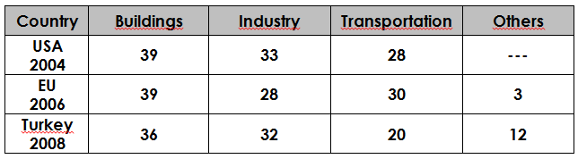
Figure 1. Energy consumption by sectors [6, 7]

Sustainable buildings rely mainly on passive environmental strategies for building climatization, utilize whole or some of its energy needs from renewable energy sources and produce less waste and carbon emissions. Broadly, there are two types of sustainable buildings: Net-Zero Energy Buildings and High-Performance Buildings. A Zero Energy Building is a carbon-neutral building that utilizes fully renewable energy sources, and it is considered an ultimate goal in achieving a sustainable building [8]. A High Performance Buildings (HPB) uses a reduced amount of fossil energy, obtains a significant portion of its energy from renewable energy sources and produces less waste while not compromising the physical comfort levels of occupants. The construction of HPB is relatively easy to accomplish, and there are many examples of such buildings in Turkey and the world. The educational approach in this article mainly focuses on High Performance Building type as a design output.

2. BUILDING PERFORMANCE ANALYSIS (BPA)
It is valuable to be able to conduct early sustainability analyses on High Performance Buildings proposed according to sustainable design principles and physical environment conditions in order to measure whether they fulfill the performance targets and design metrics prior to construction. These analyses may initiate reevaluations and revisions in design decisions for lower operating cost in buildings and improved comfort levels of their occupants.

Sustainability analyses on buildings can be accomplished mainly in the areas of energy consumption, daylight intake, solar and shadow relations with building itself and the surrounding settlement, solar radiation gain, wind and natural ventilation. Historically, these analyzes were used to perform with physical models under laboratory conditions. Later, Computer Aided Design (CAD) tools contributed to this process by offering a virtual graphical test environment. This form of work typically divides design and analysis processes, each of which is performed with different applications. CAD software generate geometrical models of buildings and these graphical models can be imported by other specialized software and supplemented with building physics related alpha numeric data to conduct sustainability analyses. This process involves data conversion and re-modeling works between different applications.
This in return negatively affects the flow of design process and reintegrating analysis results into design in a real time.

For precise sustainability analyses, accurate representation of a building is very important. Similar to a real building, a digital building model is expected to integrate both geometrical data such as graphical entities of a model and alpha-numeric (text and number-based) data, dealing with buildings’ physical quality such as heat, daylighting, air, acoustics, etc. Presently, there is a relatively new computational approach called BIM (Building Information Modeling) that allow modeling buildings in real physical qualities and incorporate necessary tools for sustainability analyses for design decisions. BIM software generates a 3-D model consisting of all the graphics (geometry, form) and alpha-numeric data (material, cost, physical environmental control, etc.) related to the building (Figure 2) and allows the exchange of this model among project stakeholders throughout the lifecycle of a project [9, 10].

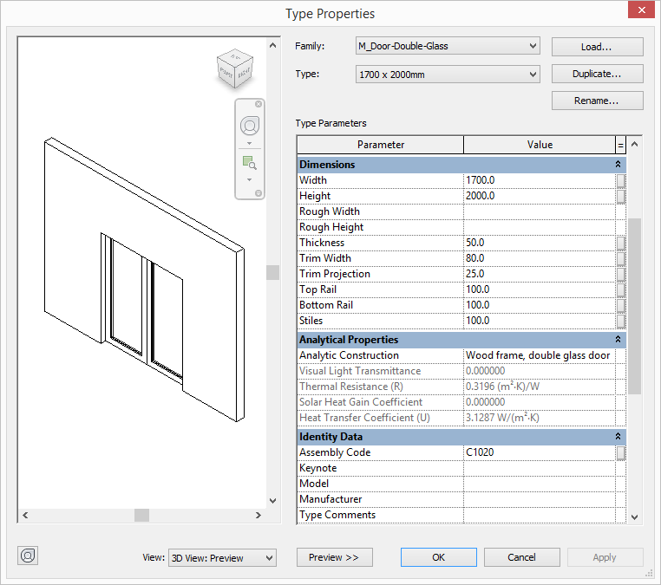
Figure 2. Graphic and alpha-numeric parameters of a Door family in Revit

BIM software provides simulation/analysis environments that measure building model performance either internally or through third-party software (Figure 3). In this simulation environment, starting from the early design phase, building performance can be tested by including data related to physical environment and building materials with numerical and graphical outputs. The ability to produce building performance data related to early phases of design such as Conceptual design phase in which basic design decisions that shape high-level decisions at later design phases are taken is very important. Building performance analysis conducted at this phase help revise design decisions and therefore the difficulties, delays and additional costs that may arise during later design, construction and operation phases can be corrected in advance.

In the professional building practice, the use of sustainability/performance analyses is becoming a commonplace. The integration of sustainability/performance analyses into architectural design process from the early design phases to the later design phases is also promoted by American Institute of Architects. Projects with energy models achieve %8 better energy performance than those without energy models [11].

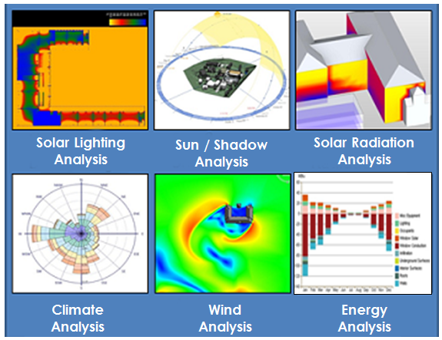
Figure 3. Types of building performance analyses produced from a conceptual design model

The design approach that relies on building performance analysis for improved design decisions is called performative design. It is a spiral design approach that incorporates architectural sustainability principles and physical environmental conditions as a numerical, measurable factor into the design process and measures building performance in real time. Four factors come to the fore in this design approach:

- Complying with principles of architectural sustainability
Efficient and economic energy/raw material consumption, proper material selection, low waste generation

- Taking physical environmental conditions into account
Utilizing passive climate techniques and renewable resources in the direction of the determined performance target

- Relying on numerical, measurable data
Generating analyzes from models incorporating object-based alpha-numeric data with BIM software

- Developing the design with real-time/spiral feedback
Allowing real-time analysis that lead design

3. BPA SUPPORTED CONCEPTUAL ARCHITECTURAL DESIGN EDUCATION
This article examines an educational approach that recommends performative design strategies for early phases of architectural design. It has been implementing in two postgraduate courses at the Mimar Sinan Fine Arts University and Beykent Universities since 2013. The course focuses on the use of performative design principles in creation of building forms at the conceptual design phase.

The course curriculum and its contents is influenced by a similar on-line educational material made available through the Building Performance Analysis Certificate Program (Figure 4) offered by the Autodesk company. The material was summarized and localized in Turkish for students and made accessible through the course web site (sayisalmimar.com). The following topics are covered in this curriculum:

- Sustainability, BIM and Building Performance Analysis
- Energy and building loads
- Sun and shadow work
- Solar radiation
- Wind and air ventilation
- Daylighting

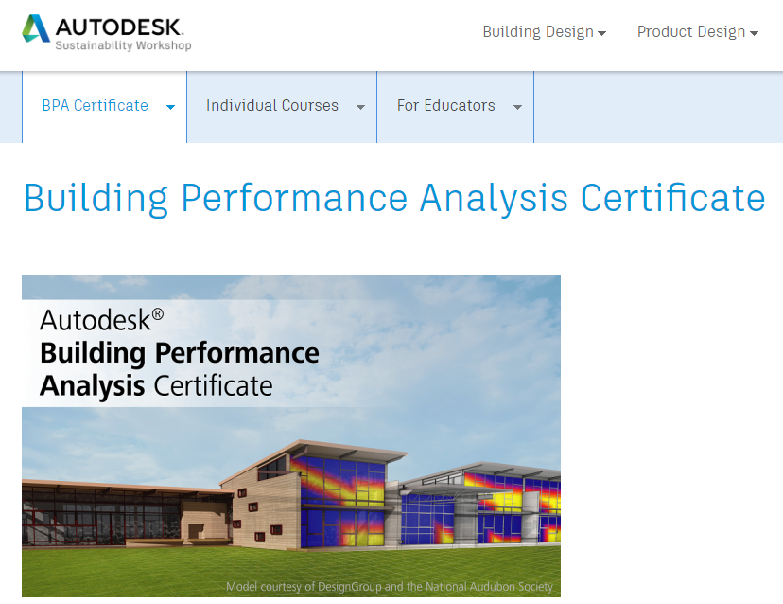
Figure 4. Autodesk Building Performance Analysis Certificate Program [12]

A typical course session consists of theoretical information in related subject fields, followed by case studies and software analysis applications. Modeling work of conceptual design and its performance analysis are conducted in the Autodesk Revit software. Revit supports early design modeling with an integrated module called conceptual mass. Even though the conceptual models developed in Revit are only geometrical, they can be easily transformed into BIM building elements for the later phases of the project. The same analyses can be applied to the updated BIM model containing more graphical exterior details, interior spaces and material parameters. Additional analyses such as “daylighting” that measures the illumination levels of interior spaces and “comprehensive energy analysis” which takes into consideration all building elements can be explored using a detailed BIM model.

3.1. Project Information and Design Strategies
As the output of the course, students are asked to develop a high performance building applying performance analysis on different design alternatives. Due to the limited time reserved for designing, the varying number of analyses and moderate software skills students have, the project was executed as teams consisting of 2-3 students.

The project started with recommending a sustainability goal by students for their designs. The main objective was to manage a low fossil-energy use and to offer a renewable energy strategy to reduce fossil-energy use partly for the building. In this framework, students followed a cyclical design process, i.e. they modeled their design, produced sustainability analysis for it and optimized their designs when necessary in order to fulfill their sustainability goals (Figure 5). The level of fossil-energy use in proposed buildings was assessed using the EPA’s average reference values for building types in the USA since such national statistical data does not exist for Turkey (Figure 6).

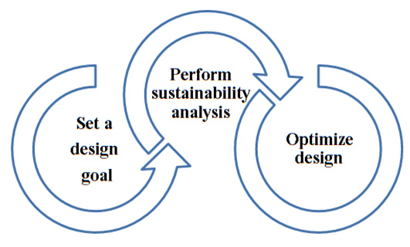
Figure 5. The cyclical process of achieving sustainable design

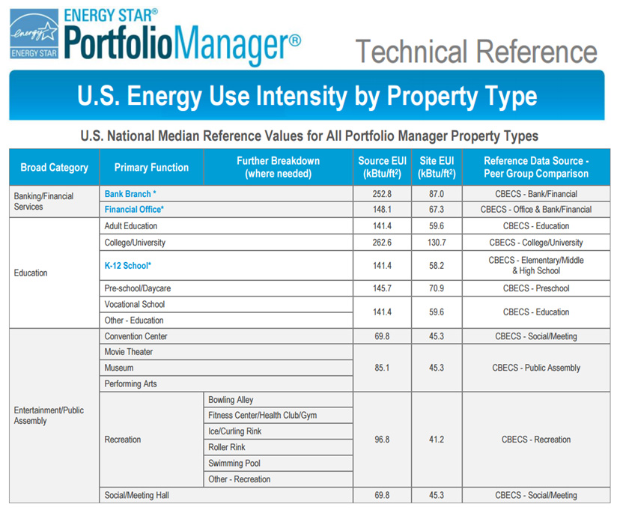
Figure 6. US Energy Use Intensity by Property Type [13]
Students selected an urban project site that is less than 7000 m² for a building with a total construction area of ​​approximately 10.000 m². Students were allowed to propose any building type for the site. Since the conceptual design stage and relevant sustainability analyses are targeted for low level modeling detail (BIM LOD100 detail level), modeling of the building’s shell, the outer skin of the building, was deemed adequate for analysis studies. In this way, students only concentrated on the building form and its relationship with the context. Revit also allows a limited number of material options to be assigned to surfaces (Figure 7).

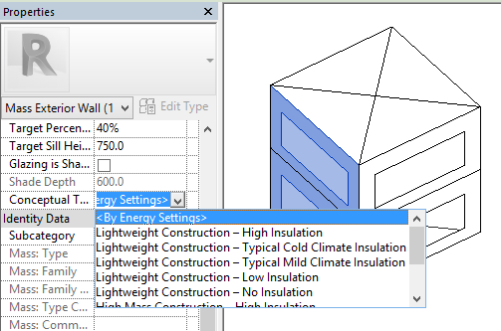
Figure 7. Material assignment to a conceptual geometry in Autodesk Revit

The modeling work conducted in the project also involved extruding other buildings in the immediate vicinity of the building as they affect daylight intake, solar and shadow relations, wind and natural ventilation analyses (Figure 8).

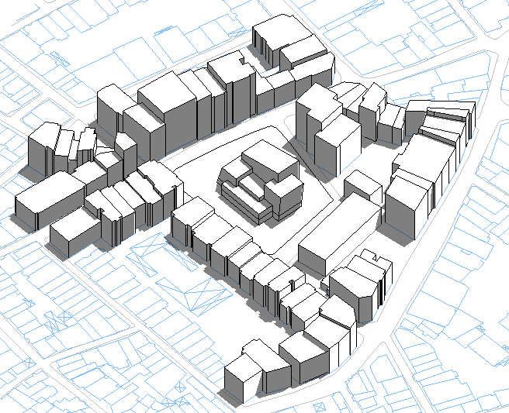
Figure 8. A Revit conceptual model containing both proposed and surrounding buildings
The basic data required for sustainability analyzes at conceptual design phase are as follows:

- 3D geometrical model of the proposed building and surrounding buildings (Figure 8)
- Window-wall ratios on facades and any facade elements such as sun shaders and light shelves if exist
- Physical environment comfort data (temperature, humidity, lighting, etc.), occupancy per square meter and operating hours for the building type (This data is adapted from ASHREA standards by Revit databases. See Figure 9.
- Climatic data from the nearest weather station to the building (Revit acquires this data from a selected weather station database on-line)

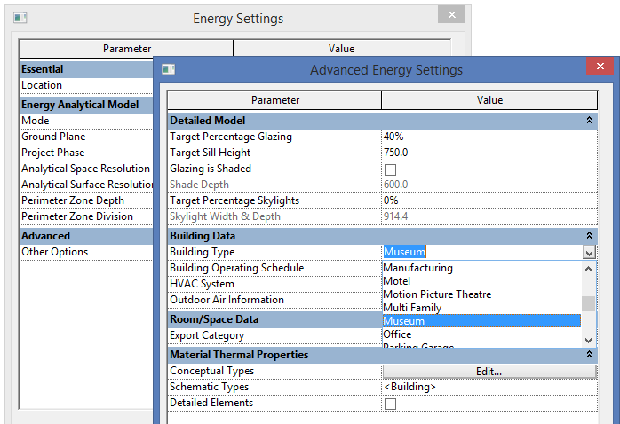 | 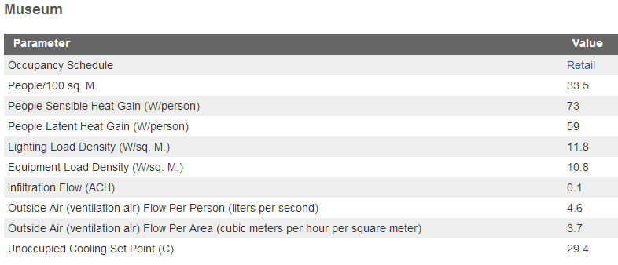
Figure 9. Spatial usage and comfort data according to museum building type (Autodesk Revit)

3.2 The Analysis Work
Each week, students are introduced a new topic related to architectural sustainability and learn how to conduct an analysis for a given task. Intermediate analyzes performed for each category were used to optimize their designs. They completed the following analyses to fulfill the earlier criteria they set for their High Performance Building proposal.

3.2.1. Conceptual Energy Analysis
It is a type of analysis that calculates the building’s total energy use by describing the internal and external heat loads to which the building is exposed considering the building’s typology, shape and climatic data. Energy performance analysis in Revit takes place in Autodesk’s Green Building Studio environment, a web-based energy analysis service. Autodesk 360 cloud service is required to perform energy analyses. Students can use this commercial service free of charge by obtaining an on-line account. Student analyses can be stored in a virtual area dedicated to this service, and/or downloaded as a PDF document if desired. Here, different design analyzes can be compared with each other and full analysis results can be listed (Figure 10).

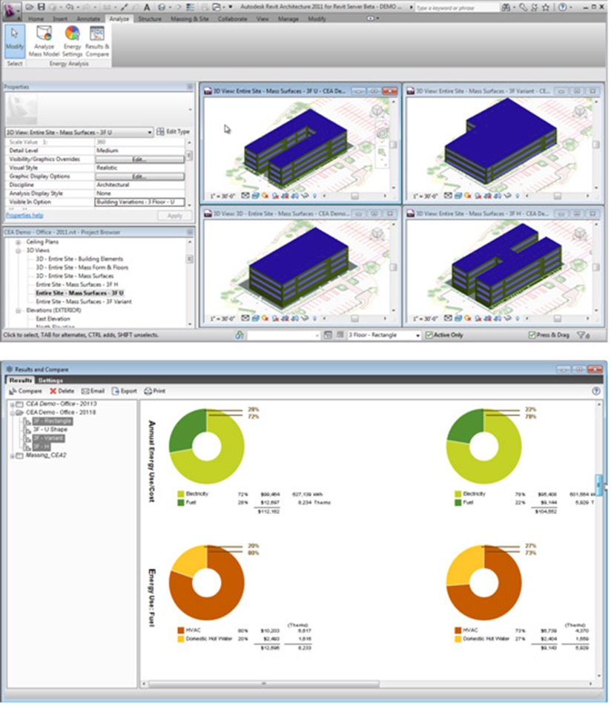
Figure 10. Energy use benchmarks of different design alternatives (Autodesk)

Depending on these energy analysis results, students observe which areas they can improve their designs and reduce their energy consumption. In the following student’s project, alterations made to the form of the building improved its carbon-emission, fossil-based fuel use, and heating and cooling loads (Figure 11).

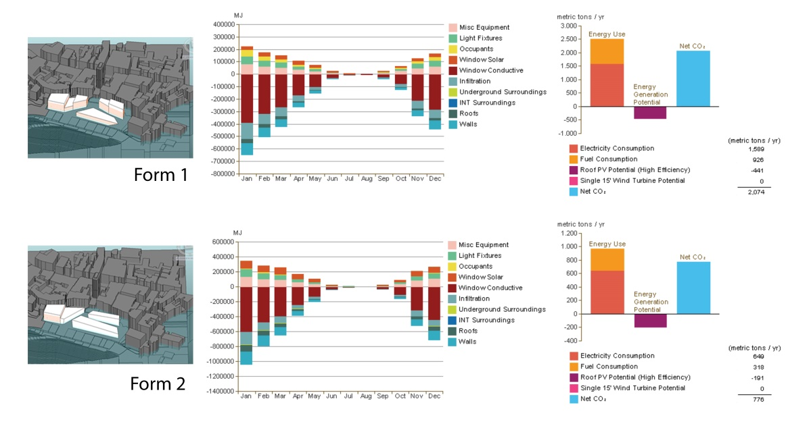
Figure 11. Energy analysis charts of different design alternatives
3.2.2. Sun and Shadow Study
This analysis examines the relationship between proposed and the surrounding buildings in terms of solar access and shadow creation. Students decide the form and position of their buildings on the site by taking into account solar access and shadows constituted during two solstices (the shortest and longest days) and equinox times. In the following example, building masses are redesigned and relocated due to shadow and poor solar access due to surrounding buildings (Figure 12).

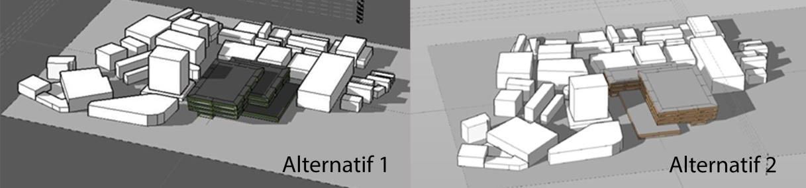
Figure 12. 21 Sun and shadow study for two different design alternatives
on 21 march (spring equinox)

3.2.3. Solar Radiation Analysis
It is used to calculate how to use solar radiation as a source of heat and energy. Students can (1) calculate the amount of radiation on buildings graphically and numerically; (2) make decisions about the location and the building’s form and facade elements (sun shaders, light shelves, etc.) used to reduce the effect of excessive radiation; (3) determine the potential of the building to generate energy through photovoltaic panels. In the example of a dormitory building project below, as represented in graphical and numerical format, the building has a limited solar access due to high-rise buildings around (Figure 13). The solar radiation level was computed using the Insight 360 software, a free Revit add-in software by Autodesk in the course.

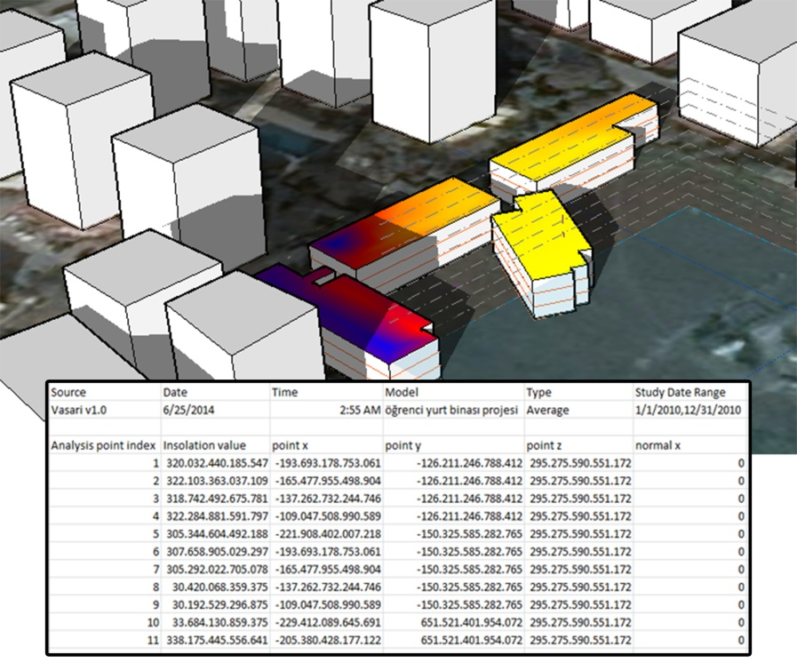
Figure 13. The amount of solar radiation per unit area of the building can be illustrated in graphical and numerical data in Autodesk Revit
3.2.4. Wind Analysis
This is an analysis that produces simulations of airflows at the project site, taking into account the building’s form, topography and surrounding buildings. These analyses help students learn how to use the wind as a natural ventilation source (Figure 14). In the course, wind analyses were conducted using an external software called Autodesk Flow Design that imports Revit files in the .STL or .FBX file formats.

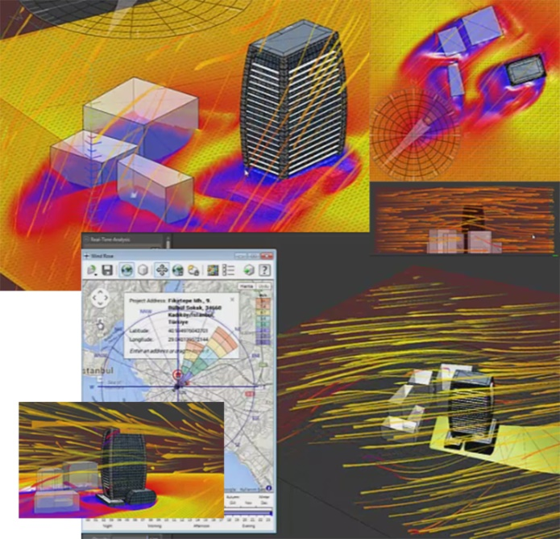
Figure 14. Demonstration of wind effects around an office building project in Autodesk Flow Design

4.CONCLUSION
This article shared the experience of using BIM-based performance analysis for developing conceptual designs in an educational context. With this approach, problems related to occupants’ comfort and high operating costs in particular that may be encountered in the later stages of design and after the construction are identified at the beginning and design decisions are optimized accordingly. One of the strength of the approach recommended in this study that it relies on objective numerical value to support design decisions rather than the subjective intuitions of designers.

It is believed that this technique, which has been applied in a theoretical way, can make a significant contribution to the creation of sustainable architectural designs in architectural project courses. As a continuation of this study, it is planned to carry out a qualitative research that will involve all the stakeholders to understand the benefits of the applied method to the design process.

REFERENCES
[1]URL-1.www.building.co.uk/news/climate-change-summit-to-have-dedicated-buildings day/5077102.article, Building.co.uk, “Climate change summit to have dedicated Buildings Day”, 19 August 2015, last accessed on 30 April 2017
[2]URL-2. www.usgbc.org/leed, Leadership in Energy & Environmental Design - LEED, US Green Building Council, last accessed on 30 April 2017
[3]URL-3. www.breeam.org, Building Research Establishment Environmental Assessment Method - BREEAM, last accessed on 30 April 2017
[4]URL-4. www.architecture2030.org, The Architecture 2030 Challenge, last accessed on 30 April 2017
[5] URL-5. www.bep.gov.tr, Binalarda Enerji Performansı Yönetmeliği, last accessed on 30 April 2017
[6] İzoder, 2010. 2010-2023 Isı Yalıtımı Planlama Raporu, İzoder, Isı Su Ses ve Yangın Yalıtımcıları Derneği
[7] EIA, 2014. International Energy Agency, World Energy Outlook.
[8] Torcellini, P. S. Pless, and M. Deru, 2006. National Renewable Energy Laboratory, ACEEE Summer Study, Pacific Grove, California August 14−18.
[9]Eastman C., 1999. Building Product Models: Computer Environments Supporting Design and Construction, CRC Press.
[10]Ofluoğlu, S., 2014. Yapı Bilgi Modelleme: Gereksinim ve Birlikte Çalışabilirlik, Mimarist, Ocak
[11]AIA, 2013. AIA Architecture 2030 Commitment Progress Report
[12]URL-6. sustainabilityworkshop.autodesk.com/bpac, Autodesk Building Performance Analysis Certificate Program, last accessed on 30 April 2017
[13]URL-7. portfoliomanager.energystar.gov/pdf/reference/US%20National%20Median%20Table.pdf, US Energy Use Intensity by Property Type Report, Energy Star, USA, Environment Protection Agency, March 2016, last accessed on 30 April 2017

SALİH OFLUOĞLU, Prof.Dr.,
He is the head of Department of Informatics at Mimar Sinan Fine Arts University, İstanbul, Turkey. He is also the Professor in charge of MSc. programs in Computer-Aided Art and Design and Architectural and Urban Informatics in the same department. He holds a BSc. degree in Architecture from Istanbul Technical University, a MSc. degree in Computer-Aided Architectural Design from Pennsylvania State University and a PhD degree in Architecture from Edinburgh University. His research interests lie in sustainable architectural design, performative design, geometric and building information modeling, and integrated project delivery.

