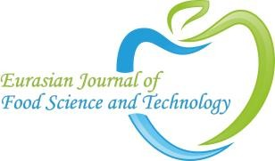
Eurasian Journal of
FOOD SCIENCE AND TECHNOLOGY
COPYRIGHT FORM

Manuscript title:

I/We certify that I/we have participated and contributed sufficiently for the completion of the manuscript and have agreed to have my/our name listed as a contributor. I/We believe that the manuscript represents valid and credible work. Neither the content of this manuscript nor any other unified content with substantially similar or comparable substance under my/our creation or authorship has been published/is constantly considered for publication elsewhere. I/We certify that complete data regarding the study is proclaimed in this manuscript and no data from the study have been/will be published solely or separately. I/we attest that, I/we will cooperate in providing any required data/information related to the study during peer review by the editor or their assignees. Any direct or indirect financial interests or conflicts that exist or may be perceived to exist have been disclosed in the cover letter. Sources of external support for this work are mentioned in the form. I/We hereby exchange all copyright proprietorship, including all rights incidental thereto, solely in the issue that such work is published. This Journal grants the rights to the corresponding author to incorporate any necessary changes and he/she will act as the guarantor or surety for the manuscript on our behalf. All persons who have made substantial and significant contributions to this work, but are not contributors, are mentioned in the acknowledgement with the written permission of the contributors to include their name. If there is no acknowledgement part in the manuscript, that means I/we have not received any contributions and also, no contributor has been omitted.
Please provide the Corresponding author details mentioned below Name and surname:
Department:

University/Organisation:

Country:

Signature: Date: / /

Name and surname Signature

1. Author:
2. Author:
3. author:
4. author:
5. author:
6. author:
7. author:
8. author:

