Title of Manuscript (ENGLISH)
(This section should be written as Calibri font, 12 point)

ABSTRACT (ENGLISH):
Purpose:
Material and Methods:
Results:
Conclusion:
Keywords: Keyword 1, Keyword 2, Keyword 3, Keyword 4, Keyword 5 (This section should be contained maximum 5 keywords and should be written as 10 point, divided by comma)
The abstract should not be exceed 250 words. This section should be prepared as Calibri font, 10 point, and one-line spacing.

INTRODUCTION (11 point)
This section should be prepared as Calibri font, 11 point, and one-line spacing.
This section should be explained the problem and contained the previous studies, especially the most recent publications. In this section, the objectives of the study should be clearly given.

MATERIAL and METHODS (11 point)
This section should be prepared as Calibri font, 11 point, and one-line spacing.
All the materials, and analytical and statistical methods and procedures should be explained in this section.

Purpose and Type of the Study
Main text paragraph.

Sampling and participant
Main text paragraph.

Data Collection Tools
Introductory Information Form
Main text paragraph.

Statistical Analysis
Main text paragraph.

Ethical Approval
Main text paragraph.

RESULTS
This section should be prepared as 11 point, and one-line spacing.
In this section should be presented tables or figures. All figures and tables should be given and numbered.

Table 1. Socio-demographic characteristics of nurses (n = 546) (Note: Please do not include the table in a textbox or frame))
Introductory Features [a] | Number | Percent
Age (26.41±7.506; 18-58)
18-22 age | 31 | 5.7
23-27 age | 146 | 26.7
28-32 age | 121 | 22.2
33-37 age | 79 | 14.5
38 age and over | 169 | 30.9
[a] Table footnote. [b] …

Scheme 1. Scheme caption.
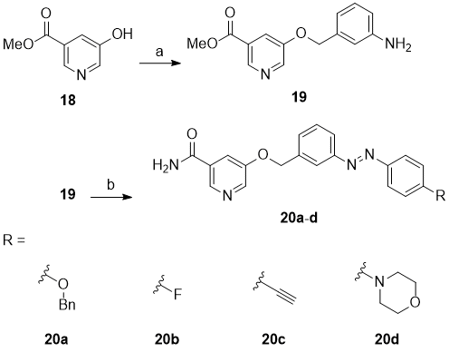

DISCUSSION (11 point)
This section should be prepared as 11 point, and one-line spacing. Results and informations discuss by considering from the previous literatures in this section.

CONCLUSION (11 POINT)
This section should be prepared as 11 point, and one-line spacing.
The contribution of the results and the importance of the results should be emphasized.

Acknowledgment (if necessary) (11 POINT)
This section should be prepared as 11 point, and one-line spacing.
In this section, the funds, grants, people and contributed to the manuscript must be placed.

Conflict of Interest (11 POINT)
Conflict of Interest text.

REFERENCES (10 POINT)
This section should be prepared as 10 point, and one-line spacing. In this section, references should be written in alphabetical and chronological order (APA 6)
References to journal article, books, proceedings, chapters in books etc. should be listed as given below:

For journal article:
In study with a single author
Citation in the text: (Şentürk, 2009)
Şentürk, R. (2009). Açık medeniyet ve sosyal içerme. Muhafazakar Düşünce, 6(21-22), 41-49. https://dx.doi.org/10.1080/13527260210145993

In study with two authors
Citation in the text: (Tonta ve Ünal, 2005)
Tonta, Y., Ünal, Y. (2005). Scatter of journals and literature obsolescence reflected in document delivery requests. Journal of the American Society for Information Science & Technology, 56(1), 84-94. https://dx.doi.org/10.1080/13527260210145993
In study with more than 3 authors
Citation in the text: (Lakic et al., 2012) or (Lakic vd., 1993)
Lakic, B., Arık, M., Aune, S. et al. (2012). Status and perspectives of the CAST experiment. Journal of Physics: Conference Series, 375(2), 1-4. https://dx.doi.org/10.1088/1742-6596/375/1/022001

For book:
In study with a single author
Citation in the text: (Şentürk, 2014)
Şentürk, R. (2014). Açık medeniyet: Çok medeniyetli toplum ve dünyaya doğru. İstanbul: İz Yayıncılık.

In study with two authors
Citation in the text: (Doğan and Bozgeyikli, 2014)
Doğan, H., Bozgeyikli, H. (2014). İşsizlik sorununa farklı bir bakış açısı: kariyer engelleri. II. Uluslararası İş ve Meslek Danışmanlığı Kongresi Bildiri Özet Kitabı, 97-105.

In study with more than 3 authors
Citation in the text: (Wolfe et al., 2015) or (Wolfe vd., 2009)
Wolfe, J. M., Kluender, K. R., Dennis, L. M. (2015). Sensation & perception (4th ed.). Sunderland, MA: Sinauer Associates.

For thesis:
Citation in the text: (İşçi, 2020)
İşci, N. (2020). Nedensel yükleme kuramı doğrultusunda verilen eğitimin hemşirelerin kariyer engelleri ve nedensel yüklemeleri üzerine etkisi. Sağlık Bilimleri Enstitüsü, Hemşirelik Anabilim Dalı. Doktora Tezi: İnönü Üniversitesi, Malatya-Türkiye.

Web Page:
Citation in the text: (İbn Haldun Üniversitesi, 2017)
İbn Haldun Üniversitesi İnsan ve Toplum Bilimleri Dergisi. (2017). Yazar rehberi. Available from https://journal.ihu.edu.tr/index.php/ihu1/about/submissions

Anonymous Web Page
Citation in the text: (“All 33 Chile Miners,” 2010)
All 33 Chile miners freed in flawless rescue. (2010, 13 Ekim). Available from https://www.budapestopenaccessinitiative.org/boai-10-recommendations

Different work done in the same year by the same author
Citation in the text: (Glenn and Johnson, 1964a); (Glenn and Johnson, 1964b)
Glenn, W. H. and Johnson, D. A. (1964a). Calculating devices. London: John Murray.
Glenn, W. H. and Johnson, D. A. (1964b). Graphs. London: Murray

