Transferring Data from Glucometer to Mobile Device Via Bluetooth with Arduino Technology

Tolga Hayıt¹*, Uçman Ergün²
¹Bozok University, Boğazlıyan Vocational High School, Department of Computer Technology, Yozgat/ Turkey
²Afyon Kocatepe University, Engineering Faculty, Department of Biomedical Engineering, Afyonkarahisar, Turkey

Abstract: Being healthy is undoubtedly an indispensable necessity for human life. With technological improvements, in the literature, various health monitoring and imaging systems have been developed to satisfy your health needs. In this context, the work of monitoring and recording the data of individual health monitoring data via wireless technology is also being part of these studies. Nowadays, mobile devices which are located in almost every house and which become indispensable of our life and have wireless technology infrastructure have an important place of making follow-up health everywhere and every time because these devices were using in the health monitoring systems. In this study, Arduino an open-source microcontroller card was used in which a sample glucose measuring device was connected in series. In this way, the glucose data (glucose ratio, time) obtained with the glucometer is transferred to the mobile device based on the Android operating system with the Bluetooth technology channel. A mobile application was developed using the Apache Cordova framework for listing data, presenting graphically and reading data over Arduino. Apache Cordova, HTML, Javascript and CSS are used in coding section. The data received from the glucometer is stored in the local database of the mobile device. It is intended that people can transfer their measurements to their mobile device by using wireless technology and access the graphical representations of their data. In this context, the aim of the study is to be able to perform health monitoring by using different wireless technologies in mobile devices that can respond to different wireless technologies at present. Thus, that will contribute the other works done in this area.

Keywords: Mobile health monitoring, bluetooth, arduino, glucose measurement

Glikoz Ölçüm Cihazından Alınan Verilerin Arduino Teknolojisi Kullanılarak Bluetooth Üzerinden Mobil Cihaza Aktarılması

Özet: Sağlık ihtiyacı, şüphesiz insan hayatı için vazgeçilmez bir ihtiyaçtır. Teknolojik gelişmelerle birlikte sağlık ihtiyacının karşılanmasına yardımcı olarak literatürde çeşitli sağlık izleme ve görüntüleme sistemleri geliştirilmiştir. Bu bağlamda; bireylerin sağlık izleme verilerinin kablosuz teknoloji üzerinden takibinin yapılmasına ve verilerin depolanması bahsi geçen çalışmaların bir ayağını oluşturmaktadır. Günümüzde hemen her evde bulunan, hayatımızın artık vazgeçilmezi haline gelen ve kablosuz teknoloji altyapısına sahip mobil cihazların sağlık izleme alanında kullanılması; her zaman ve her yerden sağlık takibinin yapılması bağlamında önemli bir yere sahip olmaktadır. Bu çalışmada örnek bir şeker ölçüm cihazının seri bağlı olduğu açık kaynak kodlu bir mikrodenetleyici kartı olan Arduino kullanılarak; şeker ölçüm cihazı ile elde edilen şeker verilerinin (şeker oranı, zaman) bluetooth teknolojisi kanalıyla Android işletim sistemi tabanlı mobil cihaza aktarılması sağlanmıştır. Verilerin listelenmesi, grafiksel gösterimi ve Arduino üzerinden okunması için Apache Cordova çatısı kullanılarak bir mobil uygulama geliştirilmiştir. Kodlama kısmında Apache Cordova, HTML, Javascript ve CSS kullanılmıştır. Şeker ölçüm cihazından alınan verileri mobil cihazın yerel veritabanında saklanması sağlanmıştır. Kişilerin ölçümlerini kablosuz teknoloji kullanarak kendi mobil cihazına aktarabilmeleri, kendi verilerine ve verilerinin grafiksel dökümüne ulaşabilmeleri amaçlanmıştır. Bu bağlamda söz konusu çalışmanın, günümüzde mobil cihazların farklı kablosuz teknolojilere de cevap verebilmesi ile farklı kablosuz teknolojiler kullanılarak sağlık takibinin yapılabilmesi anlamında bu alanda yapılan diğer çalışmalara katkıda bulunacağı düşünülmektedir.

Anahtar Kelimeler: Mobil sağlık takibi, bluetooth, arduino, şeker ölçüm

Reference to this paper should be made as follows (bu makaleye aşağıdaki şekilde atıfta bulunulmalı):
T. Hayıt, U. Ergün, ‘Transferring Data from Glucometer to Mobile Device Via Bluetooth with Arduino Technology’, Elec Lett Sci Eng, vol. x , (200X), xx-xx

1 Introduction

In today's world, the number of patients and health problems are increasing seriously. The increase in the number of patients leads to the weakening of the communication between the doctor and the patient. It becomes difficult to follow the patient due to the problems such as understaffed hospitals, space problems, accessibility etc. as well as the increase in the number of patients. Such problems lead researchers to find alternative methods for the follow-up of patients.

The systems that enable a person to control his/her own health condition independently of a hospital and to monitor the body functions closely are defined as mobile health monitoring systems. Thanks to mobile health monitoring systems, disabled, elder and clinical patients can keep their health under control, can take precaution against any health problem or can contact with the health professionals and have the opportunity for an early diagnosis through the data they obtained from the system.

It has become possible to implement portable, wireless, cost-efficient remote health monitoring systems with the advances within the areas of communication and informatics [1]. These systems enable people to be followed outside the hospital, promptly alert the relevant institutions in case of an emergency, use a long-term recording system in the diagnosis of certain diseases, and most importantly raise the life standards of people [1].

Diabetes, which is known as diabetes mellitus in medical literature, is a chronic disease that proceeds in lifelong and is caused by insufficient secretion of insulin by the pancreas [2]. Chronic diseases such as diabetes are diseases that affect the daily lives of patients and should be followed at an important level. With the advances in today's technology, such diseases can be followed through wireless mobile devices and the negative consequences can be prevented in advance.

In this study, the sugar data (sugar level, time) obtained from the sugar meter has been transferred to the Android operating system based mobile device via Bluetooth technology by using Arduino, which is an open source microcontroller card in which a sample sugar meter device is connected in series.

The Android operating system-based mobile application used in the study has been built by using the Apache Cordova framework, which allows applications to be written on almost any platform.

2 Literature Review

Various health monitoring and imaging systems have been developed to help meet the health need, which is undoubtedly an indispensable need for every human being.

In the study carried out by Zarka [3], a system was developed that runs on a computer that provides data communication between the computer and the mobile phone. Part of the system consists of a client application running on a mobile phone used by doctors. This application allows doctors to store diagnosis results such as temperature, pressure, drugs, analyzes etc. on their mobile phones and to send information to the server via SMS to be stored in the server database. The server can respond to any request from the client, and the result can be sent via Bluetooth, infrared or OTA (Over The Air) technology.

In a study by Yüce, Bilge and Saka [4], a mobile phone application that would help doctors to access in the daily basic data of their asthma patients and to keep the patient's asthma under control was developed.

Chung et al. [5] developed a simple wireless electrocardiogram (ECG) diagnostic system for cardiac patients, independent of place.

In a study conducted by Tang, Hu and Hsu [6], a health monitoring system sustainable at home was designed by using multimedia message (MMS) technology.

In a study by Klug, Krupka, Dickhaus, Katus and Hilbel [7], a mobile application based on Windows Phone operating system was developed. ECG data of patients were displayed through the application.

A remote health monitoring system that includes a mobile application was developed by Yang, He, Gao and Zhao [8]. The system provided in the study consists of three components: a mobile application, a web site application, and a server running on the background. Users can upload their own health data and view the records and graphs of their previous entries through the developed mobile application. In case there is an inconsistency in the data, the application warns the users.

In a study conducted by Rozanowski, Piotrowski and Ciolek [9], a mobile interface was devised for the use of data obtained from a vehicle equipped with a data recorder to monitor the health status of the driver remotely. The data recording device used in the study collects the data transmitted by the sensors installed on the driver and the vehicle. This data is transmitted to the smartphone and the data transferred by the smartphone is stored, tracked and controlled by the mobile application designed on the device.

In the study of Cura [10], he proposed a mobile patient monitoring system particularly for medium-sized hospitals. The system consists of three components: an android application installed on the patient's mobile device, another android application installed on a mobile device connected to the local network and server of the hospital, and a remote server. The system designed in accordance with this study has shown that medium-sized hospitals can successfully provide services to the patients.

Kumar and Venkatesan [11] have designed a cost-efficient and reliable wireless patient monitoring system for patients with coronary failure and diabetes. The system they have developed consists of microcontrollers, sensors, GSM module, serial interfaces, Bluetooth module, personal computer and android mobile device. A mobile application developed for the system is used on the mobile device. The data obtained by the sensors attached to the relevant parts of the patient's body are processed regularly by the microprocessing unit. The processed data is transmitted to the mobile device and the system computer. The data is stored on these devices and is shown statistically.

Chua et al. [12] supported the development of a health monitoring system with features such as cost-efficiency and easy data collection. Bluetooth technology, as well as some medical devices, was used as data transmission technology in the study.

An interactive mobile application was developed by Villarreal, Fontecha, Hervas and Bravo [13] to track and intervene in a specific chronic disease without the need for the support of any healthcare personnel. The application has user tabs such as the patient and the doctor. According to the stored data, the doctor and the patient can interact with each other, if it is required.

Triantafyllidisa et al. [14] designed a personalized mobile health monitoring system tailored to the needs of patients with coronary failure. In the study, patients were provided with tablet computers and medical sensors to make their own physiological measurements, to answer the questions related to the symptoms of their diseased, to review their personal measurements and to communicate with the relevant specialists. Bluetooth technology has been used to transmit the monitoring data obtained from sensors attached to the patients to the tablet computers. Tablet computers has been used to transmit this data to the server over the Internet in order to enable the health professionals to store, process and display the data.

In the study by Panicker and Kumar [15], an application was developed to the physiological symptoms of the patient to be followed at home. This system allows the patient to evaluate physiological measurements such as blood pressure and pulse rate and to collect data simultaneously and continuously. Bluetooth technology is used in the study. A mobile application running on the Android based operating system has been developed to display data on a mobile phone.

Hayıt and Ergün [16] have developed a mobile application for diabetes patients in order to the patient's to have a more active role during the disease by own follow-up and the patient's data can be monitored and evaluated by the physician in consideration of the interaction between the patient and the doctor. On the patient side of the study, a mobile application based on the Android operating system; on the doctor side, a web-based management system has been developed. The system's mobile app works through 6 basic screens: patient record and patient login screen, application home screen, reports, history, graphics, my doctor. The patients enter glucose data to the application manually. They can report historical data using mobile application and graphically display it. In addition to these, they can instantly communicate with their doctor through the "my doctor" screen. The web site application of the system has been created to be used only by physicians. Doctor uses the web application to communicate with the own patient or to access the graphical representation of the patient's data. It is emphasized that data can be transferred automatically to the application by combining the system with wireless technologies.

In this study, the Arduino development card, in which the sugar meter is connected in series, has been used and the transmission of the sugar data to the mobile device based on the Android operating system has been accomplished through Bluetooth technology.

3 Overview of System Architecture

System architecture consists of 4 main components:

1) e-Health Sensor Shield and Glucometer BLE Sensor
2) Arduino UNO R3 connected in series to the sugar meter
3) HC06 Serial Port Bluetooth Module providing communication via Bluetooth with Arduino and mobile device (Bluetooth Transceiver Module HC-06)
4) Android-based mobile device and the mobile application running on the device

The system architecture is shown in Figure 1.

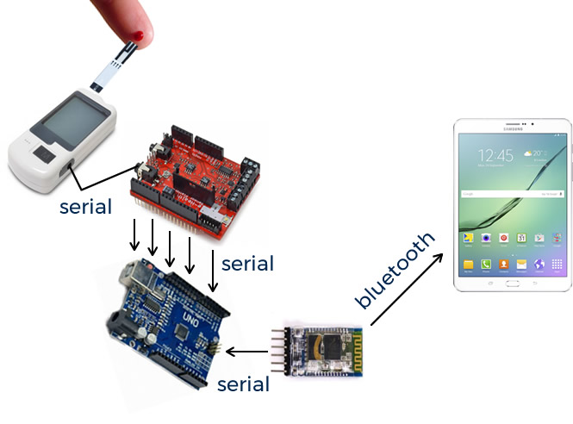
Figure-1 System Architecture

3.1 e-Health Sensor Shield and Glucometer BLE Sensor

e-Health Sensor Shield and Glucometer BLE Sensor units are manufactured by the company Libelium and imported from abroad for this study. The e-Health Sensor Shield is an interface developed for Arduino users to follow up their physiological features such as pulse check, oxygen status, airflow(breathing) follow-up, glucose follow-up, etc. (Figure 2) [17].

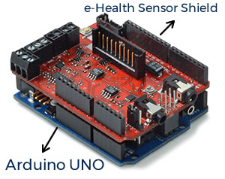
Figure-2 e-Health Sensor Shield

The Glucometer BLE Sensor is a medical device that is connected serially to the Arduino via the e-Health Sensor Shield interface and is used to determine the approximate concentration of glucose in blood [18]. The device counts the blood cell and calculates the blood sugar level with a small drop of blood obtained by puncturing the skin with a lancet (Figure 3) [18].

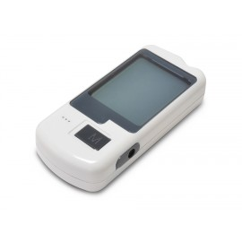
Figure-3 Glucometer BLE Sensor

The Glucometer BLE Sensor is connected to the e-Health Sensor Shield in series via a cable. The e-Health Sensor Shield is mounted on the Arduino. By this way, the connection between the Arduino and the glucometer is established.

3.2 Arduino UNO R3

Arduino Uno is a microcontroller card. There are 14 digital input-output pins (6 of them can be used as PWM outputs), 6 analog inputs, a 16 MHz quartz crystal, a USB connection, a power outlet, an ICSP header and a reset button on the card [19]. It contains everything required to support the microcontroller; it is simply connected to a computer via a USB cable and the power supply is provided by an AC-DC adapter or battery (Figure 4) [19].

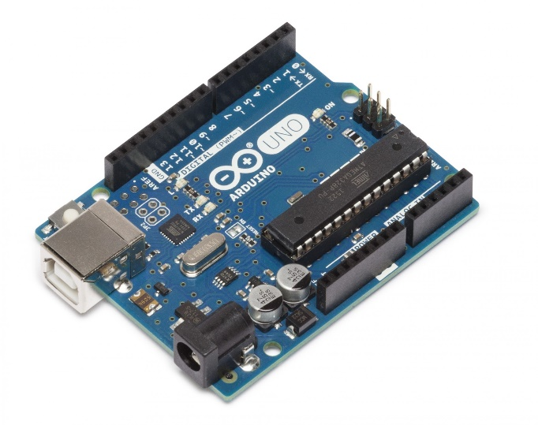
Figure-4 Arduino UNO R3

3.3 Bluetooth Transceiver Module HC-06

The HC-06 Bluetooth module can easily carry out serial wireless data transmission.
The operating frequency is between the 2.4GHz ISM frequency band, which is the most popular frequency band. It supports Bluetooth 2.0 + EDR standard. This module is programmed with a serial interface that is easy to use and simplifies the design-development cycle (Figure 5) [20].

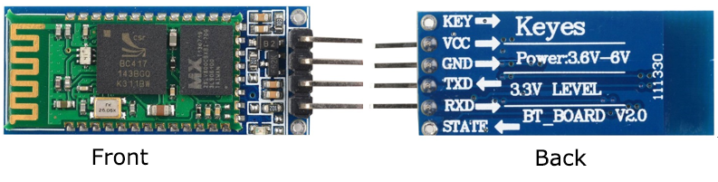
Figure-5 Bluetooth Transceiver Module HC-06

3.4 Mobile Device and Mobile Application

An Android operating system-based Samsung tablet was used for the mobile device, which will enable the collection of information from patients during glucose monitoring and assessment process. One of the reasons for choosing the Android operating system for the development of the application used in the study is that the Android operating system has the biggest market share for mobile applications across the world. According to the data shared by the international data search company IDC (International Data Corporation), as of the second half of the 2016, Android is dominating the mobile operating system market with the rate of 87.6% [21]. This data can be shown as a proof that the Android operating system is the most used mobile operating system in the world.

Another reason for choosing the Android operating system in the application is that product range of the Android device is higher than the other operating systems. The diversity of the device brings about cost diversity. The production from scratch of an Android-based mobile device can be achieved at a very low cost. Device and cost diversity also support the reason why the Android operating system leads the market share.

One another reason for choosing the Android operating system is that Google, which owns the system, supports developers. The Android operating system is partially open-source in nature and supports free software.

The mobile application, which stores and lists the data transmitted by the mobile device, has been developed using the Apache Cordova framework on the android operating system. Apache Cordova is an open source mobile development framework [22]. It provides developers to build cross-platform through the web technologies such as HTML5 (Hypertext Markup Language 5), CSS3(Cascading Style Sheets 3) and JavaScript by abstaining from using programming languages of various mobile platforms [22].

The application is named as "Glucose Monitoring System". The software used in the application consist of Apache Cordova framework for Java language and the CSS software for HTML, JavaScript and design.

jQuery, which is one of the open source JavaScript libraries, has been used in the application. The jQuery library allows the use of JSON method, which is a data exchange format. Access to the PHP files on the server has been provided through the JavaScript by using the JSON format in the application. The PHP files on the remote server are accessed via Java Script by using the JSON format. Processing on the database is performed by using PHP. By this means, the appropriate data is retrieved to the application or insertion, deletion or updating processes are performed on the application.

Mobile application of the system runs on 3 basic screens: my datas, graphs and connect with Bluetooth. Main screen of the mobile application is shown in Figure 6.
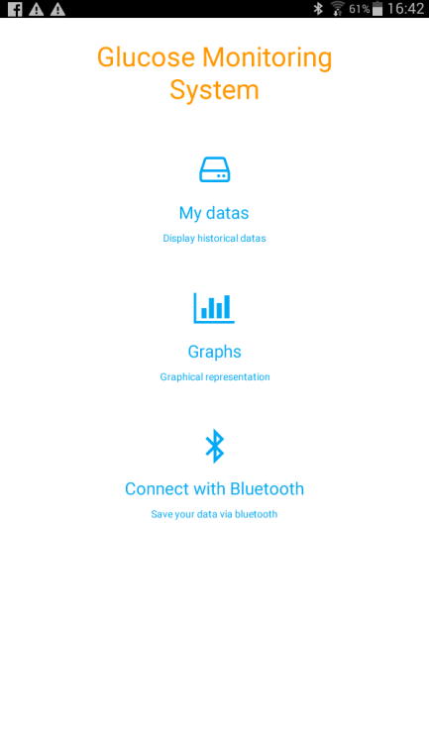
Figure-6 Main screen of the application

My datas screen displays a numerical list of measurements that the user has made in the last month (Figure 7-a). The user may send the data to a desired e-mail address. The graphs screen displays the graphical status of the user's measurement within the last month (Figure 7-b). On the connect with Bluetooth page, the user connects to the HC-06 module via the mobile device and accesses the data on the glucometer, which is connected to the Arduino in series.

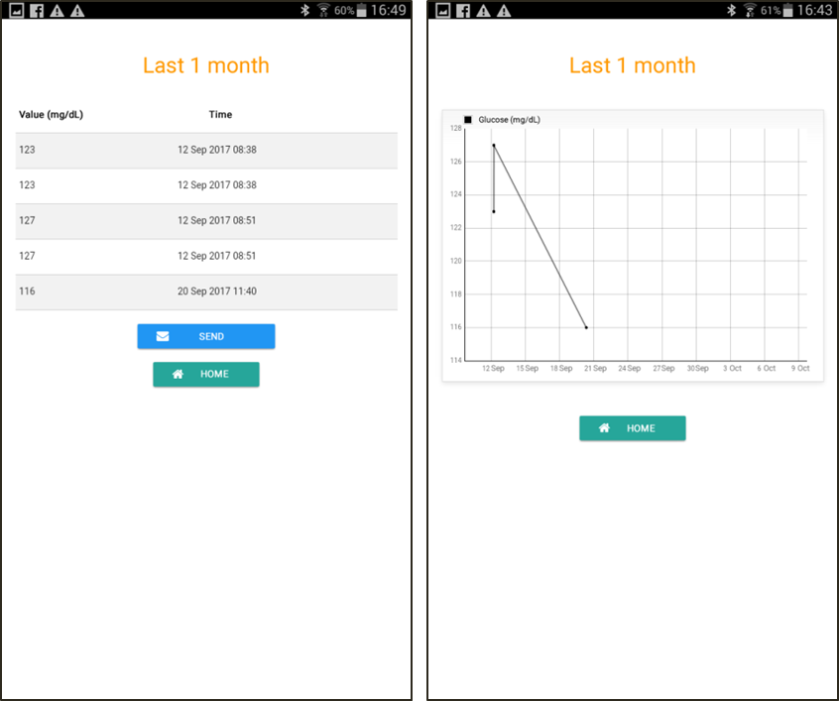
Figure-6 The other screens from left to right: (a) "my data'' screen, (b) "graphs''" screen

4 Discussion and Results

In this study, a sample glucometer, in which the patient records sugar measurement data, is provided to transmit data to the mobile device via Bluetooth technology with serial data transferred to Arduino. The six measured glucose data have been successfully transferred to the mobile device, and the data received by the mobile device has been stored in the remote server with the help of a special mobile application. The user has been provided to access this data, to send this data to an e-mail address via a form when it is required and to display the data graphically. In the application, the user can access the sugar measurement data by connecting to the HC-06 Bluetooth module installed on Arduino.

Nowadays, with the development of the features of all the mobile devices ingrained in our lives, instant data sharing can be done anytime and anywhere easily. For this reason, the use of mobile devices in such studies is important for diseases that require continuous follow-up, such as diabetes mellitus.

Most of the technologies used in the development of the mobile application designed in the study are free of charge, and most of the software used is open source. The connection of the users to the server is provided via the internet in the background. Since the connection with the server is provided over the internet, internet speed is important. If the internet speed is good in quality, the speed of the data retrieved from the server will be fast in direct proportion. In case of a network problem at certain points, the patient will not be able to connect to the server. It constitutes a key point where the system can be discussed. If there is an interruption caused by internal or external factors, continuous access to the system becomes difficult regardless of the usefulness or quality of the remote server.

There is no additional study carried out on the safety of the system. In case the telephone and identification numbers of the users are known, any other person can log in to the user account and display the data. These issues should be taken into consideration in future studies.

The type of database used to store data in the study should be selected by taking into account the number of users.

The system needs to be tested by real diabetes patients so that they can be evaluated for usefulness. In order to evaluate the system in terms of practicability, it should be tested by real diabetic patients.

It can be considered a defect that the mobile application used in the system is designed only for the Android operating system. The Apache Cordova framework allows application development on every platform, for this reason, the current application can be developed further and designed on other platforms in future studies.

References

1. R. Kurban, Wireless Portable Remote Health Monitoring System:Mobile Health Assistant. Graduate dissertation, University of Erciyes, Kayseri, (2006)

2. İ. Aydın, Diabetes. Ayrıntı Journal, Vol. 1:9, (2013), 25-28

3. N. Zarka, “Patient Keeper” Medical Application on Mobile Phone, International Conference on Information and Communication Technologies: From Theory to Applications, Syria, April (2004).

4. Y.K. Yüce, U. Bilge, O. Saka, MATDS: Mobil Astım Takip ve Değerlendirme Sistemi, 2nd National Medical Informatics Congress, Antalya, November (2005)

5. W.Y. Chung, C.L. Yau, K.S. Shin, R. Myllyla, A Cell Phone Based Health Monitoring System With Self Analysis Processor Using Wireless Sensor Network Technology, 29th Annual International Conference of the IEEE EMBS Cite Internationale, Lyon, August (2007)

6. W.T. Tang, C.M. Hu, C.Y. Hsu, A Mobile Phone Based Homecare Management System On The Cloud. Biomedical Engineering and Informatics (BMEI), Vol. 6, (2010), 2442 – 2445

7. S. Klug, K. Krupka, H. Dickhaus, H.A. Katus, T. Hilbel, Displaying Computerized ECG Recordings and Vital Signs on Windows Phone 7 Smartphones, Computing in Cardiology, Vol. 37, (2010), 1067 – 1070

8. M. Yang, X. He, L. Gao, L. Zhao, An Innovative System Of Health Monitoring Using Mobile Phones, 14th International Conference on e-Health Networking, Applications and Services (Healthcom 2012), Beijing, October (2012)

9. K. Rozanowski, Z. Piotrowski, M. Ciolek, Mobile Application for Driver’s Health Status Remote Monitoring, Wireless Communications and Mobile Computing Conference (IWCMC), Sardinia, July (2013)

10. T. Cura, Sağlık Sektörü İçin Düşük Maliyetli Bir Mobil Hasta Takip Sistemi Önerisi. Alphanumeric Journal, Vol. 1, (2013), 13–26

11. K.M. Kumar, R.S. Venkatesan, A Design Approach To Smart Health Monitoring Using Android Mobile Devices, 2014 IEEE International Conference on Advanced Communication Control and Computing Technologies (ICACCCT) , Ramanathapuram, May (2014)

12. J.E. Chua, J.A. Zaldua, T.J. Sevilla, M.J. Tapel, M.R. Orlino, D.C. Rasing, C.M. Lee-Ramos, An Android Phone Application for a Health Monitoring System with Integrated Medical Devices and Localized Health Information and Database For Healthy Lifestyle Changes, 7th IEEE International Conference Humanoid, Nanotechnology, Information Technology Communication and Control, Environment and Management (HNICEM), Philippines, November (2014)

13. V. Villarreal, J. Fontecha, R. Hervas, J. Bravo, Mobile and Ubiquitous Architecture for the Medical Control of Chronic Diseases Through The Use of Intelligent Devices: Using the Architecture for Patients with Diabetes, Future Generation Computer Systems, Vol. 34, (2014), 161–175

14. A. Triantafyllidis, C. Velardo, T. Chantler, S.A. Shaha, C. Patonb, R. Khorshidi, L. Tarassenko, K. Rahimi, A Personalised Mobile-Based Home Monitoringsystem for Heart Failure: The SUPPORT-HF Study, International Journal of Medical Informatics, Vol. 3192, (2015), 743-753

15. N.V. Panicker, A.S. Kumar, Development of a Blood Pressure Monitoring System for Home Health Application, Circuit, Power and Computing Technologies (ICCPCT), 2015 International Conference, Nagercoil, March (2015)

16. T. Hayıt, U. Ergün, Sağlık Sektöründe Geliştirilen Mobil Uygulamaların Incelenmesi ve Mobil Cihazlar için Hasta Takip Uygulaması Örneği, Online Academic Journal of Information Technology, Vol. 7:23, (2016), 97 – 114

17. e-Health Sensor Shield Description. (2017, July). Retrieved from https://www.cooking-hacks.com/ehealth-sensor-shield-biometric-medical-arduino-raspberry-pi

18. Glucometer BLE Sensor Description. (2017, August). Retrieved from https://www.cooking-hacks.com/glucometer-ble-sensor-mysignals-ehealth-medical

19. Arduino Uno Rev3. (2017, August). Retrieved from https://store.arduino.cc/usa/arduino-uno-rev3

20. Bluetooth Transceiver Module. (2017, September). Retrieved from http://wiki.sunfounder.cc/
index.php?title=Bluetooth_Transceiver_Mo dule_ HC-06

21. Smartphone OS Market Share. (2017, September). Retrieved from https://www.idc.com/
promo/smartphone-market-share/os

22. Apache Cordova Overview. (2017, September). Retrieved from https://cordova.apache.org/
docs/en/latest/guide/overview/

