TITLE OF PAPER FOR THE JOURNAL OF COGNITIVE SYSTEMS (TIMES NEW ROMAN, 14 P)

N. Surname, N. Surname, N. Surname, and N. Surname

***Abstract*—** The Journal of Cognitive Systems (JCS), The Journal of Cognitive Systems (JCS), The Journal of Cognitive Systems (JCS), The Journal of Cognitive Systems (JCS), The Journal of Cognitive Systems (JCS), The Journal of Cognitive Systems (JCS), The Journal of Cognitive Systems (JCS), The Journal of Cognitive Systems (JCS), The Journal of Cognitive Systems (JCS), The Journal of Cognitive Systems (JCS), The Journal of Cognitive Systems (JCS), The Journal of Cognitive Systems (JCS), The Journal of Cognitive Systems (JCS), The Journal of Cognitive Systems (JCS), The Journal of Cognitive Systems (JCS).

***Keywords—*** *Keyword, Keyword, Keyword, Keyword (at least 4)*

1. Introduction

T

HE journal of cognitive systems, the journal of cognitive systems, the journal of cognitive systems, the journal of cognitive systems, the journal of cognitive systems, the journal of cognitive systems, the journal of cognitive systems, the journal of cognitive systems, the journal of cognitive systems, the journal of cognitive systems [1].

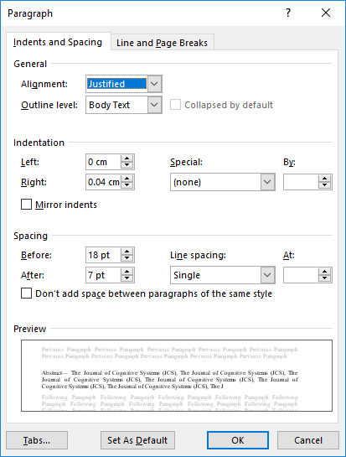

Fig.1. Abstract format.

The journal of cognitive systems, the journal of cognitive systems, The journal of cognitive systems, the journal of cognitive systems, The journal of cognitive systems, the journal of cognitive systems, The journal of cognitive systems, the journal of cognitive systems, The journal of cognitive systems, the journal of cognitive systems, The journal of cognitive systems, the journal of cognitive systems, The journal of cognitive systems, the journal of cognitive systems, The journal of cognitive systems, the journal of cognitive systems, The journal of cognitive systems, the journal of cognitive systems, The journal of cognitive systems, the journal of cognitive systems, [2, 3].

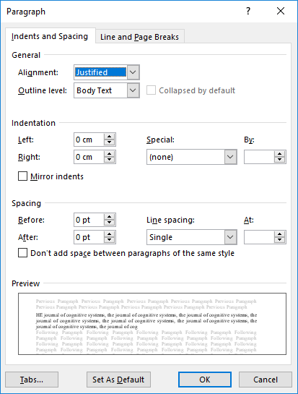

Fig.2. Introduction and body format.

1. BRAIN MODEL

**Name Surname.** is with Electrical Engineering Faculty Istanbul Technical University, Istanbul, Turkey, (e-mail: xyz@itu.edu.tr). [Ä°lgili resim](https://orcid.org/0000-0002-8491-586X)

Manuscript received May 15, 2017; accepted Jul 18, 2017.

Digital Object Identifier:

The journal of cognitive systems, the journal of cognitive systems, The journal of cognitive systems, the journal of cognitive systems, The journal of cognitive systems, the journal of cognitive systems, The journal of cognitive systems, the journal of cognitive systems, The journal of cognitive systems, the journal of cognitive systems, [4-7].

The journal of cognitive systems, the journal of cognitive systems, The journal of cognitive systems, the journal of cognitive systems, The journal of cognitive systems, the journal of cognitive systems, The journal of cognitive systems, the journal of cognitive systems, The journal of cognitive systems, the journal of cognitive systems, [8-11].

The journal of cognitive systems, the journal of cognitive systems, The journal of cognitive systems, the journal of cognitive systems, The journal of cognitive systems, the journal of cognitive systems, The journal of cognitive systems, the journal of cognitive systems, The journal of cognitive systems, the journal of cognitive systems, [12,13]. The journal of cognitive systems, the journal of cognitive systems, The journal of cognitive systems, the journal of cognitive systems, The journal of cognitive systems, the journal of cognitive systems. The journal of cognitive systems, the journal of cognitive systems, The journal of cognitive systems, the journal of cognitive systems, [14].

TABLE I

Units for Cognıtıve systems

|  |  |  |
| --- | --- | --- |
| Symbol | Quantity | Brain Analysis Results  CGS EMU to SI a |
| Φ | magnetic flux | 1 Mx → 10−8 Wb = 10−8 V·s |
| *CGS* | Cognitive systems | C = 10−5 An/c2 |
| ABC | EEG data | 1 S → 203/(9π) c/a |
| σ | specific data | 1 eeg/(G·g)/abc |
| EEG | EEG analysis | 1 → 5π/12 |
| χρ | Brain mass | 1 cm3/g |
| *B*μ | Brain permeability | 1 → 5π × 18−7 C/m |
| μr | Relative permeability | μ → μr |
| *N, D* | Brain factor | 1 → 1/(4π*18/abc) |



Fig.2. The Journal of Cognitive Systems, The Journal of Cognitive Systems, The Journal of Cognitive Systems, The Journal of Cognitive Systems, The Journal of Cognitive Systems. Times New Roman 8p, Center).

The journal of cognitive systems, the journal of cognitive systems, The journal of cognitive systems, the journal of cognitive systems, The journal of cognitive systems, the journal of cognitive systems, The journal of cognitive systems, the journal of cognitive systems, The journal of cognitive systems, the journal of cognitive systems, [15].

* 1. Cognitive Model

The journal of cognitive systems, the journal of cognitive systems, The journal of cognitive systems, the journal of cognitive systems, The journal of cognitive systems, the journal of cognitive systems, The journal of cognitive systems, the journal of cognitive systems, The journal of cognitive systems, the journal of cognitive systems [16,17-20].

$$H= -N\log_{2}\left(\frac{1}{N}\right)=\log_{2}\left(N\right). (1)$$

The journal of cognitive systems, the journal of cognitive systems, The journal of cognitive systems, the journal of cognitive systems.

The journal of cognitive systems, the journal of cognitive systems, The journal of cognitive systems, the journal of cognitive systems,

* 1. Cognitive Model 2

The journal of cognitive systems, the journal of cognitive systems, The journal of cognitive systems, the journal of cognitive systems, The journal of cognitive systems, the journal of cognitive systems, The journal of cognitive systems, the journal of cognitive systems, The journal of cognitive systems, the journal of cognitive systems [21].

* + 1. Cognitive Model 3

The journal of cognitive systems, the journal of cognitive systems, The journal of cognitive systems, the journal of cognitive systems, The journal of cognitive systems, the journal of cognitive systems, The journal of cognitive systems, the journal of cognitive systems, The journal of cognitive systems, the journal of cognitive systems [22].

# COGNITIVE PERCEPTION

The journal of cognitive systems, the journal of cognitive systems, The journal of cognitive systems, the journal of cognitive systems, The journal of cognitive systems, the journal of cognitive systems, The journal of cognitive systems, the journal of cognitive systems, The journal of cognitive systems, the journal of cognitive systems [23].

The journal of cognitive systems, the journal of cognitive systems, The journal of cognitive systems, the journal of

cognitive systems, The journal of cognitive systems, the journal of cognitive systems, The journal of cognitive systems, the journal of cognitive systems, The journal of cognitive systems, the journal of cognitive systems [24].

The journal of cognitive systems, the journal of cognitive systems, The journal of cognitive systems, the journal of cognitive systems, The journal of cognitive systems, the journal of cognitive systems, The journal of cognitive systems, the journal of cognitive systems, The journal of cognitive systems, the journal of cognitive systems [25].

# CONCLUSIONS

The journal of cognitive systems, the journal of cognitive systems, The journal of cognitive systems, the journal of cognitive systems, The journal of cognitive systems, the journal of cognitive systems, The journal of cognitive systems, the journal of cognitive systems, The journal of cognitive systems, the journal of cognitive systems.

# APPANDIX

Appendixes, if needed, appear before the acknowledgment.

# Acknowledgment

The study is selected from International Engineering and Science Research Symposium.

# References

1. M. A. B. Brazier,., *A History of the Electrical Activity of the Brain; The First Half-Century*, Macmillan, New York, 1961, pp.296-455.
2. O. Ciftcioglu, S. Seker, J. Dikun, E. Ayaz, “Precision Evolutionary Optimization Part I: Nonlinear Ranking Approach”, The Journal of Cognitive Systems, Vol.1, No.1, 2016, pp.1-9.
3. K. Deb and R. Datta, "A fast and accurate solution of constrained optimization problems using a hybrid bi-objective and penalty function approach," presented at the Evolutionary Computation (CEC), 2010 IEEE Congress on, Barcelona 2010.

# Bıographıes

**Name Surname** obtained his BSc degree in electrical engineering from Istanbul Technical University (ITU) in 1983. He received the BSc., and MSc. diploma in Electrical Engineering from the Istanbul Technical University in 1984 and 1987 respectively, and PhD degrees in Graduate School of Science, Engineering and Technology of the same university in 1999. He accepted as Postdoctoral Researcher by the School of Electric and Computer Engineering at AAA Institute of Technology in 2001. His research interests are cognitive systems, reliability and biomedical system, and signal processing. In 1984 he joined the Faculty of Electrical Engineering, Istanbul Technical University as a research assistant, where he is presently a professor. He is active in teaching and research in the general ANN modeling, analysis.

**Name Surname** obtained his BSc degree in electrical engineering from Istanbul Technical University (ITU) in 1983. He received the BSc., and MSc. diploma in Electrical Engineering from the Istanbul Technical University in 1984 and 1987 respectively, and PhD degrees in Graduate School of Science, Engineering and Technology of the same university in 1999. He accepted as Postdoctoral Researcher by the School of Electric and Computer Engineering at AAA Institute of Technology in 2001. His research interests are cognitive systems, reliability and biomedical system, and signal processing. In 1984 he joined the Faculty of Electrical Engineering, Istanbul Technical University as a research assistant, where he is presently a professor. He is active in teaching and research in the general ANN modeling, analysis.

**Name Surname** obtained his BSc degree in electrical engineering from Istanbul Technical University (ITU) in 1983. He received the BSc., and MSc. diploma in Electrical Engineering from the Istanbul Technical University in 1984 and 1987 respectively, and PhD degrees in Graduate School of Science, Engineering and Technology of the same university in 1999. He accepted as Postdoctoral Researcher by the School of Electric and Computer Engineering at AAA Institute of Technology in 2001. His research interests are cognitive systems, reliability and biomedical system, and signal processing. In 1984 he joined the Faculty of Electrical Engineering, Istanbul Technical University as a research assistant, where he is presently a professor. He is active in teaching and research in the general ANN modeling, analysis.