Title of Manuscript

Abstract
This editable Microsoft Word document is prepared for researchers who are considering submitting an article to Bitlis Eren University Journal of Science. The articles considered to be sent to our journal must be prepared according to this template in order to accelerate the editing, evaluation and publication stages of the article. By using the Style tab at the top of the Word document, article type, article title, abstract title, abstract and other components can be easily selected and related edits can be made quickly. The abstract of the article should be written fully justified, Times New Roman and with 10 font size. It should be no longer than 250 words maximum. The abstract should be concise and briefly define the purpose of the research, the main results and substantial conclusions. Immediately after the abstract, provide a minimum of 3 and maximum of 6 keywords with 10 font size.

Keywords: Keyword 1, Keyword 2, Keyword 3, Keyword 4, Keyword 5, Keyword 6.

1. Introduction

In this section, adequate literature review about the study should be given, the aims of the study and its importance in the literature should be emphasized. Detailed literature review and summary of results should be avoided [1], [2].
Paragraphs following the first paragraph should begin with the paragraph indentation.

2. Material and Method

The method should be given in detail and clearly in terms of reproducibility of the study. The methods used should be supported by previously published references. Changes that contribute to the method in the study should be described in detail [3], [4].
Paragraphs following the first paragraph should begin with the paragraph indentation.

2.1. Example Subtitle 1 (BEU-FBD-Main Title)

If necessary, subheadings can be added under the main heading [5].
Paragraphs following the first paragraph should begin with the paragraph indentation.
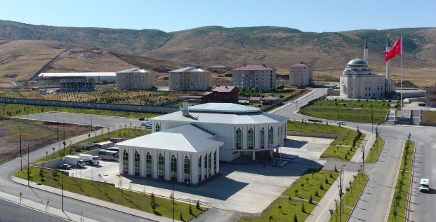
Figure 1. For captions, please use the figure description style.

When you add a figure to your article, please refer to the relevant picture in the text, such as Figure 1. When using shapes, be attentive to use the Shape Description style. Additionally, there should be a 5 nk space between the figure and its caption [6], [7].

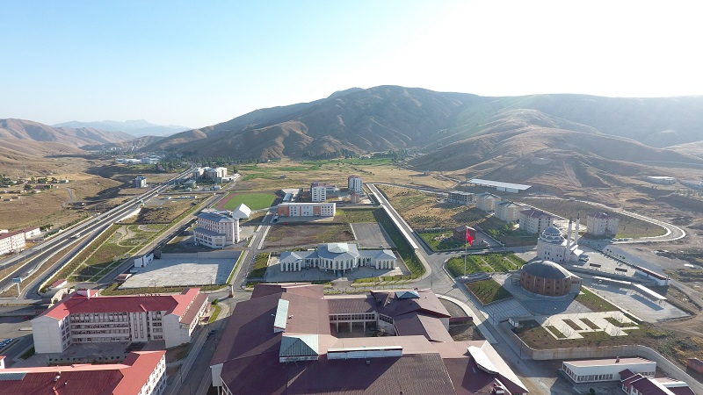
Figure 2. Bitlis Eren University campus

When using equations, they should be numbered sequentially. The equation numbers should be enclosed by parentheses and located at the right-hand side of the page [8]. In addition, equations should be prepared with Word or other equation editors and should not be in picture format [9], [10].

$f\left(x\right)={\frac{1}{xσ\sqrt{2π}}e}^{\frac{-{\left(lnx-μ\right)}^{2}}{2σ^{2}}},x>0$ (1)

Tables must be in editable form and each table column must be navigated with the Tab key. Table headings should be placed above the table. Each heading should be numbered and the table should be referenced within the main text. There should be a 5 nk space between the table and its heading. Besides, refer to the relevant table in the text, such as Table 1 [10]-[12].

Table 1. Possible flood flow rates of E26A010 AGI
Heading 1 | Heading 2 | Heading 3
10.52 | 11.25 | 12.25
13.25 | 14.25 | 15.25
10.52 | 11.25 | 12.25
10.52 | 11.25 | 12.25
13.25 | 14.25 | 15.25

Table 2. Possible flood flow rates of E26A010 AGI
Heading 1 | Heading 2 | Heading 3 | Heading 4 | Heading 5 | Heading 6 | Heading 7 | Heading 8
10.52 | 11.25 | 12.25 | 10.52 | 11.25 | 12.25 | 10.52 | 10.52
13.25 | 14.25 | 15.25 | 13.25 | 14.25 | 15.25 | 13.25 | 13.25
10.52 | 11.25 | 12.25 | 10.52 | 11.25 | 12.25 | 10.52 | 10.52

3. Results and Discussion

The results obtained should be included in this section and supported by figures and tables if necessary. The findings can be compared with the relevant literature if required. Results should be clear and concise. In the discussion section, the important results of the study should be highlighted and excessive citation and literature discussion should be avoided.
Paragraphs following the first paragraph should begin with the paragraph indentation.

3.1. Example Subtitle

Subtitle(s) can be given if necessary.
Paragraphs following the first paragraph should begin with the paragraph indentation.

4. Conclusion and Suggestions

The conclusion section should be stand alone. The aim of the study and its significant results should be given briefly in a concrete way. In addition, suggestions and opinions that are requested to be conveyed to the readers regarding the results of the study can be stated.
Paragraphs following the first paragraph should begin with the paragraph indentation.

Acknowledgment

If necessary, the people, institutions and organizations that helped in the study should be thanked for their help and support.

Conflict of Interest Statement
There is no conflict of interest between the authors.

Statement of Research and Publication Ethics

The study is complied with research and publication ethics

(References should be IEEE format. For more information, please click here. For create a bibliography in accordance with IEEE format, please click here. An example bibliography is given below.)

References

[1] U. J. Gelinas, Jr., S. G. Sutton, and J. Fedorowicz, Business Processes and Information Technology. Cincinnati: South-Western/Thomson Learning, 2004.
[2] L. Liu and H. Miao, "A specification-based approach to testing polymorphic attributes," in Formal Methods and Software Engineering: Proc. of the 6th Int. Conf. on Formal Engineering Methods, ICFEM 2004, Seattle, WA, USA, November 8-12, 2004, J. Davies, W. Schulte, M. Barnett, Eds. Berlin: Springer, 2004. pp. 306-19.
[3] T. J. van Weert and R. K. Munro, Eds., Informatics and the Digital Society: Social, ethical and cognitive issues: IFIP TC3/WG3.1&3.2 Open Conf.e on Social, Ethical and Cognitive Issues of Informatics and ICT, July 22-26, 2002, Dortmund, Germany. Boston: Kluwer Academic, 2003.
[4] G. Liu, K. Y. Lee, and H. F. Jordan, "TDM and TWDM de Bruijn networks and shufflenets for optical communications," IEEE Trans. Comp., vol. 46, pp. 695-701, June 1997.
[5] J. R. Beveridge and E. M. Riseman, "How easy is matching 2D line models using local search?" IEEE Transactions on Pattern Analysis and Machine Intelligence, vol. 19, pp. 564-579, June 1997.
[6] M. Lehmann, Data Access in Workflow Management Systems. Berlin: Aka, 2006.
[7] J. Geralds, "Sega Ends Production of Dreamcast," vnunet.com, para. 2, Jan. 31, 2001. [Online]. Available: http://nl1.vnunet.com/news/1116995. [Accessed: Sept. 12, 2004].
[8] European Telecommunications Standards Institute, “Digital Video Broadcasting (DVB): Implementation guidelines for DVB terrestrial services; transmission aspects,” European Telecommunications Standards Institute, ETSI TR-101-190, 1997. [Online]. Available: http://www.etsi.org. [Accessed: Aug. 17, 1998].
[9] A. Rezi and M. Allam, "Techniques in array processing by means of transformations, " in Control and Dynamic Systems, Vol. 69, Multidemsional Systems, C. T. Leondes, Ed. San Diego: Academic Press, 1995, pp. 133-180.
[10] O. B. R. Strimpel, "Computer graphics," in McGraw-Hill Encyclopedia of Science and Technology, 8th ed., Vol. 4. New York: McGraw-Hill, 1997, pp. 279-283.
[11] W.-K. Chen, Linear Networks and Systems. Belmont, CA: Wadsworth, 1993, pp. 123-135.
[12] K. E. Elliott and C.M. Greene, "A local adaptive protocol," Argonne National Laboratory, Argonne, France, Tech. Rep. 916-1010-BB, 1997.

