**PRODUCTION OF ANNULAR AND COMPACT TYPE BURNABLE ABSORBER NUCLEAR FUEL PELLETS BY POWDER METALLURGY AND SOL GEL ROUTE**

Ahmet YAYLI

Turkish Energy, Nuclear and Mineral Research Agency, Nuclear Energy Research Institute,

Küçükçekmece, İstanbul, TURKEY

[ahmet.yayli@taek.gov.tr](mailto:ahmet.yayli@taek.gov.tr)

YANABİLİR SOĞURUCULU BÜTÜN VE DELİKLİ NÜKLEER YAKIT PELETLERİNİN TOZ METALURJİSİ VE SOL JEL YÖNTEMLERİYLE ÜRETİMİ

**Abstract:**

The aim of this study is to produce UO2-Gd2O3 burnable absorber nuclear fuels of nuclear power reactors. Today's nuclear power reactors have different neutron absorbers for different applications. One of the major challenges of the nuclear industry is to improve the performance, safety and lifetime of reactors. In this area there are many efforts focused on the research and development of new materials in order to extend the fuel lifetime, increase the burn up and optimize the power density distribution. With this aim a neutron absorber material is usually incorporated into the UO2 nuclear fuel. Gadolinium is an excellent burnable poison because it presents a large cross section for neutron absorption and allows the compensation of the excess reactivity of the fuel in the beginning of its life. The need to improve reactor performance through longer cycle lengths or improved fuel utilization has been apparent since the beginning of commercial nuclear power generation. Among several modifications introduced as a consequence, the fuel initial enrichment has been increased, which means that the additional amount of fissile material (235U) in the reactor core has to be compensated by the introduction of additional neutron absorber material in the reactor core. This compensation was initially achieved only by using neutron absorber materials assembled in control rods or/and by addition of soluble absorber (boric acid) in the reactor coolant. In Boiling Water Reactors (BWR), the use of soluble absorber in the coolant/moderator was prohibited for technological reasons. In Pressurized Water Reactors (PWR), boric acid as a soluble absorber added to the coolant/moderator has been routinely used, but the increase in initial fuel enrichment cannot be indefinitely compensated by increasing the boric acid concentration. Beyond a certain concentration, thermal expansion of water at start-up reduces the quantity of boron in the core, resulting ultimately in a positive moderator reactivity coefficient, which is an unacceptable situation regarding to the safe reactor operation. This is the reason why the introduction of solid burnable absorbers (or burnable poison) within the fuel rods was considered. The use of a burnable poison in nuclear reactors provides the necessary negative moderator reactivity coefficient at the beginning of core life and help to shape the core power distributions (IAEA-TEC-DOC-844, 1995; Yayli, 1995; Böhm et al., 1987; Zinkle & Was, 2013; Tobia et al., 2014) The poison material should have a high neutron absorption cross section and form daughter products with low absorption cross sections. Then, as soon as the irradiation proceeds, the burnable poison burns up and the macroscopic absorption cross section decreases. From a nuclear viewpoint, gadolinia is an excellent burnable poison, having a high neutron absorption cross section coupled to a burn up rate that, if properly designed, can match approximately the 235U depletion, minimizing the reactivity penalty at the end-of-cycle (EOC) (Stogen, Nielsen & Grummer, 1982; Brandberg, 1973). In this study two methods were used to obtain UO2-Gd2O3 burnable-absorber fuels. The first method was conventional powder metallurgical route and the second method was sol-gel route. In this study, the investigation of the microstructure and U-Gd distribution in sintered bodies along with the achieved SEM-EDAX results showed that both methods provide homogeneous structures. The solid state investigations of sintered UO2-Gd2O3 pellets by x-ray diffraction showed that, gadolinium dissolved in UO2 matrix. Production of the burnable absorber compact and annular type nuclear fuel pellets by powder metallurgical and sol-gel routes showed that; we obtained the nuclear fuels in accordance with international standards.

**Abbreviations:**

ADU (ammonium diuranate) : (NH4)2U2O7; UNH (uranyl nitrate hexahydrate): UO2(NO3)2·6H2O; TD: Theoritical density; PM: (Powder Metallurgy) ; UO2, urania; Gd2O3, gadolinia

THFA: Tetrahydrofurfuryl Alcohol, C5H10O2 , PVA: Polyvinyl alcohol, [CH2CH(OH)]n

ÇNAEM: Cekmece Nuclear Research and Training Center

LTS: Low temperature sintering, HTS: High temperature sintering

**Özet:**

Günümüz nükleer reaktörleri farklı uygulamalar için farklı nötron soğurucularına sahiptirler. Nükleer endüstrinin en büyük zorluklarından biri, reaktörlerin performansını, güvenliğini ve ömrünü arttırmaktır. Bu alanda yakıt ömrünü uzatmak, yanmayı arttırmak ve güç yoğunluğu dağılımını optimize etmek için yeni malzemelerin araştırılmasına ve geliştirilmesine odaklanmış birçok çaba vardır. Bu amaçla bir nötron soğurucu malzeme genellikle UO2 nükleer yakıtına ilave edilir. Gadolinyum mükemmel bir yanabilir zehirdir çünkü nötron absorblanması için geniş bir kesit sunar ve ömrünün başlangıcında yakıtın aşırı reaktivitesinin dengelenmesini sağlar. Reaktör performansının daha uzun çevrim uzunlukları veya geliştirilmiş yakıt kullanımı yoluyla geliştirilmesi ihtiyacı, ticari nükleer enerji üretiminin başlangıcından beri belirgin taleplerden biri olmuştur. Bunun sonucunda ortaya çıkan çeşitli modifikasyonların başında, reaktör çekirdeğindeki ek parçalanabilir malzemenin (235U) arttırılması anlamına da gelen yakıtın ilk zenginlğinin arttırılması gelmektedir ve bu, ancak reaktör çekirdeğine ek nötron soğurucu malzeme eklenerek telafi edilebilmektedir. Bu dengeleme, başlangıçta sadece kontrol çubuklarına monte edilen nötron soğurucu malzemeler kullanılarak ve / veya reaktör soğutucusunda çözünebilir emici (borik asit) ilave edilerek sağlanabilmiştir. Kaynar Su Reaktörlerinde (BWR), soğutucu moderatörde çözünebilir soğurucunun kullanımı teknolojik nedenlerle yasaklanmıştır. Basınçlı Su Reaktörlerinde (PWR), soğutucu / moderatöre eklenen çözünebilir bir soğurucu olarak borik asidin kullanımı rutin olarak gerçekleştirilmektedir, fakat ilk yakıt zenginleştirilmesindeki artış borik asit konsantrasyonunu arttırılmasıyla süresiz olarak telafi edilememektedir. Belirli bir konsantrasyonun ötesinde, başlangıçta suyun termal olarak genleşmesi, çekirdek içindeki bor miktarını azaltır ve sonuç olarak, güvenli reaktör operasyonuna ilişkin kabul edilemez bir durum olan pozitif bir moderatör reaktivite katsayısı ile sonuçlanır. Yakıt çubukları içinde katı yanıcı soğurucuların (ya da yanabilir zehirin) kullanılmasının nedeni budur. Nükleer reaktörlerde yanabilir bir soğurucu zehir kullanılması, kor yaşamın başlangıcında gerekli negatif moderatör reaktivite katsayısını sağlar ve kor güç dağılımlarını şekillendirmeye yardımcı olur (TEC-DOC-844,1995; Yayli, 1995; Böhm et al., 1987; Zinkle & Was, 2013; Tobia et al., 2014). Yanabilir soğurucu zehir malzemesi yüksek bir nötron tesir kesitine sahip olmalı ve düşük soğurma tesir kesitli kız ürünlerini oluşturmalıdır. Ardından, ışınlama ilerledikçe, yanabilir zehir yakılır ve makroskobik absorpsiyon kesiti azalır. Nükleer bakış açısından, gadolinyum oksit, uygun bir şekilde tasarlandığında, yaklaşık olarak 235U tükenmesiyle eşleşebilen ve döngü sonunda reaktivite hatasını en aza indiren yanma oranına bağlı yüksek bir nötron emilim kesitine sahip mükemmel bir yanıcı zehirdir (Stogen, Nielsen & Grummer, 1982; Brandberg, 1973). Bu çalışmada UO2-Gd2O3 yanabilir soğuruculupeletleri elde etmek için iki yöntem kullanıldı. Birinci yöntem konvansiyonel toz metalurjisi ve ikincisi sol-jel yöntemidir. Bu çalışmada sinterlenmiş UO2-Gd2O3 peletlerinde mikroyapı ve U-Gd dağılımı incelemeleri SEM-EDAX yöntemleriyle yapıldı ve her iki yöntemle de üretilen ürünlerde homojen yapılar elde edildi. Sinterlenmiş UO2-Gd2O3 peletlerinde X- ışınları kırınımı yöntemiyle yapılan katı hal incelemelerinde, gadolinium UO2 matrisinde çözünmüştür. Sol-jel ve toz metalurjisi yöntemleri ile elde ettiğimiz yanabilir-soğuruculu kompakt ve delikli peletler, uluslararası standartlara uygun olarak elde edilmiştir.

**Key words:** Burnable Absorber, Nuclear Fuel, Gadolinia, Annular type pellets, sol gel

**Anahtar Kelimeler:** Yanabilir-soğurucu,Nükleer yakıt, Gadolinyum oksit, Delikli tip yakıt, Sol jel

Kısaltmalar:

ADU (amonyum di-uranat) : (NH4)2U2O7; UNH (uranil nitrat hekza-hidrat): UO2(NO3)2·6H2O; TD: Teorik yoğunluk; PM: (toz metalurjisi) ; UO2, uranya; Gd2O3 , gadolinya,

THFA: Tetra hidro furfuril alkol, C5H10O2 , PVA: Poli vinil alkol, [CH2CH(OH)]n

ÇNAEM (Çekmece Nükleer Araştırma ve Eğitim Merkezi)

LTS: Düşük sıcaklık sinterlemesi, HTS: Yüksek sıcaklık sinterlemesi

1. **Introduction**

Today's nuclear power reactors have different neutron absorbers for different applications. One of the most used oxide is Gadolinia, Gd2O3 which has been employed as UO2-Gd2O3 fuel pellets for compensating reactivity of the light water reactors. In UO2-Gd2O3 pellet characteristics, homogeneity of UO2-Gd2O3 solid solution and grain size are recognized as notable characteristics, there upon it is substantial for commercial fuel fabricators to enhance UO2-Gd2O3 pellets as uniform in solid solution and large in grain size as possible in reasonable fabrication cost. Recently, Gd2O3 concentration tends to become higher with extension of burn up of fuels. Therefore it is useful to understand the effects of manufacturing parameters on solid solution formation and grain growth.

One of the major challenges of the nuclear industry is to improve the performance, safety and lifetime of reactors (Yayli, 1995; Zinkle & Was, 2013). In this area there are many efforts focused on the research and development of new materials in order to extend the final lifetime, increase the burn up and optimize the power density distribution. With this aim a neutron absorber material is usually incorporated into the UO2 nuclear fuel. Gadolinium (Gd) is an excellent burnable poison as it presents large cross section neutron absorption and allows the compensation of the excess reactivity of the fuel in the beginning of its life. The solid solution (U,Gd) O2 can be fabricated by several processes and the material presents different physical and chemical properties depending on the Gd concentration and the synthesis route (Tobia et. al., 2014). The study of the sintering densification process (Durazzo et. al., 2013; Song et. al., 2001) and phase homogeneity (Leyva et. al., 2002; Grossbeck, Renier & Bigelow 2003) is crucial because the presence of microspheres or an inhomogeneous distribution of Gd ions could cause internal cracks and/or affect the fuel performance. The incorporation of Gd2O3 has a harmful effect on the traditional UO2 sintering behaviour (Grossbeck, Renier & Bigelow 2003). Burnable poisons are used in all modern nuclear reactors to permit higher loading of fuel without the necessity of an overly large control rod system. This not only permits a longer core life but can also be used to level the power distribution such that power is produced throughout the core volume rather than a small region where control rods have been removed. Commercial nuclear reactors commonly use B4C in separate non-fueled rods and more recently, zirconium boride coatings on the fuel pellets or gadolinium oxide mixed with the fuel pellets. Boron, which is an effective neutron absorber, transmutes to lithium and helium upon absorption of a neutron. Helium is insoluble and is eventually released to the interior of the fuel rod, where it produces an internal pressure. When sufficiently high, this pressure stress could cause separation of the cladding from the fuel, causing very high fuel centerline temperatures. Gadolinium has several very strongly absorbing isotopes, but not all have large cross sections and hence result in residual burnable poison reactivity worth at the end of the fuel life. Even if the amount of this residual absorber is small and the penalty in operation small, the cost of this penalty, even if only several days, can be very high (Grossbeck, Renier & Bigelow 2003). Demands for extended fuel cycles and higher target burnups are strong incentives to use Gd2O3 as burnable poison in modern pressurized water reactors (PWRs).

The relationship between the use of burnable absorber or, in other words, the use of burnable poison and reactor life is one of the most important issues that are emphasized in today's reactors. This issue also concerns also our country closely. Nuclear power reactors being installed in Akkuyu-Mersin will also use burnable absorbers and new materials to provide safer and longer periodic fuel loading cycles in the life extension and reactor operation. For these reasons, the issue is among the strategic interests of our country. UO2 has face-centered cubic CaF2 (fluorite type) lattice structure and the schematic representation of this structure given in Figure 1 (Yayli, 1995) with possible oxygen sites. Uranium and oxygen system has many oxides as can be seen from the uranium-oxygen phase diagram is given in Figure 2.

The thermal neutron absorption cross section of the gadolinium, Westcott factor and resonance integral values ​​are given in Table 2, and the properties of the main burnable absorbers currently used are listed in Table 1 (IAEA-TECDOC-844, 1995).

Table 1. The thermal neutron absorption cross section of the gadolinium, Westcott factor and resonance integral values (IAEA-TECDOC-844, 1995).

|  |  |  |  |  |
| --- | --- | --- | --- | --- |
| Gd isotopes | Natural isotopic ratio (%) | Thermal Cross-section (Barn=10-24 cm2) | Westcott Factor | Resonance integral |
| Gd (natural) |  | 48890+104 | 0,8467 | 390+10 |
| 152Gd | 0,2 | 735+20 | 0,9784 | 2020+160 |
| 154Gd | 2,1 | 85+12 | 0,9967 | 230+26 |
| 155Gd | 14,8 | 60900+50 | 0,8425 | 1447+100 |
| 156Gd | 20 | 1,5+1,2 | 1,0006 | 104+15 |
| 157Gd | 15,7 | 254000+815 | 0,8512 | 700+20 |
| 158Gd | 24 | 2,2+0,2 | 1,0009 | 73+7 |
| 160Gd | 21,8 | 0,77+0,2 | 0,9997 | 7,2+1 |

Table 2: Main burnable-absorber properties (IAEA-TECDOC-844, 1995).

|  |  |  |  |
| --- | --- | --- | --- |
| Burnable absorber | **Gd** | **ZrB2 (IFBA)** | **Er** |
| Producers | a | Westinghouse | ABB/CE |
| Thermal conductivity decreasing | High | Low | Lowes |
| Melting point decreasing | Important | Very low | low |
| Burnable absorber in bundle % | 3-6 | 30-40 | 20-30 |
| U decreasing | Important | Very low | Important |
| 235U decreasing | Low | Very low | Very low |
| Delaying rate | High | High | Medium |
| Excess activity | Low | Very low | Important |
| Fuel bundle power distribution | Good | Middle | Good |
| Localpower densification | Important | Low | low |
| Moderator temperature control (MTC) | Good | Worst | Best |
| Fabricability | Good | Separate installation | Separate installation |
| Fuel reprocessing | Good | Difficult | Good |
| a: **FBFC** (Belgium), **SIEMENS** (Germany), **Fabricazione Nucleari** (İtaly), **JNF-MNF and** **NFI** (Japan), **KNFC** (S.Korea), **ENUSA** (Spain), **ABB Atom** (Sweden), **BNFL** (England), **BWFC-GE ve SPC** (US). | | | |

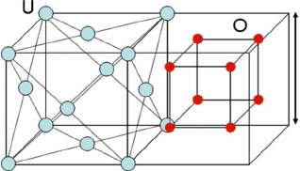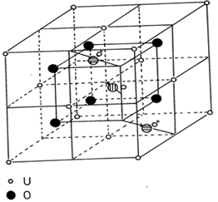

Figure 1. Lattice structure of UO2 and possible oxygen sites (Yayli,1995).

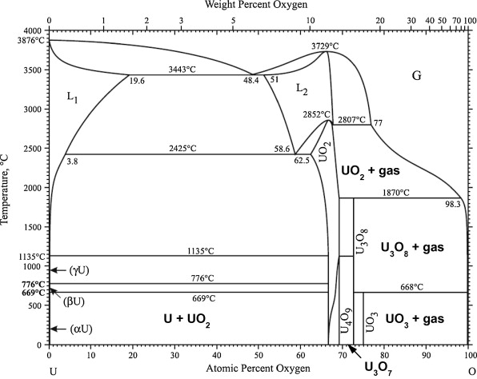

Figure 2. Uranium-oxygen phase diagram.

The savings in cycle length is not the only factor that must be considered. The following primary factors must all be considered in the choice of a burnable poison:

1. Rate of burnout

2. Initial negative reactivity worth

3. Available volume for burnable poison loading

4. Effect of burnable poison on the moderator void coefficient of reactivity

5. Cost of the burnable poison material 6. Compatibility of the burnable poison with the fuel or cladding (Renier & Grossbeck, 2001).

In a light water reactor (LWR), burnable absorbers are usually used for controlling excess reactivity of the fresh fuel and the reactor core at the beginning of burn up stage, and flattening the power distribution to avoid an excessively high power peak at some fresh fuel assemblies Gd2O3 particle dispersed burnable absorber fuels in WWER 1000 Power Reactor (Hoai, Hung & Liem, 2017) is given in Figure 3.

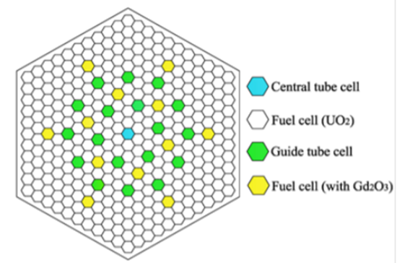  
Figure 3. Gd2O3 particle dispersed burnable absorber fuels in WWER 1000 Power Reactor (Hoai, 2017).

Comparison of Δk values as a function of burnup depending on the amount of gadolinium is given in Figure 4 (NUREG/CR- 6760). As can be seen from Figure 4, the decrease in reactivity in linear burn up rates with the amount of gadolinium is linear up to a certain point. There is no significant difference after burn up rates of 20 GWd / MtU (NUREG/CR- 6760).

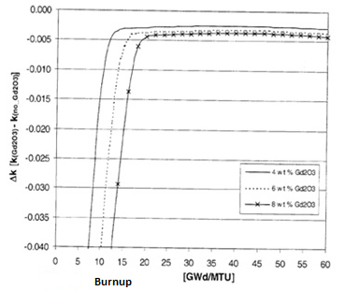

Figure 4. Comparison of Δk values as a function of burnup depending on the amount of gadolinium (NUREG/CR- 6760).

Durazzo et. al. (2013) have reported that the diffusion of Gd2O3 into UO2 in UO2 - Gd2O3 binary system is more than, diffusion of UO2 into Gd2O3. The SEM picture of Gd2O3 powders in that study is given in Figure 5. The forms of Gd2O3 powders and some other physical characteristics like particle sizes and distributions, agglomeration etc. used in the study of (Durazzo et. al., 2013) are similar with those of the Gd2O3 powders used in this study.

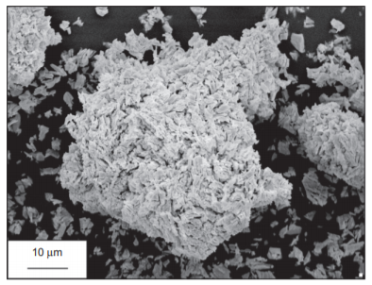

Figure 5. SEM image of Gd2O3 powders in a study (Durazzo, 2013).

UO2-Gd2O3 pellets with different microstructures and different grain sizes were obtained. Microstructure images of these pellets are given in Figure 6 (Durazzo et. al., 2013).

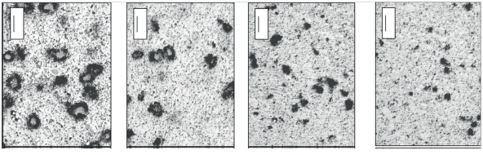a)

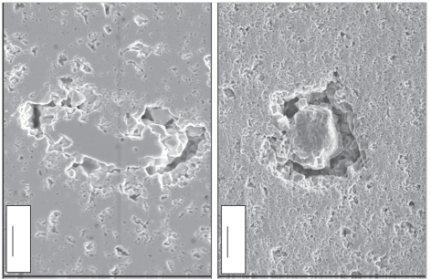

b)

Figure 6. SEM images of grain sizes depending on the Gd2O3 in UO2-Gd2O3 sintered pellets a), pore and grain boundaries in sintered pellets b). (Durazzo et. al., 2013).

1. **Experimental**

In this study two methods were used to obtain UO2-Gd2O3 burnable-absorber fuels. The first method was conventional powder metallurgical route and the second method was sol-gel route. Powder metallurgical route include powder preparation, powder compaction and sintering steps.

Urania, UO2 powders were prepared by ex-ADU, (NH4)2U2O7 process (UO2-ex ADU). Gd2 O3 powder was supplied from Merck and used as received. UO2- ex ADU and Gd2O3 powders were mechanically blended in a mortar. Powder production methods and the powder treatments (heat treatment, granulation, milling, sieving, etc) affect the properties of end products. ADU based UO2 powders were not free flowable, and hence before pellet pressing it needed pre compacting with approximately 100 MPa pressure. Then, UO2 compacts were milled sieved and then, pressed using a cylindrical die at different pressures ranging between 200-500 MPa.

In this study, we obtained UO2-Gd2O3 kernels in spherical form by sol gel method. These microspheres were milled and then pressed via powder metallurgical methods. Steps of the powder metallurgical and sol-gel route are showed in Figure 7.

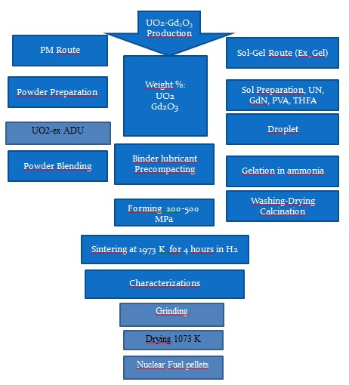

Figure 7. Steps of powder metallurgical and sol-gel routes followed to produce UO2- Gd2O3 burnable absorber nuclear fuel.

Uranyl nitrate UNH, UO2(NO3)2·6H2O was produced by us at CNAEM and gadoliniumn nitrate was supplied by Merck Company. The UNH and gadolinium nitrate solutions were mixed in liquid phase to obtain 10% Gd2O3 + 90% UO2 composition by weight at predetermined rates. Poly vinyl alcohol (PVA) and tetra hydro furfuryl alcohol (THFA) were supplied by Merck company. THFA was used as stabilizer whereas PVA was used to adjust the viscosity of the solutions. The concentration of metal nitrate solutions is adjusted to 2M. The half volume of the total feed solution, consisting of metal nitrate solution and 40 vol% THFA and 10 vol% 10% PVA solutions, was prepared at room temperature. This feeding solution was dropped into 7 N NH4OH solution at room temperature by first passing through N2 and then ammonia (NH3) gases. The detailed flow diagram of the UO2-Gd2O3 pellet production by external gelation route is given in Figure 8.

U,Gd Nitrate Sol

PVA+THFA

Mixing at 20 o C

Viscosity control

Reduction at 923K under Ar+ %5 H2 atmosphere UO 2+x – Gd2O3

Washing with isopropyl alcohol, water

Drying at 323 K,373 K,423 K for 2 hours in air

Drop formation

NH3, NH4OH

Dış Jelleşme 20 o C

Pressing 300-500 MPa

Sintering: LTS: at 1423 K for 1 hour under CO2 atm., HTS: under H2 atmosphere at 1973 K for 4 hours

Calcination at 573 K: UO3-Gd2O3

Calcination at 1073 K : U3O8- Gd2O3

ThO2

Sintered SGMP UO2 Gd2O3 Pellets



Figure 8. Detailed flow diagram of UO2-Gd2O3 pellet production by external gelation in this study. (LTS: Low temperature Sintering , HTS: High Temperature Sintering).

The external gelation set up of this study and produced ex-gel UO3-Gd2O3 microspheres are given in Figure 9.

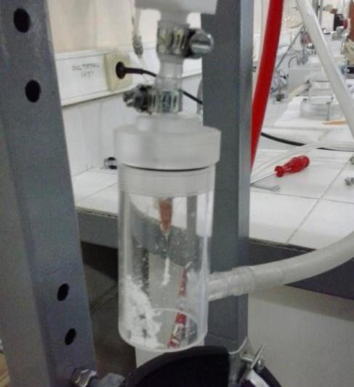 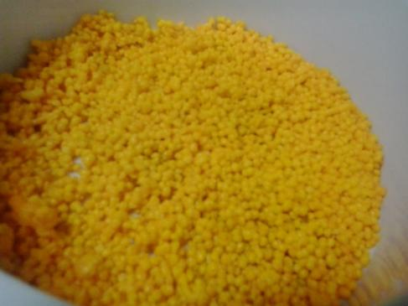

Figure 9. The external gelation set up for this study (left) and obtained ex-gel UO3-Gd2O3 microspheres (right).

Ex-gel UO3-Gd2O3 microspheres are reduced in H2 atmosphere in a laboratory furnace at 923 K for 2 hours and then UO2+x - Gd2O3 microspheres were obtained. These microspheres were partly milled in a mortar to obtain better pressing properties. Figure 10 shows SEM pictures of the partly milled **e**x-gel UO3-Gd2O3 microspheres**.**

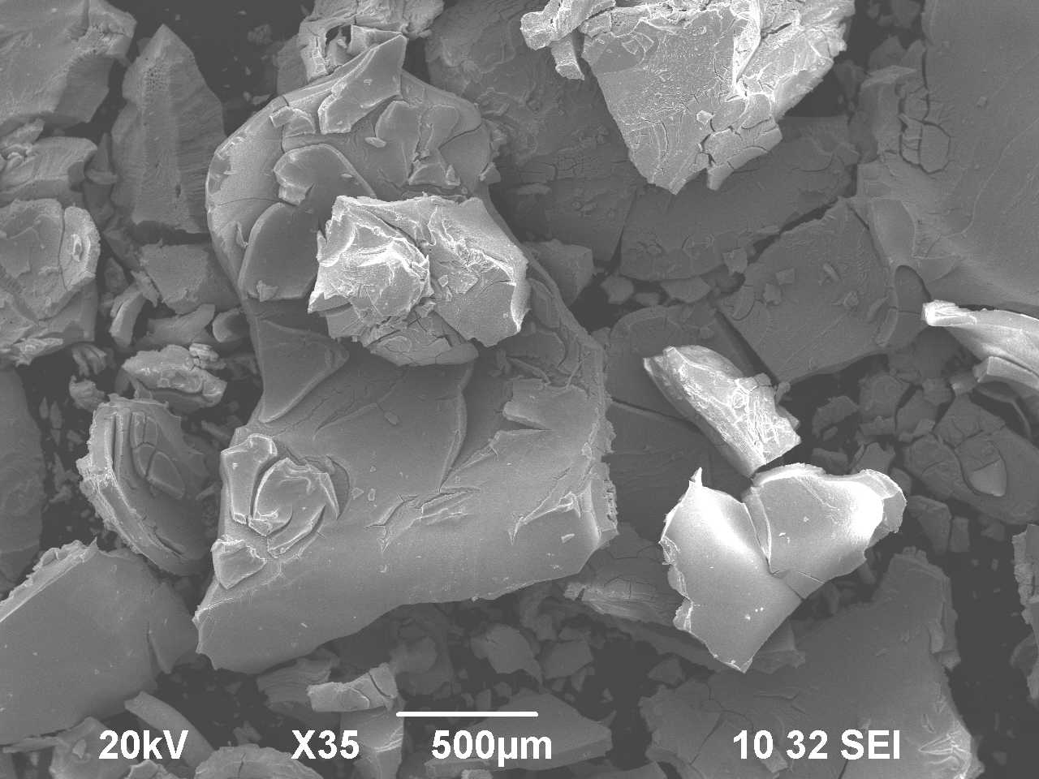 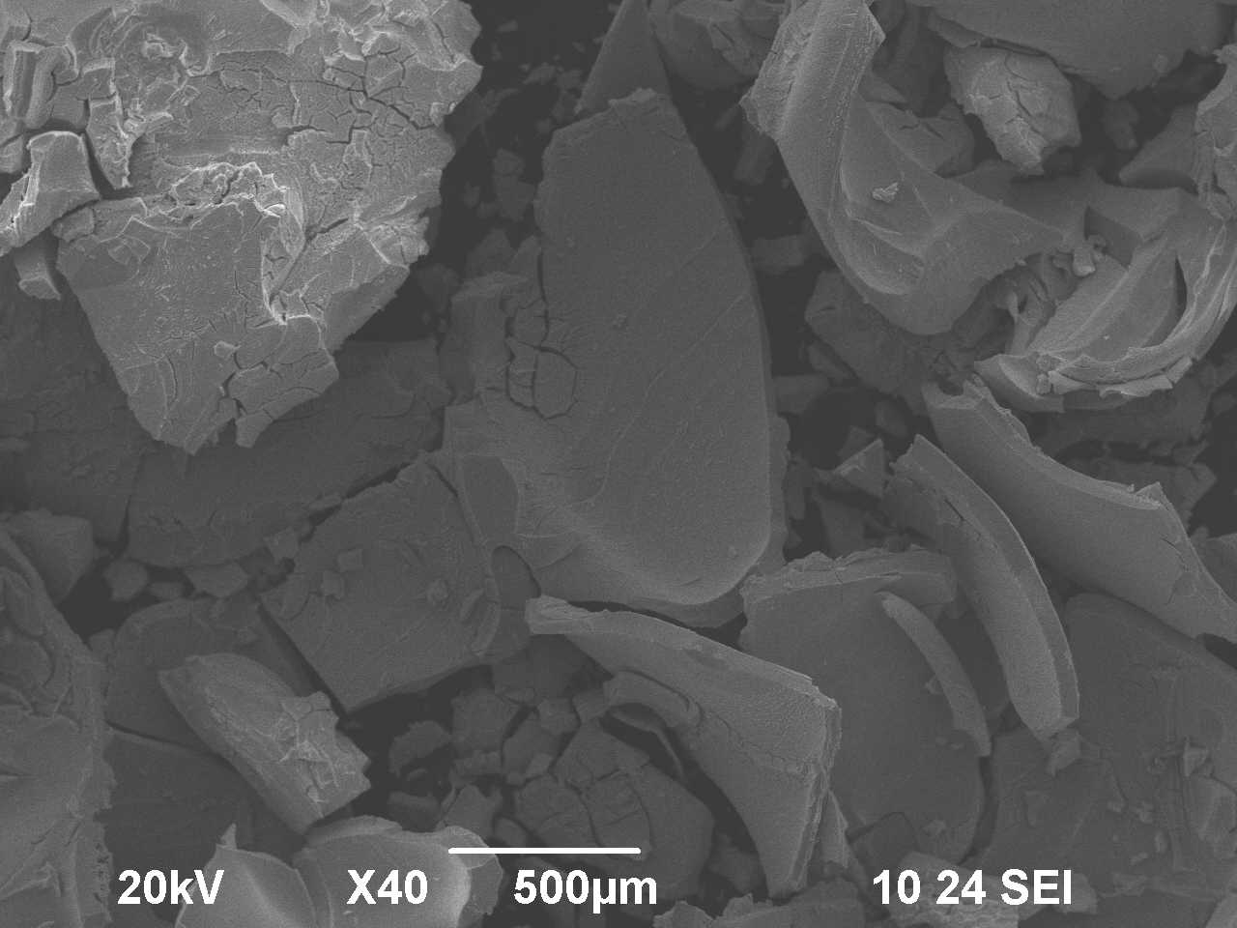

Figure 10. SEM pictures of the partly milled **e**x-gel UO3-Gd2O3 microspheres**.**

As mentioned previously, UO2 was prepared by Ex-ADU route (UO2-Ex ADU) at CNAEM, Gd2O3 was supplied from Merck and used as received.SEM pictures of the ADU and UO2-Ex ADU powders are given in Figure 11. The SEM investigations of gadolinia (Gd2O3) powders used in this study for the powder metallurgical route are given in Figure 12.

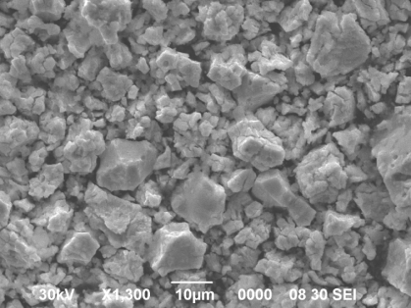 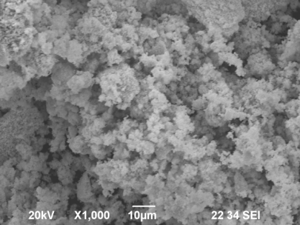

Figure 11. The ADU (left) and UO2-Ex ADU powders (right) SEM pictures.

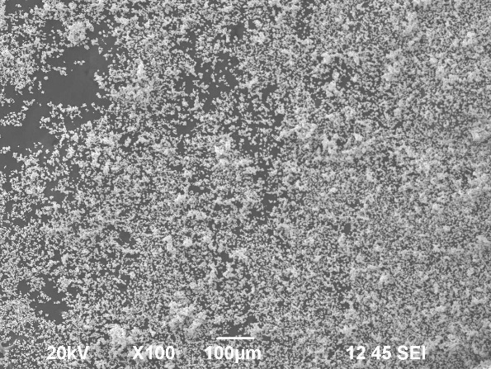 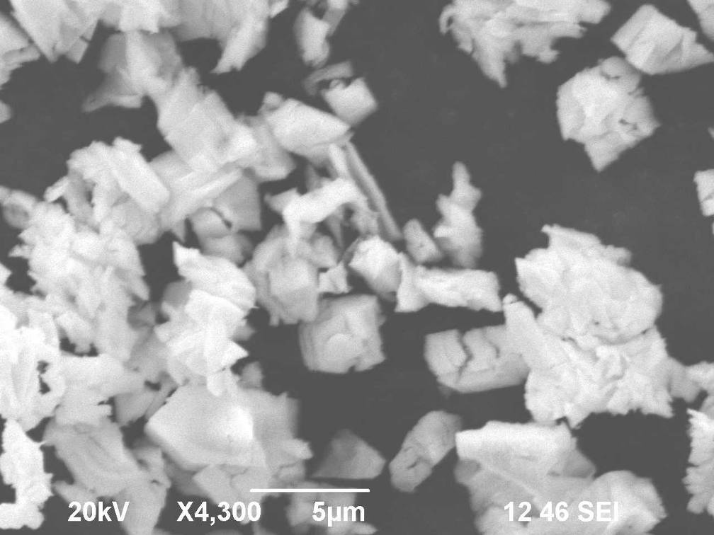

Figure 12**.** SEM pictures of Gd2O3 powders that used in this study for PM route.

The urania-gadolinia powders were prepared by external gelation route (for the detailed flow diagram see Figure 8). These blended powders are pressed at 300 MPa using a cylindrical die with an inner diameter of 10 mm in compact form to obtain green pellets. The green pellets were sintered at 1923 K under dry H2 (95% Ar volume+H2) atmosphere for 4 hours.

Mechanically blended urania-gadolinia powders were also pressed in annular form at 300 MPa and then, obtained green pellets were sintered at 1923K under dry H2 (95 % Ar volume +H2) atmosphere for 4 hours.

Surface areas of powders were measured by BET method. The UO2 and gadolinia powders used in this study have 3.7 m2/g and 4.8 m2/g specific surface area values, respectively. The densities of green pellets were determined by geometrical method whereas densities of sintered pellets were determined by both geometrical and immersion methods. There has been a little difference between the green densities of urania-gadolina compact and annular green pellets. The calculated green density values of compact ex-gel urania-gadolinia green pellets were % 54 TD, and annular type powder metallurgical urania-gadolinia green pellets were 49 % (TD) . The sintered densities of the urania-gadolinia burnable absorber nuclear fuel pellets produced by sol gel and powder metallurgical routes were reached approximately 93% TD and 95% TD, respectively.

Solid state investigations were carried out by x-ray diffraction (XRD), the morphological and micro-structural investigations were carried out by scanning electron microscopy (SEM). Homogeneity and elemental distributions of sintered bodies were investigated by EDAX mapping method.

XRD diagrams of UO2-ex- ADU and Gd2O3 powders are given in Figure 13 and Figure 14,respectively.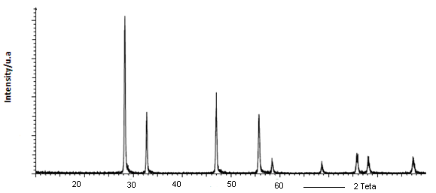

Figure 13. XRD diagram of UO2 powders produced by Ex- ADU route.

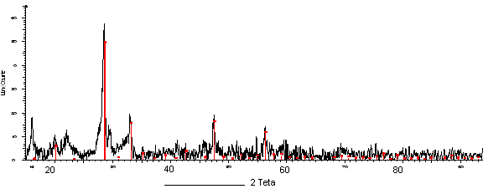

Figure 14. XRD diagram of Gd2O3 powders

X - Ray diffraction diagram of UO2- Gd2O3 powder produced by external gelation is given in Figure 15. X - Ray diffraction diagrams of UO2- Gd2O3 annular type pellets fabricated by PM route i.e. mechanical blending and sintering are given in Figure 16.

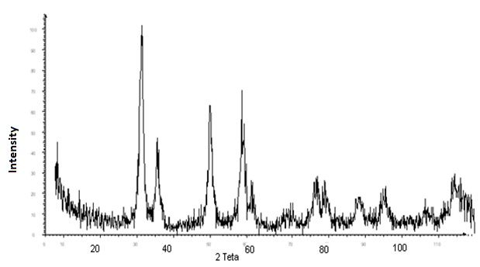

Figure 15. X - Ray diffraction diagram of UO2- Gd2O3 powder produced by external gelation.

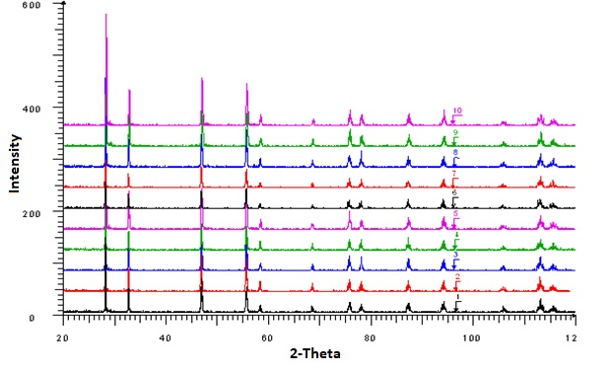

Figure 16. XRD of UO2- Gd2O3 annular type pellets fabricated by PM route.

In another study (Wang, 2015), the sintering behaviour of UO2- Gd2O3 pellets and solid state investigations were examined using dilatometer and x-ray diffractometer, respectively. The X-ray diffraction diagrams of TiO2 doped UO2- Gd2O3 and undoped UO2- Gd2O3 pellets are given in Figure 17.

.



Figure 17. The X-ray diffraction diagrams of TiO2 doped UO2- Gd2O3 and undoped UO2- Gd2O3 pellets (Wang, 2015).

In this study, the sintering behaviour of UO2-Gd2O3 pellets were investigated by dilatometer. The sintering curve of UO2-Gd2O3 pellets produced by external gelation is given in Figure 19

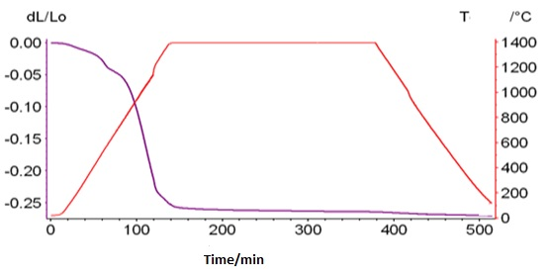

Figure 18.The sintering curve of UO2-Gd2O3 pellets produced by external gelation.

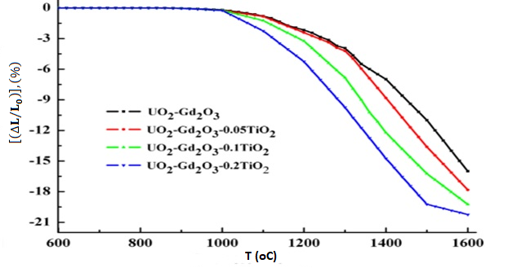

Figure 19. The sintering behaviour of PM route UO2-Gd2O3 pellets(Wang, 2015).

Wang et al. examined the sintering behaviour of UO2 – Gd2O3 pellets with different amount TiO2 additives in their study (Wang et. al., 2015) using the dilatometer. The experimental data achieved in that study is given in Figure 19. As can be seen from the results, the increase in the shrinkage rate started at lower temperatures with the increase in the TiO2 amount. The results achieved for the undoped UO2-Gd2O3 pellet is consistent with our experimental studies.

The USA continues to work on these issues in the form of state-sponsored projects on a national strategy scale (Grossbeck et. al, 2003; NUREG, 2000; Venneri, Michael &Yonghee, 2017). Studies on UO2-Gd2O3 are being carried out regarding the burnable absorbers, not only in nuclear power reactors but also in space studies in the USA (Venneri, Michael &Yonghee, 2017)

In this study, the sintering process was carried out using Linn H Moly high temperature atmosphere controlled static bed furnace, the sintering behaviours were examined using in NETZSCH 402 C Dilatometer, solid state investigations were performed using D8 BRUKER Advance X-Ray Diffractometer, microstructural and EDAX investigations were carried out using JEOL 6390Scanning Electron Microscope (SEM).

In this study the sintering process is carried out at 1973 K for 4 hours under hydrogen argon atmosphere mixture in a static bed controlled atmosphere furnace. The high temperature sintering furnace screen and sintered UO2-Gd2O3 compact pellets produced by sol-gel route and annular UO2-Gd2O3 pellets produced by powder metallurgical route are given in Figure 20.

Ceramographic examinations in sintered pellets were carried out by SEM. SEM images and SEM –EDAX investigations of UO2–Gd2O3 sintered pellets prepared by powder metallurgical method are given in Figure 21 and Figure 22, respectively.

The SEM-EDAX elemental mapping of UO2 – Gd2O3 pellets prepared by powder metallurgical method is given in Figure 23. Microstructural SEM investigation of UO2 – Gd2O3 pellets prepared by external gelation are presented in Figure 24.

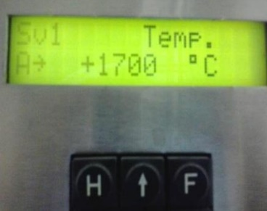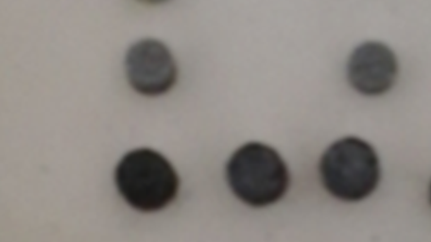

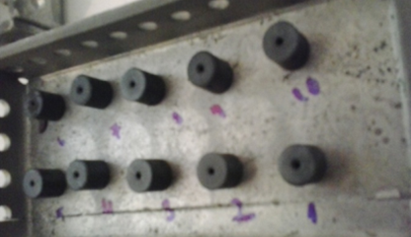

Figure 20. The high temperature sintering furnace screen and sintered UO2-Gd2O3 compact pellets produced by sol-gel route at the (top) and annular UO2-Gd2O3 pellets produced by powder metallurgical route at the (bottom).

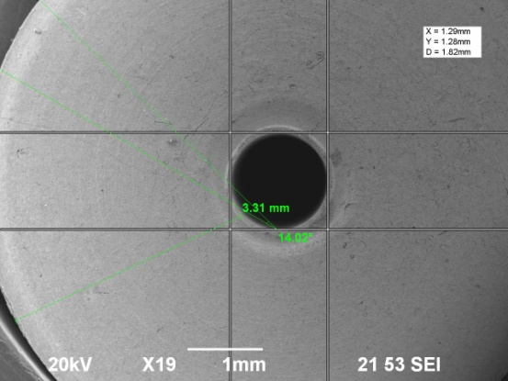 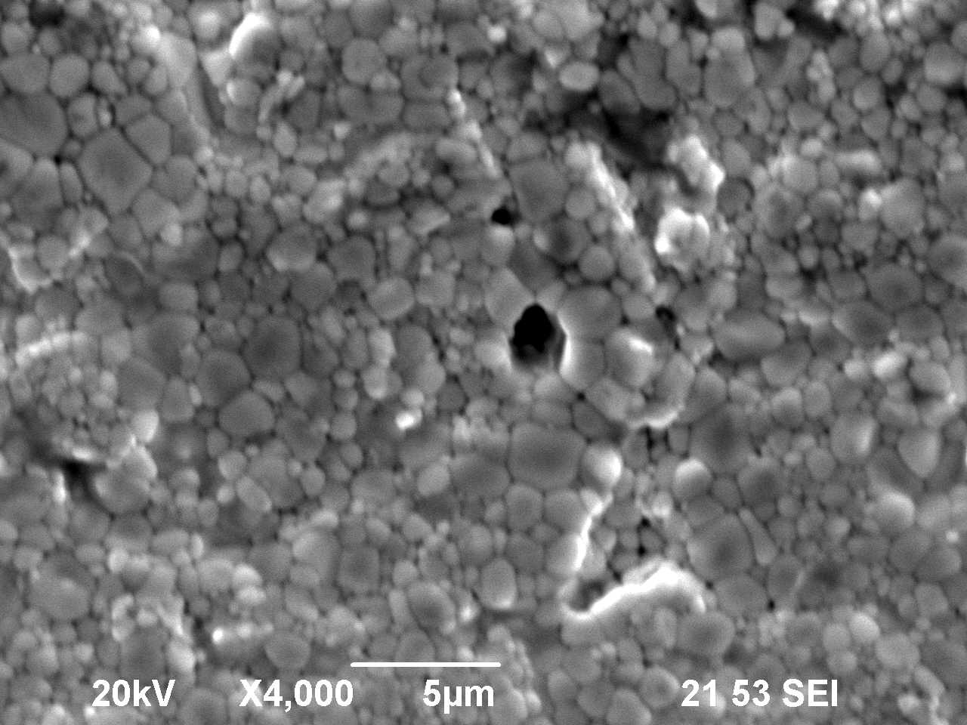

Figure 21**.** SEM micrographs of annular type UO2-Gd2O3 produced via PM route.

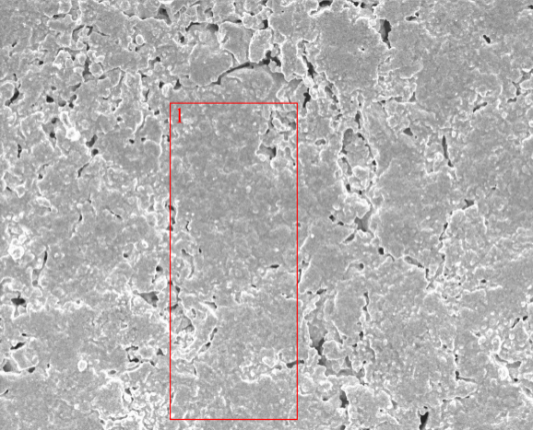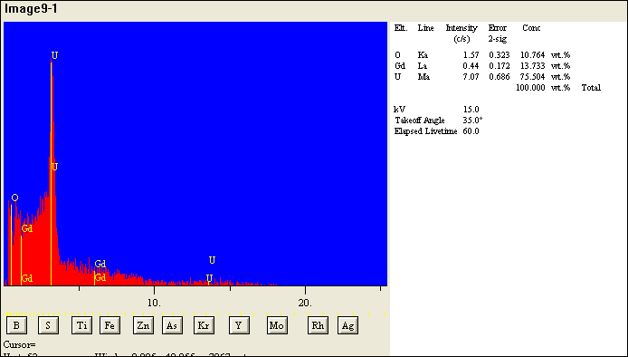

Figure 22**.** SEM-EDAX investigations of UO2-Gd2O3 pellet produced via PM route.

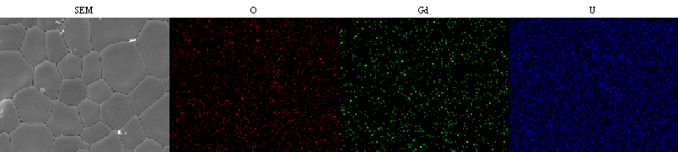

Figure 23. SEM-EDAX elemental mapping investigations of PM route UO2-Gd2O3 pellet produced via PM route.

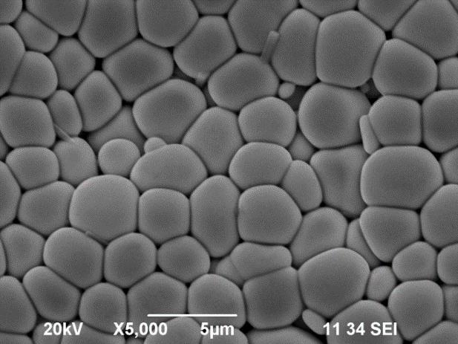 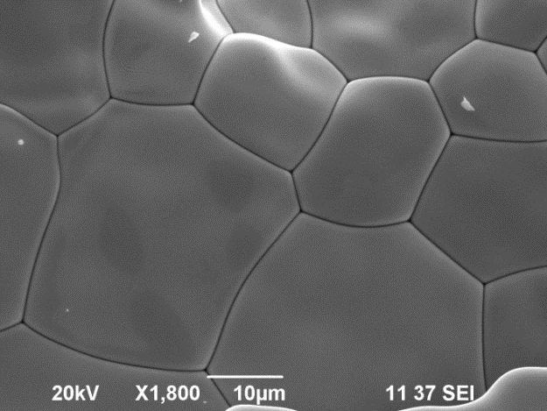

Figure 24. SEM pictures of UO2 – Gd2O3 pellets prepared by external gelation.

The elemental analysis investigations were carried out using SEM-EDAX. The elemental analysis of UO2 – Gd2O3 pellets prepared by external gelation method is given in Figure 25.

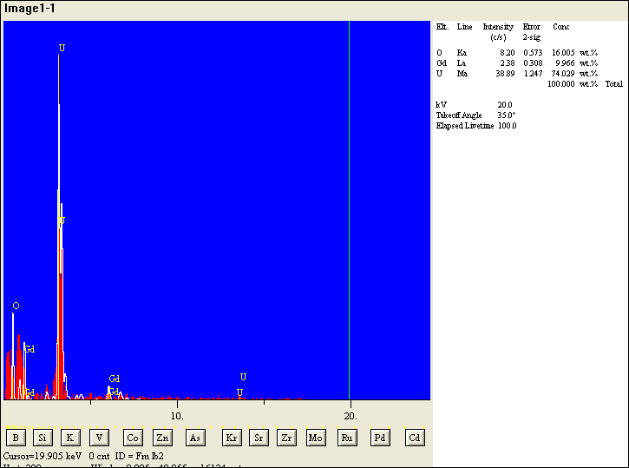

Figure 25. The elemental analysis taken from the surface of UO2 – Gd2O3 pellets prepared by external gelation method.

Differences in the rate of diffusion of uranium and gadolinium atoms cause uranium and gadolinium rich regions in the sintered bodies. Therefore long-time sintering should be avoided (Durazzo, 2008) UO2 / Gd2O3 interface view and element distribution are given in Figure 26.



Figure 26. UO2 / Gd2O3 interface view and element distribution (Durazzo, 2008).

1. **Discussion**

Demands for extended fuel cycles and higher target burnups are strong incentive to use gadolinia (Gd2O3) as burnable poison in modern pressurized water reactors (PWRs). Gadolinia, a burnable absorber, has been employed as UO2-Gd2O3 fuel pellets for compensating reactivity of the light water reactor. In UO2-Gd2O3 pellet characteristics, homogeneity of UO2-Gd2O3 solid solution and grain size are recognized as notable characteristics, there upon it is substantial for commercial fuel fabricators to enhance UO2-Gd2O3 pellets as uniform in solid solution and large in grain size as possible in reasonable fabrication cost. Recently, Gd2O3 concentration tends to become higher with extension of burn up of fuels. Therefore, it is useful to understand the effects of manufacturing parameters on solid solution formation and grain growth. The USA and some other countries continue to work on these issues in the form of state-sponsored projects on a national strategy scale (Grossbeck, Renier & Bigelow, 2003; NUREG CR-6760 ORNL 2003; Wang et. al, 2015; Venneri, Michael &Yonghee, 2017; Jeongmook, 2017). Studies on UO2-Gd2O3 are being carried out regarding the burnable absorbers, not only in nuclear power reactors but also in space studies in the USA (Venneri, Michael &Yonghee, 2017). The most used burnable absorber nuclear fuels are UO2-Gd2O3 pellets in power reactors. The conventional production methods of UO2-Gd2O3 burnable absorber nuclear fuel pellets are either powder metallurgical route or sol-gel route. PM and sol-gel routes have some different product characteristics like grain size and pore size distributions. In this study, the investigation of the microstructure and U-Gd distribution in sintered bodies along with the achieved SEM-EDAX results showed that both methods provide homogeneous structures. The solid state investigations of sintered UO2-Gd2O3 pellets produced by both methods showed that, gadolinium dissolved in UO2 matrix. UO2-Gd2O3 is an actinide oxide/ lanthanide oxide binary system and is known for forming highly non-stoichiometric oxide systems as given in Figure 17. The solid state investigations, microstructural investigations and SEM-EDAX investigations showed that the we obtained by powder metallurgical and by sol-gel route very good homogeneity in the sintered UO2-Gd2O3 pellets. This result is in good agreement with the result reported by Wang et al. (Wang et. al, 2015) as shown in Figure 17. It is important that the homogeneous gadolinium distribution in the sintered bodies like plutonium distribution in mixed oxide (MOX) nuclear fuels.

1. **Results**

The results of this study can be summarized as follows:

Producibility of the UO2-Gd2O3 nuclear fuel in Turkey has provided significant technological gains. It also made important contributions in training qualified people. The external gelation devices were successfully installed and used in this study. The results are quite compatible with the data reported in literature. In the next stages, trials will be made with internal gelation experiments with and without dopant additions. The products with the desired qualities have been obtained by both methods. Density and homogeneity values of the products comply with international standards. As given in Figure 16, this result is compatible with the result reported by Wang et al. (2015) as shown in Figure 17. As seen in Figure 24, two different grain sizes are formed. In the literature, the reason of different grain size is either attributed to the different diffusion rates of uranium and gadolinium or the barrier created by gadolinium. We also think that the different diffusion rates and any barrier may lead to the regions with different grain sizes in UO2-Gd2O3 system. As stated in the literature studies (Jeongmook, 2017; Wang et. al., 2015; Durazzo et. al., 2008; Zinkle & Was, 2013; Song et.al, 2001; Nishida & Yuda, 1998; Agueda et. al, 1994; Loose et. al., 1987), many different phases may occur in the UO2-Gd2O3 system and each should be studied separately. In this study, PM and sol-gel methods have provided homogeneous U-Gd distributions in sintered UO2-Gd2O3 burnable absorber fuels. Production of the burnable absorber compact and annular type nuclear fuel pellets by powder metallurgical and sol-gel routes showed that; we obtained nuclear fuels in accordance with international standards. Solid state investigations should be examined in detail depending on the amount of gadolinium (Gd) temperature and sintering atmospheres.

1. **Acknowledgements**

The results presented here have all been obtained within the framework of Turkish Atomic Energy Authority–Technology Improvement Department, Burnable Absorber Nuclear Fuel Technology Improvement in Nuclear Fuel Technology Unit activities.

1. **References**
2. IAEA-TECDOC-844, Characteristics and use of urania-gadolinia fuels, 1995.
3. Yaylı, A., (1995). UO2-Gd2O3 Nükleer yakıt peletlerinde gadolinyum miktarıyla mikroyapı ve yoğunluk değişiminin düşük sıcaklık sinterlemesinde incelenmesi, Yüksek Lisans Tezi (MSc),YTÜ FBE-Yıldız-İstanbul.
4. Böhm W. Kiehlmann H. D., Neufert A.& Peehs M., (1987). Kerntechnik. 50, 234-240.
5. Stogen F. B., Nielsen L. A. & Grummer R. G., (1982). Transactions of the American Nuclear Society.40, 194-198.
6. Brandberg S. G., (1973). Nuclear Technology. 18, 177-184.
7. Zinkle S.J. & Was G.S., (2013). Materials challenges in nuclear energy, Acta Materialia. 61, 3, 735-758.
8. D.Tobia, E.L. Winkler, J. Milano, A.Butera, R.Kempf, L. Bianchi & F. Kaufmann, (2014) Determination of Gd Concentration Profile in UO2-Gd2O3 Fuel Pellets, CNEA and CONICET, (8400) S.C. de Bariloche, Argentina.
9. Durazzo, M., Saliba-Silva, A.M., Urano de Carvalho, E.F. & Riella, H.G. (2013). Sintering behavior of UO2–Gd2O3 fuel: Pore formation mechanism. Journal of Nuclear Materials. 433, 334.
10. Durazzo, M. & Riela, H.G., (2008 September). Studies on the Sintering Behaviour of UO2-Gd2O3 Nuclear Fuel Interlaken, Switzerland, Paper No. 114 IYNC 2008.
11. Song, K.W., Kim K.S., Yang J.H., Kang K.W. & Jung Y.H., (2001). A Mechanism for the Sintered Density Decrease of UO2-Gd2O3 Pellets under an Oxidizing Atmosphere. Journal of Nuclear Materials. 288, 92.
12. Leyva, A.G., Vega, D., Trimarco, V. & Marchi, D., (2002). Homogeneity characterisation of sintered (U,Gd)O2 pellets by X-ray diffraction, Journal of Nuclear Materials. 303, 29-33.
13. Renier J.-P. A. & Grossbeck, M. Development of Improved Burnable Poisons For Commercial Nuclear Power Reactors, ORNL/TM-2001/238.
14. Hoai-Nam Tran, Hung, T.P. Hoang & Peng Hong Liem. (2017). Using Gd2O3 Particles in WWER1000 Fuel Assembly for Controlling Excess Reactivity Energy Procedia 131, 29-36.
15. Grossbeck, M. L., Renier J.P.A. & Bigelow, T. (2003). Development of Improved Burnable Poisons for Commercial Nuclear Power Reactors, Prepared by the University of Tennessee for the Oak Ridge National Laboratory.
16. Study of the Effect of Integral Burnable Absorbers for PWR Burnup Credit NUREG/CR- 6760 ORNL/TM--321 Oak Ridge National Laboratory, 2000.
17. Wang, Y, Fan C., Wang H, Wang F., Xu J., Duan P. & Zhang Y., (2015). Effects of TiO2 on the sintering densification of UO2-Gd2O3 burnable poison fuel, Ceramics International. 41, 10185–10191.
18. Venneri P. F., Michael E. & Yonghee K., (2017). Passive Reactivity Control of Nuclear Thermal Propulsion Reactors. Journal Nuclear Technology.197.
19. Nishida T. & Yuda R., (1998 November). Effect of Particle Size and Oxygen Potential on UO2/Gd2O3 Pellet Sintering”, Proceedings of a Technical Committee Meeting, Vienna, Austria. pp. 73-84. IAEA-TECDOC--1036.
20. Agueda H. C., Heredia A. D., Amaya D. C., Sterba M. E. & Russo D., (1994, September). “Efectos del Oxido del Gadolinio en la Sinterizacion de Dioxido de Uranio”, Proceedings of the 5 General Congress on Nuclear Energy, Rio de Janeiro,2, 567-571, Brazil
21. Song K. Woo, Kim K.S., Yang, J.H., Kang Y.H. & Jung K.W., (2001). A mechanism for the sintered of UO2 –Gd2O3 pellets under an oxidizing atmosphere, Journal of Nuclear Materials. 288 92-99.
22. Loose A., Ilic R., Marinkovic V. & Trkov A., (1987, September) “Diffusion Measurements in UO2-Gd2O3”, Proceedings of The International Symposium on Improvements in Water Reactor Fuel, V. Technology and Utilization, Vienna, Austria. pp. 578-584. IAEA-SM-288/36P.
23. Jeongmook L., Jandee K., Young-Sun Y. & Nazhen L., (2017). Raman Sudy on Structure of U1-y GdyO2. Journal of Nuclear Materials, 486,216-221.