INVESTIGATION OF THE EFFECT USING DIFFERENT COOLANT ON THE PERFORMANCE OF A TOKAMAK FUSION REACTOR BLANKET
¹Hacı Mehmet Şahin, ²Alper Karakoç
¹University of Karabük, Department of Energy Systems Engineering, Karabük, Türkiye
mehmetsahin@karabuk.edu.tr
²University of Karabük, Graduate Education Institute, Department of Energy Systems Engineering, Karabük, Türkiye
alper_krkc@hotmail.com

BİR TOKAMAK FÜZYON REAKTÖR BATTANİYESİ PERFORMANSINA FARKLI SOĞUTUCU KULLANMANIN ETKİSİNİN İNCELENMESİ

Abstract:
In this study, magnetic fusion reactor modeling with three-dimensional TOROID structure geometry has been completed for the first wall load 5 MW/m² (2.22 x 10¹⁴ n/s) and 500 MW fusion power. In the modeled fusion reactor, D-T fuel was used in the plasma region. Within the scope of five different models, 1DS-ODS steel in the first wall region and Flibe (LiF-BeF), Flina (LiF-NaF), Flinak (LiF-NaF-KF) Flinabe (LiF-NaF-BeF) and Li materials were used in the cooling zone of the reactor. In the first stage of this study, tritium breeding ratio (TBR), energy multiplication factor (M) and heat flux of the reactor were calculated for five different cooling materials. In the second stage of the study heat flux gas production and displacement per atoms (DPA) values in the first wall region and nuclear heat generation in the magnet layer were calculated by using Monte Carlo methods with Monte Carlo neutron‐photon transport code (MCNP5) and nuclear data libraries named as ENDF/B‐VI and CLAW‐IV. According to investigated models, it was observed that the density of lithium isotopes in the coolant material and produced in the reactor TBR and M were directly proportional. In all models with high neutron density, the minimum TBR (≥1.05) required for the operation of the reactors was obtained. In this context, the models which contains lithium and Flibe as coolants, they showed the best neutronic performance according to all considerations.
Özet:
Bu çalışmada, ilk duvar yükü 5 MW/m² (2.22 x 10¹⁴ n/s) ve 500 MW füzyon gücü için üç-boyutlu TOROID yapıya sahip geometrili bir manyetik füzyon reaktör modellemesi yapılmıştır. Modellenen füzyon reaktöründe, plazma bölgesinde D-T yakıtı kullanılmıştır. Beş farklı model kapsamında, ilk duvar bölgesinde 1DS-ODS çeliği ve reaktörün soğutucu bölgesinde Flibe (LiF-BeF), Flina (LiF-NaF), Flinak (LiF-NaF-KF) Flinabe (LiF-NaF-BeF) ve Li malzemeleri kullanılmıştır. Bu çalışmanın ilk aşamasında, beş farklı soğutma malzemesi için trityum üretim oranı (TBR), enerji çoğaltım faktörü (M) ve ısı akısı hesaplanmıştır. Çalışmanın ikinci aşamasında, ilk duvardaki ısı akısı ve gaz üretimi ile atom başına kayma (DPA) değerleri ve mıknatıs tabakasındaki nükleer ısı üretimi Monte Carlo nötron ‐ foton transport bilgisayar kodu (MCNP5) yardımıyla ENDF/B‐VI ve CLAW‐IV olarak adlandırılan nükleer bilgi kütüphaneleri kullanılarak hesaplanmıştır. İncelenen modellere göre, TBR ve M değerlerinin reaktöründe üretilen soğutucu malzeme içindeki lityum izotoplarının yoğunluğu ile doğrudan orantılı olduğu gözlenmiştir. Yüksek nötron yoğunluğuna sahip tüm modellerde, füzyon reaktörlerin çalışması için gereken minimum TBR (≥1.05) değeri elde edilmiştir. Bu değerlendirmeler sonucunda, soğutucu olarak lityum ve Flibe içeren modeller en iyi nötronik performansı göstermiştir.

Keywords: Magnetic Fusion Reactor, TBR, Energy Multiplication Factor, Gas Production, DPA
Anahtar Kelimeler: Manyetik Füzyon Reaktörü, TBR, Enerji Çoğaltım Faktörü, Gaz Üretimi, DPA
- Introduction
Nuclear fusion is the process by which atomic nuclei are transformed into heavier nuclei. Although American scientist Langmuir first discovered plasma in 1929, fusion was not considered a potential energy source until the early 1950s. In the progress from the 1950s to the present, research on fusion has increased and applications of magnetic confinement fusion have taken an important place in the field of fusion. During the seventy-year period, TOKAMAK, Stellarator and magnetic mirrors concepts were developed and deuterium-tritium (D-T) fuel cycles were used in most experiments and studies. Considering the developments in the last 70 years, future trends in magnetic fusion energy can be understood. El-Guebaly (2010) predicted that future magnetic confinement fusion research will focus on TOKAMAK devices. ITER (International Thermonuclear Experimental Reactor) and DEMO projects are the most important TOKAMAK devices that work with magnetic confinement fusion concept. A number of criteria must be met for successful fusion reactor design. The first of these criteria is the demonstration of self-sufficient tritium production to plant availability. There is no general consensus on what design Tritium Breeding Ratio (TBR) should be. There are many studies mentioned that design TBR ranging from 1.1 to 1.3 with net TBR of 1.05 ("UW NCOE: ARIES Project," 2014). In the study conducted by Zandi et. al. (2015), blanket simulation and TBR were calculated for the ITER reactor. In the reactor where He was used as a coolant, the rate of tritium production was sufficient for the reactor to be self-sustaining. In the study of Ishibashi et al. (Ishibashi, Fujimoto & Matsumoto, 2014) based on the ITER module, tritium production rates were calculated according to the changing coolants. Catalán et. al. (2011) carried out a comprehensive examination the tritium production performance of dual He/LiPb coolants for DEMO fusion reactor. According to the results obtained, the performance of the coolants is sufficient for sustainable tritium production. The study found that He and Li refrigerants have higher tritium production rates to other coolants. Although He gas performs well as a coolant, but the reactor needs to be operated at high pressure and temperature due to its low thermal capacity. In order for the heat produced in the reactor to be transferred smoothly, additional cautions must be taken for reactor safety. For this reason, coolants consisting of molten salts are used as coolant material in magnetic fusion reactors. In their study, Şahin, Tunç & Şahin (2016) used Flibe, Flinak, Li and LiPb coolants along with Li₂C₂ tritium production material. As a result of their study, all the coolants have sufficient performance for tritium production whereas Flibe and Flinak showed lower performance in tritium production compared to other coolants. In the study conducted by Übeyli (Übeyli, 2003), the tritium production performances of Flibe, Flinabe and LiSn coolants in fusion-fission hybrid reactor were investigated. As a result of the work done, Flibe has the best tritium production performance. There are many studies in the literature where molten salts are used as coolant material. The common result to be obtained from these studies is that the molten salt coolants with high lithium isotope density and neutron breeder isotopes provide sufficient tritium production rate for sustainable reactor operation. The second criterion for a successful fusion reactor design is to have a layer that will protect the blanket structure of the reactor from the damage of the high-energy neutrons released as a result of the fusion reaction in plasma chamber. This layer is called the first wall in the design of fusion reactors, and in addition to reducing neutron damage, the property of the reactor's blanket structure is maintained for a long time. Selection of a candidate material for the first wall of the blanket is an important issue. Solid and liquid wall concepts, whose chemical and mechanical advantages differ, appear in the literature as the main concepts of first wall. According to Kwakowski et. al. (1994), SiC was used as the first wall material in the TOKAMAK structure. In this study, it was determined that the solid wall concept is a simpler design than the liquid wall concept. Cadwallader (2001), examined solid and liquid wall concepts in fusion reactor designs. He stated that the advantages of the solid wall concept are much greater than the disadvantages, due to the high number of coolants available in the solid wall concept and the good results obtained in the Tore Supra project. Reduced-activation ferritic/martensitic (RAFM) steels and oxide dispersion strengthened (ODS) steels considered as main candidate first wall materials for fusion reactors (Dobran, 2012). They are resistant to heat and radiation damage. Vicente, Dudarev & Rieth (2014), have reviewed development of structural and protection materials for fusion reactors. Their work structured as, integrated radiation effects modelling and experimental validation for high heat flux materials and nano-structured oxide dispersion strengthened ferritic steel (ODSFS) development. According to the study, it is revealed that ODS steels are an important candidate as the first wall material. Tunç, Şahin, & Şahin (2017) have examined radiation damage parameters of ODS steel alloys were evaluated on the first wall of deuterium-tritium hybrid reactors. Considering all the numerical calculations made in this study, it was seen that the second generation oxide dispersion reinforced (1DS-ODS) steel is the most suitable first wall material compared to the other studied ODS steels. Sahin, Sahin, & Sözen (1998) undertook a detailed neutronic analysis of VISTA spacecraft. In this work, a magnet and shielding design was made for the VISTA spacecraft, which was conducive to use up to 17500 MW of fusion power. In the study conducted by Bohm et al (2012), the heat loads of the magnets in the ITER reactor were calculated by using MCNP 5. El-Guebaly (1991), investigated that the dimension of ITER magnetic coil. According to the concept design of ITER, the magnet thickness was determined as 26 cm. Şahin & Şahin (1999), carried out the nuclear heat generation of the magnets designed for the VISTA spacecraft and in their design, it is seen that the nuclear heat generation limit of this magnet calculated as 80 $\text{μW}\text{/}{\text{cm}}^{\text{3}}$. The magnets designed for ITER were compared and it was calculated that the nuclear heat generation values of the magnet designed for VISTA were much lower than the magnets used in ITER.
There are many studies in the literature about the neutronic performance of fusion reactors. However, most of these studies are based on existing systems without any modifications about their design conditions. In this study, modelling of magnetic fusion reactor was completed based on ITER’s blanket parameters. The effects of changing coolants on the reactor, neutronic performance of fusion blanket for tritium breeding ratio (TBR), heat flux, gas production (¹H, ⁴He production) and displacement per atom (DPA) in the first wall will be investigated. In the modeled reactor, 1DS-ODS steel will be used as the first wall material. Different coolants (Flibe, Flina, Flinak, Flinabe and Li) will be used to evaluate for coolant zones performance.
2. Description of geometry and calculation tools
The geometry used in this study was created based on the components and material contents of magnetic fusion reactors in the literature. In the reactor used in the study, the plasma chamber was simulated with the D-shape neutron source and the plasma chamber of the reactor was surrounded by the blanket structure. The fusion chamber is surrounded by the first wall, coolant zone, reflector, tritium breeding zone insulation, space and magnet layers, respectively. The geometry of magnetic fusion reactor investigated in this study is shown Figure 1.

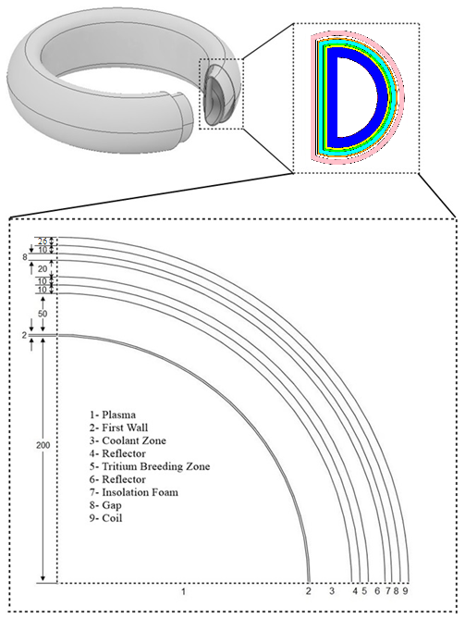
Figure 1. Blanket structure of investigated magnetic fusion reactor

Table 1. lists the atomic densities of the blanket materials used in this study.
Table 1. Atomic densities of the blanket materials
Blanket  Zone | Material | Nuclide | Specific Weight (gr/cm³) | Nuclei Density (atom/b.cm)
2 | 1DS-ODS | C-12 | 7.32 | 3.629E-04
 |  | C-13 |  | 4.074E-06
 |  | O |  | 2.755E-04
 |  | Ti |  | 3.684E-04
 |  | Cr-50 |  | 4.218E-04
 |  | Cr-52 |  | 7.822E-03
 |  | Cr-53 |  | 8.702E-04
 |  | Cr-54 |  | 2.126E-04
 |  | Fe-54 |  | 4.067E-03
 |  | Fe-56 |  | 6.157E-02
 |  | Fe-57 |  | 1.397E-03
 |  | Fe-58 |  | 1.827E-04
 |  | Y |  | 1.983E-04
 |  | W |  | 6.474E-04
3 | Flibe (coolant) | Li-6 | 2.031 | 2.193E-03
 |  | Li-7 |  | 2.276E-02
 |  | Be |  | 1.227E-02
 |  | F |  | 4.946E-02
3 | Flina (coolant) | Li-6 | 2.145 | 2.108E-03
 |  | Li-7 |  | 2.188E-02
 |  | F |  | 3.992E-02
 |  | Na |  | 1.597E-02
3 | Flinak (coolant) | Li-6 | 2.097 | 1.256E-03
 |  | Li-7 |  | 1.304E-02
 |  | F |  | 3.058E-02
 |  | Na |  | 3.516E-03
 |  | K |  | 1.283E-02
3 | Flinabe (coolant) | Li-6 | 2.088 | 7.711E-04
 |  | Li-7 |  | 9.335E-03
 |  | Be |  | 1.011E-02
 |  | F |  | 4.271E-02
 |  | Na |  | 1.011E-02
3 | Natural lithium (coolant) | Li-6 | 0.485 | 3.702E-03
 |  | Li-7 |  | 3.843E-02
4 | Graphite (reflector) | C-12 | 2.26 | 1.122E-01
 |  | C-13 |  | 1.162E-03
5 | Natural lithium (coolant) | Li-6 | 0.485 | 3.702E-03
 |  | Li-7 |  | 3.843E-02
6 | Graphite (reflector) | C-12 | 2.26 | 1.122E-01
 |  | C-13 |  | 1.162E-03
7 | Insolation foam | O | 0.2 | 1.098E-01
 |  | Si-28 |  | 3.172E-01
 |  | Si-29 |  | 1.606E-02
 |  | Si-30 |  | 1.066E-02
8 | Gap
9 | Coil | H-1 | 4.3 | 9.558E-03
 |  | H-2 |  | 1.434E-06
 |  | C-12 |  | 5.107E-03
 |  | C-13 |  | 5.732E-05

The neutronic analysis performed via Monte Carlo method using Monte Carlo N-Particle Transport Code (MCNP5) and the cross-section library CLAW-IV basen on ENDF/B‐VI nuclear library (X-5 Monte Carlo Team, 2005; Al Kusayer, Şahin & Drira, 1988; Rose, 1991).
Fusion Neutron Source
In the course of three-dimensional calculations, a D-shaped neutron source distribution used in the plasma chamber. It assumed that to be an isotropic and does not strike the first wall of the blanket structure. This gives a more realistic and accurate source definition than a point and spherical source would do. In this study, D-T-fueled plasma with a fusion power of 500 MW was used as a neutron source. The first wall load is 5 MW/m² verifies that the neutron flux of 2.22 x 10¹⁴ (14.1 MeV) n/cm²s. The thermal and electrical power obtained from the reactor varies according to the characteristics of the coolant materials used in the blanket structure.
3. Numerical results
3.1. Tritium breeding ratio
The ratio of the amount of tritium produced in the blanket structure of the fusion reactor to the consumption of tritium in plasma is defined as the tritium breeding ratio (TBR). The tritium isotope, which is the basis of the DT fusion reaction, is not present in nature and must be produced in the reactor blanket structure for the continuity of the fusion reaction. Tritium breeding reactions are listed below;
$${}_{3}^{6}{Li}+n \left(thermal\right)→ {}_{2}^{4}{He}+{}_{1}^{3}T+4.8 MeV \text{(1)}$$
$${}_{3}^{7}{Li}+n \left(fast\right)→ {}_{2}^{4}{He}+{}_{1}^{3}T+n-2.5 MeV \text{(2)}$$
Considering the decay time of tritium and other losses, TBR should be ≥1.05 for adequate tritium production and sustainable fusion reactions (Sawan & Abdou, 2006). Based on calculations, TBR values for five different coolants are shown in Figure 2.
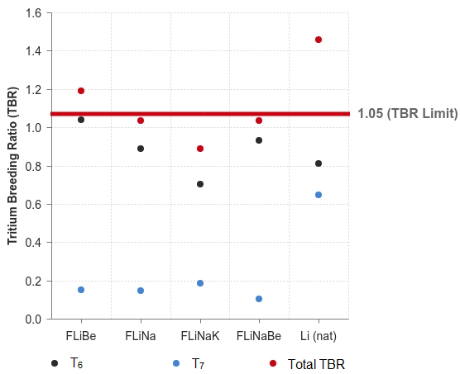
Figure 2. TBR of various coolants
According to the TBR values shown in Figure 2, Flibe and Li are used as coolant in the reactors to be able to exceed the TBR value limit required for self-operation of the reactor. The most important factor affecting the TBR value is the density of lithium isotopes in the coolant material. In this way, the amount of TBR in the reactors used in Flibe and Li performed better than other coolants.
3.2. Energy multiplication factor
The energy multiplication factor (M) is expressed as the ratio of total energy stored in the system to neutron kinetic energy. Power loss occurs in the reactor due to neutron, alpha and gamma radiation released as a result of fusion reactions in the reactor. In order to compensate for the power loss in question and to produce higher thermal power, the energy produced in the reactor must be higher than the energy of the plasma. For this, the energy reproduction factor must be high and at least 1.2 (Jolodosky & Fratoni, 2015). The two most important factors in the production and consumption of heat energy in the calculation of the energy reproduction factor are the exothermic ⁶Li(n, α)T and endothermic ⁷Li(n, αn)T reaction energies;
$$M=1+ \frac{4.784*T_{6}-2.467*T_{7}}{14.1} \text{(3)}$$
Where, $T_{6}$ ve $T_{7}$ tritium contrubition from ⁶Li and ⁷Li respectively. The energy multiplication factor results of all models in the study are shown in Fig. 3.
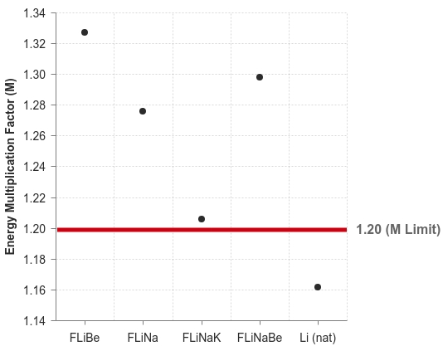
Figure 3. Energy multiplication factor of all models with various coolants

3.3. Heat flux
In the fusion reaction, neutrons released from plasma cause nuclear reactions at the first wall, coolant, tritium production site and coil of the reactor. As a result of these reactions, nuclear heat generation occurs in the reactor layers. The heat flux and nuclear heating in the first wall and coil layer results are shown in Figure 4 and 5.
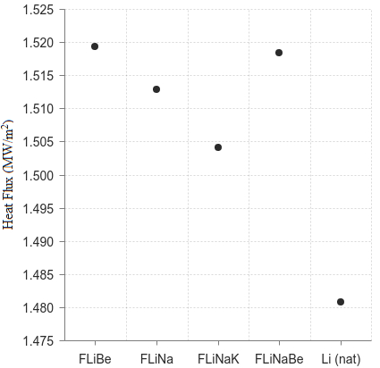
Figure 4. Heat flux of the first wall with various coolants
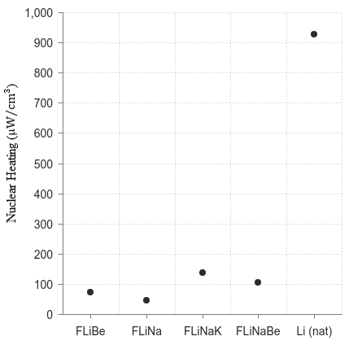
Figure 5. Nuclear heating of the coil with various coolants

3.4. Gas production
High-energy neutrons released in fusion reactions react at the first wall of the reactor, causing radiation damage and helium, hydrogen gas production occurs in the first wall material. As hydrogen gas moves out of the material's structure at high operating temperatures, helium gas stays inside the material, causing the first wall material to lose its properties and material life to decrease significantly over time. Therefore, the production of helium gas on the first wall should be examined and to calculate the period of replacement of the first wall material, the upper production value of helium gas was determined to be 500 appm and the calculations were made according to full power year (FPY) (Cadwallader, 2001). H and ⁴He production according to varying coolant materials are shown in Figure 6 and 7.
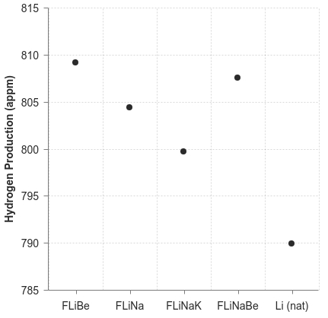
Figure 6. Hydrogen production of the first wall with various coolants
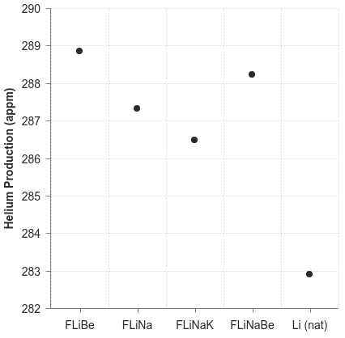
Figure 7. Helium production of the first wall with various coolants
3.5. Displacement Per Atom (DPA)
In the first wall material, DPA is defined as the displacement of atoms in the structure of the material with the effect of high energy neutrons and helium isotopes released from plasma. This parameter, which is used to measure the radiation damage in the first wall material of the reactor, should be as low as possible in order to avoid undesirable situations such as deterioration and loss of function of the first wall material. Within the scope of the study, the DPA upper limit value was determined as 100 appm (Tunç, Şahin, & Şahin, 2017). Radiation damage parameters of the first wall with various coolants are shown in Figure 8.
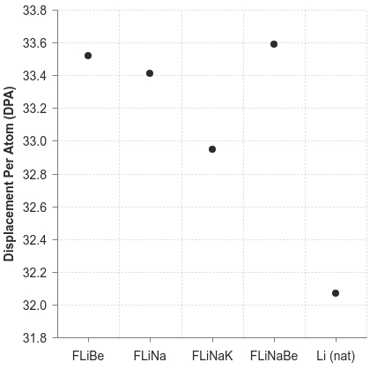
Figure 8. Radiation damage parameters of the first wall with various coolants
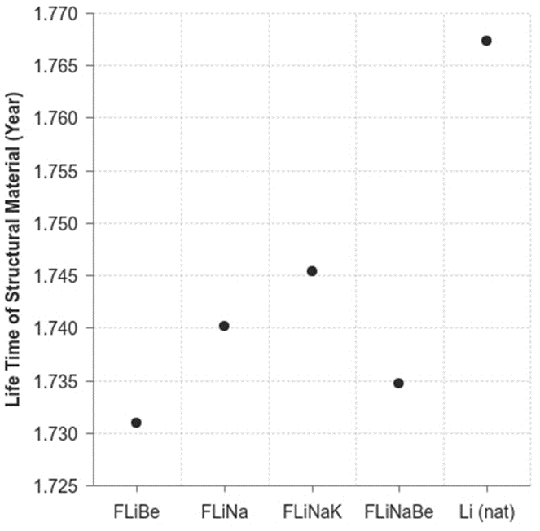
Figure 9. Life time of structural material with various coolants
4. Conclusion
This paper has investigated to use of molten salt coolants (Flibe, Flina, Flinak and Flinabe) and natural lithium as a coolant in D shaped magnetic fusion reactor. With the help of MCNP5 code with ENDF/B‐VI and CLAW‐IV cross section libraries, the neutronic performance of coolants and 1DS-ODS steel as first wall material have investigated by calculations of TBR, M, heat flux and gas production. Consequently, following results can be summarized as below:
- The neutronic performance of the materials used as coolant is directly proportional to the density of the lithium isotopes they contain. Accordingly, Flibe and natural lithium show the highest tritium breeding performance.
- The energy multiplication factor value appears to be inversely proportional to the Li-7 isotopes found in the coolants. According to this, the energy multiplication factor is the highest model Flibe, the lowest model is the model in which natural lithium is used as a coolant.
- According to the results of heat flux in the first wall, DPA and gas production calculation in the first wall of the reactor, the results obtained in all models are closely related. Accordingly, the changing coolants made no significant difference to the neutron damage that occurred on the first wall relative to each other. However, considering the nuclear heat generation values in the magnet layer, it is seen that other models except Flibe and Flina exceed the limit value (80 $\text{μW}\text{/}{\text{cm}}^{\text{3}}$) as a results of the fast neutron. This is the same for ⁷Li(n, αn)T reactions on coolant and tritium breeding zone. Accordingly, in models where the limit value is exceeded, it is necessary to add shield to the reactor design and make shielding calculations.
It is thought that the results obtained by the materials combinations and evaluation methods evaluated in the study will contribute to future studies on magnetic fusion reactors, and the following propositions may be considered for further studies:
- The neutronic performance of different first wall materials can be compared by evaluating the liquid wall concept instead of the solid wall concept.
- The ratios of lithium isotopes of coolant materials in the coolant zone can be increased.
- TBR and M values can be calculated by using Li-6 enriched coolant and tritium production material as coolant and comparison with the current study.
5. References
- Al Kusayer T.A., Şahin S. & Drira A. (1988). “CLAW-IV, Coupled 30 Neutrons, 12 Gamma- Ray Group Cross Section With Retrieval Programs for Radiation Transport Calculations”, available from the Radiation Shielding Information Center, Oak Ridge National Lab., RSIC-Newsletter.
- Bohm, T. D., Sawan, M. E., Jackson, S. T., & Wilson, P. P. (2012). Detailed nuclear analysis of ITER ELM coils. Fusion Engineering and Design. 87, 5-6, 657-661. doi:10.1016/j.fusengdes.2012.01.031
- Cadwallader, L. C. (2001). Qualitative Reliability Issues for In-Vessel Solid and Liquid Wall Fusion Designs. Fusion Technology. 39(2P2), 991-995. doi:10.13182/fst01-a11963371
- Catalán, J., Ogando, F., Sanz, J., Palermo, I., Veredas, G., Gómez-Ros, J., & Sedano, L. (2011). Neutronic analysis of a dual He/LiPb coolant breeding blanket for DEMO. Fusion Engineering and Design. 86, 9-11, 2293-2296. doi:10.1016/j.fusengdes.2011. 03.030
- Dobran, F. (2012). Fusion energy conversion in magnetically confined plasma reactors. Progress in Nuclear Energy. 60, 89-116. doi:10.1016/j.pnucene.2012.05.008
- El-Guebaly, L. A. (2010). Fifty Years of Magnetic Fusion Research (1958–2008): Brief Historical Overview and Discussion of Future Trends. Energies. 3, 6, 1067-1086. doi:10.3390/en30601067
- El-Guebaly, L. A. (1991). Overview of the US-ITER magnet shield: Concept and problems. Fusion Technology. 19(3P2B), 1475-1480. doi:10.13182/fst91-a29549
- Ishibashi, K., Fujimoto, S., & Matsumoto, T. (2014). An optimization study of structure materials, coolant and tritium breeding materials for nuclear fusion-fission hybrid reactor. Progress in Nuclear Science and Technology. 4, 130-133. doi:10.15669/ pnst.4.130
- Jolodosky, A., & Fratoni, M. (2015). Neutronics Evaluation of Lithium-Based Ternary Alloys in IFE Blankets. doi:10.2172/1223840
- Krakowski, R. A., Bathke, C. G., Miller, R. L., & Werley, K. A. (1994). Lessons Learned from the Tokamak Advanced Reactor Innovation and Evaluation Study (ARIES). Fusion Technology. 26(3P2), 1111-1118. doi:10.13182/fst94-a40302
- Rose PF (compiler and editor). ENDF‐201, ENDF/B‐VI summary documentation, BNL‐NCS‐17541. Brookhaven National Laboratory 1991.
- Sawan, M., & Abdou, M. (2006). Physics and technology conditions for attaining tritium self-sufficiency for the DT fuel cycle. Fusion Engineering and Design. 81, 8-14, 1131-1144. doi:10.1016/j.fusengdes.2005.07.035
- Şahin, H. M., Tunç, G., & Şahin, N. (2016). Investigation of tritium breeding ratio using different coolant material in a fusion–fission hybrid reactor. International Journal of Hydrogen Energy. 41, 17, 7069-7075. doi:10.1016/j.ijhydene.2015.11.174
- Şahin, S., & Şahin, H. M. (1999). Radiation shielding mass saving for the magnet coils of the VISTA spacecraft. Annals of Nuclear Energy. 26, 6, 509-521. doi:10.1016/s0306-4549(98)00066-8
- Şahin, S., Şahin, H. M., & Sözen, A. (1998). Evaluation of the Neutron and Gamma-Ray Heating in the Radiation Shielding and Magnet Coils of the VISTA Spacecraft. Fusion Technology. 33, 4, 418-434. doi:10.13182/fst98-a41
- Tunç, G., Şahin, H. M., & Şahin, S. (2017). Evaluation of the radiation damage parameters of ODS steel alloys in the first wall of deuterium-tritium fusion-fission (hybrid) reactors. International Journal of Energy Research. 42, 1), 198-206. doi:10.1002/er.3782
- UW NCOE :: ARIES Project. (2014, May 20). Retrieved from https://fti.neep.wisc.ed u/ncoe/aries
- Übeyli, M. (2003). On the Tritium Breeding Capability of Flibe, Flinabe, and Li20Sn80 in a Fusion-Fission (Hybrid) Reactor. Journal of Fusion Energy. 22, 1, 51-57. doi:10.1023/b:jofe.0000021555.70423.f1
- Vicente, S. M., Dudarev, S., & Rieth, M. (2014). Overview of the Structural Materials Program for Fusion Reactors under EFDA. Fusion Science and Technology. 66, 1, 38-45. doi:10.13182/fst13-764
- X‐5 Monte CarloTeam. MCNP5-a general Monte Carlo, N‐particle transport code version 5, LA‐CP 03‐0245. Los Alamos National Laboratory 2005.
- Zandi, N., Sadeghi, H., Habibi, M., Jalali, I., & Zare, M. (2015). Blanket Simulation and Tritium Breeding Ratio Calculation for ITER Reactor. Journal of Fusion Energy. 34, 6, 1365-1368. doi:10.1007/s10894-015-9970-z.

