DETECTION OF IRRADIATED FOODS BY ESR AND TL METHODS IN THE SCOPE OF INTERCOMPARISON TESTS
Semra TEPE ÇAM^{*1}, Canan AYDAS², Talat AYDIN²

- Turkish Energy, Nuclear and Mineral Research Agency, Education and Publication Department, Besevler, Ankara, Turkey;
Tel.:+90 312 2126230/3040; fax:+90 312 2226421

- Turkish Energy, Nuclear and Mineral Research Agency, Nuclear Energy Research Institute, Kahramankazan, Ankara, Turkey

semra.cam@taek.gov.tr

KARŞILAŞTIRMA TESTLERİ KAPSAMINDA IŞINLANMIŞ GIDALARIN ESR VE TL YÖNTEMLERİ İLE SAPTANMASI

Abstracts:

Different kinds of foodstuffs such as spices and legumes (leguminosae) have been investigated whether they are irradiated or not according to TS EN standards. These investigations have been performed as intercomparison tests on detection of irradiated foodstuffs between different laboratories in Radiation and Accelerator Technologies Department (earlier called Sarayköy Nuclear Research and Training Center -SANAEM) of Turkish Atomic Energy Authority (TAEA) and Magnetic Resonance Laboratory of Physics Engineering Department in Hacettepe University to fulfill the accreditation requirements of TS EN ISO/IEC 17025 standard. SANAEM's Quality Management Section (QMS) organized these intercomparison tests by carrying out stages such as the provision of foodstuffs, irradiation, distribution of samples to laboratories and evaluation of results. The samples were irradiated with Co-60 gamma cell at the SANAEM. Randomly coded samples were provided to the laboratories. The foodstuffs samples were analyzed using various methods proposed as EN standards: (1) Physical techniques TS EN 1787: Electron Spin Resonance (ESR) technique for foodstuffs containing cellose and TS EN 1788: thermoluminescence (TL) technique and biological techniques (EN 13784: DNA comet assay and TS EN 13783: Direct Epifluorescent Filter Technique/Aerobic Plate Count (DEFT/APC)). The results evaluation was done according to criteria as correctly detection of irradiated /unirradiated samples by the QMS. We present here the details of physical methods applying ESR and TL techniques to detect irradiated/unirradiated foods which were chickpea, beans, red lentil, red mullet,lentil green, mint, cumin, ground cumin, thyme, black pepper, red pepper and pistachio. As QMS reported, the results of ESR and TL methods were considered satisfactory like all methods. It can be concluded that immediate reach of samples to the laboratories after irradiation and relatively higher irradiation doses of samples lead to all methods including biological methods used as screening method being successful in this intercomparison tests.

Özet:

Baharatlar ve baklagiller (leguminosae) gibi farklı gıdaların ışınlanıp ışınlanmadığı TS EN standardlarına göre araştırılmıştır. Bu araştırmalar, akreditasyon gereksinimlerini yerine getirmek adına ışınlanmış gıda maddelerinin tespiti üzerine Türkiye Atom Enerjisi Kurumu Radyasyon ve Hızlandırıcı Teknolojileri Daire Başkanlığı’nın (önceki adıyla, Sarayköy Nükleer Araştırma ve Eğitim Merkezi -SANAEM) farklı laboratuvarları ve Hacettepe Üniversitesi Fizik Mühendisliği Bölümü Manyetik Rezonans Laboratuvarı arasında karşılaştırma testi kapsamında gerçekleştirilmiştir. SANAEM Kalite Yönetimi Birimi (KYS), gıda maddelerinin tedariki, ışınlanması, laboratuvarlara örneklerin dağıtılması ve sonuçların değerlendirilmesi gibi aşamaları yerine getirerek şekilde bu karşılaştırma testlerini düzenlemiştir. Örnekler, SANAEM'de Co-60 gama kaynağı ile ışınlandıktan sonra laboratuvarlara rastgele kodlanmış örnekler verilmiştir. Gıda maddesi örnekleri EN standartları olarak önerilen çeşitli metodlar kullanılarak analiz edilmiştir: (1) Fiziksel teknikler TS EN 1787: Selüloz içeren gıdalar için Elektron Spin Rezonans tekniği (ESR) ve TS EN 1788 Termolüminesans (TL) tekniği ve (2) biyolojik teknikler. Sonuçların değerlendirilmesi KYS tarafından, ışınlanmış / ışınlanmamış numunelerin doğru bir şekilde saptanması kriterine göre yapılmıştır. Bu çalışmada; nohut, fasulye, kırmızı mercimek, barbunya, yeşil mercimek, nane, kimyon, öğütülmüş kimyon, kekik, karabiber, kırmızı biber ve antep fıstığı örneklerinin ışınlanmış/ışınlanmamış oldukları ESR ve TL teknikleri gibi fiziksel metodlar uygulanarak tespit edilmesi çalışmalarının detaylarını sunulacaktır. KYS’nin raporuna dayanarak, ESR ve TL yöntemlerinin sonuçları tüm yöntemler gibi başarılı bulunmuştur. Işınlama işleminden sonra numunelerin laboratuvarlara hemen ulaşmasının ve nispeten daha yüksek ışınlama dozları uygulanmasının, tarama yöntemi olarak kullanılan biyolojik teknikler dahil tüm yöntemlerin bu karşılaştırma testlerinde başarılı olmasını sağlayabileceği düşünülmektedir.

Keywords: Foodstuffs, irradiation, gamma rays, EN 1787, EN 1788, ESR, TL
Anahtar Kelimeler: Gıda maddeleri, ışınlama, gama ışınları, EN 1787, EN 1788, ESR, TL

1.Introduction

In the last 20-30 years, irradiation has been accepted as a new food preservation method to prevent food, delaying their maturation, killing bacteria and insects that occur in them and extending their shelf life in this way. In food irradiation studies under the leadership of international organizations such as WHO, FAO and IAEA, irradiation up to a dose value of 10 kGy has been found that foods do not lose their nutritional values ​​and have no risk for use on foods (WHO, 1981). Radiation sterilization of foods has started to be used increasingly in the food sectors in the world and in our country because of simple, fast, applicable to a wide range of foods, having low costs and a minimum of false results (Bayram & Delincee, 2004). Therefore, it is of great importance to determine whether food samples are irradiated and if they are irradiated, whether the dose limits set by international institutions are complied with. In Dosimetry Laboratories of TAEA, studies are carried out to determine irradiated foods and depending on the sample, to determine whether foods are irradiated in the dose range prescribed by the above-mentioned international organizations by ESR and TL techniques.
ESR is a spectroscopic method that detects unpaired electrons (free radicals). ESR has been utilized to detect the presence of radiation-induced free radicals in dry plant samples containing cellulose for a long time (Raffi et al., 1989; Desrosiers, 1991; Raffi et al., 2000; Korkmaz & Polat, 2001; Polovka et al., 2006). Besides foods containing crystalline sugar (EN 13708, 2001) and bone (EN 1786,1997), this technique has also been accepted as a standard method (EN 1787, 2000) for irradiated foods containing cellulose in the EU community.
Identification of irradiated plant products containing cellulose is based on the detection of a characteristic pair of satellite ESR lines found at the symmetric positions on both sides of the single non-specific central ESR signal due to gamma induced cellulose free radicals in studies mentioned above. These signals are marked as “a” and “c” in Fig.1. The spacing of this radiation-induced signal pair is about 6 mT as shown in Figure 1. In some case, only single ESR signal can be observed after irradiation (Raffi et al., 2000; Yordanov and Gancheva, 2000; Engin, Aydas & Polat, 2011). This signal cannot be distinguished from the naturally present ESR singlet even in Q-band spectrometry (Yordanov & Aleksieva, 2004). In this case, recently, a new approach based on thermal treatment and ESR saturation have been used for detection of previous radiation treatment (Yordanov and Gancheva, 2000; Yordanov et al., 2005; Engin, Aydas & Polat, 2011). In addition to cellulose-like signals, carbohydrate free radical signals were also observed in some irradiated dry plants (Franco et al., 2004; Aleksieva et al., 2011).
In case ESR could not give useful information about the radiation history of the dry plant sample, other techniques such as TL analysis have to be used. TL is an analysis method that measures accumulated radiation dose on some materials containing crystalline minerals by trapped charge carriers following irradiation. TL method has been tested for detection of dry plant samples containing silicate minerals (quartz, feldspar, etc.) by several authors and was adopted as a European Standard method for detecting irradiated foods from which silicate minerals can be isolated (Raffi et al., 2000; EN1788, 2001; Bayram & Delincée, 2004; Engin, 2007; Correcher & Garcia-Guinea, 2011).

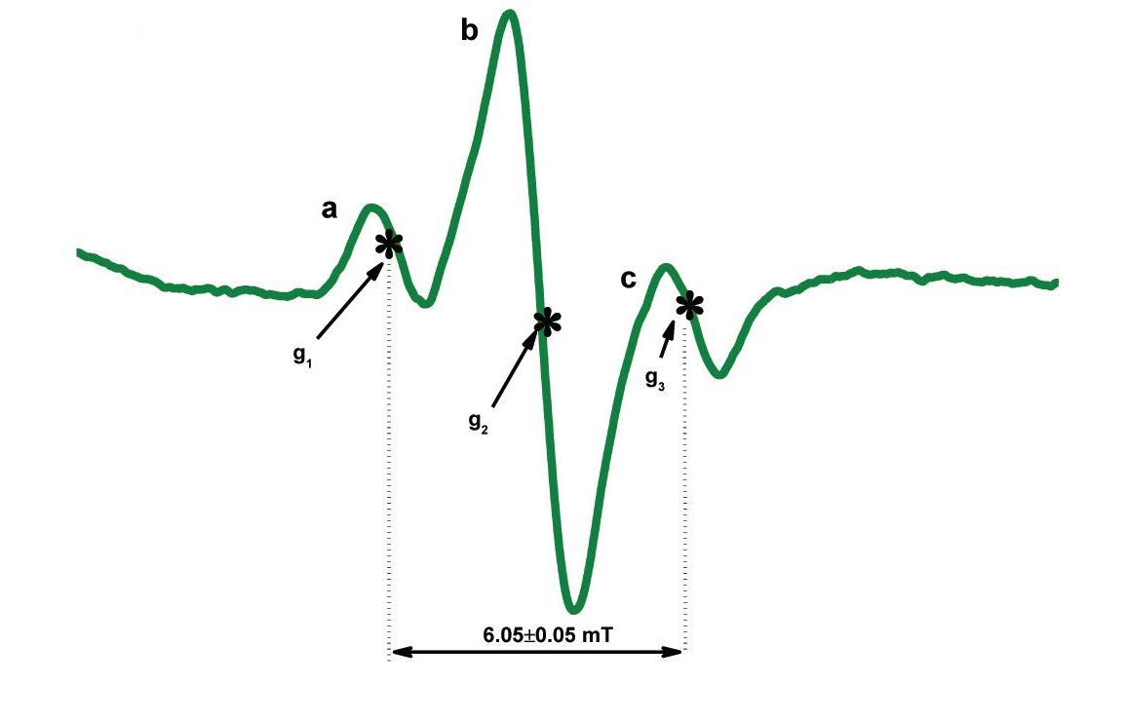

Figure 1. The satellite ESR signals (a,c) observed in irradiated foods containing cellulose (Kwon, Shahbaz & Ahn, 2014, this figure was uploaded by Jae-Jun Ahn)

Two different food irradiation detection methods, the DEFT/APC and the DNA Comet Assay can also be applied to detect irradiation treatment. DEFT/APC is a microbiological screening method based on the use of the direct epi fluorescent filter technique (DEFT) and the aerobic plate count (APC). DNA Comet Assay detects DNA damage due to ionizing radiation which allowed distinguishing non-irradiated samples from irradiated ones, which showed different types of comets owing to DNA fragmentation. Both DEFT/APC method and DNA Comet Assay would be satisfactorily used as a screening method for indicating irradiation processing (Araujo, 2008).
This study presents the determination of unirradiated or irradiated food samples containing cellulose using ESR technique (TSE EN 1787) and on the basis of the TL technique (TSE EN 1788: Determination of Irradiation in Foods-Silicate Minerals) under Dosimetry laboratories of SANAEM Material and Detector Technologies Unit in the scope of accreditation requirements.

2. Experimental
The samples were irradiated with Co-60 gamma cell (dose rate 1.1 kGy/hour) at the SANAEM. Randomly coded samples were provided to the laboratories by the Quality Management Section (QMS) of SANAEM. The foodstuffs such as spices and legumes (leguminosae) were analyzed using methods proposed as EN 1787 and 1788 standards. Evaluation was done by QMS according to criteria as correctly detection of irradiated /unirradiated samples. When necessary, the samples were powdered by grinding mortar and sieving them. Powder samples were used in ESR measurements. All ESR measurements were performed at least 24 h after reached to laboratory in order to avoid any interference by the radiation-induced short-lived free radicals. The samples were placed in standard Pyrex tubes with inner diameter 4.0 mm not exhibiting any ESR signal. ESR measurements were performed on samples open to air at room temperature using a Bruker e-scan X-band spectrometer. The sample weight was ~ 150 mg for all the ESR measurements and all the samples were positioned in exactly the same manner in the cavity to avoid any errors in the g-factor and signal intensities arising from changes in the cavity-filling factor. The spectrometer parameters used were; central field 3488 G, modulation amplitude 1 G, microwave power 1.58 mW, scan range 100 G, scan time 5.24 s, receiver gain 3,17x10². Each sample was measured three times and the average of three such measurements was used for each data point. Thus, the maximum experimental error was estimated to be about ± 4 %. The strong pitch (g = 2.0028) was used as a standard sample for measuring g-factor.
For TL measurements, all samples were stored under normal laboratory conditions (in dark) after reached to laboratory. For TL analysis, adequate amounts of inorganic dust (silicate based minerals) need to be isolated from the foods. Sufficient mineral grains could be isolated using a density separation step applying high density sodium polytungstate solution according to EN 1788 European Standard for investigation of samples whether unirradiated (control) or irradiated. The silicate weight used for all the TL measurements was 3.9 mg. No special care was used to obtain dust grains in unique size.
The first TL glow curves (TL1) for polyminerals isolated from food samples were recorded. The already measured minerals were re-irradiated at 1 kGy radiation dose for the purpose of normalization and the second TL glow curves (TL2) were obtained. TL measurements were carried out using a Risø TL/OSL reader (TL/OSL-DA-20) in the 70-500 °C range with a heating rate of 6 °C/s under continuous nitrogen flux to reduce spurious TL signals. As typical, the sample preparation and TL recording procedures take circa, 72 h.

3. Results and Discussion
Chickpea, bean, mint, black cumin, cumin, thyme, black and red pepper, pistachio, red and green lentil, kidney bean samples sent to our laboratory from the Quality Management Section were examined whether they are irradiated or not by ESR and TL technique within the scope of inter-comparison experiments to fulfill the accreditation of TS EN 1787 standard. The inter-comparison tests results are shown in Table 1. We present here the results of analysis by ESR and TL a physical techniques. All comparative results were declared by QMS. According to these results, it can be concluded that immediate reach of samples to the laboratories after irradiation and relatively higher irradiation doses of samples lead to all methods being successful even though biological techniques used as screening methods. ESR and TL are reliable detection methods since the appearance of ESR signal of radiation-induced radicals and having enough amount of silicate minerals for TL prove irradiation treatment. However, fading of ESR signals, applied low radiation dose, long deposition time after irradiation and inability to collect enough dust for TL are the lacks of these methods. The optimal strategy may be to first analyze samples by ESR as a rapid method, then in case of doubt to apply TL as a time consuming method.
We presented here the ESR spectra of red lentil and chickpea samples as representatively. The ESR spectrum of unirradiated red lentil (control) samples at room temperature is a single-line spectrum with peak to peak line-width ΔHpp ≈ 0.9 mT and spectroscopic splitting factor g = 2.005. ESR spectra for unirradiated and irradiated red lentil samples are given in Figure 2. The ESR signal intensity was observed to increase linearly with the applied radiation dose in radiation dose range of 0.5-5.0 kGy. Red lentil sample is one of the food samples which exhibit ESR singlet after the irradiation process (Raffi et al., 2000; Yordanov and Gancheva, 2000; Engin, Aydas & Polat, 2011). This signal cannot be distinguished from the naturally presents ESR singlet even in Q-band spectrometry (Yordanov and Aleksieva, 2004).

Table 1. The intercomparison results

 | Evaluation |  | Explanation
1 | Sample Experimental Result Reality  ESR Biological technique  Chickpea-4,1 Irradiated Irradiated Irradiated  Chickpea-3,2 Unirradiated Unirradiated Unirradiated  Beans (4,3) Unirradiated Unirradiated Unirradiated  Beans (1,2) Irradiated Irradiated Irradiated  Lentil red T Irradiated Irradiated Irradiated  Lentil red U Unirradiated Unirradiated Unirradiated  Red mullet A Irradiated Irradiated Irradiated  Red mullet Z Unirradiated Unirradiated Unirradiated  Lentil green C Unirradiated Unirradiated Unirradiated  Lentil greenM Irradiated Irradiated Irradiated | Satisfactory
2 | ESR TL  mint Irradiated Irradiated Irradiated  cumin Unirradiated Unirradiated Unirradiated  Ground cumin Irradiated Irradiated Irradiated  thyme Irradiated Irradiated Irradiated  Black pepper Irradiated Irradiated Irradiated | Satisfactory
3 | ESR Biological technique  mint Irradiated Irradiated Irradiated  cumin Unirradiated Unirradiated Unirradiated  Ground cumin Irradiated Irradiated Irradiated  thyme Irradiated Irradiated Irradiated  Black pepper Irradiated Irradiated Irradiated | Satisfactory
4 | DZL ESR Hacettepe Unv. ESR  Black pepper Unirradiated Not detected Unirradiated  thyme Unirradiated Unirradiated Unirradiated  cumin Irradiated Irradiated Irradiated  Red pepper Irradiated Irradiated Irradiated  Pistachio Irradiated Irradiated Irradiated | Satisfactory

ESR spectra of unirradiated (control) and irradiated chickpea samples were given in Figure 3. In the study of Aydas et al. (2008), an ESR investigation on gamma-irradiated chickpea cultivated in Turkey is reported in details. The unirradiated sample ESR spectra were composed of an equally spaced sextet originating from the presence of Mn²⁺ ions and a weak ESR signal both centered at g=2.0054±0.0006. Although irradiation was found to have no effect on the Mn²⁺ signals, it caused a noteworthy increase in free radical signal intensity of chickpea in the studied dose range of 0.1–4.5 kGy. As reported all characteristics of this sample under radiation in the above mentioned study, we easily detected the radiation treatment of chickpea sample.

Magnetic Field (mT)
Figure 2. ESR Spectra of unirradiated and irradiated red lentils

Figure 3. Room temperature ESR spectrum of chickpea samples recorded with scan range of 10 mT. (a) Unirradiated (control), (b) just after the irradiation at 3kGy and (c) 2h after the irradiation at 3kGy (Aydas et al., 2008).

TL analysis has been done in accordance with the EN 1788 (2001). According to this standard, TL glow curves (TL1) of the irradiated polymineral samples exhibit a peak in the temperature range of 150-250 °C whereas in unirradiated samples (control) low level natural radioactivity causes TL signal (TL1) above 300 °C. As shown in Fig.4 a and b, these criteria were fulfilled for thyme samples. As it is seen from this figure, TL1 intensity is approximately 100 fold higher than the TL 1 intensity of control sample. Therefore, the detection treatment just based on the first glow curve (TL1) is possible.

It is recommended in EN 1788 that also the TL glow ratio (TL1/ TL2) is applied for evaluation to verify the reliability of detection results. TL glow ratios, integrated in the temperature range of 150-250 °C from irradiated samples are typically greater than 0.5 whereas those from unirradiated samples are usually below 0.1. The ratio criteria were satisfied for unirradiated and irradiated samples. According to TS EN1788 standard, it was concluded that thyme sample coming to laboratory was irradiated.

The presence (intensity) of the TL signals used in the detection of such samples is greatly influenced by the environmental conditions (ambient temperature, humidity, light… etc.). In particular, it is known that daylight resets the TL signals originating from silicate minerals and thus, allow the detection of irradiation. In this tests, all samples were stored under normal laboratory conditions (in dark) after reached to laboratory

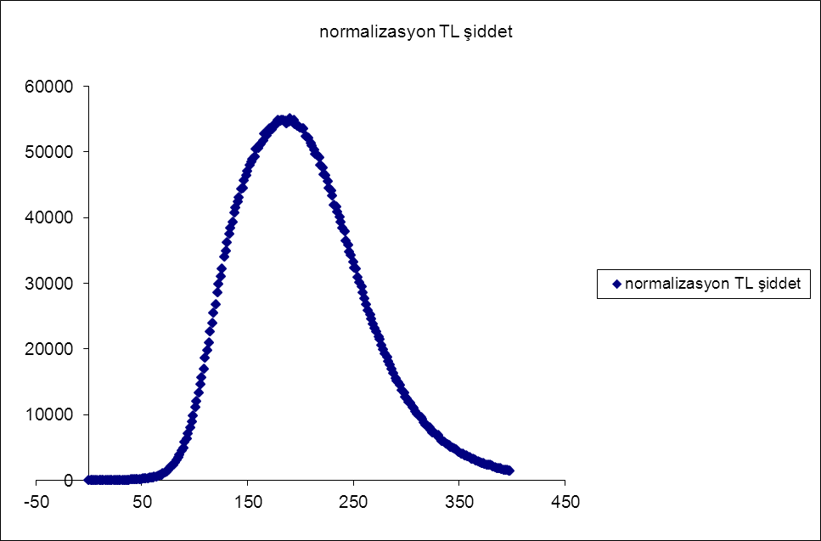
(a)
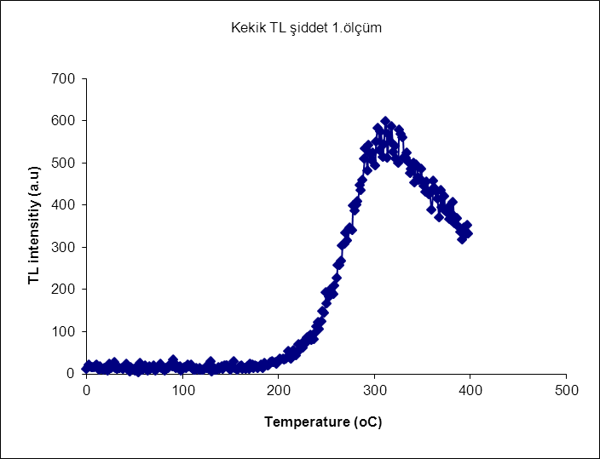
(b)

Temperature (°C) Temperature (°C)

Figure 4. TL Glow curves of thyme sample. a) irradiated, b) unirradiated (control) sample

4. Conclusion

In conclusion, identiﬁcation of gamma-irradiated foods listed in Table 1 containing cellulose were carried out by using ESR and TL techniques in the scope of inter-comparison tests between laboratories of SANAEM and Hacettepe Unv. The discrimination of unirradiated and irradiated samples seems to be possible just by comparing their ESR spectra recorded at room temperature which is compatible with EN 1787, 2000. Moreover, TL investigation of the silicate minerals isolated from the samples allowed to discriminate clearly irradiated and unirradiated samples and therefore, EN1788 standard can also be applied to the mint, cumin, thyme and black pepper samples. By the way, Dosimetry Laboratories of RHTD (SANAEM) in TAEA fulfilled the requirements of the accreditation certificate which have owned since 2008 and has been the role model in a country in determining irradiated foods.

5. References

- Anonymous. Wholesomeness of Irradiated Food. (1981). Report of Joint FAO/IAEA/WHO Expert Commitiee. World Health Organisation, Geneva. Technical Report Series 659.

- Bayram G. & Delincée H. (2004). Identification of irradiated Turkish foodstuffs combining various physical detection methods. Food Control, 15, 2,81-91.

- Raffi, J., Evans, J.C., Agnel, J.P., Rowlands, C.C. & Lesgards, G. (1989). ESR analysis of irradiated frog's legs and fishes. Applied Radiation and Isotopes 40, 1215-1218.

- Desrosiers, M.F. (1991). Electron spin resnance for monitoring radiation-processed meats containing bone. Journal of Food Science. 56, 1104- 1105.

- Rafﬁ,J., Yordanov,N.D., Chabane,S., Douiﬁ,L., Gancheva,V. & Ivanova,S. (2000). Identification of Irradiation Treatment of Aromatic Herbs, Spices and Fruits by Electron Paramagnetic Resonance and Thermoluminescence. Spectrochim. ActaA, 56, 409–416.

- Korkmaz, M. & Polat, M. (2001). Radical kinetics and characterization of the free radicals in gamma irradiated red pepper. Radiation Physics and Chemistry, 62, 411–421.

- Polovka, M., Brezova,V., Stasko,A., Mazur, M., Suhaj, M. & Simko, P. (2006). EPR investigations of gamma-irradiated ground black pepper. Radiation Physics and Chemistry, 75, 309–321.

- EN 13708, Determination of Irradiated Food Containing Crystalline Sugar:Analysis by EPR. (2001). European Committee for Standardization: Brussels.

- EN 1786, Detection of Irradiated Food Containing Bone: Analysis by Electron Paramagnetic Resonance. (1997). European Committee for Standardization: Brussels.

- EN 1787, Determination of Irradiated Food Containing Cellulose: Analysis by EPR. (2000). European Committee for Standardization: Brussels.

- Yordanov, N.D. & Gancheva,V. (2000). A new approach for extension of the identification period of irradiated cellulose containing foodstuffs by EPR spectroscopy. Applied Radiation and Isotopes. 52, 195–198.

- Engin, B., Aydaş, C. & Polat, M. (2011). Detection of gamma irradiated fig seeds by analysing electron spin resonance. Food Chemistry. 126, 1877–1882.

- Yordanov, N.D. & Aleksieva, K. (2004). X- and Q- band studies on fine powders of irradiated plants. New approach for detection of their radiation history by using Q-band EPR spectrometry. Radiation Physics and Chemistry. 69, 59–64.

- Yordanov, N.D., Aleksieva, K. & Mansour,I. (2005). Improvement of the EPR detection of irradiated dry plants using microwave saturation and thermal treatment. Radiation Physics and Chemistry. 73, 55–60.

- Franco, R.W.A., Martin-Neto, L., Kato, M.S.A., Furlan, G.R., Walder, J.M.M. & Colnago, L.A. (2004). Identification of irradiation treatment in black pepper by electron paramagnetic resonanceInt. Journal of Food Science and Technology. 39, 395–401.

- Aleksieva, K., Lagunov, O., Dimov, K. & Yordanov, N.D. (2011). EPR Study on Non-and Gamma-Irradiated Herbal Pills. Radiation Physics and Chemistry. 80, 767–770.

- Kwon J.H., Shahbaz H.M., & Jae-Jun. (2014). Advanced Electron Paramagnetic Resonance Spectroscopy for the Identification of Irradiated Food. American laboratory 46,1,1-4.

- EN 1788, Foodstuffs Thermoluminescence Detection of Irradiated Food from which Silicate Minerals can be Isolated. (2001). European Committee for Standardization: Brussels.

- Engin, B. (2007). Thermoluminescence parameters and kinetics of irradiated inorganic dust collected from black peppers. Food Control. 18, 243–250.

- Correcher,V. & Garcia-Guinea, J. (2011).Application of the EN 1788 European standard for the control of saffron, pepper and blends. Food Control. 22, 173–179.

- Araujo, M.M. (2008) .Application of the microbiological method DEFT/APC and DNA comet assay to detect ionizing radiation processing of minimally processed vegetables,IAEA INIS-BR-5636.

- Aydaş, C., Engin, E., Polat, M. & Aydın, T.(2008). Electron spin resonance study of γ-irradiated Anatolian chickpea (Cicer arietinum L.). Radiation Effects & Defects in Solids. 163, 1, 7–17.

