DEVELOPMENT OF A PROBLEM-BASED TEACHING MATERIAL FOR SCIENCE EDUCATION IN A WEB ENVIRONMENT: THE SUBJECT OF ACIDS AND BASES

Beyza KARADENIZ BAYRAK

Abstract

This study aims to develop a problem-based teaching (PBT) material for the Science and Technology course in a web environment, with the purpose of providing a more meaningful and permanent learning experience for the students. Participants of the study were a total of 56 eighth grade students attending a public primary education school in Istanbul. The author has developed a web-based teaching material for the students to be able participate in PBT activities. This material contained five problem situations concerning the subject of acids and bases, scripted and animated using Adobe Flash CS4. The web-based software developed by the author using hypermedia tools aimed to teach the students the subject of acids and bases via interactive animations and simulations. Students had the opportunity to cooperate, interact, and share information with other group members.
Key Words: Science education, problem based teaching, web environment, acid, base.

Introduction
In educational studies conducted in recent years, constructivism has emerged as an important approach to be used in the study and designing of educational programs. Contemporary approaches to education emphasize the importance of methods that enable the active participation of students in class activities. One of the most popular of these methods is the constructivist-based teaching method. Problem Based Learning is a specific example of a constructivist based approach to teaching. Problem based learning gives the students an opportunity to practice what they learn, and to make more use of their higher level thinking skills, compared to traditional learning environments, by organizing and presenting the information and material required for the solution of problems. Problem based teaching is a teaching strategy that helps the students to understand the underlying principles and issues by working on issues arising out of specific problems (Spencer and Jordan, 1999), and encourages them to think, to question and to discover (Wilkie and Burns, 2003).
As science education has many practical applications, is very much involved in daily life, requires cooperation and makes good use of interpretation, PBT is a very attractive model for science education. More and more programs adopt the PBT approach for science education (Greenwald, 2000; Yuzhi, 2003; Treagust, 1998).
Problem based learning environments are considered to offer opportunities both for the socialization and cognitive development of students (Moallem, 2003). Johnson and Johnson (1990) found that students who study in a cooperative environment attain higher levels of academic achievement compared to those who study individually.
Veermann and Veldhuis-Diermanse (2001) emphasize that cooperative learning creates a feasible environment for students to solve problems and to restructure their knowledge. Gokhale argues that the support group members provide for one another during cooperative learning makes the learning process more efficient because the different levels of knowledge and experience group members have contribute to the process (Özdemir, 2005). In student-centered designs such as cooperative learning, students are not only free to express their own opinions; they are also required to listen to other group members for the solution of a problem or realization of a project (Neo, 2003). During discussions held with other group members for the solution of a problem or in preparation for a project, students can test their ideas by comparing them with the ideas of others, and can have the opportunity, by listening to other members’ ideas, to grasp some knowledge or implication that they had not thought of before (Craig, 2003; cited by Özdemir, 2005).
The widespread use of educational technologies in recent years has resulted in a surge of interest in studies on the use of PBL in web environments. Various studies have found that online learning environments are more effective in facilitating learning and problem solving among students (Oliver and Omari, 1999), and that an exchange of ideas over various communication and cooperation tools such as e-mail, chat rooms, and discussion groups facilitates learning (Taradi and Taradi, 2004). The web is used as a tool that provides students with easier access to different sources of information. In using the web, students are able to search for sources effectively, solve problems freely, and structure their own knowledge.
Jonassen and Kwon (2001) argue that in computer-assisted communication environments, students participate more and engage in more communication with one another compared to face-to-face communication environments. When working cooperatively in online learning environments on the solution of a problem, students acquire higher level thinking skills, such as problem solving, communication, scientific curiosity and critical thinking (Reeves, 2004). Sage (2000) emphasizes that web-based technologies are very powerful tools for the organization, distribution and presentation of information.
Problem-Based Teaching in a Web Environment
Activities prescribed by learning models based on the constructivist approach require students to structure their own knowledge and are different from those used in the traditional approach, which means traditional teaching methods are not suitable for use in constructivist learning environments (Jonassen and Murphy, 1999). Thus, effective environments that take student needs and requirements into account and that would allow the students to learn by themselves need to be designed.
Problem-based learning aims to create an environment in which students manage their own learning, acquire professional thinking and decision making skills, and discover and unearth required information by themselves. In this approach, the teaching program is designed to provide an environment where students read about and try to identify the problem, and discover and discuss strategies to solve the problem. Platforms for cooperation and discussion, indispensable elements of PBT, can be difficult to establish due to time and space limitations. Students need to be in the same place at the same time to be able to have a group discussion. Experts, who act as resources upon student demand, should also be there. Web environments provide a convenient platform for meeting these challenges (Tekedere, 2009).
Paralleling the development of web-based technologies and their increasingly more frequent use in teaching applications, studies on PBT started to use online learning environments as well. Problem-based teaching focuses on creating an experience-based learning environment that involves the identification and solution of real-life problems. Web-based technologies can assist in the creation and implementation of such environments (ChanLin and Chan, 2004; cited by Özdemir, 2005), and instructional designers can create effective, lively and functional environments by combining PBT and web-based learning (Oliver and Omari, 1999). As a hyper-environment, the web plays an important role in supporting computer-assisted constructivist learning. As Keser et al. (2001) argue, web-based teaching materials offer important advantages for accessing rich information sources, creating a meaningful and interactive environment, and facilitating an exchange of ideas with other people.
The concepts of web-based teaching and PBT share some common characteristics. In constructivist learning environments, where teachers guide the learning process instead of acting as sources of information, web-based teaching provides certain advantages, such as encouraging students to take responsibility (Vrasidas and McIsaac, 2000) and offering interactive environments in which knowledge and meanings can be structured (Keser et al., 2001). These characteristics make web-based teaching especially suitable for use in PBT, which is a student-centered method and which aims to have the students structure their own knowledge.
Recent studies on problem-based teaching focus on specific aspects of the subject. Development of web applications for problem-based teaching, in particular, seems to be gaining more attention as web-based teaching becomes more widespread paralleling the advances in information technologies.
Most studies on primary education are on the conceptual understanding of the students. Many of them try to identify common misconceptions concerning the subject under study, and develop various methods and techniques for removing these misconceptions (Psillos and Kariotoglou, 1999; She, 2002; Besson, 2004).
The subject of acids and bases has an important place in primary and secondary chemistry education. Concepts concerning acids and bases are inter-related. Theories concerning these concepts, frequently perceived by students as too complex to learn, need to be taught using appropriate methods and misconceptions need to be prevented. When students have difficulty understanding one of these concepts, they also experience difficulties in related subjects (Kauffman, 1988) and have misconceptions (Cros et al., 1986), which are known to affect their learning in later grades (Toplis, 1998).
Due to the opportunities provided by web environments for the creation, storage, distribution and sharing of the information required for PBT applications, this study uses PBT and a web-based education environment in combination.
This study aims to develop a learning environment supported by problem-based teaching in a web environment with the purpose of providing a more meaningful and permanent learning experience for the students.
Materials and Methods
Teaching Material
As part of this study, a web-based teaching material was developed by the author for the students to be able to participate in PBT activities. This material contained five problem situations concerning the subject of acids and bases, scripted and animated using Adobe Flash CS4. During the five-week implementation period, a different problem situation was activated each week.
The web-based software developed by the author using hypermedia tools aimed to teach the students the subject of acids and bases via interactive animations and simulations. Students had the opportunity to cooperate, interact, and share information with other group members.
The teaching material was developed on the basis of the Harper-Marinick (2001) model. The Harper-Marinick (2001) model is based on the following learning sequences (Bayrak, Bayram; 2011):
1. Presentation of Introductory Information: The new learning environment is introduced, students’ tasks are stated, and information is given on what they need to achieve the learning goals.
2. Presentation of an Ill-Structured Problem: A problem appropriate for use in PBL is presented. Presentation of the problem needs to be made in such a way as to generate curiosity and raise interest among the students, and to motivate them.
3. Online Collaboration: Using the chat tool, groups analyze the problem among themselves. They identify their existing information, what additional information they need, and what needs to be known to be able to solve the problem. During this process of collaboration, the teacher acts as a guide, facilitator, and enabler. The teacher observes and manages the whole process.
4. Accessing Resources over the Web: Each student is assigned a personal research task. The software includes links to necessary resources. Students search these resources and obtain the information they need. This practice is crucial for the students to acquire the skill of “learning to learn”, which is an important part of problem-based learning.
5. Follow-up Online Collaboration: Following independent and individual research, groups continue discussing in the web environment. At this stage, each group member presents what he or she learnt and how it might help solve the problem. The hypothesis is re-examined in the light of this new information.
6. Solution of the Problem: Processes 4 and 5 are repeated until the group is satisfied that answers to the problem have been found. Group members decide how they will present the solution that they came up with using the tools provided.
Teaching material was prepared using the “Problem-Based Learning Environment Design Compliance Form”, developed by Özdemir (2005) on the basis of the problem-based learning designs by Savery and Duffy (1996) and Jonassen (2000), and expert opinion was acquired on the suitability of the teaching material in question for PBT. The material was revised based on the feedback received from the experts (Bayrak, Bayram; 2011).
To deal with potential issues that might arise concerning the feasibility of the material and the student-material and student-student interactions, a pilot implementation of the software was made for five weeks in the spring semester of the 2008-2009 academic year with eighth grade students. Necessary revisions were made following the pilot implementation, and three eighth grade students used the teaching material in the 2009-2010 academic year prior to conducting the present study. The author made observations on their use of the program, subjected the software to another revision, and gave its final form.
Problem situations created were presented to the students using a cycle [Fig. 1] that contained the six learning sequences set forth in the Harper-Marinick (2001) model (Bayrak, Bayram; 2011).
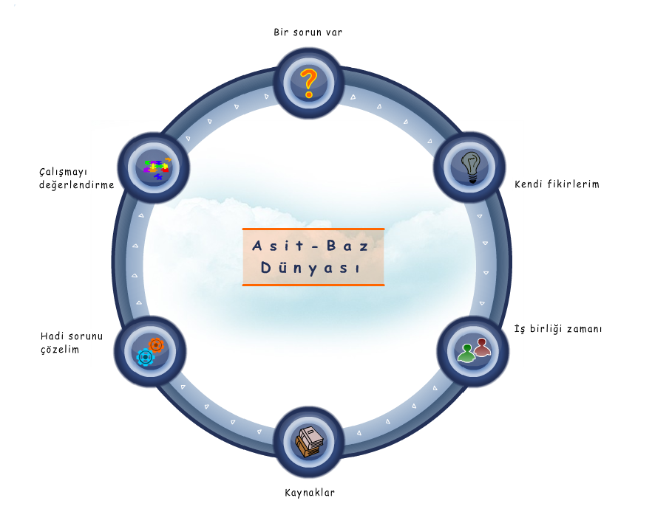
Figure 1. Learning Cycle
During the five-week implementation phase in the spring semester of the 2009-2010 academic year, a different problem situation was presented to the students each week, from simple to more complex.
The online environment used for the application was developed using C# language on Microsoft .NET (DotNet) technology. Every activity made by the students during the time they used the application (navigating between menus, writing their own ideas, sending messages to group members, information sharing, etc.) was saved on the database via SQL (Structured Query Language) commands. Thus, the author was able to monitor, using the administration panel prepared for the administrator of the online environment, which student studied which subject for how long, what they produced in the process of problem solving and how they did it [Fig. 2].
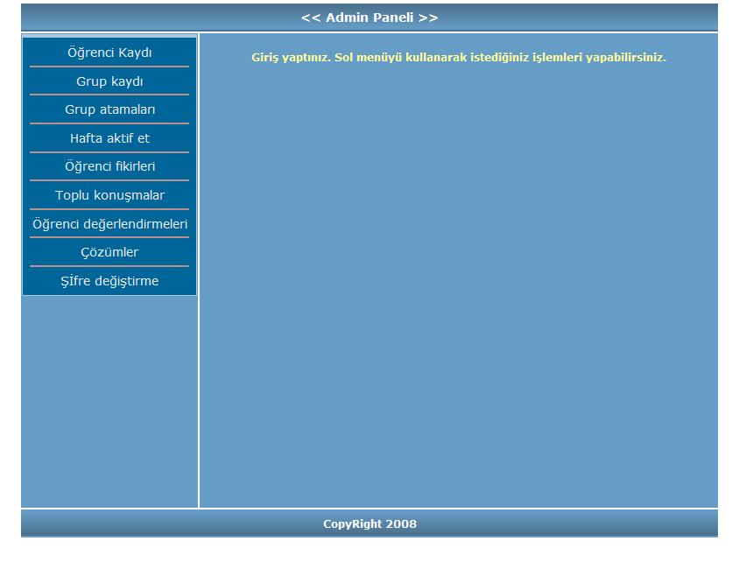
Figure 2. Admin Panel
With the help of the tabs on the menu of the administration panel, students were registered with the system, heterogeneous groups were created on the basis of the suggestions of the teacher of the course, and students were assigned to different groups.
The “Activate week” tab was used to activate a different problem situation each week, from among the five problem situations developed for the study.
Students’ own ideas concerning the problem situation and the group discussions they had were recorded under the “Student ideas” and “Joint discussions” tabs.
Evaluations made by the students concerning themselves and their group members in the evaluation phase were controlled using the “Student evaluations” tab.
The “Solutions” tab displayed the solutions provided by individual students.
The “Change password” tab was used to change the user name and password required for logging into the administration panel.

Implementation
During the five-week implementation period in the 2009-2010 academic year, each student worked on the subject for at least 10 hours, two hours each week.
Prior to their use of the program, the author introduced the learning tool and showed the students how to use the menus. There were a total of five problems to work on and to provide solutions for during their study. They were to solve the problems [Fig. 3] using a cycle [Fig. 1] that contained the six steps of learning in the Harper-Marinick (2001) model.
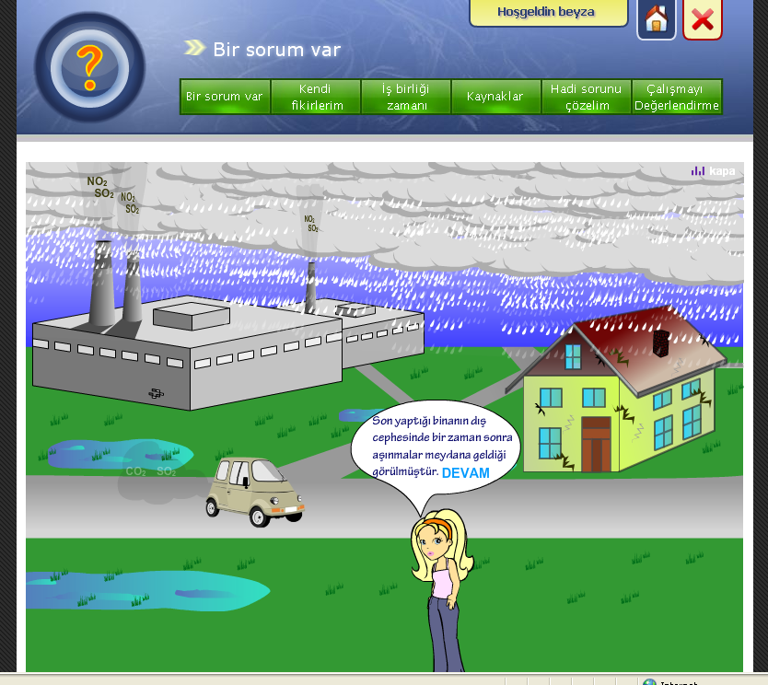
Figure 3. Fourth Problem Situation
A different problem situation was activated and presented each week following the cycle, and the implementation phase took a total of five weeks.
Students accessed the application using MS Internet Explorer, and were met with the learning cycle, which is the first screen on Figure 1. The steps of this cycle were as follows:
- Step: There is a Problem
- Step: My Own Ideas
- Step: Time for Cooperation
- Step: Sources
- Step: Let’s Solve the Problem
- Step: Evaluate the Study
The “There is a Problem” step introduced the problem situation to the students.
Then, students selected the “My Own Ideas” step to write down their own ideas on the problem, and typed their ideas in the textbox that appeared on the screen.
After writing their ideas, students selected the “Time for Cooperation” step to share information with their group members. The heterogeneous groups created on the basis of the suggestions of the course teacher consisted of five students each. In the “Time for Cooperation” step, students typed their ideas in the window that appeared on the screen, and exchanged ideas and information with one another.
After they exchanged ideas and information with the group, students moved on to the “Sources” step, which is the fourth step in the cycle. This step consisted of two sub-categories. The first sub-category was named “Games”, the second was named “General Sources”, and the third was named “Additional Study”. The “General Sources” and “Additional Study” sub-categories were the same for all five problem situations. The “General Sources” sub-category contained studies titled “Soil Detective” and “pH Scale”, and four study sheets. The “Additional Study” sub-category contained various internet games on the subject of acids and bases. The “Games” sub-category contained animations and simulations on the problem situation currently activated.
After they had accessed the sources on the problem situation and studied them, students selected the “Let’s Solve the Problem” step. At this step, students tried to solve the problem situation individually. With the help of the cooperation and sharing of information they made with other group members and the sources they studied, they solved the problem.
At the final step of “Evaluate the Study”, students evaluated the study by assigning scores to themselves and to other group members.
Results and Discussion
A number of studies have found that problem-based learning in a web environment improves student achievement. Bayrak (2011) observed that using the method of problem-based learning in a web environment improved eighth grade students’ academic achievement, conceptual understanding and cognitive process skills. Taradi, Taradi, Radic and Pokrajac (2004) found that when problem-based learning in a web environment and cooperative learning methods were used together, they had a positive effect on the academic achievement of the students, as measured by their posttest scores. Oliver and Omari (1999) observed an increase in student performance. Alper (2003) found that following the implementation of problem-based learning in a web environment, significant differences were observed between the pretest-posttest and pretest-retention test scores of the students. Ortiz (2006) found that learning processes that are based on the principle of online cooperative learning were helpful in attaining learning goals. Ünlü (2007) examined the effects of a web-based education environment developed on the basis of problem solving method on student achievement. A web-based mathematics course was developed for use in an experimental setting. At the end of the study, it was found that web-based education made a positive impact on student achievement. Sulaiman, Atan, Idrus and Dzakiria (2004) used the problem-based learning approach to design a web-based learning environment on the basis of the Harper-Marinick model, and found that cooperation in a web-based learning environment had many positive effects. Dennen (2000) found that cooperative study in a web environment for problem-based learning improved student success. Murphy et al. (2001) designed problem-based activities to be conducted via online discussions in a web environment, and found a significant increase in the achievement of the experimental group students. Chanlin and Chan (2007) compared problem-based teaching in a web environment with web-based teaching, and found that problem-based teaching in a web environment improved student performance to a greater degree. Gürpınar et al. (2009) found that problem-based teaching in a web environment improved academic achievement. Own et al. (2010) found that students who learnt about organic chemistry via problem-based teaching in a web environment improved their academic achievement. Chen (2010) found that instruction given over the web using semi-structured problem situations had a positive effect both on achievement and on problem solving skills. Karal et al. (2010) created problem situations presented via simulations over the web, and found that student performance increased after the teaching. In a study on the computer using skills of the students, Hong-Rae (2003) used the problem-based approach to learning, and found that students had an easier time solving the problems when they studied in cooperation. Students made use of the internet sources in particular, and reached the solution more easily.
Use of information and communication technologies is considered to be an alternative method and an efficient tool in science instruction. Use of information and communication technologies in science education can help overcome some of the problems that traditional teaching methods fail to address (difficulties in understanding and conception and misconceptions) (Williamson and Abraham, 1995; Burke, Greenbowe & Windschitl, 1998; Ebenezer, 2001; Marcano, Williamson, Ashkenazi, Tasker & Williamson, 2004; Sırabaşı, 2006; Kelly and Jones, 2007).

References
Alper, A.Y. (2003). Web ortamlı probleme dayalı öğrenmede bilişsel esneklik düzeyinin öğrenci başarısı ve tutumları üzerindeki etkisi. Yayımlanmamış Doktora Tezi,. Ankara Üniversitesi Eğitim Bilimleri Enstitüsü.
Bayrak, B. (2011). Web ortamında problem tabanlı öğretim ile desteklenmiş fen ve teknoloji öğretiminin 8. Sınıf öğrencilerinin akademik başarı, kavramsal anlama ve bilimsel süreç becerileri üzerine etkisi: asit baz konusu. Yayımlanmamış Doktora Tezi, Marmara Üniversitesi, Eğitim Bilimleri Enstitüsü.
Bayrak, K.B., Bayram, H. (2011). Effects of problem-based learning in a web environment on conceptual understanding: the subject of acids and bases. International Online Journal of Educational Sciences, 3(3),831-848.
Besson, U. (2004). Some features of causal reasoning: Common sense and physic teaching. Research in Science & Technological Education, 22 (1) (2004), 113–125.
Burke, K. A., Greenbowe, T. J., & Windschitl, M. A. (1998). Developing and using conceptual computer animations for chemistry instruction. Journal of Chemical Education, 75(12), 1658-1660.
Chanlin, L.J. & Chan, K.C. (2007). Integrating inter- disciplinary experts for supporting problem-based learning. Innovations in Education and Teaching International, 44(2), 211-224.
Chen, C.H. (2010). Promoting collage students’ knowledge acquisition and ill-structured problem solving: web-based integration and procedure prompts. Computer &Education, 55, 292-303.
Cros, D., Maurın M, Amouroux, R., Chastrette, M., Leber, J. & Fayol, M. (1986). Conception of first- year university students’ of the constituents of matter and the notions of acids and bases. European Journal of Science Education, 8(3), 305-313.
Dennen, V.P. (2000). Task structuring for online problem based learning: a case study. Educational Technology&Society. 3(3).ISSN 1436-4522.
Ebenezer, J. V. (2001). A hypermedia environment to explore and negotiate students’ conceptions: Animation of the solution process of table salt. Journal of Science Education and Technology, 10(1), 73-92.
Greenwald, N.L. (2000). Learning From Problems. The Science Teacher, 67(4), 28-32.
Gürpınar, E., Zayım, N., Özenci, Ç.Ç. & Alımoğlu, M.K. (2009). First report about an e-learning application supporting pbl: students’ usages, satısfactions and achievements. The Turkish Online Journal of Educational Technology, 8(2).
Harper-Marinick, M. (2001). Engaging students in problem-based learning. Maricopa center for learning and instruction. Retrieved 09.10.2011 from http://www.mcli.dist.maricopa.edu/forum/spr01/t11.html.
Hong-Rae, K.(2003). Enhancement of quality learning through problem-based learning in computer education. Implementing Problem Based Learning: Proceedings of the First Asia Pacific Conference on Problem Based Learning, Hong Kong Convention and Exhibition Centre, December, The University of Hong Kong Publications Unit, Hong Kong.
Huang, H. (2000). Instructional technologies facilitating online courses, Educational Technology, 4, 41-46.
Johnson, D.W., & Johnson, R.T. (1990). Social skills for successful group work. Educational Leadership, 47(4), 29-33.
Jonassen, D. H. & Rohrer-Murphy, L. (1999). Activity theory as a framework for designing constructivist learning environments. Educational Technology Research and Development, 47, 61-79.
Jonassen, D.H. (2000). Toward a design theory of problem solving. Educational Technology Research and Development. 48 (4), 63-85.
Jonassen, D.H. & Kwon, H.I. (2001). Communication patterns in computer mediated versus face to face group problem solving. Educational Technology Research and Development. 49 (1), 35-51.
Karal, H., Çebi, A. ve Pekşen, M. (2010). The web based simulation proposal to 8th grade primary school students’ difficulties in problem solving. Procedia Social and Behavioral Sciences, WCES-2010, 4540-4545.
Kauffman, G. B. (1988). The brönsted- lowry acid-base concept. Journal of Chemical Education, 65(1), 28-31
Kelly, R. M., & Jones, L. L. (2007). Exploring how different features of animations of sodium chloride dissolution affect students’ explanations. Journal of Science Education and Technology, 16(5), 413-429.
Keser, H., Şen, H., Göçmenler, G. ve Kalfa, F. (2001). Web tabanlı öğretim materyali hazırlama sürecinin temel evreleri ve internet kullanımına yönelik bir uygulama örneği. I. Uluslararası Eğitim Teknolojileri Sempozyumu ve Fuarı Bildirileri. 28-30 Kasım 2001, Sakarya,189-197.
Marcano, A. V., Williamson, V. M., Ashkenazi, G., Tasker, R., & Williamson, K. C. (2004). The use of video demonstrations and particulate animation in general chemistry. Journal of Science Education and Technology, 13(3), 315-323.
Moallem, M., (2003). An Interactive Online Course: A Collaborative Design Model. Educational Technology Research and Development. 51 (4), 85-103.
Murphy, R., Ness, G. & Pelletier, J. (2001). Problem based learning using web-based group discussions: a positive learning experience for undergraduate students. In J. Price et al. Conference. Chesapeake.
Neo, M. (2003). Developing a collaborative learning environment using a web based design. Journal of Computer Assisted Learning. 19, 462-473.
Oliver, R. & Omari, A. (1999). Using online technologies to support problem based learning: Learners’ responses and perception. Australian Journal of Educational Technology, 15(1), 58-79.
Ortiz, B. I. L. (2006). Online collaborative problem based learning: design, facilitation, student work strategies and supporting technologies. Ph.D Thesis. Columbia University
Own, Z.Y.; Chen, D.U. & Chiang, H.R. (2010). A study on the effect of using problem-based learning in organic chemistry for web based learning. Computers & Applied Sciences Complete. 37(4), 417-430.
Özdemir, S. (2005). Web ortamında bireysel ve işbirlikçi problem temelli öğrenmenin eleştirel düşünme becerisi, akademik basarı ve internet kullanımına yönelik tutuma etkileri. Yayımlanmamış Doktora Tezi. Gazi Üniversitesi Eğitim Bilimleri Enstitüsü.
Psillos ,D. & Kariotoglou, P. (1999). Teaching fluids: intended knowledge and students’ actual conceptual evolution. International Journal of Science Education, 21 (1) (1999), 17–38.
Reeves, T.C., Herrington, J., & Oliver, R. (2004). A development research agenda from online collaborative learning. Educational Technology Research and Development, 52 (4), 53-65.
Sage, S. (2000). A natural fit: problem-based learning and technology standards. Learning and Learning with Technology, 28(1), 6-12.
Savery, J.R. & Duffy,T.M. (1996). Problem Based Learning an Instructional Model and Its Constructivist Framework. In Constructivist Learning Environments: Case Studies in Instructional Design. Wilson (Ed). Educational Technology Publications, Englewood Cliffs, New Jersey. s. 135-148
She, H.C. (2002). Concepts of a higher hierarchical level require more dual situated learning events for conceptual change: a study of air pressure and buoyancy. International Journal of Science Education, 24 (9), 981-996.
Sırabaşı, A. (2006). Bilgisayar destekli öğretimin lise öğrencilerinin asitbaz ve ph konusunu öğrenmedeki başarılarına ve kimyaya karşı olan tutumlarına etkisinin geleneksel yöntemle karşılaştırılması. Yayımlanmamış Yüksek Lisans Tezi. Gazi Üniversitesi Eğitim Bilimleri Enstitüsü.
Spencer, J.A. & Jordan, R.K. (1999) Learner centred approaches in medical education, British Medical Journal, 318, 1280-1283.
Sulaiman, F., Atan, H., Idrus R. & Dzakiria, H. (2004). Problem based learning: a study of the web based synchronous collaboration. Malaysian Journal of Instructional technology, 1(2).
Taradi, S.K., Taradi M., Radic K. & Pokrajac N. (2004). Blending pbl with web technology positively impacts student learning outcomes in acid-base physiology. Advances Physiology Education, 29:35-39.
Tekedere, H. (2009). Web tabanlı probleme dayalı öğrenmede denetim odağının öğrencilerin başarısına, problem çözme becerisi algısına ve öğrenmeye yönelik tutumlarına etkisi. Yayımlanmamış Doktora Tezi. Gazi Üniversitesi Eğitim Bilimleri Enstitüsü.
Toplis, R. (1998). Ideas about acids and alkalis. School Science Review, 80(291), 67-70.
Treagust, D.F. & Peterson, R.F. (1998). Learning to teach primary science trough problem based learning. Science Education, 82(2), 215-237.
Ünlü, M. (2007). Problem çözme ve buluş yoluyla öğretim kuramına göre geliştirilmiş web tabanlı eğitimin öğrenci başarısına etkisi. Yayımlanmamış Yüksek Lisans Tezi. Gazi Üniversitesi Eğitim Bilimleri Enstitüsü.
Veerman, A., & Veldhuis-Diermanse, E. (2001). Collaborative learning through computer mediated communication in academic education, in proceedings CSCL. Maastricht McLuhan Institute.
Vrasidas, C. & McIsaac, M.S. (2000). Principles of pedagogy and evaluation for web based learning. Educational Media International, 37 (2), 105-111.
Wilkie, K. & Burns, I. (2003). Problem- Based Learning. A Handbook for Nurses. Bristol. Palgrave.
Williamson, V. M., & Abraham, M. R. (1995). The effects of computer animation on the particulate mental models of college chemistry students. Journal of Research in Science Teaching, 32(5), 521-534.
Yuzhi, W. (2003). Using Problem–Based Learning and Teaching Analytical Chemistry, The China Papers., July, 28-33.

Arş. Gör. Dr.,Yildiz Technical University Faculty of Education, Istanbul, bbayrak@yildiz.edu.tr

