Planning of Sectoral Water Allocation:
A case study of Seyhan River Basin

Sektörel Su Tahsisi Planlaması: Seyhan Havzası Örneği

Nuray Ayten*, Saliha Değirmencioğlu, Taner Kimençe ¹

¹Ministry of Forestry and Water Affairs, Directorate General for Water Management 06510, Yenimahalle-Ankara
taner.kimence@ormansu.gov.tr, sdegirmencioglu@ormansu.gov.tr, nayten@ormansu.gov.tr

Abstract

In this study water allocation plan for Seyhan Basin that is the second largest after the Nile basin located in the eastern Mediterranean was prepared. The purpose of the study is that a plan for water allocation among groups of water use, or sector is developed by considering environmental and socio-economic conditions as well as the potential of surface and groundwater resources. Current (the year 2016) and future conditions (2017, 2022, 2027 and 2037) have been analyzed in terms of economic and environmental aspects. Scenarios on water allocation were created to determine the most suitable water use pattern. The major finding is that water potential is expected to drop to 6.6 billion m³ in mild drought conditions and 6.3 billion m³ in severe drought conditions due to the impacts of climate change. Consequently, agricultural water needs are met in the range of 90% level (the year 2037) to 94% level (the year 2017), and environmental flow needs are met in C level of environmental management class in the context of applied method (GEFC).
Keywords: water resources management, water potential, sectoral water demands, sectoral subbasin, water allocation.

Öz

Bu çalışma kapsamında Doğu Akdeniz’de yer alan ve Nil’den sonra ikinci en büyük havza olan Seyhan Havzası için su tahsis planı hazırlanmıştır. Çalışmanın amacı yüzey ve yer altı su kaynakalrı potansiyelinin yanı sıra çevresel ve sosyo-ekonomik koşullar değerlendirilerek suyu kullanan gruplar ya da sektörler arasında su tahsisi için bir planın geliştirilmesidir. Çalışmada öncelikle mevcut ve gelecek koşullar analiz edilmiştir. İlgili koşullar altında optimum su kullanımını temsil edecek senaryolar oluşturuldu. Elde edilen bulgulara göre, havzada su potansiyelinin iklim değişikliğinin olası etkileri neticesinde hafif kurak koşullarda 6.6 milyar m³, şiddetli kurak koşullarda ise 6.3 milyar m³’e düşmesi öngörülmektedir. Sonuçta, tarımsal su ihtiyacı 2017 yılında %90 seviyesinde, 2037’de ise %94 seviyesinde karşılanmaktadır ve çevresel akış ihtiyacı GEFC metodu kapsamında C seviyesi çevresel yönetim sınıfı olarak karşılanmaktadır.
Anahtar sözcükler: su kaynakları yönetimi, su potansiyeli, sektörel su talepleri, sektörel althavza, su tahsisi.

Introduction

As a result of growing demand for water, efficient use of resources is becoming vital. The main objective of water management is to protect and enhance the water in terms of quality and quantity for the benefit of society and ecosystem. Similarly, water allocation among sectors aims to recognize all the interest of different users, all requirements including cultural, social, and environmental. Water use planning, as an answer to the pressures on the water resources, has been providing the optimization of existing supply and balance between sectors via economic, social and environmental analysis. Water allocation among sectors is also a significant issue in Turkey depending on the sectoral structure since at river basin the annual available water potential exceeds or the limits available enforce.
In this study, water allocation was studied for Seyhan River Basin with an area about 21 000 km² that are the second largest after the Nile basin located in the eastern Mediterranean covering 2% of the surface area of Turkey. Seyhan River pouring to the Mediterranean Sea has a length of 560 km, the western part of Çukurova. The basin was selected because of preliminary studies that are showed it as the most sensitive and vulnerable region to global warming by Intergovernmental Panel on Climate Change (IPCC) Mediterranean Region. Therefore, in addition to the growing demands for water in the Seyhan River Basin, it has been expected to be negatively affected by climate change. The purpose of the project is to the preparation of sectoral water allocation plan in the Seyhan River Basin based on the total water potential and an appropriate supply-demand balance. The basin separated into three subsection to evaluate efficiently sectoral interaction. In the context of the study, these sections were named sectoral subbasin that refers to subbasins or zones that are merged or divided taking into account these sectoral uses of water in a river basin as Zamanti, Göksu and Seyhan sectoral subbasin that are river systems in Seyhan River Basin. Seyhan river is the stream starting at the junction of Zamanti and Göksu rivers.

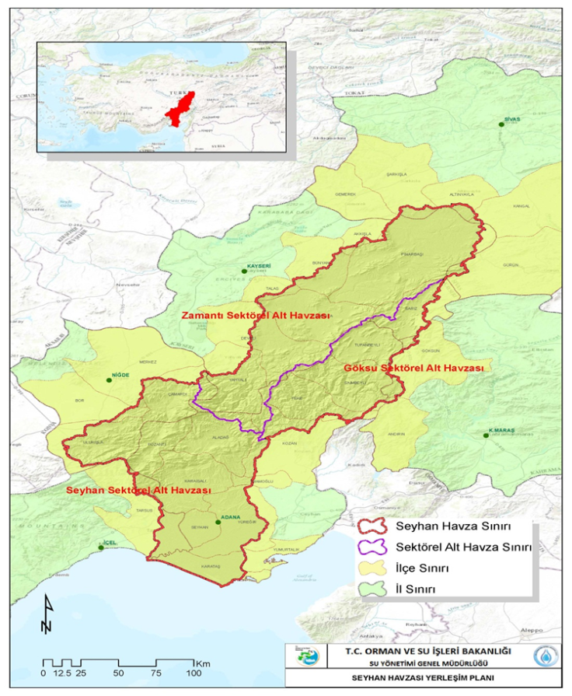
Basin border
Sectoral Subbasin Province border
Provincial border

Figure 1. Seyhan River basin and sectoral subbasins

The average precipitation is reported 615 mm in the Basin Master Plan completed by DSI. The yearly water potential of Zamanti and Göksu river are 2 049 hm³ and 1 828 hm³, respectively. The basin has two big reservoirs: Çatalan and Seyhan Reservoir with 5 145 hm³ and 6 183 hm³ of water potential, respectively. The safe groundwater reserve defined in DSI Basin Master Plan for Seyhan is 1 259 hm³/year (DSI, 2014). Table 1 shows the water potential for the current and future periods of the basin.
Table 1. Water potential of Seyhan River Basin
Water Potantial (hm³) | Current (2016) | 2017 | 2022 | 2027 | 2037
Surface Water | 5 991 | 5 386 | 6 063 | 5 462 | 5 194
Groundwater | 1 145 | 1 145 | 1 145 | 1 145 | 1 145
TOTAL | 7 135 | 6 530 | 7 207 | 6 606 | 6 338

In the study environmental flow and 4 sectors as agriculture, drinking water, industry and energy were considered. First of all drinking water demand was evaluated and it is calculated depending on the rural and urban population in the basin. Under agriculture sector for existing irrigation area by examining the appropriate crop pattern is determined. The industry as another sector in basin accounts for just a small amount of water consumption with 54.1 hm³ per year composed of 41.2 hm³/year of surface and 12.9 hm³/year of groundwater in 2016. The interbasin transfers have been taking place in the basin, as well. Water transferred in the amount of water to be allocated were also taken into consideration. Hydrometeorological conditions were analyzed as well. Standard Precipitation Index (SPI) approach was used to evaluate drought conditions. The outcomes of the project of Impacts of Climate Change on Water Resources (by the General Directorate of Water Management) was used. In this context, current conditions (the year 2016) was defined as normal state and water resources in the coming years (2017, 2022, 2027 and 2037) were evaluated accordingly. The normal conditions, mild, moderate and severe drought classes were identified by using the outcomes of SPI analyses associated with meteorologic drought (WMO). Then it was determined as normal conditions for 2016, mild drought conditions for 2017, moderate drought conditions 2027, severe drought conditions 2037. The work carried out in the study was addressed in three basic stages: social, environmental and economic analyses. At last stage, all results coming from sectoral analyses were optimized using the water allocation model (WEAP). In total 16 different scenarios were created to show how the water should be evaluated in the short, medium and long term from 2017 to 2037.

Environmental Analysis

The environment as a sector was evaluated under 4 topics: Environmental flow needs, fishery and aquaculture production, wetlands and water quality.

Economic Analysis

In addition to drinking water and environmental flow, three main sectors considered in the context of the project including agriculture, industry, energy for Seyhan River Basin. The currently irrigated area accounts for approximately 208 000 hectares in the basin. This area is expected to increase to 327 000 hectares in the long term according to the other planning activities in the Seyhan River Basin. In this context, the irrigation needs, production amount, and economic value are defined.

It is seen that industrial water consumption accounts for the just small amount of total budget, 54.1 hm³/year. The industrial water consumption is based on the water allocation records documented by General Directorate of State Hydraulics Works (DSI) for industrial activities including also bottling, mining, thermal power plant.
The annual energy production by the hydroelectric power plants accounts for approximately 6 007 GW-hour. The hydroelectric power plants under construction and planning meet another 1 369 GW-hour which in total represents 7 376 GW-hour production capacity. Water needs for hydropower and income from the sector were calculated. The sectoral water consumption for drinking-potable, agriculture and industry sectors is summarized in Figure 2.

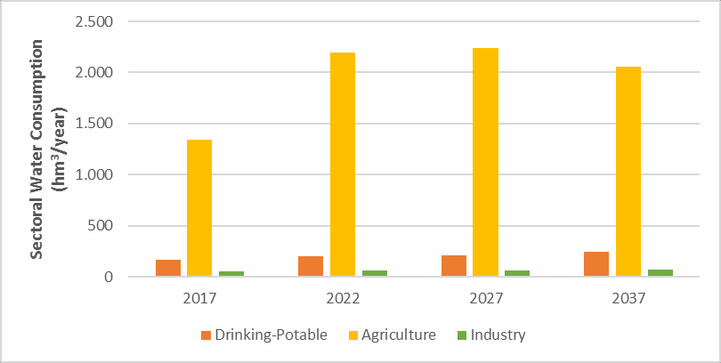

Figure 2. Sectoral Water Use

Social Analysis

In the works, water management was handled from a social point of view as well. The people's attitude towards the protection of water resources was investigated by a survey. For this purpose, a survey was conducted by a method known as the willingness to pay frequently used in natural resource valuation. As a social dimension, the need for domestic water for the current situation and future in the basin was determined by considering regional and urban development plans. The terrestrial and temporal trends of the population in the basin were analyzed. It was revealed via the survey that the people in rural area are willing to pay to 111.8 TL per year per capita while the people in the urban area are willing to pay 226.1 TL per year per capita. When the survey is taken into consideration it is estimated that the people in Seyhan River Basin are willing to pay a total of 431.1 million TL annually for the protection of the environment.

Method

The methodology used during the study is based on environmental, social and economic analyses. Various modeling tools and analysis methods have been used for evaluations such as Water Evaluation and Planning System (WEAP), Global Environmental Flow Calculation Model (GEFC), Population Statistical Package for the Social Sciences (SPSS), Penman-Monteith Method, IRSIS Computer Software and the Rainbow programme. Population projected for 1-5-10-20 years (for years 2017-2022-2027-2037) via population calculations and predictions on domestic water use by using SPSS. Minimum and maximum population predictions are made with linear and S-Curve method supplied by the software SPSS. The Linear method gives negative population values in the rural area, in that case, S-curve method is used for calculating minimum population. Current and future conditions for the water potential has been determined by the information below in Seyhan Basin and Sectoral subbasins:
- The period of 1970–2008 was used as a reference to determine flow-rainfall coefficiency.
- In order to determine reference period rainfall (1970 – 2008) data from gauging stations were used. Accordingly, average rainfall in each sectoral subbasin is calculated. For the reference flow (1970 – 2008) natural flow conditions defined in DSI Master Plan were used.
- Rainfall changes in future were determined by using results from SYGM Project of Climate Model for Seyhan Basin. In the project had been used Regional Climate Model (RegCM4.3) and HadGEM2-ES, MPI-ESM-MR, and CNRM-CM5.1 which were produced for RCP4.5 and RCP8.5 scenarios (Representative Concentration Pathways). To define 2015 – 2100 period, data set of 30 years (1971 – 2000) has been used.

The Standard Precipitation Index (SPI) method was used for the assessment of drought conditions. As known, drought index values at 3-month, 6-month, 9-month, 12-month and 24-month intervals can be calculated in SPI analyzes. Using the results of the SPI analysis in the context of meteorological drought, normal conditions, mild drought, moderate drought and severe drought classes were identified.

The environmental flow was calculated by GEFC which is one of the hydrologic environmental flow calculation methods. It aims to sustain or improve the ecosystem in flow analysis at different levels under ecological management category or environmental management class. In GEFC for each environmental management class could be an environmental flow scenario in terms of the water allocated for the sustainability of the ecosystem. Therefore, monthly environmental flow quantities are calculated for 6 classes such as A,B,C,D, E, and F which are ranging from unmodified to critically modified conditions. C class in moderately changed category as optimal is selected in environmental flow calculations.

The evaluation was performed by using 8 cross-sections located in gauging stations on the river system. In all cross-sections, the flow needs for fishery were met, as well. Akyatan and Tuzla Wetlands protected as Wildlife Development Field, as the most important wetland in the study area, were identified in the allocation model by reflecting the outcomes of a project finalized by the General Directorate of Nature Conservation and National Parks of Turkey in 2010. Spatial and temporal changes in water quality also is another issue considered in works. The data sets recorded during the period of 1981-2014 by DSI from 37 gauging stations in Seyhan Basin was used. These data sets were used to identify surface water and groundwater quality through the use of relevant environmental quality standards. Water quality was evaluated according to the 3 different regulations in force.

Water quality was evaluated using 3 different regulations, by laws on The Quality of Surface Waters for Drinking Water Source, Surface Water Quality Management and Concerning Water Intended For Human Consumption, controlling the use of water resources. In accordance with regulations and usage purposes the quality is taken into consideration. Quality classes according to the purposes of water use are classified as Class I-high quality water, Class II-less contaminated water, Class III-contaminated water, Class IV-highly contaminated water. Hence, surface water quality in Seyhan Basin was identified. It is assessed that Zamantı Sectoral subbasin is Class III and the result for Göksu Sectoral subbasin is Class II. The value in the lower part of Seyhan is defined as Class IV.

In the works, irrigation areas which are operated by several institutions are listed with their properties. The total estimated size of 517 irrigation areas is 327 000 hectare. Most of the area are located in Seyhan sectoral subbasin in the downstream. Data obtained from 11 meteorological stations were used in order to calculate water consumption of crops and timing plan of irrigation. Net income values for each crop were obtained from Ministry of Food, Agriculture, and Livestock. Irrigation areas in the basin were grouped according to cities, stations, and water usage operators. Optimum crop pattern and water -income relation is determined for each group. After this stage, the amount of water need for the agriculture sector and corresponding income value are determined for the current situation. Calculations also are made for short, medium and long terms. The Penman-Monteith method and the Rainbow program were used to determine irrigation water needs. Optimum water demand is taken into account in the agricultural sector, taking into account irrigation efficiency. By starting from the Plant Water Consumption, the irrigation water was determined and accordingly the irrigation time was planned. Optimum crop pattern was obtained (FAO).

Sectoral water allocation strategy and plan were prepared to take sectoral water usage, climate change, and drought conditions into consideration according to sectoral development, change and distribution in 2017, 2022, 2027 and 2037 years. At the final stage of the study, all results are incorporated by using Water Evaluation and Planning model (WEAP) to simulate optimum water use pattern in the basin for four different time horizon. WEAP model simulates demand points (irrigation area, hydropower plant, settlement area) changes conditions and demands as sectors as well as reservoirs in the basin.

Results

In the study allocation scenarios reflecting sectoral, environmental and economic conditions are explained.

Sectoral Water Allocation

Sectoral water allocation scenarios were developed by using associated spatial and temporal data. Existing conditions (2016) and future conditions for scenarios from 2017 to 2037. The main characteristics of conditions for different years are summarized Table 2.

Table 2. The main characteristics of different years
Scenario  (reference: 2016) | Year | Total Water Potential (hm3) | Population  (million) | Irrigation area  (million da) | GEFC Class
1 year | 2017 | 6.5 | 1.9 | 2.1 | C
5 year | 2022 | 7.2 | 2.1 | 3.1 | C
10 year | 2027 | 6.6 | 2.2 | 3.2 | C
20 year | 2037 | 6.3 | 2.4 | 3.3 | C

In the study water allocation among sectors, expected economic values associated with sectoral water use, a vulnerability in the quantity of water allocation were evaluated. The existing total water resources potential in the basin is determined approximately as 7.2 billion m³. Surface water accounts 6 billion m³ and the rest is groundwater (1.2 billion m³). It is estimated that the current potential will drop to 6.6 billion m³ in moderate drought conditions. The value will be 6.5 billion m³ in severe drought conditions due to the impacts of climate change. Water allocation in terms of demands was identified by considering total water resources potential and consumption of water resources in Seyhan basin. Considering sectoral demands basic conditions are shaped:

- Drinking-potable water and industrial water needs are met in all sectoral subbasins for all scenarios.
- Agriculture sector water needs are met in the range of 90% level in 2037 to 94% level in 2017.
- Environmental flow needs class C as environmental management class is met in all sectoral subbasins for all scenarios.
- Energy sectors hydroelectric power production was controlled through the operation model in which results represent a good level of accuracy at 94%. Energy sector water needs are met in the range of 85% (2022) to 94% level (2017).
- Total existing and future transfer was considered to be 229 million m³ per year from Zamanti sectoral subbasin. Interbasin transfer of water to İmamoglu Irrigation field from Yedigöze reservoir was assumed to be 543 million m³ yearly in the lower part of Seyhan. Figure 3 shows changing of water allocation for three sectors from 2017 to 2037.

Economic Value of Sectoral Water Allocation

It is important to identify the economic value of the water resources allocated as part of the plan developed for Seyhan basin. In this context, the economic value of respective sectors are summarized: Seyhan sectoral subbasin leads high economic value in all sectors (agriculture, drinking- potable water, industry, and energy). The main reason is the fact that the sectoral production in using of water resources is the highest there. In Zamanti subbasin there are no industrial activities and agriculture sector shapes economic activities. The existing economic value was calculated of approximately 643 million TL. It is expected to reach approximately 2 billion TL by 2037. In Göksu subbasin economic value of energy sector from hydroelectric power plants follows industrial sector. The existing economic value in the energy sector of approximately 478 million TL is expected to reach approximately 1.5 billion TL by 2037. In Seyhan sectoral basin, industrial activities following agricultural activities generate the highest economic value.

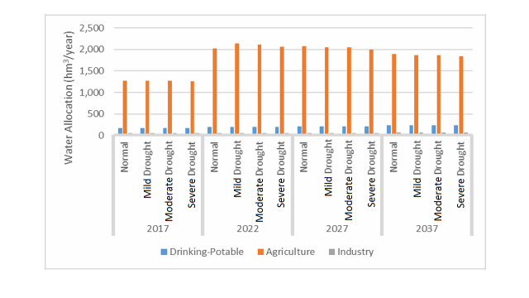
Figure 3. Sectoral Water Allocation

The existing economic value in industry sector of approximately 12 billion TL is expected to reach approximately 31 billion TL by 2037. In Seyhan basin total existing economic value of all sectors of approximately 20 billion TL is expected to reach approximately 44 billion TL by 2037. Drinking-potable water sector, the city center of Adana located in Seyhan sectoral subbasin is the main driver of water consumption and associated economic value. The agriculture sector, the largest irrigated areas located in the Seyhan sectoral subbasin is the main driver of water consumption and associated economic value, but yet is below the economic value generated by the industry sector. The economic value generated in agriculture sector is lower than the economic value of industry sector. This highlights the importance of crop patterns in the agriculture sector to generate a higher level of economic value. This structure needs to support through the use of strategic product policies and associated subsidies. The economic value generated by the industry sector is higher than the economic value of all other sectors in total. Principally the water needs of drinking-potable water and environmental flow are met without giving consideration to the economic value generated due to the use of water resources in these sectors. The economic value generated in each sector is summarized below (Table 3). The economic value of sectoral water allocation for all 16 scenarios is summarized in Figure 4. The irrigation needs, production amount and economic value in Seyhan basin are defined in Figure 5.

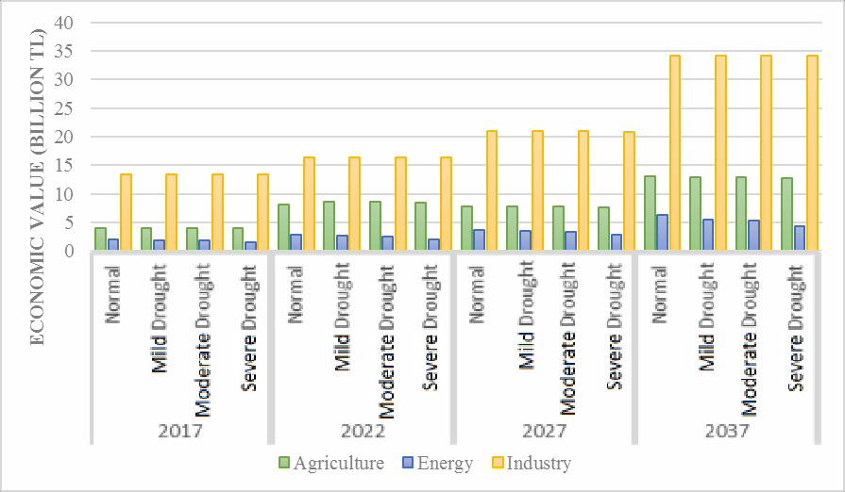Figure 4. Economic value of sectoral water allocation for all 16 scenarios

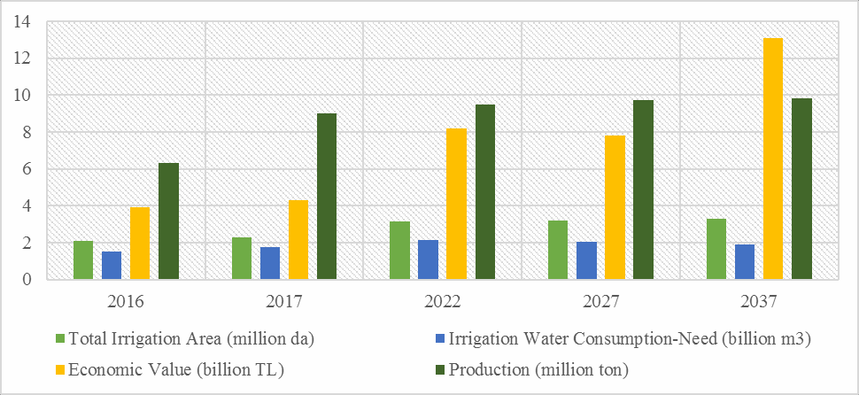
Figure 5. Agriculture Sector Characteristics

Table 3. Consumption, allocation and ratio in water use for agriculture and energy
TERMS | SECTORS | Normal |  |  | Mild Drought |  |  | Moderate Drought |  |  | Severe Drought
 |  | Con. | All. | Ratio | Con. | All. | Ratio | Con. | All. | Ratio | Con. | All. | Ratio
2017 | Agriculture (hm3/year) | 1 345 | 1 269 | 94.4% | 1 345 | 1 268 | 94.2% | 1 345 | 1 267 | 94.2% | 1 345 | 1 259 | 94%
 | Energy (GW-hour) | 6 007 | 5 651 | 94.1% | 6 007 | 5 552 | 92.4% | 6 007 | 5 440 | 90.6% | 6 007 | 4 590 | 76 %
2022 | Agriculture hm3/year | 2 195 | 2 018 | 91.9% | 2 195 | 2 136 | 97.3% | 2 195 | 2 117 | 96.5% | 2 195 | 2 057 | 93.7%
 | Energy (GW-hour) | 7 376 | 6 321 | 85.7% | 7 376 | 5 959 | 80.8% | 7 376 | 5 678 | 77.0% | 7 376 | 4 721 | 64 %
2027 | Agriculture (hm3/year) | 2 239 | 2 070 | 92.5% | 2 239 | 2 042 | 91.2% | 2 239 | 2 048 | 91,4% | 2 239 | 1 994 | 89%
 | Energy (GW-hour) | 7 376 | 6 480 | 87.9% | 7 376 | 6 177 | 83.7% | 7 376 | 5 976 | 81.0% | 7 376 | 4 905 | 67%
2037 | Agriculture (hm3/year) | 2 055 | 1 892 | 92.1% | 2 055 | 1 864 | 90.7% | 2 055 | 1 868 | 90.9% | 2 055 | 1 840 | 90%
 | Energy (GW-hour) | 7 376 | 6 892 | 93.4% | 7 376 | 5 981 | 81.1% | 7 376 | 5 753 | 78% | 7 376 | 4 733 | 64%

Discussion And Conclusion

Sectoral Water Allocation Plan

The purpose of this study is to determine the sectoral water allocation which includes hydrological, environmental, economical, social analysis and optimal demand management for water potential in Seyhan Basin. This study is an example for our country in order to ensure sharing of water resources in the basin scale, planning for the future and fairly meeting the water needs of each sector. The studies were carried out in three stages, namely the current situation analysis, sectoral analysis and the Sectoral water allocation plan, in consideration of the environmental flow need, social objectives and socio-economic benefit analysis. The spatial distribution of surface and groundwater resources and sectoral use in the basin has been determined in the current conditions (2016). Population, environmental flow, sectoral development, sector demand projection and economic analysis have been done. Following, the temporal and spatial distribution of both water resources and sectoral use are determined in future conditions from 2017, to 2037. Lastly, evaluations were made on the most appropriate water allocation taking into account socio-economic benefit optimization.

In the study drinking-potable water consumption was evaluated as first priority. It is followed by environment, agriculture, energy, and industry. The ecosystem water needs also are identified and guaranteed. The environmental flow has been evaluated at the basin scale by using a modeling approach. The quantity and quality of water resources have been evaluated in sectoral allocation of water resources. The spatial and temporal relations are identified for availability and demand of water resources in the context of both quantity and quality. Water consumption, demand, and allocation for all sectors were calculated using numerical models. Environment sector needs were met by considering an integrated approach and integrating water quality, environmental flow, fishery products and wetlands. Crop water requirements are calculated and optimum crop pattern is based. Trend analysis of precipitation was considered for long periods (30 and 50 years). It was considered that year 2017 represents mild drought conditions and 2037 represent severe drought conditions. In the basin scale the economic values of agriculture, industry, the energy associated with the consumption of water resources are determined.

Benefits from water resources were identified by using optimization approach and economic analysis. The sustainable use of water resources is considered for economic development. Optimization of benefits and economic analyses were undertaken in each sector. A comparative analysis of sectoral water consumption, demand, and economic return was implemented by WEAP. Sectoral development projections were identified for each sector and 16 scenarios were improved.

Acknowledgements
This study was supported by General Directorate of Water Management, the Ministry of Forestry and Water Affairs. We would like to thank the executives and the staff of Alfar Project Const. Ind. and Trade. Co. Ltd. who had executed the project.

References

DSI (2014). Master Plan Report for Seyhan River Basin. Devlet Su İşleri Genel Müdürlüğü.

Food and Agriculture Organization of the United Nations (1998). Crop evapotranspiration Guidelines for computing crop water requirements (FAO Irrigation and Drainage paper 56.)

Huber-Lee, A., D. Yates, D. Purkey, W. Yu, B. Runkle, (2003). Water, climate, food, and environment in the Sacramento Basin — contribution to ADAPT: Adaptation strategies to changing environment. Stockholm Environment Institute, Boston, MA, USA.

Intergovernmental Panel on Climate Change (2014). Climate Change 2014: The Physical Science Basis. Contribution of Working Group I to the Fifth Assessment Report of the Intergovernmental Panel on Climate Change, (Cambridge University Press).

McKee, T.B., N.J. Doesken & J. Kleist, (1993). The relationship of drought frequency and duration to time scale. Proceedings of the Eighth Conference on Applied Climatology, California, 1993. Boston, American Meteorological Society, pp. 179–184.)

Psomas, A., Y. Panagopoulos, D. Konsta & M. Mimikou, (2016) Designing water efficiency measures in a catchment in Greece using WEAP and SWAT models (2nd EWAS International Conference).

Raes, D., Mallants, D., & Song, Z., (1996). Rainbow: A software package for Analyzing hydrologic data. (Hydraulic engineering software VI. Southampton, Boston, Mass., Computational Mechanics publications, pp. 525-34.)

Sánchez, R. & G. Schmidt., (2012). Environmental flows in the EU.

Suryawanshi, R. A. & A. J. Shirke, (2014). Watershed Management of Subernarekha River Basin using WEAP, (International Journal of Recent Trends in Science and Technology, Vol. 12, No. 1, pp. 156-163.)
SYGM (2016). Sectorale Water Allocation Plan for Seyhan River Basin. Orman ve Su İşleri Bakanlığı, Su Yönetimi Genel Müdürlüğü.

SYGM, (2016). The Project of Impacts of Climate Change on Water Resources. Orman ve Su İşleri Bakanlığı, Su Yönetimi Genel Müdürlüğü.

SPSS Statistics Base 17.0 User’s Guide (2007). USA, pp. 640.

Tena B. A., Srinivasa Rao G. V. R., Abbulu Y., (2015). WEAP Modeling of Surface Water Resources Allocation in Didessa Subbasin, West Ethiopia, Sustainable Water Resources Management.

Tennant, D.L., (1976). Instream flow regimens for flush, wildlife, recreation and related environment resources (Fisheries, Volume 1, 1976 - Issue 4).

World Meteorological Organization (2012). Standardized Precipitation Index, User Guide.

Extended Turkish Abstract (Genişletilmiş Türkçe Özet)

Sektörel Su Tahsisi Planlaması: Seyhan Havzası Örneği

Bu çalışmanın amacı, Seyhan Havzası yeraltı ve yerüstü su kaynakları için hidrolojik, çevresel, ekonomik ve sosyal analizler yapılarak toplam su potansiyeline uygun talep yönetimini içeren sektörel su tahsis planının hazırlanmasıdır. Su kaynaklarının havza ölçeğinde paylaşımının sağlanması, geleceğe yönelik planlanması ve her sektörün ihtiyacı olan suyun adil bir şekilde karşılanması için bu çalışma ülkemiz açısından örnek teşkil etmektedir. Bilindiği gibi beşeri faaliyetlere bağlı olarak su kaynakları üzerinde kalite ve miktar açısından sistemli ve devamlı artan bir baskı söz konusudur. 2030 yılı itibariyle gıda ve enerji ihtiyaçlarının yaklaşık %50 oranında artacağı, su ihtiyacının ise %40 oranında artacağı öngörülmektedir. Bununla birlikte, iklim değişikliği tahminlerine göre yağışlı bölgelerin daha yağışlı ve kurak bölgelerin daha da kurak olacağı öngörülmektedir. Buna ilaveten, hem atmosferik hem de hidrolojik süreçlerde yaşanan değişimlerinden dolayı havzaların su potansiyeli olumsuz yönde etkilenmekte olup, bu sebeple havzalar arası su transferleri de gündeme gelmektedir. Tüm bu gelişmeler, su kaynakları yönetimini daha da meşakkatli hale getirmektedir. Başarılı bir su yönetimi, arz ve talep değişimlerinin öngörülmesini ve sosyo-ekonomik koşullar dikkate alınarak suyun verimli ve etkin kullanımını gerektirmektedir. Sektörel Su Tahsis Planlaması, su kaynaklarının adil ve dengeli paylaşımını sağlayan bütünleşik bir yönetim sistemidir. Bu kapsamda, su tahsisinin havza bazında ve sektörel ölçekte planlaması, ülkemizde ilk defa Seyhan Havzası’nda gerçekleştirilmiştir. Seyhan Havzası Sektörel Su Tahsis Planında, içme-kullanma, çevresel akış, zirai sulama, sanayi ve enerji sektörlerinin ihtiyaçları dikkate alınmış ve bunlar arasındaki sosyo-ekonomik ilişkiler analiz edilmiştir. Planda, içmesuyu, tarım ve sanayi sektörleri suyu kullanan, enerji sektörü ve çevresel akış ise suyu tüketmeyen ancak suya ihtiyaç duyan sektörler olarak ele alınmıştır. Seyhan Havzası, Türkiye ve Avrupa’nın tarımsal açıdan en verimli bölgelerinden biridir. Biyolojik çeşitlilik bakımından da dünyanın en zengin bölgelerinden biri olan havza; tarım, sanayi, enerji, kentleşme, turizm alanında pek çok faaliyeti barındırmaktadır. Çalışmalar, hem havza bütünü hem de 3 sektörel alt havza ölçeğinde ilgili sektörler dikkate alınarak gerçekleştirilmiştir. Bu sektörel alt havzalar sırasıyla,
- Tarım sektörü faaliyetlerinin yoğun olduğu, su transferinin gerçekleştirildiği Zamantı Sektörel Alt Havzası
- Enerji sektörü faaliyetlerinin yoğun bir şekilde yapıldığı Göksu Sektörel Alt Havzası
- Tarım, sanayi ve enerji sektörü faaliyetlerinin yoğun olduğu, havza içi ve dışına su transferinin gerçekleştirildiği Seyhan Sektörel Alt Havzasıdır.
Çalışmalar, çevresel akış ihtiyacı, sosyal amaçlar ve sosyo-ekonomik fayda analizleri dikkate alınarak, mevcut durum analizi, sectörel analizler, sektörel su tahsis planı hazırlama aşaması olmak üzere 3 aşamada gerçekleştirilmiştir: Mevcut koşullardaki yerüstü ve yeraltı su kaynakları ile sektörel su kullanımlarının havza içerisindeki mekansal dağılımı belirlenmiştir. Mevcut durum analizinde ele alınan konuların birbirleriyle ilişkileri kurulmuştur. Bu kapsamda; nüfus, çevresel akış, sektörel gelişim, sektörlerin su talep projeksiyonu ile tüm bulguların ekonomik analizleri yapılmıştır. Bunu takiben hem su kaynaklarının hem de sektörel su kullanımlarının gelecek koşullarda zamansal ve mekansal dağılımı belirlenmiştir. Gelecek koşulların tanımlanmasında; mevcut durum (2016 yılı), 2017, 2022, 2027 ve 2037 yıllarındaki koşullar esas alınmıştır. Son aşamada ekonomik ve sosyal açıdan en uygun düzey gözetilerek havzanın sektörel su tahsis planına yönelik sentezler ve buna bağlı değerlendirmeler yapılmıştır. Bu kapsamda; Sektörel su tahsis kararlarının açıklandığı, genel ve özel hükümlerin yer aldığı sektörel su tahsis planı hazırlanmıştır. Çevresel, ekonomik, sosyal hedefler ve bu hedeflerin gerçekleştirilmesine esas teşkil eden stratejiler planlama yaklaşımı esasları dikkate alınarak açıklanmıştır. Su kaynakları potansiyeli, değişimi ve sektörel gelişmeler tespit edilerek en faydalı sektörel su kullanım koşulları belirlenmiştir. Proje sürecinde, tahsis planına altlık teşkil eden çevresel, sosyal ve ekonomik değerlendirmeler yapılmıştır. Sözkonusu değerlendirmelerin yapılabilmesi için çeşitli teknik sayısal modelleme araçları kullanılmıştır. Bu kapsamda; Su tahsis modeli çalışmaları için Su Kaynakları Değerlendirme ve Planlama Modeli, WEAP (Water Evaluation and Planning System) (Huber-Lee ve ark., 2003); Çevresel akış ihtiyacının hesaplanmasında Küresel Çevresel Akış Hesaplama Modeli (GEFC), Tennant; Nüfus analizlerinin değerlendirilmesi kapsamında Sosyal Bilimler için İstatistiksel Paket Programı (Statistical Package for the Social Sciences) (SPSS, 2007); Sulama suyu ihtiyaçlarının belirlenmesinde Penman-Monteith yöntemi (FAO), IRSIS yazılımı ve Rainbow programı (Raes ve ark., 1996); ve Sosyo-ekonomik değerlendirmeye yönelik olarak da İstatistiksel yaklaşım ve Ödeme İstekliliği (WTP) metodu kullanılmıştır. Havzanın hidrolojik ve sosyo-ekonomik özelliklerine bağlı olarak kaynakları koruma ve geliştirme ilkeleri esas alınarak; 2017, 2022, 2027, ve 2037 yıllarındaki sektörel gelişim, değişim ve dağılıma göre sektörel su kullanımları, iklim değişikliği ve kuraklık koşulları da dikkate alınarak sektörel su tahsis stratejisi ve planı hazırlanmıştır. Seyhan Havzası’ndaki toplam su kaynakları potansiyeli ve su kaynakları kullanımlarına bağlı olarak sektörel su tahsis miktarları belirlenmiştir. Bu kapsamda elde edilen başlıca sonuçlar şunlardır:
- İçme-kullanma ve Sanayi sektörlerinin su kaynakları ihtiyaçları tüm sektörel alt havzalarda ve tüm yıllarda karşılanmaktadır. Tarım sektörünün gelecek yıllardaki su kaynakları ihtiyaçları yıllar içerisinde % 90 (2037 yılı) ile % 94 (2017 yılı) mertebesinde karşılanmaktadır. Çevre sektörünün temel ihtiyacı olan C sınıfı çevresel yönetim sınıfı için belirlenen su kaynakları ihtiyaçları tüm sektörel alt havzalarda ve tüm yıllarda karşılanmaktadır.
- Enerji sektöründe mevcut koşullarda Seyhan Havzası’nın toplam enerji üretimi olan 6 007 GW-saat, işletme modeli kullanılarak 5 650 GW-saat olarak % 94 seviyesinde karşılanmıştır. Enerji sektörünün gelecek yıllardaki su kaynakları ihtiyaçları % 85 (2022 yılı) ile % 94 (2017 yılı) mertebesinde karşılanmaktadır.
- İçme-kullanma ve sanayi sektörlerinin su kaynakları ihtiyaçları tüm sektörel alt havzalarda ve tüm yıllarda karşılanmaktadır.
- Havza genelinde mevcut durumda tüm sektörlerde üretilen toplam ekonomik gelir yaklaşık 20 milyar TL iken, yapılan analizler neticesinde elde edilen optimizasyon sonuçlarına göre 2037 yılında bu değer yaklaşık 44 milyar TL’ye ulaşmaktadır.

Total Number of Words: | 5187
Total Number of Words in Extended Abstract: | 847

