The Synthesis of D-π-D Derivate Phthalocyanines for Dye-Sensitized Solar Cell, Investigation of Spectroscopic and Electrical Properties
I. Erden^{1,}*, K. Caktı¹, F. Aytan Kılıçarslan¹
¹Yıldız Technical University, Department of Chemistry, 34220 İstanbul, TURKEY
ierden@yildiz.edu.tr

Abstract
We report on photovoltaic cell devices based on metallo phthalocyanine structures, such as zinc and nickel phthalocyanines (ZnPc and NiPc), which are formed by 4-(Diphenylamino) benzaldehyde containing substituents D-π-D features were synthesized and used for dye-sensitized solar cells (DSSCs). These novel compounds were characterized by using FTIR, UV-vis, MS spectroscopic data and elemental analysis. Furthermore, the relationship between ZnPc and NiPc morphology and photovoltaic properties are discussed. Among ZnPc and NiPc, the ZnPc-DSSC exhibited significantly excellent photovoltaic activities under radiation of visible light. In this case, photovoltaic cell efficiencies are up to 1.139% for ZnPc, compared to an average of 0.427% for NiPc. Moreover, the ZnPc device prepared at room temperature exhibits relatively higher photovoltaic cell efficiency (PCE) because of the significant improvements in short-circuit photocurrent (J_{sc}) and open-circuit voltage (V_{oc}). However, a DSSC assembled with NiPc material due to metallic behavior of nickel in the structures electrochemical reactions run at the interface between NiPc and back contact, which causes electrochemical corrosion of metal. Thus NiPc-DSSC shows lower photovoltaic properties than ZnPc-DSSC.

Keywords: Phthalocyanine; Triphenylamine; DSSC; Fluorescence

* Corresponding author. Tel: +90 212 3837070 Ex: 4170; Fax: +90 212 3834011
E-mail address: ierden@yildiz.edu.tr

- Introduction
Dye-sensitized solar cells (DSSCs) demonstrated by Grätzel’s group have attracted considerable interest for the conversion of sunlight to electricity. As a key part of DSSCs, the dyes take the function of light absorption and injection of the photo excited electrons to the conduction band of the semiconductor in the anode. Phthalocyanines (Pcs), a family of aromatic macrocycles based on an extensive delocalized 18π electron system have been extensively studied due to their unique optical, electronic, catalytic and structural properties [1-4]. Over the past decade the use of phthalocyanine molecule (Pc) and its derivatives have been an important class of dyes due to the possibility to fabricate them in photovoltaic devices suitable for a variety of technological applications. There have been two kinds of dyes, namely, metal-organic complexes and metal-free organic dyes [5-7]. Up to now, polypyridyl ruthenium (II) complex-based dyes have exhibited conversion efficiencies over 10% for solar power to electricity in the standard DSSCs with an I⁻/I₃⁻ solution electrolyte, owing to their broad metal-to-ligand charge-transfer (MLCT) absorption bands and chemical stability of photo excited states [8,9].

Metallo phthalocyanine structures have been proved as highly promising photo sensitizers for photovoltaic applications due to their intense absorption in the red/near -IR region of the visible light. Furthermore, metallo phthalocyanines have attracted significant interest because of their unique physico-chemical properties and potential applications [10,11]. In addition, besides these properties, metallo phthalocyanine revealed molecular stability, negligible toxicity and high thermal stability. ZnPc and NiPc and their derivatives possess a wide visible light response range between 600-800nm [12-14].

In the work presented in this paper we investigated the feasibility of fabricating D-π-D solar cells using small soluble metal-organic molecules (dyes) and discuss their (J-V) characteristics. Using phthalocyanine-dyes investigated different types of device structures.
Among the organic dyes, triphenylamine (TPA) and imine group as donor units have displayed promising properties in the development of photovoltaic devices. In this study, these groups were substituted at peripheral position of phthalocyanine framework. Experimental studies confirm that larger π-conjugated bridge and richer electron donor of the dyes are beneficial for the photovoltaic performance of the DSSCs [15-18]. These different architectures have been developed in the past to meet the specific requirements for efficient charge separation and charge transport in organic solar cells.

- Experimental procedure
2.1 Materials
All reagents and solvents were of reagent grade quality and were obtained from commercial suppliers. Triphenylamine (TPA) was purchased from Merck. The FTIR spectra were recorded on a spectrum one Perkin Elmer 1600 FTIR spectrophotometer, using ATR. ¹H NMR spectra were recorded on a Bruker Avance III 500 MHz spectrometer in CDCl₃, and chemical shifts were reported (δ) relative to Me₄Si as internal standard. Absorption spectra were recorded with an Agilent 8453 UV-visible spectrophotometer. The elemental analyses and Bruker Microflex LT MALDI-TOF mass spectra were determined in the TUBITAK Laboratory (Center of Science and Technology Research of Turkey). Fluorescence excitation and emission spectra were recorded on a Varian Eclipse spectra fluorometer using 1 cm path length cuvettes at room temperature.

2.2 Fabrication of Dye-Sensitized Solar Cells
The dye-sensitized TiO₂ electrodes were prepared by following the procedure reported in the literature [19]. Briefly, a double layer of TiO₂ particle (~ 10 µm) was screen-printed on the indium tin oxide (ITO) coated glass (12-14 Ω per square, TEC 15, USA). After that, the TiO₂ thin-film electrodes were sintered at 450 ºC for 30 min and used as the photoelectrode. After cooling to room temperature, the TiO₂ thin-film electrodes were immersed in a CHCl₃ solvent containing 3x10⁻⁶ mol L⁻¹ dye sensitizers for at least 24 h, then rinsed with anhydrous CHCl₃ to remove any unadsorbed dye and used as such for photovoltaic measurements. The composition of electrolyte 0.5 M potassium iodide and 0.05 M iodine were mixed in pure ethylene glycol as described by Smestad [20].

2.3 Photovoltaic performance of DSSCs
The current density versus voltage (J-V) characteristic of the cells were measured in the dark and under simulated ABET 1.5G solar illumination by using a Keithley 2400 Digital Source Meter at room temperature. Incident power was adjusted by using a calibrated silicon photodiode to match 1-sun intensity (100 mW/cm²). The cell area of sample is 1.62 cm². The electrical performance of a solar cell is determined by the short-circuit current (I_{sc}), open-circuit voltage (V_{oc}), current at the maximum power point (I_{mp}), voltage at the maximum power point (V_{mp}), maximum power (P_{max}), fill factor (FF) and cell efficiency (η). The solar cell efficiency and fill factor are calculated using the Eq.1 and Eq.2 equations, respectively:

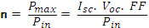 (1)

where the FF is most commonly determined from measurement of the IV curve, is given by

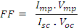 (2)

2.4 Synthesis
The starting compounds 4-(Diphenylamino)benzaldehyde was synthesized and purified according to well-known literature [21]. The synthetic route of phthalonitrile and Zn(II), Ni(II) phthalocyanine derivatives is shown in Schema 1.
Schema 1. Synthetic pathway of tetra-[4-(diphenylamino)benzylidene] amino substituted phthalonitrile and Zn(II), Ni(II) phthalocyanines derivatives.

4-[(diphenylamino)benzylidene]imino phthalonitrile (1)
4-aminophthalonitrile (0.22 g, 1.83 mmol) was dissolved in 10.0 mL dry toluene under N₂ atmosphere, and of 4-(Diphenylamino)benzaldehyde (0.50 g, 1.83 mmol) was added to mixture. The reaction mixture was stirred under N₂ at 120 ºC for 24 h and progress of the reaction was monitored by TLC on silica, methanol/chloroform 1:5. The solvent was evaporated to 1/2 of the initial volume.
A yellow precipitate was obtained when the solution was cooled to room temperature. The precipitate was filtered, washed by cold toluene, dried under vacuum and purified by chromatography over a silica gel column a mixture of methanol:chloroform (1: 5 by volume) as eluents. Yield: 0.42 g, 73.32 %. Calc. for C₂₇H₁₈N₄: C, 81.39; H, 4.55; N, 14.06 %, Found: C, 81.44; H, 4.38; N, 14.11 %. FT-IR (KBr), υ/cm⁻¹: 3080-3040 (aromatic-CH), 2975-2858 (aliphatic-CH₂), 2226 (C≡N), 1627 (C=N), 1156 (C-N). ¹H NMR (CDCl₃): δ (ppm) 8.21 (s, H, HC=N), 7.20 (s,H), 6.90 (d,2H), 7.38-7.60, (d, 4H), 7.1-7.8 (m, 10H): Q-TOF (m/z): 398.45 [M+H] ⁺.
4-[(diphenylamino)benzylidene]imino phthalocyaninato Zn(II) (2)
The 4-[(diphenylamino)benzylidene]imino phthalonitrile (1) (0.50 g, 1.25 mmol) and Zn(OAc)₂ 2H₂O (0.135 g, 0.62 mmol) in n-pentanol (1.0 mL), in the presence of a drop of 1.8-diazabicyclo[5.4.0]undec-7-ene (DBU) was heated and stirred at 140 ºC for 6 h under N₂. Yield: 0.060 g, 40.32 %. Calc. for C₁₀₈H₇₂N₁₆: C, 78.18; H, 4.37; N, 13.51 %, Found: C, 78.27; H, 4.28; N, 13.34 %. FT-IR (KBr), υ/cm⁻¹: 3076-3042 (aromatic-CH), 2977-2859 (aliphatic-CH₂), 1624 (C=N), 1168 (C-N). MALDI-TOF (m/z): 1659.34 [M + H]⁺
4-[(diphenylamino)benzylidene]imino phthalocyaninato Ni(II) (3)
The 4-[(diphenylamino)benzylidene]imino phthalonitrile (1) (0.50 g, 1.25 mmol) and anhydrous Ni(OAc)₂ 2H₂O (0.155 g, 0.62 mmol) in n-pentanol (1.0 mL), in the presence of a drop of 1.8-diazabicyclo[5.4.0]undec-7-ene (DBU) was heated and stirred at 140 ºC for 8 h under N₂. Yield: 0.055 g, 38.82 %. Calc. for C₁₀₈H₇₂N₁₆: C, 78.50; H, 4.39; N, 13.56 %, Found: C, 78.40; H, 4.51; N, 13.54 %. FT-IR (KBr), υ/cm⁻¹: 3078-3041 (aromatic-CH), 2974-2855 (aliphatic-CH₂), 1622 (C=N), 1165 (C-N). MALDI-TOF (m/z): 1652.52 [M + 2H]⁺.
- Results and Discussion
The synthesis of new symmetrical metallo phthalocyanine was completely characterized by FTIR, UV-Vis, H NMR, MS, as well as fluorescence spectroscopies. Electronic spectra are especially useful to establish the structure of the metallo phthalocyanine. The ground state electronic absorption spectra of the Zn(II) and Ni(II) phthalocyanines as depicted in Fig. 1 and Fig. 2, respectively. The typical UV-vis absorption spectrum of metallo phthalocyanines exhibited a characteristic by a single Q band in the visible region at 600 nm and 800 nm. It is attributed to the π→π* transitions from the highest occupied molecular orbital (HOMO) to the lowest unoccupied molecular orbital (LUMO) of the Pc²⁻ ring. The absorption spectra of the as-synthesized dyes CHCl₃, CH₂Cl₂, THF, DMF solution, with two distinct absorptions around 320-390 nm and 650-780 nm. The absorption band around 320-390 nm was assigned to a π→π* transition; while the absorption band with λ_{max} around 650-780 nm corresponded to an intramolecular charge transfer between the TPA donor part of the molecule and the 18 π electron systems of phthalocyanine.

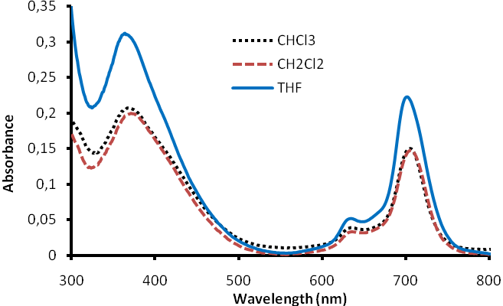
Fig. 1. UV-vis absorption spectra of compound 2
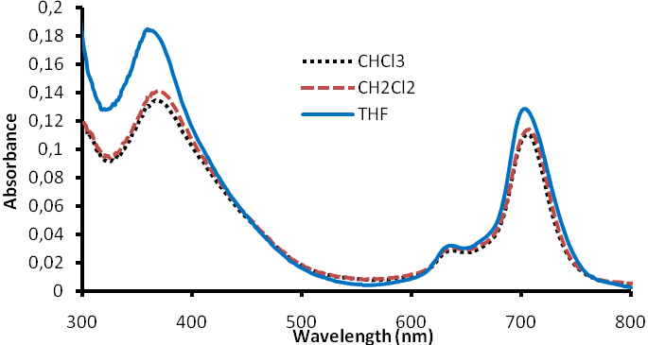
Fig. 2. UV-vis absorption spectra of compound 3

FTIR spectroscopy has been proved the nature of metallo phthalocyanine in tetrapyrrole sandwich complexes. The characteristic vibrations corresponding to C≡N were observed at 2226 cm⁻¹ for 1 in the FTIR spectra. The strong C≡N vibrations of 1 were disappeared after conversion to the ZnPc and NiPc. The imines (C=N) vibrations for compounds 2 and 3 were observed at 1624-1622 cm⁻¹, respectively.

In addition to these verifying results for the structures, the MALDI-TOF mass spectra of compounds (1, 2 and 3) gave the characteristic molecular ion peaks at m/z: 398.45 [M+H]⁺, 1659.34 [M + H]⁺, 1652.52 [M + 2H]⁺ respectively, confirming the proposed structures Schema 1.
Fig.3 indicates the J-V curves under simulated sunlight and in the dark. It can be seen from Table 1 that the cell efficiency with V_{oc} and J_{sc} has the maximum cell efficiency value in ZnPc derivative in DSSC than NiPc derivative.

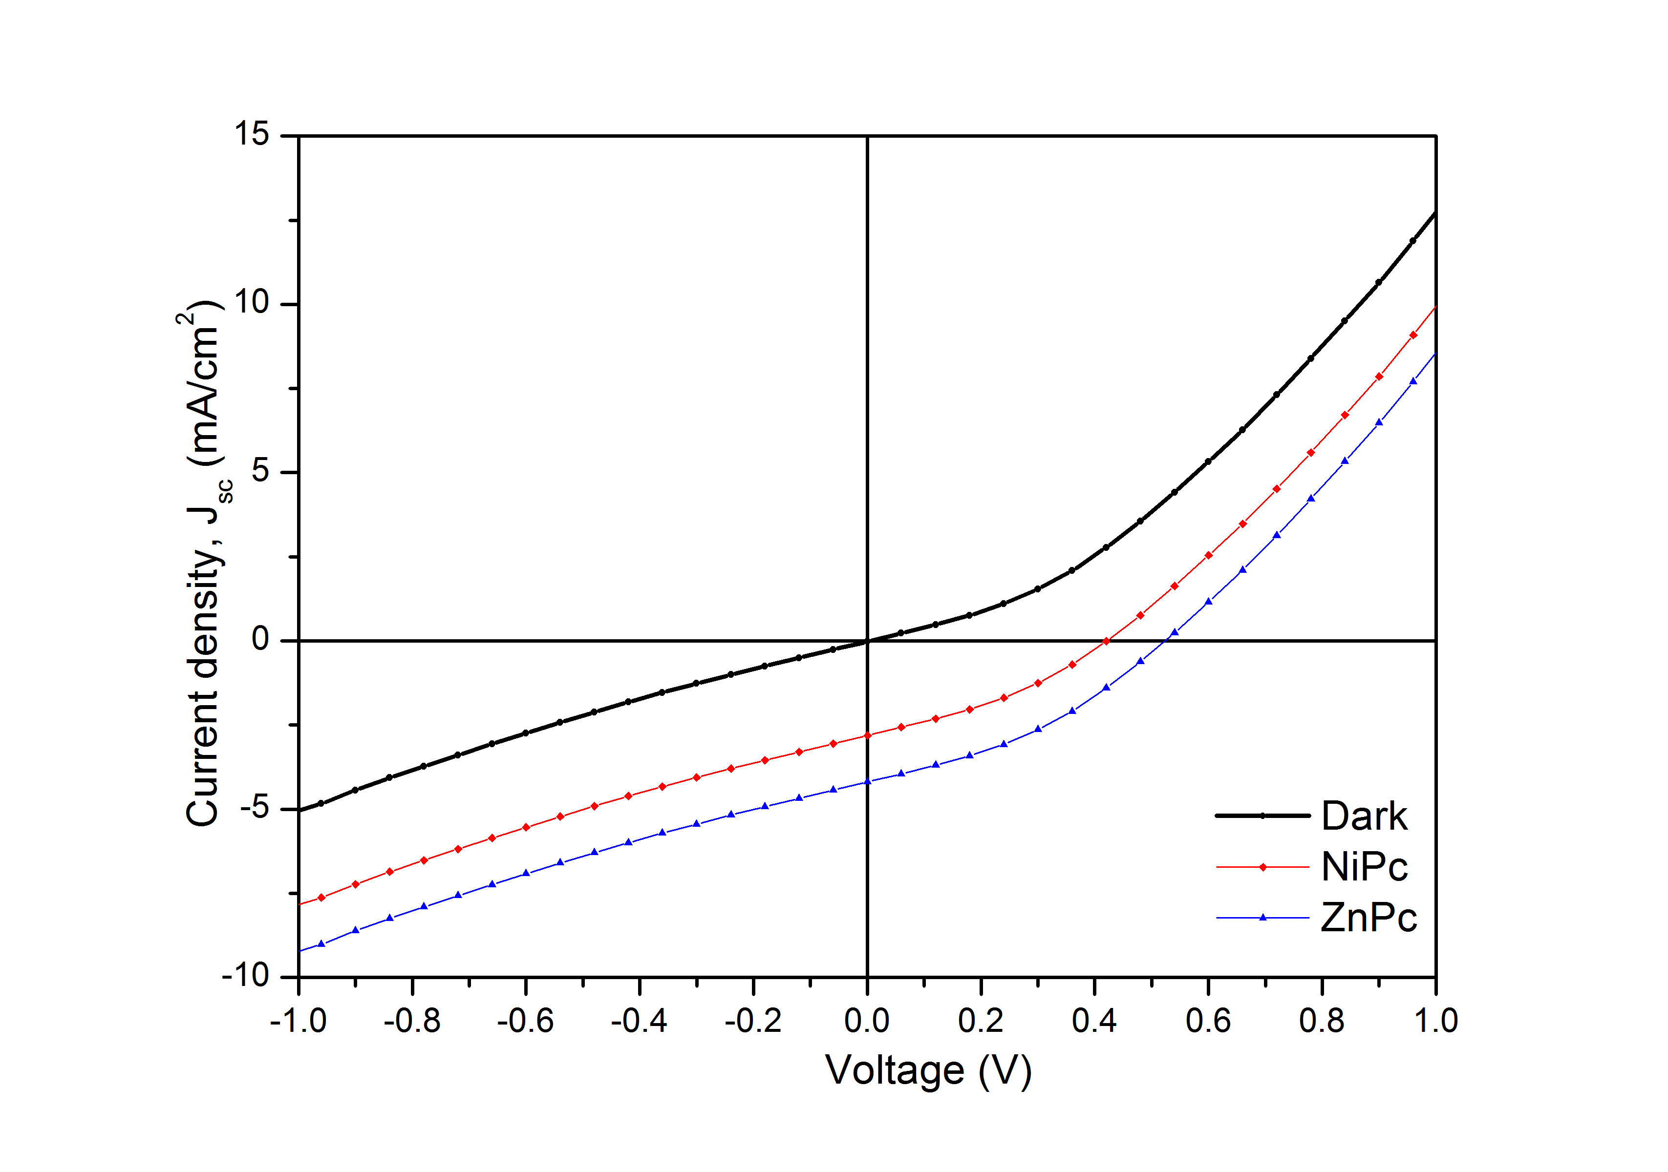

Fig. 3. Photocurrent density vs. voltage curves for ZnPc-DSSC and NiPc-DSSC
The DSSC parameters, the saturation current density (Jsc), and the open circuit voltage (Voc), of the devices with an effective area of 1.62 cm² are represented in Fig. 4. By using the values of these parameters, the other parameters such as the fill factor (FF), the conversion efficiency (η), the current density and the open circuit voltage at the maximum power (Jmp, Vmp), of the devices were calculated and summarized in Table 1. The FF and η were determined using the Eq.1 and Eq.2 as described above in detail. A DSSC assembled with NiPc material had a V_{oc} of 0.422V and Jsc of 2.821 mA/cm² at an incident light intensity of 100 mW/cm². The cell efficiency of the NiPc material was 0.427%. However, it reached 1.139% in the DSSC made from the ZnPc photovoltaic film. From this result, it was confirmed that ZnPc based DSSC has a better photovoltaic device than NiPc based DSSC. Moreover, it is revealed that ZnPc is the most common donor materials in small molecule organic photovoltaic devices.
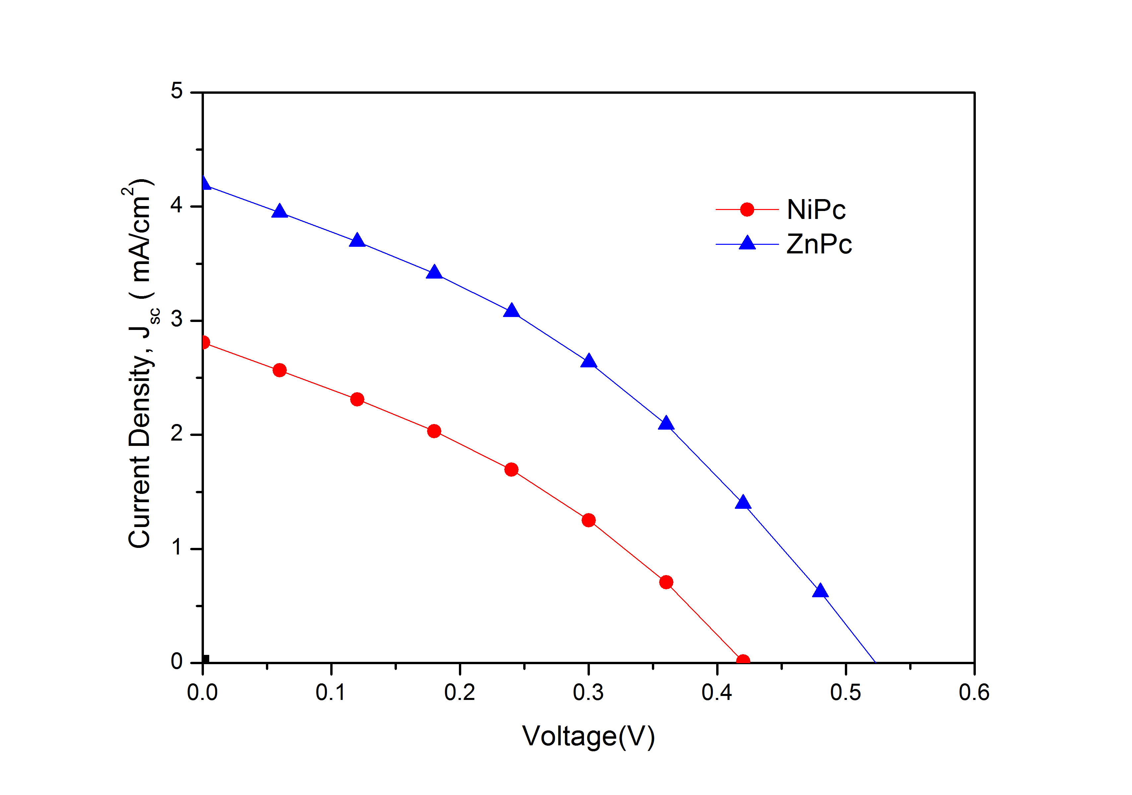
Fig. 4. J-V characteristics of the DSSCs based on NiPc and ZnPc.

Table 1. Photovoltaic performance parameters of the DSSCs based on ZnPc and NiPc.

Sample Name | J_{sc} (mA/cm²) | V_{oc} (V) | FF | η (%)
NiPc | 2.821 | 0.422 | 0.359 | 0.427
ZnPc | 4.206 | 0.527 | 0.514 | 1.139

In the literature these photovoltaic cell efficiency (PCE) value are compatible with ZnPc and NiPc derivatives in DSSC. Ying Zhou et al [25] has reported that organic photovoltaic devices using ZnPc prepared at room temperature with different growth rate show same V_{oc} of 0.40 V, while higher growth rate also slightly enhance the J_{SC} and FF, resulting in a higher PCE of 1.02%. Moreover, Jaron G. Van Dijken et.al [26] has investigated that photovoltaic cell efficiencies are up to 3.0%, compared to an average of 2.3% when using chlorobenzene (CB) as the solvent on the same film, and 2.3% also for bilayer devices when using dichlorobenzene (DCB) as the solvent. Therefore, one can say that the value of cell efficiency depending on structure of film, rough surface, best solvent choice and exposure time. Besides Y. Wan et al has reported that as-prepared ZnPc/MWCNTs composites displayed much higher photovoltaic activity than pure ZnPc under visible light irradiation. Hence they obtained a strong correlation between conduction mechanism and the ZnPc/MWCNTs with high photovoltaic activity will greatly promote their industrial application to eliminate the organic pollutants from wastewater [27].

According to Fig. 4 and the results given in Table 1, important outcome can be deduced. Type of the dye; using of ZnPc and NiPc clearly enhanced the properties of the DSSC device. All the parameters of the DSSC devices with ZnPc increased. This may be due to the better light harvesting capacity of ZnPc in the visible region and a broadened absorption band after using ZnPc.

Fig.5 indicates the I-V curve in the dark (black) and under illumination (red and blue) in logarithmic scale. The black curve is the dark current with a Jsc of 1.22 mA/cm² at -1V. The red (NiPc) and blue (ZnPc) curves are the photocurrent measured with a V_{oc} of 0.422V and J_{sc} of 2.821 mA/cm² and a V_{oc} of 0.527V and Jsc of 4.206 mA/cm² at an incident light intensity of 100 mW/cm².
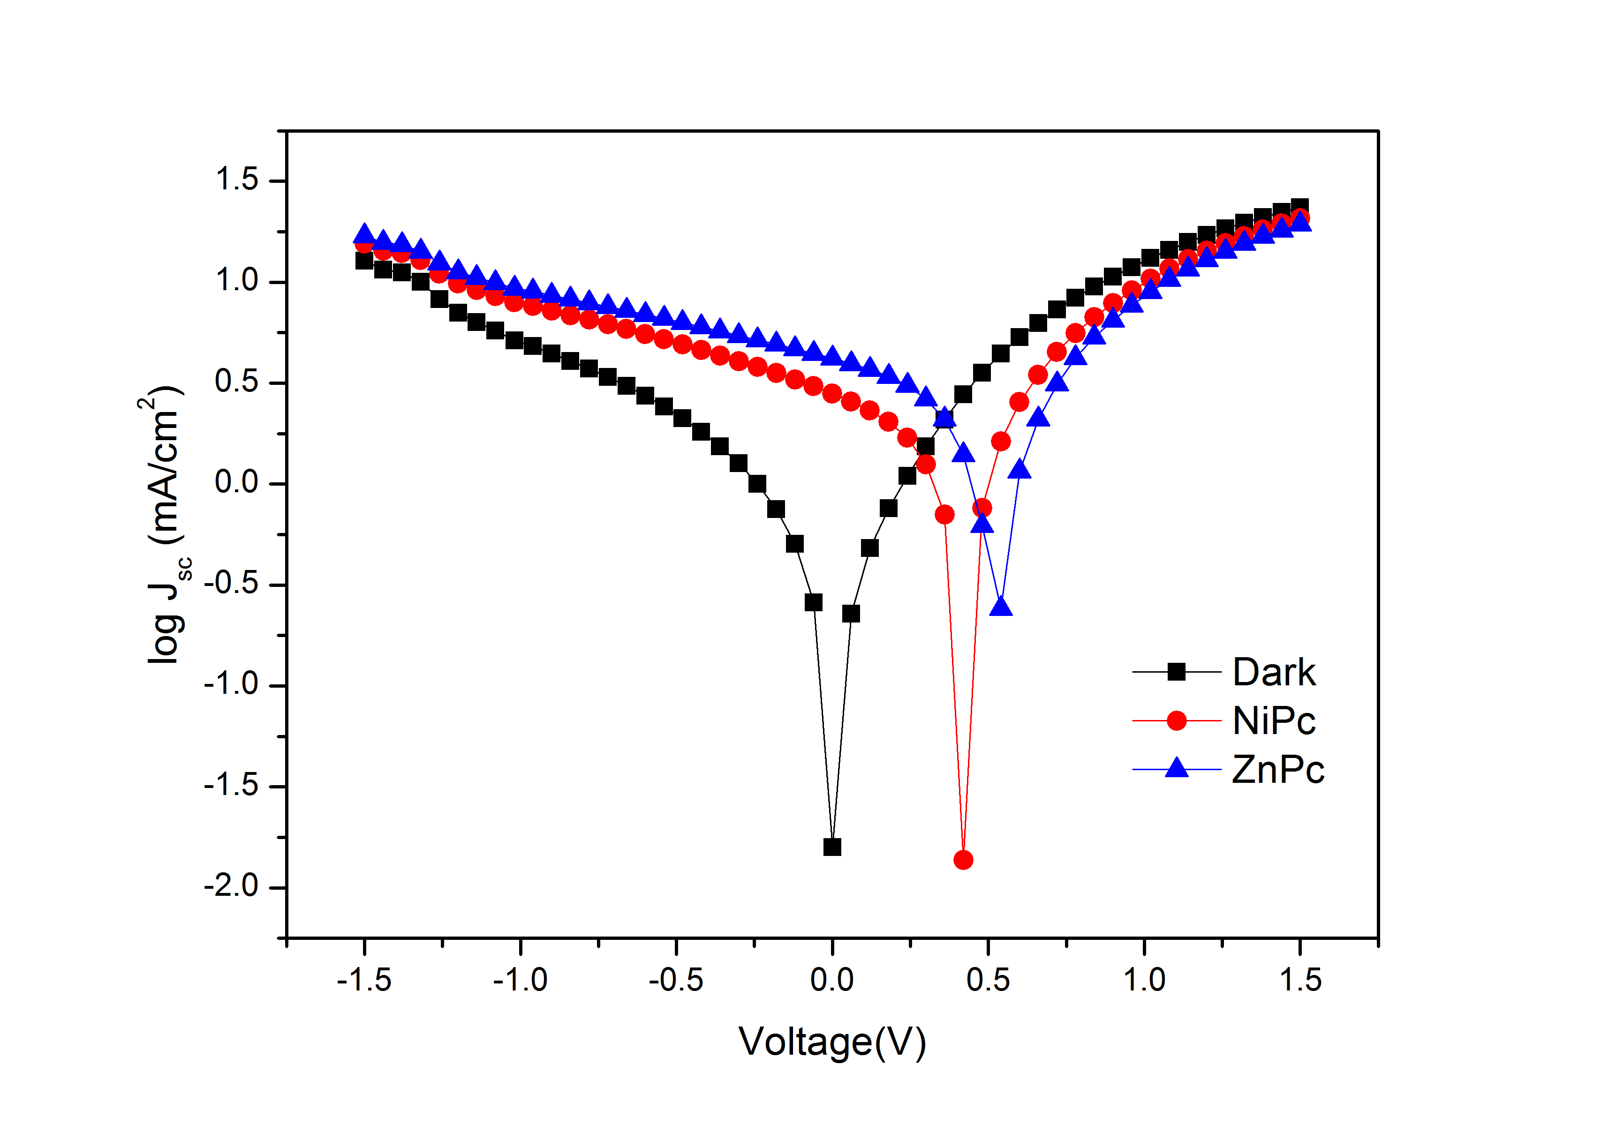
Fig.5. I-V characteristic of DSSC based on NiPc and ZnPc in semi-log plot.

Clearly, the present results indicate that ZnPc in DSSC plays a significant role in improvement of PV device performances. However NiPc derivative in DSSC due to metallic behavior of nickel in the structures electrochemical reactions run at the interface between nickel phthalocyanine and back contact, which causes electrochemical corrosion of metal.

Aggregation is mostly described as a coplanar association of rings progressing from monomer to dimer and higher order complexes. It is dependent on the concentration, nature of the solvent, nature of the substituent, complexes metal ions and temperature. High aggregation tendency of phthalocyanine compounds due to the interactions between their 18 π-electron systems often cause weak solubility or insolubility in many solvents. The spectroscopic, photophysical, photochemical and electrochemical properties of the phthalocyanines were seriously affected by the aggregation [25-26]. In this study, the aggregation behaviors of phthalocyanines compounds were investigated in different solvents such as CHCl₃, CH₂Cl₂, DMF and THF. All the synthesized metallo phthalocyanines did not any aggregation in CHCl₃, CH₂Cl₂, DMF and THF.

The aggregation behavior of phthalocyanines compounds were also studied at different concentrations for determination of the aggregation depends on concentration in CHCl₃ Fig. 6, 7. Metallo phthalocyanines did not show any aggregation concentration ranges between 10x10⁻⁶-20x10⁻⁶ M and 2x10⁻⁵-12x10⁻⁵ M.

For complexes 2 and 3, as the concentration was increased, the intensity of absorption of the Q band also increased in parallel and there were no new bands (normally blue shifted), which might be attributed to aggregated species, were observed.
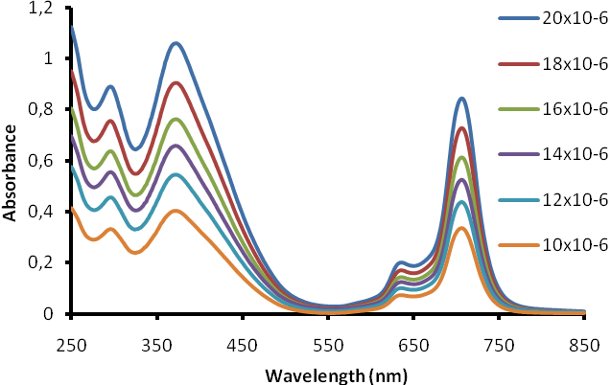
Fig. 6. UV-vis absorption spectra of compound 2 in CHCl₃ at different concentration.
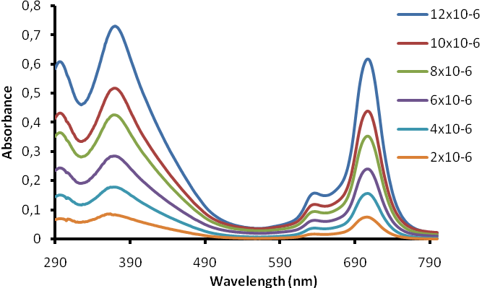
Fig. 7. UV-vis absorption spectra of compound 3 in CHCl₃ at different concentration.

Fig. 8 and 9 shows absorption, fluorescence emission and excitation spectra of metallo phthalocyanines (2,3) were obtained at room temperature in CHCl₃, CH₂Cl₂, THF. The fluorescence emission maximum was observed at 721 nm for 2, 721 nm for 3 in CHCl₃. The excitation spectrum obtained by exciting emission maximum shows a maximum at 704 nm for 2, 714 nm for 3 in CHCl₃. The observed Stokes shifts were within the region observed for metallo phthalocyanines [27].

The fluorescence excitation and emission spectra of the complexes are typical phthalocyanines complexes, with Stokes shifts (λ_{emis}- λ_{exc}) ranging from 18 to 7 nm. The fluorescence quantum yields (Φ_{Φ}) of zinc (II) (2) and nickel (II) (3) phthalocyanines were studied in CHCl₃. As shown in Table 2, the Φ_{Φ} value of zinc (II) and nickel (II) phthalocyanine complexes are lower than typical of phthalocyanine complexes.
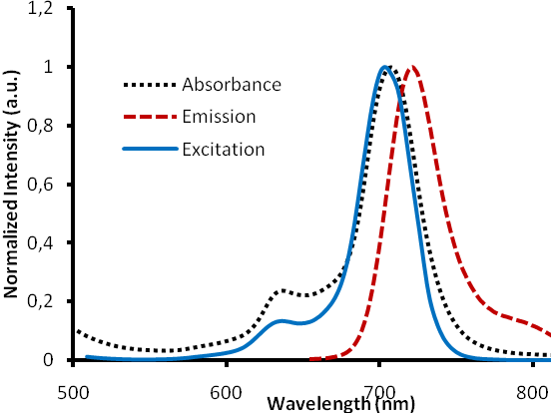
Fig. 8. Absorption, excitation and emission spectra of the compounds 2 in CHCl₃
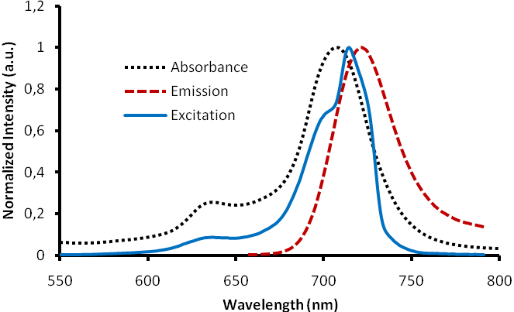
Fig. 9. Absorption, excitation and emission spectra of the compounds 3 in CHCl_{3.}

Table 2. Absorption, emission and excitation spectral data for compounds 2 and 3 in different solvents.
Sample | Solvent | λ_{B} (Abs)/ nm | λ_{B} (Ems) /nm | λ_{B} (Exc) / nm | ∆λ_{Stokes}/nm | Φ_{Φ}
Zn | CHCl₃ | 706 (4.36) | 721 | 704 | 17 | 0.0134
 | CH₂Cl₂ | 706 (4.34) | 721 | 704 | 17 | 0.0273
 | THF | 701 (4.38) | 721 | 703 | 18 | 0.0040
Ni | CHCl₃ | 707 (4.71) | 721 | 714 | 7 | 0.0247
 | CH₂Cl₂ | 707 (4.58) | 722 | 714 | 8 | 0.0222
 | THF | 704 (4.62) | 724 | 717 | 7 | 0.0134

Conclusion
In this study, we have successfully designed Zn (II) and Ni (II) phthalocyanine complexes that contain donors with triphenylamine and tetrapyrroles bridged by an imine fragment. Metallo phthalocyanines derivatives in polar organic solvents are enhancing. The spectral and fluorescence properties of the metallo phthalocyanines were investigated in CHCl₃, CH₂Cl₂, THF. The metallo phthalocyanines did not show any aggregation concentration ranges between 10x10⁻⁶- 20x10⁻⁶ M and 2x10⁻⁵-12x10⁻⁵ M. The fluorescence quantum yields (Φ_{Φ}) value of zinc (II) and nickel (II) phthalocyanine complexes are lower than typical of phthalocyanine complexes. Fluorescence emission peaks were observed two the complexes feature similar fluorescence emission. Photovoltaic performance in our ZnPc and NiPc in DSSCs appears to be strongly related to their structure, morphology and rough surface. Our best result in this work is achieved with a ZnPc film in DSSC, which exhibits photovoltaic efficiency of up to 1.139% whereas NiPc film in a DSSC shows photovoltaic efficiency of 0.427%. It was confirmed that ZnPc metallo phthalocyanine in DSSC is a better device than NiPc in DSSC. Further modifications on electron donor and π-conjugation system of these two compounds which may improve the solar cell performance are in progress and will be published soon.

Acknowledgements
This research has been supported by the Scientific and Technological Research Council of Turkey (TUBITAK), Project Number: 113Z910 project

References
- B. O’Regan, M. Gratzel, “A low-cost, high-efficiency solar cell based on dyesensitised colloidal TiO₂ films”, Nature, 353 (1991), 737-740.

- M. Gratzel, “Dye-sensitized solar cells”, Journal of Photochemistry and Photobiology C: Photochemistry Reviews, 4 (2003), 145-153.

- R.K. Kanaparthi, J. Kandhadi, L. Giribabu “Metal-free organic dyes for dye-sensitized solar cells” Tetrahedron, 68 (2012), 8383-8393

- G. Wu, F. Kong, J. Li, W. Chen, X. Fang, C. Zhang, Q. Chen, X. Zhang, S. Dai, “Influence of different acceptor groups in julolidine-based organic dye-sensitized solar cells”, Dyes and Pigments, 99 (2013), 653-660.

- A. Kay, M. Graetzel, “Photosensitisation of TiO₂ solarcells with chlorophyll derivatives and related natural porphyrins” J.Phys. Chem., 97(23) (1993).6272-6277.

- H. Tributsch, "Dye sensitization solar cells: a critical assessment of the learning curve", Coordination Chemistry Reviews, 248(13) (2004), 1511-1530.

- L. Wang, M. Liang, Y. Zhang, F. Cheng, X. Wang, Z. Sun, S. Xue, “Influence of donor and bridge structure in D-A-π-A indoline dyes on the photovoltaic properties of dye-sensitized solar cells employing iodine/cobalt electrolyte”, Dyes and Pigments, 101 (2014), 270-279.

- Hwang S, Lee J.H., Park C., Lee H., Kim C., Park C., Lee M.H., Lee W., Park J., Kim K., Park N.G., Kim C., “A highly efficient organic sensitizer for dye-sensitized solar cells” Chem.Commun., 14(46) (2007) 4887-4889.

- P.C. Kao, S.Y. Chu, S.J. Liu, Z.X. You, C.A.Chuang, “Improved Performance of Organic Light-Emitting Diodes Using a Metal-Phthalocyanine Hole-Injection Layer”, Journal of the Electrochemical Society, 153(6) (2006) 122-126.

- M. Yanagisawa, F. Korodi, J. Bergquist, A. Holmberg, A. Hagfeldt, B. Akermark, L.C.Sun, “Synthesis of Phthalocyanines with two Carboxylic Acid Groups and Their Utilization in Solar Cells Based on Nanostructured TiO₂”, Journal of Porphyrins and Phthalocyanines, 8(10) (2004) 1228-1235.

- S. Kim, D. Kim, H. Choi, M.S. Kang, K. Song, S. O. Kang and J. Ko, “Enhanced photovoltaic performance and long-term stability of quasi-solid-state dye-sensitized solar cells via molecular engineering”, Chem. Commun., (2008) 4951-4953.

- Z. Ji, K. Yu-He, L. Hai-Bin, G. Yun, W. Yong, S. Zhong-Min, “How to design proper p-spacer order of the D-π-A dyes for DSSCs, A density functional response”, Dyes and Pigments, 95(2012) 313-321.

- Y. Wu, W. Zhu “Organic sensitizers from D–π–A to D–A–π–A: effect of the internal electron-withdrawing units on molecular absorption, energy levels and photovoltaic performances” Chem Soc Rev, 42 (2013) 2039-2058.

- W. Ling, S. Ping, C. Zhencai, L. Xinping, H. Yuanshuai, L. Chunyan, C. Pan, Z. Bin, TT. Songting, “Effects of the acceptors in triphenylamine-based D-π-A-π-A dyes on photophysical, electrochemical, and photovoltaic properties”, Journal of Power Sources, 246 (2014) 831-839.

- J.L. Song, P. Amaladass, S.H. Wen, K.K. Pasunooti, A. Li, Y.L. Yu, et al. “Aryl/hetero-arylethyne bridged dyes: the effect of planar π-bridge on the performance of dye sensitized solar cells” New J Chem, 35 (2011) 127-136.

- S. Ping, L. Xinping, J. Shenghui, W. Ling, Y. Ling, Y. Dandan, Z. Bin, T. Songting, “Synthesis of new N, N-diphenylhydrazone dyes for solar cells: Effects of thiophene-derived π-conjugated bridge”, Dyes and Pigments, 92 (2012) 1042-1051.

- A. Erdogmus, Nyokong T., “Synthesis of zinc phthalocyanine derivatives with improved photophysicochemical properties in aqueous media”, Journal of Moleculer Structure, 977 (2010) 26-38.

- A. Erdogmus, Nyokong T., “New soluble methylendioxy-phenoxy-substituted zinc phthalocyanine derivatives: Synthesis, photophysical and photochemical studies” Polyhedron, 28(14) (2009) 2855-2862.

- L. Hu, S. Dai, J. Weng, S. Xiao, Y. Sui, Y. Huang, “Microstructure design of nanoporous TiO₂ photoelectrodes for dye-sensitized solar cell modules” J. Phys. Chem. B 111 (2006) 358-362.

- G.P. Smestad, “Education and solar conversion: demonstrating electron transfer” Solar Energy Materials and Solar Cells 55 (1998) 157-168.

- J.B. Yuan, M.L. Louis, M. Gong, Tetrahedron Letters 45 (2004) 6361
- Z. Ying et al., “Controlled growth of ZnPc thin films for photovoltaic appplications” Physics Procedia 14 (2011) 221-252.

- J. G. van Dijken, M. D. Fleischauer, and M. J. Brett, “Solvent effects on ZnPc thin films and their role in fabrication of nanostructured organic solar cells,” Organic Electronics, 12(12) (2011) 2111-2119.

R. Zhou, F. Josse, W. Göpel, Z.Z Öztürk and Ö. Bekaroğlu, “Phthalocyanines as sensitive materials for chemical sensors” Appl. Organometallic Chem. 10(8) (1996) 557-577.
- M. Liang, W. Xu, F. Cai, P. Chen, B. Peng, J. Chen, Z. Li, “New Triphenylamine-Based Organic Dyes for Efficient Dye-Sensitized Solar Cells”, J., Phys. Chem. C.111(2007) 4465-4472.

- A. Erdogmus, M. Sharon, L. Christian, T. Nyokong, "Photophysical properties of newly synthesized fluorinated zinc phthalocyanines in the presence of CdTe quantum dots and the accompanying energy transfer processes", Journal of Photochemistry and Photobiology A: Chemistry, 210 (2010) 200-208.

- A. Erdogmus, T. Nyokong, “Synthesis, photophysical and photochemical properties of novel soluble tetra[4-(thiophen-3yl)-phenoxy]phthalocyaninato zinc(II) and Ti(IV)O complexes” Inorganica Chimica Acta, 362 (2009) 4875-4883.

