 

**Synthesis of 2,3-Dihydroxypropyl-Sulfanyl Derivative Nonionic Surfactants and Their Inhibition Activities Against Metal Corrosion in Acidic Media**

Serkan Öztürk*, Sebghatullah Mudaber, Ayhan Yıldırım

Uludağ University, 16059, Bursa, Turkey

*Corresponding author. Serkan Öztürk. E-mail: serkanozturk@uludag.edu.tr

**Abstract:** Metallic corrosion is one of the most important problem in various industrial fields. One of the most effective methods to deal with metallic corrosion is to design and use appropriate organic corrosion inhibitors. In the present study, various amide-based, sulfur-containing nonionic surfactants were synthesized and characterized by spectroscopic methods. The corrosion inhibition properties of these synthesized compounds were investigated. For this purpose, mild steel coupons were immersed for 24 hours at room temperature in 1 M HCl containing different concentrations of inhibitor according to the ASTM NACE / ASTMG31-12a standart method. As a result of these corrosion tests, the synthesized compounds exhibited very good inhibitory properties (76.58-93.74 *IE*%). Surface characterization studies were also performed for the metal coupons to support the obtained corrosion inhibition efficiency results.

**Keywords:** Metal corrosion; non-ionic surfactant; acidic medium; SEM.

**INTRODUCTION**

Corrosion is the change of physical, chemical and mechanical properties of materials as a result of chemical and electrochemical reactions with the influence of environment [1]). If the material consists of metals and alloys, then it can be used as metal corrosion and can be defined as corrosion of metal or metal alloys by oxidation or other chemical effects. Corrosion is an undesirable phenomenon, causing economic loss for every country. As a result of corrosion, a large portion of iron and steel is lost annually or becomes unusable. The metal, which is lost after the corrosion, causes economic losses at much higher cost than its own cost. On the other hand, corrosion losses affect not only the iron and steel industry but also the efficiency of all the investments being made by utilizing this industry, and it is a topic that interests the country's economy. Corrosion is also a cause of damage to human life and health and environmental pollution as well as material losses.

The corrosion phenomenon in the metals consists of two electrochemical reactions that proceed in the same way as oxidation in the anode, reduction in the cathode. Elements inducing to corrosion (metal, anodic reaction, cathodic reaction and electrolyte) must be in one piece for the formation of metallic corrosion at the electrode / electrolyte interface, which is called the electrical interface.

Acid cleaning (pikling), which is an extremely effective surface cleaning method, is frequently used in Industry to clean the rust and foreign materials on the metal surface. The most commonly used acids in this cleaning process are HCl and H2SO4 solutions [2]. During the cleaning process with acid, metal corrosion occurs on the metal surface over time. In the cathode reaction of the metal corrosion in the acidic medium, hydrogen ions from the acid are reduced to form H2 gas. The most common method for inhibiting or reducing metal corrosion in the acidic environment is the use of inhibitors. Corrosion inhibitor is a substance that significantly reduces corrosion rate when added at low concentrations.

Researches made in recent years have discovered that surfactants can be used as inhibitors against metal corrosion. In particular, it has been proven in scientific studies that nonionic surfactants are effective inhibitors against metal corrosion in acidic environments [3-7]. In light of this, in this study (2,3-dihydroxypropyl) sulfanyl derivatized three nonionic surfactants containing long carbon chain amide functional group were synthesized and their corrosion inhibition efficiencies against metallic corrosion in acidic medium were investigated.

**MATERIALS AND METHODS**

**Materials and Instrumentation**

Reagents and solvents were purchased from Merck (Germany). Thermo Nicolet 6700 FT-IR spectrometer was used for FT-IR spectra. 1H-NMR and 13C-NMR spectra were measured using Agilent 600 MHz Premium Compact NMR spectrometer in DMSO using TMS as the internal standard. The elemental analyses were performed using an LECO CHNS-932 elemental analyzer.

**Synthesis of Compounds**

**Synthesis of 2-chloro-*N*-alkylacetamides (1a-c):** The octylamine, decylamine, dodecylamine and chloracetyl chloride compounds used as starting materials in the synthesis were purchased from Merck (Germany). Synthesis of the 2-chloro-N-octyl, -decyl and dodecylacetamide compounds obtained from the reaction of each amine compound with chloroacetyl chloride was carried out as previously reported in the literature [8, 9].

**Synthesis of 2-[(2,3-dihydroxypropyl)sulfanyl]-*N*-octylacetamide (2a):** In a round-bottom reaction flask 0.27 g (4.76 mmol) of KOH was dissolved in absolute ethanol and 0.52 g (4.76 mmol) of 3-mercapto-1,2-propandiol was added gradually to the reaction flask. The mixture was stirred for about 10 minutes and then 0.98 g (4.76 mmol) of 2-chloro-*N*-octylacetamide (**1a**) was added slowly to the flask. The reaction mixture was stirred overnight at room temperature. At the end of the reaction, ethanol was evaporated in an evaporator, the residue was dissolved in dichloromethane and extracted with water. The organic phase was dried over sodium sulfate, and the solvent was removed with a rotary evaporator. The residue was crystallized from petroleum ether / ethyl acetate to give white solid product. Yield (0.69 g, 52%); mp 64-65 ◦C.

**Synthesis of 2-[(2,3-dihydroxypropyl)sulfanyl]-*N*-decylacetamide (2b):** 0.32 g (5.69 mmol) of KOH, 0.62 g (5.69 mmol) of 3-mercapto-1,2-propandiol and 1.33 g (5.69 mmol) of 2-chloro-*N*-decylacetamide (**1b**) were used for the synthesis. The same experimental procedure as used in the synthesis of compound **2a** was carried out. Yield (0.97 g, 56%); mp 66-67 ◦C.

**Synthesis of 2-[(2,3-dihydroxypropyl)sulfanyl]-*N*-dodecylacetamide (2c):** 0.43 g (7.66 mmol) of KOH, 0.83 g (7.66 mmol) of 3-mercapto-1,2-propandiol and 2.0 g (7.66 mmol) of 2-chloro-*N*-dodecylacetamide (**1c**) were used for the synthesis. The same experimental procedure as used in the synthesis of compound **2a** was carried out. Yield (2.0 g, 79%); mp 79-79 ◦C.

**Corrosion Tests Performed in Acidic Media**

**Preparations of Coupons and Acidic Solutions**

Gravimetric measurements were performed using coupons made from cold-rolled low-carbon steel and possessed DIN EN 10130 technical conditions [10] with a composition of 0.07 % C, 0.35 % Mn, 0.015 % P and 0.015 % S. The coupons were cut into rectangular shapes of 0.1 x 2.2 x 5.0 cm in thickness, width and length, respectively. Before the immersion test, the coupons were immersed in 15 % HCl, polished lightly with paper tissue, washed with deionized water and immersed in acetone. 1.0 M HCl solution was prepared from the concentrated HCl (37 %) (Merck grade).

**Weight Loss Measurements**

The synthesized cationic surfactants with the concentration of 25, 50, 100, 150 and 250 ppm were tested to determine the inhibition efficiency in 100 mL 1.0 M HCl solution. All of the corrosion inhibitors were directly dissolved in the acid solution. The treatment solutions were poured into 150-mL sealed glass bottles, and the coupons were suspended in these solutions without stirring for 24 h at room temperature. Control tests were performed in the same way without the inhibitors. After the corrosion test, the coupons were removed, rinsed with water and wiped with paper tissues. Then, they were washed with acetone and dried to a constant weight in an oven [11, 12].

**SEM**

The carbon steel specimens (of a size of 0.1 cm x 2.0 cm x 2.0 cm) were abraded with emery paper and then were washed with distilled water and acetone. After immersion in 1.0 M HCl with and without the addition of 250 ppm of the prepared inhibitors at room temperature for 24 h, the steel specimens were cleaned with distilled water and dried in a vacuum desiccator, and then, the surface was evaluated using a Carl Zeiss EVO 40 (SEM).

**RESULTS AND DISCUSSION**

**Synthesis of nonionic surfactants**

The synthesis scheme of the designed and synthesized organic nonionic surfactants to test corrosion inhibition in acidic media is given in Scheme 1. As seen in Scheme 1, the synthesis of organic surfactants was carried out in two steps. In the first step, the long chain amine compound was reacted with chloroacetyl chloride in the presence of triethylamine to synthesize 2-chloro-N-alkylacetamides (**1a-c**). In the second step, 2-chloro-N-alkylacetamides (**1a-c**) were reacted under basic medium with 3-mercapto-1,2-propanediol in alcohol to obtain the nonionic surfactants (**2a-c**).



**Scheme 1.** Synthetic pathways for the preparation of (**2a-c**).

The structures of the nonionic were conﬁrmed by FT-IR, 1H NMR and 13C NMR spectroscopic methods. The spectral data of **2a**, **2b** and **2c** compounds are shown in Table 1. FT-IR, H-NMR and C-NMR spectra of compound **2b** as spectrum samples are given in Figure 1. The FT-IR spectra of (**2b**) showed absorption bands at 3332 cm-1, due to the -OH groups, at 3266 cm-1, due to the amide N-H group, at 1638 cm-1, due to the amide C=O group, and at 698 cm-1, due to the CH2-S-CH2 group. The 1H NMR spectrum of (**2b**) showed a triplet peak at δ = 6.83 ppm for the amide-NH (HN–CO) proton, a sextet peak at δ = 3.85 ppm for the S–CH2–CH–OH proton, a doublet peak at δ = 3.70 ppm for the S–CH2–CH–OH proton, a doublet peak at δ = 3.68 ppm for the HO–CH2–CH–OH proton, a singlet peak at δ = 3.26 ppm for the HN–CO–CH2–S protons and a quartet peak at δ = 3.24 ppm for the CH2–HN–CO protons. The peak attributed to the HN–CO–CH2–S protons at 3.26 ppm is the evidence that the nucleophilic substitution reaction between **1b** and 3-mercapto-1,2-propandiol was successfully actualized. The formation of the compound 2b have been proved by the peak showed at 36.24 ppm for the carbon atom in the C-NMR spectrum.

**Table 1.** Spectral data of compound **2a, 2b** and **2c**

|  |  |
| --- | --- |
| **Compound** | **Spectral Data** |
| **2a** | FT-IR (KBr), v/cm-1 : 3336 (-OH), 3268 (amide N-H), 2919 and 2852 (aliphatic C ̶ H), 1639 (amide C=O), 1548 (second amide band, N-H bending), 697 (CH2-S-CH2)  1H NMR (600 MHz, CDCl3): *δ* (ppm) = 6.87 (t, 1H, HN–CO), 3.84 (quin., 1H, S–CH2–CH–OH), 3.68 (d, 1H, S–CH2–CH–OH), 3.66 (d, 1H, HO–CH2–CH–OH), 3.56 (dd, 2H, HO–CH2–CH–OH), 3.26 (s, 2H, HN–CO–CH2–S), 3.24 (quartet, 2H, CH2–HN–CO), 2.69 (d, 2H, CO–CH2–S–CH2–CH–OH), 1.50 (quin., 2H, CH2–CH2–HN–CO), 1.32–1.22 (m, 10H, –(CH2)5–), 0.86 (t, 3H, CH3)  13C NMR (150 MHz, CDCl3): *δ* (ppm) = 169.65 (HN–CO–CH2–S), 71.24 (S–CH2–CH–OH), 65.29 (HO–CH2–CH–OH), 40.04 (CH2–HN–CO), 36.35 (HN–CO–CH2–S), 36.19 (CO–CH2–S–CH2), 31.74 (CH3–CH2–CH2–), 29.37 (CH3–(CH2)2–CH2–), 29.20 (CH3–(CH2)3–CH2–), 29.16 (CH3–(CH2)5–CH2–CH2–HN–CO), 26.90 (CH3–(CH2)4–CH2–(CH2)2–HN–CO), 22.59 (CH3–CH2–), 14.04 (CH3–CH2–) |
| **2b** | FT-IR (KBr), v/cm-1 : 3332 (-OH), 3266 (amide N-H), 2917 and 2851 (aliphatic C ̶ H), 1638 (amide C=O), 1551 (second amide band, N-H bending), 698 (CH2-S-CH2)  1H NMR (600 MHz, CDCl3): *δ* (ppm) = 6.83 (t, 1H, HN–CO), 3.85 (sextet, 1H, S–CH2–CH–OH), 3.70 (d, 1H, S–CH2–CH–OH), 3.68 (d, 1H, HO–CH2–CH–OH), 3.56 (dd, 2H, HO–CH2–CH–OH), 3.26 (s, 2H, HN–CO–CH2–S), 3.24 (quartet, 2H, CH2–HN–CO), 2.70 (d, 2H, CO–CH2–S–CH2–CH–OH), 1.51 (quin., 2H, CH2–CH2–HN–CO), 1.32–1.22 (m, 14H, –(CH2)7–), 0.87 (t, 3H, CH3)  13C NMR (150 MHz, CDCl3): *δ* (ppm) = 169.61 (HN–CO–CH2–S), 71.17 (S–CH2–CH–OH), 65.25 (HO–CH2–CH–OH), 40.04 (CH2–HN–CO), 36.34 (HN–CO–CH2–S), 36.18 (CO–CH2–S–CH2), 31.85 (CH3–CH2–CH2–), 29.52 (CH3–(CH2)2–CH2–), 29.39 (CH3–(CH2)5–CH2–), 29.26 (CH3–(CH2)7–CH2–CH2–HN–CO), 26.91 (CH3–(CH2)6–CH2–(CH2)2–HN–CO), 22.63 (CH3–CH2–), 14.06 (CH3–CH2–) |
| **2c** | FT-IR (KBr), v/cm-1 : 3332 (-OH), 3265 (amide N-H), 2917 and 2850 (aliphatic C ̶ H), 1638 (amide C=O), 1551 (second amide band, N-H bending), 698 (CH2-S-CH2)  1H NMR (600 MHz, CDCl3): *δ* (ppm) = 6.74 (t, 1H, HN–CO), 3.85 (sextet., 1H, S–CH2–CH–OH), 3.70 (d, 1H, S–CH2–CH–OH), 3.68 (d, 1H, HO–CH2–CH–OH), 3.57 (dd, 2H, HO–CH2–CH–OH), 3.26 (s, 2H, HN–CO–CH2–S), 3.25 (quartet, 2H, CH2–HN–CO), 2.71 (d, 2H, CO–CH2–S–CH2–CH–OH), 1.51 (quin., 2H, CH2–CH2–HN–CO), 1.32–1.24 (m, 18H, –(CH2)9–), 0.87 (t, 3H, CH3)  13C NMR (150 MHz, CDCl3): *δ* (ppm) = 169.52 (HN–CO–CH2–S), 71.12 (S–CH2–CH–OH), 65.27 (HO–CH2–CH–OH), 40.04 (CH2–HN–CO), 36.34 (HN–CO–CH2–S), 36.27 (CO–CH2–S–CH2), 31.85 (CH3–CH2–CH2–), 29.51 (CH3–(CH2)2–CH2–), 29.40 (CH3–(CH2)7–CH2–), 29.26 (CH3–(CH2)9–CH2–CH2–HN–CO), 29.25 (CH3–(CH2)3–(CH2)4–(CH2)4–HN–CO), 26.90 (CH3–(CH2)8–CH2–(CH2)2–HN–CO), 22.63 (CH3–CH2–), 14.06 (CH3–CH2–) |

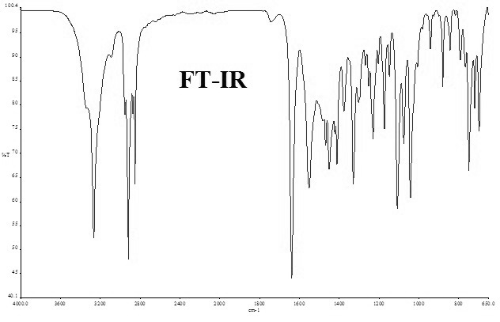

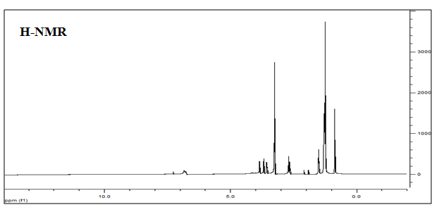

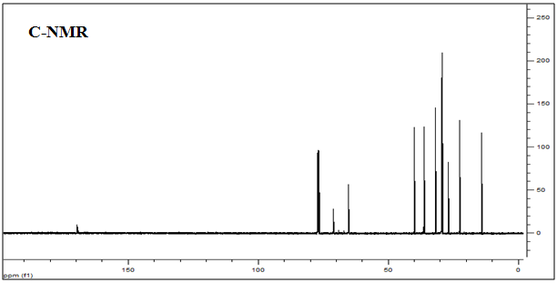

**Figure 1.** FT-IR, H-NMR and C-NMR spectra of(**2b**).

**Corrosion tests in acidic media**

Corrosion tests in acidic media (1.0 M HCl) were performed using weight loss measurements according to the ASTM NACE / ASTMG31-12a standart method [13]. The corrosion test results of the synthesized **2a-c** surfactants in 1.0 M HCl corrosive media are shown in Table 2. In the corrosion tests, corrosion inhibitors were directly dissolved in the acid solution. Corrosion inhibition capabilities of the synthesized compounds tested in 1.0 M HCl are given as percentage inhibition efﬁciencies (IE %). Percentage inhibition efﬁciencies were calculated using the following Eq. 1:

(1)

$$IE \%= \frac{Wo-W}{Wo} x 100$$

where (IE %) is the percentage inhibition efﬁciency, Wo is the weight loss of the coupon in the absence of an inhibitor and W is the weight loss of the coupon in the same environment in the presence of an inhibitor. The corrosion rate (CR) values that are given in Table 2, are derived from Eq. 2 [14-16]:

(2)

$$CR= \frac{∆W}{A t}$$

where, ΔW is the weight loss (mg); A is the area of the coupon (cm2) and t is the immersion time (hr).

**Table 2** Weight loss, corrosion rate and corrosion inhibition efficiencies (*IE%)* for varying concentrations of compounds **2a-c** in 1.0 M HCl medium for 24 h at room temperature

|  |  |  |  |  |  |  |  |  |  |
| --- | --- | --- | --- | --- | --- | --- | --- | --- | --- |
| ***Concentration***  ***(ppm)*** | ***Weight loss***  ***(mg cm -2) a*** | | | ***Corrosion Rate***  ***(mg cm -2 hr -1)***  ***x 10 -2*** | | | ***Inhibition Efficiency***  ***(IE%)*** | | |
| **2a** | **2b** | **2c** | **2a** | **2b** | **2c** | **2a** | **2b** | **2c** |
| 0 | 12.50 | 12.50 | 12.50 | 52.08 | 52.08 | 52.08 | — | — | — |
| 25 | 2.93 | 1.12 | 1.25 | 12.20 | 4.66 | 5.19 | 76.58 | 91.05 | 90.04 |
| 50 | 2.32 | 1.04 | 0.90 | 9.66 | 4.32 | 3.75 | 81.45 | 91.71 | 92.80 |
| 100 | 1.42 | 0.93 | 1.07 | 5.91 | 3.86 | 4.47 | 88.65 | 92.58 | 91.42 |
| 150 | 1.35 | 0.91 | 1.24 | 5.61 | 3.79 | 5.15 | 89.24 | 92.73 | 90.11 |
| 250 | 0.78 | 0.85 | 0.83 | 3.26 | 3.52 | 3.45 | 93.74 | 93.24 | 93.38 |

When Table 2 is examined, it can be seen that at high concentrations, 3 surfactants exhibit very good inhibition activity. It was determined that the corrosion resistance of the 3 compounds at 250 ppm inhibitor concentration was almost the same. However, it has been found that the inhibitory activities of compounds **2b** and **2c** are close to each other in all studied inhibitor concentrations. Furthermore, compound **2a** showed lower corrosion inhibition activity at lower concentrations than compounds **2b** and **2c**. The reason for this is that the long carbon chain of compound **2a** is shorter than the other two compound. As the long carbon chain in the inhibitor molecules grows, more effective protection against corrosion is achieved, especially at low concentrations. However, as the inhibitor concentration increases, the increase in inhibition activity is an expected result. Because, the inhibition efficiency generally increases with the increasing of the inhibitor concentration. On the other hand, as seen in Table 2, the weight loss and corrosion rates in the inhibitor medium are considerably lower than in the uninhibited environment. All these results demonstrate that the synthesized nonionic surfactants are effective against metal corrosion.

**SEM**

Surface analysis with scanning electron microscopy is important in terms of the interaction of organic molecules with the metal surface and the observation of the morphological changes occurring on the surface of the metal. As for this purpose, scanning electron microscope images were recorded to verify the interaction of the synthesized nonionic surfactants with the metal surface (Figure 2). The SEM image of Figure 2a, which was taken from the 1,000 x magnified surface, show the feature of the steel surface after immersion in 1.0 M HCl at room temperature for 24 h in the absence of inhibitor. Figures 2b, 2c and 2d, which were also taken from the 1,000 x magnified surface, show the features of the steel surface after immersion in 1.0 M HCl at room temperature. As seen in Figure 2a, wear was observed on the entire surface of the metal exposed to the acid environment without the inhibitor. It is clear that corrosion products are accumulated on the metal surface due to corrosion and therefore the surface becomes rough. On the other hand, there is no wear or roughness on the metal surfaces exposed to the inhibitor-containing acid environment. The scratch marks on the metal surfaces are due to the sanding process made before the test. This proves that the inhibitor molecules are adsorbed to the metal surface and protect the surface against corrosion in HCl media. As a result, the metal surface images obtained from the SEM device support the high inhibition activity results given in Table 2.

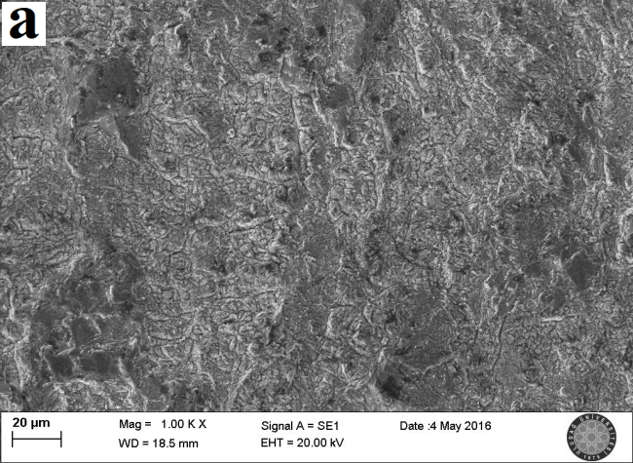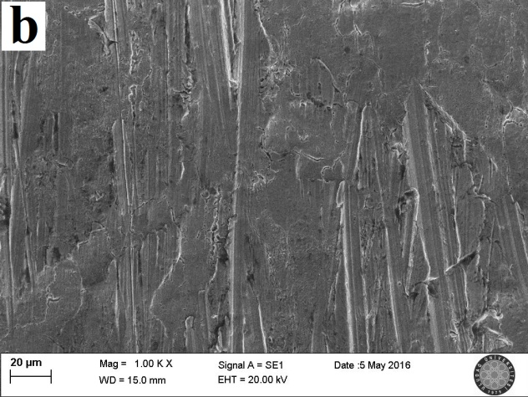

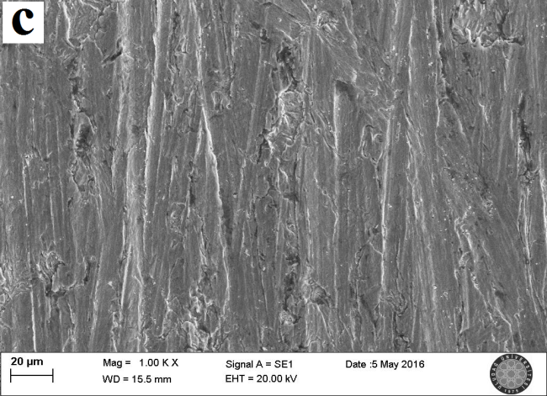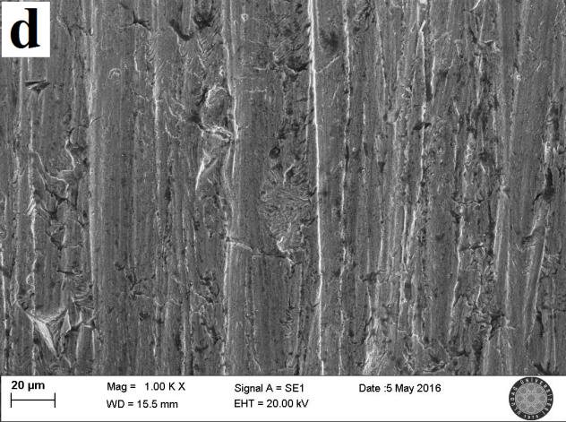

**Figure 2.** SEM images of the metal coupon surfaces immersed in 1.0 M HCl for 24 h. **a** without inhibitor 1,000x, **b** 250 ppm (**2a**) 1,000x, **c** 250 ppm (**2b**) 1,000x, **d** 250 ppm (**2c**) 1,000x

**Corrosion inhibition mechanism**

In order for an inhibitor to exhibit activity against corrosion,

* It must be sufficiently well dissolved in the corrosive electrolyte medium
* It has to close the active centers which form relatively weak spots on the material surface
* It needs to adsorb onto the surface well and cover the entire surface
* It must cut through the contact of the surface or active centers with the corrosive solution

When the structures of the synthesized nonionic surfactants are examined,

* There are two hydroxyl groups to facilitate dissolution in water
* There are N, O and S heteroatoms in their structure. Through these heteroatoms, they adsorb to the metal surface by chemical adsorption and reduce the adverse effect of the acidic corrosive environment on the metal surface by closing the active centers on the surface.
* They contain a hydrophobic group (long carbon chain) which prevents the contact of the corrosive environment with the metal surface. The long carbon chain pushes water molecules and prevents the acidic aqueous solution from approaching the surface. However, the long alkyl chains enter non-polar interaction with each other due to the van der Waals attraction forces, and as a result of this interaction, they provide more effective protection on the metal surface against corrosive medium.

The orientations of the inhibitor molecules at the metal-acidic solution interface and the possible inhibition mechanism are shown in Figure 3. As can be seen, molecules are found in an upright position in the metal surface which provides maximum protection. Expecially, to form bilayer or multimolecular layers, the hydrophobic tail of the surfactant molecule is oriented perpendicularly to the metal surface. This layers, designated as protective layers, behave as barrier between the metal and the corrosive medium [12].

F:\Casper Belgeler (13.04.2017)\6. Fiziksel Kimya Kongresi 2017 (to serisi)\Makale Taslağı (to serisi)\İngilizce\mek to.tif

**Figure 3.** Possible orientation of non-ionic surfactant molecules between the metal–acidic solution interfaces.

In figure 3, it can also be seen that nonionic surfactant molecules are adsorbed on the metal surface via N and S heteroatoms with chemical adsorption. The chemical adsorption occurs via the interactions between the unpaired electrons of the heteroatoms and the vacant d-orbitals of Fe. Through this chemical adsorption, coordination bonds occur between the heteroatom and iron [17]. In addition, intermolecular H-bonds are formed via hydroxyl groups, which increase the stability of the protective layer. The formation of the hydrogen bond and the van der Waals interactions between the hydrophobic groups increase with increase of the inhibitor concentration. This leads to better protection of the metal surface and increased the inhibition efficiency of the non-ionic surfactants [18, 19].

**ConclusIons**

2,3-dihydroxypropyl-sulfanyl derivatized three nonionic surfactants containing long carbon chain amide functional group were synthesized as potential corrosion inhibitors for mild steel in 1M HCl acidic media. From the results, we can conclude the following:

* All of the non-ionic surfactants exhibited good corrosion inhibition at high inhibitor concentrations.
* The corrosion inhibition efficiencies of the synthesized compounds generally increased with the increase in inhibitor concentration.
* In the corrosion inhibition mechanism, the adsorption of the synthesized non-ionic surfactants to the metal surface was performed via chemical adsorption.
* The SEM images supported the inhibition results obtained by weight loss measurements.

**CONFLICT OF INTEREST**

The authors declare no conflict of interest.

**REFERENCES**

1. Görenler A. Al-Si Matrisli Kompozit Malzemelerin Korozyon Davranışlarının İncelenmesi. Yıldız Teknik Üniversitesi, Fen Bilimleri Entüsü, Yüksek Lisans Tezi, 2007 İstanbul.

2. Bereket G, Pinarbasi A. Inhibition effect of some heterocyclic compounds on pure aluminium in 0.1 M hydrochloric acid solution. Corrosion. 2008 16: 17-22.

3. Yıldırım A, Çetin M.Synthesis and evaluation of new long alkyl side chain acetamide, isoxazolidine and isoxazoline derivatives as corrosion inhibitors. Corros Sci. 2008 Jan; 50:155–165 DOI: 10.1016/j.corsci.2007.06.015.

4. Negm N A, Kandile N G, Badr E A, Mohammed M A.Gravimetric and electrochemical evaluation of environmentally friendly nonionic corrosion inhibitors for carbon steel in 1 M HCl. Corros. Sci. 2012 Dec; 65:94-103. DOI: 10.1016/j.corsci.2012.08.002

5.Hegazy M A, El-Tabei A S, Ahmed H M.Synthesis of nonionic surfactants and their inhibitive action on carbon steel in hydrochloric acid.Corros.Sci.2012 Nov; 64:115-125 DOI: 10.1016/j.corsci.2012.07.004

6. El-Tabei A S, Hegazy M A.A corrosion inhibition study of a novel synthesized gemini nonionic surfactant for carbon steel in 1 M HCl solution. J. Surfact. Deterg. 2013 Sep;16:757-766. DOI: 10.1007/s11743-013-1457-1

7. Sobhi M, El-Sayed R, Abdallah M.Synthesis, surface properties, and inhibiting action of novel nonionic surfactants on carbon steel corrosion in 1M hydrochloric acid solution. Chem. Eng. Commun. 2016; 203:758-768. DOI: 10.1080/00986445.2015.1103228

8. Van Esch J H, Hoffmann M M, Nolte R J M.Reduction of nicotinamides, flavins, and manganese porphyrins by formate, catalyzed by membrane-bound rhodium complexes. J. Org. Chem. 1995 Mar; 60:1599–1610. DOI: 10.1021/jo00111a018

9. Maksoud SAAE (2004) The effect of hexadecyl pyridinium bromide and hexadecyl trimethyl ammonium bromide on the behaviour of iron and copper in acidic solutions. J. Electroanal. Chem. 2004 Apr; 565:321–328. DOI: 10.1016/j.jelechem.2003.10.026

10. Anonim. Cold rolled low carbon steel flat products for cold forming - Technical delivery conditions; German version EN 10130:2006, DIN Deutsches Institut für Normung e. V., 14s., 2007, Berlin, Germany.

11. Öztürk S, Yıldırım A, Çetin M, Tavaslı M. Synthesis of quaternary, long-chain N-alkyl amides and their corrosion inhibition in acidic media. J. Surfact. Deterg. 2014 May; 17:471–481. DOI: 10.1007/s11743-014-1566-5

12.Yıldırım A, Öztürk S, Çetin M. Novel amide-based cationic surfactants as efficient corrosion inhibitors for carbon steel in HCl and H2SO4 media. J. Surf. Deterg. 2013 Jan; 16:13–23. DOI: 10.1007/s11743-012-1356-x

13. ASTM NACE / ASTMG31-12a, Standard Guide for Laboratory Immersion Corrosion Testing of Metals, ASTM International, West Conshohocken, PA, 2012 Oct; p.10 [www.astm.org](http://www.astm.org/) DOI: 10.1520/NACEASTMG0031-12A

14. Okoronkwo A E, Olusegun S J, Oluwasina O O. The inhibitive action of chitosan extracted from Archachatina marginata shells on the corrosion of plain carbon steel in acid media. Anti. Corros. Method M. 2015; 62:13-18. DOI: 10.1108/ACMM-10-2013-1307

15. Mohamed H A,Rehim, M H A. Surface active hyperbranched polyamide-ester as a corrosion inhibitor for carbon steel in both neutral and acidic media. Anti. Corros. Method M. 2015; 62:95-102. DOI: 10.1108/ACMM-11-2013-1324

16. Lashgari M, Arshadi M R, Biglar M. Comparative studies of some heterocyclic compounds as corrosion inhibitors of copper in phosphoric acid media. Chem. Eng. Commun. 2010; 197:1303-1314. DOI: 10.1080/00986441003622887

17. Athareh D, Fatemeh B. A new synthesized corrosion inhibitor for mild steel in 0.5 M H2SO4. Gazi University Journal of Science (GU J Sci). 2011; 24:219–226.

18. Ramachandran S, Jovancicevic V. Molecular modeling of the inhibition of mild steel carbon dioxide corrosion by imidazolines. Corrosion. 1999 Jun; 55:259-267.

19. Mahmoud S S, Ahmed M M, Marie A H, El-Kasaby R A. Pitting Corrosion Inhibition of Some Copper Alloys in Neutral Solutions by Straight Chain Carboxylates. Portugaliae Electrochim. Acta.2007; 25:453-470.