International Journal of Thermodynamics (IJoT)(8 pt Arial Bold) Vol. xx (No. x), pp. xxx-xxx, 20yy
ISSN 1301-9724 / e-ISSN 2146-1511 doi: 10.5541/ijot.PID
www.ijoticat.com Published online: Mmm dd, 20yy

Changes of refractive indices for
Ethanol + Water + (Ethyl Acetate or 1-Pentanol) at 298.15 K

R.S. Andrade^{1,2,*}, C. Gonzalez³ and M. Iglesias¹

¹Departamento de Engenharia Química, Universidade Federal da Bahia, Salvador, Brasil
²CETENS, Universidade Federal do Recôncavo da Bahia, Feira de Santana, Brasil
³Dpto. de Ingeniería Química. Facultad de Farmacia. Universidad del País Vasco, UPV/EHU. Apto. 450. Vitoria. (Spain)
E-mail: rebeccasa@ufba.br

Abstract
Analysis of different thermodynamic properties as refractive index in multicomponent systems provides valuable information about mixing characteristics in complex media. In this work, the refractive index of the ternary mixtures ethanol + water + (ethyl acetate or 1-pentanol) at 298.15 K and atmospheric pressure, has been measured over the whole concentration range, due to the importance of the latest compounds (ethyl acetate and 1-pentanol) as main trace chemicals in distillated liquors. The obtained experimental values indicate varying extent of interstitial accommodation among unlike molecules on mixing, the steric hindrance of the alkyl chains of ethyl acetate or 1-pentanol being the key factor. Because of the high accuracy technology for refractive index measurements, numerous theoretical/empirical models have been developed in the last few years. An adequate agreement between the measured and predicted values was showed by the tested methods, despite the high non-ideal trend of the studied ternary mixtures.

Keywords. Refractive index; complex mixture; prediction; density

1. Introduction
Knowledge of different thermodynamic properties and phase equilibria of ethanol, water and the different flavour components in distillated alcoholic beverages (as ethyl acetate or 1-pentanol) is of practical interest to the food industry to obtain a high quality final product. In the last few years, open literature has highlighted a clear need for accurate physical data related to this kind of mixtures to develop, simulate and optimize industrial processes. A considerable effort has been developed in the field of thermodynamic properties in the last few years, although a great scarce of data is yet observed in open literature for mixtures enclosed into distillated alcoholic beverages. Such properties are strongly dependent of hydrogen-bond potency of hydroxyl or polar groups, chain length, isomeric structures, and molecular package. Attending to the different origin of fruits or vegetal fiber (apples, grapes, sugar cane, etc), thermal conditions of fermentation reactions, distillation process and the complexity of composition and molecular chains of components, currently it can be observed a considerable lack of accuracy in calculations when used disposable open literature data for this kind of mixtures. Then, it is not always possible to obtain proper values at such temperature and pressure, moreover when it is referred to mixtures in non-standard condition. Simulation and optimization are not used in a right way in this matter, an overestimation of equipment or high energy-consuming conditions being usually applied due to inaccurate calculations. The difficulties of simulation in these types of processes, as well as possible errors derived from that, have been commented upon previously [1-6]. Among the different thermodynamic properties of solvents, volumetric, ultrasonic and optical magnitudes have proved particularly informative in elucidating molecular interaction into liquid media, being these values of main interest for direct industrial applications. As a continuation of previous works related to alcoholic beverages components [7-14], we present in this paper, the refractive index on mixing of the mixtures ethanol + water + (ethyl acetate or 1-pentanol) at the temperature 298.15 K and atmospheric pressure, as a function of molar fraction. From the experimental values, the corresponding changes of refractive on mixing values were computed, a Cibulka type polynomial being fitted to the results. Due to the expense of the experimental measurement of such data and current processes design is strongly computer oriented, consideration was also given to how accurate different theoretical models work. Despite the importance of computation in chemical processes, the disposable theoretical procedures published in scientific journals are far away of being accurate and of wide application. The aim of this study is to analyze the use of empirical equations for refractive index calculations of these mixtures based on the pure values and the application of mathematical relations for density mixture estimation from the experimental values of refractive index of the studied ternary mixtures. To this end, the experimental measurements of these systems were compared with the computed values by different refractive index empirical rules [15-19]. Estimation of the density of mixtures was also evaluated using a modified Heller equation [20]. An analysis of the obtained predictions by different methods with density experimental values was made. Our purpose is to discuss the dependence of composition of refractive index on mixing in these multicomponent systems in order to provide a better understanding concerning the factors which contribute to the special behaviour in enclosing slight polar molecules into hydroxylic environment. Attending to the obtained results, it should be concluded that the tested empirical relations offer accurate results for refractive index on mixing for polar multicomponent mixtures. The modified Heller equation, extended for ternary mixtures, showed an adequate capability of prediction of density, based on experimental refractive index on mixing.

2. Experimental
All chemical solvents used in the preparation of samples were of Merck quality with richness better than 99.5 mol%. Water was treated by the Millipore process (organic total mass (TOC) ≤ 5 ppb, resistivity at 298.15 K, 18.2 MΩcm). The chemicals were recently acquired and kept in inert argon atmosphere, stored in sun light protected form and constant humidity and temperature, without any further treatment after ultrasonic degassing and molecular sieves drying (type 3A or 4A, 1/16 inch). Precautions were taken such as cooling chemicals before samples preparation and minimizing empty space in the crystal vessels, in order to avoid evaporation losses during laboratory manipulation or errors in molar fractions calculations. Gas-liquid chromatographic testing of the solvents showed purities which fulfilled supplier specifications. Further verification was realized ascertaining the constancy of the values in refractive indices at 298.15 K, which was reasonably in accordance with recommended and recent published values (Table 1). Mixtures were prepared by mass using a Salter ER-182A balance, the whole composition range of the ternary mixture being covered. The accuracy in molar fractions was obtained as higher than ±5·10⁻⁴.

Table 1 Comparison of experimental and literature data for pure liquids at 298.15 K
 | Mª (g/mol) | n_{D}
component |  | exptl. | lit.
Ethanol | 46.069 | 1.35941 | 1.35941^{b} | 1.35950^{c}
Water | 18.015 | 1.33250 | 1.33250 ^{b} | 1.33280^{d}
Ethyl acetate | 88.107 | 1.36978 | 1.36978 ^{b} | 1.36720e
1-Pentanol | 88.149 | 1.40770 | 1.40800 ^{b} | 1.40790^{f}
a) Ref. 21, b) Ref. 22, c) Ref. 23, d) Ref. 24, e) Ref. 25, f) Ref. 26

Refractive indices were measured with a precision of ±1·10⁻⁵ in a Mettler Toledo RE50 refractometer. Maximum deviations in the calculation of changes of refractive indices on mixing for these mixtures have been estimated better than 10^{–4}. Thermostation of refractometer was realized by an inside controller bath with a temperature stability of 10⁻² K.

Table 2 Refractive indices and changes of refractive indices on mixing of the ternary systems at 298.15 K
Ethanol+Water+Ethyl Acetate
x₁ | x₂ | n_{D} | δn_{D}
0.8953 | 0.0546 | 1.36089 | 0.0026
0.0519 | 0.0601 | 1.36928 | 0.0023
0.8040 | 0.0961 | 1.36197 | 0.0043
0.6977 | 0.1003 | 1.36326 | 0.0046
0.6985 | 0.2016 | 1.36312 | 0.0082
0.5956 | 0.2040 | 1.36376 | 0.0079
0.5974 | 0.3023 | 1.36389 | 0.0117
0.5985 | 0.1035 | 1.36441 | 0.0048
0.4997 | 0.4002 | 1.36426 | 0.0147
0.5002 | 0.2980 | 1.36510 | 0.0117
0.4977 | 0.2043 | 1.36545 | 0.0086
0.4957 | 0.1084 | 1.36550 | 0.0050
0.3976 | 0.1078 | 1.36658 | 0.0050
0.3989 | 0.2026 | 1.36657 | 0.0086
0.3930 | 0.3124 | 1.36625 | 0.0123
0.3993 | 0.4017 | 1.36554 | 0.0150
0.4008 | 0.4987 | 1.36423 | 0.0173
0.2996 | 0.1006 | 1.36742 | 0.0046
0.2998 | 0.2026 | 1.36745 | 0.0084
0.3001 | 0.3002 | 1.36732 | 0.0119
0.2994 | 0.3994 | 1.36683 | 0.0151
0.2998 | 0.5008 | 1.36563 | 0.0177
0.2998 | 0.6004 | 1.36457 | 0.0203
0.1990 | 0.1058 | 1.36825 | 0.0045
0.1994 | 0.2048 | 1.36832 | 0.0083
0.2006 | 0.2997 | 1.36824 | 0.0118
0.1989 | 0.4039 | 1.36778 | 0.0152
0.1990 | 0.5007 | 1.36686 | 0.0179
0.2001 | 0.5997 | 1.36488 | 0.0196
0.1998 | 0.7007 | 1.36196 | 0.0204
0.1016 | 0.2018 | 1.36915 | 0.0080
0.1503 | 0.0502 | 1.36863 | 0.0023
0.2483 | 0.0565 | 1.36781 | 0.0028
0.1494 | 0.7978 | 1.35768 | 0.0192
0.2500 | 0.6987 | 1.36100 | 0.0199
Ethanol+Water+1-Pentanol
x₁ | x₂ | n_{D} | δn_{D}
0.8981 | 0.0523 | 1.36433 | 0.0041
0.0498 | 0.0458 | 1.40582 | 0.0040
0.8037 | 0.0947 | 1.36917 | 0.0076
0.5976 | 0.2010 | 1.37608 | 0.0125
0.6997 | 0.1039 | 1.37055 | 0.0046
0.6996 | 0.2006 | 1.37771 | 0.0190
0.6014 | 0.2984 | 1.37148 | 0.0154
0.5974 | 0.1010 | 1.38256 | 0.0114
0.5014 | 0.3983 | 1.37215 | 0.0187
0.5005 | 0.3000 | 1.37891 | 0.0180
0.4983 | 0.2017 | 1.38413 | 0.0158
0.5012 | 0.0963 | 1.38773 | 0.0116
0.4010 | 0.0955 | 1.39266 | 0.0116
0.4002 | 0.1992 | 1.38942 | 0.0161
0.3986 | 0.3022 | 1.38530 | 0.0196
0.4010 | 0.3988 | 1.37987 | 0.0216
0.4005 | 0.4981 | 1.37242 | 0.0216
0.3026 | 0.0958 | 1.39672 | 0.0109
0.2968 | 0.2023 | 1.39415 | 0.0161
0.3000 | 0.3014 | 1.39074 | 0.0202
0.2871 | 0.4241 | 1.38595 | 0.0241
0.2992 | 0.4993 | 1.38064 | 0.0250
0.3007 | 0.6001 | 1.37197 | 0.0240
0.2009 | 0.0988 | 1.40031 | 0.0098
0.2008 | 0.1996 | 1.39820 | 0.0152
0.2031 | 0.3003 | 1.39552 | 0.0202
0.1995 | 0.4009 | 1.39199 | 0.0241
0.2003 | 0.5006 | 1.38712 | 0.0268
0.1999 | 0.7001 | 1.37087 | 0.0255
0.1004 | 0.1029 | 1.40340 | 0.0083
0.1032 | 0.2046 | 1.40178 | 0.0145
0.0986 | 0.3001 | 1.39979 | 0.0194
0.0994 | 0.3996 | 1.39697 | 0.0241
0.1479 | 0.0469 | 1.40293 | 0.0059
0.2520 | 0.0482 | 1.39947 | 0.0076
0.1131 | 0.8343 | 1.36562 | 0.0261
0.1500 | 0.8005 | 1.36223 | 0.0220
Before each serie of measurements, the instrument was calibrated in accordance with the use instructions, being not detected systematic errors in the measurements. Previously published papers explain more details of the experimental procedure in our laboratory [12-13]. In Table 1, the pure experimental and literature data are compared.

3. Data correlation
The refractive indices and changes of refractive indices on mixing are gathered in Table 2. The Eq. 1 is applied to compute the corresponding changes of refractive index from the experimental measured data:

(1)

In this equation, n_{D} is the refractive index of mixture, n_{Di} the refractive index of pure components at the same temperature, x_{i} the molar fraction of component i in the mixture, N is the number of components and δn_{D} is the change of refractive index.
A Redlich-Kister type equation was used to correlate the changes of refractive indices on mixing of the enclosed binary mixtures, which are presented in earlier papers [27-28]. The parameters of these binary mixtures are those corresponding to the Redlich-Kister equation which is expressed as:

(2)

where δQ is the change of the refractive index on mixing, m is the limit of the expansion (Bevington test) and B_{p} are the fitting parameters.
Values of the ternary changes of refractive indices of the both systems were correlated with the equation [29]:

(3)

where δQ_{ij}, δQ_{ik}, δQ_{jk} are the binary contribution expressed by the Redlich-Kister’s expression for each binary mixture. The parameters C_{i} from Eq. 3, and corresponding root mean square deviations are gathered in Table 3.
The root mean square deviations are expressed in accordance to Eq. 4, where the value of the derived property and the number of experimental data are represented by δn_{D} and n, respectively.

(4)

Least-squares method was used to fit the polynomial to the data, using binary contributions expressed by means of Eq. 2. The correlation was realized by the method of least squares with all points weighting equally by means a routine developed in accordance with Marquard algorithm.

(a)

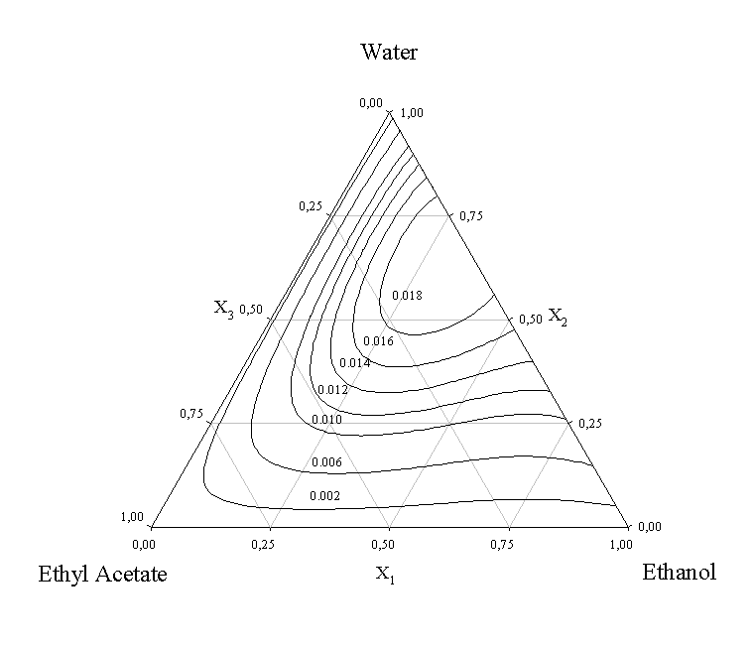

(b)

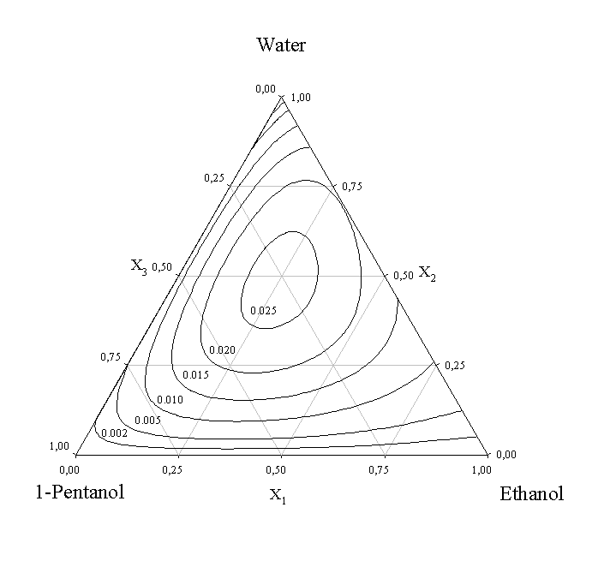
Figure 1. Curves of constant changes of refractive indices in accordance with Eq. 3 at 298.15 K for the studied mixtures (a) ethanol + water + ethyl acetate and (b) ethanol + water + 1-pentanol

Figures 1a and 1b show the change of refractive index against molar fraction, as well as, the curves fitted for both systems. No values of refractive index for the investigated ternary systems have been published in currently available literature.
In Figure 2, the ternary contribution to the change of refractive index is observed for these mixtures. It gathers numerically the last term on the right side of Eq. 3, describing the simultaneous effect on the derived property of ternary molecular interactions. In both cases, a positive maximum is showed at almost ternary equimolar compositions. The ternary mixture containing ethyl acetate, shows a negative ternary contribution at the ethanol corner, which is in accordance with the slight contraction at this area of the mixtures ethanol+water+ethyl acetate, as previously observed [8, 9]. Those compositions with the highest positive changes of refractive index are coincident with high negative excess volumes.

 | Table 3. Parameters of Eq. 3 and root mean square deviations () in accordance to Eq. 4 for the ternary mixtures at 298.15 K
Mixture |  |  |  |  | Parameters
 | Ethanol+Water+Ethyl Acetate |  |  | C₁ =0.260364  C₂ =-0.434243  75.14 |  |  | σ =9.934 10⁻⁴
C₂ =-0.475168

C₂ =-0.434243

75.14
C₃ =0.227011

C₂ =-0.434243

75.14
 | Ethanol+Water+1-Pentanol |  |  | C₁ =0.535784 |  |  | σ = 3.314 10⁻³
 |  |  |  | C₂ =-0.955329
 |  |  |  | C₃ =0.414983

4. Modeling
4.1 Refractive index on mixing estimation
Refractive index is a very useful fluid characterization magnitude with widespread academic and industrial applications. It has been used for many years for accurate characterization of pure fluids and mixtures. Values are disposable into open literature for many pure liquids but really scarce data should be found for binary, ternary and multi-component mixtures. The prediction of different thermodynamic properties of complex mixtures has been subject of study in the last few years, applying different empirical/semiempirical models. In this paper, the measured experimental refractive indices of ethanol+water+(ethyl acetate or 1-pentanol) mixtures were compared with those estimated with several mixing rules (Lorentz-Lorenz (L-L), Gladstone-Dale (G-D), Arago-Biot (A-B), Eykman (Ey), Newton (Nw), Oster (Os), and Eyring-John (E-J)), as follows:

Lorentz-Lorenz
(5)

Dale-Gladstone
(6)

Arago-Biot
(7)

Eykman
(8)

Newton
(9)

Oster
(10)

Eyring-Jhon
(11)

where:
(12)

where n_{D} is the refractive index on mixing, n_{Di} is the refractive index of pure compounds into mixture at the same temperature, φi is the volumetric fraction (Eq. 12), ρ_{i} is the density of pure compounds at the same temperature, M_{i} is the molecular mass of pure compounds (Table 1) and N the number of compounds.

(a)

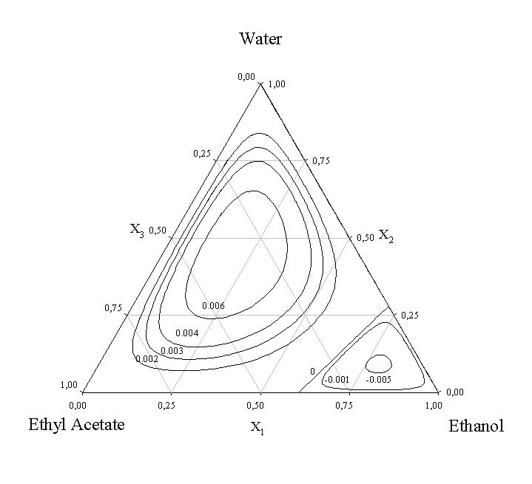

(b)

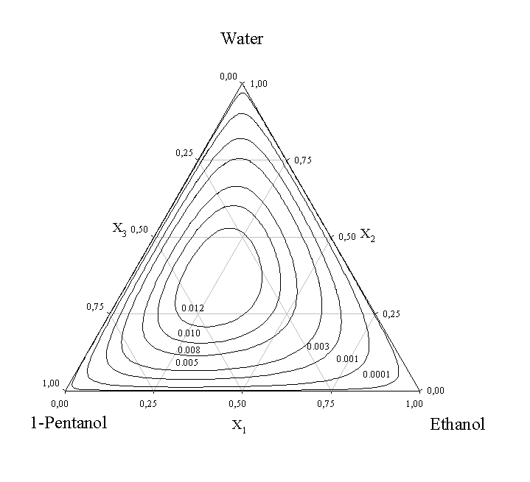
Figure 2. Curves of constant ternary contributions of changes of refractive indices (Eq. 3 without binary contributions) at 298.15 K for (a) ethanol + water + ethyl acetate and (b) ethanol + water + 1-pentanol

Table 4. Root mean square deviations of the experimental refractive indices from the prediction results at 298.15 K, for the Lorentz-Lorenz (L-L), Dale-Gladstone (D-G), Arago-Biot (A-B), Eykman (Ey), Newton (Nw), Oster (Os) and Eyring-Jhon (E-J) equations
L-L | D-G | A-B | Ey | Nw | Os | E-J
Ethanol + Water + Ethyl Acetate
0.00467 | 0.00463 | 0.00463 | 0.00464 | 0.00458 | 0.00460 | 0.00465
0.00104* | 0.00070* | 0.01397* | 0.00084* | 0.00071* | 0.00065* | 0.03284*
Ethanol + Water + 1-Pentanol
0.00331 | 0.00315 | 0.00315 | 0.00321 | 0.00298 | 0.00307 | 0.00324
0.00124* | 0.00117* | 0.00952* | 0.00121* | 0.00114* | 0.00117* | 0.02198*
*An asterisk indicates computation considering non additivity on mixing

In Table 4, the root mean square deviations of the estimations are shown. The best refractive indices estimation are those obtained by D-G, Ey, Nw and Os equations considering non additivity on mixing for both mixtures.

4.2 Binary contribution models
Many different models exist to correlate and predict thermodynamic properties. Most of them perform satisfactorily for binary mixtures but the situation becomes complicated in the case of multicomponent mixtures. Moreover, accurate multicomponent thermodynamic data to evaluate models parameters are scarce and testing models and parameters computation becomes difficult. Some empirical expressions for fitting excess functions require molar fraction dependent parameters and it may cause problems in their application to a multicomponent systems. Some simple procedures in the multicomponent derived magnitude estimation at standard or non-standard conditions is the application of semiempirical binary contribution models, which are useful due to its high simplicity and only enclose binary systems data requirements at the same condition of temperature and pressure. These models perform with general accuracy when ternary contribution is reduced by similar structure in involved solvents. They have been proposed to determine excess functions as molar enthalpies or free energies but can also be applied to other derived magnitudes. In order to estimate the ternary values of change of refractive index on mixing, we applied different semitheoretical three-binary contributions models [30-38] which determine such magnitudes by means of different graphical rules. The ternary excess or derived properties of mixtures may be estimated from binary values applying the following general equation:

(13)

For each ternary mixture the molar fractions x’ may be obtained from a triangular diagram by projecting the point representing the ternary mixture onto the corresponding binary axis, using different symmetric or asymmetric criteria of binary contribution to the ternary value. In said rules asymmetry is understood to be the contribution of the three binaries to the ternary excess, all three of which contribute in similar way. On the other hand, asymmetry is understood to indicate the individual contribution of one of the binaries, the latter being normally attributed to polar components. In Table 5, the experimental and estimated derived values of change of refractive index on mixing for both ternary systems at 298.15 K are compared showing root mean square deviations (Eq. 4). In general, it could be observed as adequate deviations are obtained at the measurement temperature for both ternary systems. Both mixtures showed the best results for symmetric rules (Knobeloch rule) and asymmetric rule Tsao-Smith (considering ethyl acetate or 1-pentanol as polar component). In the Figure 3, the Kohler, Knobeloch and Scatchard models are compared as a function of composition, attending to a z parameter which is related to molar fraction . This parameter is the product of all molar fraction values at every experimental point in the mixture and is useful to depict into a two dimension figure, the multicomponent behaviour. Moreover, an equimolar analysis is possible due to the nature of the mathematical function.

Table 4. Standard deviations from the experimental and estimated values of changes of refractive index on mixing molar obtained with the theoretical rules listed above. For the asymmetric equations, three numberings of the components have been compared, in this order, 123, 231, 312.
Equation | E+W+EA | E+W+1-P
Kohler | 0.00411 | 0.00863
Jacob-Fitzner | 0.00437 | 0.00889
Colinet | 0.00407 | 0.00861
Tsao-Smithª | 0.00292 | 0.00765
Tsao-Smith^{b} | 0.00515 | 0.00874
Tsao-Smith^{c} | 0.00175 | 0.00612
Scatchardª | 0.00293 | 0.00766
Scatchard^{b} | 0.00527 | 0.00969
Scatchard^{c} | 0.00435 | 0.00879
Toopª | 0.00292 | 0.00765
Toop^{b} | 0.00527 | 0.00970
Toop^{c} | 0.00409 | 0.00852
Mathieson-Tynneª | 0.00792 | 0.01261
Mathieson-Tynne^{b} | 0.00925 | 0.00953
Mathieson-Tynne^{c} | 0.00395 | 0.00766
Hillertª | 0.00292 | 0.00765
Hillert^{b} | 0.00503 | 0.00819
Hillert^{c} | 0.00570 | 0.00541
Knobeloch | 0.00264 | 0.00658
ª Ethanol is the asymmetric component in the equation
^{b} Water is the asymmetric component in the equation
^{c} Ethyl Acetate or 1-Pentanol is the asymmetric component in the equation

4.3 Excess molar volume estimation from refractive index on mixing
For many practical purposes it is necessary to show the capability to predict the non-ideality of liquid mixtures which goes expressed by means of excess or changes of physical properties. The methods applied to these ternary mixtures compute the excess molar volume from refractive indices on mixing based on the Heller equation [20] and different mixing rules for the refractive indices on mixing, as previously indicated. In the last few years, prediction of excess volumes from refractive index mixing rules was suggested for binary mixtures by some authors [39-40]. In some cases it has been proposed that the mixing rules for refraction indices are functions of the volume fractions of the mixture, since it is possible to generalize them in a function of the density of the mixture and of the pure components:

(14)

In this equation, w_{i} is the weight fraction, ρ is the density and f is a mathematical function of the refractive indices of the mixture, and the refractive mixture of each component, at the same temperature.

(a)
(b)
Figure 3. Deviations of experimental data from computed changes of refractive indices by application of the symmetric binary contribution models of (●) Kohler and (▼) Knobeloch,, and the assymmetric binary contribution model of (○) Scatchard (123), for the ternary mixtures ethanol+water+((a) ethyl acetate and (b) 1-pentanol) at 298.15 K. The computed values from experimental data in mixture are shown through the dashed line of zero value. Parameter z is the adimensional product of the ternary molar fractions of mixture.

Expressed in another way, taking into account the usual expression of excess molar volumes, the relation of this magnitud to the function of refractive indices would be:

(15)

In this way, Nakata and Sakurai [40] have proposed an expression to relate excess volumes by means of expansions in powers to first order with different mixing rules:

(16)

where f´ means the first derivation of the mathematical relation f. In this work, experimental [8-9] and estimated values of excess molar volumes using Eqs. 15 and 16 are compared applying the Lorentz-Lorenz, Dale-Gladstone, Eykman and Oster (Eqs. 17, 18, 19 and 20, respectively) refractive index mixing rules:

(17)

(18)

(19)
(20)

In Figure 3a and b, the lines corresponding to the experimental data (zero line), and the estimated values by means of D-G at 298.15 K by Eqs. 15 and 16 are presented. A good concordance are showed between theoretical and experimental values, which keep a diference better than ±10% (△), approximately, only slight higher deviations being obtained for seudobinary compositions at ethanol+water+ethyl acetate system. These equations show a good capability in the estimation of excess molar volumes, although the first derivation (Eq. 16) computes better results for the gathered systems. As it could observed in this figure, these equations could be used with similar accuracy for estimation of excess volume in multicomponent mixtures too, although high complex, associative components or partially miscible mixtures are involved.

Table 5. Root mean square deviations of the experimental excess molar volumes from literature and those estimated by Eq. 15 and Eq. 16 applying different mixing rules for refractive index on mixing for the systems ethanol + water + (ethyl acetate or 1-pentanol)
 |  | (L-L) | (D-G) | (Ey) | (Os)
Ethanol+Water+Ethyl Acetate | eq. 15 | 0.050 | 0.055 | 0.043 | 0.070
 | eq. 16 | 0.050 | 0.062 | 0.046 | 0.082
Ethanol+Water+1-Pentanol | eq. 15 | 0.145 | 0.167 | 0.155 | 0.176
 | eq. 16 | 0.155 | 0.181 | 0.166 | 0.193

5. Discussion and conclusions
Ethanol has been used in the last few years as distillation entrainer or extractive solvent in the chemical industry, as a carrier or additive in food and pharmaceutical processes, and antimicrobial applications. As it occurs in heavy alcohols, this molecule contains an active hydrophilic hydroxyl group which is available to hydrogen-bond to compounds as water, alcohols or amines, a residual end conferring a variable degree of hydrophobicity on the molecule. The mixing properties and behaviour of ethanol vary with the nature of the chemical environment, operation conditions, and then, steric hindrance molecular effects as it was observed. A survey of literature of binary and ternary liquid mixtures indicates that studies related to refractive indices are useful in understanding the molecular interactions. As commented, the growing interest in the alcoholic multicomponent mixtures is caused by the occurrence in nature, as well as, their interest for different industrial applications, as spirit alcoholic beverages, high quality of thermodynamic data of the different compounds enclosed into mixture being necessary for design and simulation in order to obtain quality final products.

(a)
∆VE
z

(b)
∆VE
z
Figure 4. Deviations (〇) (ΔVE (cm³mol⁻¹), 10% ∆) from computed changes of refractive indices by application of Eq. 15 combined with D-G mixing rule (Eq. 17) and experimental data of this work for (a) ethanol + water + ethyl acetate and (b) ethanol + water + 1-pentanol at 298.15 K. The computed values from experimental data in mixture are shown through the solid line of zero value. Parameter z is the adimensional product of the ternary molar fractions of mixture.

In this work, our attention was focused towards ternary mixtures of ethanol, water and two of the main flavor components in distilled alcoholic beverages due to its interest for food technology. In the mixtures ethanol+water+(ethyl acetate or 1-pentanol), the interaction of the two hydroxylic solvents and the solutes is analyzed, the steric hindrance effect being of major importance. These factors are clearly demonstrated by the unusual packing characteristics of hydroxylic compounds in mixtures [8-9]. No values of refractive index for the investigated ternary systems have been published in currently available literature, as far as we know.
Different empirical equations were tested in terms of refractive index estimation of mixtures. Although consideration of volumetric additivity trend was made, the empirical equations gather low deviations and accurate behavior when estimations are computed for both ternary mixtures. In what is referred to density estimation by the modified Heller equation by means of values of refractive index, accurate results were obtained too, despite the application of previously estimated refractive index by mixing rules. The tested procedures showed good trend when estimations were tried, proving to be a useful tool for refractive index on mixing calculations into complex systems, when density data are not available.

Acknowledgments

The authors would like to thank CAPES (Coordenação de Aperfeiçoamento de Pessoal de Ensino Superior) by the financial support for developing this research.

Nomenclature

B_{p} – fitting parameters of Redlich-Kister equation

C_{i} – fitting parameters of Cibulka equation

f – mathematical function

f’ – first derivation of a mathematical function

- excess molar volume (cm³mol⁻¹)

M – molar mass (gmol⁻¹)

n – number of experimental data of each mixture

n_{D} – refractive index on mixing

n_{Di} – refractive index of pure component

x_{i} – molar fraction of i compound into a mixture

x_{j} – molar fraction of j compound into a mixture

x’_{i} – molar fraction of i compound into a mixture, obtained from a triangular diagram by projecting the point representing the ternary mixture onto the corresponding binary axis

x’_{j} – molar fraction of j compound into a mixture, obtained from a triangular diagram by projecting the point representing the ternary mixture onto the corresponding binary axis

w_{i} – molar weight of i compound into a mixture

δn_{D} – change of refractive index on mixing

δQ_{ij} – change of magnitude Q for a binary mixture ij

δQ_{ijk} – change of magnitude Q for a ternary mixture ijk

ρ - density of a mixture (g/cm³)

ρ_{i} - density of pure component (g/cm³)

φ_{i} – volume fraction i compound into a mixture

σ - root mean square deviation

References:
[1] M. Gaiser, G. M. Bell, A. W. Lim, N. A. Roberts, D. B. F. Faraday, R. A. Schulz, R. Crob, “Computer simulation of a continuous whisky still,” J. Food Eng., 51, 27-31, 2002.
[2] C. A. Faúndez, J. O. Valderrama, V. H. Alvarez, “Phase equilibrium in binary aqueous mixtures of interest in alcoholic distillation using a modified PSRK equation of state,” J. Phase Eq. and Diffusion, 25, 230-236, 2004.
[3] C. A. Faúndez, J. O. Valderrama, “Phase equilibrium modeling in binary mistures found in wine and must distillation,” J. Food Eng., 63, 577-583, 2004.
[4] O. Perez, L. Zumalacarregui, O. Gozá, “Simplificaciones en el cálculo de columnas de destilación alcohólica,” Inf. Tecnol., 21, 103-112, 2010.
[5] J. Sacher, L. García-Llobodanin, F. López, H. Segura, J. R. Pérez-Correa, “Dynamic modeling and simulation of an alembic pear wine distillation,” Food Bioprod. Process., 91, 447-456, 2013.
[6] C. A. Faúndez, G. A. Ramírez, J. O. Valderrama, “Thermodynamic consistency of low pressure equilibrium data of water+congener mixtures using a versatile equation of state,” J. Taiwan Inst. Chem. Eng., 68, 15-22, 2016.
[7] J. M. Resa, C. Gonzalez, J. M. Goenaga, M. Iglesias, “Density, refractive index, and speed of sound at 298.15 K and vapor-liquid equilibria at 101.3 kPa for binary mixtures of ethyl acetate+1-pentanol and ethanol+2-methyl-1-propanol,” J. Chem. Eng. Data, 49, 804-808, 2004.
[8] J. M. Resa, C. Gonzalez, J. M. Goenaga, M. Iglesias, “Temperature dependence of excess molar volumes of ethanol+water+ethyl acetate,” J. Solution Chem., 33, 169-198, 2004.
[9] J. M. Resa, C. Gonzalez, J. M. Goenaga, M. Iglesias, “Influence of temperature on volumetric properties of ethanol+water+1-pentanol,” J. Serb. Chem. Soc., 69, 1073-1097, 2004.
[10] J. M. Resa, C. Gonzalez, J. M. Goenaga, M. Iglesias, “Influence of temperature on ultrasonic velocity measurements of ethanol+water+ethyl acetate mixtures,” Phys. Chem. Liq., 43, 065-089, 2005.
[11] J. M. Resa, J. M. Goenaga, J. Lanz, M. Iglesias, “Vapor-liquid equilibrium of binary mixtures containing ethyl acetate+2-methyl-1-propanol and ethyl acetate+2-methyl-1-butanol at 101.3 kPa,” J. Chem. Eng. Data, 51, 595-598, 2006.
[12] J. M. Goenaga, R. Gonzalez-Olmos, M. Iglesias, J. M. Resa, “Measurement and modelling of phase equilibria for ethanol+water+1-pentanol at isobaric condition,” Korean J. Chem. Eng., 23, 631-637, 2006.
[13] R. Gonzalez-Olmos, M. Iglesias, J. M. Goenaga, J. M. Resa, “Phase equilibria for ethanol+water+2-propanol at isobaric condition,” Phys. Chem. Liq., 45 683-694, 2007.
[14] S. M. Barros, R. S. Andrade, M. Iglesias. “Thermodynamics of ethanol+water+2-propanol mixture at the range of temperature 288.15-323.15 K,” Int. J. Thermodyn. (Submitted for publication)
[15] A. Z. Tasic, B. D. Djordjevic, D. K. Grozdanic, “Use of mixing rules in predicting refractive indices and specific refractivities for some binary liquid mixtures,” J. Chem. Eng. Data, 37, 310-313, 1992.
[16] C. J. F. Bottcher, Theory of Electric Polarization, Amsterdam: Elsevier, 1952.
[17] S. S. Kurtz Jr., A. L. Ward, “Refractivity intercept and the specific refraction equation of Newton: I. Development of the refractivity intercept and comparison with specific-refraction equations,” J. Franklin Inst., 222, 563-592, 1936.
[18] G. Oster, “The scattering of light and its applications to chemistry,” Chem. Rev., 43, 319-365, 1948.
[19] H. Eyring, M. S. John, Significant Liquid Structures, New York: Interscience; 1969.
[20] M. Iglesias, B. Orge, M. Dominguez, J. Tojo, “Mixing properties of the binary mixtures of acetone, methanol, ethanol, and 2-butanone at 298.15 K,” Phys. Chem. Liq., 37, 9-29, 1998.
[21] TRC Thermodynamic Tables, Thermodynamic Research Center, Texas A&M University, College Station, TX, 1994.
[22] J. A. Riddick, W. B. Bunger, T. K. Sakano, Organic Solvents, Techniques of Chemistry, 4th ed., Vol. 2, ed., New York-Wiley-Interscience, 1986.
[23] A. K. Nain, P. Droliya, R. K. Manchanda, A. Khurana, D. Nayak. “Physicochemical studies of extremely diluted solutions (homoeopathic formulations) of sulphur in ethanol by using volumetric, acoustic, viscometric and refractive index measurements at different temperatures.” J. Mol. Liq., 211, 1082-1094, 2015.
[24] R. K. Ameta, M. Singh, R. K. Kale, “Comparative study of density, sound velocity and refractive index for (water+ alkali metal) phosphates aqueous systems at T=(298.15, 303.15, and 308.15) K,” J. Chem. Thermodyn., 60, 159-168, 2013.
[25] V. H. Alvarez, S. Mattedi, M. Aznar, “Density, refraction index and vapor–liquid equilibria of N-methyl-2-hydroxyethylammonium butyrate plus (methyl acetate or ethyl acetate or propyl acetate) at several temperatures,” J. Chem. Thermodyn., 62, 130-141, 2015.
[26] M. S. Reddy, I. Khan, K. T. S. Raju, P. Suresh, B. H. Babu, “The study of molecular interactions in 1-ethyl-3-methylimidazolium trifluoromethane sulfonate+ 1-pentanol from density, speed of sound and refractive index measurements,” J. Chem. Thermodyn., 98, 298-308, 2016.
[27] J. M. Goenaga, A. Gayol, R. G. Concha, M. Iglesias, J. M. Resa, “Effect of temperature on thermophysical properties of ethanol + aliphatic alcohols (C₄–C₅) mixtures,” Monatsh. Chem., 138, 403-436, 2007.
[28] R. S. Andrade, M. Iglesias, “Effect of temperature on mixing properties of ethanol+polar solvents systems,” J. Thermal Anal. and Calorimetry. (Submitted for publication)
[29] I. Cibulka, “Estimation of excess volume and density of ternary liquid mixtures of non-electrolytes from binary data,” Coll. Czech. Comm., 47, 1414-1419, 1982.
[30] F. Kohler, “Zur berechnung der thermodynamischen daten eines ternaren systems aus den zugehorigen binaren systemen,” Monatsh. Chem., 91, 738-740, 1960.
[31] K. T. Jacob, K. Fitzner, “The estimation of the thermodynamic properties of ternary alloys from binary data using the shortest distance composition path,” Thermochim. Acta, 18, 197-206, 1977.
[32] C. Colinet, Thesis, University of Grenoble, France, 1967.
[33] C. C. Tsao, J. M. Smith, “Heat of mixing of liquids,” Chem. Eng. Prog. Symp. Series, 49, 107-111, 1953.
[34] G. Scatchard, L. B. Ticknor, J. R. Goates, E. R. McCartney, “Heats of mixing in some non-electrolyte solutions,” J. Am. Chem. Soc., 74, 3721-3724, 1952.
[35] G. W. Toop, “Predicting ternary activities using binary data,” Trans. TMS-AIME, 223, 850- 855, 1965.
[36] A. R. Mathieson, J. C. J. Thynne, Thermodynamics of hydrocarbon mixtures. Part II. The heats of mixing of the binary mixtures formed by benzene, cyclohexane, n-heptane, toluene, and n-hexane,” J. Chem. Soc., 00, 3708-3713, 1956.
[37] M. Hillert, “Empirical methods of predicting and representing thermodynamic properties of ternary solution phases,” Calphad, 4, 1-12, 1980.
[38] J. B. Knobeloch, C. E. Schwartz, “Heats of mixing of ternary system: sulfuric acid-phosphoric acid-water,” J. Chem. Eng. Data, 7, 386-387, 1962.
[39] E. L. Arancibia, M. Katz, “Relationship between excess molar volume and refractive index in binary non-electrolyte mixtures,” Phys. Chem. Liq., 26, 107-112, 1993.

[40] M. Nakata, M. Sakurai, “Refractive index and excess volume for binary liquid mixtures. Part 1.-Analyses of new and old data for binary mixtures,” J. Chem. Soc. Faraday Trans. I., 83, 2449-2457, 1987.

