The Turkish Journal of Occupational / Environmental Medicine and Safety
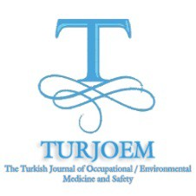

Vol:1, No:1(2), 2017 Web: http://www.turjoem.com ISSN : 2149-4711

SS-020 . The determination of the residues of amitraz and fluvalinate in honey samples

obtained from Çukurova Region

Ali Bilgili, Erdal Selçukoğlu

Ankara University Faculty of Veterinary Medicine Department of Pharmacology and Toxicology,

Ankara, Turkey.

The aim of this study was to determine the residues of amitraz and fluvalinate pesticides used to

treat the varroa disease in honey. For this purpose, totally 135 honey samples representing 8330

beehives were collected from Çukurova Region. Equally 15 samples were obtained from each areas

of Adana, Kadirli, Kozan, Ceyhan, Osmaniye, Karataş, Yumurtalık, Mersin and Tarsus.

The residues of amitraz and fluvalinate were determined according to the method of Hammerling

(1987). This method was included the preparation of an extract from honey and its application to

an capillary gas chromatography. However, amitraz residues at 1.34-33.48 ppm levels were found

in 25 out of 135 honey samples obtained from 9 residences. This amitraz residue was found in 4, 5,

10 and 6 samples of the honey obtained from Adana, Kozan, Karataş and Tarsus respectively.

These results showed that there was no contamination of fluvalinate in the honey samples obtained

from Çukurova Region. However, the contamination of honey samples with amitraz was seen in

this region. This amitraz contamination of the honey samples may be hazardous for the human

health as the honey is the main nutrients of humans. These findings suggest that the precautions

against the pesticide contamination with amitraz should be taken during the treatment of the

varroa disease and the consumption of the honey by humans.

Keywords: Amitraz, honey, fluvalinate, residue, pesticide

TURJOEM , 2017 , 1 ,1 (2)

