**An Analysis of Pre-service Primary Teachers’ Drawings of the Digestive System[1]**

**Sınıf Öğretmeni Adaylarının Sindirim Sistemi Çizimlerinin İncelenmesi**

Yılmaz ÇAKICI[2]

**Abstract:** This study explores pre-service primary teachers’ drawings of the digestive system. The research data was collected through the use of drawing method with 102 third grade pre-service primary teachers studying in the Faculty of Education at Trakya University during 2016-2017 academic year. The findings revealed that primary teacher candidates’ drawings of the digestive system were quite far from the scientifically acceptable ones. A small percentage of students (12.7%) produced a relatively scientific representation of the digestive system, including all the digestive organs. Although a great majority of the students depicted the mouth, gullet, stomach and intestines in their drawings of the digestive organs, they mostly omitted the pharynx, liver and pancreas. They commonly had lack of knowledge about the digestive system organs, and size of them in the human body. These results also reveal that, in teaching and learning process, drawings are an important tool in revealing knowledge shortages or misconceptions, and may be used more commonly in improving students understanding of some scientific phenomena.

***Keywords****: Drawings, digestive system, science education, pre-service classroom teachers.*

**Öz**: Bu çalışmanın amacı sınıf öğretmeni adaylarının sindirim sistemi çizimlerini incelemektir. Araştırma verileri, 2016-2017 eğitim-öğretim yılında Trakya Üniversitesi Eğitim Fakültesi Sınıf Öğretmenliği programında öğrenim gören 102 üçüncü sınıf öğrencisine uygulanan çizimlerle toplanmıştır. Araştırma bulgularına göre, öğretmen adaylarının sindirim sistemi çizimleri bilimsel olarak kabul edilebilirlik seviyesinden oldukça uzaktır. Öğretmen adaylarının küçük bir yüzdesi (%12.7) tüm sindirim organlarını belirterek nispeten doğru olarak sindirim sistemini çizebilmişlerdir. Öğretmen adaylarının büyük çoğunluğu ağız, yemek borusu, mide, ince ve kalın bağırsakları sindirim sistemi çizimlerinde gösterirken, yutak, karaciğer ve pankreas ise çoğunlukla çizimlerinde yer almamıştır. Genel olarak öğretmen adaylarının sindirim sisteminin hangi organlardan oluştuğu ve sindirim sistemi organlarının büyüklüğü ile ilgili olarak yanlış bilgiye sahip oldukları ortaya çıkmıştır. Bu sonuçlar, aynı zamanda çizimlerin eğitim-öğretim sürecinde öğrencilerin eksiklerini ve kavram yanılgılarını ortaya çıkarmada önemli bir araç olduğunu ortaya koymakta ve çizimlerin öğrencilerin bilimsel kavramlarla ilgili anlamalarını geliştirmede daha yaygın olarak kullanılabileceğini göstermektedir.

***Anahtar sözcükler****: Çizimler, sindirim sistemi, fen eğitimi, sınıf öğretmeni adayları.*

# **1. INTRODUCTION**

Since 1980, the alternative conceptions that students hold about several scientific phenomena are accepted as one of the important factors which prevent them to have a sound understanding of science topics. Aiming to enhance meaningful learning, many researchers have sought to identify students’ ideas about several scientific concepts. Research results in this area have caused reform efforts in science education which have focused on the need for students to understand science conceptually rather than learning a lot of scientific facts (American Association for Advancement of Science [AAAS], 1993; Osborne, 1994). This means, not only knowing the ideas of science but also the relationships between them, and ways to use these ideas to explain other natural phenomena or to apply them to the similar events (National Research Council [NRC], 1996). On the other hand, research literature reveals that this aim is not always being met as many students lack scientific understanding of even basic science concepts (Richardson, 1997; Weiss, 1994).

Despite some studies in several countries, there are still basic areas, in which only a very limited number of studies have explored preservice primary teachers’ ideas of the digestive system. In the literature, several studies investigated students’ and teachers’ views of the digestive system. To explore children’s ideas about digestion in the SPACE Project (1987-1990), Osborne, Wadsworth and Black (1992) gave them an outline of the body to show what happened to food in their body. In their drawings, many children were not aware of the correct size and location of the digestive organs. Some children did not show any physical connection between the mouth and the stomach. They tended to show stomach in the center of the abdomen, with no illustration of intestines.

Teixeira (2000) explored Brazilian children's (four to ten years old) conceptions of the structure and function of the human digestive system by using drawing and interview methods. They tended to represent the digestive system as a tube beginning from the mouth and ending in the abdominal area. Furthermore, this tube had separate divisions that means distinct organs have a different function during the digestion of food. They also commonly illustrated the stomach lower than its actual location and larger than its actual size.

Dempster and Stears (2014) reported seven-year-old South African children’s understanding of their internal body systems. Their study was based on the premise that children commonly obtain their scientific knowledge through personal experience in the environment. They used drawings to identify children’s knowledge of internal body systems, by giving an A3 sheet of paper which had two outlines of a human body. Research results showed that children were tended to draw individual organs, but were unable to illustrate relationships between them. Boys were better able to represent what they thought was inside their bodies than girls. The digestive system was one of the most commonly drawn organ systems. It might be due to that children often experience hunger, food, eating and other body functions closely related to the digestive system. They also found that most of the knowledge children hold about their internal body organs seems to be obtained by informal means, outside the school.

Sasmaz Oren and Ormanci (2014) investigated 95 science teacher candidates’ ideas about the digestive system by using the drawing method. They found that the biggest deficiency in the student teachers’ drawings was the disconnection among digestive system organs. Furthermore, the students showed lack of knowledge about the location and shape of the digestive organs.

Similarly, Cardak (2015) examined science teacher candidates’ understanding of the digestive system. He collected the data from 116 science students by using the drawing method. The research results revealed that students had many misconceptions about the digestive system organs e.g. digestive system organs have no relationships with each other and it is a single open-ended structure which ends in the stomach, and incorrect size and locations.

As in many countries, the digestion topic is one of the core topics in the primary and secondary school syllabus in Turkey. It is also closely related to circulation, respiration, excretion and growth. For his reason, it deserves particular attention in teaching learning process. Although there have been some studies of this nature in the literature with preservice teachers, it is still difficult to find any references to studies with preservice primary teachers.

# **2. METHOD**

Literature reveals that there are many ways to reveal different aspects of a students’ understanding of scientific phenomena e.g. interviews (Driver, Guesne, & Tiberghien, 1985), concept maps (Novak & Gowin, 1984), word association tests (Cachapuz & Maskill, 1987). In this study, drawings as the eliciting device was considered as appropriate to reveal particular aspects of students’ understanding of the digestive system (Reiss & Tunnicliffe, 2001). Therefore, the research data was collected through the use of drawing method with 102 third grade pre-service primary teachers (aged 19-23) studying in the Faculty of Education at Trakya University during 2016-2017 academic year.

The pre-service primary students were asked to draw the digestive system on a human outline given on A4 paper during a science teaching course. Drawings do have some important advantages in revealing students’ views. We simply told them to feel free to draw about what they thought as their digestive system, and also not to copy from each other. They completed their drawings about 12-15 minutes. All students had studied General Biology course in the first grade and the Science and Technology Laboratory Practices in the second grade. In this study, any gender comparison was not conducted as almost all were female.

The drawings were coded by two persons. The author and an academician independently analyzed all the drawings. When the differences were the case, these were sorted out by negotiating among them. If the digestive organs are mostly in the correct position, they were accepted as correct.

# **3. FINDINGS**

The digestive system (DS) consists of the mouth, pharynx, gullet, stomach, liver, pancreas, small intestine, large intestine and anus. In addition to this, the salivary glands in the mouth, liver and pancreas help the digestion process by means of their digestive juices. Students’ drawings helped to reveal their conceptions of the digestive system, and their ideas about the size and location of its components.

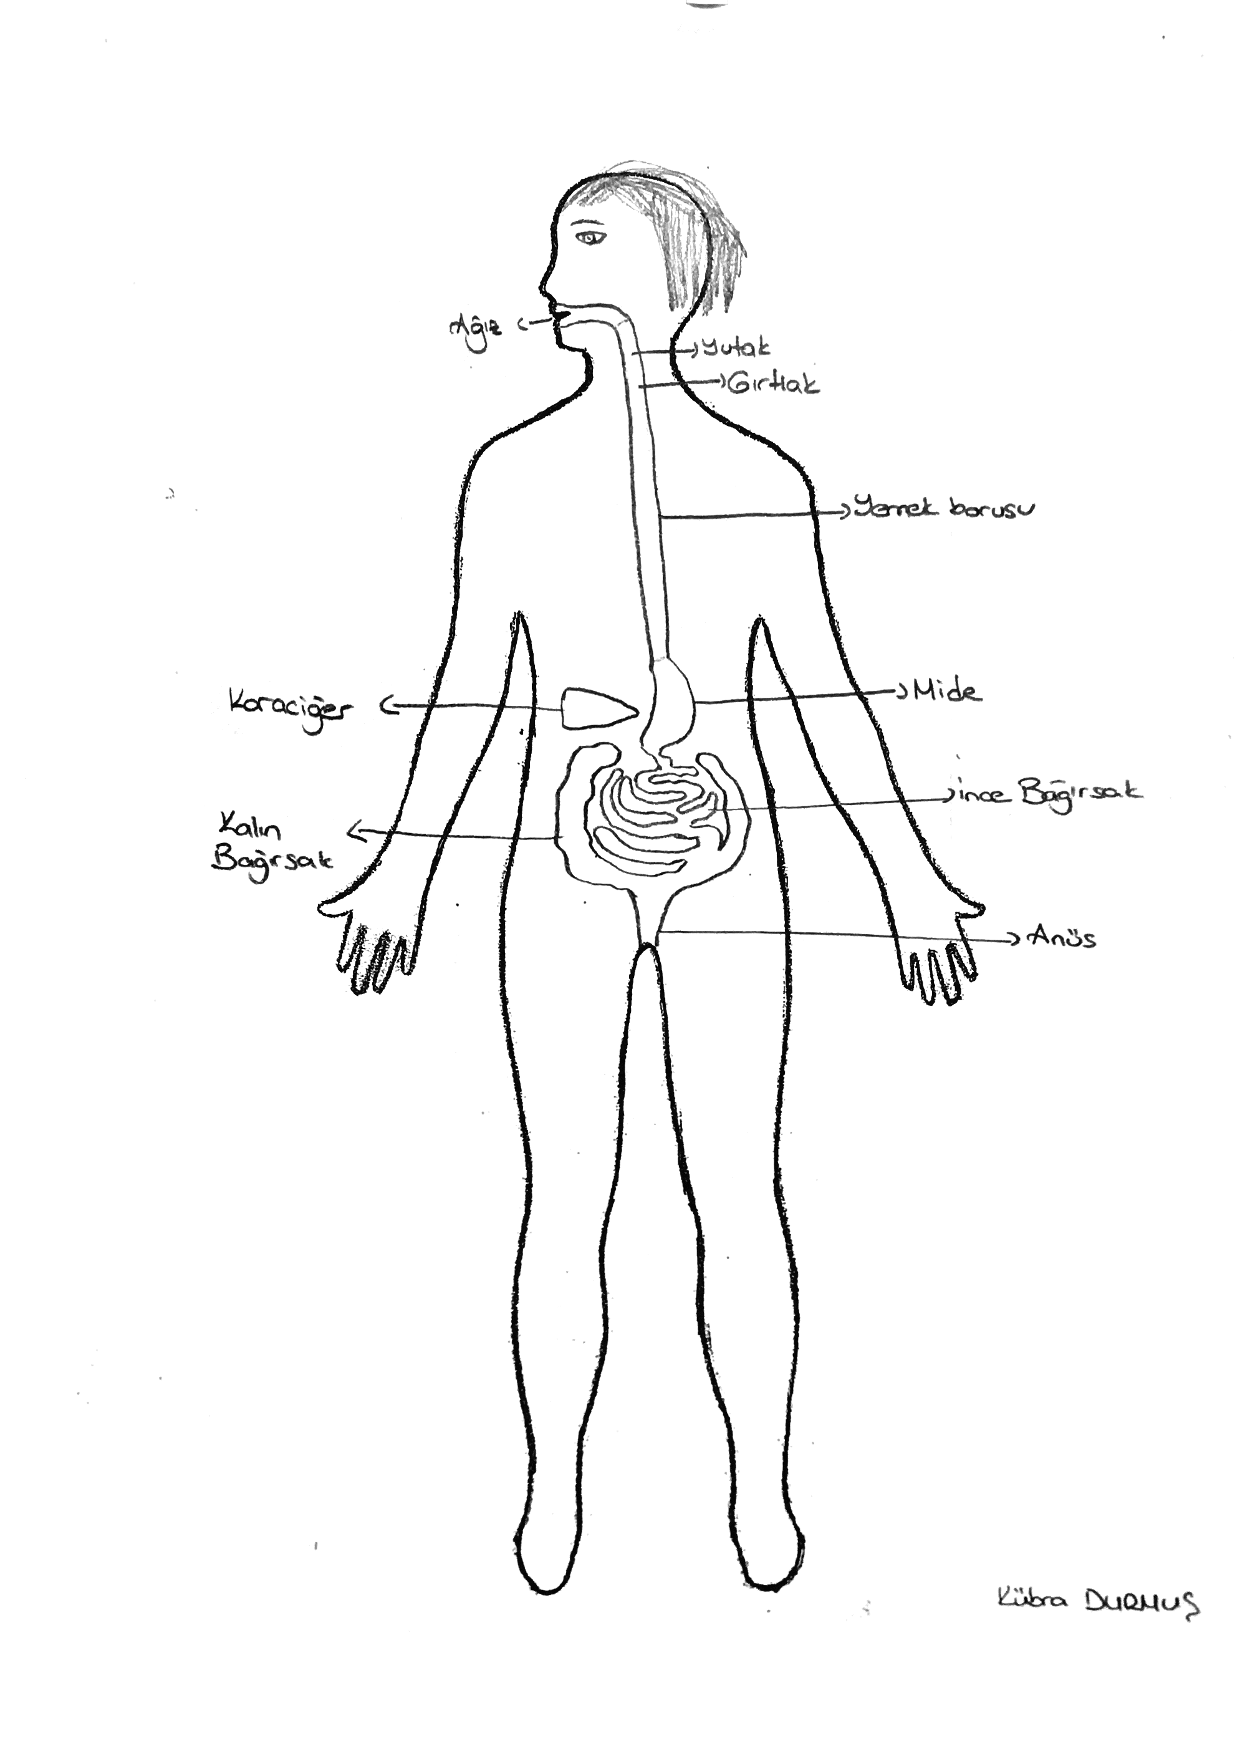 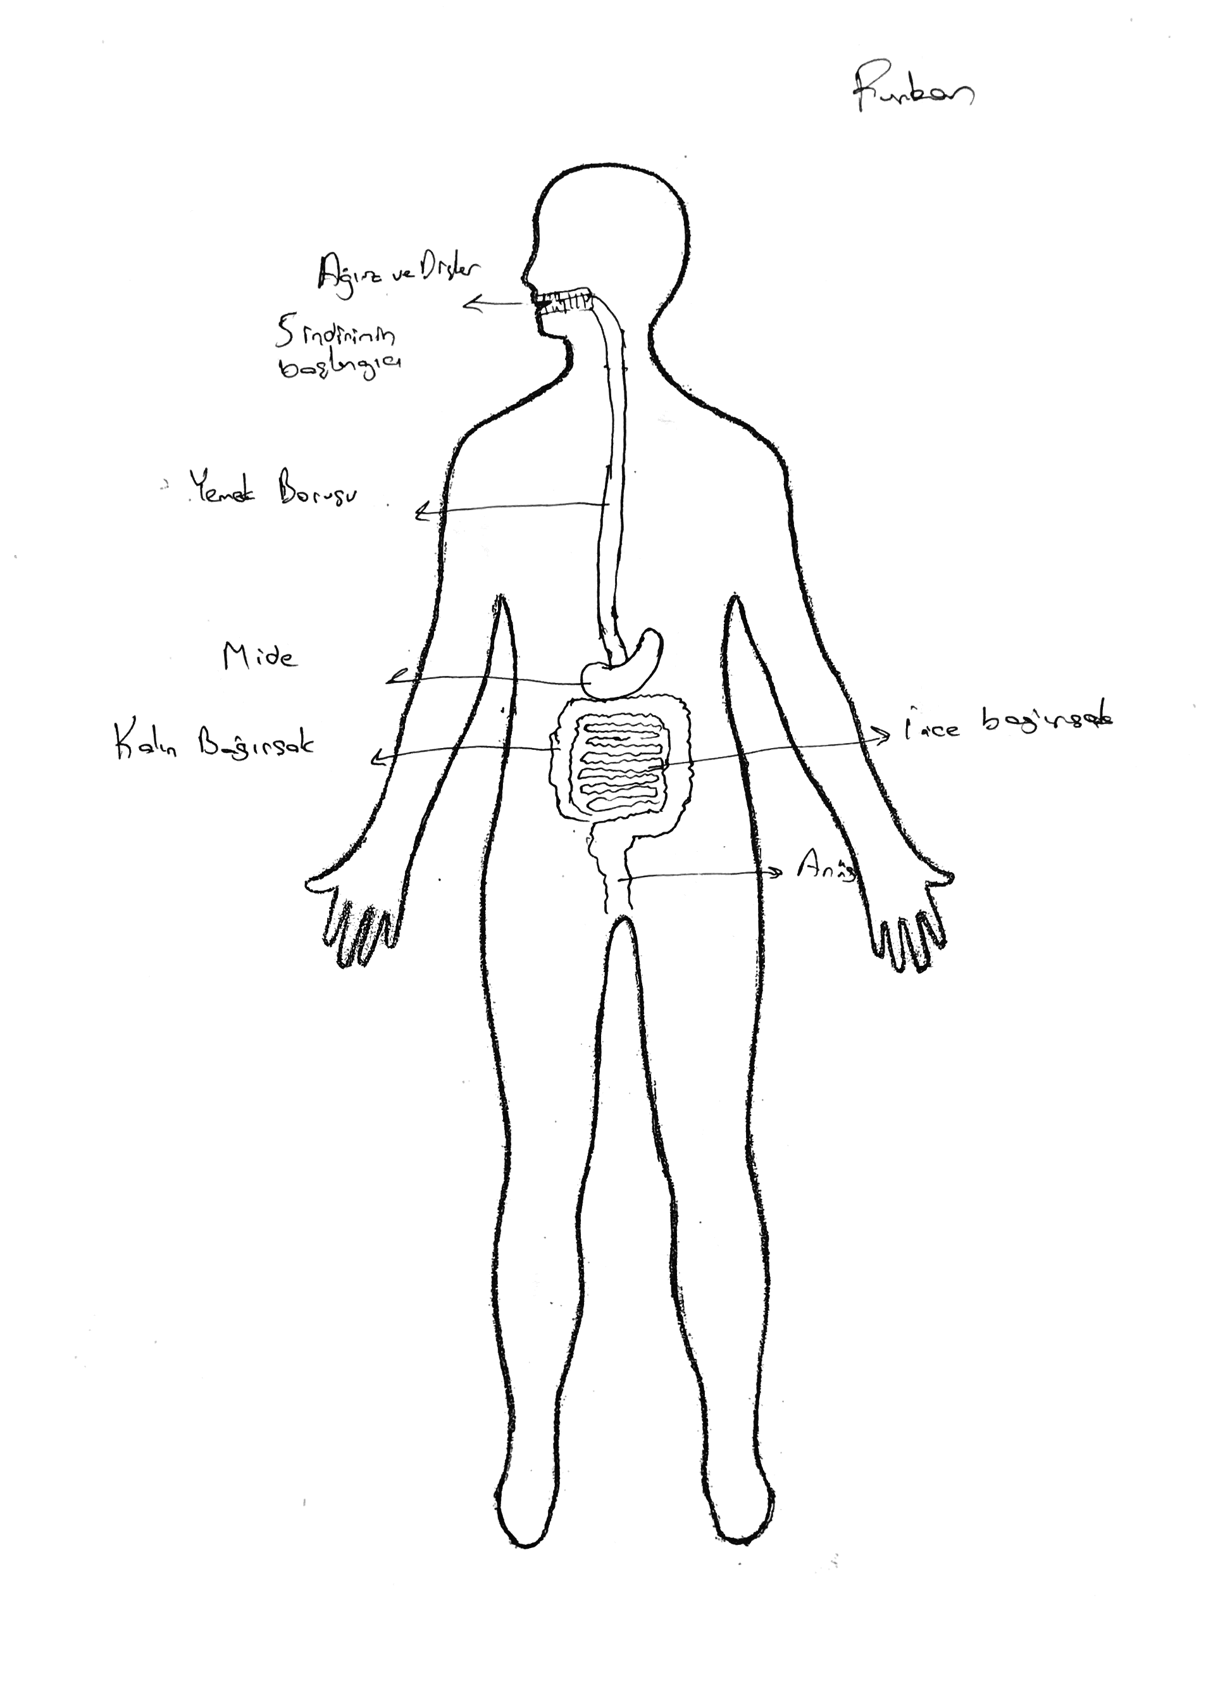

Figure 1. A student’s drawing of the DS. Figure 2. A student’s drawing of the DS.

At the beginning, Table 1 below was prepared in order to demonstrate the digestive system illustrated by the students. Many students depicted the digestive system by drawing only some of its organs, showing them in incorrect locations and with incorrect sizes (See Figures above 1 and 2).

**Table 1.** The organs shown in the students’ drawings of the digestive system.

|  |  |  |  |  |
| --- | --- | --- | --- | --- |
| **The organs shown**  **in the drawings** | **Drawn**  **N** | **%** | **Not drawn**  **N** | **%** |
| **Scientific** |  |  |  |  |
| Mouth | (82) | 80.4 | (20) | 19.6 |
| Pharynx | (16) | 15.7 | (86) | 84.3 |
| Gullet | (86) | 84.3 | (16) | 15.7 |
| Stomach | (102) | 100 | - | - |
| Liver | (22) | 21.6 | (80) | 78.4 |
| Pancreas | (13) | 12.7 | (89) | 87.3 |
| Duodenum | (4) | 3.9 | (98) | 96.1 |
| Small Intestines | (86) | 84.3 | (16) | 15.7 |
| Large Intestines | (86) | 84.3 | (16) | 15.7 |
| Intestines | (13) | 12.7 | (3) | 2.9 |
| Anus | (54) | 52.9 | (48) | 47.1 |
| **Non-scientific** |  |  |  |  |
| Lungs | (12) | 11.8 |  |  |
| Kidneys | (12) | 11.8 |  |  |
| Urine bladder | (7) | 6.9 |  |  |
| Heart | (6) | 5.9 |  |  |
| Gall bladder | (3) | 2.9 |  |  |
| Backbone | (1) | 1.0 |  |  |

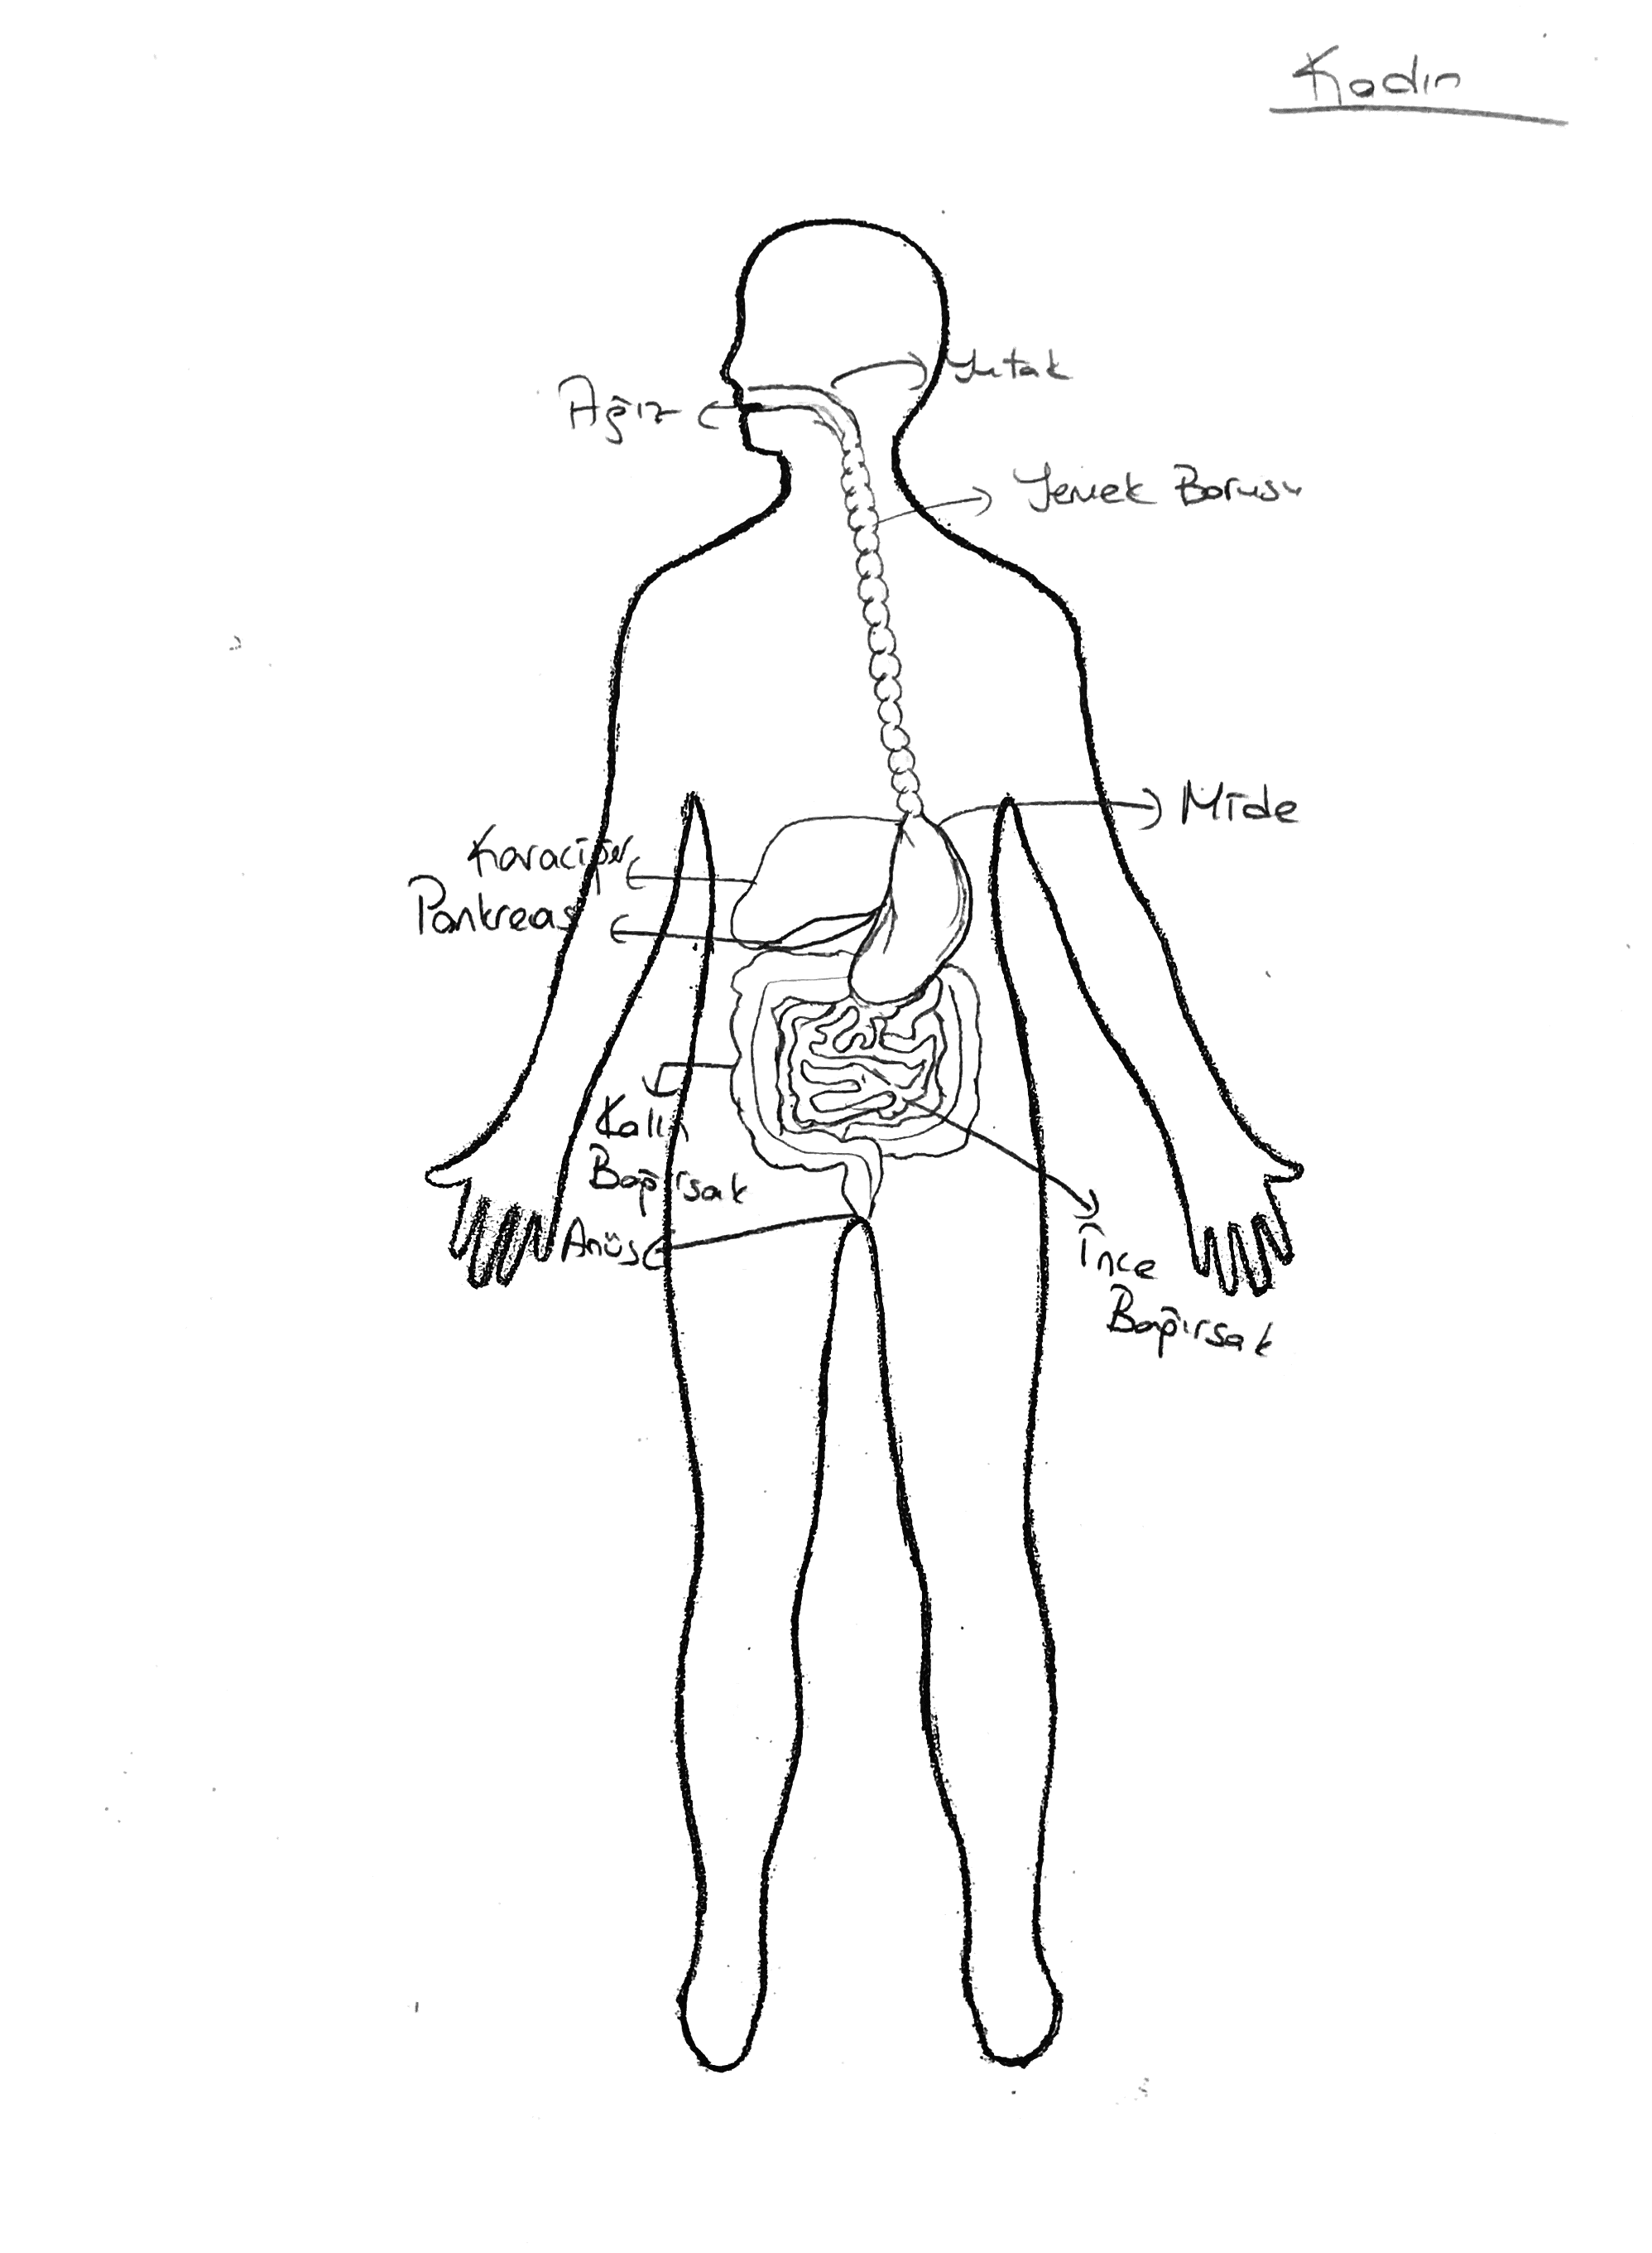 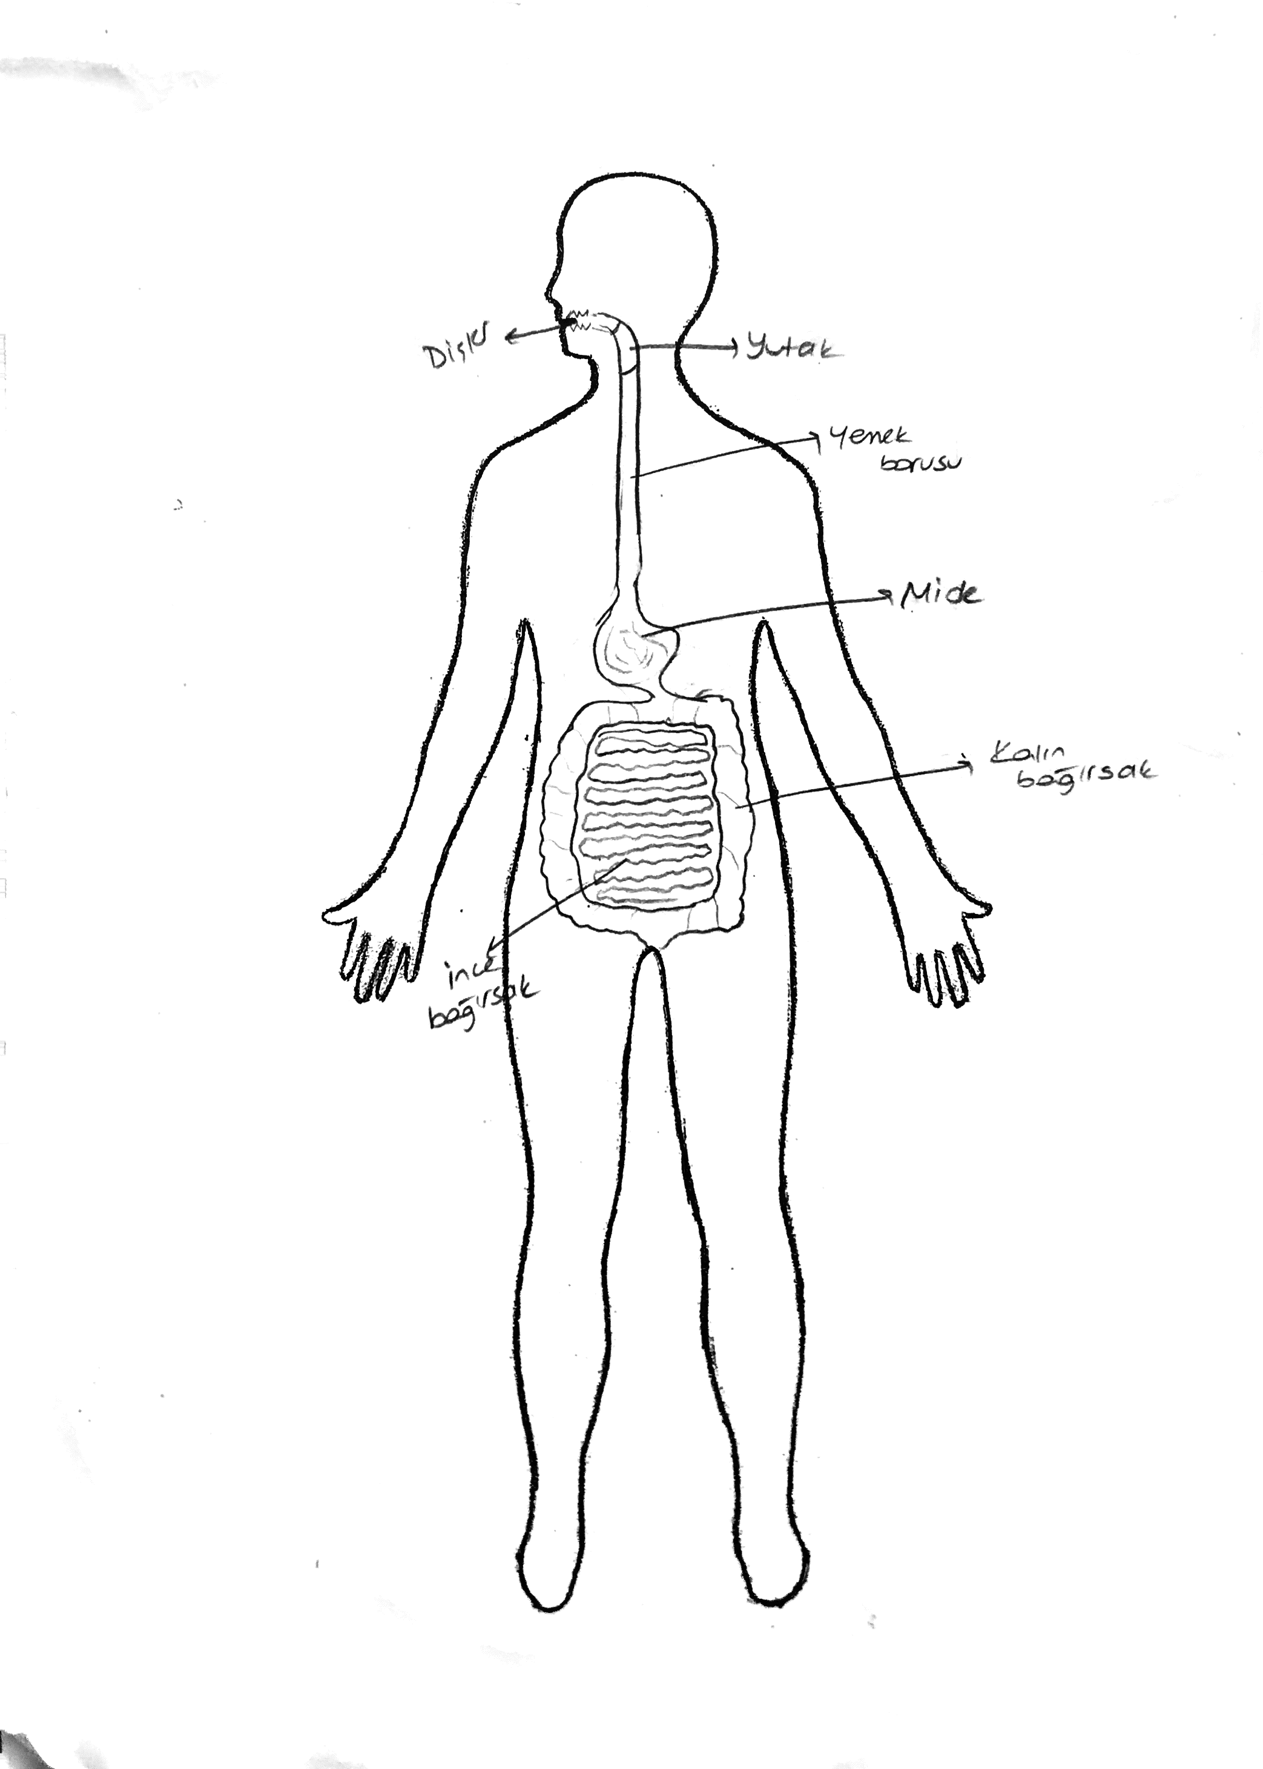

Figure 3. A relatively correct drawing. Figure 4. A drawing without liver and pancreas.

A small number of students (12.7%) produced a relatively scientific representation of the digestive system, including all the digestive organs (Figure 3). Although a high percentage of students depicted the mouth, gullet, stomach and intestines in their drawings of the digestive organs, a great majority of them omitted the pharynx, liver and pancreas (Figure 4).

Not surprisingly, all students depicted the stomach in their drawings. Similarly, a great majority of students (84%) illustrated the gullet, small and large intestines in their drawings of the digestive system but mostly located in the wrong places and in a wide variety of sizes and shapes (Figure 5).

Although, four in five of the students showed the mouth as the starting point of the digestive system, nearly 20 percent of the students ignored it in the digestive tract. In addition to this, about half of the students did not show the anus in their drawings (Figure 6). One possible reason is that cultural notions might have had a negative effect, deterring them from pointing this out in a drawing rather than ignoring the egestion process.

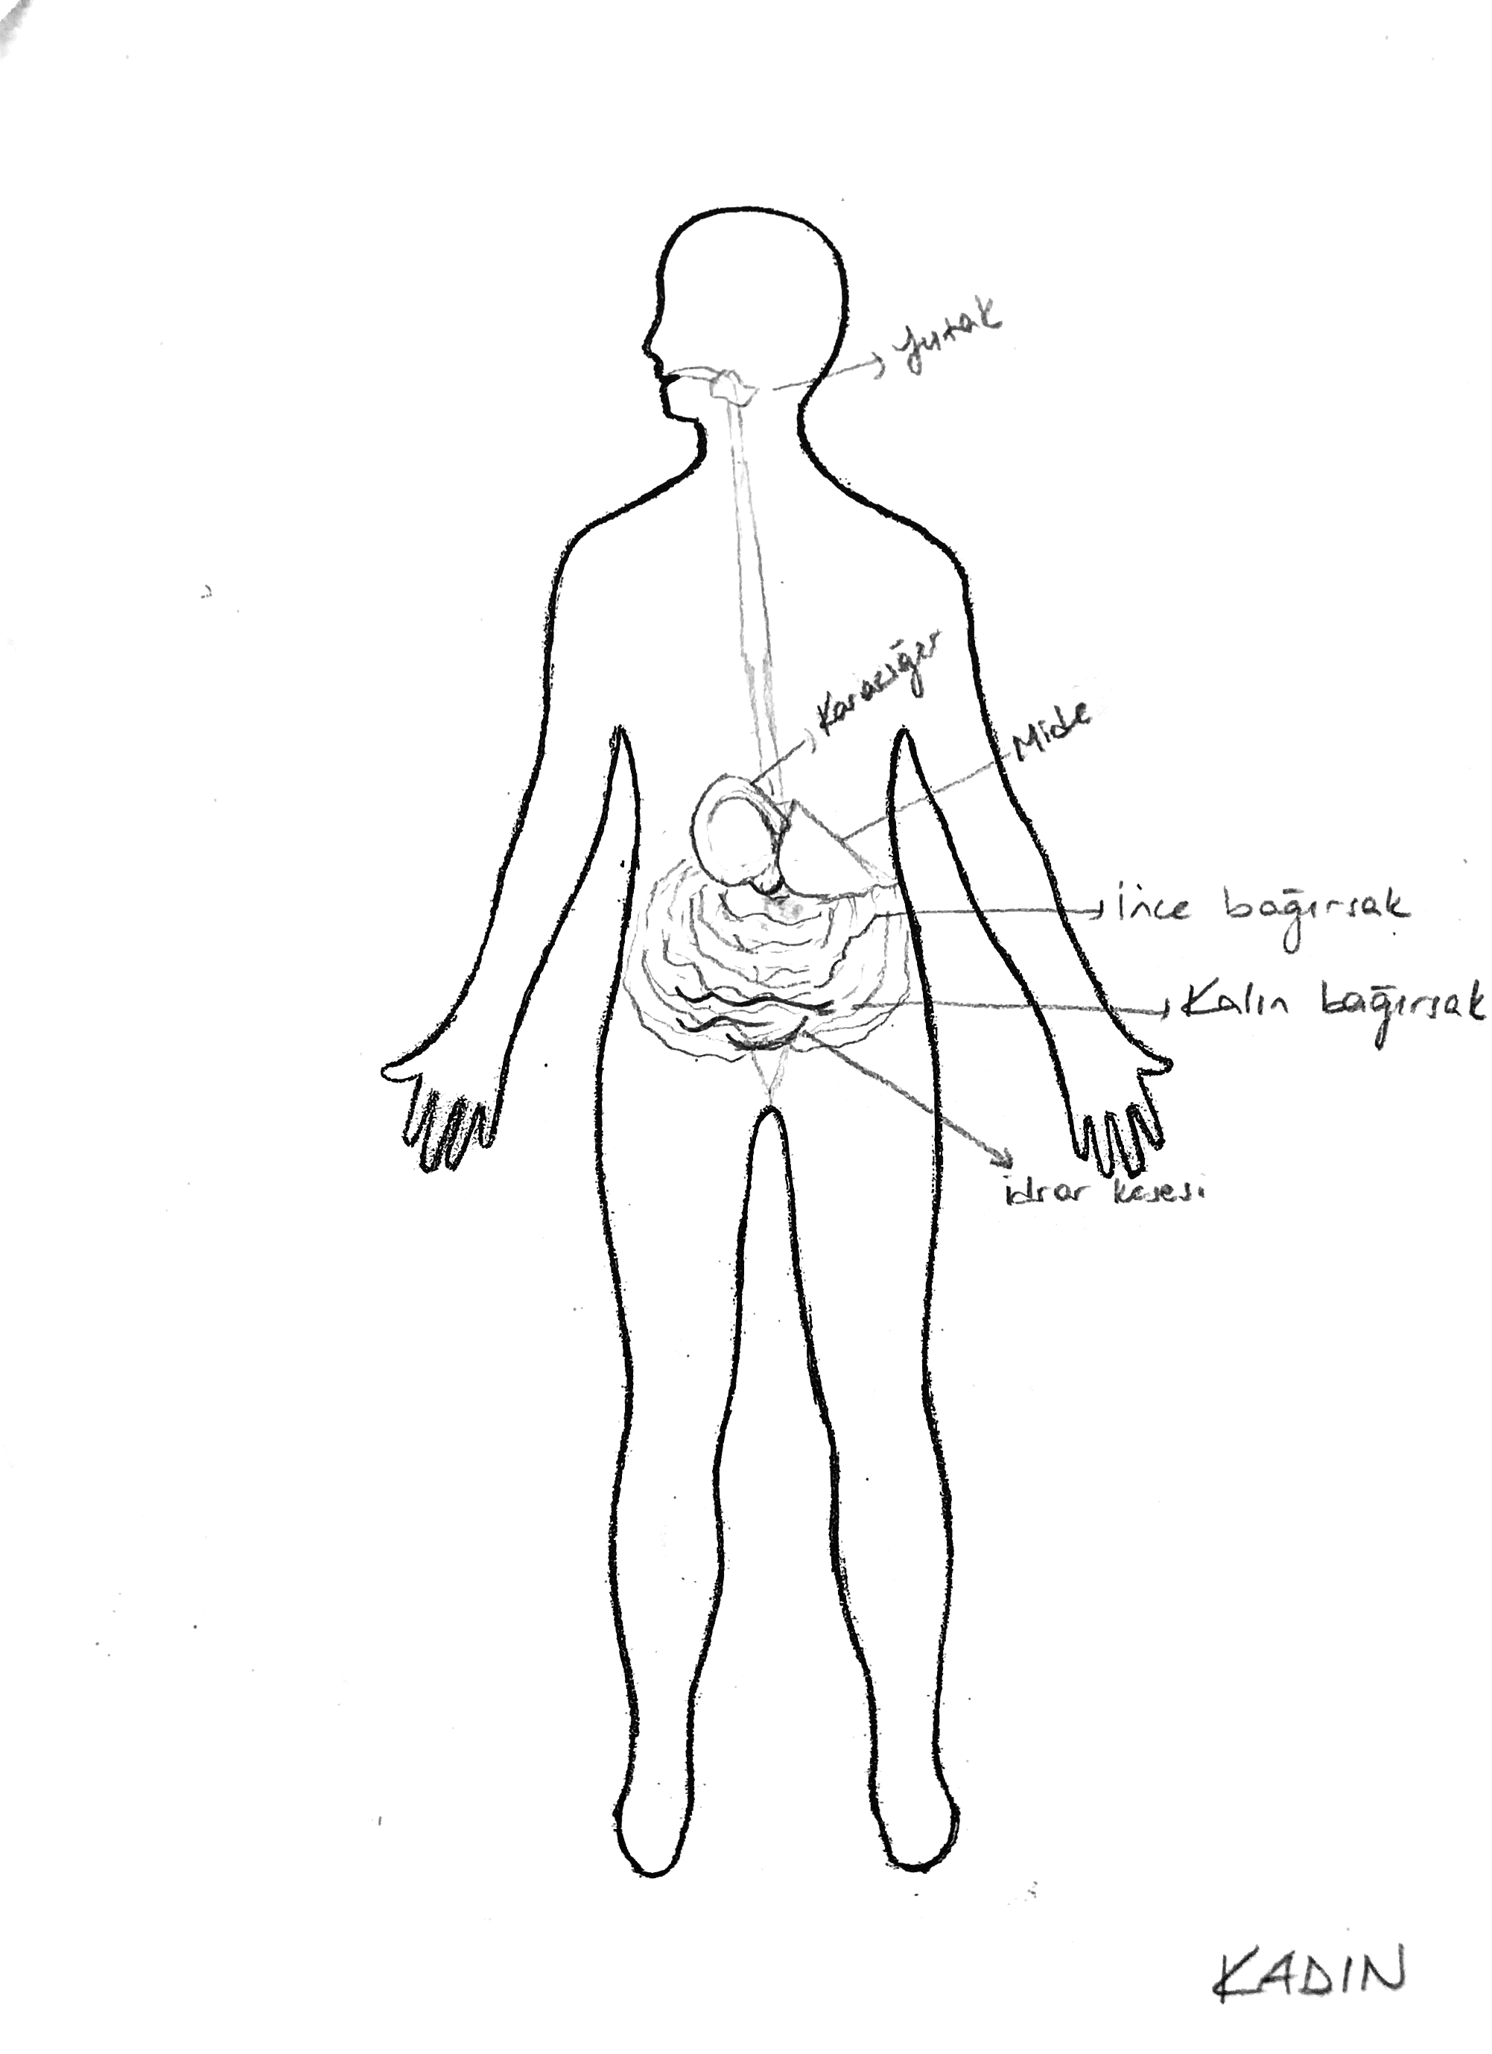 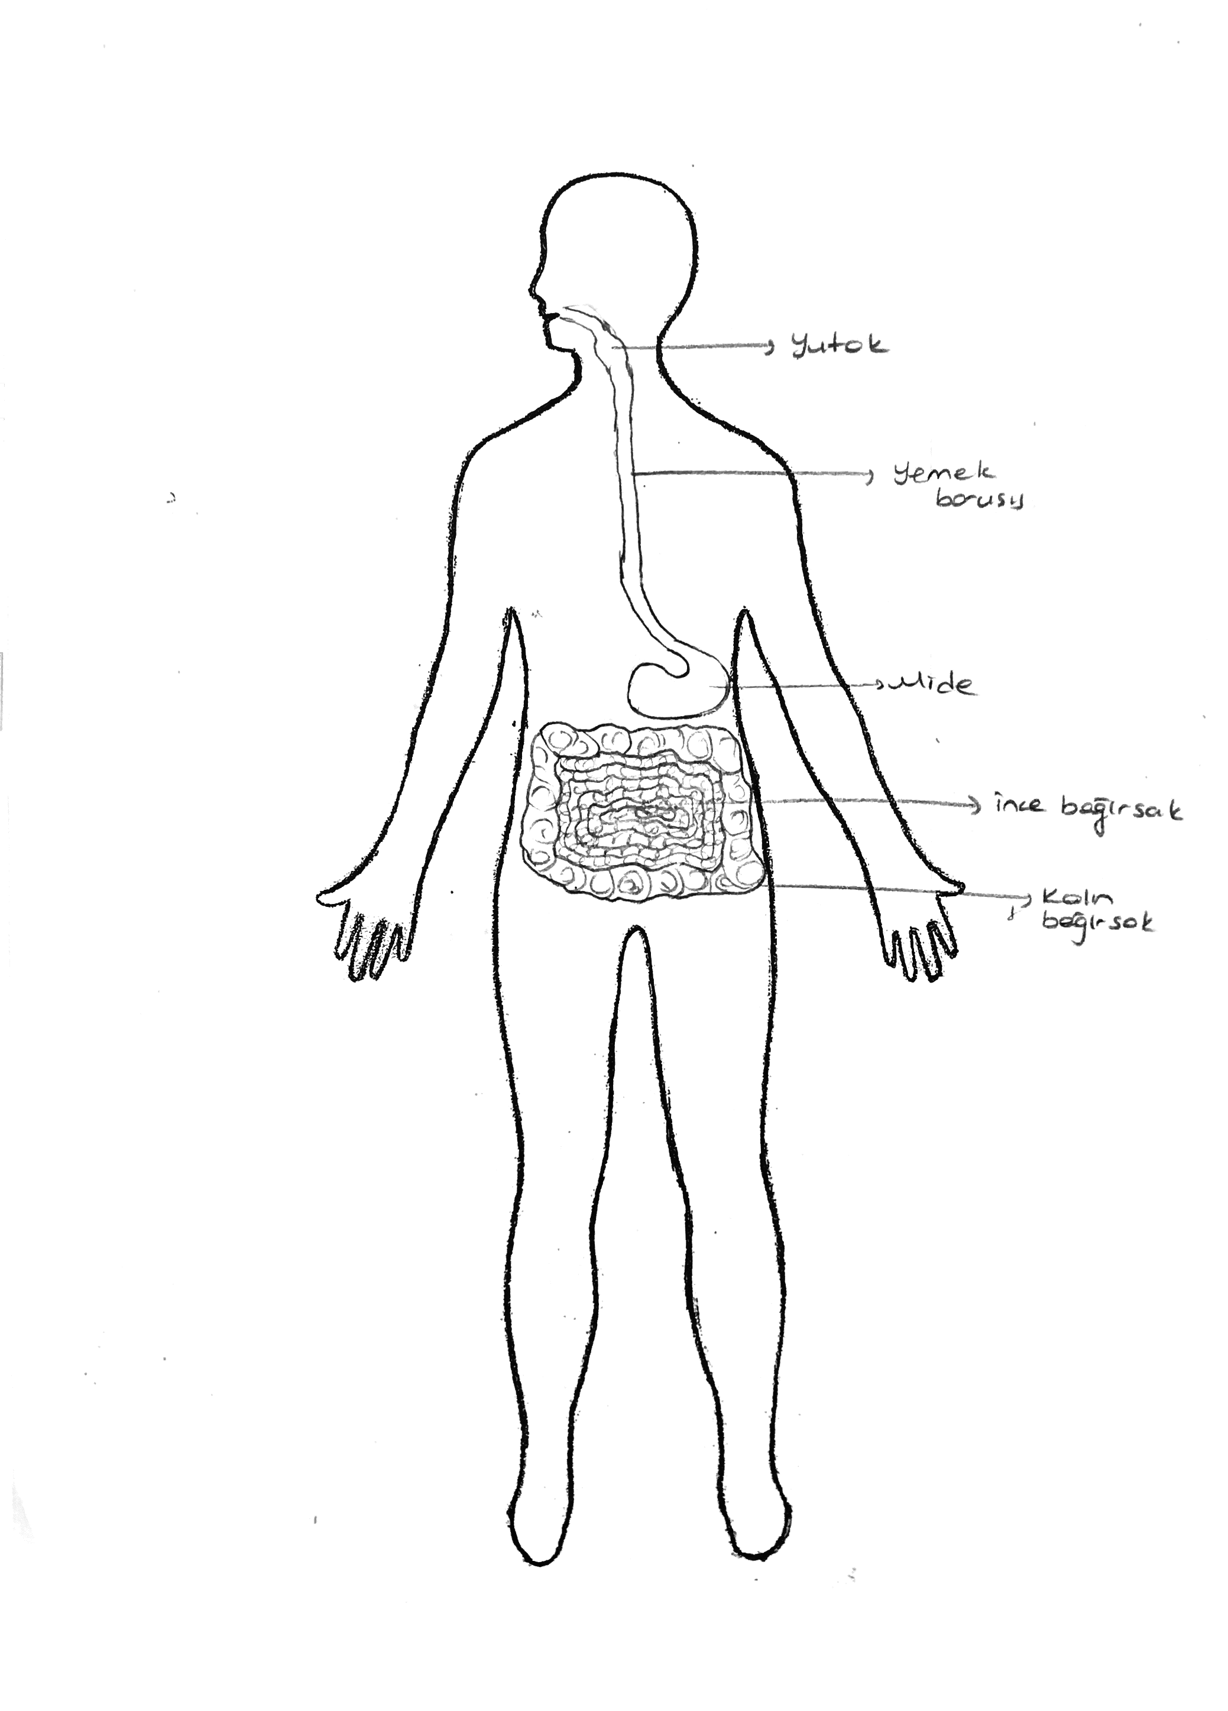

Figure 5. A drawing showing small and Figure 6. A drawing omitting the anus.

large intestines wrongly.

Interestingly, while a great majority of the students (84%) illustrated the gullet in their drawings, only a small minority (15%) drew the pharynx. This might be due to that the gullet is more frequently used in the daily life compared to the pharynx. Although a great majority of students (84%) drew the small and large intestines in their drawings, 12 percent of the students did not show the small and large intestines separately (Figure 7).

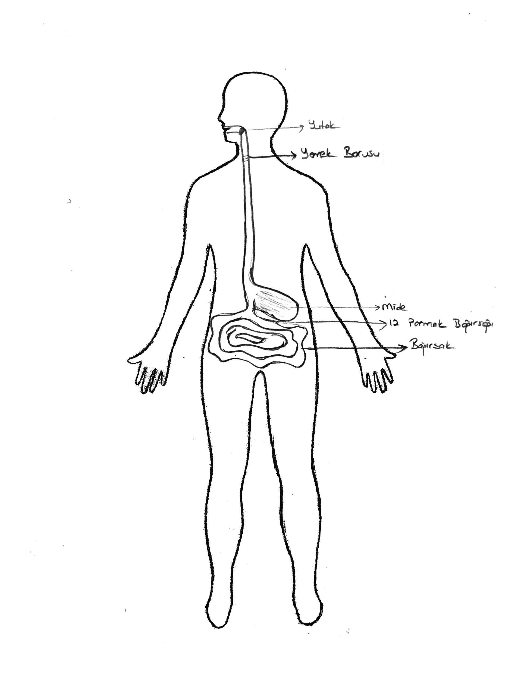 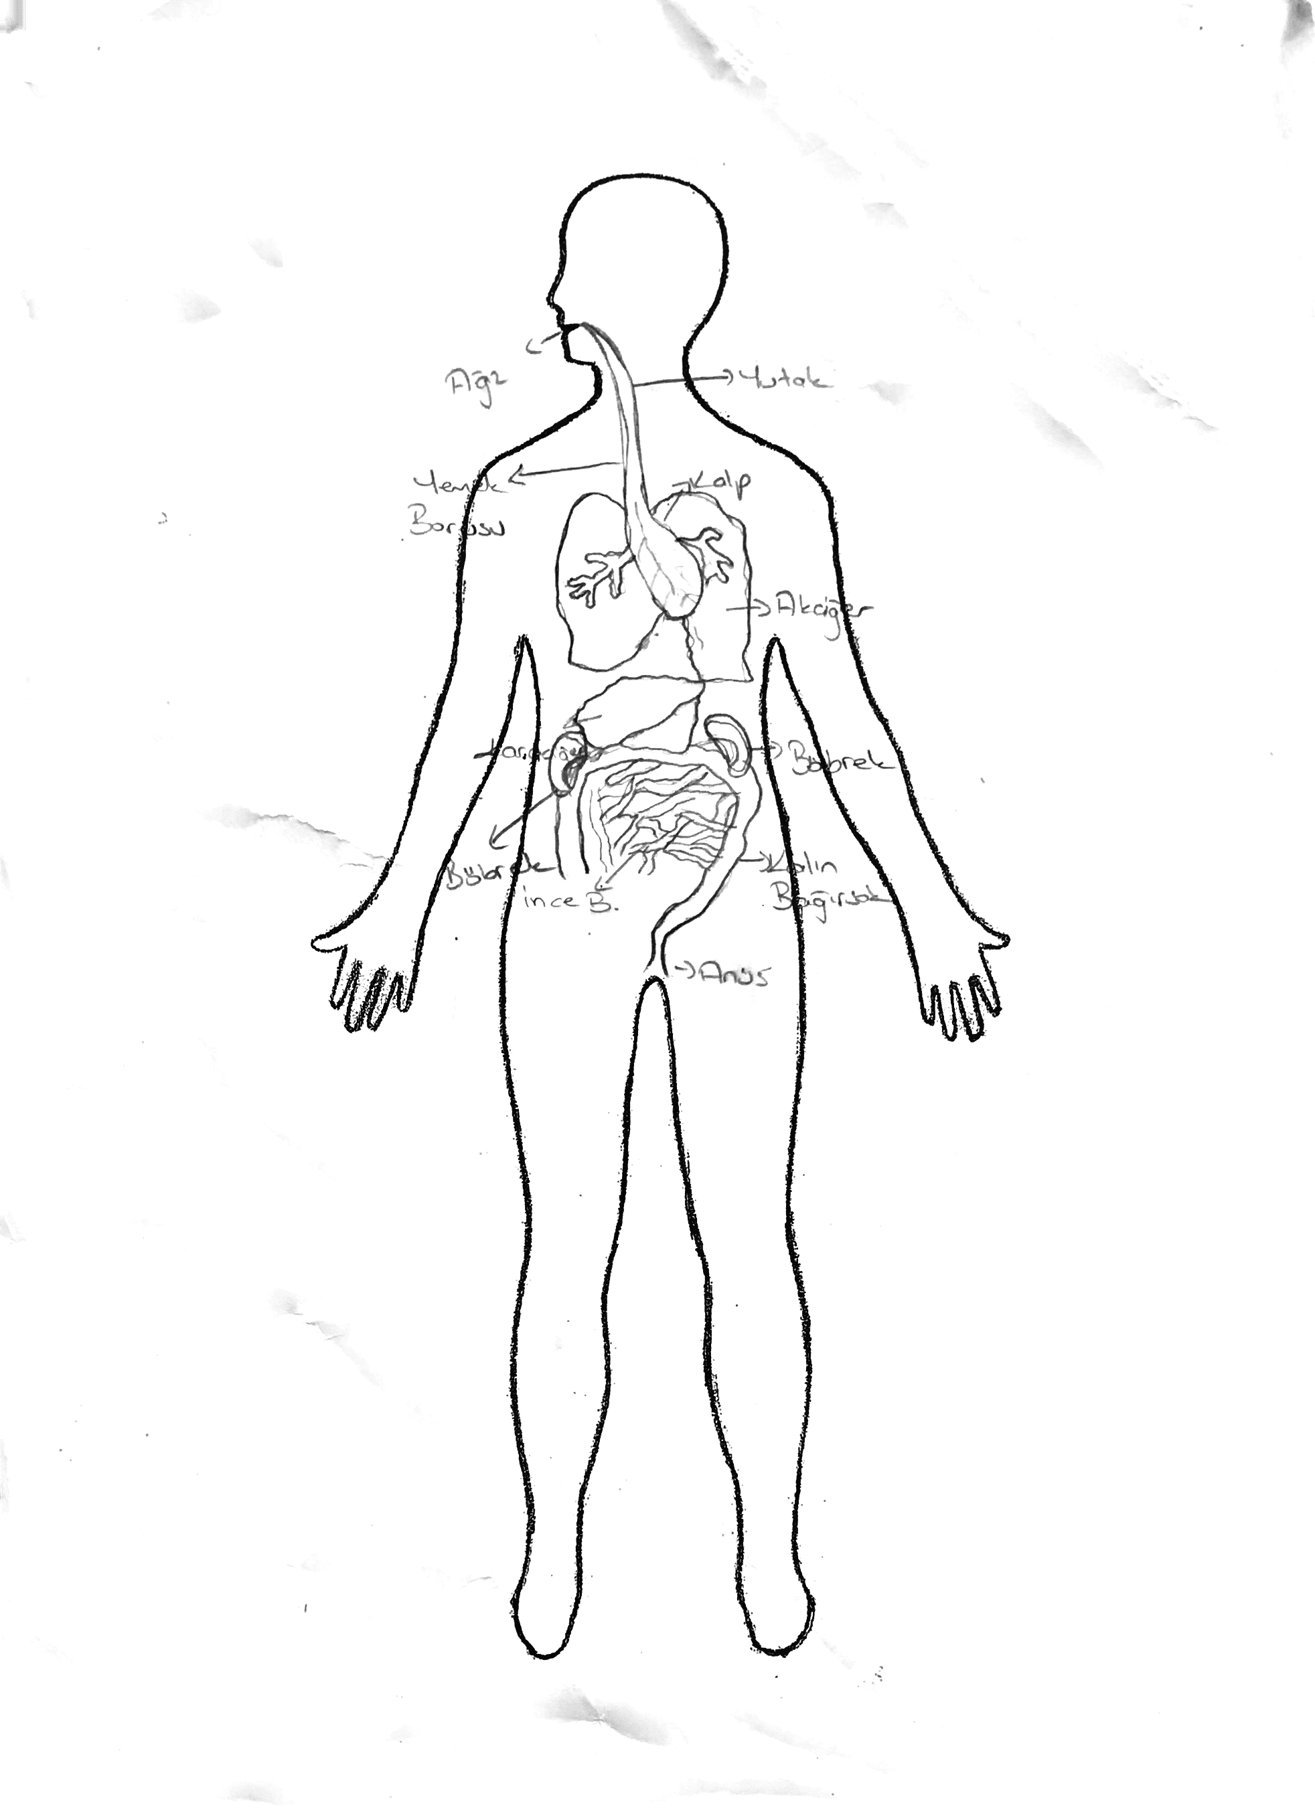

Fig.7. A drawing not separating intestines. Fig. 8. A drawing showing lungs and kidneys.

As seen in Figure 8 above, a small number of students, 11.8 percent, thought that the lungs and kidneys were part of the digestive system. A few students also drew the urine bladder, heart, gall bladder and backbone in their drawings of the digestive system. They appeared to be confused about the digestive organs and the respiratory system.

**3.1. Pre-service Primary Students’ Conception of the Stomach Location and Size**

In order to analyze and interpret students’ drawings, the human body cavity was divided into 9 parts as shown in Figure 9. Stomachs placed in cells 1, 2 and 3 on the human body cavity were classified as being too high when compared to the correct location. Similarly, stomachs placed in cells 7, 8 and 9 were classified as being too low, and cells 4, 5 as median line. In relation to the size of the stomach, five criteria were used: as normal, smaller than normal, very much smaller, larger and very much larger.

The criteria used to decide the students’ drawings for the correct location and size of the digestive organs were rather liberal. Any placement that is in accordance mostly with the true location and size of the digestive organ was considered correct.

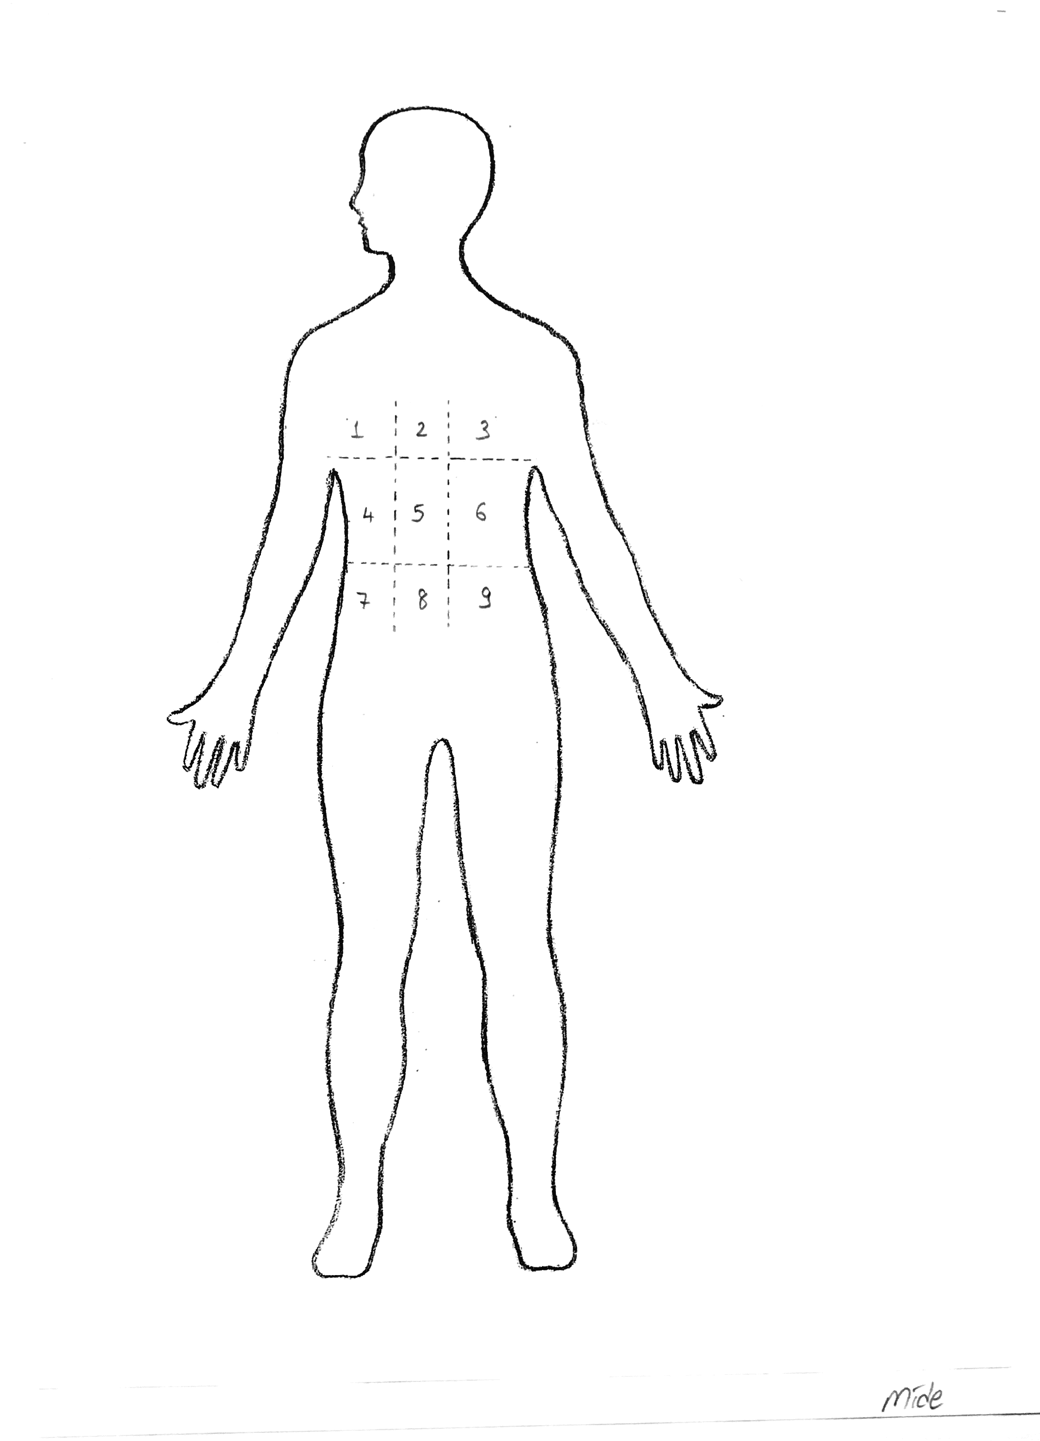

Figure 9. Demonstrates judgement criteria for the stomach location.

**Table 2.** Pre-service primary teachers’ conception of the stomach location.

|  |  |  |
| --- | --- | --- |
| **Students’ conception of the stomach location** | **N %** | |
| **Scientific** | **(25)** | **24.5** |
| Mostly the area encompassed by the stomach (cell 6) | (25) | 24.5 |
| **Non-scientific** | **(77)** | **75.5** |
| **Median line** | **(55)** | **53.9** |
| The area the stomach and liver overlap (cell 5) | (51) | 50.0 |
| To the left of the actual position (cell 4) | (4) | 3.9 |
| **Too high** | **(17)** | **16.7** |
| Over the liver (cell 1)  On the median line of body (cell 2)  Above the correct place of the stomach (cell 3) | (-)  (14)  (3) | -  13.7  2.9 |
| **Too low** | **(5)** | **4.9** |
| Below the liver (cell 7)  On the median line of body (cell 8)  Below the stomach (cell 9) | (-)  (3)  (2) | -  2.9  1.9 |
| **Total showing stomach** | **102** |  |

As seen from Table 2, teacher candidates generally located the stomach in different parts of the abdominal and chest cavity, rather than in its actual place. Only about 25 percent of pre-service primary teachers encircled the area encompassed by the stomach accurately and located it in its actual place. Over half of the students (53.9%) located the stomach on the median line of body. Half of the students showed the stomach in the middle of abdominal cavity, where the area the stomach and liver overlap, as seen Figure 10. In addition, nearly 17 percent of them tended to place the stomach too high as seen in Figures 11. A small number of them illustrated the stomach too low.

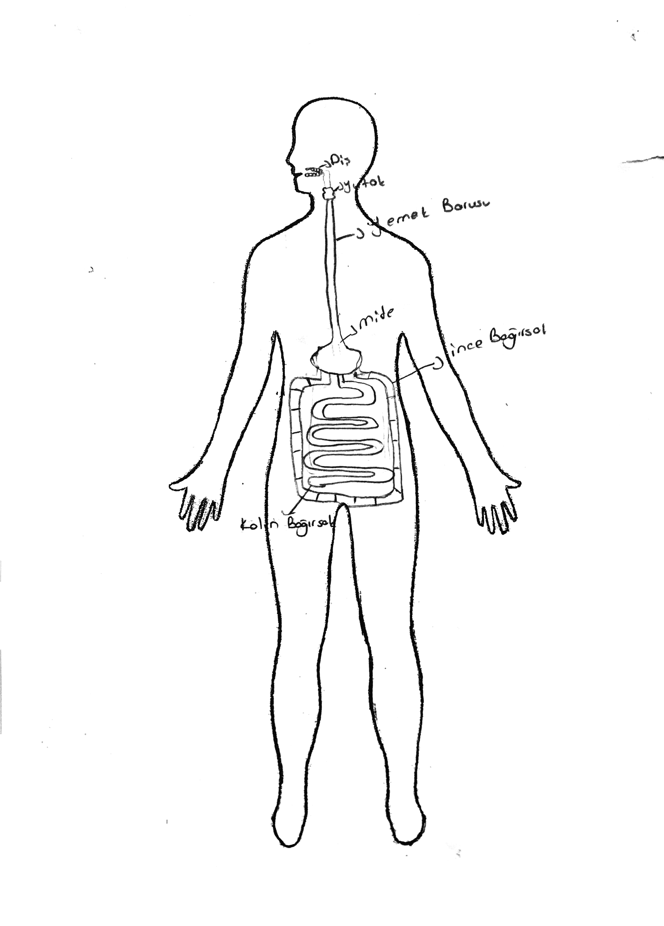 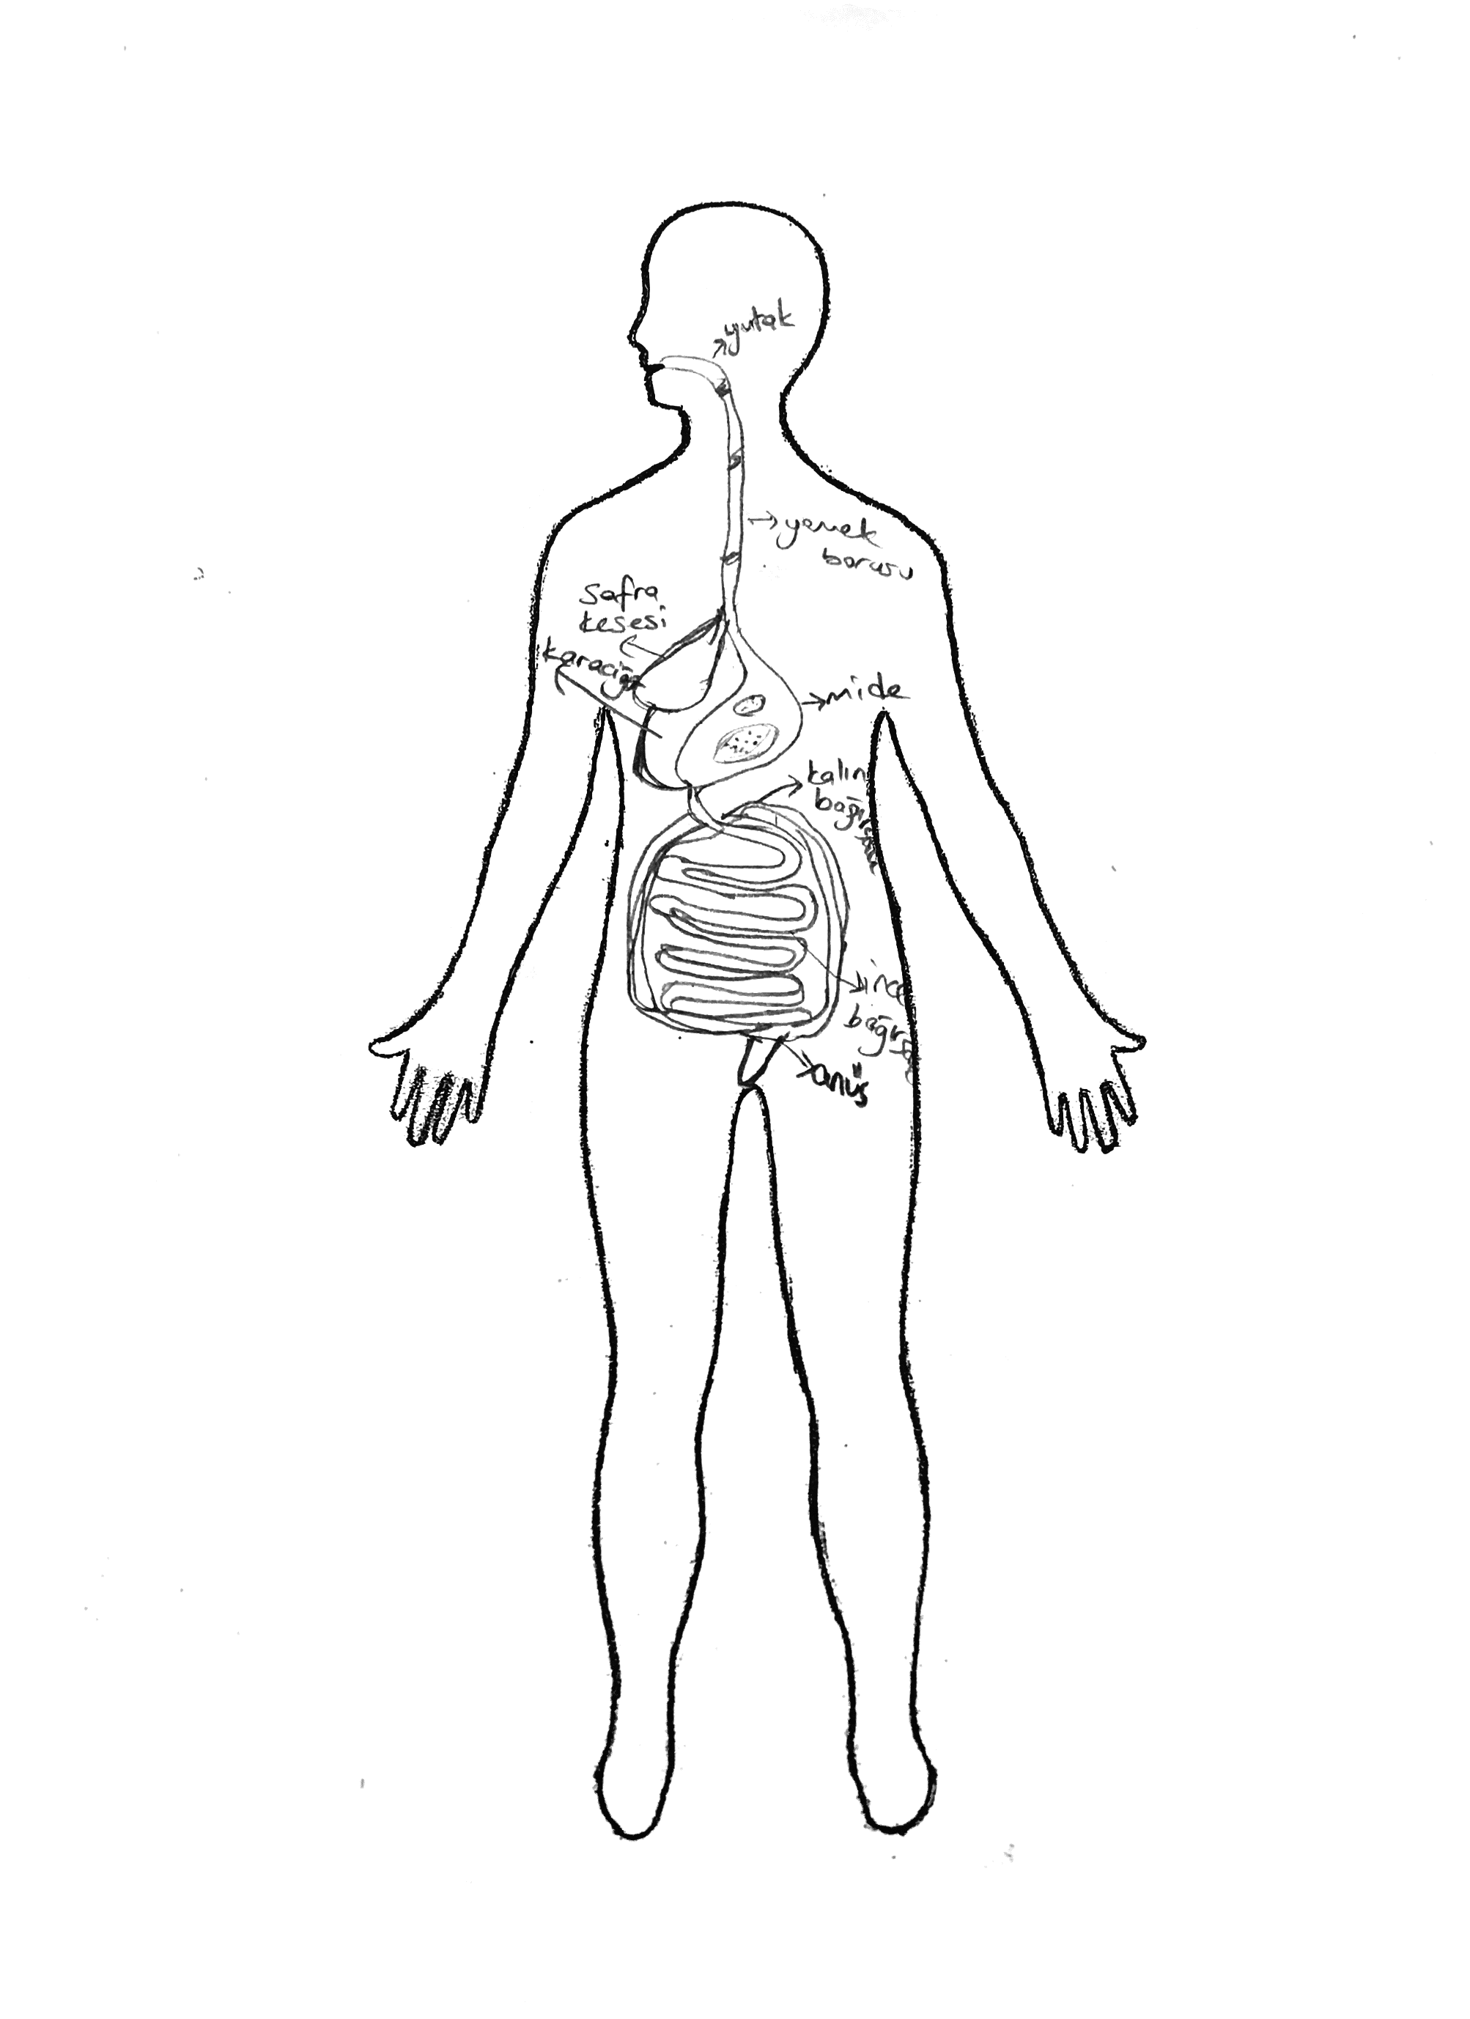

Fig.10. Drawing showing the stomach in the middle. Fig.11. Showing the stomach too high.

**Table 3.** Pre-service primary teachers’ conception of the stomach size.

|  |  |  |  |
| --- | --- | --- | --- |
| **The stomach size** | **N %** | | |
| **Scientific** | | **(38)** | **37.3** |
| Normal size | | (38) | 37.3 |
| **Non-scientific** | | **(64)** | **62.7** |
| **Too small** | | **47** | **46.1** |
| Smaller than normal | | (35) | 34.3 |
| Very much smaller | | (12) | 11.8 |
| **Too large** | | **17** | **16.7** |
| Larger than normal | | (13) | 12.7 |
| Very much larger | | (4) | 3.9 |
| **Total showing stomach** | | **102** |  |

As seen from Table 3 above, 37.3 percent of students drew the stomach close to its normal size. Nearly half of the students tended to draw the stomach smaller or very much smaller than normal size, as shown in Figure 12. A small minority of the students, 16.7 percent drew the stomach larger than normal or very much larger (Figure 13).

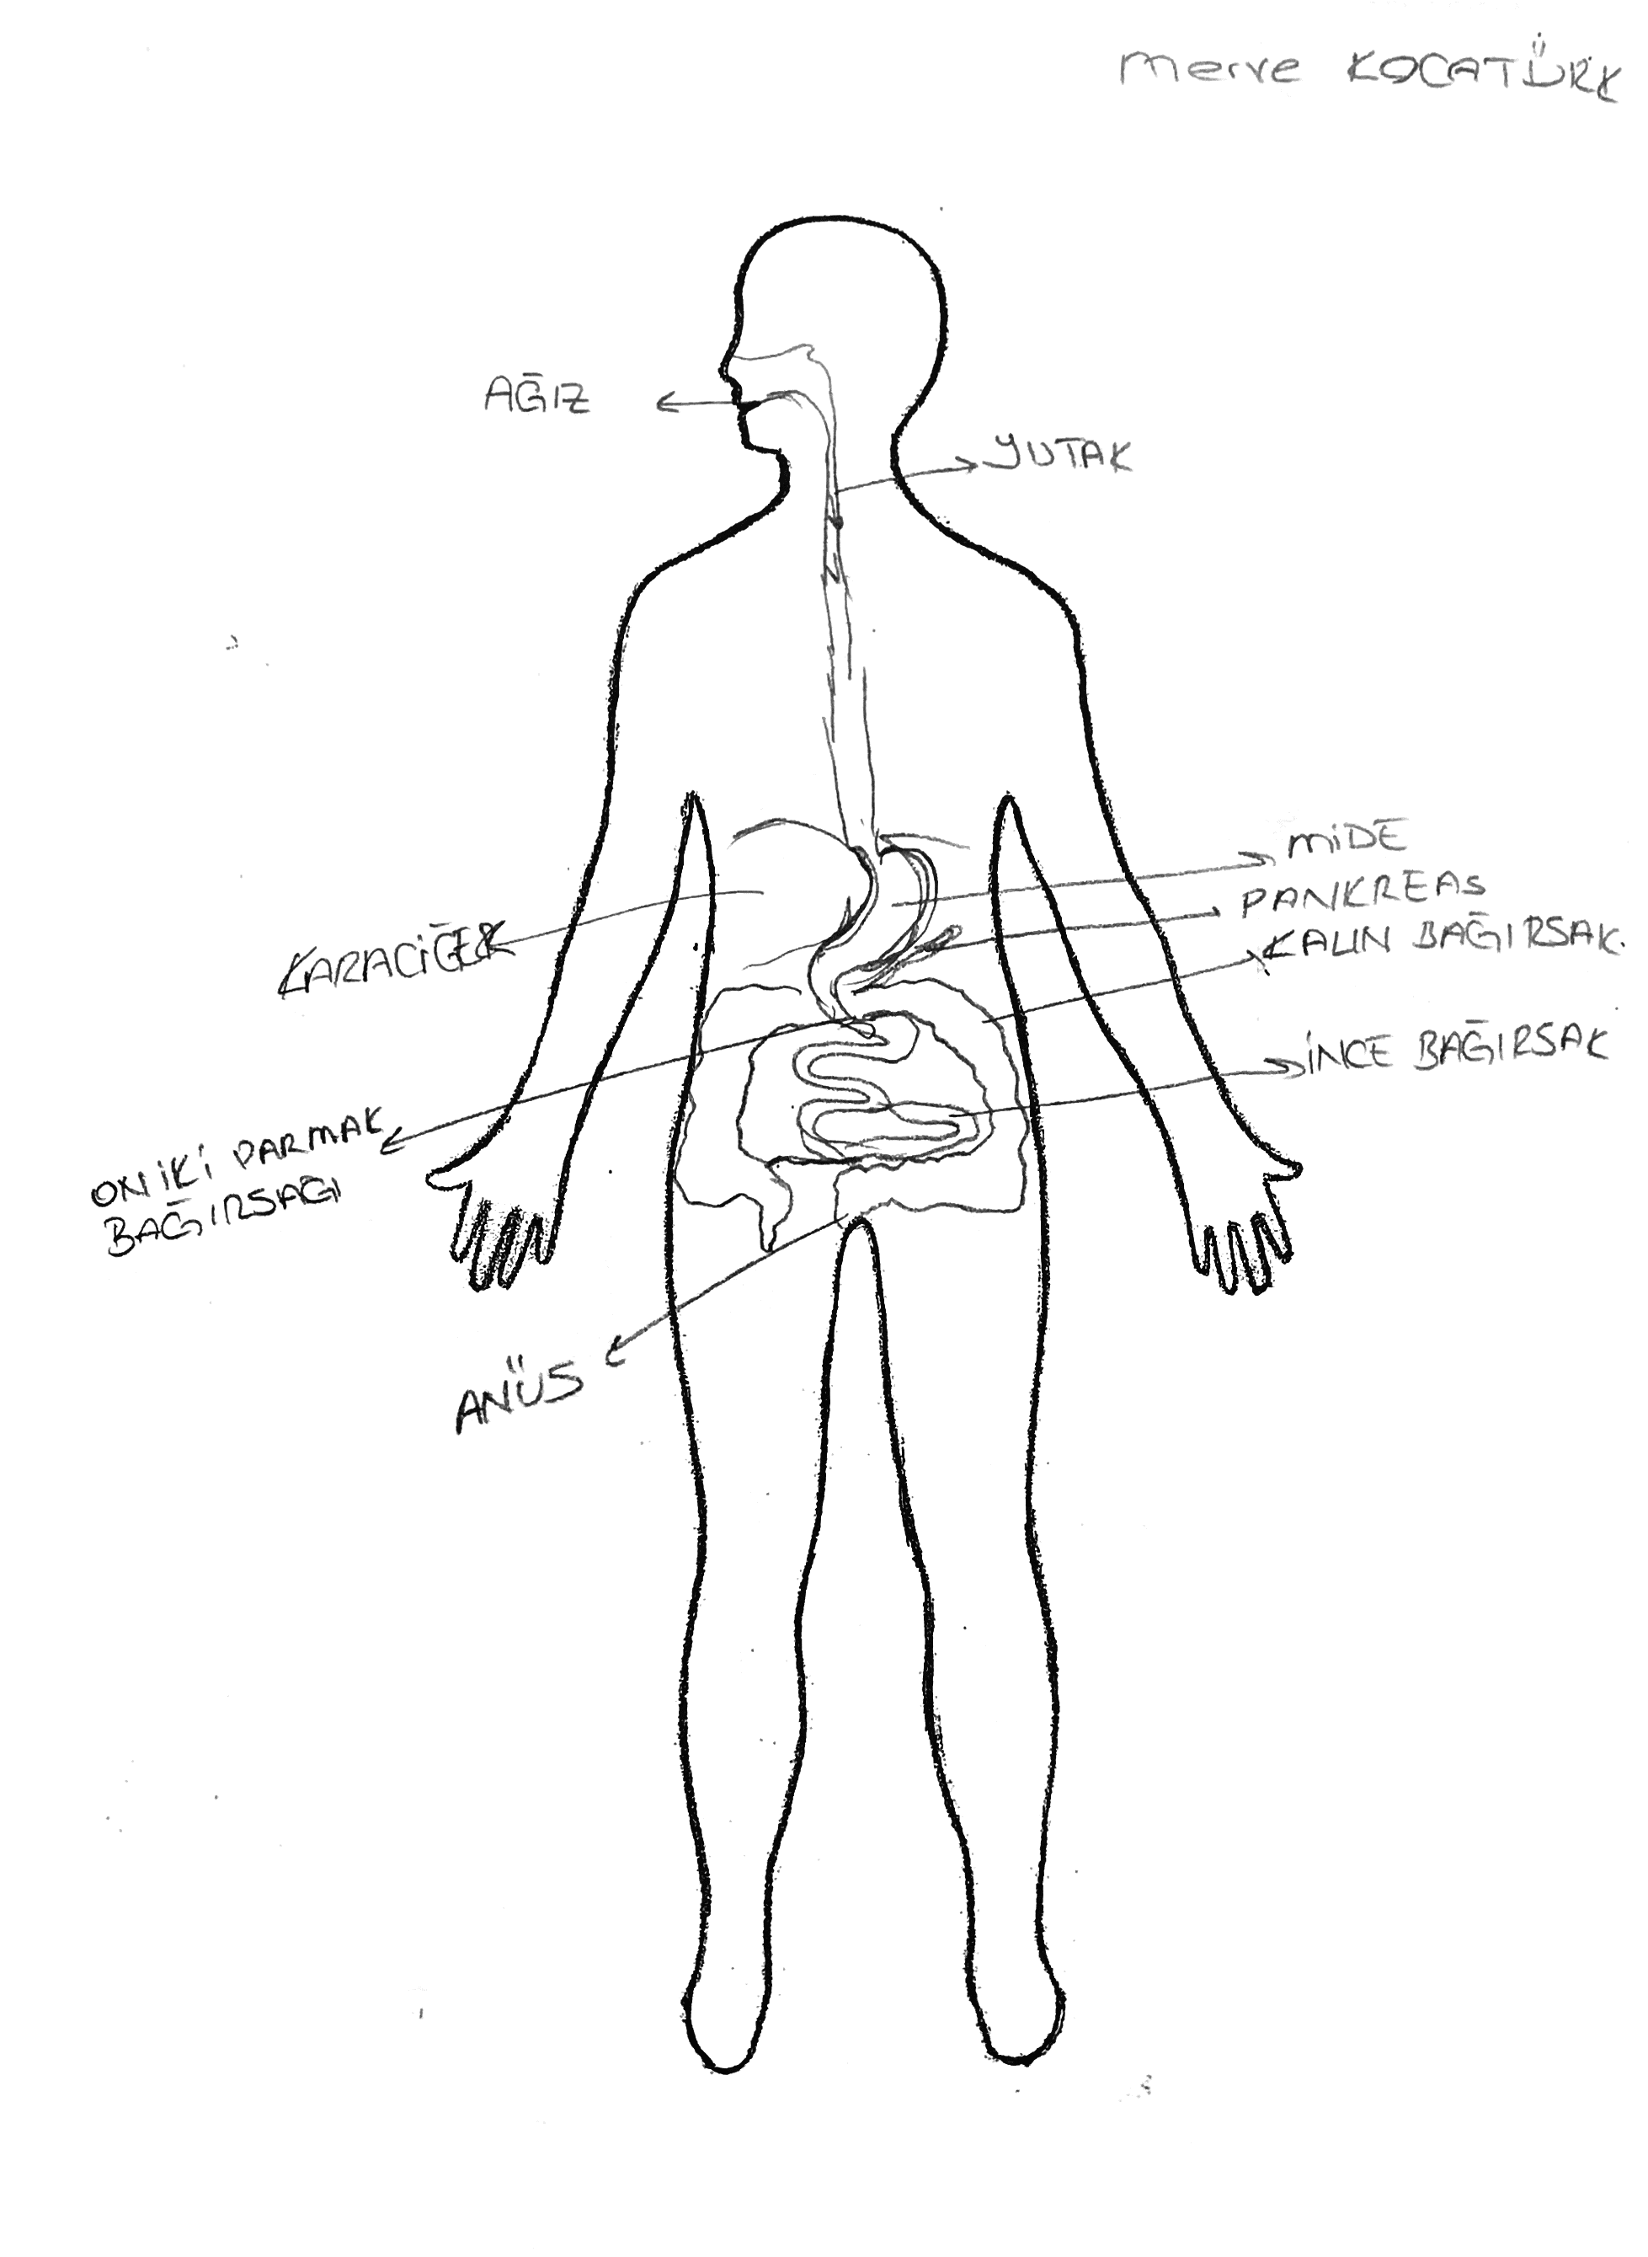 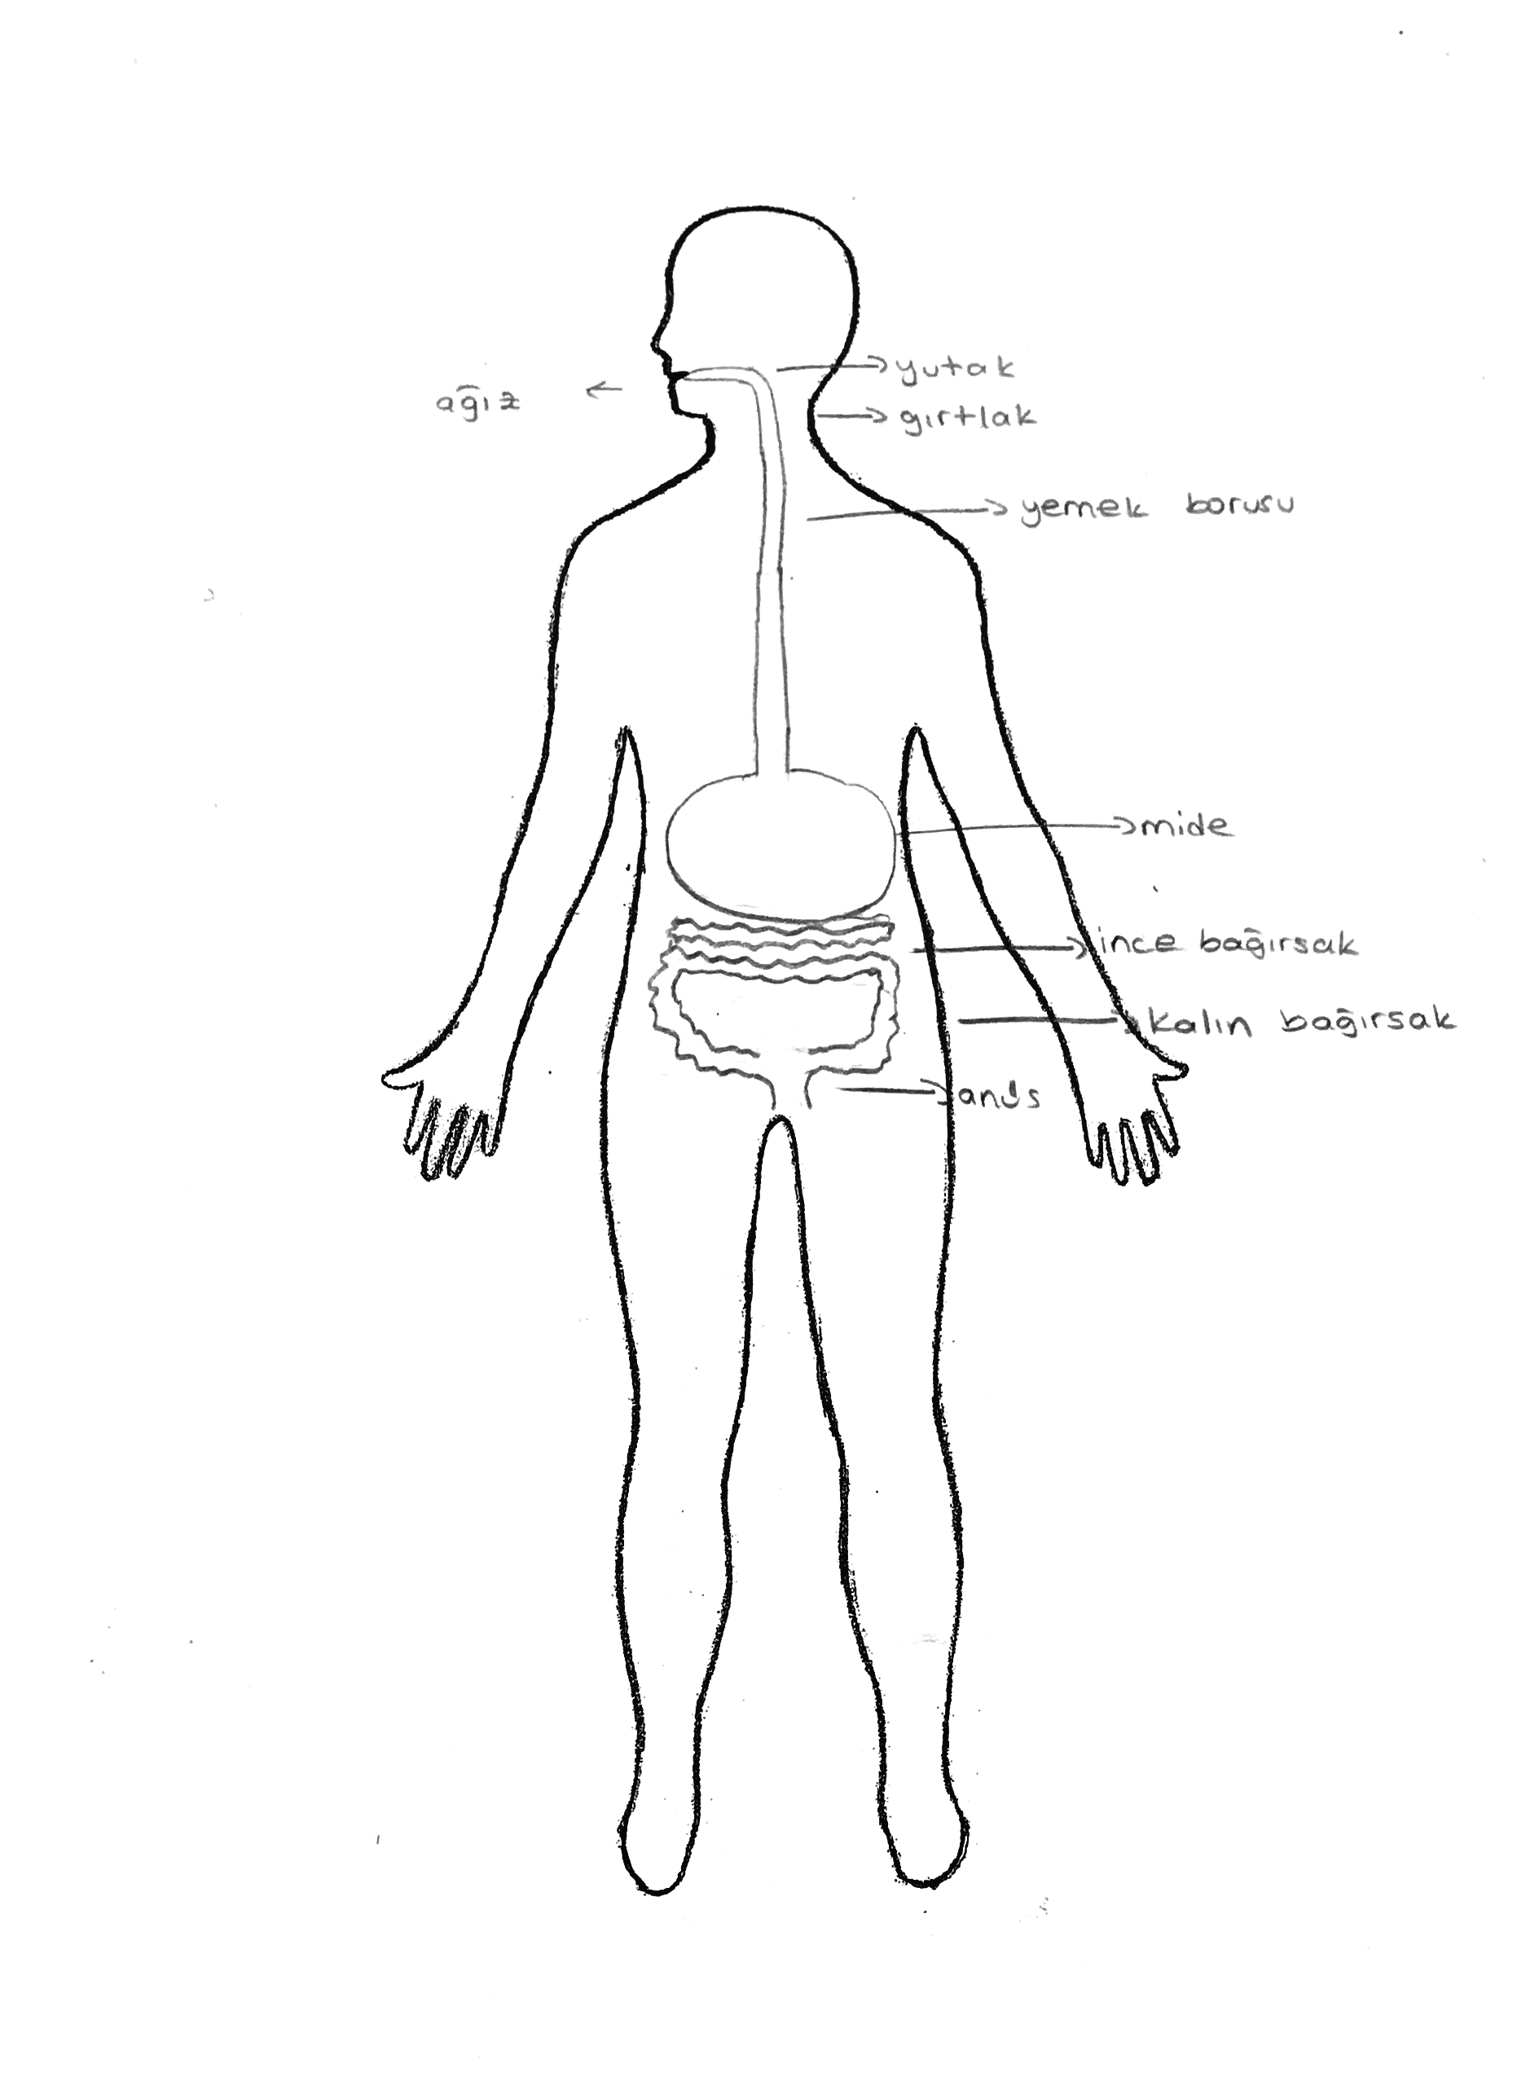

Fig12. Drawing showing the stomach smaller. Fig13. Drawing showing the stomach larger.

**3.2. Liver**

The liver aids the digestion of fats by its secretions into the duodenum. Although the liver is a relatively big and vital digestive organ, it is too rarely shown by the students in their drawings, as was the case in the study conducted by Cerrah Özsevgeç (2007). Possible reason for this situation might be that students are less well informed about the liver in terms of its function, location and size when compared with other digestive organs such as the mouth, stomach and intestines. Therefore, they do not relate the liver with the digestive organs. About one in five of the students, 21.6 percent, showed the liver as a part of the digestive system. Of these, some located the liver too high, and tended to think of it as smaller than it really is.

**3.3. Pancreas**

A very small number of students (12.7%) drew the pancreas in their drawings. They mostly located it correctly between the stomach and intestines. However, although they recognized that the pancreas was a part of the digestive system and knew its relative location in the body, there was great variety in their representations of its size and shape.

1. **DISCUSSION and CONCLUSION**

In this study, we explored pre-service primary teachers’ drawing of the digestive system. In general, many educational sources emphasize that the digestive system consists of the mouth, pharynx, gullet, stomach, liver, pancreas, small intestine, large intestine and anus. The salivary glands in the mouth, liver and pancreas contributes to the digestion process through their digestive juices.

Pre-service primary students’ drawings revealed their conceptions of the digestive system, and in particular, their ideas about the size and location of the digestive organs. A great majority of them could not illustrate the digestive system sufficiently. Many students’ drawings demonstrated their lack of understanding about the digestive system. These findings were in accordance with the studies conducted by Sasmaz Oren and Ormanci (2014) and Cardak (2015) with science teacher candidates about the digestive system.

In this study, not surprisingly, all preservice primary students have shown the stomach in their drawing of the digestive system. However, it was represented in a variety of ways, but most commonly as a small round figure in the center or higher than its actual position. The research literature about the digestive organs support the views of Gellert (1962) who emphasizes that the organs whose existence and function are often mentioned, may be thought of as larger than organs whose existence and function are not well known. However, in this study, pre-service primary teachers tended to draw the stomach and liver smaller than they are really.Furthermore, the students also were not aware of the actual shape of the stomach. They tended to draw the stomach as a roundish figure, rather than depicting its actual shape. This point needs to be carefully emphasized during the teaching-learning process in the classroom.

Although a great majority of students have shown the mouth, gullet and intestines in their drawings of the digestive system, only a small minority of them illustrated the pharynx, liver, pancreas and duodenum. In particular, students tended to exclude the pancreas from the digestive system. Almost half of the students also ignored the anus in their drawings. These digestive organs should be openly stressed in teaching process as a part of the digestive system.

In essence, preservice primary teachers’ drawings reveal that the knowledge they have about the digestive organs includes many misconceptions, and seems to be still based on informal experiences obtained personally or socially rather than formal information gained in the classroom through the long school years.

Teacher candidates should be aware of that, as Dempster and Stears (2014) emphasized, drawings is an effective tool for accessing students’ knowledge and ideas obtained through several experiences in environment. Teachers may use this valuable knowledge from a constructivist perspective to help students remove their misconceptions and enhance their understanding (Driver, Squires, Rushworth, & Wood-Robinson, 1994). It is also worth noting that in this study, students’ drawings belong to only one undergraduate department so that the findings may not generalize to the whole preservice primary teachers. However, it means that drawings as a teaching technique deserves more attention in science courses in teacher education programs. It is also clear that knowledge of students’ digestive organs is essential for effective planning of curricula and teaching-learning methods in the classroom.

1. **REFERENCES**

American Association for Advancement of Science [AAAS] (1993). Benchmarks for science literacy. New York: Oxford University Press.

Cachapuz, A. F. C. & Maskill, R. (1987). Detecting changes with learning in the organization of knowledge: use of word association tests to follow the learning of collision theory. *International Journal of Science Education*, 9, 491–504.

Cardak, O. (2015) Student science teachers’ ideas of the digestive system. *Journal of Education and Training Studies*, 3(5), 127-133.

Cerrah Özsevgeç, L. (2007). What do Turkish students at different ages know about their internal body parts both visually and verbally. *Journal of Turkish Science Education*, 4(2), 31-44.

Dempster, E. R. & Stears, M. (2014). An analysis of children's drawings of what they think is inside their bodies: A South African regional study. *Journal of Biological Education,* 48(2), 71-79.

Driver, R. & Guesne, E. & Tiberghien, A. (1985). Children’s ideas in science. Milton Keynes: Open University Press.

Driver, R. & Squires, A. & Rushworth, P., & Wood-Robinson V. (1994). Making Sense of Secondary Science, research into children's ideas. London and New York: Routhledge.

Gellert, E. (1962). Children's conceptions of the content and functions of the human body. *Genetic Psychology Monographs*, 65, 293-405.

National Research Council (1996). National science education standards. Washington: National Academy Press.

Novak J. D. & Gowin D. B. (1984). Learning how to learn. New York: Cambridge University Press.

Osborne, J. & Wadsworth, P., & Black, P. (1992). The Science processes and concept exploration (SPACE) research report: Processes of life. Liverpool: Liverpool University Press.

Osborne, J. (1994). Young Children’s Understanding of Science in 4 Domains and Its Development Through A Constructivist Approach to Teaching. Ph.D Thesis. London University. London.

Reiss, M. J. & Tunnicliffe, S. D. (2001). Students’ understandings of human organs and organ systems. *Research in Science Education*, 31, 383-399.

Richardson, V. (Ed.) (1997). Constructivist Teacher Education. Building a World of New Understandings. London: The Falmer Press.

Sasmaz-Oren, F. & Ormanci, U. (2014). Exploring pre-service teachers’ ideas about the digestive system by using the drawing method. *Journal of Baltic Science Education*, 13 (3), 316-326.

Teixeira, F. M. (2000) What happens to the food we eat? Children’s conceptions of the structure and function of the digestive system. *International Journal of Science Education*, 22 (5), 507-520.

Weiss, I. (1994). National survey of science and mathematics education. Research Triangle Park: Centre for Educational Research and Evaluation.

**UZUN ÖZ**

**Giriş**

1980’li yıllardan beri öğrencilerin çeşitli fen kavramları ile ilgili mevcut düşünceleri ya da kavram yanılgıları, onların bu kavramları anlamlı olarak öğrenmelerini engelleyen en önemli faktörlerden biri olarak kabul edilmektedir. Bu nedenle pek çok araştırmacı, ezbere öğrenme yerine anlamlı ve kalıcı öğrenmeyi geliştirmek için fen kavramları ile ilgili öğrencierin mevcut düşüncelerini ortaya çıkarmaya yönelik çalışmalar yapmışlardır. Kavram yanılgıları alanındaki araştırma sonuçları öğrencilerin çok fazla bilgi yerine temel fen kavramlarını anlamlı olarak öğrenmeleri gerektiğini ortaya koymuş ve fen eğitimi alanındaki reform hareketleri bu hususa odaklanmıştır. Anlamlı öğrenme kavramları tek başına bilmeyi değil, kavramlar arasındaki ilişkiyi ve kavramları benzer durumlarda uygulamayı gerektirmektedir. Ancak, pek çok araştırma eğitim öğretim sürecinde durumun böyle olmadığını, öğrencilerin en temel fen kavramlarıyla ilgili kavram yanılgılarına sahip olarak mezun olduklarını göstermektedir.

Çocukların ve öğrencilerin sindirim sistemi ile ilgili kavram yanılgıları konusunda çeşitli ülkelerde araştırmalar yapılmasına rağmen sınıf öğretmeni adayları ile ilgili literatürde bir çalışmaya rastlamak zordur. 1987-1990 yılları arasında İngiltere’de yürütülen SPACE Projesi’nde araştırmacılar öğrencilere bir insan vücudu taslağı vererek bunun üzerine yedikleri besinlerin vücutlarında ne olduğunu düşünerek çizmelerini istemişlerdir. Proje sonunda, pek çok çocuğun sindirim sistemi organlarının boyutu ve yerleşimi konusunda kavram yanılgılarına sahip olduğu ve başta ağız ile mide arasında olmak üzere sindirim sistemi organları arasında bağlantı yapmadıklarını belirlemişlerdir. Ayrıca, çocukların yaygın olarak mideyi karın boşluğunun ortasında ve olduğundan daha büyük olarak gösterme eğiliminde oldukları ortaya çıkmıştır. Benzer bir çalışmada, Teixeira (2000) Brezilya’da 4-10 yaş arasındaki çocukların sindirim sistemi ile ilgili düşüncelerini araştırmış ve benzer sonuçlar elde etmişlerdir. Çocukların genel olarak mideyi karın boşluğunun ortasında ve biraz aşağısında ve ayrıca daha büyük çizme eğiliminde oldukları belirlenmiştir.

Ülkemizde Sasmaz Oren and Ormanci (2014) ve Çardak (2015) fen bilgisi öğretmen adaylarının sindirim sisemi ile ilgili düşüncelerini çizim tekniğinden yararlanarak ortaya koymaya çalışmışlardır. Fen bilgisi öğretmen adayları, genel olarak sindirim sistemi organları arasında bağlantı yapmamışlar ve organların boyutu ve vücut boşluğundaki yerleşimi konusunda çeşitli kavram yanılgılarına sahip oldukları belirlenmiştir. Ayrıca, fen eğitiminde anlamlı öğrenmeyi güçlendirmek için çizimlerin önemine dikkat çekmişlerdir.

Sindirim sistemi; dolaşım, solunum, boşaltım ve büyüme ile yakından ilişkili olduğu için pek çok ülkede ilkokul ve ortaokuldaki fen bilgisi derslerinin en önemli konularından bir tanesini oluşturmaktadır. Bu nedenle, sindirim konusu eğitim öretim sürecinde özel bir ilgiyi hak etmektedir. Bu bağlamda, bu çalışmanın amacı sınıf öğretmeni adaylarının sindirim sistemi organları ile ilgili çizimlerini inceleyerek onların sindirim sistemi organları ile ilgili yanlışlarını ya da kavram yanılgılarını ortaya çıkarmaktır.

**Yöntem**

Kavram yanılgıları alanındaki alanyazın incelendiğinde öğrencilerin kavram yanılgılarını ortaya çıkarmak için görüşme, kelime ilikilendirme, kavram haritaları gibi çeşitli teknikler ve yaklaşımlar kullanıldığı görülmektedir. Bu araştırmada öğretmen adaylarının, sindirim sistemi organları ve organların vücut boşluğundaki yeri ve boyutu konusunda düşüncelerini ortaya çıkarmak amaçlandığından veri toplama aracı olarak çizimler kullanılmıştır.

Araştırma verileri, 2016-2017 eğitim-öğretim yılında Trakya Üniversitesi Eğitim Fakültesinde üçüncü sınıfta okuyan 102 sınıf öğretmenliği öğrencisine uygulanan çizimlerle toplanmıştır. Öğretmen adaylarına üzerinde bir insan vücudu taslağı bulunan A4 kağıdı verilmiş ve bunun üzerine sindirim sistemi organlarını çizmeleri istenmiştir. Öğrencilere herhangi bir zaman kısıtlaması veya değerlendirme söz konusu olmadığı ve düşündükleri şekilde rahatça çizimlerini yapmaları tavsiye edilmiştir. Öğrenciler 12-15 dakika içerisinde çizimlerini tamamlamışlardır. Öğrencilerin çizimleri yazar ve bir akademisyen tarafından bağımsız olarak kodlanmış ve daha sonra farklılıklar görüşülerek giderilmeye çalışılmıştır. Ayrıca, mide gibi organların yerleşiminde toleranslı yaklaşılmış, eğer belirtilen organ büyük oranda doğru yerde yer alıyorsa doğru olarak kabul edilmiştir.

**Bulgular**

Sindirim sistemi ağız, yutak, yemek borusu, mide, karaciğer, pankreas, ince ve kalın bağırsak ve anüsten oluşmaktadır. Ayrıca, ağız, karaciğer ve pankreastaki salgı bezleri çeşitli enzimler salgılayarak besinlerin sindirimine yardımcı olmaktadırlar. Araştırma bulgularına göre, öğretmen adaylarının sindirim sistemi çizimleri bilimsel olarak kabul edilebilirlik seviyesinden oldukça uzaktır. Öğretmen adaylarının küçük bir yüzdesi (%12.7) tüm sindirim organlarını belirterek nispeten doğru olarak sindirim sistemini çizebilmişlerdir.

Tüm öğretmen adayları beklenildiği şekilde mideyi çizimlerinde göstermişlerdir. Ancak, mide daha çok karın boşluğunun üst kısmında, ortada ve olduğundan biraz daha küçük olarak belirtilmiştir. Literatürde öğrenciler mideyi olduğundan daha büyük çizme eğilimindeyken bu çalışmada öğretmen adaylarının daha küçük çizdikleri görülmüştür. Ayrıca, mide kendi doğal şekli yerine daha çok yuvarlak olarak çizilmiştir. Öğretmen adaylarının büyük çoğunluğu ağız, yemek borusu ve bağırsakları sindirim sistemi çizimlerinde gösterirken, yutak, karaciğer ve pankreas ise çoğunlukla çizimlerinde yer almamıştır. Bu araştırmanın sonuçları, Sasmaz Oren ve Ormanci (2014) ile Cardak (2015) tarafından fen bilgisi öğretmen adayları ile yapılan çalışmaların sonuçlarıyla büyük oranda benzerlik göstermektedir.

**Tartışma ve Sonuç**

Genel olarak öğretmen adaylarının sindirim sisteminin hangi organlardan oluştuğu ve sindirim sistemi organlarının büyüklüğü ve yerleşimi ile ilgili olarak yanlış bilgiye sahip oldukları ortaya çıkmıştır. Bu sonuçlar, aynı zamanda çizimlerin eğitim-öğretim sürecinde öğrencilerin eksiklerini ve kavram yanılgılarını ortaya çıkarmada önemli bir araç olduğunu ortaya koymakta ve çizimlerin öğrencilerin bilimsel kavramlarla ilgili anlamalarını geliştirmede daha yaygın olarak kullanılabileceğini göstermektedir. Dempster ve Stears (2014)’ın vurguladığı gibi, öğretmen adayları çizimlerin öğrencilerin kavram yanılgılarını belirlemede ve eksiklerini gidermede önemli bir araç olduğunun farkında olmalıdırlar. Öğretmenler çizimler yoluyla elde ettikleri bilgileri yapılandırmacı yalaşıma göre değerlendirerek öğrencilerin kavram yanılgılarını düzeltmeye çalışmalıdırlar. Ayrıca, bir öğretim tekniği olarak çizimlere, öğretmen yetiştirme programlarında daha fazla yer verilmelidir.

1. A brief summary of this study was presented in *World Conference on Science and Technology Education-World STE,* 1-5 November 2016, Antalya-Turkey..
2. Assoc. Prof. Trakya University Faculty of Education, e-mail:yilmazcakici@trakya.edu.tr