ELECTROCHEMICALLY EXFOLIATED GRAPHENE PRODUCTION BY USING PURE GRAPHITE AND PENCIL CORE

Emrah Bulut¹*

¹Sakarya University, Department of Chemistry
*ebulut@sakarya.edu.tr

Abstract: Under the scope of this study, graphene sheets were produced with different graphite precursors by electrochemical exfoliation technique as an environmentally friendly approach. Pure graphite and pencil core with different grade were used as a precursor material (working electrode). A Pt wire and Ag/AgCl were used as counter and reference electrode, respectively. Electrodes were immersed into H₂SO₄ electrolyte solution. The resultant electrochemically exfoliated graphene sheets (EGS) were dispersed in N,N-dimethylformamide (DMF) by sonication at low power for 10 min. Structural analysis of as obtained EGS were performed by Fourier Transform Infrared (FTIR) spectroscopy, Raman spectroscopy, and X-Ray Diffraction (XRD) spectroscopy. Microscopic structure of the pre- and post-production of graphite and as obtained graphene sheets were investigated by Field Emission Scanning Electron Microscopy (FE-SEM). The purity of the graphene sheets was identified qualitatively by Electron Diffraction spectroscopy (EDS).

Keywords: A few layered graphene, Electrochemical exfoliation, Pencil core.

INTRODUCTION

Nanostructured materials, as compared with bulk materials, are seen to exhibit improved performance (1). One of the most unique products of nanotechnology is graphene. Graphene is an emerging class of ultrathin carbon membrane materials with high electrical and thermal conductivity, specific surface area, elasticity, and chemical stability.

Graphene is an only one atom-thick, mono-layered, and 2 dimensional sp² carbon lattice. It has exceptional properties, such as elastic modulus of up to 1 TPa, electrical conductivity of up to 104 S/cm and surface area of over 2500 m²/g. These superior physicochemical properties have inspired applications in electronics (2), conductive composites (3), catalysis (4), photovoltaics (5), energy storage (6), and biology (7,8).

The number of the methods that can be used to obtain graphene is limited. These methods can be sorted as Chemical Vapor Deposition (CVD) (9), ultrasonic exfoliation of graphite (10), epitaxial growth on nonconductive surfaces (11), Hummers (12) and electrochemical exfoliation of graphite (13-15). Of these, the most widely used is Hummers method. In this method, primarily, graphite is oxidized to the graphene oxide then it is reduced to the graphene sheets. However, this method requires large volumes of chemicals, also intermediate processes take too much time.

Electrochemical method is another approach for the exfoliation of graphite. Compared to the other methods, it is more controllable and causes less defect. In suitable electrolytes, graphite electrodes were intercalated to give graphene intercalation compounds by adjusting the driving potential, and then exfoliated by solvent decomposition directly during electrochemical treatment (16). This study will also contribute to the production of cheap graphene in the literature.

MATERIALS AND METHODS

Environmentally benign production of graphene was achieved through the electrochemical exfoliation by using different graphite sources. Pure graphite rods and pencil leads with different hardnesses were used as graphite sources and also the working electrode. Platinum wire and Ag/AgCl electrode were used as counter and reference electrode, respectively. All electrodes were immersed to the 0,1 M H₂SO₄ solution which was the electrolyte in this study. 5 V electrical potential was applied for 10 minutes to the electrolytic cell. Thus obtained graphene sheets were filtered and washed then ultrasonically dispersed in N,N-dimethylformamide. A few drops of the dispersion were dried on a glass substrate for characterization.
For the structural analysis of the synthesized graphene sheets, Fourier Transform Infrared (FTIR) Spectroscopy, Raman Spectroscopy and X-Ray Diffraction (XRD) Spectroscopy were utilized. FTIR measurement was performed using a Perkin Elmer Spectrum Two spectrometer. XRD spectrometer (Rigaku D/Max 2200) equipped with graphite monochromatized Cu Kα radiation (λ=1.5406 Å). The operation voltage and current were 40 kV and 40 mA, respectively. The diffracted intensities were recorded from 10° to 50°, 2θ angles. The morphological characterizations were performed by scanning electron microscopes (field emission FE-SEM: FEI Quanta FEG 450 and SEM: JEOL JSM-6060 LV).

RESULTS AND DISCUSSION

Graphene sheets were primarily analyzed by XRD. Figure 1 shows XRD patterns of the as produced graphene powder and graphite rod. The peak at around 2θ=26,6° belongs to the (002) diffraction (17). This peak was derived from repetitive interlayer structure of graphite. However, it disappeared at graphene pattern due to the intercalation of graphite structure. Disappearance of this peak showed that graphite has decomposed to the graphene sheets. Also, similar XRD patterns obtained for the pencil core before and after the exfoliation.
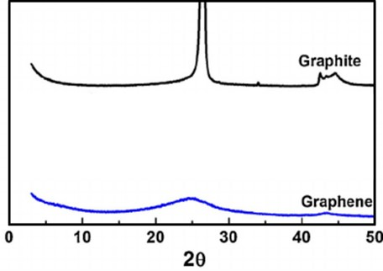
Figure 1: XRD patterns of graphite and graphene

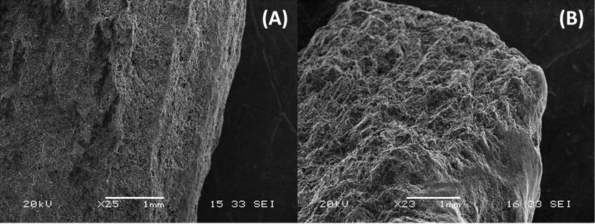
Figure 2: FE-SEM images of the graphene sheets.

FE-SEM images of the graphene sheets, produced from graphite rod and pencil core by electrochemical exfoliation, were shown in Figures 2, 3, and 4. Figure 2 A and B show the block type morphology of the graphite rod and pencil core, respectively, before electrochemical exfoliation.

Interlayers of the graphene can be seen in Figure 3 very clearly. In addition, a few layered graphene sheet was shown in Figure 4. As seen on the figures, the production of a few layered graphene was proved to be successful.
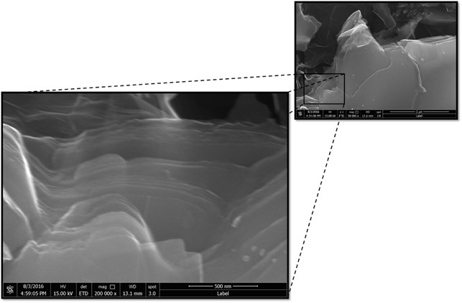
Figure 3: FE-SEM images of graphene interlayers (200000 x).

Figure 4: FE-SEM images of a few layered graphene sheet.

Molecular structures of working electrodes and as produced graphene sheets were examined by attenuated total reflection (ATR-FTIR). Pencil core used as graphite source was compared with pure graphite rod. FTIR spectra of the both are very similar. However, there are some different bands in pencil core spectrum due to clay and wax, which are mixed and immersed into pencil during the production.

Figure 5 shows the FTIR spectra of pencil core and pure graphene. The spectrum of the pencil core exhibits absorption bands at 2954, 2921, 2855 cm⁻¹ representing the symmetric and asymmetric CH, CH₂, CH₃ stretching modes. 1376 and 1459 cm⁻¹ bands corresponding to the CH₂ and CH₃ deformations. The band at around 1640 cm⁻¹ originates from the presence of C≡C bonds (18). Also the peak around 1700 cm⁻¹ indicates the C-O derivatives and caused by the wax existing in pencil core content. Bands around 1100 cm⁻¹ can be assigned to the Si-O derivatives in the clay which is a component of pencil core. We observed that the components of the pencil core, like clay and wax, have no negative effect on the production of graphene.
Figure 5: FTIR spectra of pencil core and pure graphene.

The absence of C-O and –OH derivatives in the FTIR spectrum of graphene confirms the low oxidation degree of the graphene sheets.

The presence of graphene, number of graphene layers, defects on graphene sheets and crystallinity can be determined influentially by Raman spectroscopy. There are three significant bands in the Raman spectrum: D (defect) band, G (vibrations of sp² carbon atoms on graphene layer), and 2D (second harmonic of the D band) band. Also Dʹ band can be observed as a shoulder on G band. D and Dʹ bands are relevant with presence of structural defects on graphene and graphite. The I_{D}/I_{G} ratio is often used to determine the quality of the graphene.

In the Raman spectrum of the electrochemically exfoliated graphene (Figure 6), ~2710 and ~1586 cm⁻¹ bands correspond to the 2D and G bands, respectively. Also defect D band was observed at ~1348 cm⁻¹. Intensity ratio of D and G bands (I_{D}/I_{G}) is 0,54. This value is much lower than that of thermally (1,5) and chemically (1,2) reduced graphene (19-20).

Figure 6: Raman spectra of graphite and graphene.

CONCLUSIONS

In this work, we evaluated the utilization of electrochemically exfoliated graphene from pencil core and pure graphite. A simple, greener, rapid, and cost-effective electrochemical method for the synthesis of GO and GNs from pencil is demonstrated at room temperature is achieved. The prepared graphene nanosheets was characterized by FE-SEM, XRD, FTIR, and Raman spectroscopy and these confirmed the formation of a few layered graphene nanosheets with fewer defects. Moreover, due to the simplicity of this method for the synthesis of graphene nanosheets, it may find promising applications in more areas.

ACKNOWLEDGMENTS

This work was supported by The Scientific and Technological Research Council of Turkiye, under Grant Number of 315M250.

REFERENCES

1. Shukla A, Kumar T. Materials for next-generation lithium batteries. Current Science. 2008;94:314-31.

2. Schwierz F. Graphene transistors. Nature Nanotechnology. 2010;5:487-96.

3. Stankovich SD, Dikin A, Dommett GHB, Kohlhaas KM, Zimney EJ, Stach EA, Piner RD, Nguyen ST, Ruoff RS. Graphene-based composite materials. Nature. 2006;442:282-86.

4. Chen D, Tang LH, Li JH. Graphene-based materials in electrochemistry. Chemical Society Reviews. 2010;39:3157-80.

5. Guo CX, Yang HB, Sheng ZM, Lu ZS, Song QL, Li CM. Layered graphene/quantum dots for photovoltaic devices. Angewandte Chemie. 2010;49:3014-17.

6. Yoo JJK, Balakrishnan JS, Huang V, Meunier BG, Sumpter A, Srivastava M, Conway ALM, Reddy JY, Vajtai R. Ultrathin Planar Graphene Supercapacitors. Nano Letters. 2011;11:1423-27.

7. He SJB, Song D, Li CF, Zhu WP, Qi YQ, Wen LH, Wang SP, Song HP, Fan CHA. A graphene nanoprobe for rapid, sensitive, and multicolor fluorescent DNA analysis. Advanced Functional Materials. 2010;20:453-59.

8. Worsley MA, Thang T. Synthesis and characterization of highly crystalline graphene aerogels. ACS Nano. 2014;8:11013-22.

9. Mattevi, C, Kim H, Chhowalla M. A review of chemical vapour deposition of graphene on copper. Journal of Materials Chemistry. 2011;21:3324-34.

10. Hernandez Y. High-yield production of graphene by liquid-phase exfoliation of graphite. Nature Nanotechnology. 2008;3:563-68.

11. Strupinski W. Graphene epitaxy by chemical vapor deposition on SiC. Nano Letters. 2011;11:1786-91.

12. Hummers WS, Offeman RE. Preparation of graphitic oxide. Journal of American Chemical Society.1958;80:1339-39.

13. Bourelle E. Electrochemical exfoliation of HOPG in formic - sulfuric acid mixtures. Molecular Crystals and Liquid Crystals. 1998;310:321-26.

14. Liu N, Luo F, Wu H, Liu Y, Zhang C, Chen J. One-step ionic-liquid-assisted electrochemical synthesis of ionic-liquid-functionalized graphene sheets directly from graphite. Advanced Functional Materials. 2008;18:1518-25.

15. Xia ZY. The exfoliation of graphene in liquids by electrochemical, chemical, and sonication-assisted techniques: A nanoscale study. Advanced Functional Materials. 2013;23:4684-93.

16. Su CY. High-quality thin graphene films from fast electrochemical exfoliation. ACS Nano. 2011;5:2332-39.

17. Abdelkader, A.M., Kinloch, I.A., Dryfe, R.A.W., Continuous Electrochemical Exfoliation of Micrometer-Sized Graphene Using Synergistic Ion Intercalations and Organic Solvents, ACS Appl. Mater. Interfaces, 2014;6:1632−1639.

18. Pavithra, C.L.P., Sarada, B.V., et.al., Synthesis of Copper-Graphene Nanocomposite Foils with High Hardness, Sci. Reports, 2014;4:4049.

19. Park S, Rouff RS. Chemical methods for the production of graphenes. Nature Nanotechnology. 2009;4:217-24.

20. Mattevi C, Eda G, Agnoli S, Miller S, Mkhoyan KA, Celik O, Mastrogiovanni D, Granozzi G, Garfunkel E, Chhowalla M. Evolution of electrical, chemical, and structural properties of transparent and conducting chemically derived graphene thin films. Advanced Functional Materials. 2009;19:2577-83.

