Investigation of The Reasoning Styles of The University Students

Volkan DURAN[1]

Bayram ÖZER[2]

**ABSTRACT**

Humans mostly don’t perceive reality as it is in some cases. The educational background, learning readiness, motivations, selective memory, cultural background, environmental, biological factors may affect the perception and interpretation of the data from surroundings in this sense. Creative thinking can be regarded among these factors for the interpretation of the data and converting them into ideas in this respect. Creativity can be defined as an ability to change, combine or use ideas or products in different situations, contexts to produce original outcomes with respect to the context, culture or history of creative individual that are located. Creative thinking skill has dimensions such as developing detailed ideas and enrichment, finding unique solutions to the problems, and having a holistic view.

The research is qualitative research based on case study design. The data collection technique was focus group interview and the data collection tool is a semi-structured interview forms consisting from pictures about the warriors. In the first part of the research participants were briefly informed about the aim of the research. In the second part the questionnaire was delivered students. The questionnaire consisting of pictures regarding those three warriors in which participants choose one picture among different representations for each warriors. Hence they chose the warrior image fitting their own previous knowledge and image of them. The population was selected by simple random sampling. The population of this research consists of 157 students from 4’Th grade from Psychological Counselling and Guidance Department. A qualitative descriptive analysis approach was used to analyse the data obtained from this research. In the analysis of data, answers are classified based on the dimensions of perceptions as concrete or abstract. Finally, the pictures they chose from the last part of the sheets and their descriptions are categorized under similar themes. The results of the analysis of pictures are compared and analysed in terms of the answers from survey questions at the end.

**Keywords:** Descriptions, Culture, Perception, Reasoning Styles

Üniversite Öğrencilerinin Akıl Yürütme Stillerinin İncelenmesi

**ÖZET**

İnsanlar gerçekliği bazı durumlarda çoğunlukla olduğu gibi algılayamazlar. Eğitsel arka plan, hazırbulunuşluk, motivasyonlar, seçici dikkat, kültürel arka plan, biyolojik etkiler çevreden gelen verilerin yorumu ve algılamasını etkileyebilir. Akıl yürütme stilleri de verilerin yorumlanması ve fikirlere dönüşmesini etkileyen faktörler arasında sayılabilir. Bu bağlamda akıl yürütme stillerinin incelenmesi bir bakıma insan algısına ilişkin bir ipucu verebilir. Literatür incelendiğinde, öğrenme, düşünme stili gibi birçok kavram çalışılmış olduğu halde akıl yürütme stiliyle ilgili çalışmaların az olduğu ve bunların daha çok bilim tarihi alanında olduğu görülmektedir. Bu yüzden bu çalışma alan yazına bu bağlamda katkı sağlamayı hedeflemektedir. Araştırma, örnek olay incelemesine dayalı bir nitel araştırma niteliğindedir. Veri toplama tekniği odak grup görüşmesi ve veri toplama aracı, çeşitli kültürlerle ilişkili savaşçılar hakkında resimlerden oluşan yarı yapılandırılmış bir görüşme formudur. Araştırmanın ilk bölümünde katılımcılara araştırmanın amacı hakkında kısaca bilgi verilmiştir. İkinci bölümde anket öğrencilere teslim edilmiştir. Katılımcıların her savaşçı için farklı sunumlar arasından bir resim seçmeleri istenmiş üç savaşçıyla ilgili resimlerden oluşan anketi doldurmaları söylenmiştir. Dolayısıyla, katılımcılar savaşçı imajını kendi önceki bilgi ve imgelerine uyarak seçmişlerdir. Örneklem, basit rasgele örneklemeyle seçilmiştir. Araştırmanın evrenini, 4. sınıftan Psikolojik Danışma ve Rehberlik Bölümü'nden 157 öğrenci oluşturmaktadır. Bu araştırmadan elde edilen verileri analiz etmek için nitel bir içerik analizi yaklaşımı kullanılmıştır. Verilerin analizinde, cevaplar somut veya soyut olarak algı boyutlarına dayalı olarak sınıflandırılmıştır. Son olarak, sayfaların son bölümünden seçtikleri resimler ve açıklamaları benzer temalar altında kategorize edilmiştir.

**Anahtar Kelimeler:** Betimleme, Kültür, Algılama, Akıl yürütme Stilleri

# INTRODUCTION

Modern educational theories and approaches view learning processes as a much more holistic manner which has many deep layers dynamically interacting with each other. There are different levels and degrees for what we have learned before and our selective memory and behaviours are influenced by the general heterogeneous structure of our cognition in this sense. In this regard, learning is not a concept that can be restricted just by once concept like “behavioural change” or “something happens in our black box (cognition). There are some levels in our learning processes which was mentioned by many scholars and philosophers like Plato, Freud, Karl Popper, Roger Penrose etc. Hypothetico-Creative reasoning skills can be defined as a reasoning skill based on six inner dimension of Lawson's hypothetico-deductive reasoning skills as inner dimension and creative thinking skills as outer dimension (Duran, 2014). Hypothetico-deductive reasoning skills encapsulate hypothetical reasoning skills, proportional reasoning, controlling variables, probabilistic reasoning, correlational reasoning and combinatorial reasoning (Lawson, 1995). Creative reasoning skills encompass and six outer dimensions which are analogical thinking, convergent thinking, divergent thinking, metaphorical thinking , vertical thinking) and lateral thinking skills. The distinction between the logical thinking skills and creative thinking skills can be understood through data-information-doxa (convictions)-knowledge-episteme conversion and extraction processes in order to construct epistemological beliefs (briefly episteme) about scientific or general concepts. As indicated by Bloom's Taxonomy of Learning Domains creativity and evaluation can be regarded as the higher dimensions of thinking but remembering can be taken as the lower dimensions of thinking skills. In this regard it may be a significant step to distinguish learning levels based on information units as data, information, knowledge, wisdom, ideas. Data as auditory, visual and tactual forms of knowledge unit can be converted into bigger and meaningful clusters which are called as information corresponding to comprehension level in Bloom’s taxonomy. Data can be defined as the information unit belonging to sensations. Information, knowledge, wisdom and ideas can be defined as the information unit in perceptions. Information can be defined as the meaningful clusters of data regarding the content of the data where it is located and related.

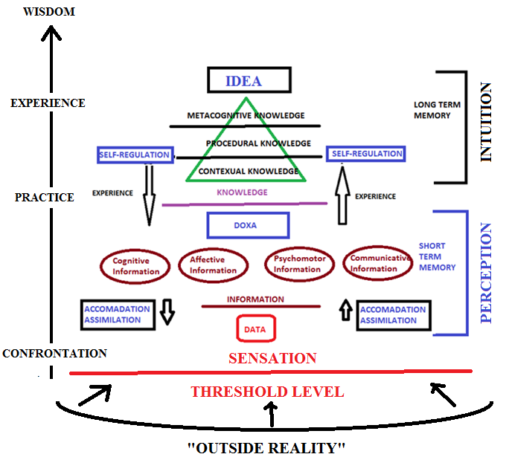

**Figure 1.** Hierarchy of information, knowledge and episteme and the flow of data through many levels (Duran, 2014).

Knowledge is the form of information processed through the dimensions of logical thinking skills which is mainly related with concepts that can be acquired through thinking, reasoning or experiences. Wisdom is defined as the ability to discern or make decisions about what is true, right based on insight, knowledge and it corresponds the sub-level in Bloom’s revised taxonomy. Finally ideas (episteme) corresponds to the extended abstract level where individuals makes connections in which they use their previous knowledge and wisdom to create new perspectives, to design original outcomes as well as to create new visions to direct themselves into the future. Humans don’t perceive reality as it is as well as they doesn’t learn new information just as an empty container. Human descriptions can be analysed in many ways. Data, content, concepts, scenarios and fictions related with descriptions can be used to analyse descriptions. As seen figure 1, wisdom corresponds to mental scenarios and maps which was shaped through experiences for decision making processes and ideas corresponds to fiction in the dimensions of descriptions.

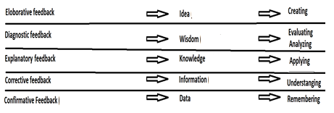

**Figure 2.** Data, information, knowledge, ideas and their relationship with Bloom’s taxanomy and the levels of feedback.

Data, information, knowledge, wisdom, idea classification can be adapted into many different theoretical situations. For example, feedbacks can be classified as confirmative feedback (teyit edici dönüt), corrective feedback (düzeltici dönüt), explanatory feedback (açıklayıcı dönüt), diagnostic feedback (teşhis edici dönüt), and elaborative feedback (genişletici ve eklemleyici dönüt). Confirmative feedback (teyit edici dönüt) refers the data regarding the accuracy of the result as right or wrong. Corrective feedback (düzeltici dönüt) provides correct information as well as providing the data related with the result. Explanatory feedback (açıklayıcı dönüt) stressed the relevant knowledge about how to reach correct solution or response. Diagnostic feedback (teşhis edici dönüt) identifies the source of misconceptions and evaluating the various aspects of the response therefore it is related with wisdom because of decision making and evaluation. Elaborative feedback (genişletici ve eklemleyici dönüt) makes new connections among ideas and related previous knowledge with the new knowledge forms. At an additional level, laboratory feedback provides related information designed to enhance and extend the learner's knowledge acquisition. These feedback types can be matched by the revised Bloom's cognitive domain as well as data-information-knowledge-wisdom-idea hierarchy (Anderson, 2005; Duran, 2014; Gelen, Duran, Ozer, 2016; Senemoğlu. 2009: 394).

Actually the classification of knowledge in accordance with a hierarchy dates back the Plato’s idealism which can simply interpreted as the reality based on the pure forms of knowledge which are ideas. Aristotle, for example, categorized cognitive states as arts or crafts (techne), scientific knowledge (episteme), practical wisdom (prognosis), Sophia and nous. Two of these, technic and prognosis, are in the category of practical science, while another two, episteme and Sophia, are in the category of theoretical science. Ibn Khaldun repeatedly uses the term *fikr (idea)* to depict the understanding level of humans which is used to satisfy their needs of their lives. The ability to think enables the human being to find ways of making a living and to establish co-operation. Similarly, Ibn Khaldun believes that the human intellect has several levels or degrees as follows: The discerning intellect is an intellectual understanding of the order of things that exist in the outside world in a natural or arbitrary order. It consists mostly of perceptions. The experimental intellect mostly conveys apperception, which is obtained through experience in a gradual way until it reaches a stage where it becomes “really useful. The speculative intellect provides knowledge or hypothetical knowledge of an object beyond sense perception without any “interference” of practical activity. It consists of both perception and apperception which is arranged according to a special order following special conditions. The end of the process is the perception of existence together with its various kinds, differences, reasons and causes. By completing this process, man achieves perfection and becomes pure intellect and perceptive soul. We can summarize Ibn Khaldun's learning theory in the following order:1. (a) Five senses → (b) Material sense (perception) → (c) Holistic comprehension → (d) Comparison → (e) Abstraction → (f) Holistic image. According to Ibn-i Khaldun, human mind is firstly a tabula rasa which can be filled with information in a social context. Human knowledge is shaped through interaction with others and then it reached a level that is called as “hal (state)” in which knowledge is emerged as a permanent quality in behaviors and mind and gain continuity. Finally those permanent qualities become a faculty of soul and mined and are converted into thinking and reasoning (Oruç, 2010; Ahmad, 2003). Although Ibn Khaldun didn’t explicitly propose taxonomy as we understand today in educational sense, we can revise them and convert them into our modern understanding.

**Figure 3.** Comparison of some taxonomy from ancient times to modern age.

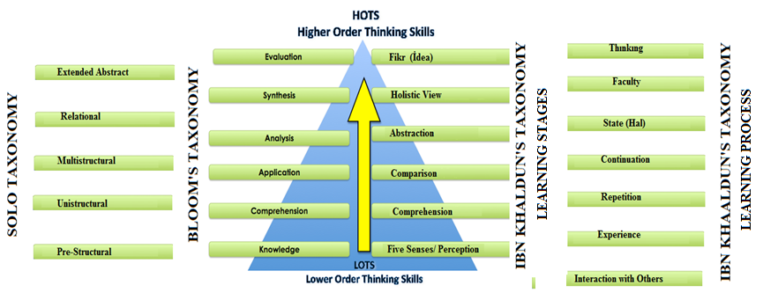

Similar classifications were made in our modern time. Piaget for example classified stages of human development as sensorimotor (from birth), preoperational. Toddlerhood (18-24 months) through early childhood (age 7), concrete operational (ages 7 to 12),formal operational. (Adolescence through adulthood). Marzano's taxonomy, Guilford's Taxonomy, Ramizowski's taxonomy, cognitive domain classification developed by Bloom and colleagues, Simpson's dynamic domain taxonomy, Karthwohl's affective domain taxonomy can be given as modern examples fort his ancient search for human knowledge. Bloom’s taxonomy of educational objectives: cognitive domain. Bloom’s taxonomy consists of six major categories and has a varying amount of detail in the form of sub-categories as knowledge, comprehension, application, analysis, synthesis or evaluation. According to Solo taxonomy there are five dimensions for learning. Pre-structural phase is a state in which students are simply acquiring bits of unconnected information, which have no organization and make no sense. Unstructured phase is a state where simple and obvious connections are made, but their significance is not grasped. Multistructural dimension is a state in which a number of connections may be made, but the meta-connections between them are missed, as is their significance for the whole. Relational state is a phase in which the student is now able to appreciate the significance of the parts in relation to the whole. Extended abstract is a state that the student makes connections not only within the given subject area, but also beyond it, and is able to generalize and transfer the principles and ideas underlying the specific instance.(Moseley, Baumfield, Elliott, Gregson, Higgins, Miller, Newton, 2005).

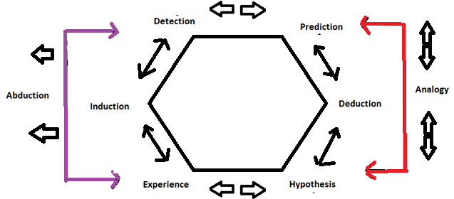

**Figure 4.** Reasoning skills are mainly classified as deductive,inductive, abductive and analogical (Duran, 2015).

Although thinking skills can be classified in many ways reasoning skills can mainly be classified as mainly inductive and deductive but analogical, adductive reasoning skills can be added those two main reasoning skills. Abduction in this scheme is simply defined as to infer the best explanation among the products of inductive and deductive reasoning and analogy is simply defined as to make analogy among the products of induction and deduction. Elements of reasoning can be given as concepts, perspectives, assumptions, inferences, purposes, problems, and information as data, facts, observations, experiences, implications and consequences. In this respect, thinking can be understood as the reflection of learning outcomes in conscious but reasoning is to use to combine different thinking modes if needed and use those thinking media effectively mainly based on premises in a coherent logic and order. As seen figure 2 problem solving for example, can be classified as analogical, deductive, inductive or adductive or the mixture of those reasoning skills as well as other mixture of thinking skills like creative problem solving or creative decision making based on deductive reasoning.

The terms style is very broad term and whether it is situation-depended inclination for choosing something or it is more permanent trait for selecting preferences is still debated in scientific community for the term thinking and intellectual styles. Style of reasoning came into agenda of scientific community especially in the field of history of science by the term of style of scientific reasoning developed by Ian Hacking. According to Hacking styles have three characteristics as (1) constructing possibilities of truth, (2) self-authenticating, and (3) stability (Ruphy, 2011; Winter, 2012; Zhang, 2001; Zhang, Sternberg, Rayner, 2002; Zhang, Sternberg, 2005; Zhang, Sternberg, 2006). In the 1980s and 1990s, A. C. Crombie and Ian Hacking developed the notion of styles of scientific thinking. Crombie identifies six main styles in the European tradition of scientific thinking which can be classified also as axiomatic, experimental, hypothetical-analogical, taxonomic, probabilistic, genealogical (Winter, 2012). Hacking adds a seventh style defined as the laboratory style characterized by the construction of apparatus intended to isolate and purify existing phenomena and to create new ones.

A style of reasoning is a pattern of inferential relations that are used to select, interpret, and support evidence for scientific results or specific phenomena (Bueno, 2012). This can be categorized as many ways. According to Bueno (2012) narrow style of reasoning is explicitly focusing on providing information transfer procedures (specific to particular subfields) that allow for inferential relations to be established within the domain of investigation. However broad styles of reasoning specify the range of what is true or false within the boundaries of that style. Sylvan et al. (1994) identify three distinctly different types of reasoning styles as case-based, explanation-based, and model-based. Case-based reasoning based on the reference to previous specific ‘cases’ or events when providing a justification for a particular choice. Explanation- based reasoning consists of an explication that includes causal assertions. Model-based reasoning is ‘prepackaged’ into a ‘law or theory’(Ishiyamaa, Wingoa, Arteagab. Hernandezc, 2001).

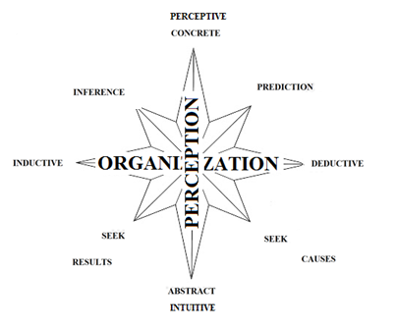

**Figure 5.** The dimensions of reasoning styles

In this paper reasoning styles are modeled similarly to the thinking styles. Firstly just as in thinking styles, it can be categorized as abstract and concrete types. Abstract reasoning mostly depend on inferential assumptions, ideas and wisdom in DIKWE classification whereas concrete reasoning depend the on the image of the phenomena itself corresponding to data, information in DIKWE. Furthermore, reasoning styles can be understood based on their orientations as inferences seeking the main causes and predictions seeking the probable results. Hence reasoning styles can be modeled as Figure 3 based on the perception dimensions as concrete and abstract, the process dimensions as deductive and inductive and orientation dimensions as prediction and inferences.

**METHODOLOGY**

In this study it is thought that pictures can be used to analyse the creativity of students in terms of their attitudes toward different cultures. The research is qualitative research based on case study design. The data collection technique was focus group interview and the data collection tool is a semi-structured interview forms. The In the first part of the research participants were briefly informed about the aim of the research. The questionnaire consisting of pictures regarding those three warriors in which participants choose one picture among different representations for each warriors. Hence they chose the warrior image fitting their own previous knowledge and image of them. The population was selected by simple random sampling. The population of this research consists of 157 students from 4’th grade from Psychological Counselling And Guidance Department. The scope of this research is limited by the questionnaire consisting of pictures and answers of students from 4’th grade from Psychological Counselling And Guidance Department in Ondokuz Mayıs University in 2016-2017 educational period.

Internal validity can be defined as the credibility of the results and research process with respect to the real phenomena itself. Internal validity can be achieved by making the data coherent and logical within itself, supporting the data with different methods and strategies as well as different sources, methods and data collection tools and previous studies and theoretical frameworks, the opinions of the experts. Namely, description of a table should be very close to what researcher is trying to figure out in terms of internal validity, this can be achieved by using different senses (data sources) and different tools such as dividers, glasses (methods).

External validity can be defined as transferability of the data into other contexts or settings. In other words, description of a table can be used and understood in other contexts such as if it is moved into another room it can be described similarly by other researchers and the idea of table can be also generalized to other tables in similar character. External validity can be achieved by detailed descriptions and the similar procedures done for the internal validity.

Internal reliability can be defined as the conformability of the data. Conformability refers to the degree to which the results could be confirmed or corroborated by others. For example it a table can be described similarly by different observers, the internal reliability is achieved. Internal reliability can be achieved by using different coding methods, different measurement tools, coding of different observers.

External reliability can be defined as the replicability or repeatability of the qualitative data. For example, if the table descripted by a researcher can be produced or observed in the same conditions, the external reliability can be achieved. It is very difficult to replicate especially qualitative research in this regard. The external reliability can be achieved partially by describing the changes that occur in the setting and context (İşcan, 2007). In this study internal validity is thought to be provided by using different pictures for each category. External validity is thought to be provided by the detailed descriptions of participants. Internal reliability is thought to be provided by the interpretation and coding of different researchers and the agreement of their similar judgments.

Data was analyzed in terms of the dimensions of of reasoning styles given in Figure 3 and compared and interpreted across the participants. Firstly the data of the participants are coded accordingly and secondly interpreted.

**The Development of Questionnaire**

Firstly 10 pictures for samurais, janissaries, knights are randomly selected on the web. 7 of them were selected in accordance with the opinions of M.S students (10) in sociology and curriculum and instruction departments as well as the suggestions of assistant professors (n=2)

**Coding Procedure for Analysis**

The coding procedure of the analysis based on Figure 3 of the data can be given as below:

If a participant seeks causes or draw conclusions based on the hypothetical past of the picture, s/he is labeled as inferential thinker and labeled as I for each interpretation.

If a participant make predictions for the on the hypothetical future of the picture, s/he is labeled as predictive thinker and labeled as P for each interpretation.

If a participant disciple the picture based on a premise or belief, s/he is labeled as deductive thinker and labeled as D for each interpretation.

If a participant disciple the picture based to reach a generalization for specific concept or thing, s/he is labeled as inductive thinker and labeled as In for each interpretation.

If a participant give answers to all three pictures based on his/her ideas s/he is a dominant abstract thinker (a-a-a).

If a participant gives answers to all three pictures based on the information in pictures s/he is a dominant concrete thinker (c-c-c)

If a participant give answers to some of three pictures based on his/her ideas s/he is a abstract thinker (a-a-c/ a-c-a/c-a-a)

If a participant give answers to some of three pictures based on the information in pictures s/he is a dominant concrete thinker (c-c-a/c-a-c/c-c-a)

**RESULTS**

**The Analysis of Images In Terms of Thinking Styles**

In the first part of the study, it is demanded from students to produce metaphors for samurai, knight, and janissary figures and only 6 of them can produce visual depictions and 144 of them produce metaphors. The ability of creating metaphors is related with higher intellectual skills. Therefore, it can be inferred that students are in formal operation stage in Piagets’ Stages of Development Model. Hence they approach problems in a systematic and organised manner and use hypothetico deductive reasoning skills (Lawson, 1995).Therefore it can be concluded that participants are suitable to conduct a research to investigate the reasoning skills.

69 individuals dominantly chose, interpreted, and described pictures based on their ideas rather than the content of the picture.40 individuals dominantly chose, interpreted, and described pictures based on the data, information content or their knowledge related with pictures.44 individuals chose, interpreted, and described some pictures based on the data, information content or their knowledge related with pictures or their ideas. In table 1, the distribution of the number of individuals interpreting pictures based on information or ideas for the categories of samurai, knight, and janissary was given.

**Table 1.** The number of individuals interpret pictures based on information or ideas.

|  |  |  |  |  |
| --- | --- | --- | --- | --- |
|  | **Samurai** | **Janissary** | **Knight** | **Dominant** |
| **Abstract** | 91 | 106 | 80 | 67(a-a-a) |
| **Concrete** | 66 | 51 | 77 | 38(c-c-c) |
| **Deductive** | 50 | 70 | 61 | 34 (d-d-d) |
| **Inferential** | 59 | 47 | 54 | 32 (inf-inf-inf) |
| **Inductive** | 43 | 37 | 38 | 21 (in-in-in) |
| **Predictive** | 5 | 3 | 4 | 1 (pre-pre-pre) |

As can be seen Table 1 and Table 1, individuals are more prone to interpret pictures based on the ideas rather than the information content present in the picture. They are more likely to interpret what is inside them rather than analysing it based on the information. When Turkish students confront with knight pictures, surprisingly it can be inferred that they use their ideas less about the figure of knight rather than the information presented in the pictures. It can easily be seen that there are significant differences for samurai and Janissary pictures than the Knight figures. As can be seen in Table 2 individuals are more prone to use deductive reasoning overall than the inductive and inferential ones. Deductive reasoning is mostly used in janissary pictures whereas inferential and inductive ones are used in samurai pictures.

**Results Regarding Samurais**

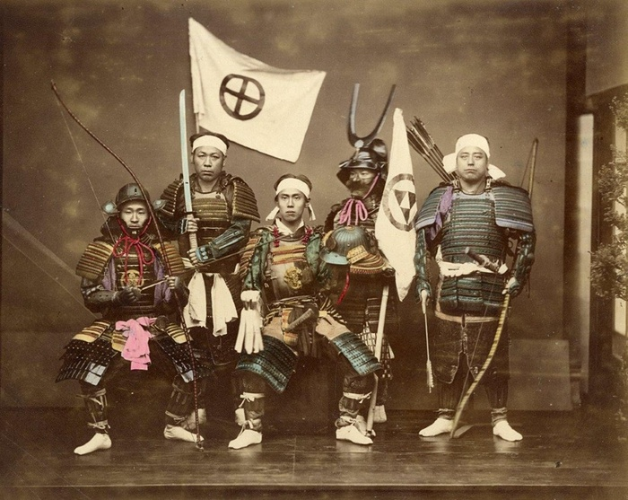

**Figure 6**

Seven participants choose the Figure 6 as the best match for the figure of Samurai and five of them interpret the picture based on the information content, two of them interpret it based on their previous ideas. It can be easily understood whether the answers of participants are based on information content or the idea they had as given in Table 3. Participant 3 can be regarded as dominant inferential thinker because s/he draws conclusions based on the hypothetical past of the picture. Participant 39 can be regarded as both inferential thinker and deductive thinker because s/he draws conclusions based on the hypothetical past of the picture as well as his beliefs about Japanese people. Participant 49 can be regarded as both deductive and predictive thinker because s/he draws conclusions based on his/her beliefs and predictions.

**Table 2.** Interpretation of the participants choosing figure 4.

|  |  |
| --- | --- |
| **Participant** | **Comments** |
| **Participant 6 (Dominant Concrete Thinker c-c-c): (Dominant Inferential Thinker)** | «Samurais are wearing those bandages and use this kind of swords. In this picture we can see both of them» |
| **Participant 39 (Dominant Concrete Thinker c-c-c): (Inferential and Deductive Thinker)** | The faces of the warriors look like Japanese people because their eyes are slanted. Japanese people are very advanced in terms of technology and these people look liked very equipped and it reminds me the Japanese samurai connection. |
| **Participant 49 (Dominant Abstract Thinker a-a-a):(Deductive and Predictive Thinker)** | It reminds me brave samurai Japanese soldier who is fearless from nothing, swearing to destroy all enemies |



**Figure 7.**

85 participants choose the Figure 7 as the best match for the figure of Samurai and 42 of them interpret the picture based on the information content, 43 of them interpret it based on their previous ideas. It can be easily understood whether the answers of participants are based on information content or the idea they had as given in Table 3.

**Table 3.** Interpretation of the participants choosing figure 5.

|  |  |
| --- | --- |
| **Participant** | **Comments** |
| **Participant 1 (Dominant Abstract Thinker a-a-a): (Dominant Deductive Thinker)** | «They are showier. When I saw a samurai, it reminds me power and ambition. This picture stands for power for me.» |
| **Participant 19 (Dominant Abstract Thinker a-a-a): (Deductive and Predictive thinker)** | This represents the power of the samurai because they are an army by alone themselves and we can’t understand when they come. |
| **Participant 16 (Dominant Concrete Thinker c-c-c): (Inferential and Deductive Thinker)** | The samurai impressions are always related with swords for me. That is why I chose it. |

Participant 1 can be regarded as dominant deductive thinker because s/he draws conclusions based on his/her beliefs about samurais. Participant 19 can be regarded as both deductive and predictive thinker because s/he draws conclusions based on his/her beliefs and predictions. Participant 19 can be regarded as both inferential thinker and deductive thinker because s/he draws conclusions based on the hypothetical past of the picture as well as his beliefs about Samurais.

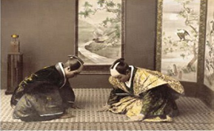

**Figure 8.**

16 participants choose the Figure 8 as the best match for the figure of Samurai and five of them interpret the picture based on the information content, 11 of them interpret it based on their previous ideas. The distinction between dominant concrete and abstract reasoning can be seen in their interpretation as given in Table 4.

**Table 4.** Interpretation of the participants choosing figure 6.

|  |  |
| --- | --- |
| **Participant** | **Comments** |
| **Participant 8 (Abstract Thinker a-a-c):**  **(Dominant Deductive Thinker)** | «These people looks like people who are serving and samurais are the serving people in Japanese culture» |
| **Participant 45 (Dominant Abstract Thinker a-a-a): (Dominant Deductive Thinker)** | It reminds me the respect and loyalty to their masters. |
| **Participant 34 (Dominant Abstract Thinker a-a-a): (Dominant Deductive Thinker)** | It reminds me the flexibility and mastery of them. |

Participant 8 can be regarded as both dominant deductive thinkers because s/he draws conclusions based on his/her beliefs, knowledge and predictions. Participant 45 can be regarded as dominant deductive thinker because s/he draws conclusions based on his beliefs about Samurais. Participant 34 can be regarded as dominant deductive thinker because s/he draws conclusions based on his beliefs about Samurais.

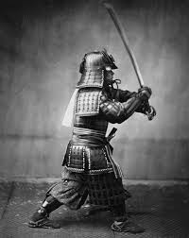

**Figure 9.**

22 participants choose the Figure 9 as the best match for the figure of Samurai and 13of them interpret the picture based on the information content, nine of them interpret it based on their previous ideas. The distinction between dominant concrete and abstract reasoning can be seen in their interpretation as given in Table 5.

**Table 5.** Interpretation of the participants choosing figure 7.

|  |  |
| --- | --- |
| **Participant** | **Comments** |
| **Participant 18 (Dominant Abstract Thinker a-a-a): (Dominant Inductive Thinker)** | «Samurais are mostly moving by themselves alone in nature.» |
| **Participant 42 (Concrete Thinker c-a-c):**  **(Inferential and Deductive thinker)** | They are elites. It reminds me the power. He also has swords and other equipment’s used by samurais. |
| **Participant 62 (Concrete Thinker a-a-c):**  **(Dominant Deductive Thinker)** | They are the masters in the art of fight. They use their swords adroitly. |

Participant 18 can be regarded as dominant inductive thinker because s/he draws conclusions based by making generalizations. Participant 42 can be regarded as both inferential thinker and deductive thinker because s/he draws conclusions based on the hypothetical past of the picture as well as his beliefs about Samurais. Participant 62 can be regarded as dominant deductive thinker because s/he draws conclusions based on his beliefs about Samurais.

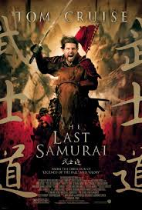

**Figure 10.**

22 participants choose the Figure 10 as the best match for the figure of Samurai and 13 of them interpret the picture based on the information content, nine of them interpret it based on their previous ideas. The distinction between dominant concrete and abstract reasoning can be seen in their interpretation as given in Table 6.

**Table 6.** Interpretation of the participants choosing figure 8.

|  |  |
| --- | --- |
| **Participant** | **Comments** |
| **Participant 14 (Dominant Concrete Thinker c-c-c): (Inferential Thinker)** | «The name of movies is samurai, the armour….» |
| **Participant 2 (Dominant Abstract Thinker a-a-a): (Inferential and Deductive Thinker)** | I always see samurais with swords and swords stand for justice for me. They always root for the underdog. Another reason why I chose this picture is that they always have schools in nice places like this having a good scene and nice places for practice. |
| **Participant 15 (Dominant Concrete Thinker c-c-c): (Inferential Thinker)** | It reminds me the samurais in Gladiator movie. They are the similar houses in the movie. |

Participant 14 can be regarded as inferential thinker because seek causes or draw conclusions based on the hypothetical past of the picture. Participant 2 can be regarded as both inferential thinker and deductive thinker because s/he draws conclusions based on the hypothetical past of the picture as well as his beliefs about Samurais. Participant 5 can be regarded as inferential thinker because seek causes or draw conclusions based on the hypothetical past of the picture.

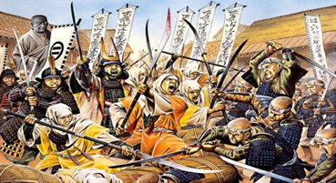

**Figure 11.**

Six participant choose the Figure 11 as the best match for the figure of Samurai and one of them interpret the picture based on the information content, five of them interpret it based on their previous ideas. The distinction between dominant concrete and abstract reasoning can be seen in their interpretation as given in Table 7.

**Table 7.** Interpretation of the participants choosing figure 8.

|  |  |
| --- | --- |
| **Participant** | **Comments** |
| **Participan 76 ( Concrete Thinker c-a-c): (Inferential Thinker)** | «The most dominant features of them are their swords and their bellicose souls. This picture depicts these two dimensions for me» |
| **Participan 9 (Dominant Abstract Thinker a-a-a): (DeductiveThinker)** | Samurais are brave people and do everything to protect their country even in the hard conditions. |
| **Participan 97 (Dominant Abstract Thinker a-a-a):(Deductive Thinker)** | They use their body power and they are fast and actives. They fight for their last breathes and they are agile. |

Participant 76 can be regarded as both inferential thinker and deductive thinker because s/he draws conclusions based on the hypothetical past of the picture as well as his beliefs about Samurais. Participant 9 and 97 can be regarded as dominant deductive thinker because s/he draws conclusions based on his beliefs about Samurais.

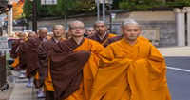

**Figure 12.**

Eight participant choose the Figure 12 as the best match for the figure of Samurai and one of them interpret the picture based on the information content, seven of them interpret it based on their previous ideas. The distinction between dominant concrete and abstract reasoning can be seen in their interpretation as given in Table 8.

**Table 8.** Interpretation of the participants choosing figure 10.

|  |  |
| --- | --- |
| **Participant** | **Comments** |
| **Participan 31 (Dominant Abstract Thinker a-a-a): (Inductive Thinker)** | «Samuraies are beautiful models to many different nations in terms of education, discipline and authority as well as their power » |
| **Participan 90 (Dominant Abstract Thinker a-a-a):** | It looks like very close to samurai image for me because it represents silence and dignity and they protect themselves rather than attack and this is very closely related for this style. |
| **Participan 152 (Dominant Abstract Thinker a-c-a):** | Samurais remind me honourable, respectful and humanist warriors and it reminds me their inner calm for me |

Participant 31 can be regarded as dominant inductive thinker because s/he makes generalizations about Samurais. Participant 90 can be regarded as both deductive and predictive thinker because s/he draws conclusions based on his/her beliefs, knowledge and predictions. Participant 152 can be regarded as dominant deductive thinker because s/he draws conclusions based on his beliefs about Samurais**.**

**The Results for Janissary Pictures**

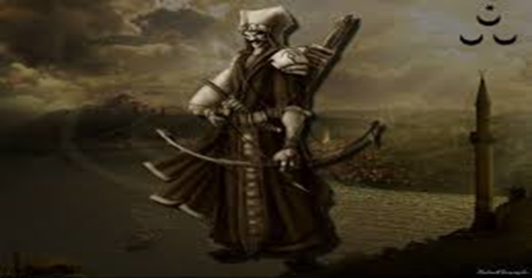

**Figure 13.**

27 participants choose the Figure 11 as the best match for the Janissary figure and 12 of them interpret the picture based on the information content, 15 of them interpret it based on their previous ideas. The distinction between dominant concrete and abstract reasoning can be seen in their interpretation as given in Table 9.

**Table 9.** Interpretation of the participants choosing figure 10.

|  |  |
| --- | --- |
| **Participant** | **Comments** |
| **Participant 2 (Dominant Abstract Thinker a-a-a): (Inferential and Deductive Thinker)** | «Janissaries put their heart and soul into the war rather than their desires and powers. They protected the Muslims for centuries and İslam. Hence if there is a minaret in any place, there is a tomb of janissary in there.» |
| **Participant 94 (Dominant Concrete Thinker c-c-c): (Inferential Thinker)** | The tools and symbols representing Turkish culture exist in there that is why it is the most appropriate one. |
| **Participant 84 (Dominant Abstract Thinker a-a-a): (Deductive Thinker)** | They are the ones takes power from their faith in order to spread Islam |

Participant 2 can be regarded as both inferential thinker and deductive thinker because s/he draws conclusions based on the hypothetical past of the picture as well as his beliefs about Janissaries indicating that there is a style pattern in there. Interestingly similar pattern exist for the comments of participant 2 for the Samurais. Participant 94 can be regarded as inferential thinker because s/he draws conclusions based on the hypothetical past of the picture. Participant 84 can be regarded as dominant deductive thinker because s/he draws conclusions based on his beliefs about Janissaries.

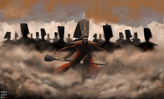

**Figure 13.**

49 participants choose the Figure 13 as the best match for the Janissary figure and 10 of them interpret the picture based on the information content, 39 of them interpret it based on their previous ideas. The distinction between dominant concrete and abstract reasoning can be seen in their interpretation as given in Table 10.

**Table 10.** Interpretation of the participants choosing figure 11.

|  |  |
| --- | --- |
| **Participant** | **Comments** |
| **Participant 9 (Dominant Abstract Thinker a-a-a): (Inductive Thinker)** | « Jannisaries are warriors. They can overcome all situations successfully. They are brave and do everything to achieve what they want» |
| **Participant 74 (Dominant Abstract Thinker a-a-a):** (**Deductive And Predictive Thinker)** | It seems that there is a victory or at least there is a posture indicating that victory will come. They seem to be very certain of something. I sense the “power” in this picture. |
| **Participant 76 (Concrete Thinker c-a-c):** (**Inductive Thinker)** | The most notable aspects of them are that they are fearless from nothing and their Strong stance. Those two of them exist in the picture. |

Participant 9 can be regarded as inductive thinker because s/he makes generalizations about Janissaries. Participant 74 can be regarded as both deductive and predictive thinker because s/he draws conclusions based on his/her beliefs about Janissaries and makes predictions about them. Participant 76 can be regarded as inductive thinker because s/he makes generalizations about Janissaries.



**Figure 14.**

Eight participants choose the Figure 14 as the best match for the Janissary figure and five of them interpret the picture based on the information content, three of them interpret it based on their previous ideas. The distinction between dominant concrete and abstract reasoning can be seen in their interpretation as given in Table 11.

**Table 11.** Interpretation of the participants choosing figure 12.

|  |  |
| --- | --- |
| **Participant** | **Comments** |
| **Participant 100 (Concrete Thinker a-c-c):**  **(Dominant Inferential Thinker)** | The clothes and the order of them |
| **Participant 112 (Dominant Abstract Thinker a-a-a): (Dominant Deductive Thinker)** | Janissaries are the ones representing Ottoman army. They work together and it reminds me their cooperative spirit. |
| **Participant 88 ( Abstract Thinker a-a-c):): (Dominant Deductive Thinker)** | It shows how confident they are. They show their bravery even they can resist against government authority. |

Participant 100 can be regarded as can be regarded as dominant inferential thinker because s/he draws conclusions based on the hypothetical past of the picture. Participant 112 can be regarded as deductive thinker because s/he draws conclusions based on his/her beliefs and knowledge about Janissaries. Participant 88 can be regarded as deductive thinker because s/he draws conclusions based on his/her beliefs and knowledge about Janissaries.

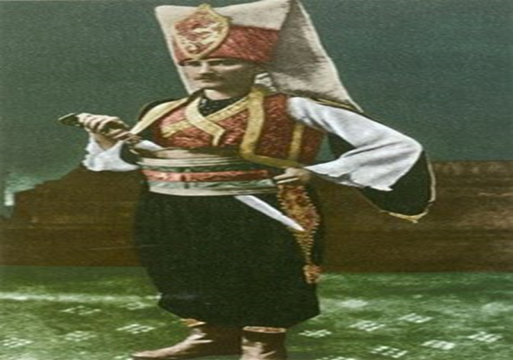

**Figure 15.**

16 participants choose the Figure 15 as the best match for the Janissary figure and nine of them interpret the picture based on the information content, seven of them interpret it based on their previous ideas. The distinction between dominant concrete and abstract reasoning can be seen in their interpretation as given in Table 12.

**Table 12.** Interpretation of the participants choosing figure 13.

|  |  |
| --- | --- |
| **Participant** | **Comments** |
| **Participant 22 (Dominant Concrete Thinker c-c-c): (Dominant Inferential Thinker)** | The Turkish style standing, clothes and hoodas well as sword |
| **Participant 89 (Concrete Thinker c-c-a): (Dominant Inferential Thinker)** | I can see the characteristics of a Turkish man in this picture |
| **Participant 91 (Dominant Abstract Thinker a-a-a): (Dominant Deductive Thinker)** | Janissary is the one representing nobility as well as tolerance, loyalty and he is a heroic figure with those characteristics. He struggled for the last times of Ottoman Empire and he had an active role for his nation. |

Participant 22 can be regarded as can be regarded as dominant inferential thinker because s/he draws conclusions based on the hypothetical past of the picture as well as the present concrete materials. Participant 89 can be regarded as dominant inferential thinker because s/he draws conclusions based on the hypothetical past of the picture as well as the present concrete materials. Participant 91 can be regarded as deductive thinker because s/he draws conclusions based on his/her beliefs and knowledge about Janissaries.

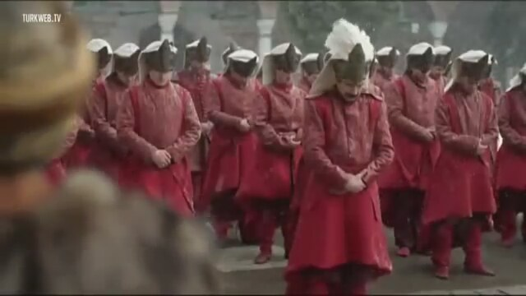

**Figure 16.**

26 participants choose the Figure 16 as the best match for the Janissary figure and six of them interpret the picture based on the information content, 20 of them interpret it based on their previous ideas. The distinction between dominant concrete and abstract reasoning can be seen in their interpretation as given in Table 13.

**Table 13.** Interpretation of the participants choosing figure 13.

|  |  |
| --- | --- |
| **Participant** | **Comments** |
| **Participant 7 (Dominant Concrete Thinker c-c-c): (Dominant Inferential Thinker)** | This pictures are the exact scene in the magnificent century (TV Series) |
| **Participant 32 (Dominant Abstract Thinker a-a-a) (Dominant Deductive Thinker)** | Their figures stand for our culture. This culture encompass many different cultures together and required to live in harmony. They are the individuals helping to develop this cultural climate. |
| **Participant 33 (Concrete Thinker c-a-a) (Dominant Deductive Thinker)** | Because they are warriors and they fight for the sake of sultans and it depicts their royalty to him. |

Participant 7 can be regarded as can be regarded as dominant inferential thinker because s/he draws conclusions based on the hypothetical past of the picture as well as the present concrete materials. Participant 32 can be regarded as deductive thinker because s/he draws conclusions based on his/her beliefs and knowledge about Janissaries.Participant 33 can also be regarded as deductive thinker because s/he draws conclusions based on his/her beliefs and knowledge about Janissaries.

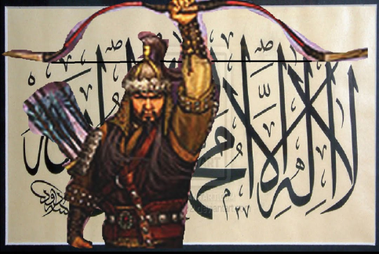

**Figure 17.**

22 participants choose the Figure 16 as the best match for the Janissary figure and four of them interpret the picture based on the information content, 18 of them interpret it based on their ideas. The distinction between dominant concrete and abstract reasoning can be seen in their interpretation as given in Table 14.

**Table 14.** Interpretation of the participants choosing figure 15.

|  |  |
| --- | --- |
| **Participant** | **Comments** |
| **Participan 90 (Dominant Abstract Thinker a-a-a): (Dominant Deductive Thinker)** | They trust on their faith rather than their swords. They fight for the sake of their faith. They never disrupt their honor, nobel standing even they left alone. This pictures remind me their faith and power that is why I chose it. |
| **Participan 6 (Dominant Abstract Thinker a-a-a): (Dominant Deductive Thinker)** | This is the picture representing the character of Janissary figure as indestructible, resistant. They accomplished many achievements in many national wars. However they also rebel the sultans when the proper and required conditions occurred. Sultans were also failed in order to suppress them**.** |
| **Participant 8 (Abstract Thinker a-a-c): (Dominant Deductive Thinker)** | It reminds me the panislamic and nationalist movement in the last times of the Ottoman empire. It also reminds me the force of the Janissary. |

Participant 90, Participant 6 and Participant 8 can be regarded as deductive thinker because s/he draws conclusions based on his/her beliefs and knowledge about Janissaries.

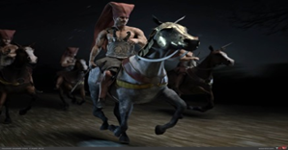

**Figure 18.**

Nine participants choose the Figure 18 as the best match for the Janissary figure and five of them interpret the picture based on the information content, four of them interpret it based on their previous ideas. The distinction between dominant concrete and abstract reasoning can be seen in their interpretation as given in Table 15.

**Table 15.** Interpretation of the participants choosing figure 16.

|  |  |
| --- | --- |
| **Participant** | **Comments** |
| **Participant 29 (Dominant Abstract Thinker a-a-a): (Inductive And Predictive Thinker)** | Ottoman soldiers drives this type of horses, they are nobles warriors, they are always preparing wars for attack by driving those horses |
| **Participant 7 (Dominant Concrete Thinker c-c-c): (Dominant Inductive Thinker)** | The clothes, horse and other equipment’s belong to Turkish culture and it reminds me Janissary figure |
| **Participant 51 (Dominant Abstract Thinker a-a-a): (Dominant Deductive Thinker)** | I always think Janissary figure someone riding a horse wearing Ottoman style clothes. They scared their enemies through their majestic posture with their eagle eye |

Participant 29 can be regarded as can be regarded as both inductive and predictive thinker because s/he draws conclusions based on generalizations and predictions. Participant 7 can be regarded as inductive thinker because s/he draws conclusions based on generalizations. Participant 51 can also be regarded as deductive thinker because s/he draws conclusions based on his/her beliefs and knowledge about Janissaries.

**The Results for Knight Pictures**

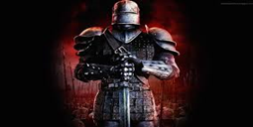

**Figure 19.**

35 participants choose the Figure 19 as the best match for the Knight figure and five of them interpret the picture based on the information content, 30 of them interpret it based on their previous ideas. The distinction between dominant concrete and abstract reasoning can be seen in their interpretation as given in Table 16.

**Table 16.** Interpretation of the participants choosing figure 17.

|  |  |
| --- | --- |
| **Participant** | **Comments** |
| **participant 12 (Dominant Concrete Thinker c-c-c): (Inferential Thinker)** | The mask, steel shield and armour is the belongings for knights. |
| **Participant 112 (Dominant Abstract Thinker a-a-a):(Dominant Deductive Thinker)** | Knights are the ones representing nobility and warrior sprit in European culture. They wear helmets like this one and that’s why it reminds me. |
| **Participant 88 ( Abstract Thinker a-a-c):**  **(Dominant Deductive Thinker)** | The figure of knight always remind me those kind of clothes and helmets. The helmets and their posture reflecting power make me to choose this picture. |

Participant 12 can be regarded as can be regarded as inferential thinker because s/he draws conclusions based on the hypothetical past of the picture. Participant 112 can be regarded as deductive thinker because s/he draws conclusions based on his/her beliefs and knowledge about Knights just as his/her similar comments on Janissaries.Participant 88 can be regarded as deductive thinker because s/he draws conclusions based on his/her beliefs and knowledge about Knights just as his/her similar comments on Janissaries.

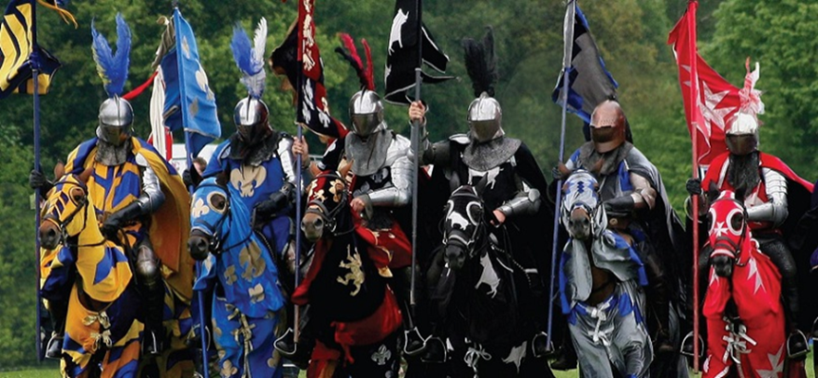

**Figure 20.**

20 participants choose the Figure 20 as the best match for the Knight figure and 10 of them interpret the picture based on the information content, five of them interpret it based on their previous ideas. The distinction between dominant concrete and abstract reasoning can be seen in their interpretation as given in Table 17.

**Table 17.** Interpretation of the participants choosing figure 18.

|  |  |
| --- | --- |
| **Participant** | **Comments** |
| **Participant 10 (Dominant Concrete Thinker c-c-c): (Inferential Thinker)** | «They wear armours to all of your body. They do exercises on the horses and the clothes and flags are the similar objects in the movies» |
| **Participant 32 (Dominant Abstract Thinker a-a-a): (Dominant Deductive Thinker)** | They are the part of a very ancient culture. They are the ruthless warriors defending and protecting Christianity and the ones who can get what they want. |
| **Participant 31 (Concrete Thinker a-a-a): (Dominant Deductive Thinker)** | They have so powerwul posture and swords scaring their enemies |

Participant 10 can be regarded as can be regarded as inferential thinker because s/he draws conclusions based on the hypothetical past of the picture. Participant 32 and 31 can be regarded as deductive thinker because s/he draws conclusions based on his/her beliefs and knowledge about Knights.

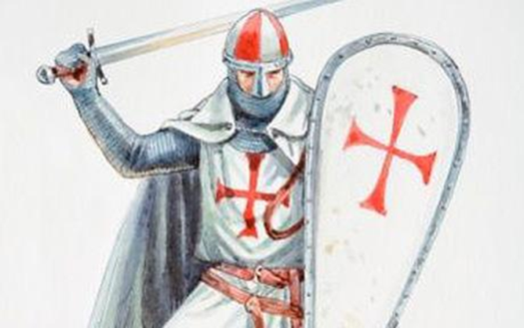

**Figure 21.**

23 participants choose the Figure 21 as the best match for the Knight figure and 16 of them interpret the picture based on the information content, three of them interpret it based on their previous ideas. The distinction between dominant and abstract reasoning can be seen in their interpretation as given in Table 20.

**Table 20.** Interpretation of the participants choosing figure 19.

|  |  |
| --- | --- |
| **Participant** | **Comments** |
| **participant 3 ( Concrete Thinker c-c -a): (Dominant Deductive Thinker)** | «They respect their beliefs as long as they stick them and have a faith» |
| **Participant 8 (Abstract Thinker a-a-c):** | There are images belonging to a knight such as knife, shield. |
| **Participant 7 (Dominant Concrete Thinker c-c-c):(Inferential Thinker)** | The clothes, symbols, helmet, cloak and other equipment’s reminds me Knights. |

Participant 3can be regarded as deductive thinker because s/he draws conclusions based on his/her beliefs and knowledge about Knights. Participant 8 and Participant 7can be regarded as can be regarded as inferential thinker because s/he draws conclusions based on the hypothetical past of the picture.

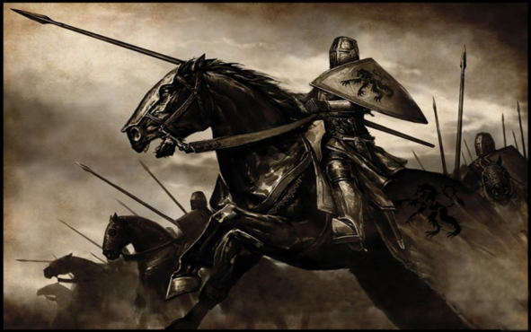

**Figure 22.**

30 participants choose the Figure 22 as the best match for the Knight figure and 17 of them interpret the picture based on the information content,13 of them interpret it based on their previous ideas. The distinction between dominant and abstract reasoning can be seen in their interpretation as given in Table 21.

**Table 21.** Interpretation of the participants choosing figure 20.

|  |  |
| --- | --- |
| **Participant** | **Comments** |
| **Participant 6 (Dominant Abstract Thinker a-a-a):** | They are indestructible forces. They are very sheltered. They have armor, body armor, sword and they manage the army by this. |
| **Participant 28 (Dominant Abstract Thinker a-a-a):** | Knights are the noble and respected people in middle ages. Horses and those types of clothes are showing their prestige. That’s why I chose it. |
| **Participant 35 (Dominant Abstract Thinker a-c-c):** | Because knights wear those types of clothes and helmets to protect themselves and others. |

Participant 6 can be regarded as deductive thinker because s/he draws conclusions based on his/her beliefs and knowledge about Knights. Participant 28 and 35 are inferential and inductive thinkers because s/he draws conclusions based on the hypothetical past of the picture and the generalization that they made.

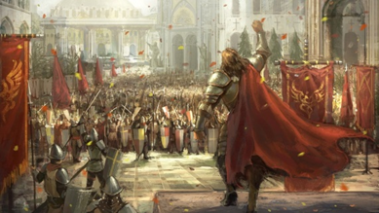

**Figure 23.**

10 participants choose the Figure 23 as the best match for the Knight figure and two of them interpret the picture based on the information content, eight of them interpret it based on their previous ideas. The distinction between dominant and abstract reasoning can be seen in their interpretation as given in Table 22.

**Table 22.** Interpretation of the participants choosing figure 21.

|  |  |
| --- | --- |
| **Participant** | **Comments** |
| **Participan 37 (Dominant Abstract Thinker a-a-a):** | «They have a powerful personalities attracting everyone around them. They are like the representative of god. They have a leader soul that can command the armies just by one statement» |

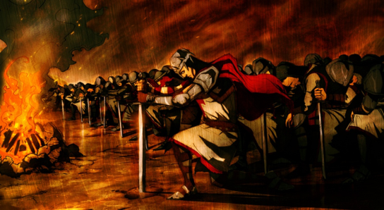

**Figure 24.**

6 participants choose the Figure 24 as the best match for the Knight figure and interestingly none of them interpret the picture based on the information content, all of them interpret it based on their previous ideas. The distinction between dominant and abstract reasoning can be seen in their interpretation as given in Table 23.

**Table 23.** Interpretation of the participants choosing figure 22.

|  |  |
| --- | --- |
| **Participant** | **Comments** |
| **Participan 11 (Dominant Abstract Thinker a-a-a):** | «They always bow on powerful elites. Altough they are sometimes right they are mostly used by others. The order they use is the imitation of the order Turkish Forces (Mete Han). I don’t know how but ı correlate the fire with knights» |
| **Participant 91 (Dominant Abstract Thinker a-a-a): (Dominant Deductive Thinker)** | It is very qualitative picture in terms of tactic and technique. They are like actors that’s why I chose it. |

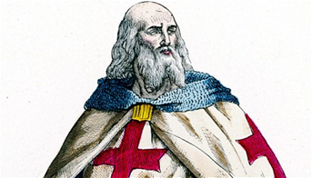

**Figure 25.**

2 participants choose the Figure 25 as the best match for the Knight figure and interestingly none of them interpret the picture based on the information content, all of them interpret it based on their previous ideas. The distinction between dominant and abstract reasoning can be seen in their interpretation as given in Table 23.

**Table 24.** Interpretation of the participants choosing figure 24.

|  |  |
| --- | --- |
| **Participant** | **Comments** |
| **Participan 138 (Dominant Abstract Thinker a-a-a):** | «The things as far I know from history is that they had religious identities and they fight for their religious purposes and this picture is correlated the things that ı know about them in this regard. |

**RESULTS and DISCUSSIONS**

As for the quantitative data, it can be seen Table 1 and Table 2, individuals are more prone to interpret pictures based on the ideas rather than the information content present in the picture because 277 pictures are interpreted in abstracted sense and 194 pictures are interpreted in concrete sense. 67 of pictures are dominantly interpreted in abstract sense whereas 38 of them are interpreted dominantly in concrete sense. Individuals are more prone to interpret samurai and janissary pictures in abstracted sense whereas there is no significant difference for the interpretation of knight pictures in terms of abstract- concrete difference. Individuals are mostly use deductive reasoning skills especially for Janissary pictures and less use predictive reasoning for the interpretation of the pictures. As for the qualitative analysis, deductive, inductive and inferential reasoning skills can be useful dimension emerging in the analysis of qualitative data of the interpretations.

**Table 25.** Graphical representation of Table 2.

It should be noted that whether a participant is dominant in his/her reasoning style might be situational. This situational character of reasoning styles can be seen in the Table 25 and Table 2. For example, deductive reasoning is mostly preferred for the interpretation of Janissary pictures whereas inferential reasoning was preferred for the interpretation of samurai pictures. Their reasoning might work differently in different cases and it can be affected by their previous experiences, knowledge or attitudes toward the image they confront. For subsequent studies, it is recommended to investigate whether reasoning styles are situational or content depended.

The concept of “perception” is a wide range subject that is studied ranging from psychology to engineering. Many studies regarding this issue are investigated by the scales, surveys or inventories in educational area in Turkish literature. Hence this study was aimed to investigate the perception levels of the students in a different method in the context of reasoning and reasoning styles. Perception is not direct correspondence of the outputs of external reality into our mental schemes but rather it is moulded with our previous information, knowledge, ideas and wisdom. Hence this study is thought to contribute the literature in this regard. As for the suggestions for the subsequent researches, this type of study can be done with the different population groups in different experimental designs.

# REFERENCES

Akkoyunlu, B. Altun, A. Soylu, M. Y. (2008). Öğretim Tasarımı, Maya Akademi, Ankara.

Ahmad, Z. (2003). The Epistemology Of Ibn Khaldun, RoutledgeCurzon, London.

Anderson, L. W. (2005). Objectives, evaluation, and the improvement of education. Studies In Educational Evaluation, 31(2-3), 102-113.

Bueno, O. (2012). Styles of reasoning: A pluralist view, Studies in History and Philosophy of Science 43, 657–665

Duran, V. (2014). The Investigation of the hypothetic-creative reasoning skills of the teacher trainees in terms of their scientific epistemological beliefs, learning styles and their demographic characteristics, Master's Thesis, Muğla Sıtkı Koçman University, Muğla

Duran, V. (2015). The Development of Hypothetico-Creativite Reasoning Skills Inventory, Presented in International Congress on Education for Future: Issues and Challanges, (ICEFIC), Abstract Book 227-228, Ankara University Publishing, <https://www.academia.edu/19775202/The_Development_of_HypotheticoCreative_Reas>oning_Skills_Inventory (Accessed, 09.07.16)

Gelen, İ. Duran, V. Ozer, B. (2016). Investigation of Hypothetico-Creative Reasoning Skills of Teacher Trainees in Terms of Their Thinking, Khazar Journal of Humanities and Social Sciences, 19(3), 82-110.

Lawson, A.E. (1995). Science Teaching and Development of Thinking. Belmont, CL: Wadsword Publishing Company, New York.

McCarthy, B. (1982). “Improving Staff Development Through CBAM and 4MAT”. Educational Leadership. 40 (1), (20-25).

Moseley, D. Baumfield, V. Elliott, J. Gregson, M. Higgins, S. Miller, J. Newton, D. (2005). Frameworks for Thinking A Handbook for Teaching and Learning, Cambridge University Press, Cambridge.

Oruç, C. (2010). İbn Haldun’un Mukaddime’sinde Öğrenme, Necmettin Erbakan Üniversitesi İlahiyat Fakültesi Dergisi, 29, 129-142.

Ishiyamaa, J.T., Wingoa, K.T., Arteagab, S. S., Hernandezc, C.M.(2001). Liberal undergraduate education and reasoning styles: using political scenarios in student assessment, The Social Science Journal 38, 125–135

İşcan, C. D. (2007). İlköğretim Düzeyinde Değerler Eğitimi Programinin Etkililiği,Yayımlanmamış Doktora Tezi, Hacettepe Üniversitesi Sosyal Bilimler Enstitüsü, Eğitim Programları ve Öğretim Anabilim Dalı, Ankara

Ruphy, S. (2011). From Hacking’s Plurality of Styles of Scientific Reasoning to “Foliated” Pluralism: A Philosophically Robust Form of Ontologico-Methodological Pluralism, Philosophy of Science, 78(5), 1212-1222

Senemoğlu, N. (2009). Gelişim Öğrenme ve Öğretim, Pegem Akademi, Ankara.

Sylvan D. A., Ostrom, T. M., & Gannon, K. (1994). Case-based, model-based and explanation-based styles of reasoning in foreign policy. International Studies Quarterly, 38:61–90.

Winter, R. G. (2012). Interweaving categories: Styles, paradigms, and models, Studies in History and Philosophy of Science Part AVolume 43, Issue 4, Pages 628–639

Zhang, L. (2001). Do Thinking Styles Contribute to Academic Achievement Beyond Selfrated

Abilities?. The Journal of Psychology. Provincetown, Kasım, 135 (5), 547-561.

Zhang, L. F., Sternberg, R. J., Rayner, S. (2002). Culture and Intellectual Styles Milestones, and Agenda, Handbook of Intellectual Styles Preferences inCognition, Learning, andThinking (Edts. Zhang,L.F., Sternberg,R. J., Rayner, S.) New York: Springer Publishing Company

Zhang, L. F., and Sternberg, R. J. (2005). A threefold model of intellectual styles. Educational Psychology Review, 17(1), 1–53.

Zhang, L. ve Sternberg, R.t J. (2006). The Nature of Intellectual Styles. Lawrence Erlbaum Associates. Mahwah, New Jersy.

1. Arş. Gör. Ondokuz Mayıs University, Faculty of Education, Samsun, Turkey, volkan.duran@omu.edu.tr
2. Doç. Dr. Ondokuz Mayıs University, Faculty of Education, Samsun, Turkey, ozer.bayram@gmail.com