Supplementary Table 1. Analysis of Variance (ANOVA) for Shear Stress

Source | DF | Seq SS |  | Contribution |  | Adj SS | Adj MS
Model | 27 | 541.614 |  | 99.79% |  | 541.614 | 20.060
Linear | 6 | 511.677 |  | 94.28% |  | 511.677 | 85.279
H | 1 | 0.015 |  | 0.00% |  | 0.015 | 0.015
L1 | 1 | 0.000 |  | 0.00% |  | 0.000 | 0.000
L2 | 1 | 277.440 |  | 51.12% |  | 277.440 | 277.440
Adhesive Thickness | 1 | 101.682 |  | 18.73% |  | 101.682 | 101.682
Fx | 1 | 132.540 |  | 24.42% |  | 132.540 | 132.540
Fz | 1 | 0.000 |  | 0.00% |  | 0.000 | 0.000
Square | 6 | 8.760 |  | 1.61% |  | 8.760 | 1.460
H*H | 1 | 1.323 |  | 0.24% |  | 0.003 | 0.003
L1*L1 | 1 | 0.190 |  | 0.04% |  | 0.003 | 0.003
L2*L2 | 1 | 0.200 |  | 0.04% |  | 0.001 | 0.001
Adhesive Thickness*Adhesive Thickness | 1 | 7.042 |  | 1.30% |  | 6.721 | 6.721
Fx*Fx | 1 | 0.002 |  | 0.00% |  | 0.003 | 0.003
Fz*Fz | 1 | 0.003 |  | 0.00% |  | 0.003 | 0.003
2-Way Interaction | 15 | 21.177 |  | 3.90% |  | 21.177 | 1.412
H*L1 | 1 | 0.000 |  | 0.00% |  | 0.000 | 0.000
H*L2 | 1 | 0.005 |  | 0.00% |  | 0.005 | 0.005
H*Adhesive Thickness | 1 | 0.003 |  | 0.00% |  | 0.003 | 0.003
H*Fx | 1 | 0.005 |  | 0.00% |  | 0.005 | 0.005
H*Fz | 1 | 0.000 |  | 0.00% |  | 0.000 | 0.000
L1*L2 | 1 | 0.000 |  | 0.00% |  | 0.000 | 0.000
L1*Adhesive Thickness | 1 | 0.000 |  | 0.00% |  | 0.000 | 0.000
L1*Fx | 1 | 0.000 |  | 0.00% |  | 0.000 | 0.000
L1*Fz | 1 | 0.000 |  | 0.00% |  | 0.000 | 0.000
L2*Adhesive Thickness | 1 | 8.000 |  | 1.47% |  | 8.000 | 8.000
L2*Fx | 1 | 9.245 |  | 1.70% |  | 9.245 | 9.245
L2*Fz | 1 | 0.000 |  | 0.00% |  | 0.000 | 0.000
Adhesive Thickness*Fx | 1 | 3.920 |  | 0.72% |  | 3.920 | 3.920
Adhesive Thickness*Fz | 1 | 0.000 |  | 0.00% |  | 0.000 | 0.000
Fx*Fz | 1 | 0.000 |  | 0.00% |  | 0.000 | 0.000
Error | 26 | 1.126 |  | 0.21% |  | 1.126 | 0.043
Lack-of-Fit | 21 | 1.126 |  | 0.21% |  | 1.126 | 0.054
Pure Error | 5 | 0.000 |  | 0.00% |  | 0.000 | 0.000
Total | 53 | 542.740 |  | 100.00%
Source | F-Value |  | P-Value
Model | 463.26 |  | 0.000
Linear | 1969.44 |  | 0.000
H | 0.35 |  | 0.561
L1 | 0.00 |  | 1.000
L2 | 6407.20 |  | 0.000
Adhesive Thickness | 2348.24 |  | 0.000
Fx | 3060.88 |  | 0.000
Fz | 0.00 |  | 1.000
Square | 33.72 |  | 0.000
H*H | 0.07 |  | 0.799
L1*L1 | 0.07 |  | 0.799
L2*L2 | 0.02 |  | 0.899
Adhesive Thickness*Adhesive Thickness | 155.21 |  | 0.000
Fx*Fx | 0.07 |  | 0.799
Fz*Fz | 0.07 |  | 0.799
2-Way Interaction | 32.60 |  | 0.000
H*L1 | 0.00 |  | 1.000
H*L2 | 0.12 |  | 0.737
H*Adhesive Thickness | 0.06 |  | 0.812
H*Fx | 0.12 |  | 0.737
H*Fz | 0.00 |  | 1.000
L1*L2 | 0.00 |  | 1.000
L1*Adhesive Thickness | 0.00 |  | 1.000
L1*Fx | 0.00 |  | 1.000
L1*Fz | 0.00 |  | 1.000
L2*Adhesive Thickness | 184.75 |  | 0.000
L2*Fx | 213.50 |  | 0.000
L2*Fz | 0.00 |  | 1.000
Adhesive Thickness*Fx | 90.53 |  | 0.000
Adhesive Thickness*Fz | 0.00 |  | 1.000
Fx*Fz | 0.00 |  | 1.000
Error
Lack-of-Fit | * |  | *
Pure Error
Total

Supplementary Table 2. Analysis of Variance (ANOVA) for Peel Stress

Source | DF | Seq SS |  | Contribution |  | Adj SS | Adj MS
Model | 27 | 13.3508 |  | 99.83% |  | 13.3508 | 0.49448
Linear | 6 | 12.8500 |  | 96.09% |  | 12.8500 | 2.14167
H | 1 | 0.0017 |  | 0.01% |  | 0.0017 | 0.00167
L1 | 1 | 0.0000 |  | 0.00% |  | 0.0000 | 0.00000
L2 | 1 | 0.0067 |  | 0.05% |  | 0.0067 | 0.00667
Adhesive Thickness | 1 | 4.8600 |  | 36.34% |  | 4.8600 | 4.86000
Fx | 1 | 2.9400 |  | 21.98% |  | 2.9400 | 2.94000
Fz | 1 | 5.0417 |  | 37.70% |  | 5.0417 | 5.04167
Square | 6 | 0.3983 |  | 2.98% |  | 0.3983 | 0.06639
H*H | 1 | 0.0333 |  | 0.25% |  | 0.0064 | 0.00643
L1*L1 | 1 | 0.0031 |  | 0.02% |  | 0.0000 | 0.00000
L2*L2 | 1 | 0.0352 |  | 0.26% |  | 0.0064 | 0.00643
Adhesive Thickness*Adhesive Thickness | 1 | 0.3267 |  | 2.44% |  | 0.3150 | 0.31500
Fx*Fx | 1 | 0.0000 |  | 0.00% |  | 0.0000 | 0.00000
Fz*Fz | 1 | 0.0000 |  | 0.00% |  | 0.0000 | 0.00000
2-Way Interaction | 15 | 0.1025 |  | 0.77% |  | 0.1025 | 0.00683
H*L1 | 1 | 0.0000 |  | 0.00% |  | 0.0000 | 0.00000
H*L2 | 1 | 0.0000 |  | 0.00% |  | 0.0000 | 0.00000
H*Adhesive Thickness | 1 | 0.0025 |  | 0.02% |  | 0.0025 | 0.00250
H*Fx | 1 | 0.0000 |  | 0.00% |  | 0.0000 | 0.00000
H*Fz | 1 | 0.0000 |  | 0.00% |  | 0.0000 | 0.00000
L1*L2 | 1 | 0.0000 |  | 0.00% |  | 0.0000 | 0.00000
L1*Adhesive Thickness | 1 | 0.0000 |  | 0.00% |  | 0.0000 | 0.00000
L1*Fx | 1 | 0.0000 |  | 0.00% |  | 0.0000 | 0.00000
L1*Fz | 1 | 0.0000 |  | 0.00% |  | 0.0000 | 0.00000
L2*Adhesive Thickness | 1 | 0.0050 |  | 0.04% |  | 0.0050 | 0.00500
L2*Fx | 1 | 0.0050 |  | 0.04% |  | 0.0050 | 0.00500
L2*Fz | 1 | 0.0000 |  | 0.00% |  | 0.0000 | 0.00000
Adhesive Thickness*Fx | 1 | 0.0450 |  | 0.34% |  | 0.0450 | 0.04500
Adhesive Thickness*Fz | 1 | 0.0450 |  | 0.34% |  | 0.0450 | 0.04500
Fx*Fz | 1 | 0.0000 |  | 0.00% |  | 0.0000 | 0.00000
Error | 26 | 0.0225 |  | 0.17% |  | 0.0225 | 0.00087
Lack-of-Fit | 21 | 0.0225 |  | 0.17% |  | 0.0225 | 0.00107
Pure Error | 5 | 0.0000 |  | 0.00% |  | 0.0000 | 0.00000
Total | 53 | 13.3733 |  | 100.00%
Source | F-Value |  | P-Value
Model | 571.39 |  | 0.000
Linear | 2474.81 |  | 0.000
H | 1.93 |  | 0.177
L1 | 0.00 |  | 1.000
L2 | 7.70 |  | 0.010
Adhesive Thickness | 5616.00 |  | 0.000
Fx | 3397.33 |  | 0.000
Fz | 5825.93 |  | 0.000
Square | 76.72 |  | 0.000
H*H | 7.43 |  | 0.011
L1*L1 | 0.00 |  | 1.000
L2*L2 | 7.43 |  | 0.011
Adhesive Thickness*Adhesive Thickness | 364.00 |  | 0.000
Fx*Fx | 0.00 |  | 1.000
Fz*Fz | 0.00 |  | 1.000
2-Way Interaction | 7.90 |  | 0.000
H*L1 | 0.00 |  | 1.000
H*L2 | 0.00 |  | 1.000
H*Adhesive Thickness | 2.89 |  | 0.101
H*Fx | 0.00 |  | 1.000
H*Fz | 0.00 |  | 1.000
L1*L2 | 0.00 |  | 1.000
L1*Adhesive Thickness | 0.00 |  | 1.000
L1*Fx | 0.00 |  | 1.000
L1*Fz | 0.00 |  | 1.000
L2*Adhesive Thickness | 5.78 |  | 0.024
L2*Fx | 5.78 |  | 0.024
L2*Fz | 0.00 |  | 1.000
Adhesive Thickness*Fx | 52.00 |  | 0.000
Adhesive Thickness*Fz | 52.00 |  | 0.000
Fx*Fz | 0.00 |  | 1.000
Error
Lack-of-Fit | * |  | *
Pure Error
Total

Supplementary Table 3. Response Surface Regression: Coded Coefficients for Shear Stress as a Function of Joint Parameters
Term | Coef |  | SE Coef | 95% CI | T-Value | P-Value
Constant | 6.8000 |  | 0.0850 | (6.6254; 6.9746) | 80.04 | 0.000
H | 0.0250 |  | 0.0425 | (-0.0623; 0.1123) | 0.59 | 0.561
L1 | -0.0000 |  | 0.0425 | (-0.0873; 0.0873) | -0.00 | 1.000
L2 | 3.4000 |  | 0.0425 | (3.3127; 3.4873) | 80.04 | 0.000
Adhesive Thickness | -2.0583 |  | 0.0425 | (-2.1456; -1.9710) | -48.46 | 0.000
Fx | 2.3500 |  | 0.0425 | (2.2627; 2.4373) | 55.33 | 0.000
Fz | -0.0000 |  | 0.0425 | (-0.0873; 0.0873) | -0.00 | 1.000
H*H | -0.0167 |  | 0.0649 | (-0.1500; 0.1167) | -0.26 | 0.799
L1*L1 | -0.0167 |  | 0.0649 | (-0.1500; 0.1167) | -0.26 | 0.799
L2*L2 | 0.0083 |  | 0.0649 | (-0.1250; 0.1417) | 0.13 | 0.899
Adhesive Thickness*Adhesive Thickness | 0.8083 |  | 0.0649 | (0.6750; 0.9417) | 12.46 | 0.000
Fx*Fx | -0.0167 |  | 0.0649 | (-0.1500; 0.1167) | -0.26 | 0.799
Fz*Fz | -0.0167 |  | 0.0649 | (-0.1500; 0.1167) | -0.26 | 0.799
H*L1 | -0.0000 |  | 0.0736 | (-0.1512; 0.1512) | -0.00 | 1.000
H*L2 | 0.0250 |  | 0.0736 | (-0.1262; 0.1762) | 0.34 | 0.737
H*Adhesive Thickness | -0.0125 |  | 0.0520 | (-0.1194; 0.0944) | -0.24 | 0.812
H*Fx | 0.0250 |  | 0.0736 | (-0.1262; 0.1762) | 0.34 | 0.737
H*Fz | 0.0000 |  | 0.0736 | (-0.1512; 0.1512) | 0.00 | 1.000
L1*L2 | 0.0000 |  | 0.0736 | (-0.1512; 0.1512) | 0.00 | 1.000
L1*Adhesive Thickness | -0.0000 |  | 0.0736 | (-0.1512; 0.1512) | -0.00 | 1.000
L1*Fx | -0.0000 |  | 0.0520 | (-0.1069; 0.1069) | -0.00 | 1.000
L1*Fz | -0.0000 |  | 0.0736 | (-0.1512; 0.1512) | -0.00 | 1.000
L2*Adhesive Thickness | -1.0000 |  | 0.0736 | (-1.1512; -0.8488) | -13.59 | 0.000
L2*Fx | 1.0750 |  | 0.0736 | (0.9238; 1.2262) | 14.61 | 0.000
L2*Fz | -0.0000 |  | 0.0520 | (-0.1069; 0.1069) | -0.00 | 1.000
Adhesive Thickness*Fx | -0.7000 |  | 0.0736 | (-0.8512; -0.5488) | -9.51 | 0.000
Adhesive Thickness*Fz | 0.0000 |  | 0.0736 | (-0.1512; 0.1512) | 0.00 | 1.000
Fx*Fz | 0.0000 |  | 0.0736 | (-0.1512; 0.1512) | 0.00 | 1.000
Term | VIF
Constant
H | 1.00
L1 | 1.00
L2 | 1.00
Adhesive Thickness | 1.00
Fx | 1.00
Fz | 1.00
H*H | 1.30
L1*L1 | 1.30
L2*L2 | 1.30
Adhesive Thickness*Adhesive Thickness | 1.30
Fx*Fx | 1.30
Fz*Fz | 1.30
H*L1 | 1.00
H*L2 | 1.00
H*Adhesive Thickness | 1.00
H*Fx | 1.00
H*Fz | 1.00
L1*L2 | 1.00
L1*Adhesive Thickness | 1.00
L1*Fx | 1.00
L1*Fz | 1.00
L2*Adhesive Thickness | 1.00
L2*Fx | 1.00
L2*Fz | 1.00
Adhesive Thickness*Fx | 1.00
Adhesive Thickness*Fz | 1.00
Fx*Fz | 1.00

Supplementary Table 4. Response Surface Regression: Coded Coefficients for Peel Stress as a Function of Joint Parameters

Term | Coef | SE Coef |  |  | 95% CI | T-Value
Constant | 2.4000 | 0.0120 |  |  | (2.3753; 2.4247) | 199.84
H | 0.00833 | 0.00600 |  |  | (-0.00401; 0.02068) | 1.39
L1 | 0.00000 | 0.00600 |  |  | (-0.01234; 0.01234) | 0.00
L2 | -0.01667 | 0.00600 |  |  | (-0.02901; -0.00432) | -2.78
Adhesive Thickness | -0.45000 | 0.00600 |  |  | (-0.46234; -0.43766) | -74.94
Fx | 0.35000 | 0.00600 |  |  | (0.33766; 0.36234) | 58.29
Fz | 0.45833 | 0.00600 |  |  | (0.44599; 0.47068) | 76.33
H*H | -0.02500 | 0.00917 |  |  | (-0.04385; -0.00615) | -2.73
L1*L1 | 0.00000 | 0.00917 |  |  | (-0.01885; 0.01885) | 0.00
L2*L2 | -0.02500 | 0.00917 |  |  | (-0.04385; -0.00615) | -2.73
Adhesive Thickness*Adhesive Thickness | 0.17500 | 0.00917 |  |  | (0.15615; 0.19385) | 19.08
Fx*Fx | 0.00000 | 0.00917 |  |  | (-0.01885; 0.01885) | 0.00
Fz*Fz | -0.00000 | 0.00917 |  |  | (-0.01885; 0.01885) | -0.00
H*L1 | -0.0000 | 0.0104 |  |  | (-0.0214; 0.0214) | -0.00
H*L2 | 0.0000 | 0.0104 |  |  | (-0.0214; 0.0214) | 0.00
H*Adhesive Thickness | -0.01250 | 0.00735 |  |  | (-0.02762; 0.00262) | -1.70
H*Fx | 0.0000 | 0.0104 |  |  | (-0.0214; 0.0214) | 0.00
H*Fz | 0.0000 | 0.0104 |  |  | (-0.0214; 0.0214) | 0.00
L1*L2 | 0.0000 | 0.0104 |  |  | (-0.0214; 0.0214) | 0.00
L1*Adhesive Thickness | 0.0000 | 0.0104 |  |  | (-0.0214; 0.0214) | 0.00
L1*Fx | -0.00000 | 0.00735 |  |  | (-0.01512; 0.01512) | -0.00
L1*Fz | -0.0000 | 0.0104 |  |  | (-0.0214; 0.0214) | -0.00
L2*Adhesive Thickness | 0.0250 | 0.0104 |  |  | (0.0036; 0.0464) | 2.40
L2*Fx | 0.0250 | 0.0104 |  |  | (0.0036; 0.0464) | 2.40
L2*Fz | 0.00000 | 0.00735 |  |  | (-0.01512; 0.01512) | 0.00
Adhesive Thickness*Fx | -0.0750 | 0.0104 |  |  | (-0.0964; -0.0536) | -7.21
Adhesive Thickness*Fz | -0.0750 | 0.0104 |  |  | (-0.0964; -0.0536) | -7.21
Fx*Fz | -0.0000 | 0.0104 |  |  | (-0.0214; 0.0214) | -0.00
Term | P-Value |  | VIF
Constant | 0.000
H | 0.177 |  | 1.00
L1 | 1.000 |  | 1.00
L2 | 0.010 |  | 1.00
Adhesive Thickness | 0.000 |  | 1.00
Fx | 0.000 |  | 1.00
Fz | 0.000 |  | 1.00
H*H | 0.011 |  | 1.30
L1*L1 | 1.000 |  | 1.30
L2*L2 | 0.011 |  | 1.30
Adhesive Thickness*Adhesive Thickness | 0.000 |  | 1.30
Fx*Fx | 1.000 |  | 1.30
Fz*Fz | 1.000 |  | 1.30
H*L1 | 1.000 |  | 1.00
H*L2 | 1.000 |  | 1.00
H*Adhesive Thickness | 0.101 |  | 1.00
H*Fx | 1.000 |  | 1.00
H*Fz | 1.000 |  | 1.00
L1*L2 | 1.000 |  | 1.00
L1*Adhesive Thickness | 1.000 |  | 1.00
L1*Fx | 1.000 |  | 1.00
L1*Fz | 1.000 |  | 1.00
L2*Adhesive Thickness | 0.024 |  | 1.00
L2*Fx | 0.024 |  | 1.00
L2*Fz | 1.000 |  | 1.00
Adhesive Thickness*Fx | 0.000 |  | 1.00
Adhesive Thickness*Fz | 0.000 |  | 1.00
Fx*Fz | 1.000 |  | 1.00

Regression Equations for Shear and Peel Stresses

Shear stress | = | -2.25 + 0.019 H + 0.0067 L1 + 0.1942 L2 - 10.92 Adhesive Thickness + 0.0600 Fx  + 0.0040 Fz - 0.000167 H*H - 0.000167 L1*L1 + 0.000083 L2*L2  + 80.83 Adhesive Thickness*Adhesive Thickness - 0.000027 Fx*Fx  - 0.000027 Fz*Fz + 0.000000 H*L1 + 0.000250 H*L2 - 0.0125 H*Adhesive Thickness  + 0.000100 H*Fx - 0.000000 H*Fz + 0.000000 L1*L2  - 0.0000 L1*Adhesive Thickness - 0.000000 L1*Fx - 0.000000 L1*Fz  - 1.0000 L2*Adhesive Thickness + 0.004300 L2*Fx - 0.000000 L2*Fz  - 0.2800 Adhesive Thickness*Fx - 0.0000 Adhesive Thickness*Fz - 0.000000 Fx*Fz | Eq.(1) | Peel stress | = | -1.008 + 0.0433 H - 0.0000 L1 - 0.0042 L2 - 6.500 Adhesive Thickness  + 0.01800 Fx + 0.02433 Fz - 0.000250 H*H + 0.000000 L1*L1 - 0.000250 L2*L2  + 17.500 Adhesive Thickness*Adhesive Thickness + 0.000000 Fx*Fx  - 0.000000 Fz*Fz + 0.000000 H*L1 + 0.000000 H*L2 - 0.01250 H*Adhesive Thickness  - 0.000000 H*Fx + 0.000000 H*Fz + 0.000000 L1*L2 - 0.0000 L1*Adhesive Thickness  - 0.000000 L1*Fx + 0.000000 L1*Fz + 0.0250 L2*Adhesive Thickness  + 0.000100 L2*Fx - 0.000000 L2*Fz - 0.03000 Adhesive Thickness*Fx  - 0.03000 Adhesive Thickness*Fz + 0.000000 Fx*Fz | Eq. (2)

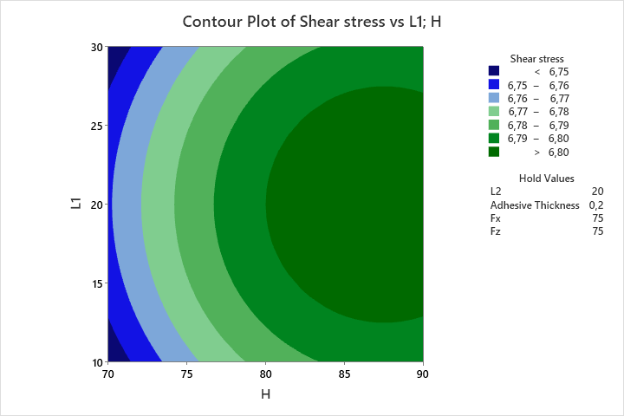  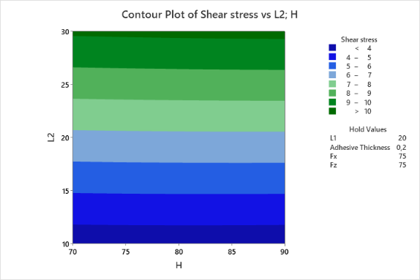  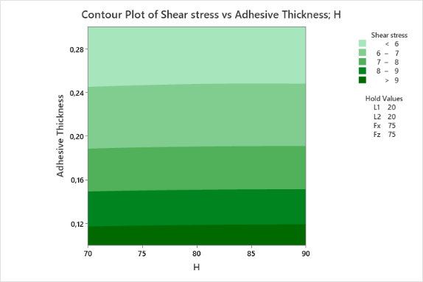  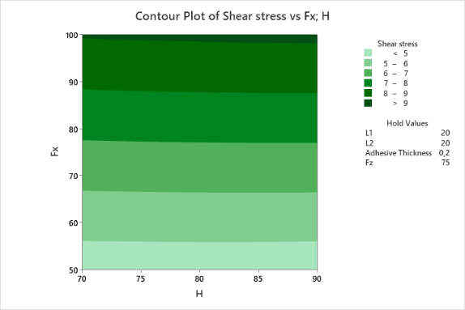  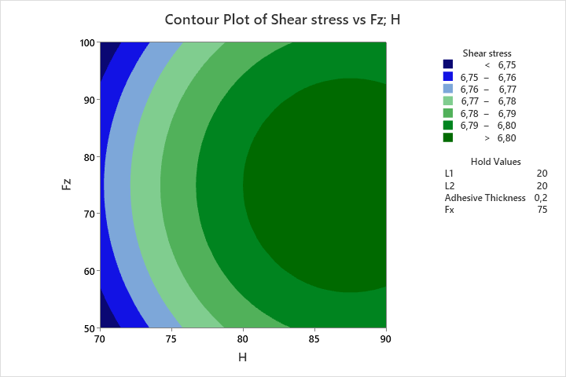  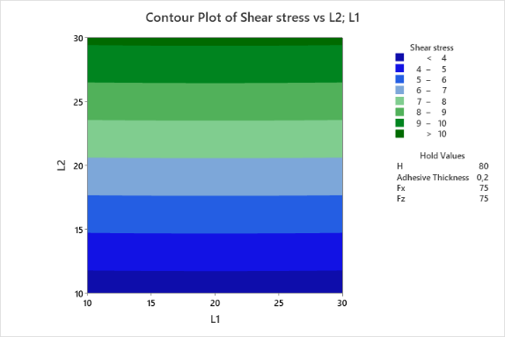  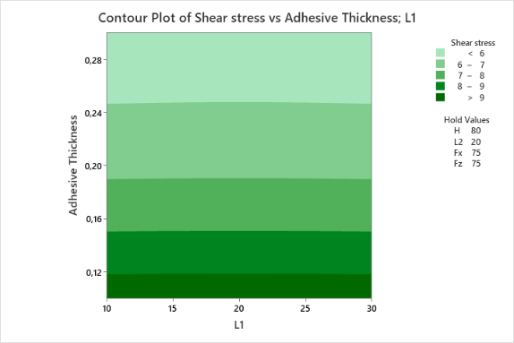  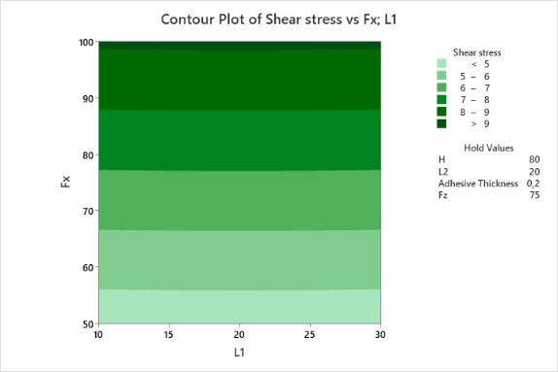  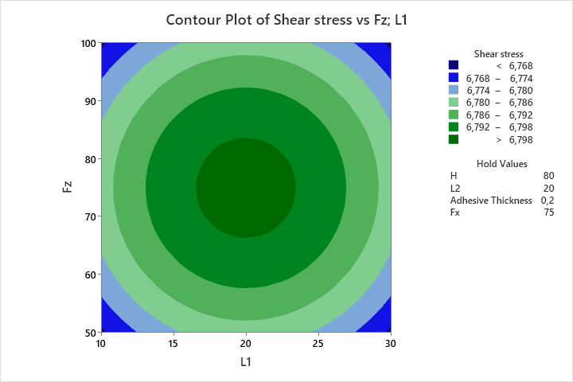  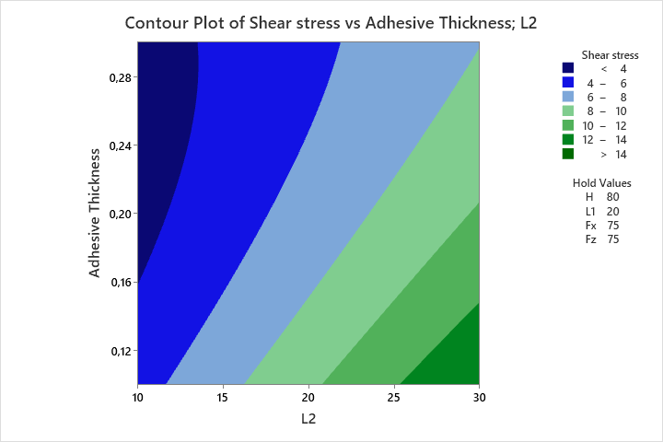  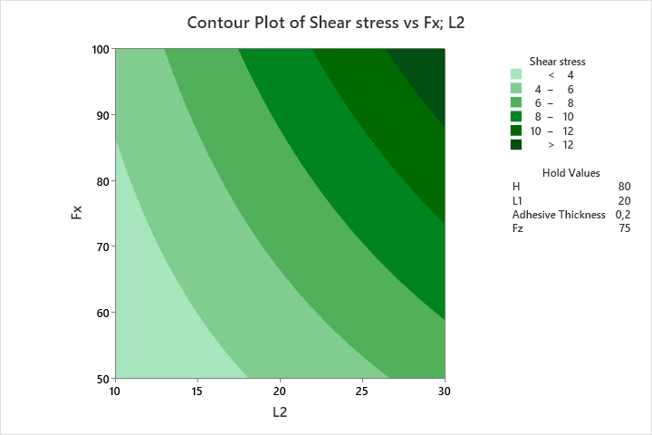  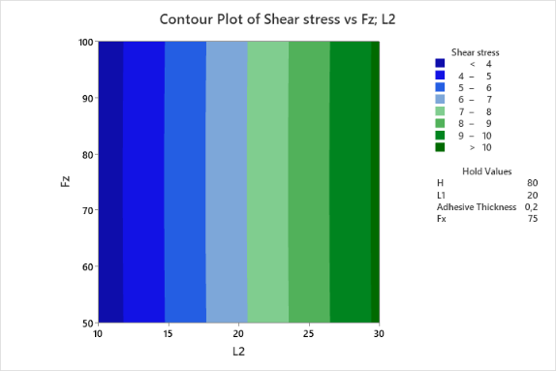  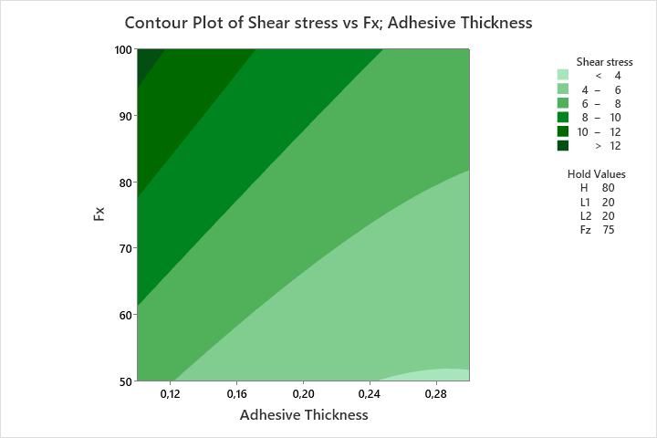  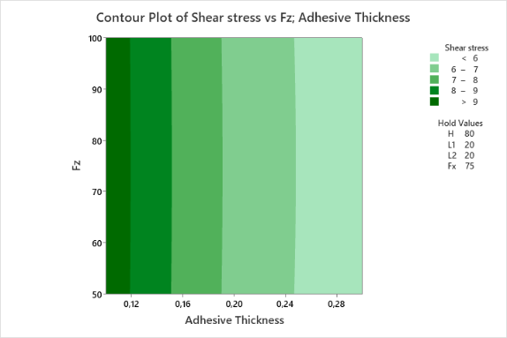  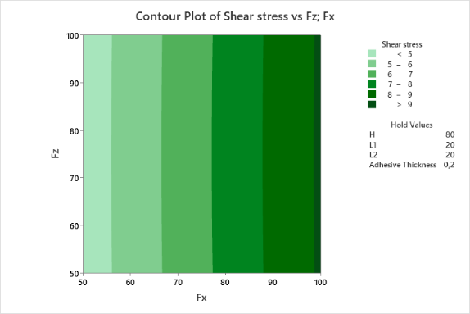 | 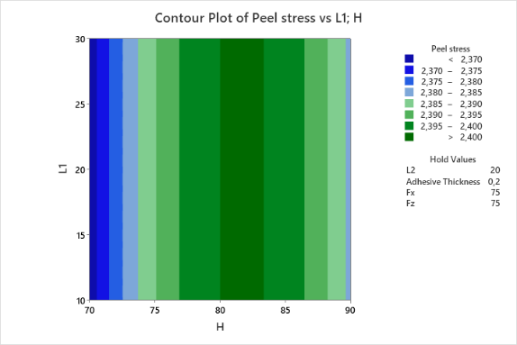  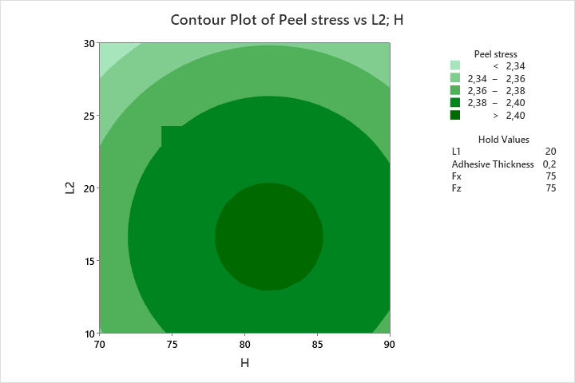  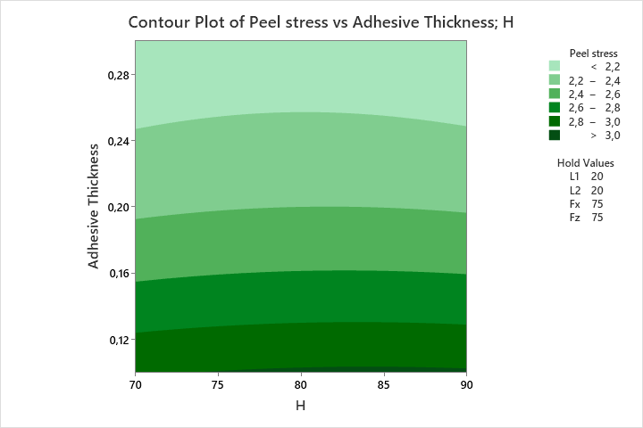  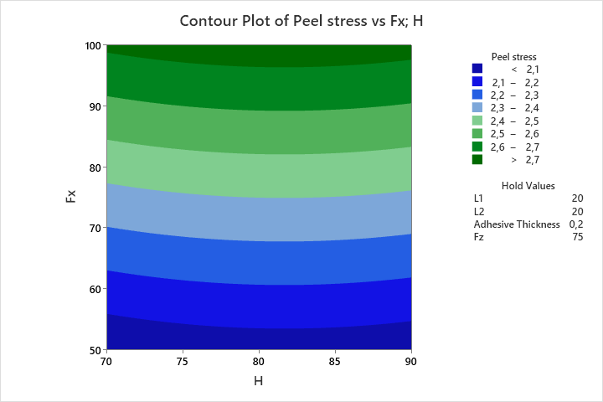  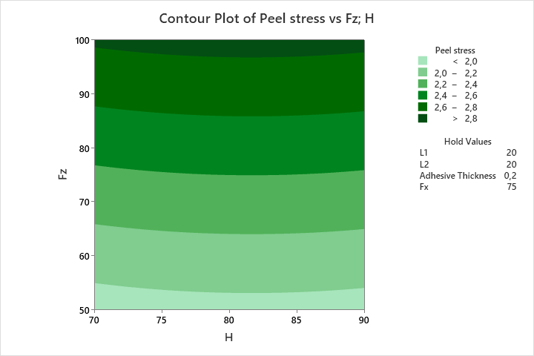  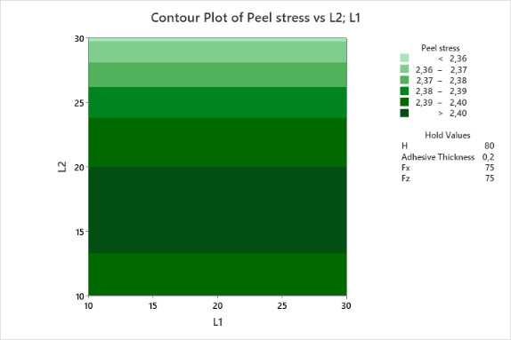  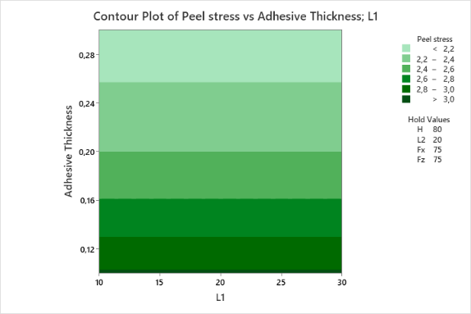  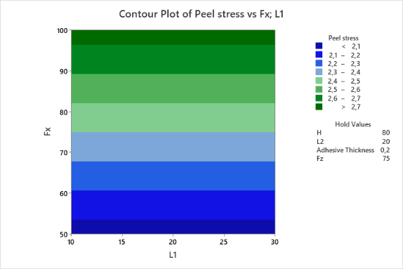  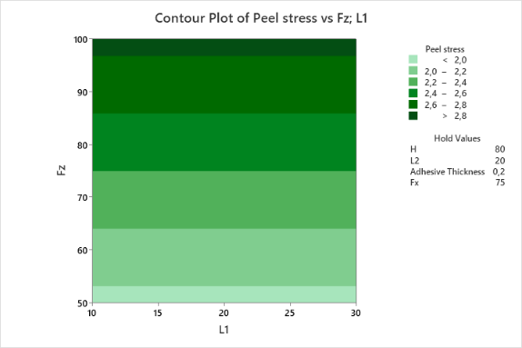  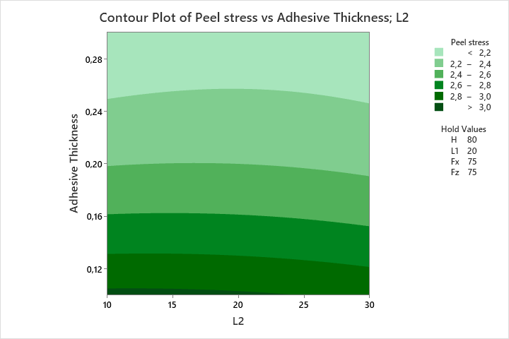  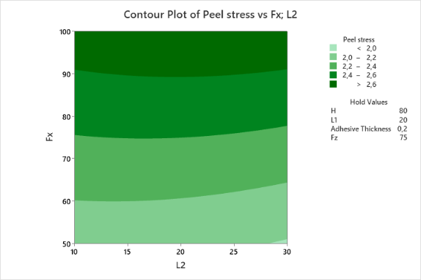  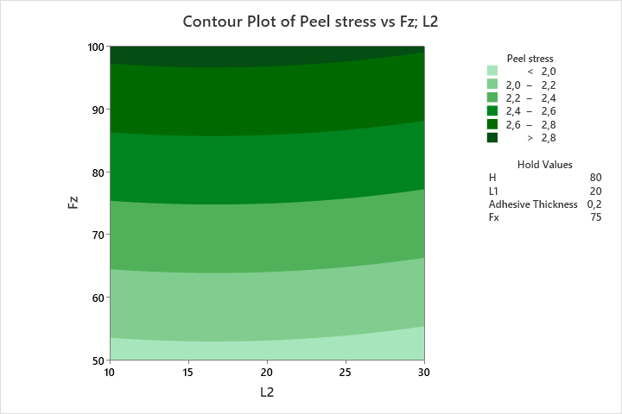  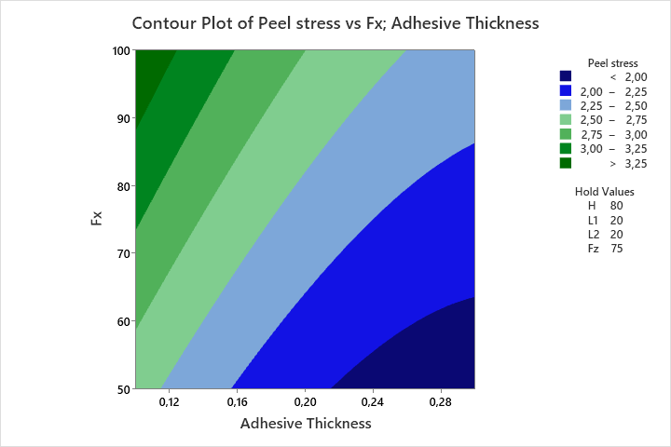  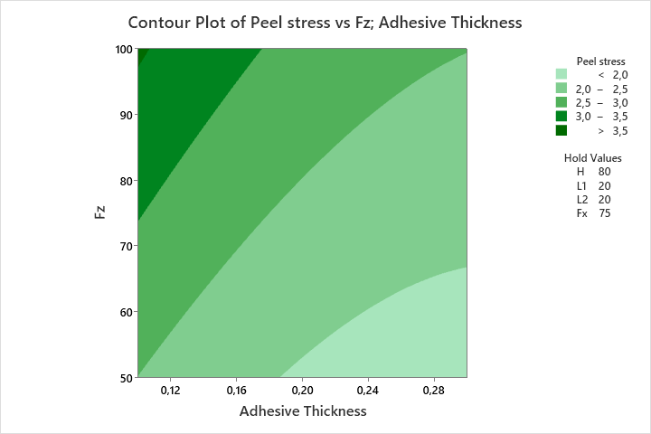  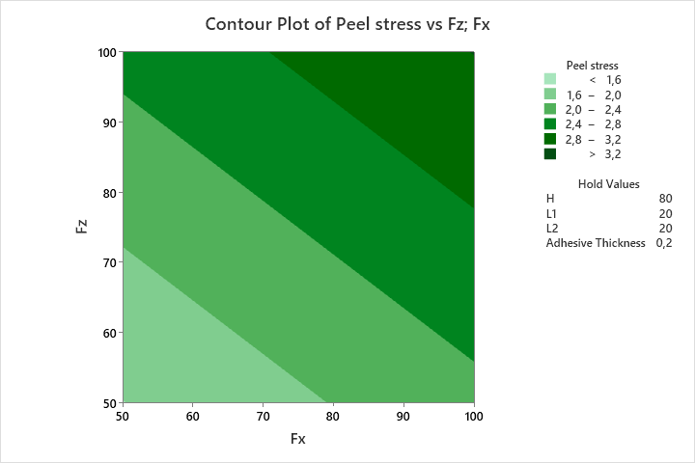
(a) | (b)
Supplementary Figure 1. Contour Plots of (a) Shear and (b) Peel stress

