
INCIDENCE OF MANDIBULAR AND MAXILLARY IMPACTED CANINES TRANSMIGRATION:A RETROSPECTIVE STUDY

ALT VE ÜST ÇENEDEKİ GÖMÜLÜ KANİNLERİN TRANSMİGRASYON İNSİDANSI:RETROSPEKTİF BİR ÇALIŞMA

Araştırma/ Research Article

Dr. Öğr. Üyesi Dilek MENZİLETOĞLU* Prof Dr Bozkurt Kubilay IŞIK*
Dr. Öğr. Üyesi Alparslan ESEN*

Makale Kodu/Article code: 3123
Makale Gönderilme tarihi: 09.11.2016
Kabul Tarihi: 06.03.2017

ABSTRACT

Aim: We attempted to determine the incidence of transmigrant maxillary and mandibular canine teeth, assess pathological changes and treatment choices.
Material and Methods: We planned a retrospective study based on panoramic radiographs and clinical re- cords. Transmigrate canines (TCs) were scanned in the panoramic radiographs. When a TC was determined, age and sex, presence of primary canines, radiog- raphic data from the adjacent teeth and treatment choice (extraction, orthodontic treatment or periodical follow-up) were taken from the patient’s records.
Results: We found 8 TCs (4 in maxilla, 4 in mandible) in 8 patients (4 males, 4 females). The rate of transmigration was 0.08%. Three of TCs were in the right and 5 were in the left side. None of the TCs showed pathological signs such as expansion of the dental follicle around the crown, cysts, or root resorption of adjacent teeth.
Conclusion: TCs are seen both in upper and lower jaws. Early detection of them can improve the prognosis and treatment outcomes. It also helps preventing the complications that may occur later on time.
Keywords: Canine tooth, transmigration

INTRODUCTION

Tooth impaction is an endemic dental problem¹⁻⁴. If a tooth is unerupted more than twelve months after the normal age for eruption has been reached; it is called as “impacted” ⁵. The incidence of impacted teeth has been reported between 6.9% and 76.6% ¹⁻⁶. The most frequently impacted teeth are third molars,
* Necmettin Erbakan Üniversitesi, Diş Hekimliği Fakültesi, Ağız Diş ve Çene Cerrahisi, Konya

ÖZ

Amaç: Transmigrant maksiller ve mandibular kaninlerin insidansını belirlemek, patolojik değişiklikleri ve tedavi seçeneklerini değerlendirmektir.
Gereç ve Yöntem: Panoramik radyograflara ve klinik kayıtlara dayanan retrospektif bir çalışma planladık. Transmigrant kaninler (TK), panoramik radyografta tarandı. TK saptandığında, yaş, cinsiyet, süt kaninlerin varlığı, komşu dişin radyografi ve tedavi seçeneği (çekim, ortodontik tedavi veya periyodik takip) hastaların kayıtlarından alındı.
Bulgular: Sekiz hastada 8 TK (4 maksilla, 4 mandi- bula) bulundu. Transmigrasyon oranı %0.08’di. TK’lerin 3’ü sağ tarafta ve 5’i sol taraftaydı. Hiçbirinde kuronun etrafındaki dental folikülde genişleme veya komşu diş kökünde rezorpsiyon görülmedi.
Sonuç: TK’ler hem alt çenede hem de üst çenede görülebilir. Erken teşhis prognozu ve tedavi sonuçlarını iyileştirebilir. Zamanla oluşabilecek olan komplikasyon- ları önlemeye de yardımcı olur.
Anahtar Kelimeler: Kanin diş, transmigrasyon

upper canines, upper central incisors and upper premolars, respectively⁷⁻⁹. Although many impacted teeth are asymptomatic, they can cause movement or external root resorption of the adjacent teeth, cystic lesions, and especially in partial eruption cases, infection, pain and trismus¹⁰.
Migration of teeth which are impacted in the bone is an unusual situation and its mechanism is still unknown ^{11,12}. The canine’s migration in the bone initiates in early mixed dentition and it frequently continues until apexification is occurred¹³. Trans- migration is an exaggerated form of migration and it is a preeruptive movement of tooth across the midline^{11,14-17}. In 1964, Ando et al.¹⁸ first used the term of “transmigrant” for a mandibular impacted canine. Later, Aydın and Yılmaz in 2003 first reported transmigration of impacted maxillary canines¹⁶.
TC’s may cause pressure resorption of adjacent teeth’s roots, they may be displaced to remote areas such as coronoid process or mandibular condyle ¹⁹ or lead to neuralgic symptoms Early diagnosis of these teeth is important for both orthodontic and surgical concerns²⁰.
The aim of our study was to evaluate the incidence of transmigrant canine teeth, assess pathological changes and treatment choices.

MATERIAL AND METHODS

We planned a retrospective study based on clinical records and panoramic radiographs were taken on patients who presented to Oral and Maxillofacial Surgery Department at Necmettin Erbakan University Faculty of Dentistry between September 2014 and March 2016. Transmigrant canines (TCs) were scanned in the panoramic radiographs of patients over the age of 14. We accepted the migration of a canine through midline in mandible and across the mid-palatal suture in maxilla, as transmigration (Figure 1, 2)¹³. When a TC was determined, following clinical and radiological data were taken from patient’s record:
1. Age and sex
2. Presence of primary canines
3. Radiographic data from the adjacent teeth (occurrence of root resorption)
4. Treatment (extraction, orthodontic treatment or periodical follow-up

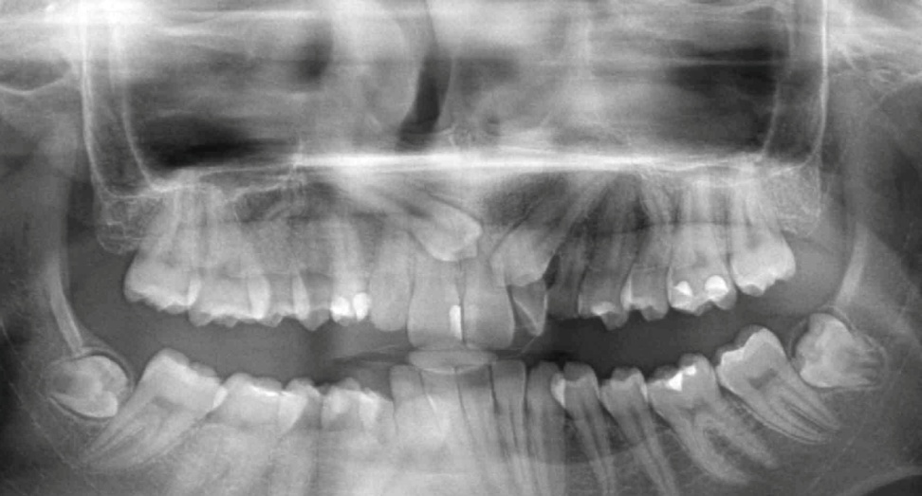
Figure1. Panoramic image showing transmigrant maxillary canine
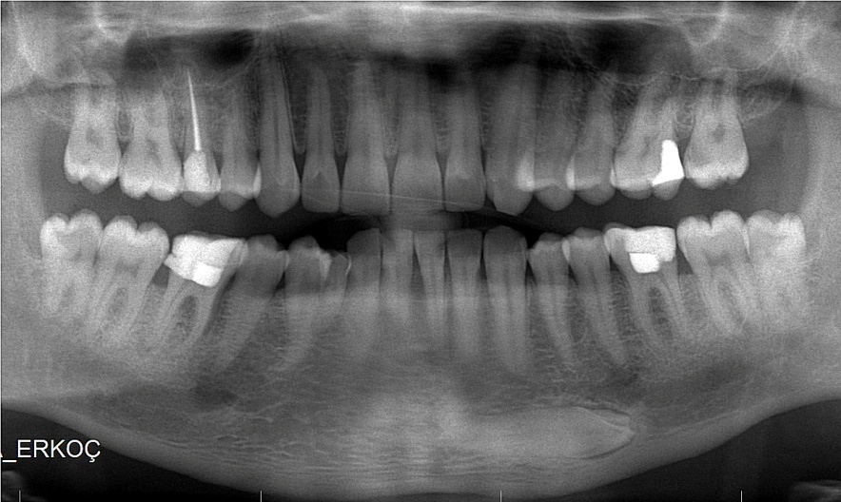
Figure 2. Excessively transmigrated mandibular canine

RESULTS

We scanned a total of 10,150 patient records who were all older than age 14. The patients aged between 18 to 88 years (mean age 40.63, SD 25.07). We found 8 TCs (4 in maxilla, 4 in mandible) in 8 patients (4 males, 4 females). The rate of transmigra- tion was 0.08% (Table 1). Three of TCs were in the right and 5 were in the left. Two patients had both transmigrant upper canine and impacted upper canine. Four patients had unexfoliated primary canines (2 in maxilla, 2 in mandible). None of the TCs had pathological signs such as expansion of the dental follicle around the crown, cysts, or root resorption of adjacent teeth. All TCs were left in place. None of them was orthodontically managed or surgically operated (Table 2).

Table 1. Incidence, age, and sex ratio for transmigrant canines

 | Cases | Incidence | Female | Male | Gender ratio | Mean age  (SD) | Age range
TCs | 8 | 0,08% | 4 | 4 | 1:1 | 40.63  (25.07) | 18-88

Table 2. Clinical and radiographic features of transmigrant canines

Patient number | Age | Sex | Max/Mand | Uni/Bi | Side | Primary teeth | Treatment protocol | Associate pathology
1 | 23 | F | Max | Uni | R | CR | observation | None
2 | 38 | M | Max | Uni | R | CR | observation | None
3 | 33 | M | Mand | Uni | L | CR | observation | None
4 | 29 | F | Mand | Uni | L | CE | observation | None
5 | 88 | M | Max | Uni | L | CE | observation | None
6 | 23 | M | Mand | Uni | L | CE | observation | None
7 | 73 | F | Mand | Uni | R | CE | observation | None
8 | 18 | M | Mand | Uni | L | CR | observation | None
F, female; M, male; Maxilla, Max; Mand, Mand; Uni/Bi, unilateral/bilateral L, left; R, right; CR, retained primary canine; CE, exfoliated primary canine

DISCUSSION

Impacted tooth is a term used for teeth that have not been placed in dental arch because of various obstacles or during normal erupting without any barrier.¹⁷ Insufficient dental arch length, super- numerary teeth, premature loss or retention of primary teeth, trauma, wider crowns, genetic factors, tumors, cysts may be the reasons of impac- tion^{11,14,15,18,21,22}. The etiology of transmigration is unknown; however, abnormal displacement of the tooth bud or deviation during development is the most commonly accepted explanation.²³
Although unerupted maxillary canine is seen almost 20 times more frequent than mandibular canines, it is interesting that TCs are more common in the mandible ³.
That difficulty of maxillary canine transmig- ration could be explained in several ways: Firstly, midpalatal suture can act as a barrier and prevent transmigration^{2,19,24}. Secondly, maxillary incisors radices are longer than mandibular incisor roots and the short distance between the base of the nose and apices of the incisors , which makes the transmigra- tion more difficult^{3,18}. Finally, it has been suggested that the most important factor in maxillary canine transmigration is their positions and angulations¹³.
Torres- Lagares et al.⁵ reported that TCs can be detected at any age between 8 and 62 years. Büyükkurt et al.²⁵ found that TCs are usually unilateral and symptomless, left side being more common. It has been stated that there is a predilection for women⁵, however, others have reported that both gender have equal incidence for transmigrant maxillary canines^{21, 26}. In our study, 8 patients had unilateral TCs. Five of them were at the left side, 3 were at the right. Transmigration rates were the same for men and women (4 men and 4 women).
TCs are generally found to be fully impacted. Mazinis et al.²⁷ reported six mandibular TCs, which all of them were fully impacted, and no maxillary TCs in 3586 patients. Aydın et al.²¹ reported 8 mandibular and 6 maxillary TCs in 4500 patients and except for maxillary one, the rest of the TCs were fully impacted. Similarly, Aras et al.²⁶ found 12 maxillary TCs in 6000 patients and they were all fully impacted as well. In our study, all of the TCs were fully impacted like the aforementioned reports.
Transmigration of canines is more common in mandible. In a study conducted by Kamiloglu et al.²⁸, prevalence of mandibular transmigration was found 0.44%. Shah et al.⁶ scanned 7886 patients and found the transmigration rates as 0.1% for mandibular canines. Aktan et al.²⁹ studied in a Turkish population and their results indicated 0.34% mandibular and 0.14% maxillary TCs. In our study, we found the total transmigration rate as 0.08%. The prevalence was the same for the maxilla and the mandible, that is, 0.04% for each jaw.
If the permanent canine is not in its accurate position, it cannot resorb the primary tooth’s root and retention is more likely. Some clinicians suggested extraction of the primary canines to stimulate normal development of the underlying permanent tooth¹³. However, not all researchers agree with this²⁶ and we also think that presence of a primary tooth might not be an etiological factor in transmigration. Indeed, in our study, five primary canines were already exfoliated or have been extracted in patients who had TCs.
Different treatment options have been sugges- ted for management of TCs. These are observation, surgical extraction, transplantation, bringing to the original position of the unerupted canine by surgical and orthodontic treatment^{18,27,28,30}.
Diaz-Sanchez et al.³¹ made a review through the literature between 1951 and 2015, and they found that the most preferred treatment choice was surgical extraction. They also reported that periodic clinical and radiographical examination should be done in cases which do not require extracting.
If TCs lead to infection, cyst, tumors, neuralgic symptoms, periodontal damage in adjacent teeth or root resorption and transplantation or orthodontic intervention is not possible, then extraction should be considered³².
Kumar et al. ³³ reported that 1 of 5 transmig- rant canines was performed orthodontic treatment and the others would be followed periodically .
Transplantation of TCs has been rarely accep- ted. Orthodontic assisted eruption is nearly impossible if the tooth is just below the roots of the lower anterior teeth and horizontally aligned. Thus, if they are asymptomatic, they may be left in place with routine radiographic evaluation³⁴.
Umashree et a.l³⁵ reported that 3 of 4 trans- migrant canines would be followed periodically and only one TC was extracted. Similarly, Ün et al.³⁶ did not make any intervention for 5 mandibular TCs.
According to our patients’ records, all TC’s were asymtomatic. None of the patients had any complaint which could be attributable to TCs and there is no pathological changes associated with TC’s. All TCs were left without any intervention.

CONCLUSION

Transmigration of the canine teeth is seen both in upper and lower jaws. Although the prevalence of TCs are not high, if permanent canines are not seen in the mouth, we recommend taking a panoramic radiograph. Early detection of them can improve the prognosis and treatment outcomes. It also helps pre venting the complications that may occur later on time.

Dilek Menziletoğlu, ORCID ID: 0000-0002-2539-0688
Bozkurt Kubilay Işık, ORCID ID: 0000-0001-6500-6858
Alparslan Esen, ORCID ID: 0000-0001-7419-3210

REFERENCES

1. Chu FC, Li TK, Lui VK, Newsome PR, Chow RL, Cheung LK. Prevalence of impacted teeth and associated pathologies-a radiographic study of the Hong Kong Chinese population. Hong Kong Med J 2003;9:158-63.
2. Hattab FN, Rawashdeh MA, Fahmy MS. Impaction status of third molars in Jordanian students. Oral Surg Oral Med Oral Pathol Oral Radiol Endod 1995;79:24.
3. Peltola JS. A panoramatomographic study of the teeth and jaws of Finnish university students. Community Dent Oral Epidemiol 1993;21:36-9.
4. Yamaoka M, Furusawa K, Yamamoto M. Influence of adjacent teeth on impacted third molars in the upper and lower jaws. Aust Dent J 1995;40:233-5.
5. Torres-Lagares D, Flores-Ruiz R, Infante-Cossio P, Garcia-Calderon M, Gutierrez-Perez JL. Transmigration of impacted lower canine. Case report and review of literature. Med Oral Patol Oral Cir Bucal 2006;11:171-4.
6. Shah RM, Boyd MA, Vakil TF. Studies of permanent tooth anomalies in 7,886 Canadian individuals. I: impacted teeth. Dent J 1978;44:262-4.
7. Murray P, Brown NL. The conservative approach to managing unerupted lower premolars - two case reports. Int J Paediatr Dent 2003;13:198-203.
8. Lee PP. Impacted premolars. Dent Update 2005;32:152-4.
9. Karapanou V. Endodontic management of an impacted premolar. J Clin Pediatr Dent 2005;29:293-8.
10. Bishara SE. Impacted maxillary canines: a review. Am J Orthod Dentofacial Orthop 1992;101:159-71.
11. Mupparapu M. Patterns of intra-osseous transmigration and ectopic eruption of mandibular canines: review of literature and report of nine additional cases. Dentomaxillofac Radiol 2002;31:355-60.
12. Shapira Y, Kuftinec MM. Unusual intraosseous transmigration of a palatally impacted canine. Am J Orthod Dentofacial Orthop 2005;127:360-3.
13. Ryan FS, Batra P, Witherow H, Calvert M. Transmigration of a maxillary canine. A case report. Prim Dent Care 2005;12:70-2.
14. Joshi MR. Transmigrant mandibular canines: a record of 28 cases and a retrospective review of the literature. Angle Orthod 2001;71:12-22.
15. Milano M, Barrett L, 2nd, Marshall E. Extraction of a horizontally impacted mandibular canine through a genioplasty approach: report of a case. J Oral Maxillofac Surg 1996;54:1240-2.
16. Aydin U, Yilmaz HH. Transmigration of impacted canines. Dentomaxillofac Radiol 2003;32:198-200.
17. Ozan F, Yeler H, Yeler D. Mandibular Gömülü Daimi Kanin Dişle İlişkili Süpernümerer Diş Ve Kompaund Odontoma: Vaka Raporu. Atatürk Üniv. Diş Hek. Fak. Derg 2005;15:61-4.
18. Ando S, Aizawa K, Nakashima T, Sanka Y, Shimbo K, Kiyokawa K. Transmigration process of the impacted mandibular cuspid. J Nihon Univ Sch Dent 1964;6:66-71.
19. Okada H, Miyake S, Toyama K, Yamamoto H. Intraosseous tooth migration of impacted mandibular premolar: computed tomography observation of 2 cases of migration into the mandibular neck and the coronoid process. J Oral Maxillofac Surg 2002;60:686-9.
20. Auluck A, Nagpal A, Setty S, Pai KM, Sunny J. Transmigration of impacted mandibular canines– Report of 4 cases. J Can Dent Assoc 2006;72:249–52.
21. Aydin U, Yilmaz HH, Yildirim D. Incidence of canine impaction and transmigration in a patient population. Dentomaxillofac Radiol 2004;33:164-9.
22. Broadway RT. A misplaced mandibular permanent canine. Br Dent J 1987;163:357-8.
23. Auluck A, Mupparapu. Transmigration of impacted and displaced maxillary canines: orientation of canine to the midpalatine suture. Am J Orthod Dentofacial Orthop 2006;129:6-7.
24. Mitchell L. Displacement of a mandibular canine following fracture of the mandible. Br Dent J 1993;174:417-8.
25. Buyukkurt MC, Aras MH, Caglaroglu M, Gungormus M. Transmigrant mandibular canines. J Oral Maxillofac Surg 2007;65:2025-9.
26. Aras MH, Buyukkurt MC, Yolcu U, Ertas U, Dayi E. Transmigrant maxillary canines. Oral Surg Oral Med Oral Pathol Oral Radiol Endod 2008;105:48-52.
27. Mazinis E, Zafeiriadis A, Karathanasis A, Lambrianidis T. Transmigration of impacted canines: prevalence, management and implications on tooth structure and pulp vitality of adjacent teeth. Clin Oral Investig 2012;16:625-32.
28. Kamiloglu B, Kelahmet U. Prevalence of impacted and transmigrated canine teeth in a Cypriote orthodontic population in the Northern Cyprus area. BMC Res Notes 2014;7:346-51.
29. Aktan AM, Kara S, Akgunlu F, Malkoc S. The incidence of canine transmigration and tooth impaction in a Turkish subpopulation. Eur J Orthod 2010;32:575-81.
30. Kumar S, Jayaswal P, Pentapati KC, Valiathan A, Kotak N. Investigation of the transmigrated canine in an orthodontic patient population. J Orthod 2012;39:89-94.
31. Díaz-Sáncheza RM, Castillo-de-Oyagüea R, Serrera-Figalloa MA, Hita-Iglesiasb P, Gutiérrez-Péreza JL, Torres-Lagaresa D. Transmigration of mandibular cuspids: review of publishedreports and description of nine new cases. Br J of Oral and Maxillofac Surg 2016;54:241–7.
32. Ezirganlı Ş, Köşger HH, Kırtay M, Özer K. Alt çenedeki kaninlerin gömülülük ve transmigrasyon insidansı: retrospektif bir çalışma. GÜ Diş Fak Derg 2011;28: 159–67.
33. Kumar S, Urala AS, Kamath AT, Jayaswal P, Valiathan A. Unusual intraosseous transmigration of impacted tooth. Imaging Sci Dent 2012; 42:47-54.
34. Camilleri S, Scerri E. Transmigration of mandibular canines-a review of the literature and a report of five cases. Angle Orthod 2003;73:753-62.
35. Umashree N, Kumar A, Nagaraj T. Transmigration of Mandibular Canines. Case Rep Dent 2013;13:69-71.
36. Ün E, Ezirganlı Ş, Özer K, Kırtay M, Hasdemir D. Alt Çene de Gömülü Transmigre Kaninler: 5 Olgu Nedeniyle. ADO Klinik Bilimler Dergisi 2011; 5: 968-72.

Yazışma Adresi
Dr. Dilek Menziletoglu
Necmettin Erbakan Üniversitesi, Diş Hekimliği Fakültesi, Konya
Tel: 0 332 220 00 25
Fax: 0 332 220 00 45
Email: dmenziletoglu@konya.edu.tr

