COMPARISON OF ULTRASONOGRAPHY AND MAGNETIC RESONANCE IMAGING IN EVALUATING ROTATOR CUFF PATHOLOGIES

Rotator Cuff Patolojilerinin Değerlendirilmesinde Ultrasonografi ve Manyetik Rezonans Görüntülemenin Karşılaştırılması

Mehmet Hamdi ŞAHAN¹, Çiçek BABUNA²

¹Kırıkkale Üniversitesi Tıp Fakültesi, Radyoloji Kliniği, KIRIKKALE, TÜRKİYE
²Okmeydanı Eğitim Araştırma Hastanesi, Radyoloji Kliniği, İSTANBUL, TÜRKİYE

ABSTRACT | ÖZ
Objective: This study was conducted to determine the effectiveness of magnetic resonance imaging in comparison to ultrasonography in the diagnosis of rotator cuff tears.  Material and Methods: Magnetic resonance imaging and ultrasonographic findings of 28 cases who admitted to our clinic with shoulder pain and dysfunction were analyzed retrospectively. Magnetic resonance imaging findings were accepted as gold standard.  Results: From among 15 cases where complete tear was determined by magnetic resonance imaging, 11 cases were confirmed by ultrasonography and in the remaining 4 of them, thinning in the tendons which is a non-specific finding was seen. In 9 cases where there was thinning in the tendons, the classifications in magnetic resonance imaging was made as follows: 5 of them were classified as stage 2 (partial tear) and 4 of them were classified as stage 3 (complete tear). In 4 cases, tear and retraction were determined in supraspinatus tendon in magnetic resonance imaging; however, supraspinatus tendon could not be visualized by ultrasonography. In our study, in rotator cuff tears, the sensitivity and specificity of the shoulder ultrasonography were found as 73% and 93%, respectively.  Conclusion: In the evaluation of rotator cuff, it was found that ultrasonography should be the first imaging method considering its low cost and easy accessiblity. Moreover ultrasonography could display a similar performance with magnetic resonance imaging if it is performed by experienced radiologist. | Amaç: Rotator cuff yırtıklarının tanısında manyetik rezonans görüntüleme ile karşılaştırıldığında, ultrason etkinliğininin belirlenmesi.  Gereç ve Yöntemler: Omuz ağrısı ve disfonksiyonu ile başvuran 28 olgunun manyetik rezonans görüntüleme ve ultrason bulguları retrospektif olarak incelendi. Manyetik rezonans görüntüleme bulguları standart olarak kabul edildi.  Bulgular: Manyetik rezonans görüntülemede komplet yırtık saptanan 15 olgunun 11 tanesi ultrasonografide tespit edilmiş; 4’ünde ise nonspesifik bulgu olan tendonda incelme izlenmiştir. Ultrasonografide tendonda incelme görülen 9 olgunun 5’i manyetik rezonans görüntülemede evre II (parsiyel yırtık), 4’ü de evre III (komplet yırtık) olarak sınıflandırıldı. Manyetik rezonans görüntülemede supraspinatus tendonunda yırtık ve retraksiyon saptanan 4 olguda ultrasonografide supraspinatus tendonu vizualize edilememiştir. Rotator cuff yırtıklarında, bizim çalışmamızda omuz ultrasonografisinin duyarlılığı % 73, özgüllüğü % 91 olarak bulundu.  Sonuç: Rotator cuff değerlendirmesinde, ultrasonografinin hem düşük maliyet, hem de kolay ulaşılabilirlik nedeniyle ilk görüntüleme yöntemi olması gerektiği, deneyimli radyolog tarafından yapıldığında, manyetik rezonans görüntüleme'ye yakın performans sergileyebileceği bulunmuştur.
Keywords: Rotator cuff, shoulder, ultrasonography, tear | Anahtar Kelimeler: Rotator manşet, omuz, ultrasonografi, yırtık

INTRODUCTION
The most common reason for the shoulder pain and dysfunction is rotator cuff tears such that in total it causes 70% of all shoulder pains (1, 2). Therefore, it is important to visualize the integrity of rotator cuff. It is very hard to differentiate rotator cuff tears by physical examination (1). This is why it is needed to validate the clinical diagnosis via radiological methods.
Previously in the determination of rotator cuff, integrity arthrography was considered the only method. However, although arthrography was invasive, the size of tendon tears could not be identified. Nowadays, ultrasound (US) and magnetic resonance imaging (MRI) has decreased the area of usage of arthrography (3). In the diagnosis of the rotator cuff tears, MRI has an important place. However, recently, US has transformed into a popular means of diagnosis in rotator cuff tears since it is cheap and easily applicable (1,3-6). The aim of this study is to evaluate the effectiveness of ultrasound in comparison to MRI in the diagnosis of rotator cuff tears.

MATERIALS AND METHODS
In Ministry of Health Okmeydani Education and Research Hospital, patients with shoulder ultrasonography followed by shoulder MRI were analyzed retrospectively in the 18-month period. We comparatively analyzed the MRI and US findings of 28 cases that admitted to our clinic with shoulder pain and dysfunction. Of the 28 cases, 10 were male and 18 were female. The mean age was 54.4 years (average means 39-63 years). In the ultrasonographic examination, 7.5-10 MHz linear probe was used. Supraspinatus tendon longitudinal and transverse section, biceps tendon longitudinal-transverse section, posterior longitudinal section and subscapular section were taken as 6 standard sections. Both shoulders were comparatively analyzed, and the results from the pathologic side were included in the present study (healthy part was excluded from the evaluation.). As this study is the specialization thesis of the first author, the data given in the study were taken from the this thesis (7).
MRI examination was performed with a 1.5 tesla in axial, coronal and sagittal oblique planes. From among the T1 SE axial images recorded as a localizer the following were taken as sequences: T2 coronal, T1 SE coronal, T1 SE sagittal, T2 FSE sagittal and GE axial. FOV (Field of view) was 16-30, matrix was 128x256, 192x256 and total average imaging exposure time was determined as 30 minutes. Rotator cuff tendons were analyzed in terms of partial, complete tears and tendinopathy.
In MRI, the rotator cuff tears were staged by using Seeger classification (8). Both MRI and US results were compared.
Seeger MRI classification
Type I impingement: Subacromial bursitis might be normal despite the signal increase in the tendon.
Type II impingement: Without retraction in supraspinatus tendon, the pathological increase in signal (tendinitis-tendinosis) in T1-weighted images and in supraspinatus tendon, hyper-intensity in T2-weighted image militate in favor of the partial tear.
Type III impingement: Retract or not, the existence of the complete tear and high signal show complete tear in rotator cuff (4,8).
The subacromial-subdeltoid bursa, glenohumeral joint and biceps tendons were routinely examined. Acromioclavicular degeneration of the joint and humeral head and the shape of acromion were evaluated. All US and MRIs were reviewed by a radiologist experienced in musculoskeletal system (MHS).
Evaluation of the data was performed by the chi-square test with SPSS version 20 software (SPSS, Chicago, IL, U.S.A).

RESULTS
MRI and US findings of 28 patients that admitted to our clinic with shoulder pain and dysfunction were analysed and comparatively examined. In US analysis, trace, contour and echo-structure of rotator cuff tendons were found normal in 6 patients (1st group) from among 28 patients. In 14 patients (2nd group) there was decrease in supraspinatus tendon thickness. In 5 patients (3rd group) supraspinatus tendon, discontinuity and heterogeneity (hypo-hyper echogenic areas) were seen. In two cases (4th group), in supraspinatus tendon, focal hypo- echogenicity whose boundaries were uncertain and minimal fluid was observed (figure, 1a). These were evaluated in favor of the tear in 6 cases (5th group), where the tendon was not observed using ultrasonography. Fluid interposition was seen and was accepted in favor of the tear (figure 2a). In two cases within the 5th group, it was seen that the volume of biceps tendon had decreased and the echo structure was heterogeneous (figure 3a). Besides, in US examination it was monitored that there was fluid in subacromial and subdeltoid areas in 12 patients in the 2nd, 3rd, 4th and 5th groups (figure 4a).

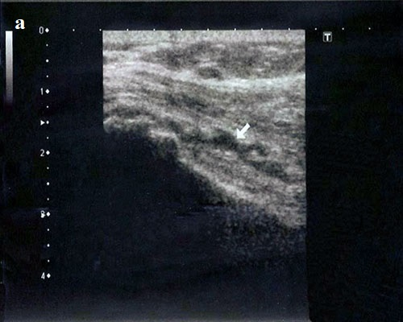 | 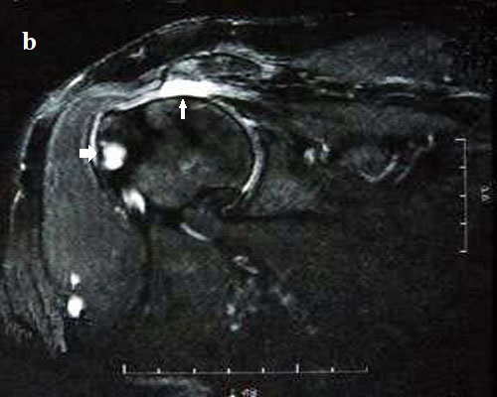
Figure 1: 54-year-old female patient. Pain in both shoulders for 6 months (the pain was more significant in the left shoulder).  Figure 1a: In US, left shoulder image in the longitudinal plane. Discontinuity of supraspinatus tendon, focal hypo echoic areas and anechoic fluid interposition (white arrow), effusion in subacromial-subdeltoid bursa, irregularity in the contour of the bone in tuberculum majus. | Figure 1b: Coronal T2-weighted MRI image of the left shoulder, full thickness tear extending from the articular surface to the bursal one in supraspinatus tendon (thin white arrow), partial retraction, effusion in subacromial-subdeltoid bursa, degenerative changes in acromioclavicular joint, cystic degenerative lesions in humeral major tubercle (thick white arrow).

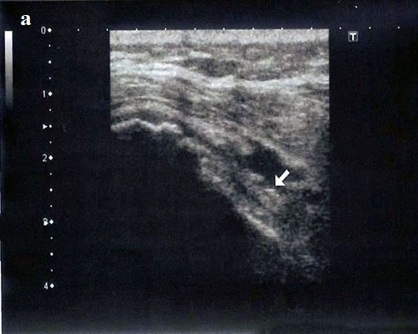 | 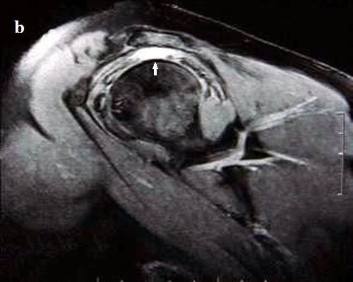
Figure 2: 56-year female patient, pain in the right shoulder for one year.  Figure 2a: In US, focal discontinuity in supraspinatus tendon, full thickness tear and fluid interposition (white arrow). | Figure 2b: In MRI, in T2-weighted sagittal image, total rupture and fluid interposition in supraspinatus tendon (white arrow).

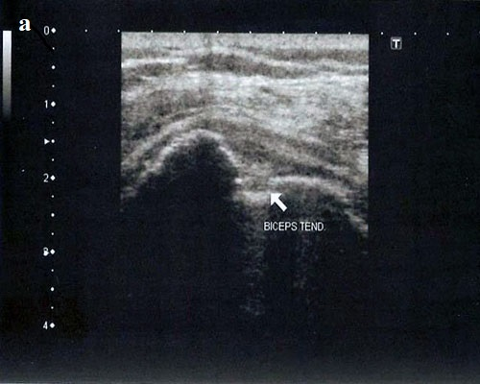 | 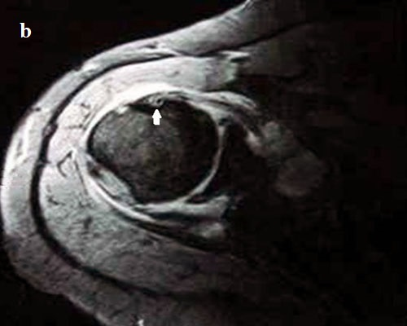
Figure 3: 62-year-old male patient, pain in the left shoulder for one year.  Figure 3a: In US, in the bicipital groove, the tendon volume of biceps has decreased and the echo structure is heterogeneous. | Figure 3b: Thinning in biceps tendon in T2 weighted axial image in MRI, irregularity in intertubercular groove (white arrow).

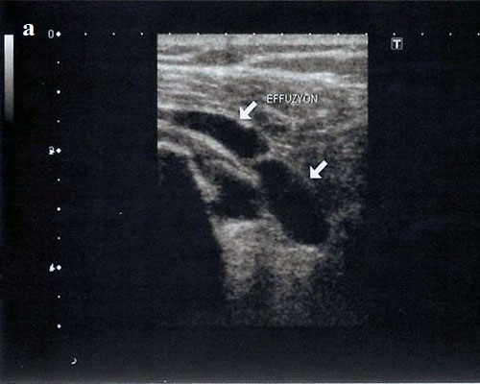 | 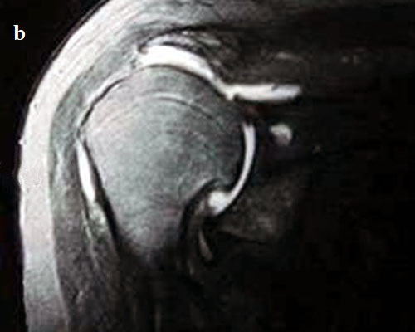

Figure 4: 59-year-old male patient, pain in the right shoulder for two years.  Figure 4a: In US, increased effusion in subacromial-subdeltoid bursa and glenohumeral joint, irregularity in the contour of the bone. | Figure 4b: In MRI, in T2-weighted coronal image, increased effusion in subacromial-subdeltoid bursa, in glenohumeral joint and subscapular recess and degenerative changes in humeral head and acromioclavicular joint.

In MRI evaluation, in three cases (1st group), the morphology of supraspinatus tendon was normal. However, in two cases with T1-weighted image and in 1 case with T1-weighted as well as T2-weighted images, it was observed that the intensity of signals was increased. The MRI findings of these three patients were evaluated as stage 1. (2nd group) In 10 cases, in T1- weighted and T2-weighted images, there was increase in intensity and irregularity and thinning in tendon contour. In addition to this, among these patients there was fluid in subacromial-subdeltoid bursa in 9 patients and in 4 patients there was fluid in glenohumeral joint (figure 4b). These findings were accepted as stage 2, partial tear. (3rd group) In 15 cases, in rotator cuff tendons, it was observed that there was signal intensity in both T1-weighted and T2-weighted images. Besides, the integrity of tendons disappeared from the articular surface to the bursal surface (figure 1b). (4th group) Out of 15 cases indicated above, fluid was determined in subacromial-subdeltoid bursa in 15 cases, in glenohumeral joint in 8 cases and around biceps tendon in 1 case. (5th group) In 4 of these cases, tear and retraction were observed in rotator cuff (figure 2b). In 2 cases in this group, thinning in biceps tendon and irregularity in intertubercular groove were monitored (figure 3b). The MRI findings of the patients in the 3rd, 4th and 5th groups were evaluated in favor of stage 3 tear. No fluid was determined in 3 cases in stage 1. Among 25 patients in stage 2 and 3, there was significant fluid in 19 patients and minimal fluid in 4 patients.
Comparison of MRI and US Findings
Among 15 cases in which complete tear was determined in MRI, 11 cases were diagnosed by US and in 4 cases, thinning in the tendon which was a non- specific finding was observed.
Among 9 cases in which tendon thinning was seen, 5 cases were classified as stage 2 (partial tear) and 4 cases were classified as stage 3 (complete tear).
In 4 cases in which tear and retraction were determined in supraspinatus tendon in MRI, supraspinatus tendon could not be visualized in US.
Among 28 cases in 19 cases (67%), fluid was determined in subacromial-subdeltoid bursa.
In 15 cases (100%) from 15 cases in which complete rupture was determined and in 4 cases (40%) from 10 cases in which partial rupture was determined there was fluid in subacromial-subdeltoid bursa.
In 12 cases among 19 cases in which fluid was determined in subacromial-subdeltoid bursa in MRI, fluid was seen with US.
In our study, in rotator cuff tears, the sensitivity and specificity of shoulder ultrasound was found as 73% and 91% respectively.

DISCUSSION
The most common reason for shoulder pain and dysfunction is rotator cuff lesions which take place in between humeral head and coracoacromial arc elements and rotator cuff tears which emerge due to the squeeze of bursa (1, 8). The findings of clinical examination are mostly insufficient to reveal the reasons for shoulder pain. In the treatment of patient with shoulder pain, direct radiography, US and MRI are methods supportive to the clinical examination (1, 8).
Brandt et al. have indicated that in rotator cuff lesions the sensitivity and specificity of US were 68% and 90% respectively (9). This ratio of sensitivity and specificity can be obtained also through the radiologists who have middle-range experience. In many studies, it has been stated that in rotator cuff tears US method could sufficiently be applied in terms of sensitivity and specificity. The effective evaluation of rotator cuff US started in 1980 (10). In the first applications, the failure was explained by lack of experience and device specifications. In the last years, developments in transducer technologies and increase in experience caused higher success rates in diagnosis (10). According to the American College of Radiology, the sensitivity and specificity of the tear which was diagnosed by radiologists were determined as follows respectively: complete/partial tear; sensitivity: 93/94%, specificity 99/97%. The American College of Radiology has indicated that US was a better option in comparison to MRI in the diagnosis of rotator cuff pathologies by considering abovementioned sensitivity and specificity ratios. In this context, US was regarded as the first application in the determination of the treatment and surgical approach (11).
While the diagnosis of complete tears using US and MRI is easier, the diagnosis of ruptures is harder since there is focal discontinuity and supraspinatus tendon cannot be monitored via US. In MRI, the discontinuity is seen in the form of a gap filled with focal fluid. In the diagnosis of partial and complete rotator cuff tears, it has been found that MRI was superior to US (1,9,10,12). However, no statistically significant difference has been found between sensitivity and specificity. While the accuracy of US and MRI in the determination of fluids in subacromial-subdeltoid bursa and biceps tendon sheaths is approximately equal, in the determination of the fluid in glenohumeral joint MRI is superior to US (4,9,12).
The problem in shoulder US is that differentiation between Type 1 and Type 2 lesions cannot be completely made. When the type of conservative treatment and medical prognosis are considered, sufficient information cannot be gathered with this diagnosis method. This is probably due to difficulty of evaluation and interpretation of the minor structural changes like inhomogeneous, hypoechoic/hyperechoic area, central echogenic band and the emergence of thickness or thinness in rotator cuff (13). However, surgical indications emerge in Type 3 lesions (14). As a result, US does not provide enough information to understand whether the surgical treatment is needed or not.
In the study, we did not find any tear in US for 3 cases in which we previously suspected presence of partial tears considering MRI results. If there is discontinuity on coronal oblique T2-weighted images and fluid intensity in this area, the diagnosis is defined as complete rotator cuff tear. It is important to distinguish complete and partial tears because their treatment procedures are different. In our study, we determined the complete tears in 15 cases and partial tear in 10 cases. According to Farley et al. the disruption of tendon continuity is a finding that has specificity at a ratio of 96%. The presence of fluid in subacromial bursa is a finding that has sensitivity at a ratio of 93% (15). The presence of fluid in subacromial bursa is not enough by itself in order to diagnose a tear. This finding can be meaningful if it is evaluated together with MRI findings (15).
Among the patients who admitted to our clinic with shoulder pain and dysfunction, the most important pathology has been rotator cuff tears (16). The tear is most frequently seen in supraspinatus tendon (17, 18). Partial tears are most common than complete ones and the tears mostly take place on articular surface. Infraspinatus, subscapularis and teres minor tears are rarer. Tendinopathy is more common than tear and it can be the precursor of the tear (12). Subacromial-subdeltoid bursa or fluid in glenohumeral joint can be seen alongside the tear. If there is fluid in both, this can be considered as a strong sign that points to the presence of the tear (12).
In rotator cuff tears, also the degeneration of acromioclavicular joint and humeral head can be seen (19). Most commonly, Type 1 is seen among the acromion shapes (18). It has been reported that Type 3 acromion creates the predisposition in rotator cuff tears (20, 21). In our study, type of acromion was also noted for each patient. We aimed to analyse whether the tear rate was high or not in the cases with Type 3 acromion. Unfortunately, Type 3 acromion was present only in two cases, and we could not conclude on this subject.
In the diagnosis of the complete tear and tendinosis via MRI, the most important advantage of the method is the high accuracy rate and low dependency on the applicator. However, if we consider the cost as an important factor, in complete tears, the rate of true diagnosis is high also via US. Both methods require developed technical equipment, and it is very hard to diagnose minor complete tears (22). Surgical treatment option comes along in complete tears (14).
There were limitations of the study. Firstly, the study population was relatively small. Secondly, ultrasound is operator dependent and evaluated by a radiologist. Thirdly, although MRI findings were compared, arthroscopic and surgical outcomes were not available. Nevertheless, we think that this study is meaningful. Additional comprehensive studies are needed with MRI, arthroscopy and surgical outcomes, in a comparison with US.
As a result, while evaluating rotator cuff, US should be preferred as the initial diagnosis method since it is cheap, repeatable, and suitable for comparison and dynamic inspection. In the patients with full thickness tear if the findings that will influence surgical treatment plan cannot be obtained, MRI can be additionally performed. If there is a response to the conservative treatment in the cases where tendinosis has been determined via ultrasonography, there is no need for MRI. In cases where there is no response to the conservative treatment, MRI can be applied in order to examine the presence of the partial tear or minor complete tear. Nonetheless, the factors like applicator and long learning time of the method restrict the usage of US (5, 6, 23). Also, it should not be forgotten that the sensitivity of US decreases in the cases with motion restrictions and bone disruptions at serious levels and obese patients.
Conflict of Interest: None
REFERENCES
- Naqvi GA, Jadaan M, Harrington P. Accuracy of ultrasonography and magnetic resonance imaging for detection of full thickness rotator cuff tears. Int J Shoulder Surg. 2009;3:94-7.
- Mitchell C, Adebajo A, Hay E, Carr A. Shoulder pain: diagnosis and management in primary care. BMJ. 2005;331:1124-8.
- Milosavljevic J, Elvin A, Rahme H. Ultrasonography of the rotator cuff: a comparison with arthroscopy in one hundred and ninety consecutive cases. Acta Radiol. 2005;46:858-65.
- Moosmayer S, Smith HJ, Tariq R, Larmo A. Prevelance and characteristics of asymptomatic tears of the rotator cuff: an ultrasonographic and clinical study. J Bone Joint Surg Br. 2009;91:196-200.
- Seibold CJ, Mallisee TA, Erickson SJ, Boynton MD, Raasch WG, Timins ME. Rotator cuff: evaluation with US and MR imaging. Radiographics. 1999;19:685-705.
- Oh CH, Schweitzer ME, Spettell CM. Internal derangements of the shoulder: decision tree and cost-effectiveness analysis of conventional arthrography, conventional MRI, and MR arthrography. Skeletal Radiol. 1999;28:670-8.
- Şahan MH. Rotator Cuff Patolojilerinin Değerlendirilmesinde Ultrasonografi ve Manyetik Rezonans Görüntülemenin Karşılaştırılması. Sağlık bakanlığı Okmeydanı Eğitim ve Araştırma Hastanesi Radyoloji kliniği. Uzmanlık Tezi. İstanbul: 2006.
- Seeger LL, Gold RH, Bassett LW, Ellman H. Shoulder impingement syndrome: MR findings in 53 shoulders. AJR Am J Roentgenol. 1988;150:343-7.
- Rutten MJ, Maresch BJ, Jager GJ, Blickman JG, Van Holsbeeck MT. Ultrasound of the rotator cuff with MRI and anatomic correlation. Eur J Radiol. 2007;62:427-36.
- Brandt TD, Cardone BW, Grant TH, Post M, Weiss CA. Rotator cuff sonography: a reassessment. Radiology. 1989;173:323-7.
- Hinsley H, Nicholls A, Daines M, Wallace G, Arden N, Carr A. Classification of rotator cuff tendinopathy using high definition ultrasound. Muscles Ligaments Tendons J. 2014;4(3):391-7.
- Edward IB, Peter HA, Carol BB, Philip WR. Ultrasound; a practical approach to clinical problems. 2th ed. New York. Thieme Medical Publishers. 2008: 486.
- Weinreb JH, Sheth C, Apostolakos J, et al. Tendon structure, disease, and imaging. Muscles Ligaments Tendons J. 2014;4(1):66-73.
- Kang CH, Kim SS, Kim JH, et al. Supraspinatus tendon tears: comparison of 3D US and MR arthrography with surgical correlation. Skeletal Radiol. 2009;38(11):1063-9.
- Neer CS. II. Anterior acromioplasty for chronic impingement syndrome of shoulder. J. Bone Joint Surg. 1972;54:41-50.
- Farley TE, Neumann CH, Steinbach LS, Jahnke AJ, Petersen SS. Full thickness tears of the rotator cuff of shoulder diagnosis with MR imaging. AJR. 1992;158:347-51.
- Westhoff B, Wild A, Werner A, Schneider T, Kahl V, Krauspe R. The value of ultrasound after shoulder arthroplasty. Skeletal Radiol. 2002;31:695-701.
- Al-Shawi A, Badge R, Bunker T. The detection of full thickness tears using ultrasound. J Bone Joint Surg Br. 2008;90:889-92.
- Kaneko K, DeMouy EH, Brunet ME. MR Evaluation of rotator cuff impingment: correlation with confirmed full-thickness rotator cuff tears. Journal of Computer Assisted Tomography. 1994;18:225-8.
- Hsu HC, Luo ZP, Stone JJ, Huang TH, An KN. Correlation between rotator cuff tear and glenohumeral degeneration. Acta Orthop Scand. 2000;74:89-94.
- Esenyel CZ, Demirhan M, Duygulu F. Arthroscopic evaluation of the mobility of the meso-acromion. Acta Orthop Traumatol Turc. 2005;39:391-5.
- Hirano M, Ide J, Takagi K. Acromial shapes and extension of rotator cuff tears: magnetic resonance imaging evaluation. J Shoulder Elbow Surg. 2002;11:576-8.
- Vlychou M, Dailiana Z, Fotiadou A, Papanagiotou M, Fezoulidis IV, Malizos K. Symptomatic partial rotator cuff tears: Diagnostic performance of ultrasound and magnetic resonance imaging with surgical correlation. Acta Radiol. 2009;50(1):101-5.
- Chang CY, Wang SF, Chiou HJ, Ma HL, Sun YC, Wu HD. Comparison of shoulder ultrasound and MR imaging in diagnosing full-thickness rotator cuff tears. Clin Imaging. 2002;26(1):50-4.

