PLAN TYPOLOGY OF TRADITIONAL AMASRA HOUSES



Özgenaz DAĞ, Asst. Prof. Dr. Alev ERARSLAN
Institute of Science Master of Architecture
Istanbul Aydin University, Florya /Istanbul /Turkey
ozgenazdag@gmail.com, aleverarslan@gmail.com

Abstract: In this research, the house culture of the province Amasra in the city of Bartin located in the Turkey's West black sea region was studied. The traditional house examples of 19th century in the centrum of Amasra was examined and specifically the plan types, construction system, and construction materials were disclosed. This analysis was conducted to remind the hous eculture that is about to disappear, to provide not to be forgotten in future and to help there storation to be done. In this research, detail edreviews were made in the traditional houses in Amasra district, the plan types of the houses were removed, the house users were interviewed and the conclusions were drawn about the future changes in the architecture of the region and the future of the houses. As a result, in this research conducted in the name of traditional house architecture of Amasra district, it has been found that the district has an important place in residential architecture with its plan scheme, construction technique and material property and documentation work has been done in order to transfer it to future generations.

Keywords: Amasra, traditional architecture, plans types.

Geleneksel Amasra Evleri Plan Tipolojisi

Özet: Bu çalışmada Türkiye’nin Batı Karadeniz Bölgesinde yer alan Bartın ili Amasra ilçesindeki geleneksel konut kültürü ele alınmıştır. Amasra’nın ilçe merkezinde yer alan 19. yüzyıl geleneksel konut örnekleri incelenmiş, öncelikle plan tipleri olmak üzere yapım sistemi ve kullanılan malzemeler ortaya çıkarılmıştır. Bu analiz yok olmak üzere olan bölgedeki konut kültürünü yeniden hatırlatmak, gelecek dönemlerde unutulmamasını sağlamak ve yapılacak olan restorasyon çalışmalarına yardım sağlamak adına yapılmıştır. Bu çalışmada Amasra ilçesindeki geleneksel evlerde detaylı incelemeler yapılmış, evlerin plan tipleri çıkarılmış, ev kullanıcılarıyla görüşülerek bölge mimarisinin geçmişten günümüze ne gibi değişimlere maruz kaldığı ve ev sahiplerinin düşünceleri doğrultusunda gelecekte oluşabilecek tablo hakkında çıkarımlarda bulunulmuştur. Sonuç olarak, Amasra ilçesi geleneksel ev mimarisi adına yapılan bu araştırmada bölge konut mimarlığı içerisinde plan şeması, yapım tekniği ve malzeme özelliği ile önemli bir yere sahip olduğu görülmüş ve gelecekteki kuşaklara aktarılması açısından belgeleme çalışması yapılmıştır.

Anahtar kelimeler: Amasra, geleneksel mimari, plan tipleri.

1. INTRODUCTION
The house is the most important living area of ​​settled life. Also it is the area where relations between human and architecture is felt intensely . the house is identifed as a producted structure of its region's tradition depending on historical, geographical, economic factors, environmental, physical conditions such as especially climate and topography as well as social, cultural and economic factors are effective on the formation of the dwelling. Various climate zones and local topography is affected directly on the architecture of house.

Topography is one of the main factors determining the settlement model. Topographical features as the most important example of the relationship between nature and human beings effects on the distribution, population and economic activities of the settlements indirectly or directly. Another natural environmental element which affects the residential settlements is the climate. Solar heat, wind and air movements, temperature and humidity are considerable affecting on building design. Rainfall affects structure design and used materials.Solar and wind influences are important for direction of houses.

Building design reflects cultural style. The house is also an element of the created by socio-cultural environment, the values, the lifestyles and the imagery that human possess are to be reflected to own buildings. While the cultural factors include worldview, cultural values, family, relatives, community relations and lifestyle, the social factors are the demographic structure, the socio-economic structure of the family, the family structure and the lifestyle [1]. Lifestyle has different characteristics in every culture. As each community has its own habits and traditions, that expectation also determines the architecture. The status of the family in society, the habits of daily life, the privacy of family life (privacy) also affect the design of housing. Religious belief is one of the another important social symbols that are effect on the dwelling. Religion studied within socio-cultural factors affecting housing designs is a fact affecting and regulating human relations. Rapoport had mentioned that religion is a factor that affects people and the environment [2]. Gender discrimination is also based on religious influences. Rapoport has introduced the concept of “cultural specificity” and “cultural values ​​and choices” in housing design [3]. According to Rapoport, buildings, especially houses, are not only physical products, but also cultural products.

In this study, we will try to read the West Black Sea Region settlement architecture Amasra example which is one of the regions where geographical features, climate and material factors as well as cultural parameters have the greatest influence on residential design.

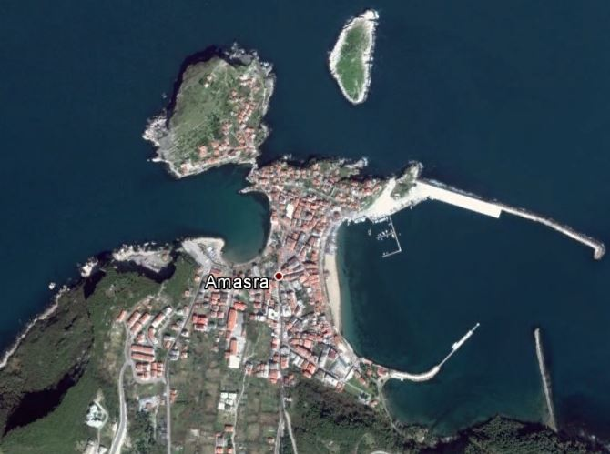
Figure 1. The latitude of Amasra, Bartin, Turkey is 41.750183, and the longitude is 32.387524. Amasra, Bartin, Turkey is located at Turkey country in the Towns place category with the gps coordinates of 41° 45' 0.6588'' N and 32° 23' 15.0864'' E. (URL-1)

2. AMASRA REGION RESIDENTIAL ARCHITECTURE

2.1. Floor Organization
In terms of understanding traditional dwellings, it would be more accurate to refer to the floor organization before examining plan types. after that It is only understandable which layer story what means in the home life.

The traditional residences of Amasra consist of ground+1, ground+2 or basement+ground+1 [4]. Although the number of floors of the houses does not exceed 3, the number of floors and the size of the house represent the financial state of the family. However, this is a certain element in the layout and decoration of the facade, and although the houses are large and the number of ornaments on the outer ceiling is abundant, this means that the financial possibilities of the family in that house are good level [5].
In the houses built in Amasya to match the slope of the land a basement has been created. Some of the houses built in flat have basement floors but not in the whole. Basements of the builds with basements are used as basements, while those in the non-basement are used as “kulluk” or “kuruluk”, in other words “gulluk” (Figure 2), and the kulluk is always used to enter into house. The upper floors of the house include a sofa at the middle or edge, and rooms which is opened to sofa are being like traditional Turkish house have been designed to be used as the living space of the family members [6].

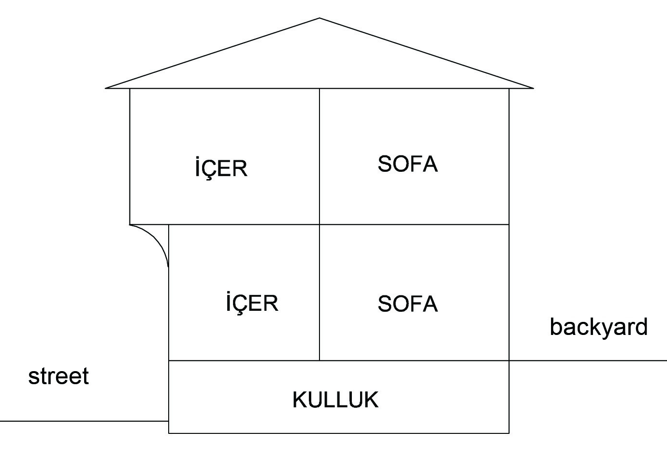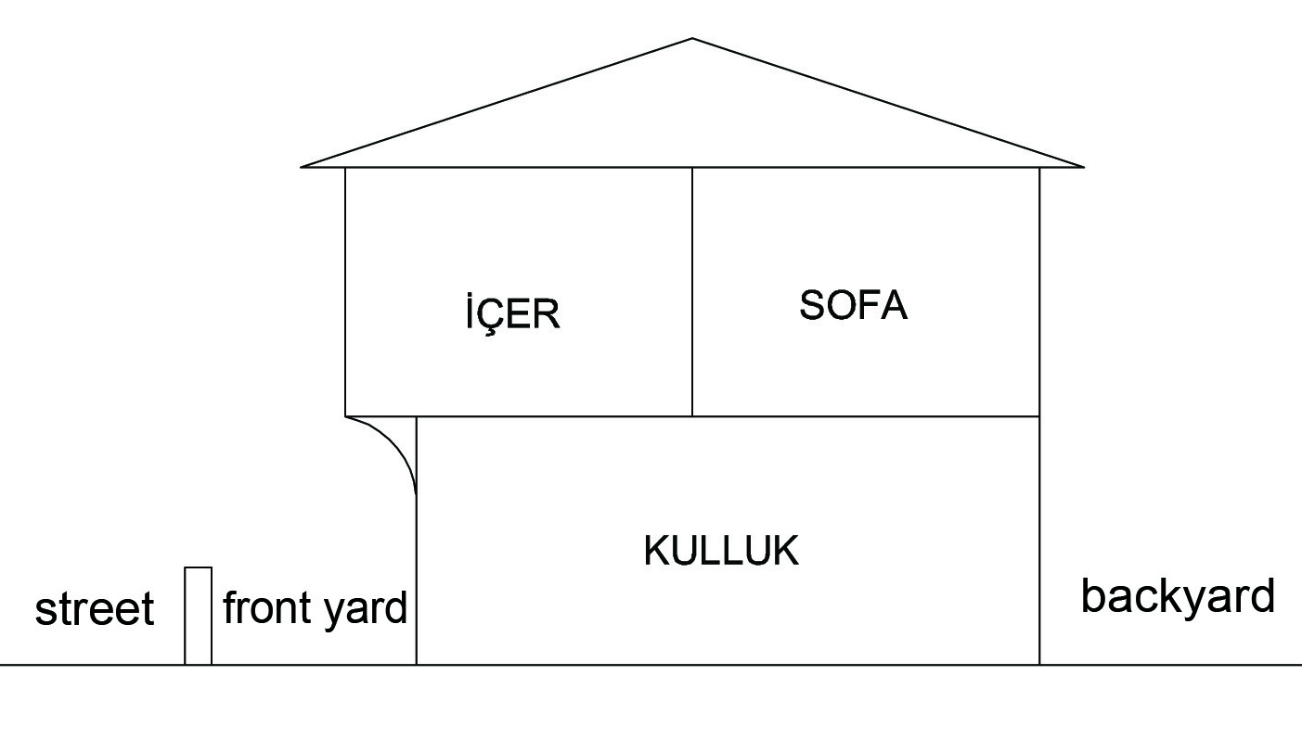
Figure 2. Locating “kulluk” to basement and used in ground floor (Drawed by author)

2.2.Plan Elements
Regional effects on the Amasra's traditional dwellings shows itself because of that plan elements are called with various names. In the nearby regions such as Safranbolu and Kastamonu, the places where they enter from the door are called “hayat” or “taşlık”, and with the dictions of Bartın and Amasra regions, kulluk, kuruluk, or gulluk [7]. There are rooms around the sofa in the upper living floors and they are also called by different names with the local diction and if we will speak with the local diction, in traditional Amasra and Bartın dwellings , sofa is called 'dışar', and rooms are called “içer” [6].

2.2.1.Kulluk
“Kulluk” is the place where the house is connected with the street and the first step is taken home. It is known that the kulluk floor is covered with slate stone and in the old days the floor is left as the soil floor. It is considered as a storage area to meet the general requirements of the family, is used as a nursery area where legumes are stored [8]. Legumes are stored in cabinet with top cover which is called “hergil cupboard” by traditional people (Figure 3). In some houses there is a edge room with stove where it is in service as kitchen (Figure 3), although there are other rooms apart from these rooms, these rooms are used as storage [8].

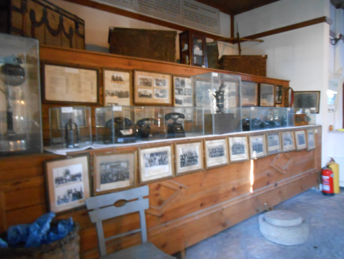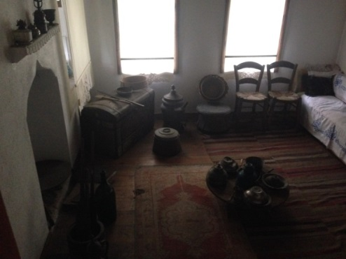
Figure 3. At left side, cupboard where foods are kept and kitchen in the kulluk at right (Photographed by author)
Kulluk is usually provided with a double-deaf deaf door, the door can sometimes be a single wing, and there is usually a window with iron bars on the door or on its side [6]. As long as the conditions of the terrain are appropriate, exit to the back garden of the house is provided via kulluk and the kulluk is servant a part of ventilating misson at the same time. With the ventilation provided by the window on the door, the humidity problem of the upper living floors is also prevented (Figure 4) [4].

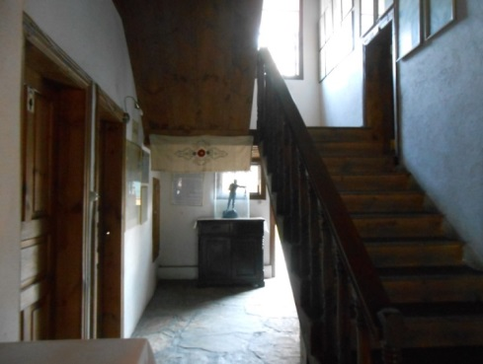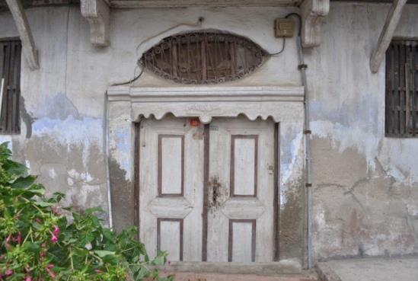
Figure 4. At left, Entrance to back garden from kulluk and winged deaf door and window on the kulluk entrance at right (Photographed by author)

2.2.2.Dışar (Sofa)
In the traditional houses of Amasra, the sofa section is called “dışar”. In the upper living floors, the place that connects the rooms of the house, where place is the common opening of all the gates and the passage between the rooms, is the sofa of house, with regional diction is dışar (Figure 5).
Dışar is the place where all the individuals of the house are gathered and living together. All room units in the house are opened to the dışar area. Apart from this, the ablution-toilet and the staircase volumes are again linked to the dışar and the same order continues on the upper floor [8]. In the old days, “there are cedars placed outside the window in dışar, and because of that the community is a common gathering area, the meals are eaten here, and the family members as well as guests are entertained, and the important events such as the meals, weddings, used to occur on the dışar ” [7].

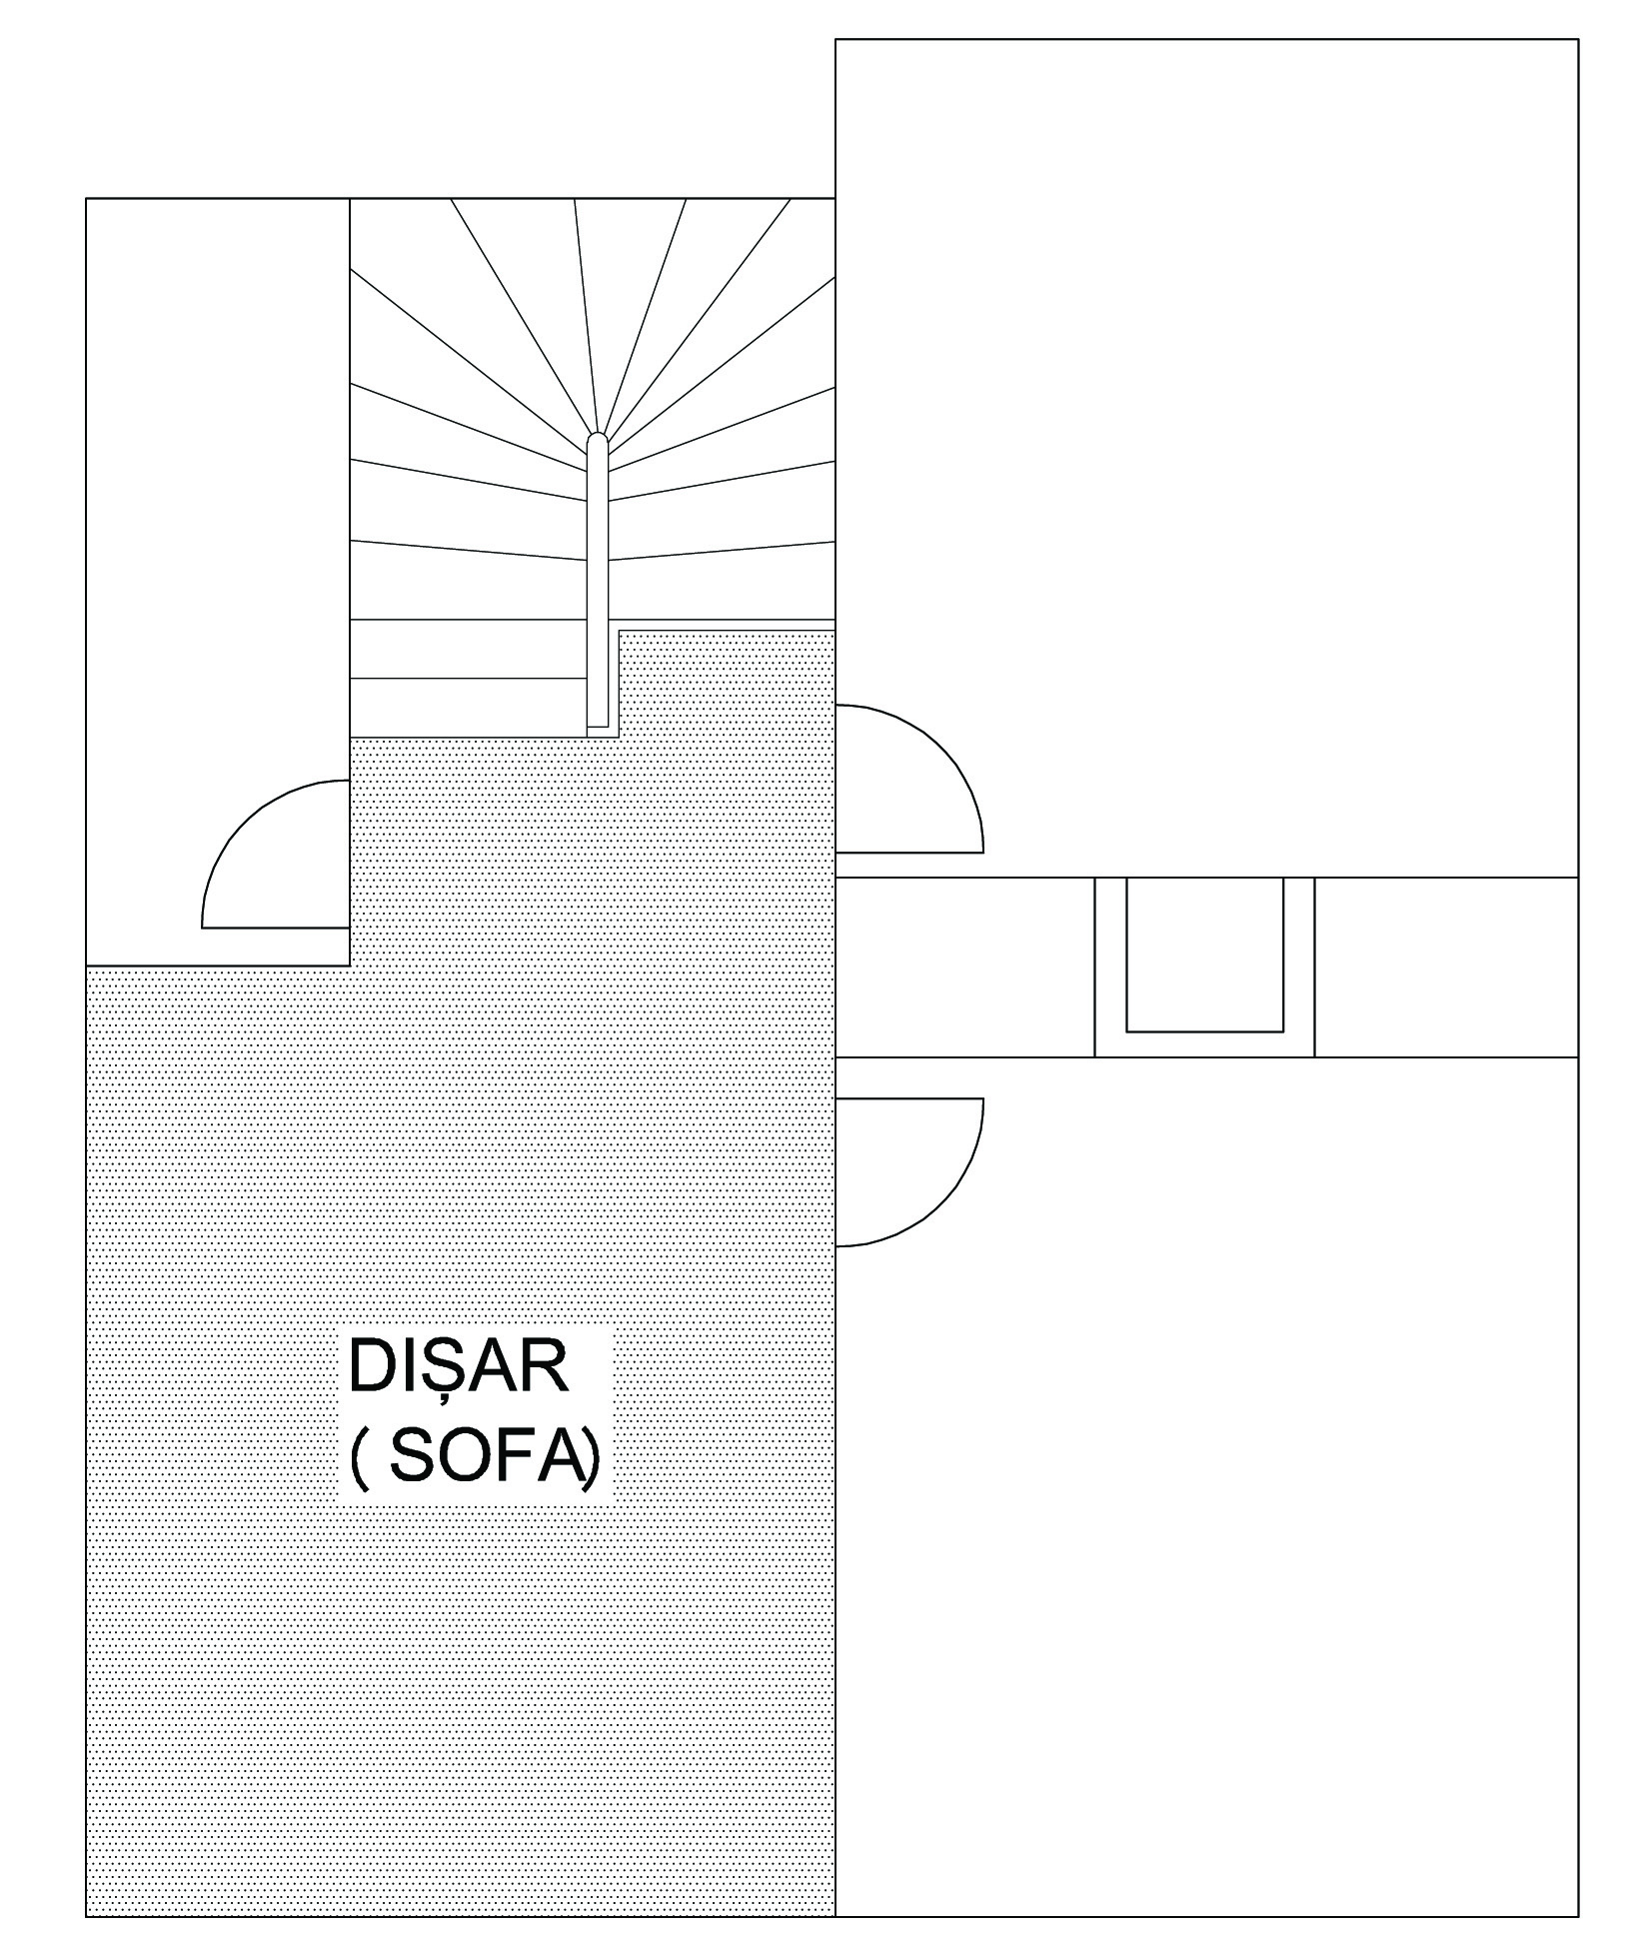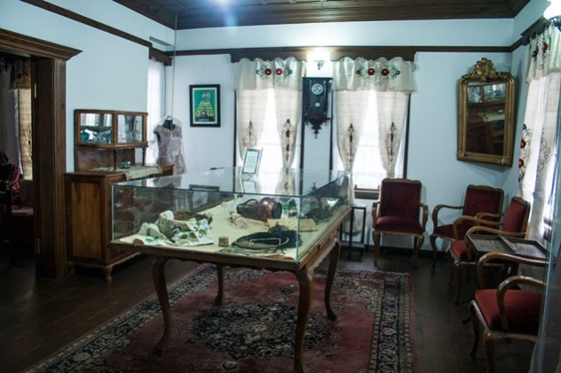
Figure 5. “Dışar” in plan schema and outlook from sofa in Kemal Samancıoğlu Etnography museum (URL- 2)

There is a great influence on the design of the house. The house is shaped and designed according to the sofa. In addition to this, it has been given some names to sofa depending on where is sofa places in the house. These naming is also available in traditional Turkish house plan typologies.

2.2.3. İçer (Room)
Traditional residences are called “içer” (Figure 6). This saying is pronounced in the same way in today’s Bartın and Amasra regions.

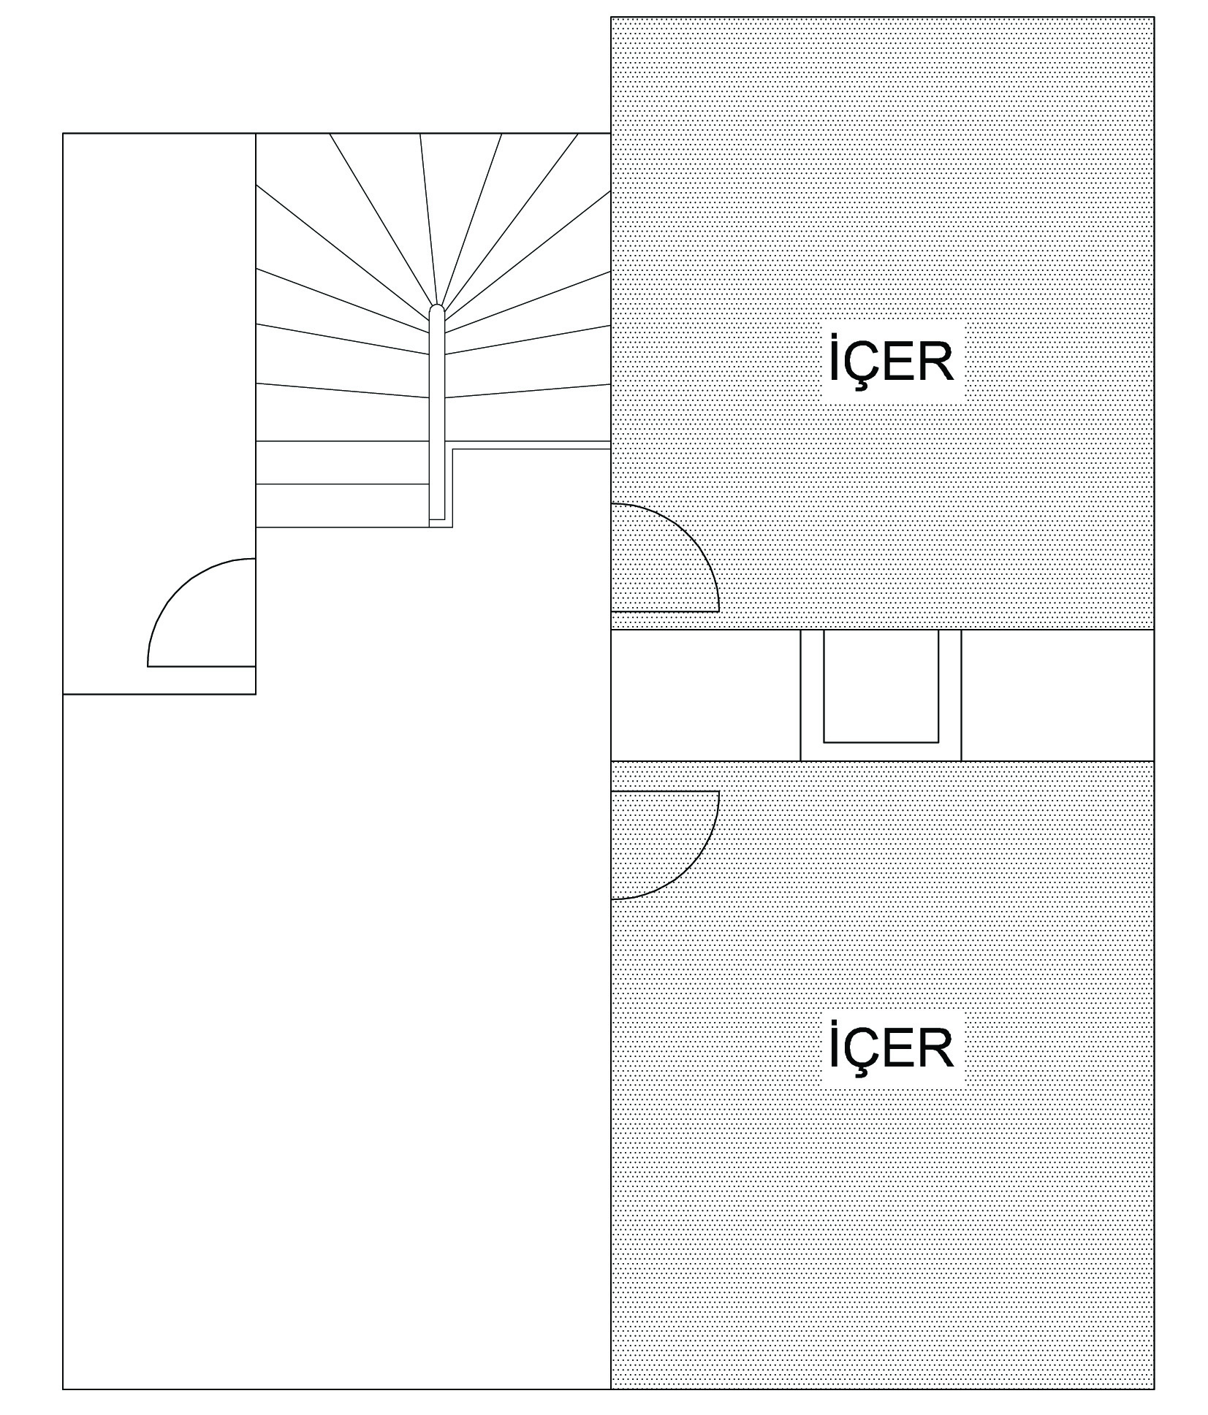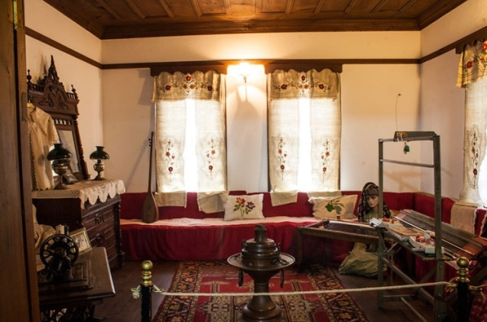
Figure 6. İçer in plan schema and outlook from içer in Kemal Samancıoğlu Etnography museum (URL-2)

Entrance of içer is provided from sofa. A family maintains life in every içer (room) whose usage is shaped according to the needs of the families. There is stove niche on the one of wall of the room. On one side of the stove there is a carpeted closet and on the other side there is a hammam cabinet [8]. İçer is designed in such a way that a family can do all the necessary actions, while the cooking is performed in the hearths and the bathing water is heated on the cooker again [5].
The “İçer” is designed to be used in a variety of functional ways to meet the needs of family life, eat meals and welcome guests. The middle part of the “İçer” was deliberately left blank so that every necessary action could be made easily and the cedars were placed on the sides of the window. Actions to be taken are left to the intended use of family members, and cupboards and stoves in the room are designed from the beginning according to the activities to be done [9].

Hearths
Depending on the size of the house, there is absolutely a hearth in all the rooms or in one of the rooms. The hearth (furnace) is placed adjacent to the wall, near the entrance wall of the entrance door or near the entrance side. It is usually located in the middle of the adjacent wall, and its cupboards are located on both sides of the hearth (Figure 7) [10].

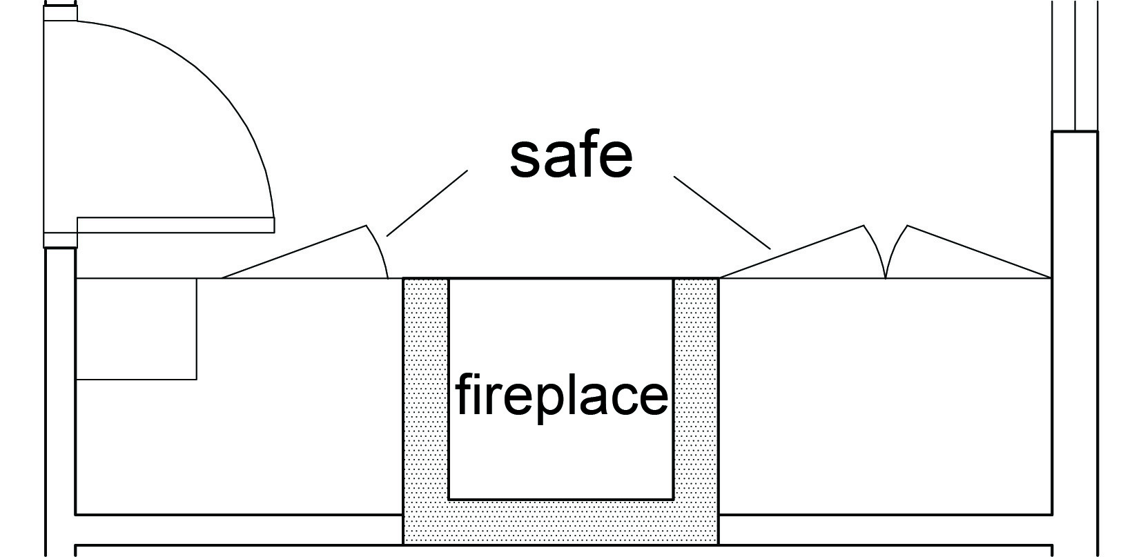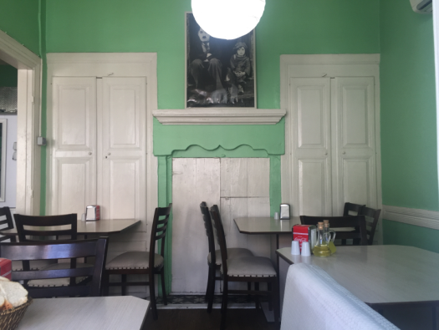
Figure 7. Hearth niche in center, bedset in left and hamam cabinet in right (Photographed by author)

The fact that hearth (furnace) are in the rooms is very influential in this lifestyle when traditional wooden houses are thought to maintain a single family life in the room. Hearth (furnace) are versatile for cooking, heating and bathing to heat the water and serve to easy the life of family members [5].

The most important feature of the hearth (furnice) is the heating. Considering that the Black Sea is experiencing hard and windy winter months, the heating factor plays a very important role. Heating is usually a little easier for houses with hearths in every room, but this is difficult for houses with single hearths. In this case, the barbecue will serve as a help. The roasted woods is placed on the barbecue and moved to the other room, so that the family members sitting in other rooms get heat as well [5].

Bedsets and Cabinets-cupboards
Large furniture such as beds, quilts, sheets and pillows are stored in large cabinets called bedsets. Since the rooms served a lot of activities in ancient times, the concept of fixed bed has not been formed as it is in today's conditions. In order to perform the necessary actions, the middle part of the room is always left blank and at bedtime, the beds are removed from the bedrooms and laid on the floor of the room. It is again folded and removed in the morning [5].

The bedsets are usually located at the entrance near the room door and on the same wall as the hearth. The depth of the bedset is 75-90 cm in average and the width is 130-150 cm and it is usually double door and 60-80 cm high from the ground. The lower part is usually used as an ablution. The bedsets extend from the floor to the ceiling of the room. The close proximity to the door is proof of the privacy of the family living in the room. When the door is opened, the side edge of the bedset is first seen and the people inside are prevented from direct eye contact [7].

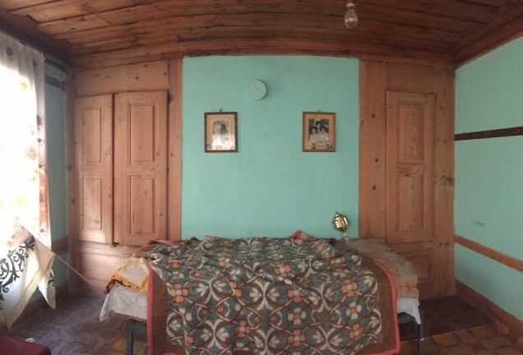
Figure 8. Bedset and hammam cabinet in left, hidden cabinet in right (Photographed by author)

Hammam Cabinet (Ablution Cabinet)
The hamam cabinet is the part in the lower space of the bedset cupboard. When the board of bedset is raised at a height of 60 cm, the bath cabinet or the name ablution appears (Figure 9).

Bath cabinets (hammam) can be thought of as today’s parents’ cabinets. Selda Çelikyay (2000) stated that it is very appropriate to evaluate the hammam cabinet as a counterpart of today's parents' bathrooms. The bath cabinets (hammam) are designed to prevent heat loss, usually on the side of the hearth, or in the back of the hearth in the side room. There is a low sitting place without a backrest called a rostrum and the washing water is heated on the cooker and washing action is performed by pouring water with the help of a water container called “maşrapa”.

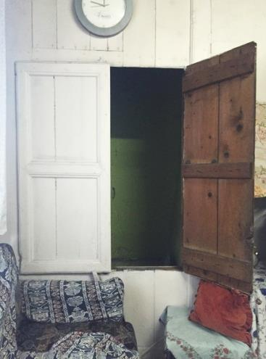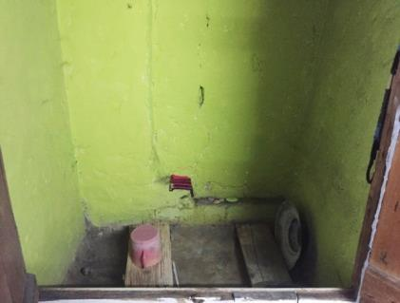
Figure 9. Outlook of “hamam” cabinet and inside metarials (Photographed by author)

2.2.4.Eyvan
The enclosed volume “eyvan” is the extension of the sofa between the rooms (Figure 10).

S. H. Eldem’s expression’ iwan can be explained as follows;
Eyvan is in the room sequence, that is, between two rooms. The narrow face looks at the sofa. When it is in the middle of the sofa, it is the middle eyvan, otherwise it is the side eyvan. Side of Eyvan's, usually a pair of kibles. Eyvan is separated from the 'köşk' even though there is also 'eyvan' with more window and 'balcony' in order to be a more reserved seat, windows are plentiful and there are also oval-shaped ones. As soon as eyvan expands, it begins to form a whole with sofa. At that time, 'eyvan' axle', the house enters the form which will constitute the main axis [11].

Eyvan types with a corner sofa and plan with single eyvan , are more than other type of eyvan. There are types of plan which includes central sofa and number of eyvan up to 4 across the region.
Eyvan can also be terminated in a balcony, sometimes as a bounce over the front (Figure 10). The top lines of the windows in the eyvan are generally designed rounded form and are complemented by a specialy design of adornments [4].

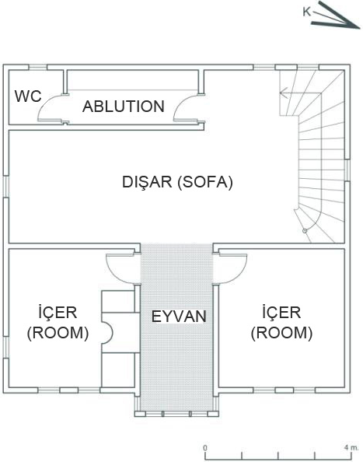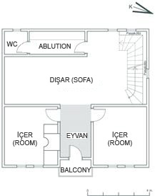
Figure 10. Eyvan with extended to outside and eyvan ended with balcony (Drawed by author)

2.2.5.Ablution and Hela (Toilet)
In Amasra traditional wooden houses, there is absolutely an ablution on every floor except for the kulluk. In the plan scheme, the staircase is generally positioned in close proximity.The ablution’s door always opens to the sofa (dışar), but it is rarely seen that the ablution’s door is opened to room (içer) of house.There is a loom similar to today's kitchen countertops in the ablution, which can sometimes be made of stone or board , and the loom is 40 to 50 cm wide. There is a hole and its generally oval shape [7]. Hand is washed on the hole.

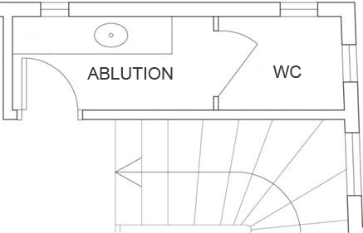
Figure 11. Ablutions and wc (hela) in the same place (Drawed by author)

There is a toilet (hela) separated by a compartment inside the ablution (Figure 12). According to the requirements of Islamic religion, toilet (hela) is always located in the same place but separately located,because hela needs and acts of ablution are not realized in the same place. whenever requirement of ablution, to the get ablution immediately,both were kept in the same room [10].

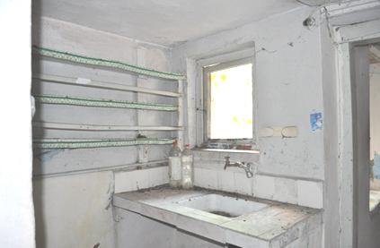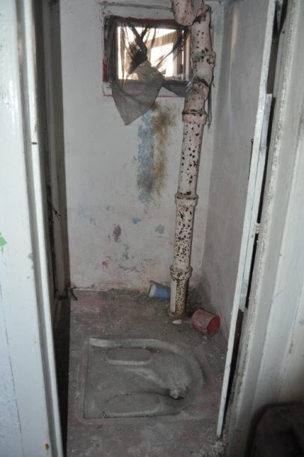
Figure 12. Ablution bench And hela stone with seperated (Photographed by author)

2.3. Plan types
Sedad Eldem had classified Turkish House acording to position of the sofa. This classification is important in terms of revealing the architect’s own language about the Turkish House plan types. All possible house varieties are classified according to the shape and the relation of sofa with rooms. The most characteristic feature of the Turkish house according to Sedad Hakkı Eldem is sofa (dışar). For this reason, the common point in the typological study is the sofa and all types of plans have developed around the sofa. According to Eldem, sofa is the center of all home life [12].

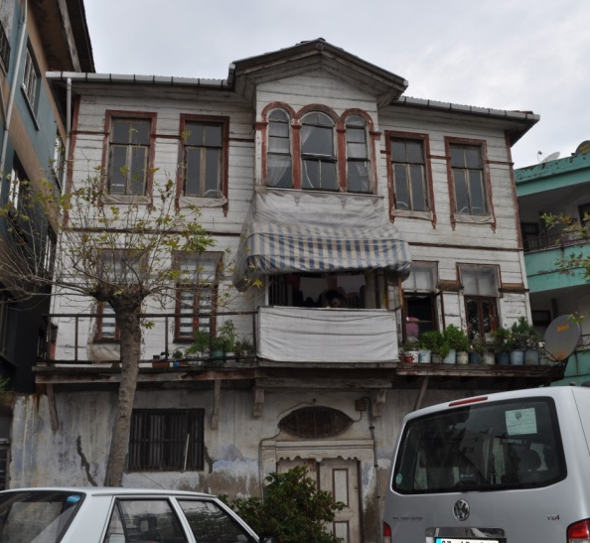
Figure 13. An example of Classic traditional Amasra’s house (Photographed by author)

2.3.1. Plan Type With Corner Sofa
The most widely used plan type in the region.This plan, which is called corner type plan type in Eldem typology [13], has two floors over kulluk and is entered the house from kulluk. There are two windows on both side of sofa. There is a staircase on one side of the sofa on the corner and there is ablution and hela(toilet) next to the staircase.One side of sofa has two large rooms one of them is small the other is large. There is no internal connection between the rooms (içer). In one room there is a hearth, in rare cases there are hearths in both rooms. There is different aplications according to positions of kulluk, toilet and ablution.

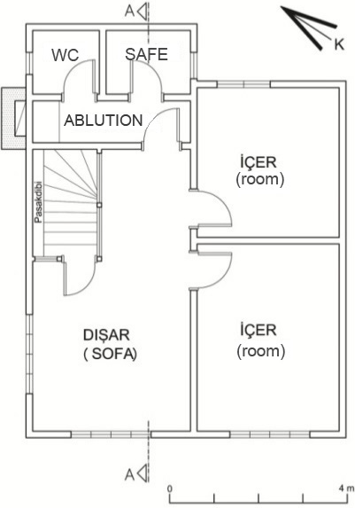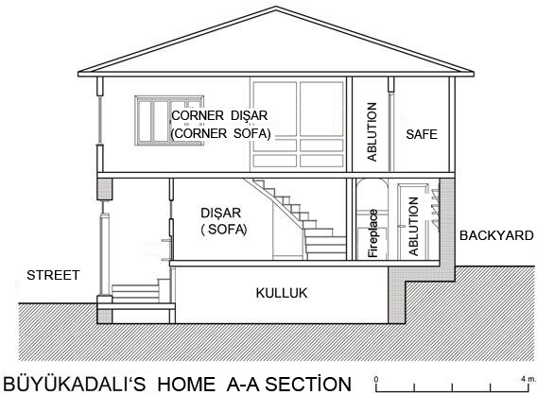
Figure 14. A plan example of corner sofa in left and a section example of sofa which placed in front line in right (Drawed by author)

Sometimes there is a kitchen in the kulluk, sometimes one of the rooms was used like a kitchen function at the same time.

2.3.2. Plan Type With Corner Sofa and Eyvan
This plan was achieved by adding the eyvan to the room of the corner sofa plan between the rooms. This plan, which has single or two storey applications on kulluk, is sofa with windows from one or two direction. It is entered to house from the kulluk. On one side of the sofa on the corner is a staircase, and on the other side of the sofa there is an ablution and toilet. On the other side of the sofa, there are rooms at the two ends and a narrow eyvan between them. Eyvan is generally with balcony in the form of a window, with one or three windows (Figure 15) [13].

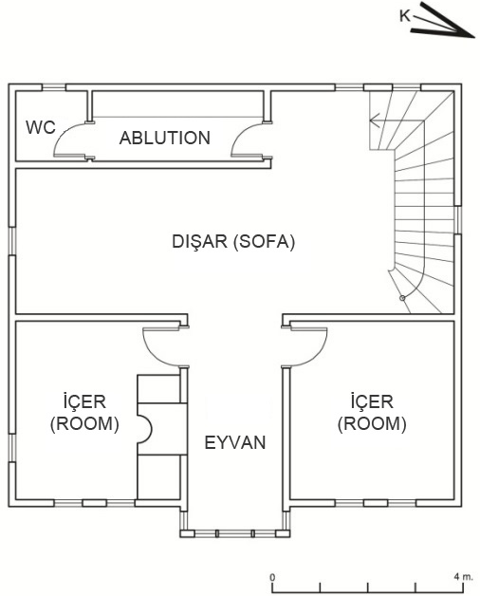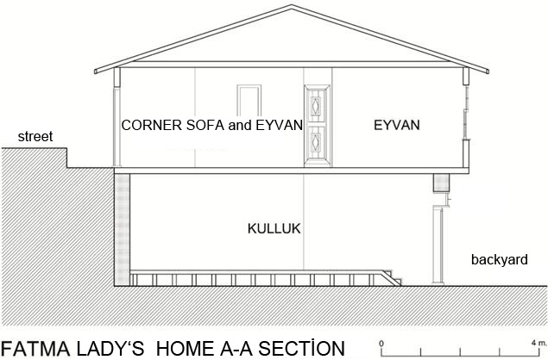
Figure 15. A plan example of corner sofa with eyvan in left and a section example of sofa with eyvan which placed in front line in right

Dimensions of the rooms are generally equal in this plan, and only one room has a hearth. In this plan, sometimes the door of the room opens directly to the sofa, sometimes opens to the eyvan. The kitchen is in the a kulluk, and the room with hearth is used as a kitchen.

2.3.3. Plan Type With Central Sofa
It is the type of plan in which all the rooms are arranged around the sofa and the sofa is in the middle. In this case, sofa gets section which is open to outside from between rooms. These sections can be all around as well. The main fiction of the central sofalerie type is that if the number of the rooms incrowded families is insufficient, the house can be widen by the same plan types is get side by side [14].

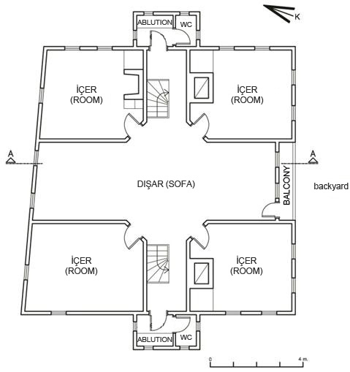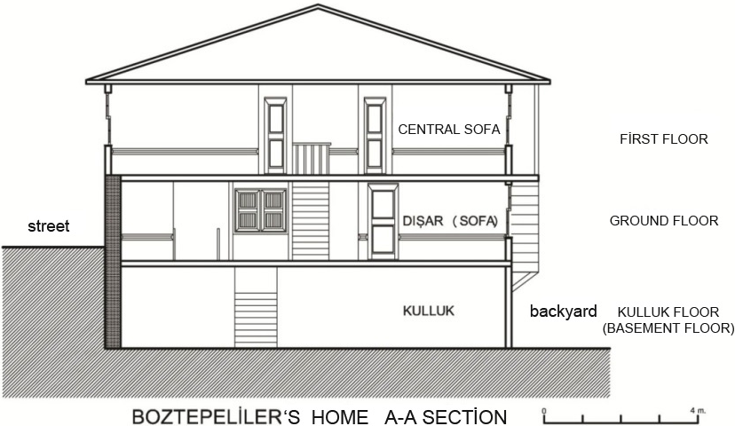
Figure 16. Plan with central sofa and section example (Drawed by author)

The central sofa plan type is the last stage of development according to Sedad Eldem and the design center is built around a sofa and the sofa is located in the center and turned into rooms on four sides and one or two rooms have been reduced and replaced by eyvan which gives better use of sunlight and they are located throughout the hall. Different combinations have been developed by increasing the number of eyvan in the same plan type. For this reason, Sedad Hakkı Eldem stated that this plan type is the most suitable plan type for development and could be applied to wider houses and residences with rich plan blends. [15].

2.4.Structure System And Material
Wood, which is the main bearing material of traditional houses, has been prepared in different sizes from different woods depending on the regions, in the section and in the technique. Chestnut, “çatkıda” on the shores of the Black Sea, the most reliable tree , stone which is in the foundation and ground floor walls are used in every region and stone, mud brick, brick and wood are used as filling material. Sludge and lime mortar as binder material can easily be provided as traditional building material. Usually the outer surface is covered with wood in damp and windy coastal areas and in other regions lime is plastered with mortar [16].

As it is in the western Black Sea region, the ground floors (kulluk) of the Amasra historical houses is built with masonry brick (40-50 cm) or rarely mud brick. On the walls there are wooden belts that are binding for the upper floors. Against the ground floor, the construction technique of the upper floors is in the form of wooden cascade conveying system consisting of wooden beams and dikes, and wooden material or mud brick is again preferred as the filling material between this carcass system [17].

2.4.1.Wooden carcass system
The houses in Amasra region were also built as wooden carcases, and the basement and basement walls are made of stone and the ground floors are completely stone [6].

Wooden frame method;
- lightness ,
- less equipment using ,
- increasing area due to the thin walls,
- short construction time,
Because of some reasons such as workmanship, ease of insulation [14], wood-retaining stone walls are prefered on the entrance floor of the houses on the foreground, and wooden frames are used on the upper floors.

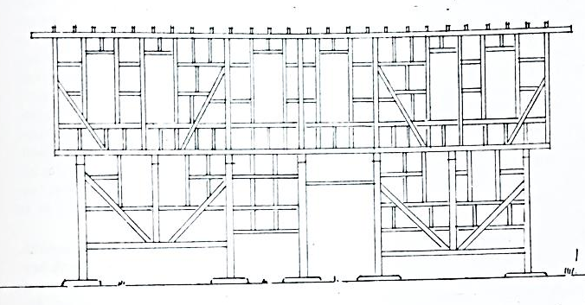
Figure 17. Sample drawing of wooden carcass system[7]

Wood filling between wooden carcass
In spite of the positive aspects such as lightness of the material, easiness of connection to wooden carcass, contribution to carrier strength and easy workmanship, it is done with old trees or structure of wooden parts of demolished houses and connections are made with nails; therefore, it has negative aspects such as high heat conductivity, limited metarial usage as well. [19]. Since the people of Amasra provide their town’s livelihoods through fishing, the old parts of the boat have been separated from by fishermen, and the remaining sturdy pieces were left to be used in the construction of the house [20].

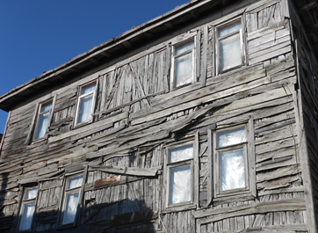
Figure 18. Wood fill technique between wooden carcass(Photographed by author)

Adobe filling between wooden carcass
It is possible to find similar examples in the Amasra region even though mud brick fillings are frequently used among the carcass frames in the areas outside the forest areas.The main reason for using adobe materials is that they have an effective thermal resistivity and that the horizontal and vertical stitches can be made with wider spacing as well as the ease of knitting and application of the smooth and compacted adobe units side by side.In this filling system the vertical carriers are connected horizontally only with the components called “boyunduruk” (yoke), there is no need for frequent horizontal connections as in the case of stone fill, in the cases where the cross braiding is applied, the stitch spacing is 20-30 cm. [19].

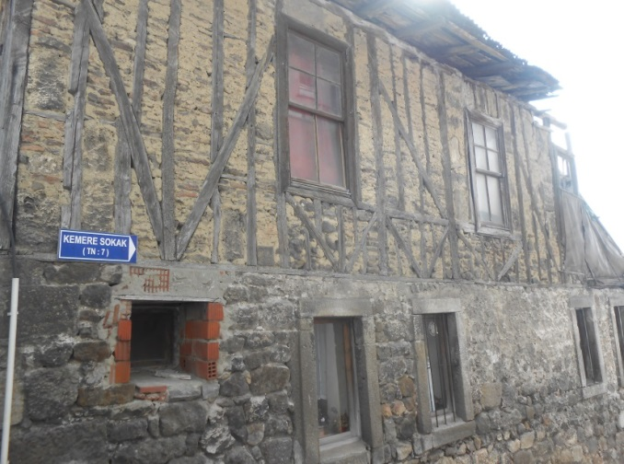
Figure 19. Adobe filling technique between wooden carcass[21]

Stone and brick filling between wooden carcass
In the settlement areas where the possibilities of providing or rebuilding the structure are increased, stone and brick were used and the walls are constructed with lime mortar’s positive contributions of binding. Fillers and wooden carcass surfaces are usually arranged with the same percentage so that carcass are visible [19].

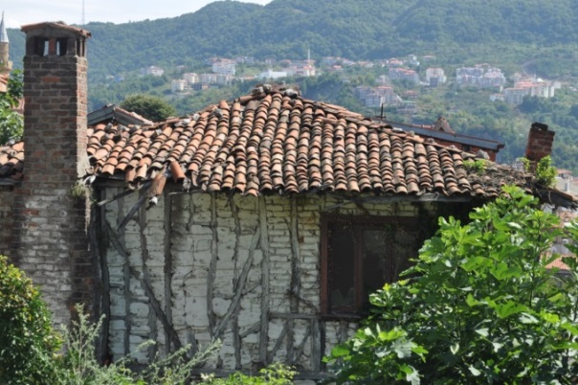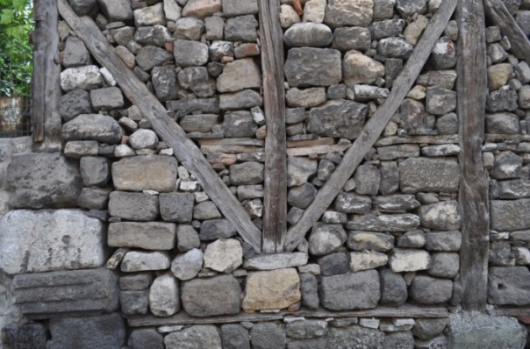
Figure 20. Stone and brick filling technique between wooden carcass (Photographed by author)

2.5. Structural Elements

2.5.1.Walls
The timber columns and beams are covered with wooden fill, overlaid with “rabbitz” or wood veneer. Wooden veneers are tied together at the upper and lower levels of the sill corner with the “yalı baskılı” and the lamp. Bending was prevented by supporters which was positioned in their place. The outcrops were supported by strut within stiffeners and covered with either wood or covered with plaster [6].

2.5.2. Roof
Roofs were usually made as a hipped and fitting roofing.The crosswise system was used in the roof and the rafters were covered with tile bottom boards and covered with alaturka tiles.The fringes were outside from house’s border with 50 to 70 centimeters, fringer’s terminal was covered with “kayıt” in 20 cm, also fringer’s bottom was covered in flat form [4]. Sometimes bottom of fringe was not covered and released with existing form.

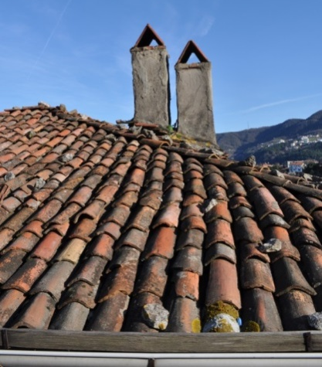
Figure 21. Example of Traditional alaturka tile roof cover (Photographed by author)

2.5.3. Floors
Wood plank is called “döşek” and ceiling cover is called “zar” in the land of Amasra and its surrounding. The carrier beams which are arranged in same directions on buildings according to its load and the gapsare organized within different intervals and sections on the buildings where the skeleton system is in the form of carcass, in the form of stacking, in the same direction,
- Single base on one side, double base on the other side,
- Both sides have double bottoms,
It can be ordered as a double in one direction and three in the other [19].

2.6. Layout And Decoration Of Facade

2.6.1. Doors and Windows
The entrance doors of traditional houses are generally double-winged deaf gates, and there is a window on the door which is essentially the same width as the door [6]. In narrow areas , the house is available which has single-winged doors. The doors of the houses are usually located in the middle of the, and some houses have been placed in the corner of the front line.

The windows of the traditional dwellings are woodblocks and and windows have been placed in the dwellings as many as possible. These windows, which provide the connection to the outside world, are designed in different forms and have the original character, the wide and usually half-proportional sliding (guillotine) windows [6].

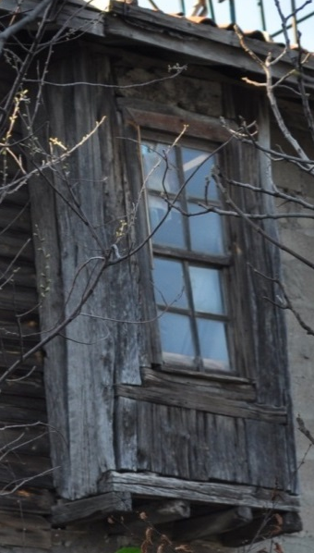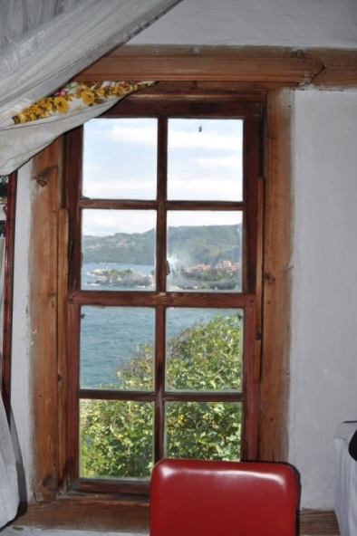
Figure 22. View of window from facade and view of window from inside (Photographed by author)

2.6.2.Çıkma Düzenleri
Wooden houses in the district can be either in the form of a colonage or a balcony [17].

Outside Extention with Strut
In the beams with the slab extension, the strut supporting the supporting function are placed on the wooden beams in the lower floor masonry structures.

If the floor is solid wooden carcass structures; struts sit to the sidewalks to allow the transfer of loads and the possibility of reaching very wide with the small sized trees [22].

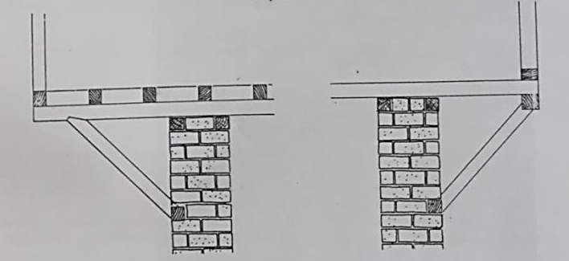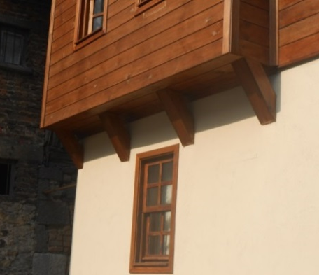

Figure 23. Sample drawing and photo for outside extention as called “göğüslemeli” [18]

Console With Beamed
It is the method of laying the floor beams outward from the ground surface by a limited measure (up to 40-60 cm) and has an intense application rate in the region [22]. A ledge has been made with wood beam on the one of the houses surveyed, as seems figure 23,wooden beams with wide sections were owerflowed to outside with interval in 50 cm intervals.

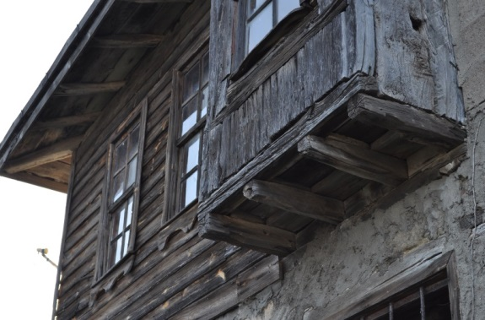
Figure 24. Sample drawing and photo for console with beamed[22]

2.6.3. Ornament Features
Some of the houses in the area have various ornaments on the roof pedestals.These are the same shape as the roof pedestal and are also in triangular form.The the sills of the windows, which is an important piece of houses, almost every house is decorated with different motifs.

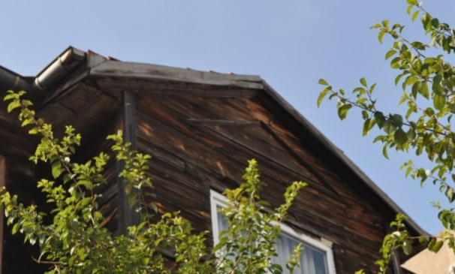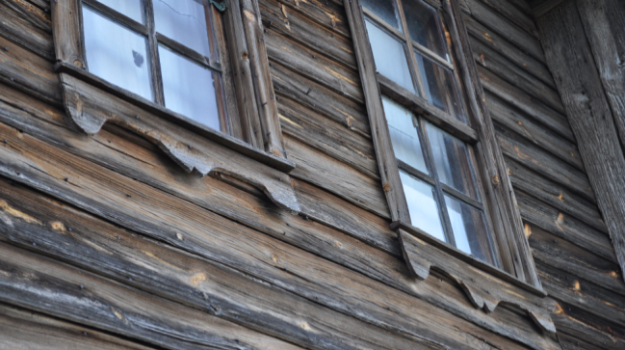
Figure 25. Ornament element on the front of roof andornament element on window’s sill(Photographed by author)

Among the windows on the facade are wooden silks called “kuşluk”, which surround the building [6]. The bottoms of the facades are mostly supported by a strut, and these struts have been decorated with various ornaments.

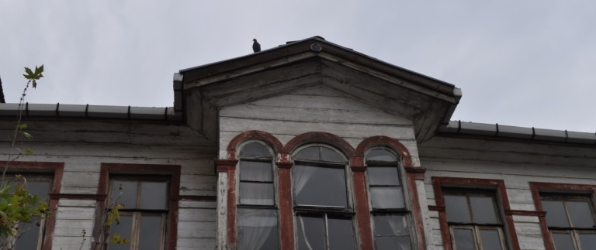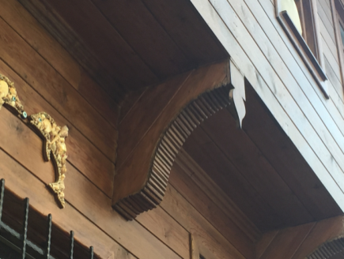
Figure 26. Ornament element “kuşluk” in left and ornament element on strutin right (Photographed by author)
3. CONCLUSION
In this study, traditional Amasra houses plan typology, plan elements, construction system, materials and façade features were investigated and it was tried to give information about the residential architecture of the district.

When the Amasra houses are examined in terms of settlement, it is seen that the settlement is scattered in the region.The houses are irregular on the land and each is different from each other. The streets are quite narrow, and the houses' balconies or outcrops also droop to out of street partly.The district center of Amasra has a hilly land in topographical terms and a small harbor in the west and two natural harbors in the east.Both have a sloping land towards the lima, and in this respect most of the houses remain in the hilly area. It is located in houses built on flat land on the sea shore. When you look at the houses in terms of positioning; the houses on the sloping ground were built to set on the slope of the terrain.The entrance door of the houses is always on the street side. Another issue in terms of positioning is the landscape.
The houses near the sea were built as parallel to the sea as possible.

Three different plan types were identified from the houses surveyed in the region: corner sofas, corner sofas with eyvan and central sofas.The houses are usually ground + 1 flat or ground + 2 flat. Today these houses have to be used with different functions according to user requirements.There was no living room in the traditional houses, but after being restored for the purpose of the hotel, the room was divided into rooms and a living environment was created.Today, the houses still used by their owners are quite neglected.All the hearth in houses are closed and not used today. Kulluk’s were left blank and were not used. In some houses, the stairway leading to the first floor passage with the kulluk was closed and the floors were left completely independent from each other.Another change is to change the windows in a way that does not fit the traditional measurements and the original details.It is possible to see this situation in almost every house. The committee of monuments controls this situation, but it can not go beyond cutting monetary penalties.but I am convinced that it is possible to prevent this situation to some extent by providing necessary trainings and aids.

As a result, in this study, the traditional plan typology and characteristics of the Amasra houses on the western Black Sea coast have been examined and a documenting study has been carried out in order to transfer these houses to future generations.The buildings built by traditional craftsmen, from the local and surrounding materials, with traditional construction techniques constitute the traditional residential architecture of the region.As a result of the researches and examinations made, Amasra houses were found to have a significant place in the residential architecture of the region with its plan, construction technique and material properties.

REFERENCES
[1] Gür, Ş. Ö., 2000. Doğu Karadeniz örneğinde konut kültürü. Yapı endüstri merkezi yayınları, 1.baskı, Nisan, İstanbul.
[2] Rapoport, A., 2004. Kültür Mimarlık Tasarım. Yapı Yayınları, İstanbul.
[3] Bretonne, C., 1979. An Interview with Amos Rapoport on Vernacular Architecture. M.B.T.U. Journal of the Faculty of Architecture, Volume 5, Number 2, Fall 1979, 113-126.
[4] Şengerze, K., 1998. Tanzimat Modernleşmesi Sürecinde Bartın Evleri. Yüksek Lisans Tezi, İstanbul Teknik Üniversitesi, İstanbul.
[5] Aliş, C., 1876. Eskiden Yeniye: Konutlar, Eski Yapılar ve Ev Eşyası.Bartın Belediyesi Gazetesi, Bartın.
[6] Kemik, C., 1986. Bartın Evleri ve Kentsel Değerleri Üzerine Araştırma. Yüksek Lisans Tezi, Yıldız Üniversitesi. İstanbul.
[7]Günay, R., 2005. Safranbolu evleri, Yapı Endüstri Merkezi Yayınları, İstanbul.
[8] Davulcu, M., 2003. Bartın Halk Mimarisi, Folklor Araştırmacıları Vakfı.
[9] Yüksel, İ., 2009. Eski Türk Evi’nin Butik Otele Dönüşümünde Karşılaşılan Problemler (Safranbolu Evleri ve Soğukçeşme Sokağı Karşılaştırmalar Dahilinde), Sanata Yeterlilik Tezi, Mimar Sinan Güzel Sanatlar Üniversitesi, İstanbul.
[10]Çelikyay, S., 2000. Bartın Evlerinde Ahşap ve Mimari, Geleneksel ve Çağdaş Mimarlıkta Ahşap Panel ve Forumu, TMMOB Genel Merkez Ankara Şubesi Bartın Temsilciliği, Bartın.
[11] Eldem, S.H., 1984.Türk Evi-Osmanlı Dönemi I-II. Yem yayın evi, İstanbul.
[12] Korkmaz, P., 2008. Sedad Hakkı Eldem “Türk Evi” ve Frank Lloyd Wright “Prairie Evleri” Üzerinden Karşılaştırmalı Bir Analiz, İstanbul Ticaret Üniversitesi Fen Bilimleri Dergisi Yıl:7 Sayı:14 Güz 2008/2 s.35-51, İstanbul.
[13] Eldem, S.H., 1954. Türk Evi Plan Tipleri, İstanbul Teknik Üniversitesi Mimarlık Fakültesi, Pulhan Matbaası, İstanbul.
[14] Bektaş, C., 2016. Türk Evi, 3.Baskı,Yapı Endüstri Merkezi yayınları, İstanbul.
[15] Özbil, A., 2002. Sedad Hakkı Eldem’sTypological Analysis Of TheTurkish House As A ToolFor An Operative Design Methodology, A ThesisSubmittedToTheGraduate School Of Natural AndAppliedSciences, Metu.
[16] Günay, R., 2000. Türk Ev Geleneği ve Safranbolu Evleri, Yapı Endüstri Merkezi Yayınları, İstanbul.
[17] Çelikyay, S., 2011. Batı Karadeniz’deki Geleneksel Ahşap Evlerin Özellikleri ve Özgün Detaylar,Mimar.ist Dergisi, Haziran 2011, Sayı:40, sh:32-36.
[18] Kafesçioğlu, R., 1955. Kuzey-Batı Anadolu’da Ahşap Ev Yapıları, Doçentlik Çalışması, İstanbul Teknik Üniversitesi, Pulhan Matbaası, İstanbul.
[19] Akdemir, Z., 1997. Batı Karadeniz Bölgesi Yerleşmelerinde Geleneksel Konut Kültürüne Bağlı Biçimsel ve Yapısal Kurgu Özelliklerine Ait Ölçüler. Doktora Tezi, Y.T.Ü. Fen Bilimleri Enstitüsü, İstanbul.
[20] Sakaoğlu, N., 2016. Amasra konut kültürü. Necdet Sakaoğlu ile söyleşi, Amasra.
[21] Yaylı, A., Ozan, Y. ve Boran, H., 2011. Bartın Kültür Varlıkları Envanteri, Bartın Valiliği İl Kültür ve Turizm Müdürlüğü, Bartın.
[22] Akdemir, M.Z. ve Korkmaz, E., 2010. Geleneksel Konut Dokularında Malzemenin Çatı ve Cephe Kurulusuna Etkileri: Batı Karadeniz Bölgesi Örneği.5. Ulusal Çatı & Cephe Sempozyumu 15 -16 Nisan 2010 Dokuz Eylül Üniversitesi Mimarlık Fakültesi Tınaztepe yerleşkesi Buca, İzmir.

ONLINE REFERENCES
URL – 1. https://maps.google.com, last accessed on 2 February 2017.
URL – 2. http://www.amasra.com.tr, last accessed on 11 January 2017.

Özgenaz DAĞ, B.Arch.,
She was born in Bartin in 1991. She completed undergraduate education at Istanbul Aydin University, Faculty of Architecture and Design, in Department of Architecture. And she was graduated master's degree at Istanbul Aydin University, Institute of Science and Technology, Department of Architectural Design. She began her working life in Bartın city of opening her own architectural office, and still designing different projects in her own office.

ALEV ERARSLAN, Asst. Prof. Dr.,
She was born in Istanbul in 1969.Shecompleted undergraduate education at Istanbul University in Department of Ancient Languages and Cultures.She completed master’s degree and doctorate education at Istanbul Technical University in Department History of Art.She began her academic life in Çanakkale Onsekiz Mart University, Department of Archeology and Art History. Between 2014-2016, she worked as part time instructor at Fatih University, Faculty of Architecture Department of Fine Arts and Design. Today, she works as an assistant professor at Istanbul Aydın University Faculty of Architecture and Design.

