Evaluating the Ecological Architecture: using the
Wooden Material

Aysel Tarım, Asst.Prof. Dr. Ufuk Fatih Küçükali
Institute of Science Master of Architecture
Istanbul Aydin University, Florya / Istanbul / Turkey
aysel_oem@yahoo.com, ufkucukali@aydin.edu.tr

Abstract: In consideration of many concepts such as “sustainable, ecological, green, climate and environment-friendly, high performance, intelligent, passive, carbon-neutral buildings” the objective of the applications, becoming evident today, is to produce structures, making us respect and take care of the “nature” with reference to the risk of failure of future generations to survive. The objective of this study is to draw attention to the utility of wood, a renewable material, in this respect in sustainable, organic and ecological architectures, which have gained more importance nowadays, based on the increasing interest in natural life and use of natural materials in the world in recent years. In this regard, technical specifications of wooden materials are mentioned, wooden-material based several structures are analyzed and samples are provided thereof.

Keywords: Sustainabilty, ecological architecture, wooden structures

Ahşap Malzeme Kullanımının Ekolojik Mimari Yapı Örnekleri Üzerinde Değerlendirilmesi

Özet: Günümüzde, “sürdürülebilir, ekolojik, yeşil, iklim ve çevre dostu, yüksek performanslı, akıllı, pasif, karbon-sıfır bina” gibi pek çok kavram incelendiğinde ortaya çıkan uygulamaların amacı, gelecekteki kuşakların varlığını sürdürememe riskinden hareketle, "doğaya" saygı duymamızı ve ona gereken özeni göstermemizi sağlayacak yapılar üretebilmektir. Bu çalışmanın amacı; son yıllarda dünyada doğal yaşam ve doğal malzeme kullanımına olan ilgideki artışa bağlı olarak günümüzde daha da önemli hale gelen sürdürülebilir, organik ve ekolojik mimari yapılarda yenilenebilir bir malzeme olan ahşabın bu çerçevede kullanılabilirliğine dikkat çekmektir. Bu bağlamda sürdürülebilir ahşap malzemenin teknik özelliklerine değinilmiş, ahşap malzeme ağırlıklı çeşitli mimari yapılar incelenmiş ve örnekler sunulmuştur.

Anahtar Kelimeler: Sürdürülebilirlilk, ekolojik mimarlık, ahşap yapılar

1. INTRODUCTION
The design of built environment has a significant role to maintain the inheritance of future generations, which is under threat due to climate change and unsustainable development with regard to continuation of human race and thousands of other species. The need for sustainable urban development requires an architectural and planning approach addressing both the city and individual buildings as complicated interactive systems, which are in a common living relation with their natural environments.

Primary objectives of sustainable design may be summarized as the use of renewable, non-polluting, environment-friendly energies and eco-technologies, materials; performance of protection, savings and recovery concerning all sources, particularly water and energy; and optimization of the potential of land and its environment and of the procedures regarding the operation, maintenance and repair of buildings. In this day and age, we need a paradigm shift, in which sustainability consciousness, on the agenda of environmentalists for the most part,will be on the agenda and practice of each individual,so that our existence could be sustained in the future.
Architectural construction materials and design criteria have also experienced many changes from past to present. In each period, constructions were built with a different method, different materials and in different styles. Most of them have reached up to present days. From time to time, studies, researches and critiques have been made regarding these structures. Many scientific researches, articles and several studies have been conducted with respect to the issue and studies have been and are still being made on either a national or international scale, which reveal theoretical bases and critical perspectives of the issue, itself.

2. ECOLOGY
Sustainability is, now, an integral part of ‘modern’ life in consideration of the global conditions today. Furthermore; it is also understood that sustainability requires an extensive planning, which should be valued inevitably above all policies when it is considered that vital sources are in danger.

The aim of sustainable architecture is to design environmentally-conscious, low-energy buildings that have the least adverse impact on the environment, provide healthy indoor environments for users and that ensure optimum levels of comfort conditions.

With reference to such definitions, sustainable architecture refers to the fact that all architectural process is ecologically, socially and economically sustainable. Here, the architectural process defines the period of architectural process from planning to recycling.

2.1. Sustainable Architectural Design Criteria
At the head of design criteria, it is essential to lay emphasis on combination of human rights with nature in a healthy, supportive, different and sustainable design.

Design specific to human and design elements interact with each other together with natural world, in a way dependent on nature and on every scale. Human beings take responsibility in design decisions for his welfare, natural systems and about applicability of correctness of such together. In the long run; they aim to create valuable and reliable objects for future generations. The objective of design criteria is to improve and evaluate all life-cycle of products and operations and deal with the status of waste-free natural systems.

Following criteria are considered such as minimizing the use of raw material as well as having natural materials to be used without making no concessions on quality and comfort, collecting recyclable wastes, creating a separate area in the building for such wastes and reusing the resources.

2.2. Ecological Architecture in a Sustainable World
Seeking solutions and recent inclinations against environmental problems experienced in the world are intensively discussed today. Now design criteria are re-questioned and it is proceeded through ecological projections in consideration of the areas surrounding the cities. From now on, it is the aim of architecture to prefer materials and methods for the structures that will minimize environmental pollution, ensure environmental conditions appropriate for human health and that protects ecological balance.

Combining requirements such as sustainability, environmental consciousness, green architecture, natural and organic approach; ecological architecture is the approach of design in compliance with the construction and its surrounding, topography as well as local micro and macroclimate conditions. The use of natural material and recyclable sources is the basic principle of ecologic architecture. Recovery of the resources, which come from the nature, without harming the nature again constitutes the basis of use of these sources.

2.2.1. Design criteria of ecological architecture
Minimizing environmental pollution, ecological structures, which further have positive impacts on local life, protection of construction culture and architecture, provide healthy, reliable and original construction service for the users.

In the light of all these useful aspects of ecological structures, it draws attention that there are some important points which should be emphasized regarding design criteria; These may be listed as follows:

- to minimize impairment of natural sources as regards the design and use of environment,
- to design in compliance with nature, to perform designs in compliance with climate conditions and topographical characteristics,
- to use recyclable materials,
- to consider ecological principles as regards vertical distribution just as horizontal distribution within the building,
- to allow for flexibility and variability criteria for design and have multi-functional spaces and,
- to have designs for the use of solar energy [1].

2.2.2. Technical specifications in ecological architecture
When technical specifications of ecological architecture are discussed under the title of “the details of the utilized material and application systems” it would be seen that the material is the principal parameter. Design approach is inspired by the nature, and the structure develops in the field with its surrounding. Appearance of a structure is similar to that of growth and development of plants from seeds in the nature.

Structures, which are in a relation of compatibility or incompatibility with the people living inside due to material requirements, and that can be considered as an organism in this respect, gradually remove from nature. In the past, organic materials (such as wood, hay, bulrush) at the rate of 30-40% and inorganic materials (such as adobe, building tile, stone and lime) at the rate of 60-70% were used in the buildings. But now, 90-100% artificial construction materials, unfamiliar to nature and people are used and many artificial materials are pretended to be natural [2].

When it comes to the relation of ecology and material, it is no doubt that wood materials are the leading among those materials which exactly comply with the ecological design criteria. Wood is the only construction material that can renew itself.

2.2.3. Wooden material in ecological material and wood specifications
Wood is one of the oldest construction materials. People have used wood since antiquity for accommodation and protection purposes. Wood has increased in value once more because forests decrease due to several reasons, failure to grow recent forests in place of the old ones or late cultivation therewith. Although plastic, metal, aluminum, concrete and cement products are used instead of wood with the advancing technology, wood has always continued to be a reason for preference due to appearance, isolation and easy performance of desired formation.

Wood is an organic-based construction material with a fibrous, heterogeneous and anisotropic tissue, obtained from trees, which are living organisms.

Physical properties; moisture, unit volumetric weight, thermal expansion, heat conductivity, electrical conductivity and durability.

Chemical properties; natural resistance, i.e., its woody tissue is the most durable in comparison to other plant tissues.
Mechanical properties; it is difficult to analyze mechanical properties of wood as it is a heterogeneous and anisotropic material. All properties regarding its fibers; pressure, tensile strength are higher than transverse strengths. As the wood is a swelling, shrinking material as a function of its water content, it is also a material with changing mechanical properties.

There may occur several deformations in wooden materials due to color change, corrosion and insects. It is essential to protect wood withmercury chloride, creosote, copper sulphate, zinc chloride, chromium, arsenic, boron or fluorine salts or linseed oil in order to protect wood from these damages [3].

3. WOOD USAGE AREAS in STRUCTURES
Wooden materials are included as carrier, coating, chopping, panel insulation and molding elements in the structures. Furthermore; they have a wide field of application as furniture elements.

As wood base elements; beamsused to provide space for the structure, lattice beam, box beam or glued laminated beam, pillar, corner post, floor, support, main beam, floor beam, yoke; and used in the areas such as ceiling beam, suspension beam, cushion, strainer, tie beam, as for roof systems. The types of the trees used are pine, fir, spruce, beech, oak and chestnut.

As wood siding elements; it has a wide field of use today in thin coated plates, plywood, fiber and flake boards as well as natural wood included in the building as floor, roofing, ceiling, internal and external wall covering. The types of trees used are generally pine, fir, beech, oak, ash tree, hornbeam, elm and walnut tree.

As woodwork elements; used as frame, sash, glazing bar, drip in windows; as cap, doorpost, glazing bar in doors and on the platforms. Woodwork elements are generally produced from trees such as pitch pine, fir, oak, beech, and platform section is manufactured using woo types such as plywood, coated fiber or chipboard.

As wood-panel elements; artificial wood is generally used in these elements, which are included in the structure in the form of dry-wall, floor and roof panel. Known as filled, porous and cellular system, wood panel systems are advanced construction materials of present-day that meets any requirements in terms of building physics.

4. WOODEN APPLICATION SYSTEMS in the STRUCTURES
Wood is one of the most commonly used materials, that spring to mind when it comes to pre-production and naturally renewable construction materials. The wood is a natural construction material, which is possible to be used without exposing to extensive processes, that is renewable and producible without creating much waste, it does not contain materials harmful to health, the amount of fossil energy utilized in its production is low and it stores CO₂ in itself [4]. Besides, it is somewhat available for heat and sound insulation and its fire activity is proper although it is a flammable substance [5]. The elements with wooden raw material may be reused following the end of their lives, they may be eliminated biologically and utilized as energy or raw material. Production of wooden structures is fast, light parts may be easily stored and transported.

In brief, wood has the potential to meet all prevalent trends in construction sector, which are theoretically stated above. Therefore; technological attempts gradually increase considering the use of wood in wood-base systems of multi-story residences.

In widespread application, all mentioned systems are generally used together. It is common to use massive walls with beam-and-slab floors or framing systems with massive floors; or application of wooden systems with steel and reinforced concrete systems. Their use in base system is preferred in low-rise residences, adding stories and in densely populated urban areas in particular. Their use in residential construction is widespread in Scandinavian countries and North American continent.

Solid/massive plates are also used in modular ready cellular systems as they are easily installed despite all of their transport challenges. Projects performed with massive wooden panels range from suspended roofs to industrial structures. Their lightness is a very significant advantage in terms of earthquakes. Wooden base system is the only construction material that can be tested on earthquake table [6].

Wooden construction systems are collected under 4 titles;

4.1. Wood Masonry Systems
Wood masonry systems can be defined as a system created by superimposition of wooden trunks. In accordance with masonry construction guidelines, walls formed by superimposition of wooden elements constitute base systems. It is not required to perform coating on the surfaces of walls, created in this system. Used for traditional construction building either in Turkey or in the World, this system is generally used in weekend houses today.

4.2. Wooden Framed Systems
Wooden framed systems are those in which single-dimension wood components assume role of bearer and wood is used more economically in comparison to masonry systems. In framed systems, while single-dimension wood components constitute the base system, walls turn into the elements which are not carrier but used only for separating spaces and surrounding the building. Wooden framed structures are in fact a frame system. Spaces remaining among the pillars are either filled with a component such as adobe, brick, gas concrete then mortar is applied thereon, or surfaces of pillars facing outwards are coated with wooden boards and desired insulation and protection is ensured against external factors [7].

4.3. Wooden Panel Systems
Wooden panel system is especially appropriate for single-story buildings (schools, offices etc.). This system is also applicable in residences with single or double storey. Wooden panel system is constituted by gathering together the elements, produced as panels. Pillars are used in corner joints of wooden panels. Panel elements are produced based on their compositions and functions as bearing or non-bearing; with or without ventilation. These elements are gathered under four groups as small bearing panels, wide bearing panels, room units and non-bearing small and wide panels [8].

4.4. Systems Formed with Glued Laminated Elements
Glued, laminated wooden elements are the wooden construction elements, generally created by gluing and combining separate wooden plates with different sizes under controlled industrial conditions and by means of special connectors. Fiber directions of all plates are parallel in longitudinal direction. Single plates have a thickness of timber. Plates are composed of parts which are attached from heading joints and that create long length; the parts, which are glued one after another and that create wide cross-sections or from the parts which are bent to obtain curved forms during gluing. This technology has gained an exclusive place in the world of architectural design since it has a very good combination and completion characteristic with other construction elements in all processes as regards rough and fine finishing of the building.

When Utopia Pavilion, Expo Lisbon 1998 is considered as an example of this system; laminated wooden construction system is thought as it was understood that this large building, located in an area of 2000m², which is one of the major meeting areas of Europe with an auditorium for 5000 people, could be built within a short time by combining different construction elements. Utopia Pavilion is a natural, fire-protected, ecologic construction model, which does nor create pollution, and functions of which were completed.The length of this structure, consisting of wooden frame arcs is 120m [9].

5. SEVERAL EXAMPLES of WOODEN MATERIAL BASED ARCHITECTURAL STRUCTURES
Wooden materials have gradually started to replace steel and concrete in developed societies as it used to be in the past. Now, buildings with impressive sizes and forms, even sky-scrappers other than small and specific houses are being built with wooden materials.

Below we will analyze structures built with wooden-based materials in different societies for different purposes.

5.1. Examples of Structure 1: Wood Bridge / Anaklia Georgia / 2012 / Peter Walz
When the 540-meter-long bridge over the Inguri in the Georgian town of Anaklia was put into operation, the locals have decided that this is only a temporary structure, and opposition to the authorities even the media were quick to announce that it has taken down after the first heavy rain. And all because the construction of the bridge was made ​​entirely of wood.

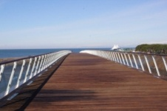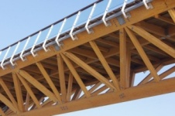
Figure 1. Wood Bridge / Anaklia Georgia [URL 1]

Nevertheless, the bridge from the German architect Peter Walz is a capital structure. Moreover, he became the longest wooden object of this kind in the whole of Europe, as well as one of the symbols of the new Georgian resort called Anaklia built on the border with Abkhazia. Serving as a vital link across the Enguri River to the Black Sea resort town of Anaklia, Georgia, the Anaklia-Ganmukhuri Pedestrian Bridge is considered longest cable-stayed timber bridge in Europe and possibly the world.
Originally conceived as a 500-metre-long steel bridge, cost challenges proved to be prohibitive. Fortunately, a Georgian contractor with a keen interest in timber construction stepped forward and engaged HESS TIMBER of Germany to assist in providing a more economical timber solution [URL 1].

5.2. Examples of Structure 2: Wooden Headquarters Tamedia in Zurich / 2014 / Shigeru Ban
Pritzker Laureate 2014 Japanese Shiregu Ban is the bully on the architecture. It creates structures of materials that are less bold and imaginative his colleagues believe quite unsuitable for the job. As an example, the Church of cardboard tubes or multi-story office center of the timber.

In the latter case, it is the headquarters of the Swiss media corporation Tamedia in Zurich. The best traditions of the construction of the real masters of this wooden building was built without a single nail. To seal part of the structure, Shigeru Ban used the traditional connection type gear notching.

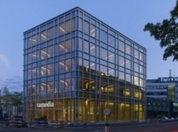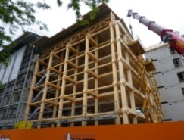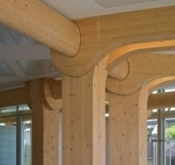
Figure 2. Wooden Headquarters Tamedia in Zurich[URL 2]

The result is an elegant five-storey building with a total area of ​​9000 square meters, it is absolutely safe in terms of seismic and protected from the fire by means of impregnation of wooden construction elements with a special solution [URL 2].

5.3. Examples of Structure 3: Globe of Science and Innovation– wood science museum at CERN/2004/ T.Buchi&H.Dessimoz
The most famous object in the campus of the European Organization for Nuclear Research (CERN) is the Large Hadron Collider – particle accelerator ring with a length of over 26 kilometers. But there is in the territory of another outstanding institution building – Museum Globe of Science and Innovation.

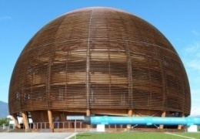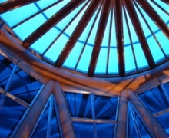
Figure 3. Globe of Science and Innovation–wood science museum [URL 3]

This domed building was discovered at CERN in 2004 as a museum of modern technology, as well as a platform for showcasing the latest advances and research results of scientists working in this organization. Design and exterior design of this building are made of wood that looks very unusual in the territory of one of the largest and most respected in the world of academia.

Interestingly, the height of the Globe of Science and Innovation is 27 meters long and 40 that the size of the second dome of St. Peter’s Basilica in the Vatican.

A symbol of sustainable development; several remarkable species of timber were used in the Globe’s construction: Scots pine, Douglas pine, spruce, larch and Canadian maple, and these enable the building to act as a carbon sink.
To produce a cubic metre of wood, a tree absorbs a total of one tonne of carbon dioxide (CO₂). It releases approximately 730 kg of oxygen (O₂) and stores 270 kg of carbon (C).
Thus, the approximately 2500 m³ of timber taken from the Swiss forest that supplied the varieties used in the Globe absorbed 2500 tonnes of CO₂ and released 1825 tonnes of oxygen (O₂) during the trees' life time [URL 3, 4].

5.4. Examples of Structure 4: Metropol Parasol – giant wooden umbrellas in Seville/2011/J.Mayer H.
In many small and large Spanish cities in the central squares have a special place where you can relax in the shade. This can be a balcony overhanging the ground floors of houses, or individual designs – giant umbrellas in the middle of the square. And the largest object of this kind appeared in 2011 in Seville.

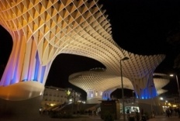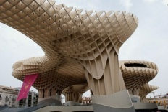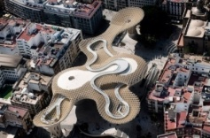
Figure 4. Metropol Parasol – giant wooden umbrellas[URL 5]

Metropol Parasol – a giant canopy of unusual shape, which resembles a cloud hovering over one of the squares in the center of the capital of Andalusia. The length of the roof of the wooden building is 175 meters, width – 50, making it the largest wooden object in the world.

Under the Metropol Parasol were equipped with not only a place for walks and get-togethers, but also a small farmer’s market, a restaurant and an observation deck, which offers a wonderful view of the historical part of Seville [URL 5].

5.5. Examples of Structure 5: Cathedral of Christ the Light – the cathedral made of wood and glass in Auckland California / 2008 /Craig W. Hartman & Skidmore, Owings and Merrilll
In the old days almost all the churches were built of wood. Reached this tradition and to our times. And, from this material not only erected a small rural churches and chapels, cathedrals and even in large cities, for example, in the California Oakland.

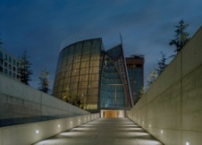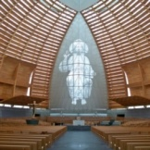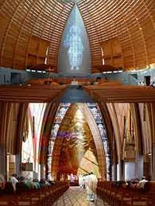
Figure 5. Cathedral of Christ the Light –
the cathedral made of wood and glass in Auckland California [URL 6]

Majestic, modern Cathedral of Christ the Light was built primarily of wood and glass. And at night, it seems as if it is of divine light that justifies the name of the church – Christ Church Cathedral – Light of Light.

The Cathedral of Christ the Light employs state-of-the-art technologies to create lightness and space. The 1,350-seat cathedral incorporates a highly innovative use of materials, including glue-laminated timber, architecturally exposed reinforced concrete, high-strength steel tension rods, aluminum, and glass to provide lightness and luminosity within an efficient structural form. With a building life goal of 300 years, it utilizes a base isolation system along with superstructure materials that allow the structure to resist strength and ductility demands beyond the maximum considered earthquake levels [URL 6].

5.6. Examples of Structure 6: Canadian Timber House Uses Salvaged Wood From Nearby Elk Reserve Canada /2011/ Scott M. Kemp
The use of salvaged wood is just one of many impressive features of this timber home in British Columbia. Designed by Architect Scott M. Kemp, the home serves as a residence for him and his family and has achieved a LEED Platinum rating from the Canadian Green Building Council. Salvaged wood, geothermal heating and cooling, green materials and an energy efficient solar passive design set the home apart.

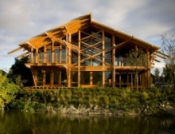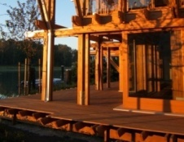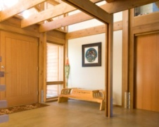
Figure 6. Canadian Timber House Uses Salvaged Wood From Nearby Elk Reserve [URL 7]

Located on the banks of the Fraser River near the village of Ladner, this eco residence takes full advantage of its river site for views as well as the relatively constant temperature of the water. A closed loop geothermal system hanging in the river below the dock works in tandem with a heat pump to provide hot water and radiant floor heating and cooling for the home. Solar passive design and high performance glazing reduce energy use along with a tight thermal envelope made from SIPs [URL 7].

5.7 Examples of Structure 7: WISA Wooden Design Hotel/ Finland /2009/ Pieta-Linda Auttila
Architect Pieta-Linda Auttila has completed a prototype holiday home in Helsinki, Finland, featuring a sculptural, wooden trellis between two box-like ends.

Called the WISA Wooden Design Hotel and created for Finnish forest products brand UPM Kymmene, the building is made of pine, spruce and birch grown in Finland.

The two solid volumes house sleeping and living areas, with large windows in each end overlooking the sea on one side and the city on the other.

The curved panels of the wooden trellis shelter a central patio from wind and filter the light. WISA Wooden Design Hotel is an architectural gem of wood situated in the maritime heart of Helsinki, capital of Finland. Around it lie the city and 200 years of architectural history.

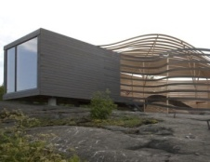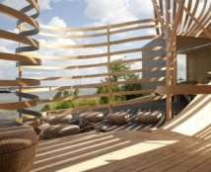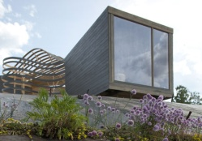
Figure 7. WISA Wooden Design Hotel/ Finland [URL 8]

The work was designed by interior architect Pieta-Linda Auttila. She hopes to spark interest in wood and highlight its role in building and interior design [URL 8].

5.8 Examples of Structure 8: Haydar Aliyev Life Area in Airport / Bakü / 2014 / Autoban

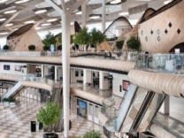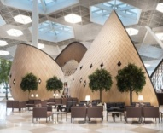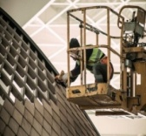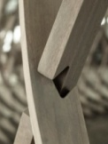
Figure 8. Haydar Aliyev Life Area in Airport / Bakü [URL 9]

Istanbul-based architecture studio Autoban creates a wooden village to encourage wandering in a vast terminal.

Baku, Azerbaijan, burns in a hot landscape-literally. In recent years, swaths of land in the country’s capital have ignited in spontaneous fires due to shallow-lying natural gas and oil. Since the country gained its independence in 1991, the government has sought to elevate its design stature, illuminating HOK’s three Flame Towers with 39-story animations of flames, and building Zaha Hadid's Heydar Aliyev Center [URL 9].

5.9. Examples of Structure 9:Kaeng Krachan Elephant Park Shell / Zurich/ 2014/ Markus Schietsch

Zurich design firm Markus Schietsch Architekten crafts a complex, freeform roof for several unusual occupants.

The Kaeng Krachan Elephant Park compound at the Zurich Zoo is capable of withstanding the 15-ton force generated by a charging occupant, but that didn’t stop local firm Markus Schietsch Architekten (MSA) from imparting an aesthetic delicacy to the structure. Completed in 2014, the 90,900-square-foot structure currently hosts eight Asian elephants, each weighing between 2 tons and 5.5 tons, in a nature-inspired habitat topped by a 73,200-square-foot shell roof made primarily from wood [URL 10].

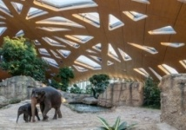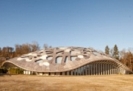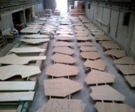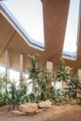
Figure 9. Kaeng Krachan Elephant Park Shell [URL 10]

5.10 Examples of Structure 10:Yogav Studio/ New York /2015/ German Rodriguez Sergio Hidalgo

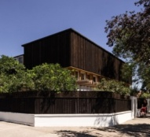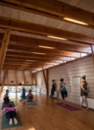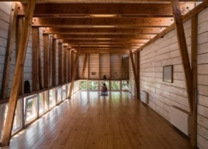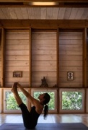
Figure10. Yogav Studio [URL 11]

Chilean studio DX Arquitectos has added a timber-framed roof extension to the home of a yoga teacher in Santiago, providing a studio where she can teach classes. Santiago-based DX Arquitectos designed the studio for the director of Ashtanga Yoga Chile – the oldest school in the country specialising in this method of yoga. She wanted a studio that would allow her to integrate and at the same time separate her home life from her work life, “architect Germán Rodríguez told Dezeen”. It needed to satisfy all the conditions for the comfortable practice of yoga – good ventilation, good acoustic and thermal insulation, and a spiritual atmosphere. The architects built the studio entirely with timber, using pine for the exterior and interior surfaces. Outside, the pine is finished with carbonileo – a protective finish commonly used in Chile that gives the extension its blackened appearance. Inside, the pine is left raw for the flooring and whitened for the walls to accentuate its grain. We also chose wood because it is suitable for absorbing the moisture generated during the practice of yoga, and it contributes to the calm atmosphere of the studio, he added [URL 11].

6. CONCLUSION and RECOMMENDATIONS
The approach “to know the nature of material and adhere to such” has revived as a reflection of positivist thinking, which has taken shape since seventeenth century when architectural information was divided into two as “artistic” and “scientific”.

When wood is compared with steel and concrete; it is a superior material in all respects thanks to its heat conductivity, naturalism, aestheticism, acoustic properties, cost, and because it is recyclable and requires low-carbon.

Today building designers call for with an increasing pressure in order to reduce carbon footprint of structured frame and balance cost targets and functionality with gradually decreased environmental impacts. Wood is a low-cost and biggest renewable source that is compatible with such a call and that can help to ensure such a balance.

It is important to consider life cycle and environmental impacts of a material when stating any material. Wood is raised naturally, and it is proved to be superior than other materials with its following characteristics to have a lesser solid energy, to create lower air and water pollution, to provide oxygen for nature during production phase and thanks to its carbon-ponding feature.

In order to determine correct cost of a construction material, environmental and financial characteristics of such material during its life cycle should also be; considered. When such characteristics are considered, it is apparent that wooden material provides better performance than steel and concrete in terms of manufacture, transport, installation, usage, maintenance, recycling, air and water pollution, energy and carbon footprint.

In the analysis conducted, it was observed that wooden materials were mainly used in religious buildings, training buildings, hotel buildings, airports, bridges, residences, museums and in many areas such as these in developed countries all over the world and its proliferation increases day by day. That they are living and alive materials makes wooden products always one step ahead in our living spaces. It is a natural outcome of our historical development to be nested with wood in every places we live in; from hand tools we use, houses we live in, from our gardens to external coating materials. That it is a natural, environmentally-friendly, recyclable, protectable, healthy and sustainable material may be considered as significant values of wood and such may be listed among the most important characteristics of wood. Today it is essential that construction industry should develop in a manner to reduce harmful factors, arising during production stage so that ecological problems, it causes, could be resolved.

In order to provide solutions, many studies are conducted mainly in developed countries regarding ecological building and support is provided thereby developing recent approaches aiming to extend the use of wood, as a natural construction material in the field of residence.

Human beings are dependent upon nature with the air they, intake; water, they drink and vegetable-based and animal nutrients. In this respect, they should interact with nature as other creatures. When it comes to select materials, if our materials of choice are the ones which consumes less energy in either during its production or utilization process, which are easily transformed by nature when they complete their life cycle, which also do not pollute environment during both of their production and destruction stages and do not lead to emergence of carcinogens, we would have contributed to protection of natural balance. Wooden material, which is available and offered to us by nature with its excellent internal structure, is the best example for this.

REFERENCES
[1]Tönük, S. 2001. Bina Tasarımında Ekoloji, YTÜ Basım –Yayın Merkezi, İstanbul.
[2]Akman, A. 1999. Ekolojik ve Biyolojik Yapı Uygulamaları, Yapı 213, 1999(8), p.91-102.
[3]Ünal, O. 2014. Yapı Malzemesi Ders Notları, İstanbul. (basılmamış)
[4]Herzog, T. 2003. Holzbauatlas, Institutfürinternationale Architektur-Dokumentation, Münih,p.48, 74-75.
[5] Affentranger, X. 2000.“Bautenund Fassaden mit Holz”, Prix Lignum, BaufachverlagAG, Zürih,p.18, 55.
[6]Sandhaas, C. 2009. “Waspassiert mit meinemHaus, wenndie Erde bebt?”, Zuschnitt-Holzstapelthoch, proHolzAustria Yayını, Dornbirn, p.21-23.
[7]Türkçü, Ç. 2000. Yapım, Birsen Yayınevi, İstanbul.
[8] Avlar, E.& Limoncu, S. 2001. Yapı Malzemesi Olarak Ahşap ve Ahşap Yapı Sistemleri, Yapı 241, 2001/12,p.87-90.
[9] Tokyay, V. 2001. Modern Mimarlık ve Modern Ahşap Sistem-2, Tasarım Dergisi 117, 2001/12, p.42-48.

ONLINE REFERENCES
URL-l. http://architizer.com/projects/anaklia-ganmuhkuri-pedestrian-bridge/)
URL-2.http://www.archdaily.com/478633/tamedia-office-building-shigeru-ban-architects
URL-3.http://www.fondationglobe.ch/index.php?id=5&L=1
URL-4. http://public-archive.web.cern.ch/public-archive/en/Spotlight/SpotlightGlobe-en.html
URL-5. http://www.dezeen.com/2011/04/26/metropol-parasol-by-j-mayer-h/
URL-6. ttp://www.som.com/projects/cathedral_of_christ_the_light__structural_engineering#sthash.0c2JXt8V.dpuf
URL-7. http://inhabitat.com/canadian-timber-house-uses-salvaged-wood-from-nearby-elk-reserve/
URL-8. http://www.dezeen.com/2009/08/06/wisa-wooden-design-hotel-by-pieta-linda-auttila/
URL-9.http://www.architectmagazine.com/technology/detail/innovative-detail-autoban-weaves-a-network-of-wood-finishes-into-cocoons-in-azerbaijan_o
URL-10. http://www.architectmagazine.com/technology/detail/kaeng-krachan-elephant-park-shell_o
URL-11. http://www.dezeen.com/2015/11/28/dx-arquitectos-ashtanga-yoga-chile-teachers-house-extension-blackened-timber-studio-santiago/

Aysel Tarım graduated from Karadeniz Technical University, Faculty of Forestry, Department of Forest Industry Engineering in 2004. Employed as production planning and project coordinator in the private sector between 2004-2014. Completed Architectural Post-Graduate Study in Aydın University, Faculty of Architecture in 2016. Still continues her doctorate study as a special student in Yıldız Technical University, Faculty of Architecture, Department of Restoration. She has five articles published internationally.

UFUK FATIH KUCUKALI, AssT.Prof.Dr., PhD,
He was born in Istanbul in 1980. After completion of his elementary, middle and high school education in Istanbul, he obtained his Bachelors degree in Landscape Architecture from Istanbul University in 2001. Then, he received his Masters degree from Yildiz Technical University, Institute of Natural and Applied Sciences in 2005, and his Ph.D. degree after completing the program of Yildiz Technical University, Institute of Natural and Applied Sciences in 2012. He has been working as an Assist. Prof. Dr. at Istanbul Aydin University since 2012. He published research papers in various academic journals in English and in Turkish on his primary research interests which are including ecological planning, ecological risk assessment, water basin planning and urban planning. He gives lectures in Urban Design Master Program and Architecture Master Program on Resource Inventory Analysis, Ecological Planning, and Sustainable Green Urban Development: Conceptual Framework and Case Studies.

