Studying Tabriz Elgöli Park in the view point of accessibility,
safety and conveniences

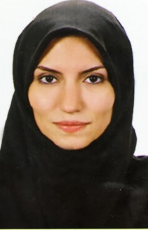   | Aysan Danesharasteh¹, Asst.Prof. Dr. Süleyman Balyemez²  ¹ IstanbulAydın University Institute of Science and Technology, Department of Architecture, ² Istanbul Aydın University Institute of Science and Technology, Department of Architecture  aysandanesha@gmail.com, suleymanbalyemez@aydin.edu.tr

Abstract: The urban problems caused by the industrialization have led to a decline in the quality of life in urban centers and a decline in urban spaces suitable for child development, this situation has increased the importance of urban parks as recreational areas where people can breathe, relax and enjoy their longing for nature. Accessibility to all recreational areas, which plays an important role on urban open space, should be arranged in such a way that people of all age groups can easily use them regardless of disability. The parks meet the needs of the people by leading them from the urban center to open areas. This study examined the functionality and accessibility of the zones in Elgölii Park in Iran Tabriz. Design and regulation principles of facilities and landscapes were evaluated in the context of the standards in Turkey, which would lead to the development of the park in the future.

Keywords: Urban parks, accessibility, Tabriz Elgöli Park.

Tebriz Elgöli Parkının Erişilebilirlik, Güvenlik ve Konfor Kriterleri Çerçevesinde İrdelenmesi

Özet: Sanayileşmenin beraberinde getirdiği kentsel sorunlar, kent merkezlerinde yaşam kalitesinin düşmesine, çocuk gelişimine uygun nitelikli kentsel mekanların azalmasına yol açmış, bu durum insanların nefes alabileceği, dinlenebileceği ve doğaya olan özlemini giderebileceği rekreasyon alanları olarak kent parklarının önemini arttırmıştır. Kentsel açık alan olarak önemli bir işlev üstlenen tüm rekreasyon alanlarının ve bu anlamda parkların erişilebilirliği, engelli ya da engelsiz farkı gözetmeksizin her yaş gurubundaki insanların rahatça kullanabileceği şekilde düzenlemelidir. Parklar kent halkını, kent merkezindeki yaşantılardan uzaklaştırarak, çeşitli ihtiyaçlarını karşılamaktadır. Bu çalışmada, İran Tebriz’deki Elgöli Parkının işlev alanlarının fonksiyonelliği ve erişilebilirliği incelenmiş, donatıların ve peyzaj öğelerinin tasarım ve düzenleme ilkeleri Türkiye’de geçerli olan standartlar bağlamında değerlendirilmiş ve parkın geleceğe yönelik gelişimine yol gösterebilecek çıkarsamalarda bulunulmuştur.

Anahtar kelimeler: Kent parkları, erişim, Tebriz Elgöli Parkı.

1. INTRODUCTION
Dense housing, concentration and rapid growth of population in urban centers following the industrial revolution have caused increase in number of people living in urban centers. Today, parks make a big contribution to move people away from the urban center’s adverse conditions, bring people close to nature and to eliminate of longing for nature and meet recreational requirements. Arrangement of parks, which are located in urban open spaces, in an accessible and freely usable way by people of all age groups whether handicapped or not, has importance. As such, functional areas like entrance of parks, pedestrian circulation paths, stairs, ramps, children playgrounds and parking lots as well as the floor coverings and urban furniture in foregoing areas should be arranged by taking into consideration the access and usage of all individuals. Elgöli Park is the biggest and most intensively enjoyed urban park of Tabriz. There are no works in the literature as to accessibility of people without handicap to this park. Accordingly, Elgöli Park of Tabriz/Iran, chosen as an example in this study, was evaluated in terms of accessibility by referring to widespread standards in Turkey determined through TSI 12576, Prime Ministry Department of the Administration of the Disabled (ÖİB), Ministry of Family and Social Policy, General Directorate of Services for Persons with Disabilities and the Elderly (ASPB) and Additional Technical Specification for Physical Environment and Constructions Accessible and Useable for Everyone (IMM).

Yıldızcı [1] states that open spaces can be utilized both as areas having a specific function such as agricultural areas and forest areas outside the city or as parks, gardens, squares and etc., which meet specific functions within the city. According to Özdengiş [2], open spaces can be divided into two main groups in terms of functionality as active and passive. They are also classified as urban green spaces and rural spaces areas according to the locations of their suitability for recreational activities, density of their green texture or their relationship with the city [2, 3]. Urban green spaces are grouped as green areas at the level of building, neighborhood unit, quarter unit and city while green areas at the urban unit level comprise urban parks and sports facilities [2, 4, 5, 6].
2. URBAN PARK CONCEPT
Urban parks consist of large green areas compared to neighborhood parks, equipped with some group units which are significant physically, psychologically and in terms of health for the city people [6]. Urban parks must be bigger than neighborhood parks and accessible and usable for healthy or disabled individuals in all age groups and include functions not covered by the neighborhood parks according to Aygün (2005). Moreover, urban parks are open green spaces which have to be located in focal points of the city in order to preserve the ecological balance of the city and meet the active-passive recreational needs of the city from all age groups [7, 8]. Adult individuals need areas of activity for relaxation and entertainment offered by urban parks in order to reduce the effects of exhausting daily routine, renew themselves, relax and become powerful spiritually. There must be integration between the functions included in the urban parks and visitors must be enabled to utilize the whole area of ​​the park [2]. Urban parks are areas which are typically located centrally and a part of the city visually. They have to be situated in easily accessible locations for people’s everyday use and ensure individual or collective activities such as walking, jogging, sitting outside, picnicking and playing games [8].

Urban parks provide opportunities for recreational activities and social and cultural interaction while eliminating the longing for nature for all members of the society suffering from the effects of daily routine. Morever, they provide space for furnishing game and education facilities for junior users in addition to opportunities such as exhibitions, shows and concerts for young people while creating healthier environments for middle aged and senior users. Furthermore, urban parks enable the cities to increase their tourism revenues by contributing to the development of the city’s fauna-flora, protecting the ecological balance, contributing to the city’s identity acquisition and promotion. Urban parks help to arrangement of human and vehicle traffic and ensure the creation of safe open spaces [8]. As such, urban parks should be arranged in an accessible and freely usable way by people of all age groups whether handicapped or not.
3. ELGÖLİ PARK AS A FIELD WORK SPACE
Tabriz is the largest city located in Iran’s north-west and the administrative center of East Azerbaijan Province. Official population of Tabriz, with an area 324 sq km, is 1,494,998 as of 2011 while Tabriz is Iran's fifth largest city in terms of population after Tehran, Mashhad, Isfahan and Kerej (Figure 1) [9].

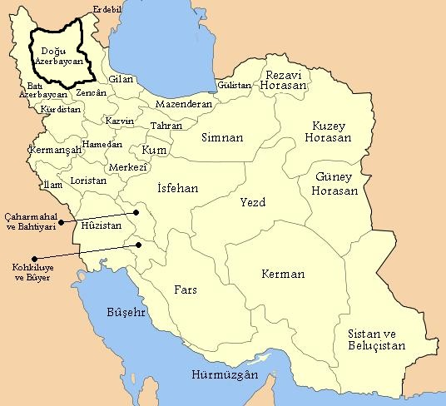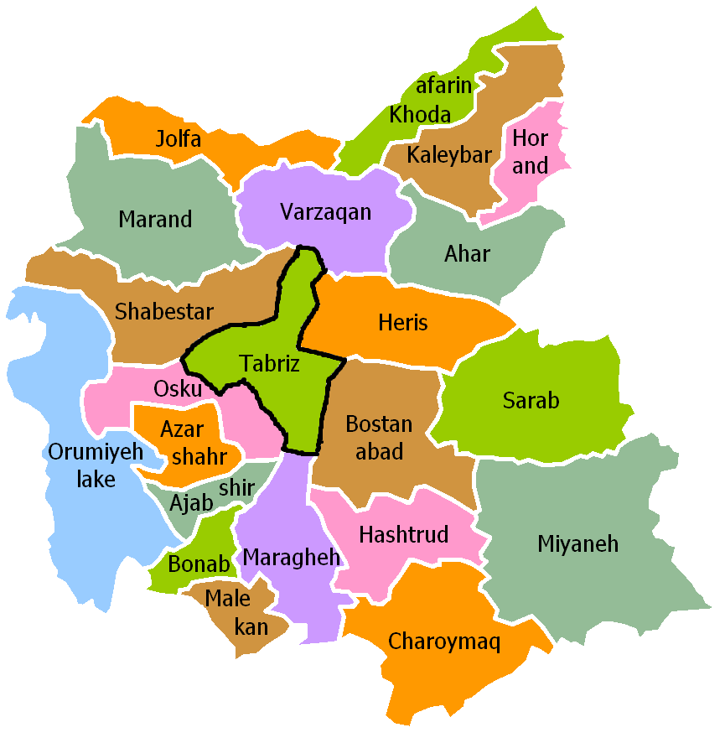
Figure 1. Iran's provincial map (left) and map of Eastern Azerbaijan (Right) [10]

Elgöli Park, situated in the south-east of Tabriz, is one of the city’s largest parks and most important places with an area of 70 ha [11]. In Iran, the districts are named with numbers. The map showing the districts of Tabriz, which consists of ten districts, is seen in Figure 2. As it can be understood from the map, Elgöli Park is located in the south of the 2nd district and close to the borders of the residential neighborhood of the city.

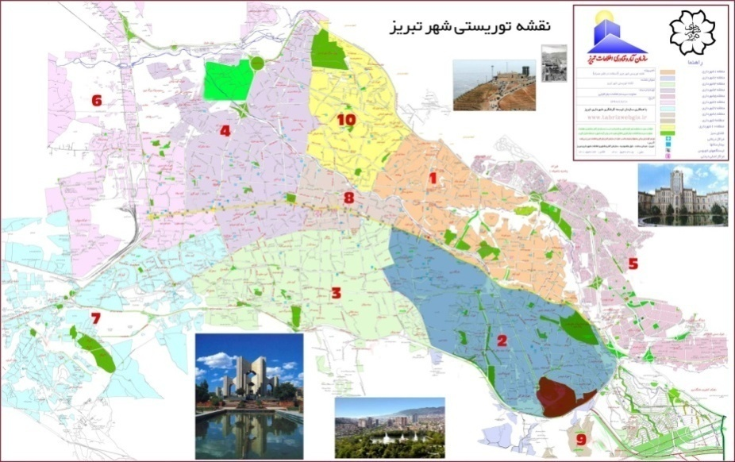
Figure 2. District borders of Tabriz metropolitan area and location of Elgöli Park
(indicated by red stain) [12]

Elgöli was built during the Aq Qoyunlu period (1378-1508) and expanded during the Safavid period (1501-1722). Elgöli was utilized as a reservoir for provision of water to big gardens surrounding Tabriz before the Safavid period [10]. In the Qajar period (1789-1925), following the Safavid period, a summer pavilion was built for the Qajar crown prince due to the beautiful, clean and cool air of the region and a street was built around the lake and various trees and roses were planted (Figure 3). Elgöli or the Shah Lake in the name of that period was planned to be converted into a public park in the Pahlavi period (1925-1979) and there for Elgöli was assigned to Tabriz municipality. Tabriz Municipality made some restorations around the lake’s coast around to convert Elgöli into an open park for everyone in this period, [13].

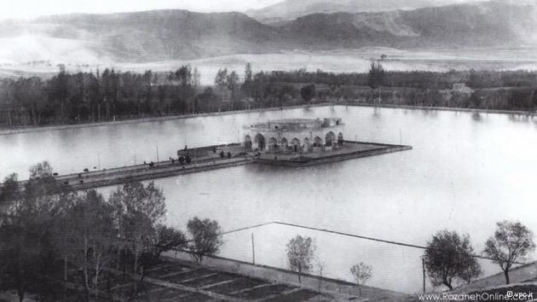
Figure 3. Elgöli kiosk during Qajar period [14]

The large octagonal building located at the center of the lake is known as the Elgöli kiosk. The building was made of adobe material and as a single-storey building in the Qajar period (Figure 3) and was reconstructed in Pehlevi period in 1945 through Tabriz Municipality as a two-storey building due to its being worn out (Figure 4). Today, this building is used as a big reception building [15].

The lake with an area of 5.5 hectare and with a depth of 12 m holds 720,000m³ of water. The lake was named as “Shah Lake” prior to the Iranian revolution however it was renamed as Elgöli Lake (People’s Lake) subsequent to the revolution (1979). The title “Shah” has been used for Iranian kings since ancient times. However, the word “Shah” used for the Shah Lake has not been taken from the Shah word used for Iranian kings but has presumably been named because the lake is grandiose and gorgeous (Figure 5) [16].

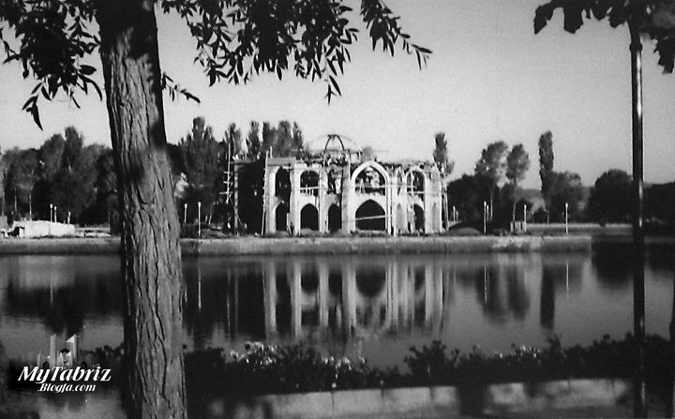
Figure 4. Elgöli kiosk constructed in 1945 [17]

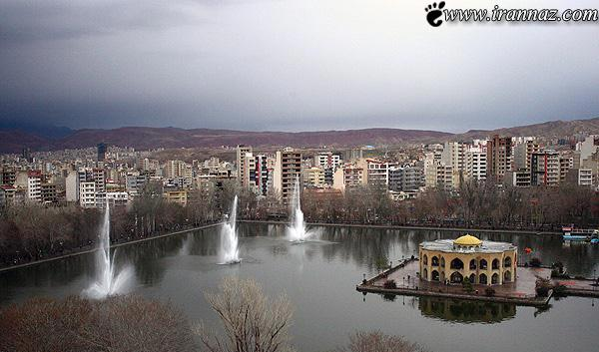
Figure 5. Elgöli park subsequent to the Iranian revolution [18]

Elgöli Park, layout plan of which is provided in Figure 6, is surrounded by a traffic way. There is a large hotel, indoor sports hall and football field at the south side of the park. In addition, there is also a large theater building on the east side of the park which is close to the main entrance. Elgöli Street, on the west side of the park hosting the 2nd, 3rd and 4th entrances, has a dense traffic flow with a giant traffic jam most of the day. This situation leads to difficult access to the park and it also affects the park’s utilization negatively by causing noise pollution. The park’s being crowded and noisy prevents users to spend their leisure time in a quiet and peaceful manner in open air. Opening of the subway station, construction of which is going on at the same street as well as taking measures to lower the effects of noise-caused adversities will be important steps for access and in order to reduce noise pollution.

3.1. User profile and utilization manner of Elgöli Park
Much as intensity of pedestrian utilization of Elgöli Park may vary within the day and in particular in summer and vacation days it has a very intensive utilization since it is the biggest urban park and one of the most important places of Tabriz. Elgöli Park is used more intensively in the afternoon and evening and many users are observed to enjoy the park also in the morning and at nights particularly in the summer season. Users utilize this park mostly as a place for picnicking and outdoor hiking along the coast of the lake. Inasmuch as Elgöli Park is a park open to public, it houses a variety of recreational activities fit for people of all ages, however teenager and children population group has a significant part compared to other park users. The reason why it has a higher usage in the evenings is that most of the users of Elgöli Park are working people who spend time with their families in the park after the working hours while their children play in the park. Various festivals are organized at the eastern part of the lake (close to the main entrance of the park). Families show a protective attitude for their children since the park is very crowded due to intensive use. Accordingly, it is observed that the children in the young age group cannot find efficient size of space to move freely.
4. PHYSICAL ASSESSMENT OF ELGÖLİ PARK
Elgöli Park is the biggest urban park of Tabriz city bearing also historical and cultural values. As mentioned in the introduction of the study, Elgöli Park was examined in titles by referring to the standards in Turkey and the physical accessibility thereof has been evaluated.

4.1. Entry points
Arrangement of entry points which enable access to the parks are of great significance for both pedestrian and car users. Elgöli Park has numerous entry points from different directions. Entries to the park have been arranged for pedestrian and vehicle entrances. The Second (main pedestrian entry), Fifth and Sixth entry points are employed only as pedestrian entries while the First (main entry), Third and Fourth entry points are utilized for both pedestrian and vehicle entries (Figure 6).

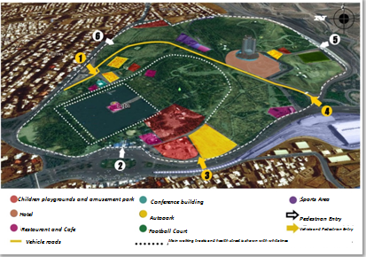
Figure 6. Layout of the Elgöli Park

Inasmuch as all entrances save the second entrance are far from the public transport stops, individuals using public transportation experience issues accessing the park from other entrances. As such, the second entrance, which is the main pedestrian entrance of the park, is the most used pedestrian entrance utilized by people using public transportation vehicles. Width sizes of all entrances of the area are sufficient and a ramp regulation is applied for the entrances with slope differences. There are ramps in all entrances to the park in order to reach the walking area along the lake. Furthermore, the Health Street, connected to the main entrance to access the upper parts of the park, is employed as a low-slope pedestrian path (Figure 7).

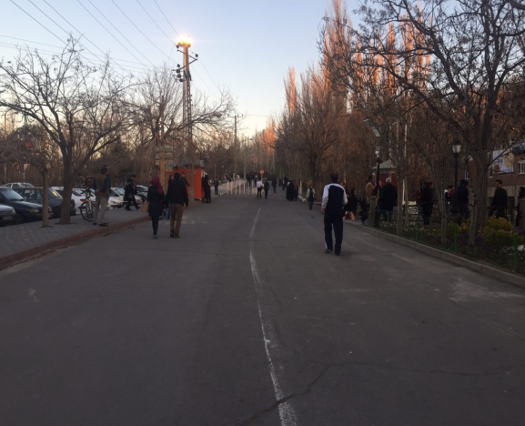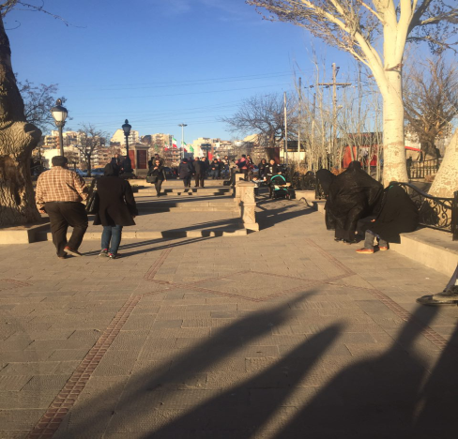
Figure 7. Health Street providing access to the upper parts of the park (left) and ramp at the main entry (right) (Aysan Danesharasteh’s personal archive)

4.2. Pedestrian ways
The main goal is to provide a clear surface without obstructions with sufficient width in pavement design for safe access of individuals with limited mobility and especially for the disabled in the society. These principles should be taken into account in the design of pavement and ramps in all urban open spaces such as pedestrian roads recreational areas and squares [19]. The ideal width for an obstacle-free pedestrian walkway should be at least net 1.50 meters while the optimum is 2.00 meters. The pavement width should be minimum 3.00 meters at bus stops and 3.50 meters in front of the shops [19]. The sidewalk width must be designed in order that a disabled person with wheelchair can turn with angles of 90 °, 180 °, 360 ° and make “U” turn [20]. The slope of the section of pavement should be kept less than 2% by ensuring that wheelchair users can move without any problems [19] and there should be no manhole grilles on the pedestrian crossings [21]. All walkways and sidewalks allocated to pedestrians in Elgöli Park are above the standard of 1.5 m. Movements of disabled people using wheelchairs are ensured more than adequate for their turns (Figure 8). The bicycle riding area and sports area are separate from the normal walkways of ​​the park. The area where the sportive actions are performed is called Health Street. Banning of bicycle riding and playing soccer applied on the lake side is not valid for the health road. This street is utilized more intensely in the morning hours of the day. There are numerous passages at the eastern and western sides of the lake for disabled people to come to the lake coast from the entrance areas (Figure 9).

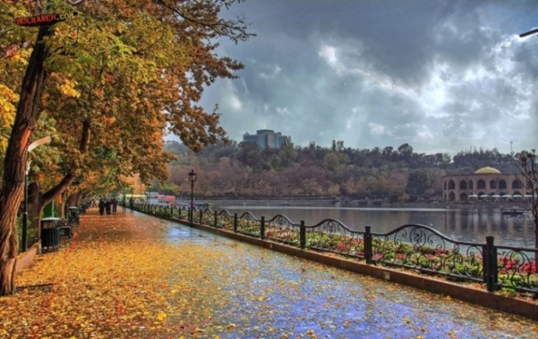
Figure 8. Lakeside walkways [22]

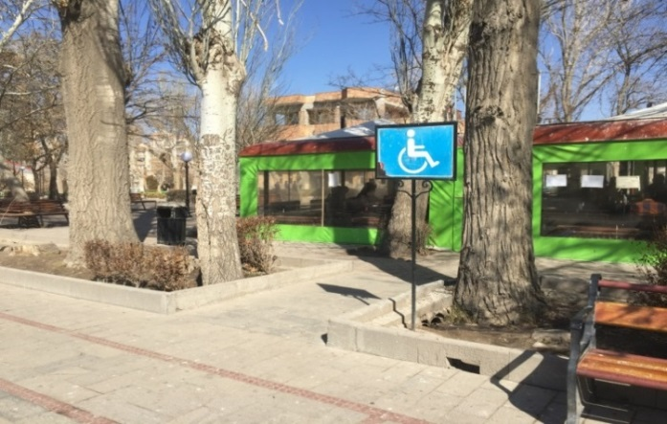
Figure 9. Access routes in walkways for people with disabilities (Aysan Danesharasteh’s personal archive)

Vehicle usage is prohibited on pedestrian roads. There are also pedestrian sidewalks on the roads allocated to vehicles. However, this creates a great deal of risk both to the people walking and especially the disabled and those who want to park their vehicles due to the depth of the water channels on the sides of these roads and the lack of grills in these channels (Figure 10). Plants, lighting elements, garbage cans and etc. on pedestrian paths do not have different texture and color contrasts to ensure that the disabled feel their surroundings and be alerted for it. This situation creates danger for visually impaired individuals. Furthermore, concrete pots and barriers placed in order to prevent vehicle access to walkways and especially to the Health Street, limit the width of the road thereby making passage difficult and dangerous for such visually impaired individuals. There are safety guards on the walkways near the lake. The height of the railings is suitable for protection of all age groups.

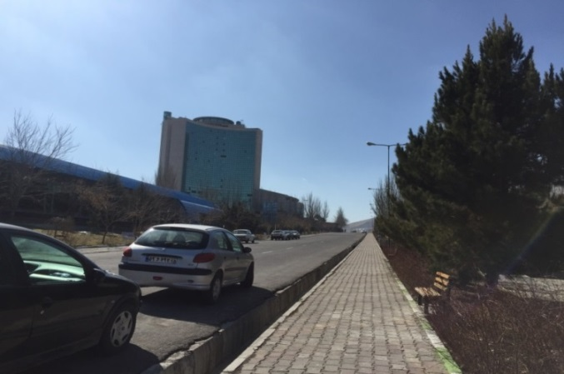
Figure 10. Roadside water channels (Aysan Danesharasteh’s personal archive)

4.3. Stairs
Stairs are typically employed to connect spaces with spaces having elevation difference in open areas in the shortest way. However, some requirements have to be met as to design and usage of stairs in open areas, taking into account the disabled, elderly and other individuals with restricted movement within the society. Furthermore, the step height must be at least 15 cm while the step width must be at least 30 cm. There must be no difference in height between the steps and all steps should be at equal height in the step group in the stairs [23]. If the height difference is more than 1.8 m on the ways with stairs continuing in the same direction depending on the topographical structure of the land there must be a stairhead of 2 m between the stairs and at the beginning and at the end of the stairs there must be a surface with a flat and different texture in the length of 1.2 m for the visually impaired people. The sensible surface should be at least 60 cm wide and must be different with its different color and texture. This surface should start at the bottom just before the first step and be placed after leaving a space same with the width of the staircase at end of the stairs at the top [21]. There must be handrails on both sides of the stairs and, if there is a wall on the sides of the stairs then a railing must be placed. A rail guard should be placed with a maximum height of 45 cm between the railing and the step floor [23].

Going of stairways in different regions of the Elgöli Park have a width of 30-40 cm and while their height is 12-15 cm. So, it is observed that both riser and step measurements of stair units are suitable(Figure 11). When the staircases in the Elgöli Park are examined generally, it is observed that their material types are suitable, their surfaces are rough, stable and non-slippery and well maintained and in this respect they are fit for disabled people. Although there should be coating material with a length of 1.2 m with flat and different texture at the beginning and end of the stairs for the visually impaired people, this is not present in any staircase in the Elgöli Park. There are parapets made of stone on both sides of the stairs (Figure 11). Inasmuch as the stairs on the southern side of the lake have many steps, the stairheads are quite wide and many stairheads have been designed in connection with the sitting areas and walkways (Figure 11).The lighting elements around the staircase provide sufficient light for the staircase.

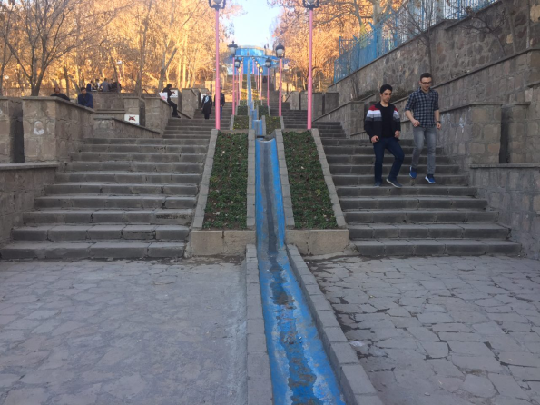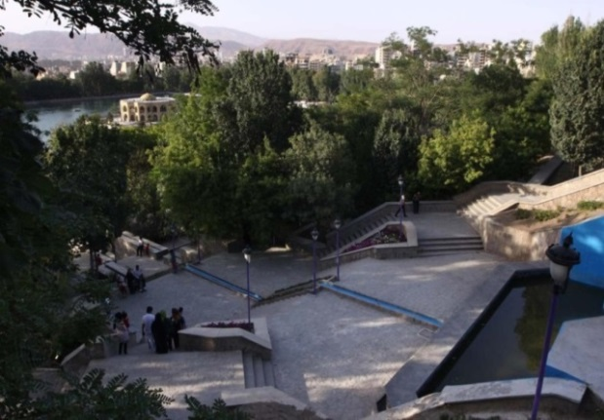
Figure 11. Lakeside stairs (left) and stairhead sample (right) (Aysan Danesharasteh’s personal archive)

4.4. Ramps
Ramps are utilized on the sidewalks, at crosswalks, at the entrances of the buildings, briefly, to eliminate the height differences on the walking ways of the pedestrians or while they partake in an activity. The main target, when designing ramps, should be to provide ergonomically required conditions while wheelchair users, people with baby carriages and visually impaired people when they have to eliminate height differences [19]. Much as the ramp size may vary due to elevation difference between two levels, the intensity of use, it is stated in the guide of the United Nations (2004), titled “Accessibility for the Disabled: A Design Manual for a Barrier Free Environment”, that the width of the plain ramps should be at least 90 cm and 140 cm in turn ramps [19]. There must be a stairhead at least with an area of 2.50 meters for resting in ramps that are longer than 10 m and exceeding the elevation difference of 50 cm. If there are more than one successive ramps the same rule should be applied [21]. The slope should be maximum 8% in ramps up to length of 10 meters and maximum 6% on ramps longer than 10 meters. The standards determined by Prime Ministry Department of the Administration of the Disabled (ÖİB) are partially different. The cited values ​​are provided in Table 1.

Table 1. Dimensions of a ramp [19]
Maximum  Slope | Maximum Length | Maximum Elevation Difference
1:20 (5%) | - | -
1:16 (6%) | 8.00 m | 0.50 m
1:14 (7%) | 5.00 m | 0.35 m
1:12 (8%) | 2.00 m | 0.15 m
1:10 (10%) | 1.25 m | 0.12 m
1: 8 (12%) | 0.50 m | 0.06 m

For wheelchair users, a protection border of at least 5 cm height should be made on the sides of the ramps which do not have guard rails [21]. Furthermore there should be a flat space 150 cm in length and different texture at the beginning and end of the ramps for the visually impaired persons. The surfaces of the ramps must be covered with hard, stable, non-slip and very less roughened material. The roughness on the surface should not create differences more than 0.2 cm [21].

The length of the only ramp at the first entrance area of the Elgöli park which attracts attention in the park is 18 m while its slope is 6% and width is 1.5 m (Figure 12). This ramp is within the appropriate limits according to the TSI (Turkish Standards Institution) however it slightly exceeds the limits of Prime Ministry Department of the Administration of the Disabled (ÖİB). It is observed that there is a protection border on the sides of the ramp. The surface of the ramp is fit for use of walking-disabled individuals. However, there is not a flat surface in length of 1.5 m with different texture for visually impaired persons at the beginning and end of the ramp. There are no ramps on the sides of the stairs inasmuch as the stairs around the lake area of ​​the park are long and the slope of the land here is not suitable for making ramps. As such, the street in the south-east of the park is utilized as a pedestrian way for disabled people to reach the upper parts of the park, and functions as a low-slope ramp for disabled people (Figure 12).

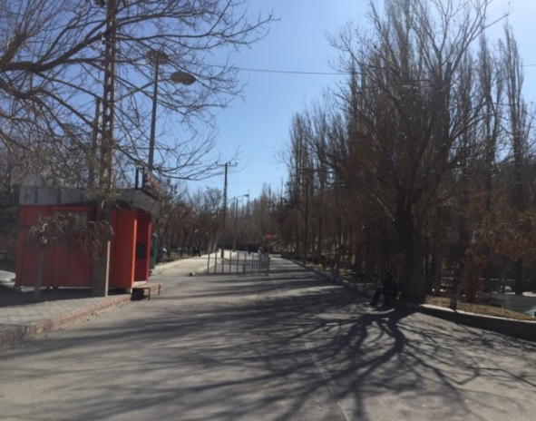
Figure 12. Health Street going to the upper parts of Park (right)
(Aysan Danesharasteh’s personal archive)

4.5. Pavement flooring
The material to be used for covering the pavement and walkways should be slip resistant and make walking easy. There must be no sudden level changes on the road surface, manhole covers must not protrude while there must be continuity at ground level. [21]. In addition, guide marks should be formed consisting of embossed surfaces that can be felt along the way in order that visually impaired people can easily find the route [19]. In this way, texture differences must be created on the surface of the equipments in order that locations of equipments can be felt by visually impaired persons [21]. The color of the guide marks must be selected in such a way as to contrast with other surrounding surface colors, while the embossed surface height of the material used should not pose an obstacle for wheelchair users [19].

Pavement flooring materials such as asphalt, slate and stone, concrete and paving stones have been employed in Elgöli Park. The slate is geologically composed of mudstone, siltstone, shale and volcanic ash. The layer surfaces of the slate which are separated naturally have a rough structure [24]. These materials are not fit for people with disabilities due to the wide and irregular joints which form between them, especially in the laying of slate stones (Figure 13). Moreover, although asphalt and stone pavement covering generally does not create difficulty in walking, it needs constantly maintenance due to climate of Tabriz and quality of the stone material used on the pedestrian paths of the park is not suitable for the park. For this reason, pavement covering must also be made again at some points in the park. It is important that the pavement covering to be used in the park should be considered as to comply with other landscaping items and urban furniture in color and material so that meaning and value is added to the space. There are no surfaces consisting of embossed surfaces that can be felt along the way on any walkway of the park in order that visually impaired people can easily find the route. As such, various problems are experienced in utilization of the park by the visually impaired people. This is one of the most significant issues of the park (Figure 13).

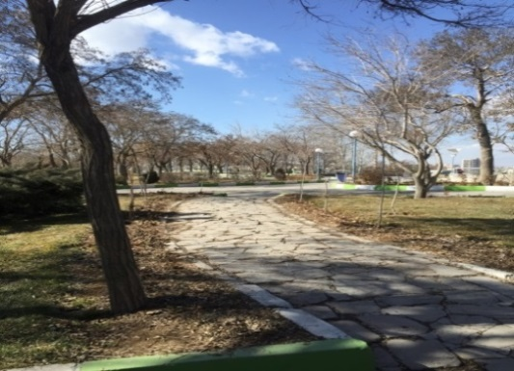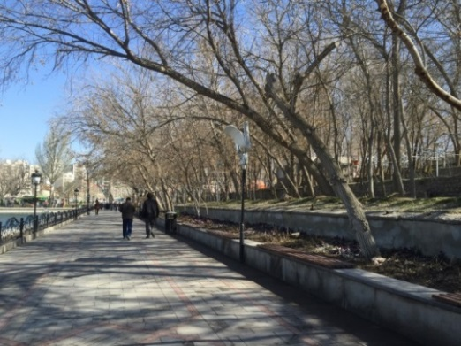
Figure 13. Pedestrian paths made of slate (left) and cobblestone(right) in Elgöli Park (Aysan Danesharasteh’s personal archive)

4.6. Children’s playgrounds
One of the most substantial design elements is safety. This subject is even more important for juvenile age groups. It is recommended that different age groups should play separately and if they will play in the same place, safety measures must be taken by considering the lowest age group [25]. Furthermore, safety barriers must be provided for children to prevent falls for safety in the playground, and materials having surface safety which will not cause injury such as grass, sand, rubber and etc., should be chosen on the ground for children against risks of falling and injuries [4, 26]. The furnishings should be plain, with little detail, well sanded and with rounded and blunt corners. In addition, the paints and colors used should not give harm to the health of the child. They should be appropriate for the language, intelligence, creativity, body and muscle development of the child ad must be fit for the child’s age, development level and height while the child’s sense of sharing should be developed. Their maintenance and repair should be easy and they must be cleanable [4]. Accessibility of children with disabilities to the playground is the first important issue to enable them participate in outdoor activities. Arrangement of pedestrian areas in a way that children using wheelchairs can move freely should also bed ensure for children with disabilities while playground equipments in the playground must be fit for use thereof by children with disabilities[27].
Elgöli Park has 4 children’s play areas. These are known as First Playing Area, Second Playing Area, Autism Park and Amusement Park (Figure 14).

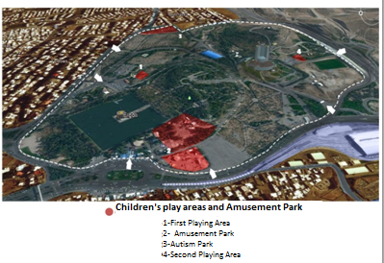
Figure 14. Playgrounds located in Elgöli Park

The first playground is situated in the south-east of Elgöli Park and is the closest playground to the lake and parking lot (Fig. 14). However, it has a very small area (Figure 15). This playground is built in the living areas located at the lake coast and is suitable for children in the small age group.

The second playground is situated away from the lake and the residential areas in the south part of Elgöli Park. This playground is situated behind the big Pars Hotel in Elgöli Park. This playground is accessed from the entry point on the Kesmai Tehran Highway (Figure 14). It has a very small area for the time being since the construction of the second play area is not yet completed, and as such it has only one game unit. Therefore, it is not preferred by both children and parents compared to other playgrounds. Its location in the park and its being far from public transportation stops are also important factors in its low utilization rate (Figure 15).

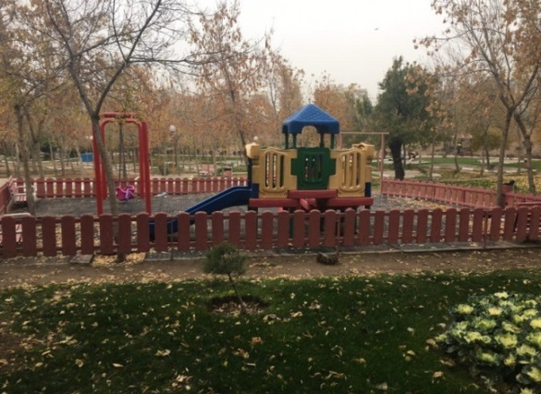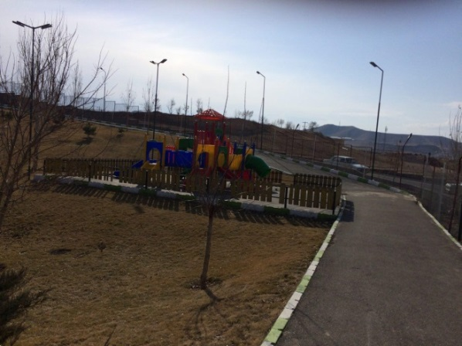
Figure 15. First playground (left) and second playground (right) (Aysan Danesharasteh’s personal archive)

The first autism park in Iran, designed in line with the needs of autistic children, is situated in the south-east of Elgöli Park (Figure 14). The use of water elements, game elements and the elements made in the form of animals in this playground were made suitable for autistic children. This playground is more suitable for children aged 3-8 in the general sense. The sports elements such as basketball hoop and tennis table in the Autism Park are used for older children (Figure 16). Game groups comprise slides, seesaws, swings, balance elements, sand pools, animal cages and water surfaces. There is a long walking distance to reach this playground because the autism playground is far from the most important areas of Elgöli Park. It is also far from public transport stops. Individuals using public transport have issues accessing this playground inasmuch as Elgöli Park has a very large area.

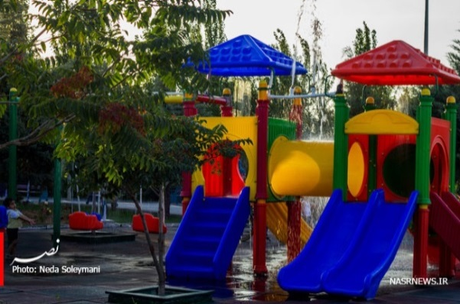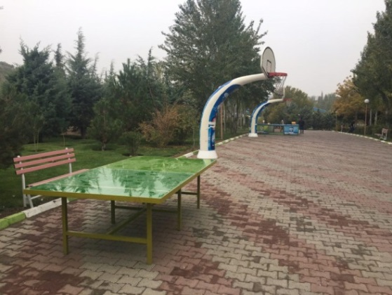
Figure 16. Autism park (left) [28] and sports elements in Autism Park (right) (Aysan Danesharasteh’s personal archive)

The amusement park is situated on the west and south west of Elgöli Park and on Elgöli Main Street. The amusement park can be entered both from the Elgöli Main Street and the south west of the Elgöli Park Lake. The Amusement Park, which is situated close to the lake and other sitting areas,
mostly houses units and activities for children in the older age group and adults. Access to the park is quite comfortable thanks to its location. It is close to public transport stops (Figure 17).

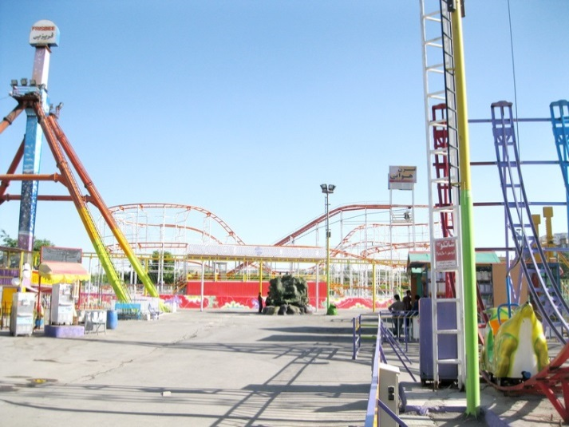
Figure 17. Amusement park (Aysan Danesharasteh’s personal archive)

The pavement covering of the First, Second and Autism playgrounds consist of a rubber-based material and is appropriate in terms of comfort and security. However, the pit occurring due to stripped playground covering under the swing in the autism park poses a potential danger for children. Moreover in the first game area, no fillings have been used around the tree trunks which create a level difference on the ground again posing a danger to children (Figure 18). Furthermore, the amusement park has been designed to serve not only children but also to adults and its pavement covering is made of asphalt and cast concrete. As such, it does not protect the children against the risks of falling and being injured.

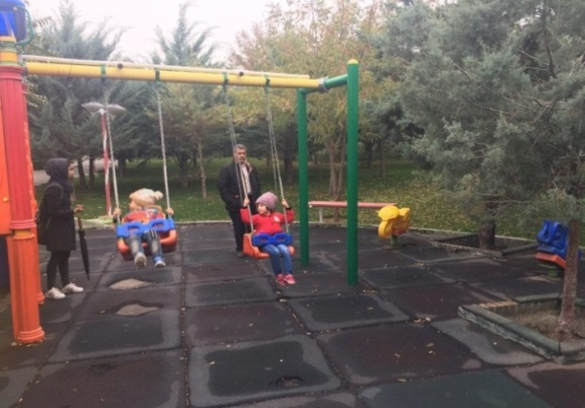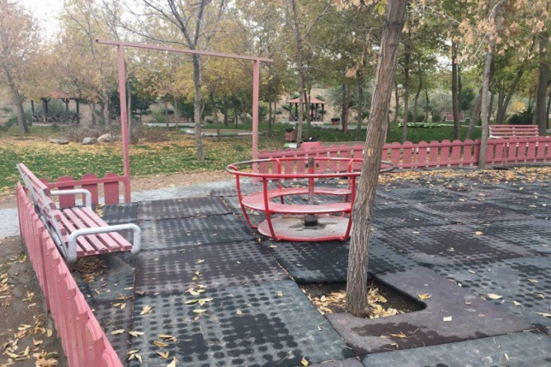
Figure 18. Stripped playground covering in the Autism Park stripped (left) and formation of level difference in the First playground (right) (Aysan Danesharasteh’s personal archive)

There is no age group seperation in any playground in Elgöli Park. As such all age groups utilize playgrounds together. This situation causes a risk of negative social and physical effect on children. Particularly in the First and Second playgrounds, the number of equipments is not sufficient and the children are bored and cannot spend much time inasmuch as they are designed only for the children in the small age group. On the contrary, in the Amusement park playgrounds are fit for use of older age groups and there are fewer options for children of younger age groups. The playing equipments comprise completely electric devices which have limited effects on children's physical development.

The materials of all the playgrounds are suitable for child safety in general however the playing elements are not clean and well maintained in the first playground. Especially the deformations in the chains of the swings pose risk, and there is vital risk for children in the second playing field due to the fact that some parts of playing elements are broken basing on lack of maintenance (Figure 19). The most significant issue of the playgrounds within the Elgöli Park is that they do not house special playgrounds for children with disabilities. As such, they are not fit for physically and visually impaired children. Surroundings of the first and second playgrounds located close to the parking lots are surrounded by fences in order to prevent children from running out to the parking lot.
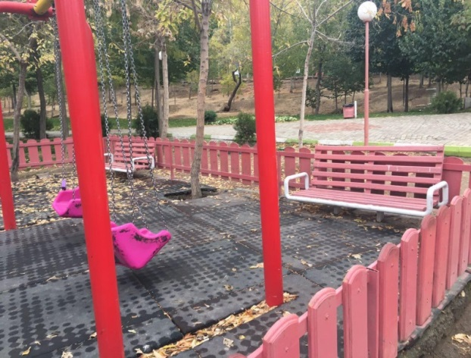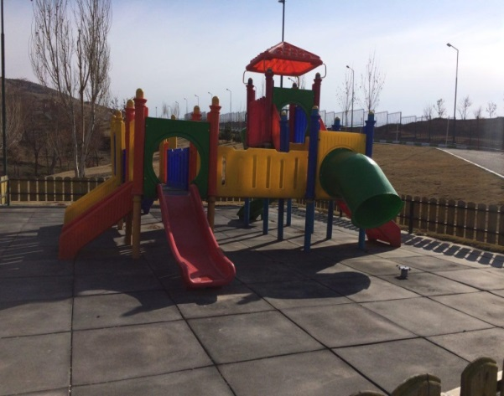
Figure 19. The detail as to the swing in first playground (left) and slide detail posing risk in the second playground (right) (Aysan Danesharasteh’s personal archive)

4.7. Parking Lots
According to TSI (Turkish Standards Institution) [21] norms, open car parks must have a smooth surface preventing slipping and there should be orientation arrows on the ground and poles. Parking spaces allocated to disabled persons in the public areas should be at the closest point to the entrance and exit of the relevant facility. In such areas, the sidewalks should be lowered to “0 cm” or “+3 cm” in line with the level of the vehicle way. Furthermore, there must be a disabled parking sign indicating that the vehicles of disabled persons can park in addition to plates showing the way to the disabled parking lot and signs within the parking lot must be illuminated during the night [21].

There is enough lighting in the parking lot for illumination during the night. On the other hand, there are no parking spaces allocated to disabled persons in Elgöli Park. Furthermore, there are no plates or signs showing the entry and exit.

8.4. Other items
Many lighting standards have been established by predicting the height of an adult human standing eye. The eye-line height of wheelchair users is about 1.19 m [29]. Height of the lighting elements must be at least 220 cm, so as to allow the passage of the pedestrians and particularly the visually impaired persons to pass safely and be suitably placed so as to provide a sufficient level of illumination.
The height of lighting elements of the Elgöli Park is 2.30 m to 2.50 m. The level of illuminationin the park is extremely sufficient. Elgöli Park has a quite spectacular appearance at nights, making it a center of attraction for everyone. Furthermore, lighting elements in the park have a significant role for safety and comfort of the users.

Elgöli Park is quite rich in terms of plant variety and number. The height of the branches of the plants extending to the walkways of the park does not pose risk. However, there are no surfaces or guard rails visually impaired persons which the can feel on the line separating the walkways and planted areas.
Waste containers should be installed with minimum 90 cm and maximum 120 cm height from the ground and at least 40 cm away from the curb stone at the side of the pedestrian sidewalk in a way not to impede the pedestrians’ movements [23]. The waste containers in Elgöli Park are made of metal and are placed on the roadside in a fixed manner not impeding with the movement of the individuals. Furthermore, the height measurements of waste containers in the park are suitable for the standards since their height is 1m. There are sufficient waste containers in the park. However, they are susceptible to visually impaired individuals since there are not areas with different textured materials surrounding them to indicate their presence.

The height of the sitting unit should have a height of 45 cm and the backrest should have a height of 70 cm from the ground, [21]. The height of sitting elements from the ground is 40-45 cm while the backrests have a height of 82 cm from the ground in Elgöli Park the ground. These measurements are in accordance with the standard. The sitting units are made of wood and metal and are sufficient in number in important areas of the park.

5. CONCLUSION
The Elgöli park has issues in terms of accessibility to park from the outside and to certain areas within the park itself. Nevertheless, it is an urban park which is visited extensively by Tabriz people of all ages with or without disability and it is the most important open green area of ​​the city. Although it can be said that the circulation network in the park is relatively convenient for physically handicapped people, foregoing is not true for visually impaired people. Another important issue within the park is observed in playgrounds. The playground has been arranged without taking into consideration children with disabilities and different age groups. There are dangerous points for children as a result of negligence and carelessness. There is also the issue of access to some playgrounds.

The gorgeous park rising over the historical and cultural richness of Elgöli will be a role model in this region of the country in terms of functionality and human values by virtue of the revisions to be made in the light of these evaluations. In this regard, firstly urban administrators and urban planning, urban design and ergonomics specialists have more important duties to carry out.

REFERENCES
[1] Yıldızcı, A.C., Relations Between The Urban Tissue and Green Tissue in Istanbul and a Proposal for the Green Space System Istanbul, PhD Thesis, Istanbul Technical University, Faculty of Architecture, Istanbul, 1978. .
[2] Özdingiş. N., A Research on Evaluation of Istanbul Urban Parks As Regards People with Physical Disabilities, M.Sc. Thesis, Bahçeşehir University, Institute of Science and Technology, Istanbul, 2007.o
[3] Özdemir, B. Evaluation of Some Urban Parks in Konya Province As Regards User Preferences, M.Sc. Thesis, Selçuk University's Institute of Science, Konya, 2013.
[4] Bal, A., Examination of children's playing areas in terms of landscape architecture principles in Zonguldak province’s green space system, M.Sc. Thesis, Karaelmas University, Institute of Science and Technology, Bartın, 2005.
[5] Öztürk Levend T., Examination of open and green spaces of Bayrampaşa district of Istanbul province in terms of quality and quantity , M.Sc. Thesis, Selcuk University Institute of Science, Konya, 2008.
[6] Demir, Z., 2004, Bringing in New Functions to Open and Green Areas in Düzce’s New Urbanization Process, PhD Thesis, Istanbul University, Institute of Science and Technology, Istanbul, 2004.
[7] Ertekin, N. Studies on Determination, Protection and Development of of Flora of Kültürpark Which Has Importance for Izmir Province as Green Area, Master Thesis, Ege University, Department of Landscape Architecture , İzmir, 1992.
[8] Özkır, A., 2007. Development of Urban Parks Management Model. PhD Thesis. Ankara University, Institute of Science and Technology, Ankara, 2007.
[9] URL-1. https://www.amar.org. is, last accessed on 02 January 2017.
[10] URL-2. http://iranrehberi.net, last accessed on 02 January 2017.
[11] Eslami, F., Tabriz, city of beauties, Iran, Tabriz (Persian) 2009.
[12] URL-3. http://www.ourism.tabriz.ir, last accessed on 02 January 2017.
[13] Maasumi, A., Tabriz province, Iran, Tehran (Persian), 1999.
[14] URL-11. Akharin news, http://www.akharinnews.com , last accessed on 02 January 2017.
[15] Rahnemayeshahsavar, N., Tabriz, the oldest city of History , Iran, Tabriz (Persian), 2003.
[16] Khamachi, B., Tabriz, my city, Iran, Tabriz (Persian), 2007.
[17] URL-4. http://www.citypedia.ir, last accessed on 02 January 2017.
[18] URL-5. http://www.irannaz.com, last accessed on 02 January 2017.
[19] ÖİB., Basic Information Technical Manual on Accessibility for Local Administrations, Prime Ministry Department of the Administration of the Disabled (ÖİB), Ankara, 2010.
[20] Gökçe, D., Usage Opportunity of the Parks by Individuals with Disabilities in Antalya Province’s Atatürk Kültür Parkı example, M.Sc. Thesis, Akdeniz University, Institute of Science, Akdeniz, 2012.
[21] TSI ., Design Rules for Intracity Roads,Alleys, Streets, Squares and Structural Measures and Marking for disabled people , TSI 12576. TSI Institute Publications, 1999.
[22] URL-6. http://www.tourismonline.com, last accessed on 02 January 2017.
[23] ASPB., Accessibility Implementation Guide for Individuals with Disabilities at Special Care Centers, the Turkish Ministry of Family and Social Affairs, General Directorate of Services for Persons with Disabilities and Elderly People 2013.
[24] URL-7. http://www.sefatas.com, last accessed on 02 January 2017.
[25] Kuşuloğlu, D.D, Qualitative and Quantitative Evaluation of the Children's Play Area in Kadıköy District of Istanbul Province, Master Thesis, Istanbul Technical University, Institute of Natural Sciences, Istanbul, 2013.
[26] Yılmaz, Ş.,, Evaluation of Utilization of Playgrounds by Users Studying Primary School and Determination of Design Principles , Master Thesis, Istanbul University, Institute of Natural Sciences, Istanbul, 2010.
[27] Çetin, G. Examination of Adequacy and Quality of Playgrounds in the Üsküdar district , Master Thesis, Istanbul Technical University, Institute of Natural Sciences, Istanbul, 2003.
[28] URL-8. https://www.nasrnews.ir, last accessed on 02 January 2017
[29] IMM., Additional Technical Specifications for Accessible and Usable Buildings and Physical Environment for everyone .Istanbul, 2012.

AYSANRMIN DANESHARASTEH; Arch,
Received her B.Arch (2012) from Tabriz Azad University, Faculty of Architecture, Department of Architecture and M.Sc. in Architectural Design (2017). After completing his undergraduate studies, she has worked in Pol Builder Construction Company in 2012-2013, and has worked Tersim Mokhtesat Construction Company, Department of Architecture in 2015-2017 in Iran.

SÜLEYMAN BALYEMEZ, Asst. Prof. Dr.,
He graduated from Istanbul Technical University, Faculty of Architecture, Department of Urban and Regional Planning. He earned his Master’s and Doctoral degrees in the same university in Urban Design and Urban and Regional Planning, respectively. His major fields of study involve Disaster Management, Risk Mitigation Planning, Urban Renewal, Community Involvement, City and Planning History, Mega Projects and Sustainability. In addition to his academic position in Faculty of Architecture and Design, he continues to work as Vice Director of Istanbul Aydın University Graduate School of Natural and Applied Sciences.

