EFFECTS OF THYMOQUINONE, ZEOLITE AND PLATELET RICH PLASMA ON THE HEALING OF ISCHEMIC COLONIC ANASTOMOSIS

İskemik Kolon Anastomoz İyileşmesinde Timokinon, Zeolit ve
Plateletten Zengin Plazmanın Etkinliği

Faruk PEHLİVANLI¹, Gökhan KARACA², Oktay AYDIN³, Canan ALTUNKAYA⁴,
İbrahim Tayfun ŞAHİNER⁵, Hüseyin ÖZDEN⁶, Hafize UZUN⁷, Mevlüt Recep PEKCİCİ⁸

^{1,2,3} Kırıkkale University, Faculty of Medicine, Department of General Surgery, KIRIKKALE, TÜRKİYE
⁴Kırıkkale University, Faculty of Medicine, Department of Pathology, KIRIKKALE, TÜRKİYE
⁵Hitit University, Faculty of Medicine, Department of General Surgery, ÇORUM, TÜRKİYE
⁶Ahi Evran Unıversıty Medical Faculty, Department of General Surgery, KIRŞEHİR, TÜRKİYE
⁷Istanbul University, Department of Biochemistry, İSTANBUL, TÜRKİYE
⁸Ankara Training and Research Hospital, Department of General Surgery, ANKARA, TÜRKİYE

ABSTRACT | ÖZ
Objective: Anastomosis on ischemic intestines is a problematic issue in daily surgical routine. In this study, we investigated the potential effects of thymoquinone, zeolite and platelet rich plasma.  Material and Methods: Fifty rats were divided into five groups. In the sham group all rats underwent colonic anastomosis without any ischemic insult. Colonic anastomosis was performed after mesenteric ischemia was induced by clamping the superior mesenteric artery in other study groups. In the control group, no medication was given to the rats after ishemic anastomosis. In Zeolite group and thymoquinone group, Zeolite and thymoquinone were applied locally on the anastomosis. In the platelet rich plasma group, platelet rich plasma was applied locally on the anastomosis. All the rats were sacrified on the 10th day. Blood and tissue samples were retrieved.  Results: Hydroxyproline levels were not different between the groups. Bursting pressure was higher in the thymoquinone group than the control group. Reepithelization was higher than the zeolite group in the sham and thymoquinone groups. TNF-α and IL 1β levels were significantly higher in the sham group than all the other groups. TNF-α and IL 1β levels were also significantly higher in the thymoquinone, zeolite and platelet rich plasma groups than the control group and higher in the thymoquinone group than the zeolite and platelet rich plasma groups. Inflammation and ischemic necrosis levels were not different between the groups.  Conclusion: Our data is suggesting that thymoquinone and platelet rich plasma have positive effects on ischemic anastomosis healing, while thymoquinone has the best results. | Amaç: Günlük cerrahi rutinde iskemik barsakların anastomozu önemli bir sorundur. Biz bu çalışmada timokinon, zeolit ve plateletten zengin plazmanın potansiyel etkilerini araştırdık.  Gereç ve Yöntemler: Toplam elli rat beş gruba ayrıldı. Sham grubuna iskemi olmaksızın kolonik anastomoz yapıldı. Çalışma gruplarında superior mezenterik arterin klemplenmesiyle oluşturulan mezenterik iskemi sonrası kolon anastomozu yapıldı. Kontrol grubuna iskemik anastomoz sonrası ilaç verilmedi. Zeolit, timokinon ve plateletten zengin plazma grubunda ilaç lokal olarak uygulandı. 10. günde ratlar sakrifiye edildi, doku ve kan örnekleri alındı.  Bulgular: Hidroksiprolin seviyelerinde gruplararası fark yoktu. Patlama basıncı timokinon grubunda kontrol grubuna göre daha yüksekti. Reepitelizasyon sham ve timokinon grubuna göre zeolit grubunda daha yüksekti. Sham grubunda diğer gruplara kıyasla TNF-α ve IL 1β düzeyleri anlamlı olarak yüksekti. Ayrıca TNF-α ve IL 1β düzeyleri timokinon, zeolit ve plateletten zengin plazma gruplarında kontrol grubuna göre anlamlı olarak yüksekti ve bu üçü arasında timokinon grubunda en yüksekti. İnflamasyon ve iskemik nekroz seviyeleri arasında gruplar arası anlamlı fark yoktu.  Sonuç: Sonuçlarımız timokinon ve plateletten zengin plazma’nin iskemik anastomoz iyileşmesi üzerine olumlu etkileri olduğunu göstermiş ve timokinon ile en iyi sonuçlar elde edilmiştir.
Keywords: Nigella sativa, zeolite, platelet rich plasma, ischemia, anastomosis | Anahtar Kelimeler: Nigella sativa, zeolit, plateletten zengin plazma, iskemi, anastomoz

INTRODUCTION
Management of intestinal ischemia and ischemic intestinal wounds are very problematic in daily surgical routine. Since the intestines are supplied by terminal arteries, prolonged ischemia can cause irreversible damages on intestines. Investigators are trying to reduce the damages caused by ischemia. Numerous substances and procedures have been tested for a long time and research is continuing on this subject. But the research about the management of ischemic intestinal wounds and anastomosis has not given very successful results so far.
Natural Zeolites have specific non-biological properties. In addition, their long-term physical–chemical stability in biological environments give rise to the idea that it can be of use in different biological settings. They can be used as antibacterial agents, diet additives and vaccine adjuvants. They are also suggested for anti cancer therapy and ion exchange in hemodialysis (1).
Thymoquinone (TMQ) is a plant extract (active derivative of Nigella sativa or black seed) that has been shown to have antimicrobial, anti-inflammatory, and antioxidant effects (2-4).
Platelet rich plasma (PRP) is shown to contain growth factors with demonstrated cytoprotective properties (5). It is also shown to have positive effects on diabetic ulcers on humans with critical limb ischemia (6). PRP is also shown to be effective on the healing of colonic anastomosis (7,8).
In this study, the potential effects of Zeolite, TMQ and PRP on colonic anastomotic integrity and healing in an experimental ischemic colitis model is investigated.

MATERIALS AND METHODS
The study was carried out under the permission of the local Ethics Committee of Experimental Animal Studies of Kırıkkale University (Date: 09.01.2014, number: 2014/10) and according to the “Principles of Laboratory Animal Care” (NIH Publication Vol 25, No. 28 revised 1996; http://grants.nih.gov/grants/guide/notice-files/not96-208.html) and ARRIVE Guidelines. Fifty-five Wistar Albino male rats weighing between 300-350 g were used for the study. The number of animals in each group was the least number required to run statistical analysis.
Preparation of PRP: Under general anesthesia, 15 ml of blood was sampled by open cardiac puncture from 5 rats which were sacrificed afterwards. The blood samples were centrifuged and the PRP was prepared by buffy coat method as described by of Dhurat and Sukesh (9).
Study Groups: Fifty rats were divided into five groups each consisting of 10 rats. In the sham group, all rats underwent colonic anastomosis without any ischemic insult. Left colonic end-to-end anastomosis with a single layer of 5/0 interrupted polypropylene sutures performed after mesenteric ischemia induced by clamping the superior mesenteric artery for 20 minutes was the standard surgical intervention in other study groups. In the control group, no medication was given to the rats after ishemic anastomosis. In Zeolite group and TMQ group, Zeolite (2mg/1ml saline) and TMQ (2mg/1ml saline) were applied locally on the anastomosis. In the PRP group, PRP (1 ml) was applied locally on the anastomosis. All the rats were sacrified on the 10th day. Blood and tissue samples were retrieved for biochemical and histopathologic examination.
Histopathological Evaluations: Tissue samples kept in 10% formaline were embedded in paraffin blocks. Haematoxyline eosine was used to stain five-micron-thick tissue slices. A blinded pathologist examined the tissue samples under light microscopy (U-MDOB3, Olympus, Tokyo, Japan). Presence of inflammatory cells, reepithelization of anastomotic mucosa, breakdown of muscular layer, and inflammatory infiltration at the anastomotic line were the surrogate parameters chosen to study histopathologic effects of the substances on ischemic colonic healing (Tables 1,2,

Table 1: Reepithelisation of anastomotic mucosa (components)
Grade 0 | No epithelisation at anastomotic line
Grade 1 | Incomplete coverage of the anastomotic line with a single cell layer
Grade 2 | Complete coverage of the anastomotic line with a single cell layer
Grade 3 | Complete reepithelisation with glandular epithelium

Table 2: Destruction of muscular layer
Grade | Ischemic necrosis | Completeness of muscular layer | Inflammatory Inflammation
Grade 1 | None | Complete disruption | None
Grade 2 | Minimal | Incomplete disruption | Minimal
Grade 3 | Moderate | Complete healing | Moderate
Grade 4 | - | - | Severe

Tablo 3: Inflammation at anastomotic line
Grade | Neutrophil | Lymphocyte | Histiocyte | Giant cell
Grade 1 | None | None | None | None
Grade 2 | Minimal | Minimal | Minimal | Minimal
Grade 3 | Moderate | Moderate | Moderate | Moderate
Grade 4 | Severe | Severe | Severe | Severe

Biochemical Evaluations: TNF-α, interleukin 1β (IL 1β) and tissue hydroxyproline (OHP) levels were chosen as surrogate parameters to evaluate inflammation and wound healing. They were measured by ELISA method (Eastbiopharm Co. Ltd., Hanngzhou, China). Bursting pressure was chosen as the mechanical indicator of healing.
Statistical Analysis: The research data was analyzed by SPSS 22.0 (SPSS Inc, Chicago, IL). Descriptive statistics were presented as median (minimum-maximum). Normality of distribution was evaluated by histogram and probability plots as well as Shapiro-Wilk Test. As it was determined that all measurement variables did not show normal distribution, Kruskal Wallis Test was used for intergroup analysis. When significant difference was detected, Bonferroni corrected Mann-Whitney U test was used in post-hoc bilateral comparisons to identify the source of difference. Confidence interval was 95%. Statistical significance level was accepted as p<0,05 with one-sided probability

RESULTS

OHP levels did not differ among the groups. Bursting pressure was found to be higher in the TMQ group when compared to the control group. The bursting pressure of the TMQ group was statistically higher than the sham, control and Zeolite groups respectively (p<0,05). Bursting pressure in PRP group was higher than the Zeolite group as well (p<0,05). (Table 4)
Reepithelization was higher in the sham and TMQ groups than the Zeolite group (p<0,05). In addition, the reepitelization rate of the PRP group was statistically higher than the Zeolite group (p<0,05). (Table 4) (Figure 1)
TNF-α and IL-1β levels were significantly higher in the sham group than all the other groups (p<0,05). TNF-α and IL-1β levels were also significantly higher in the TMQ, Zeolite and PRP groups than the control group and higher in the TMQ group than the Zeolite and PRP groups (p<0,05). (Table 4)
Inflammation at the anastomotic line, destruction of the muscular layer levels were not statistically different between the groups. (Table 4) (Figure 2)

Table 4. OHP, TNF-α, IL-1B, re-epithelialization score and bursting pressure values of the groups
 | Group I | Group II | Group III | Group IV | Group V | p-value¹
OHP | 479.42  (219.44-978.91) | 371.27  (164.51-785.45) | 473.03  (215.33-963.43) | 459.15  (182.44-738.21) | 613.22  (158.55-801.82) | 0.267
TNF-α | 160.50 ^{a.b.c.d}  (102.56-195.24) | 33.14 ^{a.e.f.g}  (19.26-66.53) | 102.44 ^{b.e.h.i}  (68.24-132.27) | 75.85 ^{c.f.h}  (56.22-81.24) | 77.45 ^{d.g.i}  (65.24-89.24) | <0.001
IL-1B | 165.19 ^{a.b.c.d}  (105.21-197.89) | 32.86 ^{a.e.f.g}  (20.49-67.76) | 100.19 ^{b.e.h.i}  (66.28-130.31) | 73.73 ^{c.f.h}  (54.26-79.28) | 75.47 ^{d.g.i}  (63.28-87.28) | <0.001
Reepithe-lialization | 2.00 ^{c}  (0.00-2.00) | 1.00  (0.00-2.00) | 2.00 ^{h}  (1.00-2.00) | 0.50 ^{c.h.j}  (0.00-1.00) | 1.50 ^{j}  (1.00-2.00) | 0.011
Bursting pressure | 217.50 ^{b.c}  (190.00-240.00) | 200.00 ^{e}  (230.00-90.00) | 235.00 ^{b.e.h}  (220.00-250.00) | 132.50 ^{c.h.j}  (85.00-150.00) | 225.00 ^{j}  (180.00-250.00) | <0.001

Values are presented as median (intraquartile range)
Group I: Sham; Group II: Control; Group III: TMQ; Group IV: Zeolite; Group V: Platelet-rich plasma (PRP)
¹Kruskal-Wallis test, a) Group I-Group II (p<0.05), b) Group I-Group III (p<0.05), c) Group I-Group IV (p<0.05),
d) Group I-Group V (p<0.05), e) Group II-Group III (p<0.05), f) Group II-Group IV (p<0.05), g) Group II-Group V (p<0.05), h) Group III-Group IV (p<0.05), i) Group III-Group V (p<0.05), j) Group IV-Group V (p<0.05).
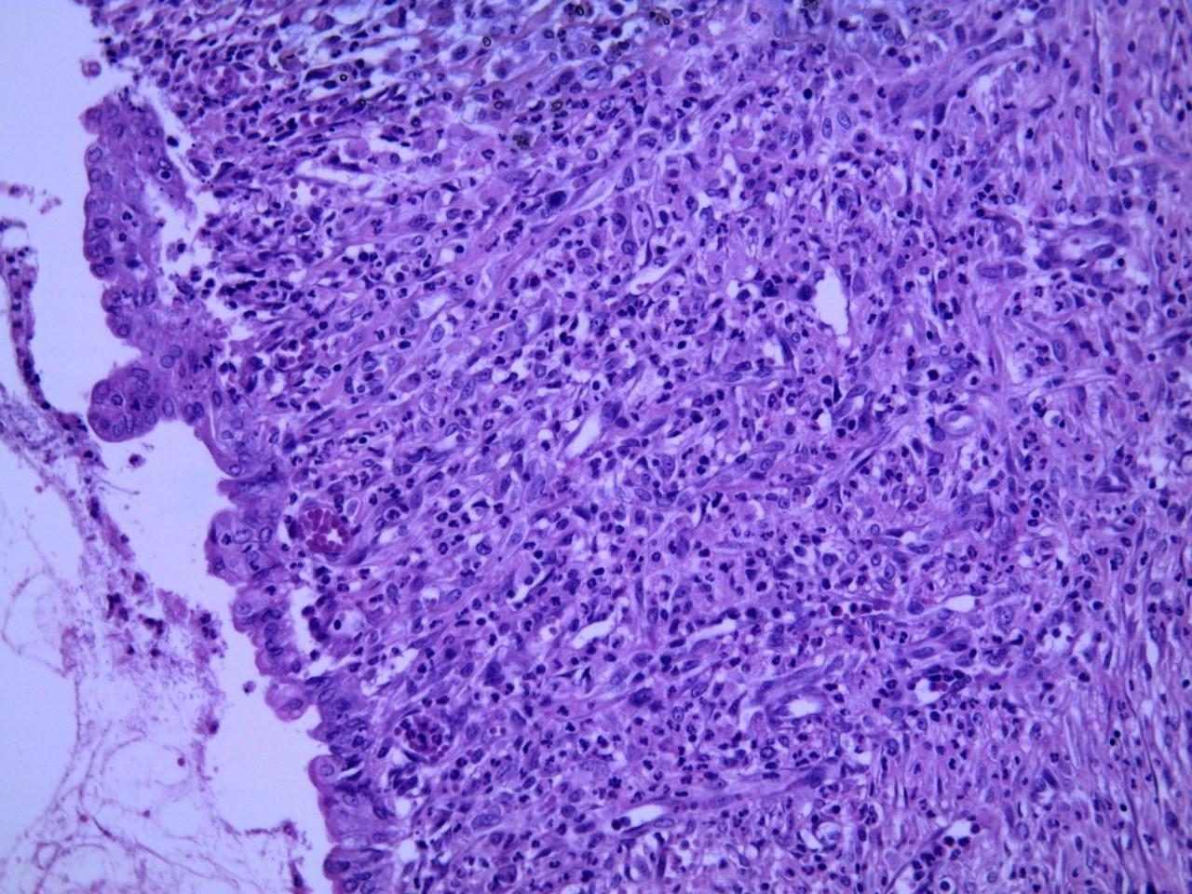
Figure 1: Reepithelization of anastomotic mucosa, Grade 2, Haematoxyline eosine, x20 magnification

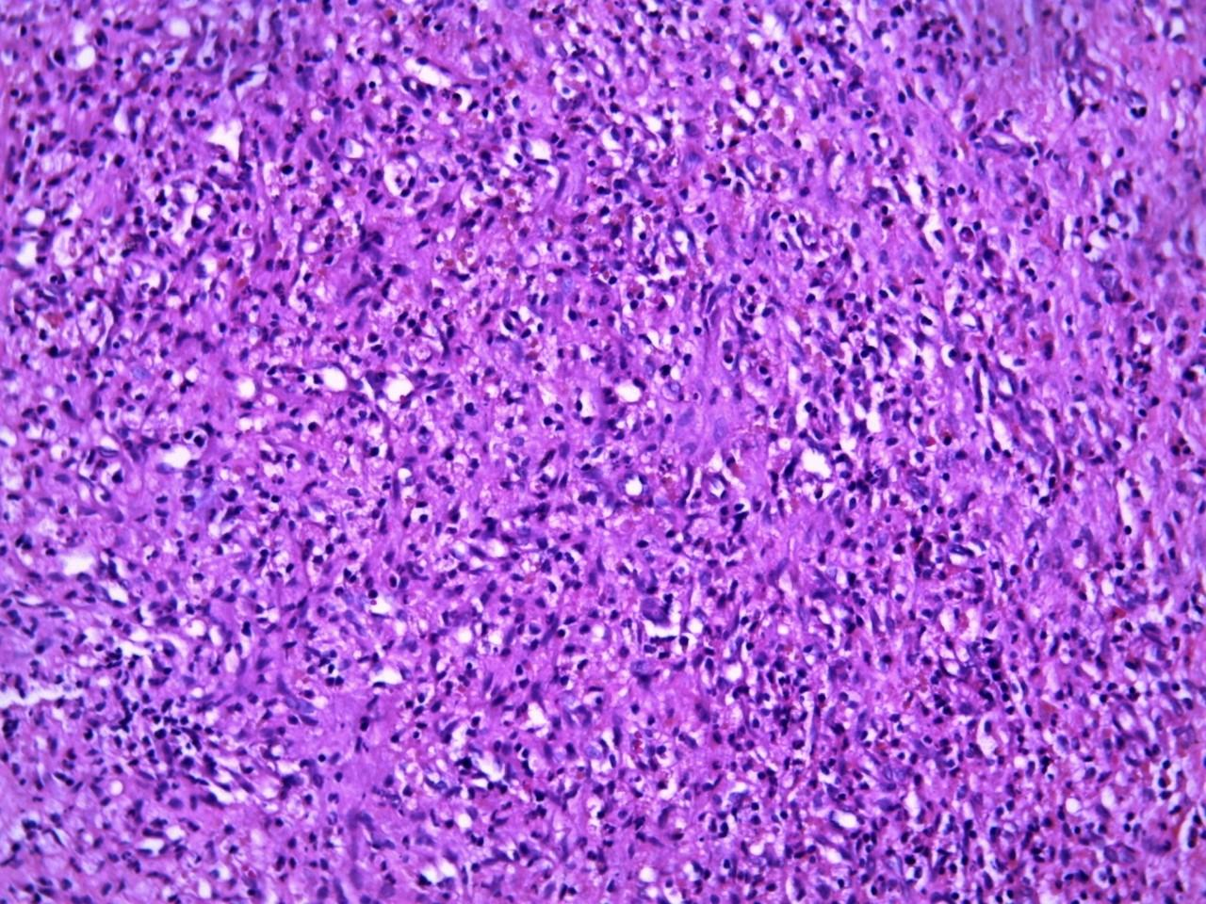
Figure 2: Inflammatory granuloma and formation of granulation tissue, Grade 3, Haematoxyline eosine, x20 magnification

DISCUSSION
Intestinal ischemia and anastomoses accomplished under ischemic conditions are important problems in colorectal surgery. Since the vessels of intestines are terminal vessels, ischemia rapidly alters the viability of intestines. There has been ongoing research on this subject where different molecules have been investigated (10). In this study, we aimed to investigate and compare potential effects of TMQ, PRP and Zeolite on anastomoses accomplished under ischemia.
TNF-α and IL-1β were widely studied in previous studies. They are well known mediators of inflammation. But there is not any standard level of these mediators set for wound healing of especially ischemic intestines. In previous studies, cytokines on different days of wound healing were investigated. In the study by Alzoghaibi et al, it was found that IL-1β expression peaked at days 5 and 7 in small bowel and colonic wounds (11). According to the authors, the high expression in IL-1β levels in small bowel and colon might explain the accelerated healing process in these wounds (11). In wound healing, tissue macrophages which are essential for wound healing become principal cells in the wound by the third day. These cells regulate and control wound healing (12). The macrophage becomes either an inflammatory macrophage or a responsive macrophage. Phagocytosis, enzymatic degradation of extracellular connective tissue, regulation of wound matrix remodelling are important features of the macrophage. These macrophages control wound healing by releasing growth factors namely, platelet-derived growth factor (PDGF), transforming growth factor (TGF), interleukin (IL), and tumor necrosis factor (TNF). Thus by the third day of wound healing, levels of TNF-α and IL 1 are likely to increase. Our results are in concordance with this proposition.
Tadros et al, insisted on the importance of IL 1 in the ischemia reperfusion injury of intestines caused by severe burn in their study (13). In severely burned patients, there was a marked reduction in IL 1 production by blood monocytes (13). Interleukin-1α administration was shown to improve survival in the animal model of burn wound sepsis. Pretreatment with IL 1 was effective in a decreasing ischemia–reperfusion injury. Our results supported this data in a different way. The lowest levels of TNF-α and IL-1β were in the control group in which an intestinal ischemia reperfusion injury was created without a treatment while the highest levels were detected in the sham group in which there was no ischemia. Among the four groups with ischemic anastomosis, lowest levels of TNF-α and IL-1β were obtained from control group. In addition, TNF-α and IL-1β were highest in TMQ group than the PRP and Zeolite group on the 10th day. On the other hand, bursting pressure was the highest in the TMQ group.
From the point of view of bursting pressure, reepitelization rate, TNF-α and IL 1β levels, we can say that, on the 10th day of ischemic colonic anastomosis, PRP and TMQ have positive effects on wound healing, while TMQ has the best results. TMQ, PRP and Zeolite were not compared in the previous studies.
The investigated molecules TMQ, PRP and Zeolite positively altered the cytokine levels in different levels. When cytokine levels and bursting pressure values of each group were evaluated together, it was seen that in Zeolite group, the improvement in the cytokine levels were not supported by bursting pressure values. Reepithelization was also better in TMQ and PRP groups when compared with Zeolite group. These findings suggest that inorganic zeolite may have acted like a foreign material hampering wound healing and specifically anastomotic healing.
When inflammatory mediators, OHP and bursting pressures were evaluated, it was seen that OHP levels did not differ among any of the groups. Similarly when inflammation and ischemic necrosis was evaluated, there were not any differences between the groups. This might be explained by the timing of sacrification where changes in bursting pressures did not correlate with changes in inflammatory and biochemical parameters.
Although regarding the limited number of animals in our study groups, our data is suggesting that TMQ and PRP have positive effects on ischemic intestinal anastomotic healing, while TMQ has the best results. On the other hand, understanding cytokine action in the wound healing process could help to develop novel and effective therapeutic strategies.

Acknowledgement: This study was supported by the xx University Scientific Research Projects Commission, xx, Turkey (2014-66).
Disclosure statement: None
Conflict of interest: No potential conflict of interest relevant to this article was reported by the authors.

REFERENCES
- Li Y, Li H, Xiao L, Zhou L, Shentu J, Zhang X et al. Hemostatic efficiency and wound healing properties of natural zeolite granules in a lethal rabbit model of complex groin injury. Materials. 2012;5(12):2586-96.
- Selçuk CT, Durgun M, Tekin R, Yolbas I, Bozkurt M, Akçay C et al. Evaluation of the effect of TMQ treatment on wound healing in a rat burn model. J Burn Care Res. 2013;34:e274-81.
- Erkut A, Cure MC, Kalkan Y, Balık MS, Güvercin Y, Yaprak E et al. Protective effects of TMQ and alpha-tocopherol on the sciatic nerve and femoral muscle due to lower limb ischemia-reperfusion injury. Eur Rev Med Pharmacol Sci. 2016;20(6):1192-202.
- Karaca G, Aydin O, Pehlivanli F, Altunkaya C, Uzun H, Güler O et al. Effectiveness of thymoquinone, zeolite, and platelet-rich plasma in model of corrosive oesophagitis induced in rats. Ann Surg Treat Res. 2017;92(6):396-401. doi: 10.4174/astr.2017.92.6.396. Epub 2017 May 29.
- Bakacak M, Bostanci MS, İnanc F, Yaylali A, Serin S, Attar R et al. Protective effect of platelet rich plasma on experimental ıschemia/reperfusion ınjury in rat ovary. Gynecol Obstet Invest. 2016;81(3):225-31. doi: 10.1159/000440617. Epub 2015 Oct 24.
- Kontopodis N, Tavlas E, Papadopoulos G, Panditis D, Kafetzakis A, Chalkiadakis G, Iaonnou C. Effectiveness of platelet-rich plasma to enhance healing of diabetic foot ulcers in patients with concomitant peripheral arterial disease and critical limb ıschemia. Int J Low Extrem Wounds. 2016;15(1):45-51.
- Zhou B, Ren J, Ding C, Wu Y, Chen J, Wang G et al. Protection of colonic anastomosis with platelet-rich plasma gel in the open abdomen. Injury. 2014;45(5):864-8.
- Yol S, Tekin A, Yilmaz H, Kücükkartallar T, Esen H, Çağlayan O et al. Effects of platelet rich plasma on colonic anastomosis. J Surg Res. 2008;146(2):190-4.
- Dhurat R, Sukesh M. Principles and methods of preparation of platelet-rich plasma: a review and author’s perspective. Journal of Cutaneous and Aesthetic Surgery. 2014;7(4):189-97.
- Kuru S, Kismet K, Bag YM, Barlas AM, Senes M, Durak M et al. Does the application of Ankaferd Blood Stopper rectally have positive effects on the healing of colorectal anastomosis and prevention of anastomotic leakage? An experimental study. Biomed Pharmacother. 2017;96:968-73. doi: 10.1016/j.biopha.2017.11.140.
- Alzoghaibi MA, Al-Oraini AI, Al-Sagheir AI, Zubaidi AM. Temporal expression of IL 1β and IL 1Β0 in rat skin, muscle, small bowel, and colon wounds: a correlative study. J Basic Clin Physiol Pharmacol. 2014;25(2):205-10.
- Steed DL. The Role of Growth Factors in Wound Healing. Surgical Clinics of North America. 1997;77(3):575-86.
- Tadros T, Traber D, Heggers JP, Herndon DN. Effects of interleukin-1α administration on intestinal ischemia and reperfusion injury, mucosal permeability, and bacterial translocation in burn and sepsis. Annals of Surgery. 2003;237(1):101-9.

