UAZİMDER Uluslararası Anadolu Ziraat Mühendisliği Bilimleri Dergisi ISSN : 2667-7571

IJAAES International Journal of Anatolia Agricultural Engineering 2019 (1): 7-13

Teslim / Received: 5.12.2018 Araştırma Makalesi / Research Article

Kabul Edilme / Accepted: 15.01.2019

Conservation Of Plant Genetic Resources For Rare And Endangered Species In Turkey

Noreen Aslam¹,CisemNildem Dogan¹, Ferdi Ağıl¹, Huri Melek Yaman¹, Nusret Zencirci^{1 *}

¹Department of Biology, Faculty of Science, Bolu Abant Izzet Baysal University, 14030, Bolu, Turkey

*Corresponding author: nzencirci@yahoo.com

Abstract
Plants in the world are used as food supply for human and animals. Many plants are utilized as pharmaceutical and industrial purposes, too. Human activities and natural phenomenon can cause some of the plants near to extinct. Therefore, the extincted species, which are consumed by human will be lesser than today and people can face with starvation in the future. Thus, the conservation of plant genetic resources isbeing carried out today. In this review we have focused onthe rare and endangered plant species and their conservation by ex-situ and in-situmethodshighlighting the plants’ varieties from Turkey.

Key Words: Endangered,rare,species, genetic resources, conservation

Introduction

Plants regulates the life on earth by all means endangered plants mean that the plant population facing with the higher risk of extinction. Habitat change, high rate of death, low birth rate can cause the plants extinction (Gundu and Adia, 2014). On the other hand, rare species grow in small places and they spread in limited area (Işık, 2011). Because of both rare and endangered species are faced with extinction, there are some methods to save their genetic materials. Besides saving these plants, conserving the other plant resources are important, too.
One in five of the world’s plant species is threatened with extinction according to the 2010 first global analysis of extinction risk. Tilman et al. predicted a massive ecological change to terrestrial plants within the next 50–100 y, accompanied by an increase in the number of global plant species facing extinction (Tilman and Lehman, 2001). Global warming is one of the threats to endangered plant species which is caused by the consumption of fossil fuel, industrialization, energy production and urbanization. Other factors like landsliding, over-grazing, uncontrolled fire and soil erosion are also destroying plant genetic resources. Further, as a result of human activities, it is estimated that 20% of the global biological diversity will be lost by 2020 due to the continuous and wrong use of natural resources.Turkey which is rich in biological diversity, also facing loss due to various negative factors.Because of that, sustainable protection of plant varieties is the need of time (Karagöz, et. al., 2010).
This review highlights how genetic resources are conserved, and giving information about endangered and rare species. Also, encompasses endangered species, and conservation strategies of plants in Turkey.
According to the IUCN Red List (2018) there are more than 26,000 species are threatened with extinction. Among them plants include just 25452, and 4537 are in endangered category such as Newmaniaorthostachys, Dialiumexcelsum, Ochrosiaborbonicaetc. In Turkey, there are 37 endangered plants found in 2018. These 37 plants are written on the Table 1.

Table 1.Endangered plant species in Turkey region (IUCN Red List, 2018).Turkish names were determined by using NezahatGökyiğitBotanikNahçesiBizimBitkiler web site (https://bizimbitkiler.org.tr/yeni/demos/technical/)
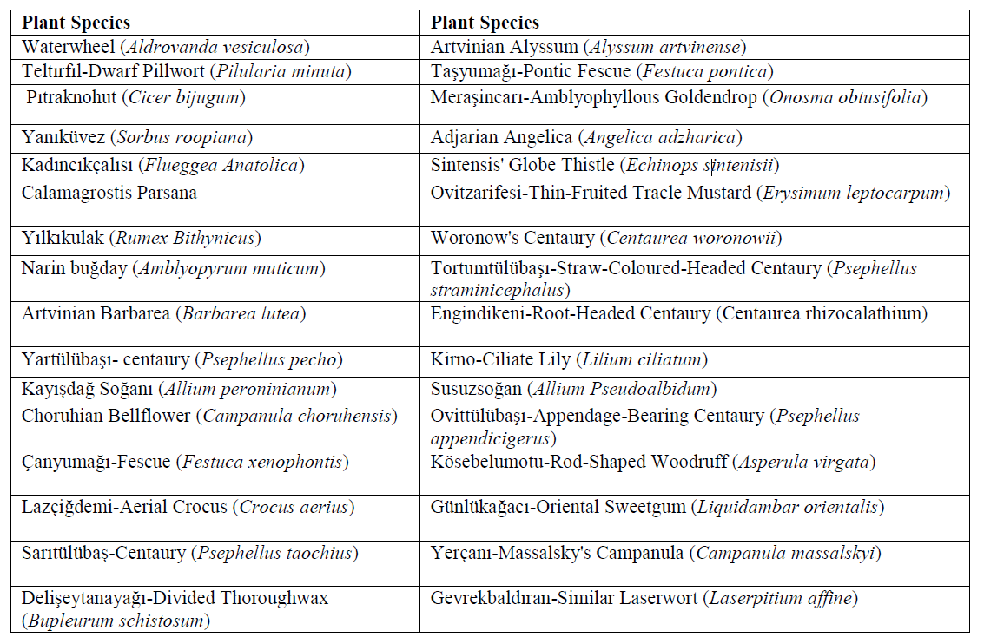

In global there are 1929 plant species face with near to threatened, and besides other countries, 13 of them are placed in Turkey (Table 2).

Table 2.Species near to threatened in Turkey (IUCN Red List, 2018). Turkish names were determined by using NezahatGökyiğitBotanikNahçesiBizimBitkiler web site (https://bizimbitkiler.org.tr/yeni/demos/technical/)
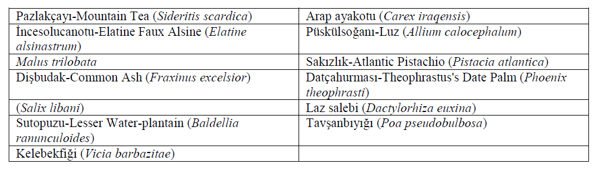
Seventeen endangered plant families are classified as endangered and threatened in Turkey are listed in Table 3.

*Table 3.List of rare and endangered plant families and species from Turkey
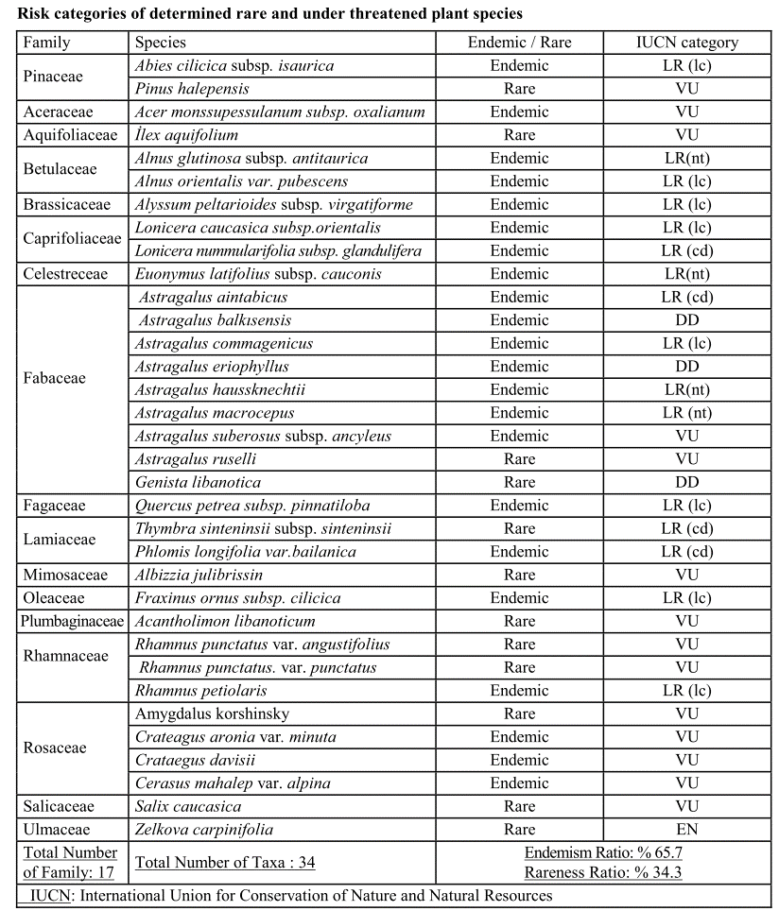
*This table was adapted from Iskender et al. (2006).

1. Preservation of Plant Genetic Resources

Preservation of the plant genetic resources is not possible with a couple of scientists. Beside them, governments and agricultural organizations must involve in this kind of projects. Among these agricultural and nutritional institutions, Food and Agriculture Organization (FAO) is very effective on taking the attention of the world to protect the products and genetic resources of forests (Cohen, et. al., 1991).
Preserving these genetic resources became compulsory for food security and well-beingof thehuman being in the future (Bilir, 2016). For this reason, the collection, storage and use of plant genetic resources have increased in order to increase and strengthen the agricultural production.Preservation of plant genetic resources may vary according to the plant species (Tan, 2013). For saving plant resources, and plants which are endangered and rare, there are some conservation and preservation techniques that are used around the World in the genetic banks. These two major methods are reported by IUCN (2009) and they are called Ex-situ and In-situ conversation.

1.1.Ex-Situ Conservation

In this conversation technique the plants replaced from their area to other place. This place could be wild or it could be controlled from human being. So basically when the plant population is facing threat, they placed in well-protected area which is made by man. Botanical Gardens and Aquarias are those places that are good examples (Corker, 2003a). Other method of ex-situ conversation is saving of reproduction parts for future such as Seed banks, Germplasm banks and Gene banks (IUCN, 2010).
There are 1,500 botanic gardens in the world and they have 35,000 plant species which means they include more than 15% plant in the world’s flora. Approximately, there are 25,000 of plant species are grow in England Royal Botanic Gardens, so within these species 2,700 of them are rare, endangered or threatened (Corker, 2003a). Turkey has 9 botanical gardens which are belong to state institutions and private organizations. Table 4 shows these gardens and their provinces (Çarbuğa and Pekerşen, 2017). Although these numbers of botanic gardens are fewer than some European countries, Turkey has high number of endemic plants than them (Kaya and Aksal, 2005; Çarbuğa and Pekerşen, 2017). In 1979, Turkey signed the agreement of European Convention on the Protection of Wildlife and Living Environments and till that year Turkey has taken necessary administrative and legal measures to protect endangered plants species together with their natural habitats. One of the endemic plant in Turkey is Centaureatchihatcheffii which is facing with extinction and got protected by this agreement (Bern, 1979).

Table 4. Name of botanic gardens and their province
Name of Botanic Gardens | Province
Ankara University Botanical Garden | Ankara
SüleymanDemirel University Botanical Garden | Isparta
Atatürk Arboretum Botanical Garden | Istanbul
Ege University Botanic Garden Research and Application Center | Izmir
Cukurova University Botanical Garden | Adana
Istanbul University Botanical Garden | Istanbul
Gaziantep Botanical Garden | Gaziantep
Karaca Arboretum Botanical Garden | Istanbul
NezahatGökyiğit Botanical Garden | Istanbul

Another type of ex-situ conversation is called seed bank. Cryogenic laboratories that keep the seeds for a long time and these seeds do not lose fertility. There are 1,400 seed banks in the world, but there is one distinguished seed bank, called Svalbard Global Seed Vault, opened and become popular in 2008. It is popular because they have an aim to store all plant seeds in the world (Mellgren, 2007). In Turkey, gene source determination and collection studies in cultural plants started with personal studies. The first gene resource collection was initiated by Mirza Gökgöl. Today, some of his collections are still stored in the herbarium of the Plant Gene Resources Research Institute in Izmir (Tan, 1992). In Turkey, the first gene bank was opened in Izmir in 1974. After that another gene bank founded in Ankara and it became the world’s third biggest gene bank after USA and China. It has got 300,000 plants capacities. Not only plants but also it includes viruses, bacteria and fungi (seedturkey.wordpress.com).Genetic reserve. Two reserves have specifically been established in the center of diversity to conserve wild wheats, at Ammiad in Israel (Anikster et al., 2000) and Ceylanpinar in Turkey (Firat and Tan, 2000).Further, T.monococcumis less conserved in Turkey need immediate attention.
Indeed, present genetic reserves in Turkey and other forms of protected areas in the Mediterranean contain clover species, but here the conservation is 'passive', (Maxted et al., 2000),and thusexposed to moreun-noticed genetic erosion and taxonomic extinction.
Two decades ago a number of forage and grain legume collection missions have been initiated in the Eastern Mediterranean, which comprised the collection of many Trifolium species. Bennett et al. (1998) collected 28 species of Trifolium in the Caucasus, in south-west Turkey.Furthermore, there is another technique such as in-vitro storage can be used for ex-situ conservation. Plant genetic material such as meristem, shoot tip and bud are generally preserving in-vitro in two ways. (Karagöz, et. al., 2010).Preservation by slowing down the development of culture (saving them inside the mineral oil, preserving by low pressure and oxygen, taken the sugar from the nutrient medium, dehydration, adding abscisic acid (5-10 mg/l) inside the medium, adding mannitol (% 3-5) or succinic acid (50 mg/l), preservation at low temperature) (Karagöz, et. al., 2010).Cryopreservation; freezing the plant parts inside the low temperature with liquid nitrogen (Karagöz, et. al., 2010).
The ex-situ conservation of plants has been active since 1964 in Turkey, and it is administered under the “National Program on Conservation of Plant Genetic Resources/Diversity”. Both generative and vegetative parts of plants are stored at National Gene Bank and field gene banks. 55.000 materials are stored at National Gene Bank, and up to 2,700 species are preserved. Also, inside of 20000 materials, there are 2,221 wild species.Field Crop Research Institute has the copy of these materials for safety; beside these nearly 10000 of field crops are preserved in there, too. Thus, totally 65,000 of plant materials are accessed in gene banks (Tan, 2010). Further, extensive methods and strategies has been stated in detail for ex-situ conservation (Hawkes et al., 2012). Exploration and field collection, seed gene bank conservation, field gene banks, botanic gardens in vitro, DNA and pollen conservation can be performed for the rare and endangered plant species of Turkey which are stated in Tables 1, 2 and 3.

1.2.In-Situ Preservation

There is no replacement occur in this method as ex-situ conservation. Endangered plants are placed in their own habitat. All in all, in this method those ecosystems are protected and the populations within (Corker, 2003b).Just in case of some changes such as climate change, environmental pollution and all kinds of natural and human-based disturbances, in the initial phase of the in-situ conservation the representative materials and seed samples are taken into the long term conservation in gene banks (Tan, 2002).
One of the important in-situ conservation is national parks which are the areas that lead to propagation, preservation, and control of flora and fauna. Turkey has 23 national parks and according to the IUCN they are all in IV category (Table 5) which means particular species or habitats are aimed to keep safe and control in protected areas by Category IV, habitat/species management area (Dudley, 2008).

Table 5. Nationalparks in Turkey(http://www.nationalparks-worldwide.info/turkey.html)
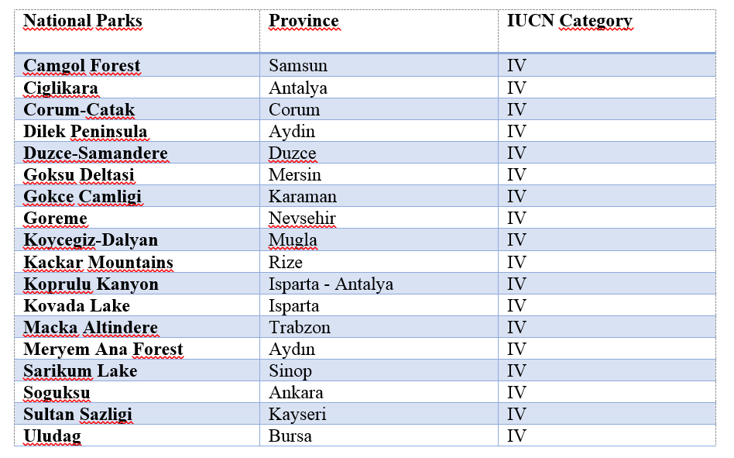

Future Of Genetics Resources

Plant genetic resources are important sources of improved quality and quantitiy of yield. They can offer bioforitfication, biotic and abiotic stress tolerant cultivars, phytoremediation, medicinal benefits, important sources of nutrients, metabolites and vitamins. However, sometimes due to unwanted/undesired genetic traits in genetic resources are posing barrier to achieve the specific trait due to genetic linkage. Those genetic linkage of unwanted trait can be removed by using state of the art CRISPR/Cas9 genome editing technique (Sameeullah et al., 2017). Therefore, incorporating the genome editing technology in crop improvement can foster our breeding programs without harsh impact on the environment, cultivated or wild plant species. Incorporating biotic tolerant genes will reduce the frequent application of pesticide which will ultimately promote the less use of pesticides to save environment and eco-friendly pollinators. Thus utilization of wild crop relative’s genetic resources which are mostly tolerant to insect pests and abiotic stresses while also promote organic farming hence ensuring safe and quality nutrition (Bretting, 2018).

Conclusion

Timely protection and habituating in protected environment would be one of protection measure. Other measures of conservations including ex-situ and in-situ conservation must be practiced simultaneously in order to foster the conservation process of endangered and rare plant species. These protection measure should be taken at national and international level and to educate the public to participate actively in protection of endangered plant species.

References

Anikster Y, Feldman M, Horovitz A (2000) The Ammiad experiment. In Plant Genetic Conservation. Springer, pp 239-253
Bennett SJ, Maxted N, Sabanci CO (1998) The ecogeography and collection of grain, forage and pasture legumes in south-west Turkey. Genetic Resources and Crop Evolution 45: 253-262
Bern. 1979. http://uhdigm.adalet.gov.tr/sozlesmeler/coktaraflisoz/ak/turkce/104_tur.pdf
Bilir Ö. (2016). Bitki Genetik Kaynaklarının Muhafazası Açısından Biyoteknoloji. Türk Bilimsel Derlemeler Dergisi, (2), 29-33.
Bretting PK (2018) 2017 Frank MeyerMedalforPlantGeneticResourcesLecture: Stewards of OurAgriculturalFuture. CropScience 58: 2233-2240.
Çarbuğa Ü, Pekerşen Y. (2017). BotanicalGardensandTourism. Gastroia: Journal of Gastronomyand Travel Research. 1 (1): 26-35.
Cohen JI, Williams JT.,Plucknett DL andShands H. (1991). Exsituconservation of plantgeneticresources: globaldevelopmentandenvironmentalconcerns. Science, 253(5022), 866-872.
Corker B. (2003a.) BiodiversityandConservation: InSituConservation - withinthenatural habitat. http://www.countrysideinfo.co.uk/biodvy3.html
Corker B. (2003b). BiodiversityandConservation: PlantCollections. http://www.countrysideinfo.co.uk/biodvy2.htm.
Dasgupta S. (2014). The 9 rarestplants in theworld. http://www.bbc.co.uk/earth/story/20141121-the-rarest-plants-in-the-world
Dudley N. (2008). GuidelinesforApplyingProtectedArea Management Categories. Norwich, UK.
Firat AE, Tan A (2000) In situ conservation of genetic diversity in Turkey. In Plant genetic conservation. Springer, pp 254-262
Gundu E. G. AndAdia J.E. (2014). ConservationMethods Of EndangeredSpecies. Journal Of ResearchInForestry, Wildlife AndEnvironmental 6: 76-83.
Hawkes JG, Maxted N, Ford-Lloyd BV (2012) The ex situ conservation of plant genetic resources. Springer Science & Business Media
hurriyetdailynews.com. (2018). Damagetorareplantspunished in Turkey. http://www.hurriyetdailynews.com/damage-to-rare-plants-punished-in-turkey-134080.
Lastaccessed in 4/12/2018.
Iskender E, Zeynalov Y, Ozaslan M, Incik F, Yayla F (2006) Investigationandintroduction of somerareandthreatenedplantsfromTurkey. Biotechnology&BiotechnologicalEquipment 20: 60-68.
Işık K. (2011). Rareandendemicspecies: whyaretheypronetoextinction? Turk J Bot 35: 411-417.
IUCN RedList (2009, 2018). International UnionfortheConservation of Nature. https://www.iucnredlist.org/
Karagöz A, Zencirci N, Tan A, Taşkın T, Köksel H, Sürek M, Toker C and Özbek K. (2010). Bitki genetik kaynaklarının korunması ve kullanımı. Türkiye Ziraat Mühendisliği VII. Teknik Kongresi, 1, 155-177.
Kaya, Y. ve Aksal, Ö. (2005). Endemik bitkilerin dünya ve Türkiye’deki dağılımı. Erzincan Eğitim Fakültesi Dergisi, 7 (1), 85-99.
Maxted N, Ford-Lloyd B, Hawkes J (2000) Complementaryconservationstrategies. InPlantgeneticconservation. Springer, pp 15-39
Mellgren D. (2007). Seed Bank Is, By Definition, VeryCool. Myers N, Mittermeier RA, Mittermeier CG, Fonseca GAB, Kent J. (2000). Biodiversityhotspotsforconservationpriorities. Nature 403: 853-858.
nationalparks-worldwide.info/turkey.htm.
Noroozi J, Talebi A, Doostmohammadi M, Rumpf SB, Linder HP, Schneeweiss GM. (2018). Hotspotswithin a globalbiodiversityhotspot - areas of endemismareassociatedwithhighmountainranges. ScientificReports8:10345.
Sameeullah M, Khan FA, Ozer G, Aslam N, Gurel E, Waheed MT, Karadeniz T (2017) CRISPR/Cas9-Mediated Immunity in PlantsAgainstPathogens. CurrIssuesMolBiol 26: 55-64.
Tan A. (2002). Türkiye Genetik ÇesitliligininInSitu (Çiftçi Sartlarında) Muhafazası. TÜB_TAK-TOGTAG/TARP-2347 projesi yayınlanmamıs sonuç raporu.
Tan A. (2009). Bitki Genetik Kaynaklarıın Önemi ve Korunması. T.C. Tarım ve Köyişleri Bakanlığı Ege Tarımsal Araştırma Enstitüsü Müdürlüğü, Teknik Broşür No:1, 1. Basım.
Tan A. (2010). State of PlantGeneticResourcesforFoodandAgriculture. Second Report of Turkey on ConservationandSustainableUtilization of PlantGeneticResourcesForFoodandAgriculture, ETAE Yayın No: 141. Meta Basım. Bornova (Turkishand English). ISBN 978-975-407-292-1.
Tan A. (2013). Bitki genetik kaynaklarının önemi ve korunması. Ege Tarımsal Araştırma Enstitüsü Müdürlüğü.Teknik Broşür. No:1. http://arastirma.tarim.gov.tr/etae/Belgeler/TeknikBrosur/BGK_Korunmas%C4%B1.pdf, 3. Basım.
Tan, A., (1992). Türkiye'de Bitkisel Çeşitlilik ve Bitki Genetik Kaynakları., Anadolu J. of AARI, 2,50-64.
https://www.cbsnews.com/news/seed-bank-is-by-definition-very-cool/
https://seedturkey.wordpress.com/2017/03/07/worlds-third-largest-gene-bank/#more-227
Tilman D, Lehman C (2001) Human-causedenvironmentalchange: Impacts on plantdiversityandevolution. Proceedings of theNational Academy of Sciences 98: 5433-5440.

