Management and Political Sciences Review
Volume: 1 Issue: 1 Year: 2019 pp: 65-79
IMPACT OF DISTANCE ON STATE UNIVERSITY ENROLMENTS: THE CASE FOR ÇOMÜ
Dr. Can BEKAROĞLU
ABSTRACT
This study aims to explain the impact of distance on state university enrolments in Turkey, based on the case for Canakkale Onsekiz Mart University (ÇOMÜ), which has an extensive statistics regarding student background. We are able to explain 2/3 of the variation by using 3 highly statistically significant variables; i) distance to the college town (Çanakkale), ii) distance to the major cities and other nearby universities, iii) the number of students who pass the university entrance test. Further analysis also shows that a relatively significant gender disparity still persists, and distance is found to be much less effective on female students. Additional non-parametric data envelopment analysis also reveals that, compared to the predicted results, conservative and mostly landlocked provinces send far fewer students to ÇOMÜ while nearby provinces, Eastern Anatolia, and the Black Sea Region shows a much greater interest.
Keywords: Distance, University Enrolments, Efficiency Analysis, DEA, Education
JEL Classification: C44, D24, I11, L 13
MESAFENİN DEVLET ÜNİVERSİTELERİ KAYITLARI
ÜZERİNDEKİ ETKİSİ: ÇOMÜ ÖRNEĞİ
ÖZET
Bu çalışma, mesafenin Türkiye’de devlet üniversiteleri kayıtları üzerindeki etkisini, öğrenci istatistikleri konusunda kapsamlı bir veri tabanı olan Çanakkale Onsekiz Mart Üniversitesi (ÇOMÜ) temelinde açıklamayı amaçlamaktadır. Çalışmamız değişkenliğin 2/3’ünü, istatistiksel olarak önemli 3 değişken kullanarak açıklayabilmektedir; i) üniversite şehrine (Çanakkale) olan mesafe, ii) diğer büyük şehirlere ve üniversitelere olan mesafe, iii) üniversite giriş sınavını geçen başarılı öğrenci sayısı. Analizler, cinsler arası tercih farklarının hala var olduğu ve mesafenin kız öğrenciler üzerindeki etkisinin erkek öğrencilere nisbeten daha düşük olduğunu göstermektedir. Ek olarak, parametrik olmayan Veri Zarflama Analizi de, beklenen sonuçlara kıyasla, muhafazakâr ve daha çok denize kıyısı olmayan Orta Anadolu’nun ÇOMÜ’yü çok daha az tercih ederken, yakın iller, Doğu Anadolu ve özellikle de Karadeniz’in ÇOMÜ’ye çok büyük ilgisinin olduğunu göstermektedir.
Anahtar Kelimeler: Uzaklık, Üniversite Kayıtları, Etkinlik Analizi, DEA, Eğitim
JEL Sınıflandırması: C44, D24, I11, L 13

1. INTRODUCTION
State Universities are generally large institutions composed of multiple divisions appealing to a diverse array of students from all over the country and potentially abroad. Understanding the mix of the student body and where they originate from is of crucial importance in many ways, and necessitates to properly evaluate the pertinent statistics in order to develop necessary policies.
Fortunately Canakkale Onsekiz Mart University (ÇOMÜ) has a large body of student enrolment statistics available to public, including but not limited to their place of origin. This provides us highly important information about the potential links between different regions of the country and help us not only get answers but also raise crucial questions.
Our study here has three main goals; a) to find the direct links for student mobility to a state university from any origin and distance, b) evaluate the potential differences between genders and the implications, c) investigate whether or not the expected amount of students arrive from a certain origin. Overall we will try to generalize the results, discuss their implications and raise questions to incite further curiosity on the issue, opening the door to studies larger in scope and methodology.
Two methodologies are employed here. Rather than survey-based techniques such as conjoint analysis, first a log-linear regression analysis based on Ordinary Least Squares (OLS) will be used to estimate the links between student enrolment both in total and gender specific numbers; and at a further stage, the statistically significant variables will be used in a non-parametric efficiency analysis to determine the relative efficiency levels of the number of students enrolled from each origin. We will further compare these results with those obtained in the Modified OLS (MOLS) figures to get a more sound and broader idea.

- LITERATURE AND DISCUSSION
2.1 Literature
The first major detailed analysis of the college selection process which was developed by Lewis and Morrison in 1975 (cited in Beswick, 1989) set the stage for further studies. Chapman (1981)’s three-stage model is the first comprehensive seminal model to formulate the university preferences in a conclusive manner and the broadest study investigating the factors that influence the university preference in Turkey is a field study by Cati, Istar, and Ozcan (2016), who list a long and well studied list of literature on the topic.
As previously studied in the literature, there are a plethora of factors affecting the university preference university (i.e. Kallio, 1995; Moogan et al., 1999; Soutar & Turner, 2002; Akar, 2012), including but not limited to the prestige of the institution, accommodation opportunities, financial support and costs, academic environment, available fields, job opportunities, campus life and social opportunities, location, and the distance (Cati, Istar, and Ozcan, 2016).
Hooley & Lynch (1981), for instance, counts 6 factors influencing the students’ university preferences in the UK: the existence of appropriate fields, location, type and prestige of the university, distance to home, and recommendation from family, friends and educators. Amca (2011) defines the factors in Turkey as the job opportunities after graduation, graduation success rates, cost of the selected institution, living cost of the college city, geographic location and social life quality. Likewise Baird (1967) and Bowers et al. (1972) define high academic standards as the most important factor influencing student preferences.
Distance to the college city consistently appears in many studies as a crucial factor for university preference as in Gibbons et al. (2002), Tatar& Oktay (2006), Dunnett et al. (2012), Kurt (2013), and Erol et al. (2013) while Çiftçi et al. (2011) emphasizes the university’s distance to the city center. Other authors such as Çokgezen (2012), Amca (2011), Kurt (2013) who find little difference between Turkish students and their Western counterparts at university preferences, also emphasize the city factor and whether or not the college is located near or in a major city or hub such as Istanbul and Ankara, which is especially important for future job opportunities and socioeconomic life.
Although Filter (2010) finds no difference between genders in his dissertation study, Shank et al. (1998) and Dunnett et al. (2012) disagree and find a significant disparity between genders in terms of university preferences; concluding that the female students, compared to their male counterparts, tend to go to universities which are closer to home, more industrialized, and located nearer to major cities.
2.2 Discussion
Despite a long list of studies dealing with the factors in general, there is hardly any study that focuses primarily on distance and evaluates the topic from a pure quantitative point of view while most studies focus on survey techniques sometimes using the conjoint analysis. Our study differs from the literature in a few major areas.
First, we do not investigate whether or not sufficient number of students are enrolled at the university as we take the number of students enrolled for granted; we rather investigate the origin of the students and whether we have attracted the expected mix of the students in terms of origin and gender, given the countrywide facts, and whether or not there is a gender disparity as it frequently appears in the literature.
Second, our goal is not to determine all the factors that influence university preference but rather determine how much of this can be explained by using “distance” variables with necessary controls, and then project the efficiency of our outcomes based on these “distance” variables, finding patterns of efficiency with respect to their origins; henceforth we can derive some policy implications and raise questions for further studies.
- METHODOLOGY AND DATA
3.1 Framework
Our analysis consists of three stages. First we analyse the data in aggregate form, using a logarithmic linear regression model with Ordinary Least Squares (OLS), then repeat the same procedure with two gender-specific datasets, as gender is shown to have significant effect in outcomes (Shank et al., 1998). Finally, based on the variables that appear statistically significant on the regression analysis, we apply a non-parametric Data Envelopment Analysis (DEA) in order to analyse whether or not the number of students enrolled in COMU is efficient. DEA relies on a number of fairly weak assumptions to construct the production technology but avoids any explicit functional relationship between the inputs and outputs through a production function. These assumptions are summarized below. Let Ψ be the feasible set:
- all observed input-output combinations are possible; (x₁, y₁) ∈ Ψ.
- the production possibility set is convex; Let α ∈ [0, 1]; If (x₁, y₁), (x₂, y₂) ∈ Ψ, then (x, y) = α(x₁, y₁) + (1−α)(x₂, y₂) ∈ Ψ.
- inputs and outputs are freely disposable; Let x₂ ≥ x₁, and y₂ ≤ y₁. If (x₁, y₁) ∈ Ψ then (x₂, y₁) ∈ Ψ and (x₁, y₂) ∈ Ψ
We employ the BCC Method (Banker, Charnes and Cooper, 1984) with variable returns to scale (VRS) in our DEA Analysis, rather than the CCR approach (Charnes, Cooper, and Rhodes, 1978), which uses constant returns to scale (CRS). For robustness check we will further compare the results obtained from the MOLS (Modified OLS).
3.2 Variables and Data
There is a strong case in the literature to include “distance” as a variable for university preference as it is only logical to assume that the distance to the college town is inversely proportional to one’s university preference, which is to say that, students are more likely to enroll in closer universities than farther ones. This is corroborated by the literature in numerous studies such as Tatar & Oktay (2006), Briggs et al. (2007), Filter (2010), Erol et al. (2012), Gibbons et al. (2012), and Kurt (2013).
However, distance to college town alone is not sufficient and other factors can be approximated and/or estimated by other distance variables. Distance to major cities or hubs also play a significant role in student enrolments, as well as the number of successful students from each location (Tatar ve Oktay, 2006; Amca, 2011 ; Kurt, 2013).
Given the general findings of the literature, the independent variables we have decided to include in the analysis to explain the student enrolments from each location are as follows;
- Distance to college town: University enrolments should be inversely correlated with the distance to the college town, that is, the closer to the university, the more students should enroll. In the case of ÇOMÜ, we would expect a higher enrollment rate from nearby locations.
- Distance to major cities: University enrollments should be positively correlated with the distance to major cities or hubs, that is, the closer to a major city, the fewer students should enroll in the university. In the case of COMU, we would expect a lower enrollment rate from locations closer to the major cities.
According to our preliminary results, distance to Istanbul and Izmir are found to be statistically and mathematically significant, while distance to Ankara is dropped as it appears ambiguous and not statistically significant, most likely due to a great degree of noise in the middle of the country, or it may just not have a universal appeal.
- Number of successful students: University enrollments should be positively correlated with the number of successful students who pass the university entrance test, that is, the higher number of students pass the university entrance test from a location, the more students should enroll in the university from that location.
- Region-specific Dummy variables: University enrollments may be positively correlated with or skewed towards a certain region, regardless of the distance, that is, a higher number of students will tend to enroll from that region. In the case of ÇOMÜ, only the dummy for the Black Sea Region is found to be statistically significant, while all others are found to be no significant and dropped.
Data used in this study are obtained from official ÇOMÜ website for enrollment statistics, OSYM website for the number of students who successfully pass the OSS test, and General Directory of Highways (KYK) for the distance variables.
3.3 Model Specification
3.3.1 First & Second Stages
A logarithmic OLS regression is used to estimate the dependent variable at first stage.
ln Y_{i} = β₀ + β₁ ln X_{1i} + β₂ ln X_{2i} + β₃ ln X_{3i} + β₄ ln X_{4i} + β₅ D_{5i} + u_{i} where we assume the following notation: Y_{i}: Number of students enrolled from province i
X_{1i}: Distance to the college town from province i
X_{2i}: Distance to Istanbul from province i
X_{3i}: Distance to Izmir from province i
X_{4i}: Number of students who passed the OSS 2006 from province i D_{5i}: Dummy variable for Black Sea region for province i (Black Sea: 1, otherwise: 0)
At the second stage, a similar logarithmic OLS regression is used to estimate the gender-specific dependent variable.
ln Yig = β0g + β1g ln X1ig + β2g ln X2ig + β3g ln X3ig + β4 ln X4ig + β5g D5ig + uig where g: 0 for male, 1 for female, with gender-specific variables
3.3.2 Third Stage
Let (x_{i}, y_{i}) represent the input-output bundle of a unit i, assuming input-output bundle observed for N units. Then given the aforementioned assumptions for DEA and VRS, production possibility set is
N N N
T_{c} ={(x, y); x ≥ ∑λ_{i} x_{i} ;y_{i} ≤ ∑λ_{i} y_{i} ;λ_{i} ≥ 0;(i =1,2,3,....,N), while∑λ_{i} =1}
^{i} ^{i} ^{i} { i }
By measuring the radial (equiproportional) efficiency levels of production under VRS, we obtain the efficient services (y*) that should have been produced. The output-oriented radial efficiency of a DMU_{s}:

The standard DEA LP problem solved to estimate the efficiency of DMU s, relative to contemporaneous VRS frontier is
Objective: Max θ, where θ: Output inefficiency, subject to {iii}
- ∑λ_{i} x_{ij} ≥ x_{0j} j = 1 (Distance to ÇOMÜ, negatively correlated) (1)
- ∑λ_{i} x_{ij} ≤ x_{0j} j = 2, 3 (Other distances, positively correlated) (2)
- ∑λ_{i} x_{ij} ≤ x_{0j} j = 4 (Control variable, number of successful students) (3)
- ∑λ_{i}y_{i} ≥ (1 + θ) y₀ (Output constraint, number of enrolments) (4)
- λ_{i} ≥ 0, ∑λ_{i} = 1 (Variable Returns to Scale Condition) (5)
In the maximization problem above (Max θ), constraints ensure that the benchmark unit created from the convex combination of actually observed data points does not create a virtual location that is closer to ÇOMÜ (eq. 1), or farther away from Istanbul or Izmir (eq. 2 and 3), or have a higher number of successful students who pass the university entrance test (eq. 4) than the comparison unit while enabling θ* y_{0k} more outputs (higher number of students enrolled), where the θ is the inefficiency rate for a given location. If θ equals 0, then the unit appears efficient given the observed data.
The dummy variable in the regression analysis is ignored at this stage as there is no way to integrate binary data into DEA. The LP problem above can also be applied to both aggregate and gender-specific data sets, although we have only considered the aggregate case for this study.
- RESULTS
4.1 Regression Analysis for the aggregate data
All variables that are used in the log-linear regression analysis appear both statistically and mathematically significant even at 1% confidence interval, with a moderately high explanatory power (R² = 0,637), though it should be noted that the logarithmic explanatory power might be deceiving as it tends to shrink the variance. Nevertheless, all variables are robust and take the correct (expected) signs. There is inevitably some degree of collinearity between distance variables as expected but this does not change the big picture. It should also be noted that the relationship is still statistically significant in the simpler non-logarithmic form, but not as robust.
As expected, distance to Canakkale is negatively proportional with output and has the strongest effect on the output among the variables included, which implies that a greater number of students is expected from closer locations. Balıkesir and Bursa, for instance would send approximately 9 and 6 more students to ÇOMÜ respectively for each 1 km drop in distance. This could be due to various reasons, indirectly manifested in terms of distance, such as greater cultural proximity, higher awareness, greater chance of word of mouth, a greater degree of business or friendly connections etc.
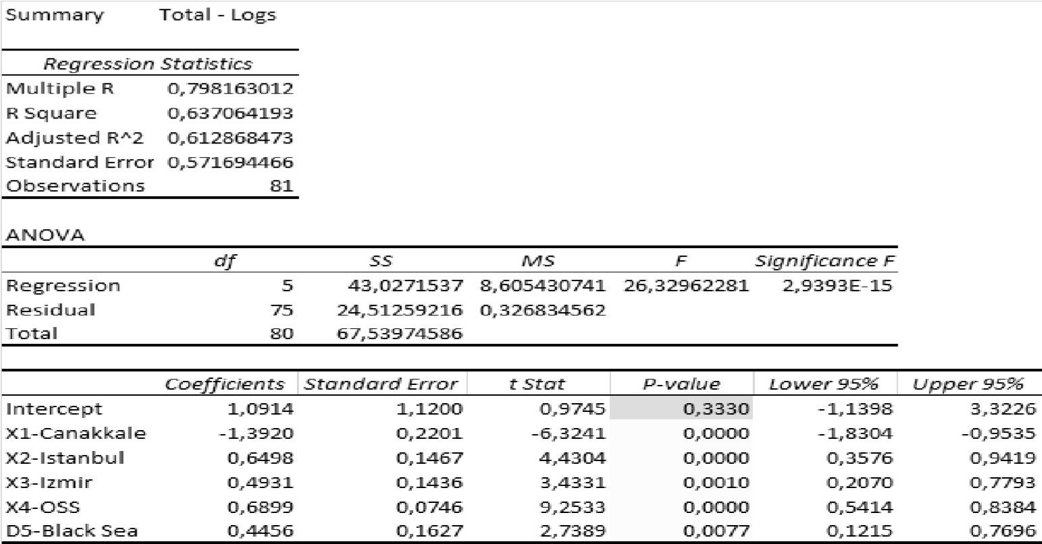
Table 1: Regression Results for All Students
Similarly, fewer number of students are expected to enrol if there is a major city or hub around. Bursa and Balıkesir would send 2-4 fewer students to ÇOMÜ respectively for each km drop to Istanbul or Izmir. Although Istanbul and Izmir are the two examples used in this analysis, this effect is by no means, limited to these two cities. Similar effects can be expected around any major city / hub in any part of the country. Also as expected, Istanbul has a larger impact on the output than Izmir.
Number of successful students at each location is to be statistically significant as expected and mathematically even more substantial than the distance to major cities. This variable also proved to be much more robust and significant than the population of each location, though both are highly correlated.
An interesting result, which is only visible to the trained eye, is the relative popularity of ÇOMÜ among students from the Black Sea Region for reasons beyond distance, which needs to be further investigated. The dummy variable for the Black Sea Region is both statistically significant and robust, and almost plays as an important role as distance. This might be due to various reasons such as a higher interest in coastal regions by the populace in the Black Sea Region (or other coastal areas in general) etc.
5.2 Regression Analysis for the gender-specific data
All variables that are used in the gender-specific log-linear regression analysis appear both statistically significant at 1% confidence interval, with R² ranging from 62% to 64%, more or less replicating the results from the regression with combined data. Similarly, all variables are robust and take the correct (expected) signs. Additionally, the impact of the number of successful students from each location is also almost identical for both genders. However, there are substantial differences between genders with respect to the distance variables and the dummy variable.
Distance to Çanakkale, though negatively proportional regardless of gender, is much stronger for males than females with a coefficient -1.45 vs. -1.33 respectively. Likewise the impact of distances both to Istanbul (0.69 vs. 0.59) and to Izmir (0.59 vs 0.38) are much stronger for males than females. In other words, the distances to any of the three cities in question has a much greater effect on male students and in their decision making. Males appear to be more calculating of and dependent on the distance.
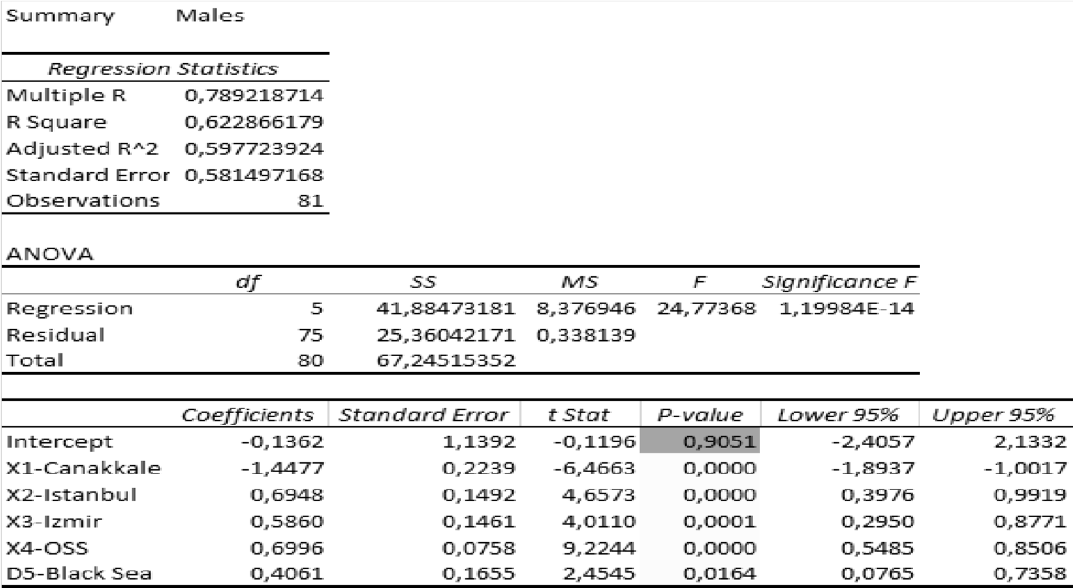
Table 2: Regression Results for Male Students only
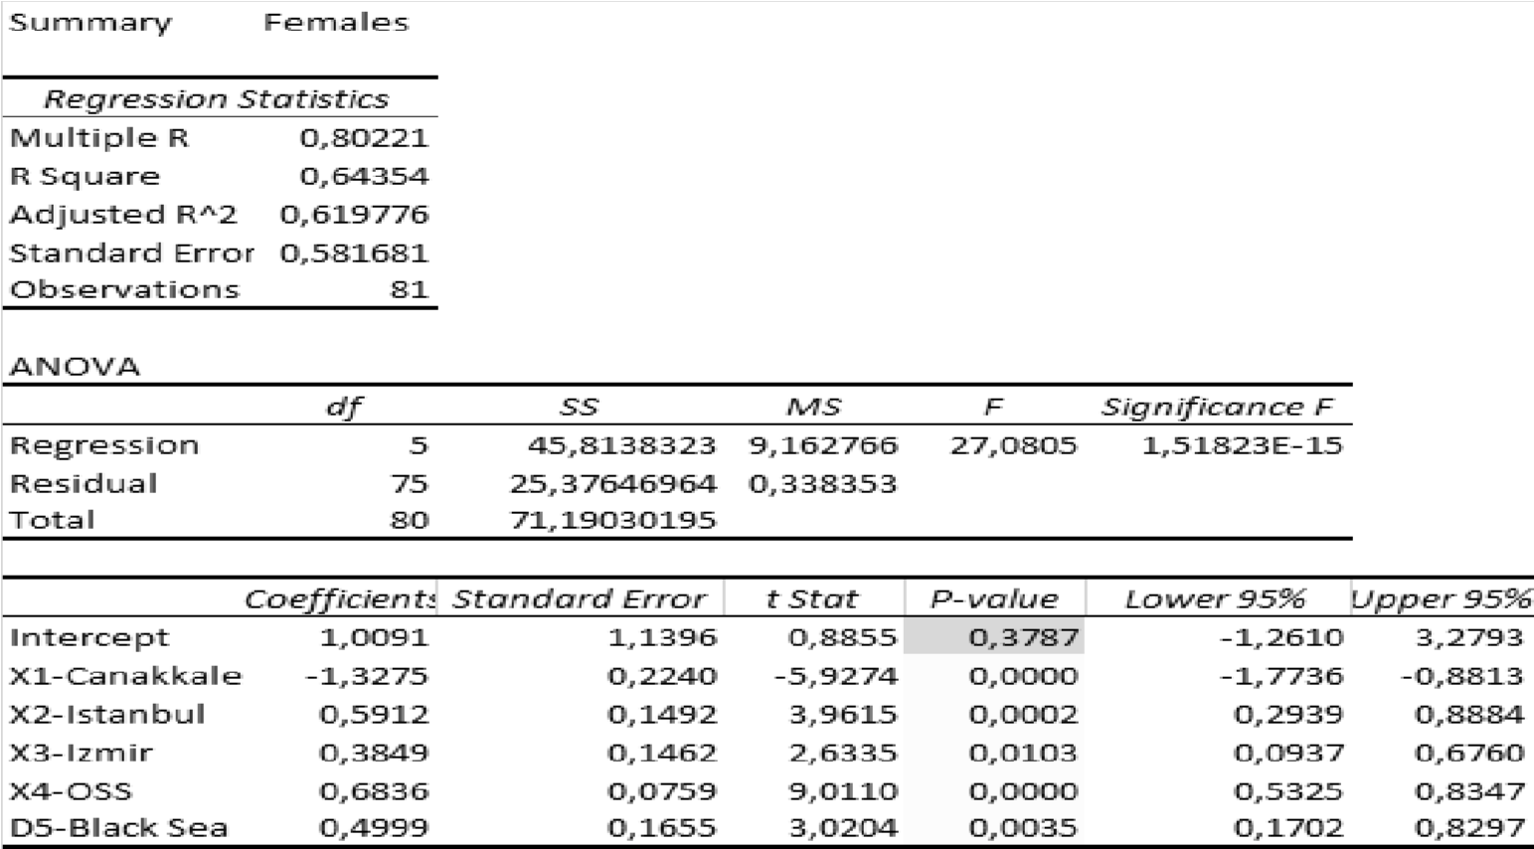
Table 3: Regression Results for Female Students only
The impact of the Black Sea region dummy, on the other hand, is much stronger for females than males (0.41 vs. (0.50), enough to compensate for the decrease in the distance variables, which is due to both lower variance and slope for females compared to males. This reveals a greater impetus for females to travel longer distances, especially towards coastal and possibly the Western Regions.
5.3 Efficiency Analysis with respect to Student Composition
Table 4
Table 4 lists the 11 provinces with the lowest efficiency levels measured in DEA-VRS, mostly overlapping with the MOLS results on the far column. This means that ÇOMÜ has attracted far fewer students (between 24% and 45%) from these locations than expected. The common characteristics of all the provinces that appear on the list are that they are highly
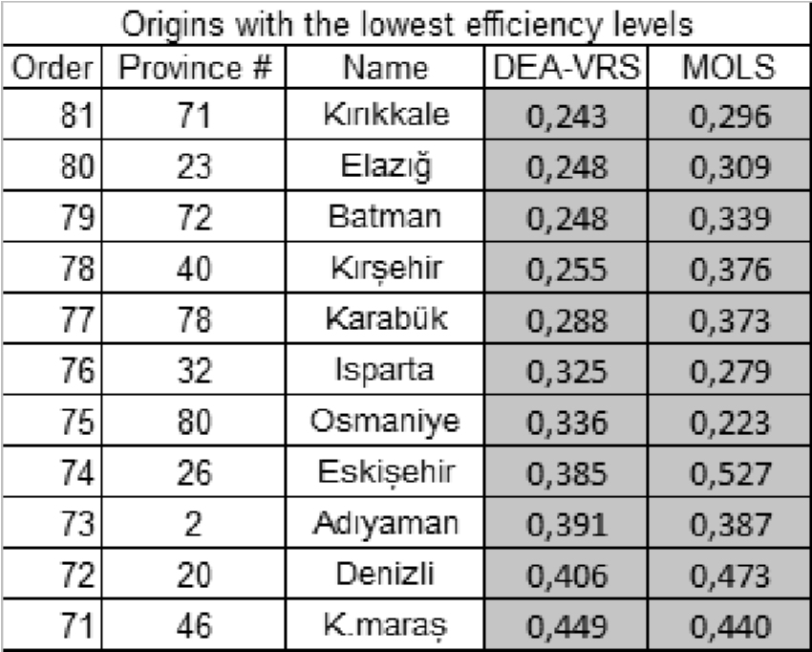
conservative and mostly landlocked provinces. Table 5
Table 5, similarly lists the 11 provinces with the highest efficiency levels measured in DEA-VRS, compared with the MOLS efficiency levels. The provinces group up in three clusters; the nearby provinces: Manisa, İstanbul, Balıkesir; the Eastern Provinces: Erzurum, Kars, Ardahan, Tunceli; and the Black Sea Cluster: Sinop, Ordu, and Kastamonu, most of which appear to be (super)
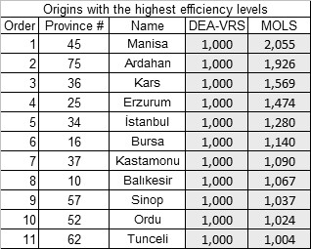
efficient, sending students at far greater numbers than expected.
Graph 1 : Number of students in ÇOMÜ 2018 by province of origin, ordered by OLS estimation
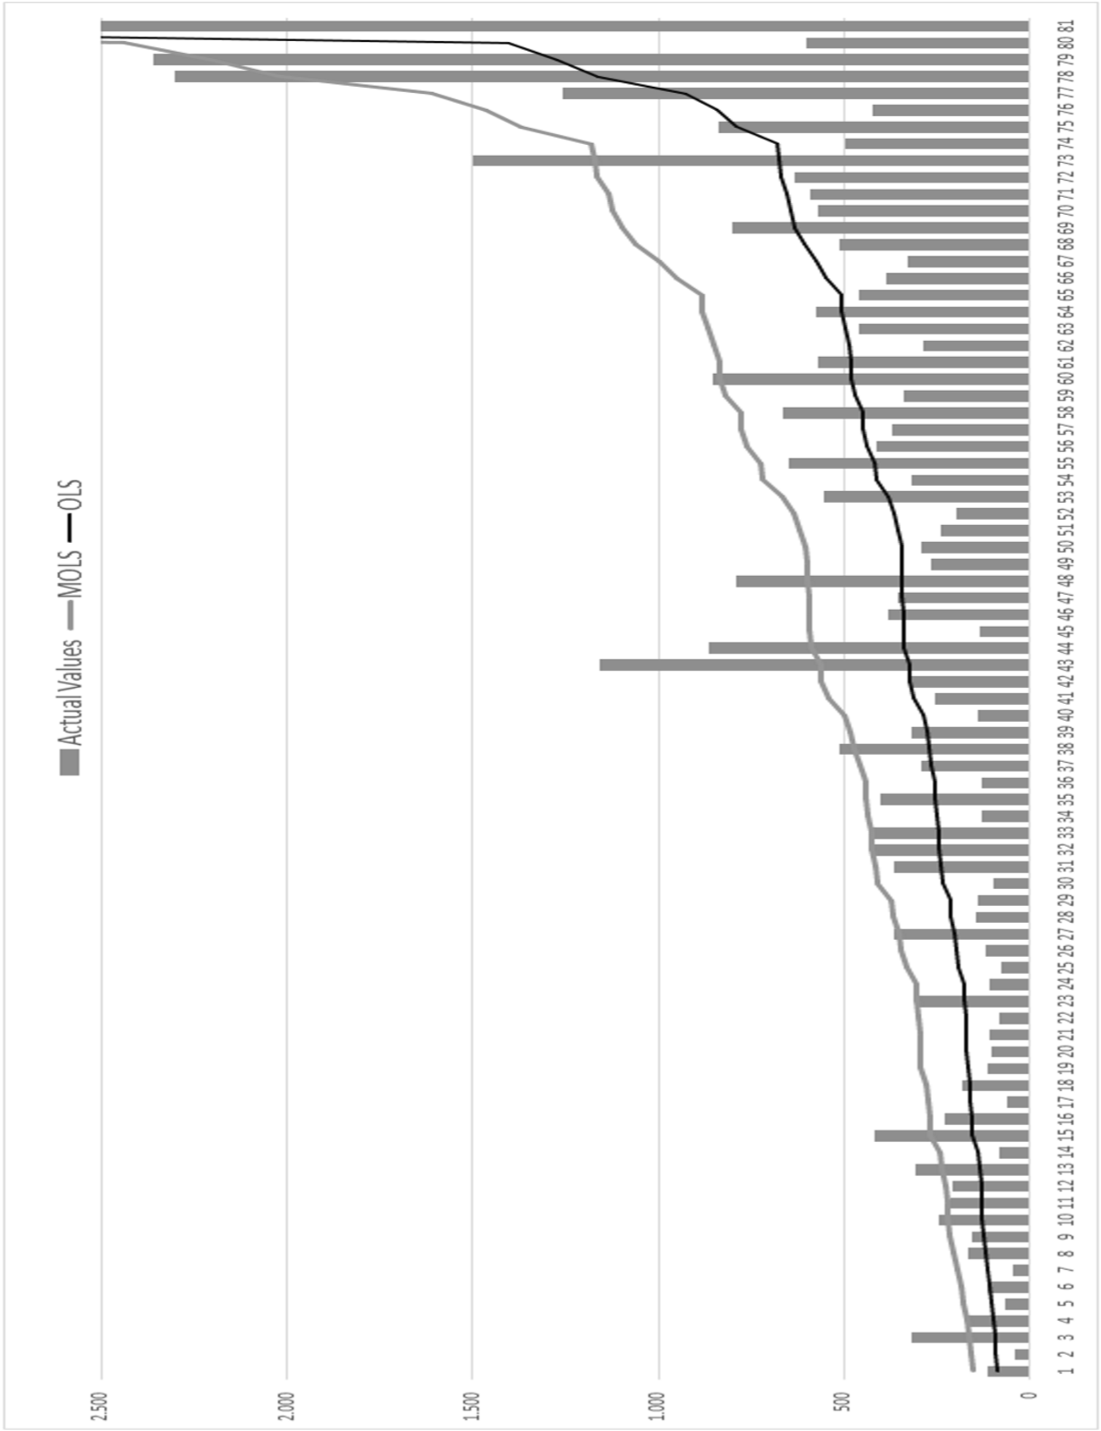
- CONCLUSION
5.1 Concluding Remarks and Limitations of the Study
Distances to both the college town and other major cities or hubs, which appear to be statistically significant, robust and mathematically substantial for both genders, can explain about 2/3 of the variation in the regression analysis; directly or indirectly as a proxy for other factors such as job opportunities, cultural proximity, networking, word of mouth, travelling opportunities etc. in one’s decision making process. While distance to college town is the most important distance factor as expected, distance to other major cities also matter often proportional with their sizes and overall attraction level.
Genders are not influenced the same way, however. Female students appear to be much more willing to get away from their immediate neighbourhoods and have a relatively higher predisposition to travel farther than their male counterparts, though distance has a similar effect on both genders overall. It seems like the female students are more prone to gain their independence away from home, possibly from cultural norms and social pressures.
DEA also reveals that there are certain patterns regarding the student origins arriving at ÇOMÜ. Nearby provinces which are physically and culturally closer, the Black Sea Region, which is also situated along the coastal line, and the Eastern Anatolia, where people are more willing to welcome a more liberal and potentially more prosperous culture. More conservative Middle Anatolian provinces, on the other hand, send much fewer students than predicted. The existence of cultural barriers might be a valid answer, though the exact reasons for such discrepancy remains unanswered.
In order to get more precise answers, a time-series data going as far back as possible would enhance our analysis and provide much more robust results. Similarly, panel data from other state universities would enable us to arrive in more generalizable judgments as well as a better efficiency measurements for regarding the origin of student enrolments.
5.2 Policy Implications
A few interesting points are raised in this study. Why does the Black Sea Region have a special interest in ÇOMÜ? Is it because of a predisposition to coastal regions? Is this interest directed at Marmara Region or even Çanakkale in particular? Similar questions can be raised for the Eastern provinces such as Kars, Ardahan and Erzurum. Are they simply rushing towards the West for cultural and economic reasons, or is there a more complicated answer to this phenomenon?
The other side of the coin, however, shows a lack of interest from the relatively conservative provinces in middle Anatolia, which tend to be more prosperous than the East and has less incentives to rush to the West for immigration. Also the cultural norms might be a hindrance while there are alternative institutions around. Further investigation for the lack interest in those provinces will certainly yield a better understanding of the student composition.
6. REFERENCES
- Akar, C. (2012). Üniversite seçimini etkileyen faktörler: iktisadi ve idari bilimler öğrencileri üzerine bir çalışma. Eskişehir Osmangazi Üniversitesi İktisadi ve İdari Bilimler Fakültesi Dergisi, 7(1), 97-120.
- Amca, H. (2011). Üniversitelerin tercihi edilmesini etkileyen faktörler. Retrieved from http://www.emu.edu.tr/amca/universitelerinTercihiEdilmesin iEtkileyenFaktorler.pdf
- Baird, L. (1967), “The educational tools of college bound youth”, American College Testing Program Research Report, Iowa.
- Banker RD, Charnes A, Cooper, (1984), WW. Some models for estimatingtechnical and scale inefficiencies in data envelopment analysis. Management Science; 30:1078–92.
- Beswick, R. L. K. (1989). A study of factors associated with student choice in the university selection process. Master thesis, University of Lethbridge.
- Bowers, T. and Pugh, R. (1972), “A comparison of factors underlying college choice by students and parents”, American Educational Research Association Annual Meeting.
- Cati, Istar, and Ozcan (2016), “Investigating the Factors that Influence the University Preference: A Countrywide Field Research in Turkey”, Journal of Higher Education and Science, Volume 6, Number 2, August 2016; Pages 163-177: DOI: 10.5961/jhes. 2016.153
- Chapman, D. W. (1981). A model of student college choice. Journal of Higher Education, 52(5), 490–505.
- Charnes A, Cooper WW, Rhodes E. (1978), Measuring the efficiency of decision making units. European Journal of Operational Research;2(6):429–44.
- Çokgezen, M. (2012). Determinants of University Choice: A Study on Economics Departments in Turkey. Retrieved from http://mimoza.marmara. edu.tr/~mcokgez/Makaleler/universitychoice-article-feb-2012.pdf
- ÇOMÜ Kurumsal Değerlendirme Sistemi, 2018, Retrieved from https:// ubys.comu.edu.tr/BIP/BusinessIntelligence/Home/Index
- Dunnett, A., Moorhouse, J., Walsh, C. & Barry C. (2012). Choosing a university: A conjoint analysis of the impact of higher fees on students applying for university in 2012, Tertiary Education and Management, 18(3), 199-220
- Gibbons, S. & Vignoles, A. (2012). Geography, choice and participation in higher education in England. Regional Science and Urban Economics, 42, 98–113.
- Dunnett, A., Moorhouse, J., Walsh, C. & Barry C. (2012). Choosing a university: A conjoint analysis of the impact of higher fees on students applying for university in 2012, Tertiary Education and Management, 18(3), 199-220
- Filter, S. (2010). The choice-of-college decision of academically talented students, The George Washington University, Dissertation, Retrieved from http://media.proquest.com/media/pq/classic/doc/2003885961/fmt/ai/rep/ NPDF?_s=gn6Nwx50WmJ6Dxi6mBmWtlq3gqo%3D.
- Hooley, G.J. and Lynch, J.E. (1981), “Modelling the student university choice process through the use of conjoint measurement techniques”, European Research, Vol. 9 No. 4, pp. 158-70.
- Kallio, R. E. (1995). Factors influencing the college choice decisions of graduate students. Research in Higher Education, 36(1), 109-124.
- Karayolları Genel Müdürlüğü, Mesafe Sorgulama, Retrieved from http:// www.kgm.gov.tr/Sayfalar/KGM/SiteTr/Uzakliklar/ilcedenIlceyeMesafe. aspx
- Kurt, A. (2013). Üniversite tercih ederken nelere dikkat edilmeli? Retrieved from http://mebk12.meb.gov.tr/meb_iys_dosyalar/01/17/950146/icerikler/ universite-tercih-ederkennelere-dikkat-edilmeli_355325.html.
- Moogan, J. Y., Baron S. & Harris, K. (1999). Decision-making behaviour of potential higher education students. Higher Education Quarterly, 53(3), 211–228.
- ÖSYS: Öğrenci Seçme ve Yerleştirme Sistemi, Sayısal Bilgiler, Retrieved from https://www.osym.gov.tr/TR,13046/2017.html
- Shank, M. D. & Beasley, F. (1998). Gender effects on the university selection process. Journal of Marketing for Higher Education, 8(3), 63-71.
- Soutar, G. & Turner, J. (2002). Students’ preferences for university: A conjoint analysis. The International Journal of Educational Management, 16(1), 40-45.
- Tatar E., Oktay M. (2006). Search, choice and persistence for higher education a case study in Turkey. Eurasia Journal of Mathematics, Science and Technology Education, 2(2), 115-129

Management and Political Sciences Review
Volume: 1 Issue: 1 Year: 2019 pp: 65-79
IMPACT OF DISTANCE ON STATE UNIVERSITY ENROLMENTS: THE CASE FOR ÇOMÜ
Dr. Can BEKAROĞLU
ABSTRACT
This study aims to explain the impact of distance on state university enrolments in Turkey, based on the case for Canakkale Onsekiz Mart University (ÇOMÜ), which has an extensive statistics regarding student background. We are able to explain 2/3 of the variation by using 3 highly statistically significant variables; i) distance to the college town (Çanakkale), ii) distance to the major cities and other nearby universities, iii) the number of students who pass the university entrance test. Further analysis also shows that a relatively significant gender disparity still persists, and distance is found to be much less effective on female students. Additional non-parametric data envelopment analysis also reveals that, compared to the predicted results, conservative and mostly landlocked provinces send far fewer students to ÇOMÜ while nearby provinces, Eastern Anatolia, and the Black Sea Region shows a much greater interest.
Keywords: Distance, University Enrolments, Efficiency Analysis, DEA, Education
JEL Classification: C44, D24, I11, L 13
MESAFENİN DEVLET ÜNİVERSİTELERİ KAYITLARI
ÜZERİNDEKİ ETKİSİ: ÇOMÜ ÖRNEĞİ
ÖZET
Bu çalışma, mesafenin Türkiye’de devlet üniversiteleri kayıtları üzerindeki etkisini, öğrenci istatistikleri konusunda kapsamlı bir veri tabanı olan Çanakkale Onsekiz Mart Üniversitesi (ÇOMÜ) temelinde açıklamayı amaçlamaktadır. Çalışmamız değişkenliğin 2/3’ünü, istatistiksel olarak önemli 3 değişken kullanarak açıklayabilmektedir; i) üniversite şehrine (Çanakkale) olan mesafe, ii) diğer büyük şehirlere ve üniversitelere olan mesafe, iii) üniversite giriş sınavını geçen başarılı öğrenci sayısı. Analizler, cinsler arası tercih farklarının hala var olduğu ve mesafenin kız öğrenciler üzerindeki etkisinin erkek öğrencilere nisbeten daha düşük olduğunu göstermektedir. Ek olarak, parametrik olmayan Veri Zarflama Analizi de, beklenen sonuçlara kıyasla, muhafazakâr ve daha çok denize kıyısı olmayan Orta Anadolu’nun ÇOMÜ’yü çok daha az tercih ederken, yakın iller, Doğu Anadolu ve özellikle de Karadeniz’in ÇOMÜ’ye çok büyük ilgisinin olduğunu göstermektedir.
Anahtar Kelimeler: Uzaklık, Üniversite Kayıtları, Etkinlik Analizi, DEA, Eğitim
JEL Sınıflandırması: C44, D24, I11, L 13

1. INTRODUCTION
State Universities are generally large institutions composed of multiple divisions appealing to a diverse array of students from all over the country and potentially abroad. Understanding the mix of the student body and where they originate from is of crucial importance in many ways, and necessitates to properly evaluate the pertinent statistics in order to develop necessary policies.
Fortunately Canakkale Onsekiz Mart University (ÇOMÜ) has a large body of student enrolment statistics available to public, including but not limited to their place of origin. This provides us highly important information about the potential links between different regions of the country and help us not only get answers but also raise crucial questions.
Our study here has three main goals; a) to find the direct links for student mobility to a state university from any origin and distance, b) evaluate the potential differences between genders and the implications, c) investigate whether or not the expected amount of students arrive from a certain origin. Overall we will try to generalize the results, discuss their implications and raise questions to incite further curiosity on the issue, opening the door to studies larger in scope and methodology.
Two methodologies are employed here. Rather than survey-based techniques such as conjoint analysis, first a log-linear regression analysis based on Ordinary Least Squares (OLS) will be used to estimate the links between student enrolment both in total and gender specific numbers; and at a further stage, the statistically significant variables will be used in a non-parametric efficiency analysis to determine the relative efficiency levels of the number of students enrolled from each origin. We will further compare these results with those obtained in the Modified OLS (MOLS) figures to get a more sound and broader idea.

- LITERATURE AND DISCUSSION
2.1 Literature
The first major detailed analysis of the college selection process which was developed by Lewis and Morrison in 1975 (cited in Beswick, 1989) set the stage for further studies. Chapman (1981)’s three-stage model is the first comprehensive seminal model to formulate the university preferences in a conclusive manner and the broadest study investigating the factors that influence the university preference in Turkey is a field study by Cati, Istar, and Ozcan (2016), who list a long and well studied list of literature on the topic.
As previously studied in the literature, there are a plethora of factors affecting the university preference university (i.e. Kallio, 1995; Moogan et al., 1999; Soutar & Turner, 2002; Akar, 2012), including but not limited to the prestige of the institution, accommodation opportunities, financial support and costs, academic environment, available fields, job opportunities, campus life and social opportunities, location, and the distance (Cati, Istar, and Ozcan, 2016).
Hooley & Lynch (1981), for instance, counts 6 factors influencing the students’ university preferences in the UK: the existence of appropriate fields, location, type and prestige of the university, distance to home, and recommendation from family, friends and educators. Amca (2011) defines the factors in Turkey as the job opportunities after graduation, graduation success rates, cost of the selected institution, living cost of the college city, geographic location and social life quality. Likewise Baird (1967) and Bowers et al. (1972) define high academic standards as the most important factor influencing student preferences.
Distance to the college city consistently appears in many studies as a crucial factor for university preference as in Gibbons et al. (2002), Tatar& Oktay (2006), Dunnett et al. (2012), Kurt (2013), and Erol et al. (2013) while Çiftçi et al. (2011) emphasizes the university’s distance to the city center. Other authors such as Çokgezen (2012), Amca (2011), Kurt (2013) who find little difference between Turkish students and their Western counterparts at university preferences, also emphasize the city factor and whether or not the college is located near or in a major city or hub such as Istanbul and Ankara, which is especially important for future job opportunities and socioeconomic life.
Although Filter (2010) finds no difference between genders in his dissertation study, Shank et al. (1998) and Dunnett et al. (2012) disagree and find a significant disparity between genders in terms of university preferences; concluding that the female students, compared to their male counterparts, tend to go to universities which are closer to home, more industrialized, and located nearer to major cities.
2.2 Discussion
Despite a long list of studies dealing with the factors in general, there is hardly any study that focuses primarily on distance and evaluates the topic from a pure quantitative point of view while most studies focus on survey techniques sometimes using the conjoint analysis. Our study differs from the literature in a few major areas.
First, we do not investigate whether or not sufficient number of students are enrolled at the university as we take the number of students enrolled for granted; we rather investigate the origin of the students and whether we have attracted the expected mix of the students in terms of origin and gender, given the countrywide facts, and whether or not there is a gender disparity as it frequently appears in the literature.
Second, our goal is not to determine all the factors that influence university preference but rather determine how much of this can be explained by using “distance” variables with necessary controls, and then project the efficiency of our outcomes based on these “distance” variables, finding patterns of efficiency with respect to their origins; henceforth we can derive some policy implications and raise questions for further studies.
- METHODOLOGY AND DATA
3.1 Framework
Our analysis consists of three stages. First we analyse the data in aggregate form, using a logarithmic linear regression model with Ordinary Least Squares (OLS), then repeat the same procedure with two gender-specific datasets, as gender is shown to have significant effect in outcomes (Shank et al., 1998). Finally, based on the variables that appear statistically significant on the regression analysis, we apply a non-parametric Data Envelopment Analysis (DEA) in order to analyse whether or not the number of students enrolled in COMU is efficient. DEA relies on a number of fairly weak assumptions to construct the production technology but avoids any explicit functional relationship between the inputs and outputs through a production function. These assumptions are summarized below. Let Ψ be the feasible set:
- all observed input-output combinations are possible; (x₁, y₁) ∈ Ψ.
- the production possibility set is convex; Let α ∈ [0, 1]; If (x₁, y₁), (x₂, y₂) ∈ Ψ, then (x, y) = α(x₁, y₁) + (1−α)(x₂, y₂) ∈ Ψ.
- inputs and outputs are freely disposable; Let x₂ ≥ x₁, and y₂ ≤ y₁. If (x₁, y₁) ∈ Ψ then (x₂, y₁) ∈ Ψ and (x₁, y₂) ∈ Ψ
We employ the BCC Method (Banker, Charnes and Cooper, 1984) with variable returns to scale (VRS) in our DEA Analysis, rather than the CCR approach (Charnes, Cooper, and Rhodes, 1978), which uses constant returns to scale (CRS). For robustness check we will further compare the results obtained from the MOLS (Modified OLS).
3.2 Variables and Data
There is a strong case in the literature to include “distance” as a variable for university preference as it is only logical to assume that the distance to the college town is inversely proportional to one’s university preference, which is to say that, students are more likely to enroll in closer universities than farther ones. This is corroborated by the literature in numerous studies such as Tatar & Oktay (2006), Briggs et al. (2007), Filter (2010), Erol et al. (2012), Gibbons et al. (2012), and Kurt (2013).
However, distance to college town alone is not sufficient and other factors can be approximated and/or estimated by other distance variables. Distance to major cities or hubs also play a significant role in student enrolments, as well as the number of successful students from each location (Tatar ve Oktay, 2006; Amca, 2011 ; Kurt, 2013).
Given the general findings of the literature, the independent variables we have decided to include in the analysis to explain the student enrolments from each location are as follows;
- Distance to college town: University enrolments should be inversely correlated with the distance to the college town, that is, the closer to the university, the more students should enroll. In the case of ÇOMÜ, we would expect a higher enrollment rate from nearby locations.
- Distance to major cities: University enrollments should be positively correlated with the distance to major cities or hubs, that is, the closer to a major city, the fewer students should enroll in the university. In the case of COMU, we would expect a lower enrollment rate from locations closer to the major cities.
According to our preliminary results, distance to Istanbul and Izmir are found to be statistically and mathematically significant, while distance to Ankara is dropped as it appears ambiguous and not statistically significant, most likely due to a great degree of noise in the middle of the country, or it may just not have a universal appeal.
- Number of successful students: University enrollments should be positively correlated with the number of successful students who pass the university entrance test, that is, the higher number of students pass the university entrance test from a location, the more students should enroll in the university from that location.
- Region-specific Dummy variables: University enrollments may be positively correlated with or skewed towards a certain region, regardless of the distance, that is, a higher number of students will tend to enroll from that region. In the case of ÇOMÜ, only the dummy for the Black Sea Region is found to be statistically significant, while all others are found to be no significant and dropped.
Data used in this study are obtained from official ÇOMÜ website for enrollment statistics, OSYM website for the number of students who successfully pass the OSS test, and General Directory of Highways (KYK) for the distance variables.
3.3 Model Specification
3.3.1 First & Second Stages
A logarithmic OLS regression is used to estimate the dependent variable at first stage.
ln Y_{i} = β₀ + β₁ ln X_{1i} + β₂ ln X_{2i} + β₃ ln X_{3i} + β₄ ln X_{4i} + β₅ D_{5i} + u_{i} where we assume the following notation: Y_{i}: Number of students enrolled from province i
X_{1i}: Distance to the college town from province i
X_{2i}: Distance to Istanbul from province i
X_{3i}: Distance to Izmir from province i
X_{4i}: Number of students who passed the OSS 2006 from province i D_{5i}: Dummy variable for Black Sea region for province i (Black Sea: 1, otherwise: 0)
At the second stage, a similar logarithmic OLS regression is used to estimate the gender-specific dependent variable.
ln Yig = β0g + β1g ln X1ig + β2g ln X2ig + β3g ln X3ig + β4 ln X4ig + β5g D5ig + uig where g: 0 for male, 1 for female, with gender-specific variables
3.3.2 Third Stage
Let (x_{i}, y_{i}) represent the input-output bundle of a unit i, assuming input-output bundle observed for N units. Then given the aforementioned assumptions for DEA and VRS, production possibility set is
N N N
T_{c} ={(x, y); x ≥ ∑λ_{i} x_{i} ;y_{i} ≤ ∑λ_{i} y_{i} ;λ_{i} ≥ 0;(i =1,2,3,....,N), while∑λ_{i} =1}
^{i} ^{i} ^{i} { i }
By measuring the radial (equiproportional) efficiency levels of production under VRS, we obtain the efficient services (y*) that should have been produced. The output-oriented radial efficiency of a DMU_{s}:

The standard DEA LP problem solved to estimate the efficiency of DMU s, relative to contemporaneous VRS frontier is
Objective: Max θ, where θ: Output inefficiency, subject to {iii}
- ∑λ_{i} x_{ij} ≥ x_{0j} j = 1 (Distance to ÇOMÜ, negatively correlated) (1)
- ∑λ_{i} x_{ij} ≤ x_{0j} j = 2, 3 (Other distances, positively correlated) (2)
- ∑λ_{i} x_{ij} ≤ x_{0j} j = 4 (Control variable, number of successful students) (3)
- ∑λ_{i}y_{i} ≥ (1 + θ) y₀ (Output constraint, number of enrolments) (4)
- λ_{i} ≥ 0, ∑λ_{i} = 1 (Variable Returns to Scale Condition) (5)
In the maximization problem above (Max θ), constraints ensure that the benchmark unit created from the convex combination of actually observed data points does not create a virtual location that is closer to ÇOMÜ (eq. 1), or farther away from Istanbul or Izmir (eq. 2 and 3), or have a higher number of successful students who pass the university entrance test (eq. 4) than the comparison unit while enabling θ* y_{0k} more outputs (higher number of students enrolled), where the θ is the inefficiency rate for a given location. If θ equals 0, then the unit appears efficient given the observed data.
The dummy variable in the regression analysis is ignored at this stage as there is no way to integrate binary data into DEA. The LP problem above can also be applied to both aggregate and gender-specific data sets, although we have only considered the aggregate case for this study.
- RESULTS
4.1 Regression Analysis for the aggregate data
All variables that are used in the log-linear regression analysis appear both statistically and mathematically significant even at 1% confidence interval, with a moderately high explanatory power (R² = 0,637), though it should be noted that the logarithmic explanatory power might be deceiving as it tends to shrink the variance. Nevertheless, all variables are robust and take the correct (expected) signs. There is inevitably some degree of collinearity between distance variables as expected but this does not change the big picture. It should also be noted that the relationship is still statistically significant in the simpler non-logarithmic form, but not as robust.
As expected, distance to Canakkale is negatively proportional with output and has the strongest effect on the output among the variables included, which implies that a greater number of students is expected from closer locations. Balıkesir and Bursa, for instance would send approximately 9 and 6 more students to ÇOMÜ respectively for each 1 km drop in distance. This could be due to various reasons, indirectly manifested in terms of distance, such as greater cultural proximity, higher awareness, greater chance of word of mouth, a greater degree of business or friendly connections etc.
Table 1: Regression Results for All Students
Similarly, fewer number of students are expected to enrol if there is a major city or hub around. Bursa and Balıkesir would send 2-4 fewer students to ÇOMÜ respectively for each km drop to Istanbul or Izmir. Although Istanbul and Izmir are the two examples used in this analysis, this effect is by no means, limited to these two cities. Similar effects can be expected around any major city / hub in any part of the country. Also as expected, Istanbul has a larger impact on the output than Izmir.
Number of successful students at each location is to be statistically significant as expected and mathematically even more substantial than the distance to major cities. This variable also proved to be much more robust and significant than the population of each location, though both are highly correlated.
An interesting result, which is only visible to the trained eye, is the relative popularity of ÇOMÜ among students from the Black Sea Region for reasons beyond distance, which needs to be further investigated. The dummy variable for the Black Sea Region is both statistically significant and robust, and almost plays as an important role as distance. This might be due to various reasons such as a higher interest in coastal regions by the populace in the Black Sea Region (or other coastal areas in general) etc.
5.2 Regression Analysis for the gender-specific data
All variables that are used in the gender-specific log-linear regression analysis appear both statistically significant at 1% confidence interval, with R² ranging from 62% to 64%, more or less replicating the results from the regression with combined data. Similarly, all variables are robust and take the correct (expected) signs. Additionally, the impact of the number of successful students from each location is also almost identical for both genders. However, there are substantial differences between genders with respect to the distance variables and the dummy variable.
Distance to Çanakkale, though negatively proportional regardless of gender, is much stronger for males than females with a coefficient -1.45 vs. -1.33 respectively. Likewise the impact of distances both to Istanbul (0.69 vs. 0.59) and to Izmir (0.59 vs 0.38) are much stronger for males than females. In other words, the distances to any of the three cities in question has a much greater effect on male students and in their decision making. Males appear to be more calculating of and dependent on the distance.
Table 2: Regression Results for Male Students only
Table 3: Regression Results for Female Students only
The impact of the Black Sea region dummy, on the other hand, is much stronger for females than males (0.41 vs. (0.50), enough to compensate for the decrease in the distance variables, which is due to both lower variance and slope for females compared to males. This reveals a greater impetus for females to travel longer distances, especially towards coastal and possibly the Western Regions.
5.3 Efficiency Analysis with respect to Student Composition
Table 4
Table 4 lists the 11 provinces with the lowest efficiency levels measured in DEA-VRS, mostly overlapping with the MOLS results on the far column. This means that ÇOMÜ has attracted far fewer students (between 24% and 45%) from these locations than expected. The common characteristics of all the provinces that appear on the list are that they are highly
conservative and mostly landlocked provinces. Table 5
Table 5, similarly lists the 11 provinces with the highest efficiency levels measured in DEA-VRS, compared with the MOLS efficiency levels. The provinces group up in three clusters; the nearby provinces: Manisa, İstanbul, Balıkesir; the Eastern Provinces: Erzurum, Kars, Ardahan, Tunceli; and the Black Sea Cluster: Sinop, Ordu, and Kastamonu, most of which appear to be (super)
efficient, sending students at far greater numbers than expected.
Graph 1 : Number of students in ÇOMÜ 2018 by province of origin, ordered by OLS estimation
- CONCLUSION
5.1 Concluding Remarks and Limitations of the Study
Distances to both the college town and other major cities or hubs, which appear to be statistically significant, robust and mathematically substantial for both genders, can explain about 2/3 of the variation in the regression analysis; directly or indirectly as a proxy for other factors such as job opportunities, cultural proximity, networking, word of mouth, travelling opportunities etc. in one’s decision making process. While distance to college town is the most important distance factor as expected, distance to other major cities also matter often proportional with their sizes and overall attraction level.
Genders are not influenced the same way, however. Female students appear to be much more willing to get away from their immediate neighbourhoods and have a relatively higher predisposition to travel farther than their male counterparts, though distance has a similar effect on both genders overall. It seems like the female students are more prone to gain their independence away from home, possibly from cultural norms and social pressures.
DEA also reveals that there are certain patterns regarding the student origins arriving at ÇOMÜ. Nearby provinces which are physically and culturally closer, the Black Sea Region, which is also situated along the coastal line, and the Eastern Anatolia, where people are more willing to welcome a more liberal and potentially more prosperous culture. More conservative Middle Anatolian provinces, on the other hand, send much fewer students than predicted. The existence of cultural barriers might be a valid answer, though the exact reasons for such discrepancy remains unanswered.
In order to get more precise answers, a time-series data going as far back as possible would enhance our analysis and provide much more robust results. Similarly, panel data from other state universities would enable us to arrive in more generalizable judgments as well as a better efficiency measurements for regarding the origin of student enrolments.
5.2 Policy Implications
A few interesting points are raised in this study. Why does the Black Sea Region have a special interest in ÇOMÜ? Is it because of a predisposition to coastal regions? Is this interest directed at Marmara Region or even Çanakkale in particular? Similar questions can be raised for the Eastern provinces such as Kars, Ardahan and Erzurum. Are they simply rushing towards the West for cultural and economic reasons, or is there a more complicated answer to this phenomenon?
The other side of the coin, however, shows a lack of interest from the relatively conservative provinces in middle Anatolia, which tend to be more prosperous than the East and has less incentives to rush to the West for immigration. Also the cultural norms might be a hindrance while there are alternative institutions around. Further investigation for the lack interest in those provinces will certainly yield a better understanding of the student composition.
6. REFERENCES
- Akar, C. (2012). Üniversite seçimini etkileyen faktörler: iktisadi ve idari bilimler öğrencileri üzerine bir çalışma. Eskişehir Osmangazi Üniversitesi İktisadi ve İdari Bilimler Fakültesi Dergisi, 7(1), 97-120.
- Amca, H. (2011). Üniversitelerin tercihi edilmesini etkileyen faktörler. Retrieved from http://www.emu.edu.tr/amca/universitelerinTercihiEdilmesin iEtkileyenFaktorler.pdf
- Baird, L. (1967), “The educational tools of college bound youth”, American College Testing Program Research Report, Iowa.
- Banker RD, Charnes A, Cooper, (1984), WW. Some models for estimatingtechnical and scale inefficiencies in data envelopment analysis. Management Science; 30:1078–92.
- Beswick, R. L. K. (1989). A study of factors associated with student choice in the university selection process. Master thesis, University of Lethbridge.
- Bowers, T. and Pugh, R. (1972), “A comparison of factors underlying college choice by students and parents”, American Educational Research Association Annual Meeting.
- Cati, Istar, and Ozcan (2016), “Investigating the Factors that Influence the University Preference: A Countrywide Field Research in Turkey”, Journal of Higher Education and Science, Volume 6, Number 2, August 2016; Pages 163-177: DOI: 10.5961/jhes. 2016.153
- Chapman, D. W. (1981). A model of student college choice. Journal of Higher Education, 52(5), 490–505.
- Charnes A, Cooper WW, Rhodes E. (1978), Measuring the efficiency of decision making units. European Journal of Operational Research;2(6):429–44.
- Çokgezen, M. (2012). Determinants of University Choice: A Study on Economics Departments in Turkey. Retrieved from http://mimoza.marmara. edu.tr/~mcokgez/Makaleler/universitychoice-article-feb-2012.pdf
- ÇOMÜ Kurumsal Değerlendirme Sistemi, 2018, Retrieved from https:// ubys.comu.edu.tr/BIP/BusinessIntelligence/Home/Index
- Dunnett, A., Moorhouse, J., Walsh, C. & Barry C. (2012). Choosing a university: A conjoint analysis of the impact of higher fees on students applying for university in 2012, Tertiary Education and Management, 18(3), 199-220
- Gibbons, S. & Vignoles, A. (2012). Geography, choice and participation in higher education in England. Regional Science and Urban Economics, 42, 98–113.
- Dunnett, A., Moorhouse, J., Walsh, C. & Barry C. (2012). Choosing a university: A conjoint analysis of the impact of higher fees on students applying for university in 2012, Tertiary Education and Management, 18(3), 199-220
- Filter, S. (2010). The choice-of-college decision of academically talented students, The George Washington University, Dissertation, Retrieved from http://media.proquest.com/media/pq/classic/doc/2003885961/fmt/ai/rep/ NPDF?_s=gn6Nwx50WmJ6Dxi6mBmWtlq3gqo%3D.
- Hooley, G.J. and Lynch, J.E. (1981), “Modelling the student university choice process through the use of conjoint measurement techniques”, European Research, Vol. 9 No. 4, pp. 158-70.
- Kallio, R. E. (1995). Factors influencing the college choice decisions of graduate students. Research in Higher Education, 36(1), 109-124.
- Karayolları Genel Müdürlüğü, Mesafe Sorgulama, Retrieved from http:// www.kgm.gov.tr/Sayfalar/KGM/SiteTr/Uzakliklar/ilcedenIlceyeMesafe. aspx
- Kurt, A. (2013). Üniversite tercih ederken nelere dikkat edilmeli? Retrieved from http://mebk12.meb.gov.tr/meb_iys_dosyalar/01/17/950146/icerikler/ universite-tercih-ederkennelere-dikkat-edilmeli_355325.html.
- Moogan, J. Y., Baron S. & Harris, K. (1999). Decision-making behaviour of potential higher education students. Higher Education Quarterly, 53(3), 211–228.
- ÖSYS: Öğrenci Seçme ve Yerleştirme Sistemi, Sayısal Bilgiler, Retrieved from https://www.osym.gov.tr/TR,13046/2017.html
- Shank, M. D. & Beasley, F. (1998). Gender effects on the university selection process. Journal of Marketing for Higher Education, 8(3), 63-71.
- Soutar, G. & Turner, J. (2002). Students’ preferences for university: A conjoint analysis. The International Journal of Educational Management, 16(1), 40-45.
- Tatar E., Oktay M. (2006). Search, choice and persistence for higher education a case study in Turkey. Eurasia Journal of Mathematics, Science and Technology Education, 2(2), 115-129

Management and Political Sciences Review
Volume: 1 Issue: 1 Year: 2019 pp: 65-79
IMPACT OF DISTANCE ON STATE UNIVERSITY ENROLMENTS: THE CASE FOR ÇOMÜ
Dr. Can BEKAROĞLU
ABSTRACT
This study aims to explain the impact of distance on state university enrolments in Turkey, based on the case for Canakkale Onsekiz Mart University (ÇOMÜ), which has an extensive statistics regarding student background. We are able to explain 2/3 of the variation by using 3 highly statistically significant variables; i) distance to the college town (Çanakkale), ii) distance to the major cities and other nearby universities, iii) the number of students who pass the university entrance test. Further analysis also shows that a relatively significant gender disparity still persists, and distance is found to be much less effective on female students. Additional non-parametric data envelopment analysis also reveals that, compared to the predicted results, conservative and mostly landlocked provinces send far fewer students to ÇOMÜ while nearby provinces, Eastern Anatolia, and the Black Sea Region shows a much greater interest.
Keywords: Distance, University Enrolments, Efficiency Analysis, DEA, Education
JEL Classification: C44, D24, I11, L 13
MESAFENİN DEVLET ÜNİVERSİTELERİ KAYITLARI
ÜZERİNDEKİ ETKİSİ: ÇOMÜ ÖRNEĞİ
ÖZET
Bu çalışma, mesafenin Türkiye’de devlet üniversiteleri kayıtları üzerindeki etkisini, öğrenci istatistikleri konusunda kapsamlı bir veri tabanı olan Çanakkale Onsekiz Mart Üniversitesi (ÇOMÜ) temelinde açıklamayı amaçlamaktadır. Çalışmamız değişkenliğin 2/3’ünü, istatistiksel olarak önemli 3 değişken kullanarak açıklayabilmektedir; i) üniversite şehrine (Çanakkale) olan mesafe, ii) diğer büyük şehirlere ve üniversitelere olan mesafe, iii) üniversite giriş sınavını geçen başarılı öğrenci sayısı. Analizler, cinsler arası tercih farklarının hala var olduğu ve mesafenin kız öğrenciler üzerindeki etkisinin erkek öğrencilere nisbeten daha düşük olduğunu göstermektedir. Ek olarak, parametrik olmayan Veri Zarflama Analizi de, beklenen sonuçlara kıyasla, muhafazakâr ve daha çok denize kıyısı olmayan Orta Anadolu’nun ÇOMÜ’yü çok daha az tercih ederken, yakın iller, Doğu Anadolu ve özellikle de Karadeniz’in ÇOMÜ’ye çok büyük ilgisinin olduğunu göstermektedir.
Anahtar Kelimeler: Uzaklık, Üniversite Kayıtları, Etkinlik Analizi, DEA, Eğitim
JEL Sınıflandırması: C44, D24, I11, L 13

1. INTRODUCTION
State Universities are generally large institutions composed of multiple divisions appealing to a diverse array of students from all over the country and potentially abroad. Understanding the mix of the student body and where they originate from is of crucial importance in many ways, and necessitates to properly evaluate the pertinent statistics in order to develop necessary policies.
Fortunately Canakkale Onsekiz Mart University (ÇOMÜ) has a large body of student enrolment statistics available to public, including but not limited to their place of origin. This provides us highly important information about the potential links between different regions of the country and help us not only get answers but also raise crucial questions.
Our study here has three main goals; a) to find the direct links for student mobility to a state university from any origin and distance, b) evaluate the potential differences between genders and the implications, c) investigate whether or not the expected amount of students arrive from a certain origin. Overall we will try to generalize the results, discuss their implications and raise questions to incite further curiosity on the issue, opening the door to studies larger in scope and methodology.
Two methodologies are employed here. Rather than survey-based techniques such as conjoint analysis, first a log-linear regression analysis based on Ordinary Least Squares (OLS) will be used to estimate the links between student enrolment both in total and gender specific numbers; and at a further stage, the statistically significant variables will be used in a non-parametric efficiency analysis to determine the relative efficiency levels of the number of students enrolled from each origin. We will further compare these results with those obtained in the Modified OLS (MOLS) figures to get a more sound and broader idea.

- LITERATURE AND DISCUSSION
2.1 Literature
The first major detailed analysis of the college selection process which was developed by Lewis and Morrison in 1975 (cited in Beswick, 1989) set the stage for further studies. Chapman (1981)’s three-stage model is the first comprehensive seminal model to formulate the university preferences in a conclusive manner and the broadest study investigating the factors that influence the university preference in Turkey is a field study by Cati, Istar, and Ozcan (2016), who list a long and well studied list of literature on the topic.
As previously studied in the literature, there are a plethora of factors affecting the university preference university (i.e. Kallio, 1995; Moogan et al., 1999; Soutar & Turner, 2002; Akar, 2012), including but not limited to the prestige of the institution, accommodation opportunities, financial support and costs, academic environment, available fields, job opportunities, campus life and social opportunities, location, and the distance (Cati, Istar, and Ozcan, 2016).
Hooley & Lynch (1981), for instance, counts 6 factors influencing the students’ university preferences in the UK: the existence of appropriate fields, location, type and prestige of the university, distance to home, and recommendation from family, friends and educators. Amca (2011) defines the factors in Turkey as the job opportunities after graduation, graduation success rates, cost of the selected institution, living cost of the college city, geographic location and social life quality. Likewise Baird (1967) and Bowers et al. (1972) define high academic standards as the most important factor influencing student preferences.
Distance to the college city consistently appears in many studies as a crucial factor for university preference as in Gibbons et al. (2002), Tatar& Oktay (2006), Dunnett et al. (2012), Kurt (2013), and Erol et al. (2013) while Çiftçi et al. (2011) emphasizes the university’s distance to the city center. Other authors such as Çokgezen (2012), Amca (2011), Kurt (2013) who find little difference between Turkish students and their Western counterparts at university preferences, also emphasize the city factor and whether or not the college is located near or in a major city or hub such as Istanbul and Ankara, which is especially important for future job opportunities and socioeconomic life.
Although Filter (2010) finds no difference between genders in his dissertation study, Shank et al. (1998) and Dunnett et al. (2012) disagree and find a significant disparity between genders in terms of university preferences; concluding that the female students, compared to their male counterparts, tend to go to universities which are closer to home, more industrialized, and located nearer to major cities.
2.2 Discussion
Despite a long list of studies dealing with the factors in general, there is hardly any study that focuses primarily on distance and evaluates the topic from a pure quantitative point of view while most studies focus on survey techniques sometimes using the conjoint analysis. Our study differs from the literature in a few major areas.
First, we do not investigate whether or not sufficient number of students are enrolled at the university as we take the number of students enrolled for granted; we rather investigate the origin of the students and whether we have attracted the expected mix of the students in terms of origin and gender, given the countrywide facts, and whether or not there is a gender disparity as it frequently appears in the literature.
Second, our goal is not to determine all the factors that influence university preference but rather determine how much of this can be explained by using “distance” variables with necessary controls, and then project the efficiency of our outcomes based on these “distance” variables, finding patterns of efficiency with respect to their origins; henceforth we can derive some policy implications and raise questions for further studies.
- METHODOLOGY AND DATA
3.1 Framework
Our analysis consists of three stages. First we analyse the data in aggregate form, using a logarithmic linear regression model with Ordinary Least Squares (OLS), then repeat the same procedure with two gender-specific datasets, as gender is shown to have significant effect in outcomes (Shank et al., 1998). Finally, based on the variables that appear statistically significant on the regression analysis, we apply a non-parametric Data Envelopment Analysis (DEA) in order to analyse whether or not the number of students enrolled in COMU is efficient. DEA relies on a number of fairly weak assumptions to construct the production technology but avoids any explicit functional relationship between the inputs and outputs through a production function. These assumptions are summarized below. Let Ψ be the feasible set:
- all observed input-output combinations are possible; (x₁, y₁) ∈ Ψ.
- the production possibility set is convex; Let α ∈ [0, 1]; If (x₁, y₁), (x₂, y₂) ∈ Ψ, then (x, y) = α(x₁, y₁) + (1−α)(x₂, y₂) ∈ Ψ.
- inputs and outputs are freely disposable; Let x₂ ≥ x₁, and y₂ ≤ y₁. If (x₁, y₁) ∈ Ψ then (x₂, y₁) ∈ Ψ and (x₁, y₂) ∈ Ψ
We employ the BCC Method (Banker, Charnes and Cooper, 1984) with variable returns to scale (VRS) in our DEA Analysis, rather than the CCR approach (Charnes, Cooper, and Rhodes, 1978), which uses constant returns to scale (CRS). For robustness check we will further compare the results obtained from the MOLS (Modified OLS).
3.2 Variables and Data
There is a strong case in the literature to include “distance” as a variable for university preference as it is only logical to assume that the distance to the college town is inversely proportional to one’s university preference, which is to say that, students are more likely to enroll in closer universities than farther ones. This is corroborated by the literature in numerous studies such as Tatar & Oktay (2006), Briggs et al. (2007), Filter (2010), Erol et al. (2012), Gibbons et al. (2012), and Kurt (2013).
However, distance to college town alone is not sufficient and other factors can be approximated and/or estimated by other distance variables. Distance to major cities or hubs also play a significant role in student enrolments, as well as the number of successful students from each location (Tatar ve Oktay, 2006; Amca, 2011 ; Kurt, 2013).
Given the general findings of the literature, the independent variables we have decided to include in the analysis to explain the student enrolments from each location are as follows;
- Distance to college town: University enrolments should be inversely correlated with the distance to the college town, that is, the closer to the university, the more students should enroll. In the case of ÇOMÜ, we would expect a higher enrollment rate from nearby locations.
- Distance to major cities: University enrollments should be positively correlated with the distance to major cities or hubs, that is, the closer to a major city, the fewer students should enroll in the university. In the case of COMU, we would expect a lower enrollment rate from locations closer to the major cities.
According to our preliminary results, distance to Istanbul and Izmir are found to be statistically and mathematically significant, while distance to Ankara is dropped as it appears ambiguous and not statistically significant, most likely due to a great degree of noise in the middle of the country, or it may just not have a universal appeal.
- Number of successful students: University enrollments should be positively correlated with the number of successful students who pass the university entrance test, that is, the higher number of students pass the university entrance test from a location, the more students should enroll in the university from that location.
- Region-specific Dummy variables: University enrollments may be positively correlated with or skewed towards a certain region, regardless of the distance, that is, a higher number of students will tend to enroll from that region. In the case of ÇOMÜ, only the dummy for the Black Sea Region is found to be statistically significant, while all others are found to be no significant and dropped.
Data used in this study are obtained from official ÇOMÜ website for enrollment statistics, OSYM website for the number of students who successfully pass the OSS test, and General Directory of Highways (KYK) for the distance variables.
3.3 Model Specification
3.3.1 First & Second Stages
A logarithmic OLS regression is used to estimate the dependent variable at first stage.
ln Y_{i} = β₀ + β₁ ln X_{1i} + β₂ ln X_{2i} + β₃ ln X_{3i} + β₄ ln X_{4i} + β₅ D_{5i} + u_{i} where we assume the following notation: Y_{i}: Number of students enrolled from province i
X_{1i}: Distance to the college town from province i
X_{2i}: Distance to Istanbul from province i
X_{3i}: Distance to Izmir from province i
X_{4i}: Number of students who passed the OSS 2006 from province i D_{5i}: Dummy variable for Black Sea region for province i (Black Sea: 1, otherwise: 0)
At the second stage, a similar logarithmic OLS regression is used to estimate the gender-specific dependent variable.
ln Yig = β0g + β1g ln X1ig + β2g ln X2ig + β3g ln X3ig + β4 ln X4ig + β5g D5ig + uig where g: 0 for male, 1 for female, with gender-specific variables
3.3.2 Third Stage
Let (x_{i}, y_{i}) represent the input-output bundle of a unit i, assuming input-output bundle observed for N units. Then given the aforementioned assumptions for DEA and VRS, production possibility set is
N N N
T_{c} ={(x, y); x ≥ ∑λ_{i} x_{i} ;y_{i} ≤ ∑λ_{i} y_{i} ;λ_{i} ≥ 0;(i =1,2,3,....,N), while∑λ_{i} =1}
^{i} ^{i} ^{i} { i }
By measuring the radial (equiproportional) efficiency levels of production under VRS, we obtain the efficient services (y*) that should have been produced. The output-oriented radial efficiency of a DMU_{s}:

The standard DEA LP problem solved to estimate the efficiency of DMU s, relative to contemporaneous VRS frontier is
Objective: Max θ, where θ: Output inefficiency, subject to {iii}
- ∑λ_{i} x_{ij} ≥ x_{0j} j = 1 (Distance to ÇOMÜ, negatively correlated) (1)
- ∑λ_{i} x_{ij} ≤ x_{0j} j = 2, 3 (Other distances, positively correlated) (2)
- ∑λ_{i} x_{ij} ≤ x_{0j} j = 4 (Control variable, number of successful students) (3)
- ∑λ_{i}y_{i} ≥ (1 + θ) y₀ (Output constraint, number of enrolments) (4)
- λ_{i} ≥ 0, ∑λ_{i} = 1 (Variable Returns to Scale Condition) (5)
In the maximization problem above (Max θ), constraints ensure that the benchmark unit created from the convex combination of actually observed data points does not create a virtual location that is closer to ÇOMÜ (eq. 1), or farther away from Istanbul or Izmir (eq. 2 and 3), or have a higher number of successful students who pass the university entrance test (eq. 4) than the comparison unit while enabling θ* y_{0k} more outputs (higher number of students enrolled), where the θ is the inefficiency rate for a given location. If θ equals 0, then the unit appears efficient given the observed data.
The dummy variable in the regression analysis is ignored at this stage as there is no way to integrate binary data into DEA. The LP problem above can also be applied to both aggregate and gender-specific data sets, although we have only considered the aggregate case for this study.
- RESULTS
4.1 Regression Analysis for the aggregate data
All variables that are used in the log-linear regression analysis appear both statistically and mathematically significant even at 1% confidence interval, with a moderately high explanatory power (R² = 0,637), though it should be noted that the logarithmic explanatory power might be deceiving as it tends to shrink the variance. Nevertheless, all variables are robust and take the correct (expected) signs. There is inevitably some degree of collinearity between distance variables as expected but this does not change the big picture. It should also be noted that the relationship is still statistically significant in the simpler non-logarithmic form, but not as robust.
As expected, distance to Canakkale is negatively proportional with output and has the strongest effect on the output among the variables included, which implies that a greater number of students is expected from closer locations. Balıkesir and Bursa, for instance would send approximately 9 and 6 more students to ÇOMÜ respectively for each 1 km drop in distance. This could be due to various reasons, indirectly manifested in terms of distance, such as greater cultural proximity, higher awareness, greater chance of word of mouth, a greater degree of business or friendly connections etc.
Table 1: Regression Results for All Students
Similarly, fewer number of students are expected to enrol if there is a major city or hub around. Bursa and Balıkesir would send 2-4 fewer students to ÇOMÜ respectively for each km drop to Istanbul or Izmir. Although Istanbul and Izmir are the two examples used in this analysis, this effect is by no means, limited to these two cities. Similar effects can be expected around any major city / hub in any part of the country. Also as expected, Istanbul has a larger impact on the output than Izmir.
Number of successful students at each location is to be statistically significant as expected and mathematically even more substantial than the distance to major cities. This variable also proved to be much more robust and significant than the population of each location, though both are highly correlated.
An interesting result, which is only visible to the trained eye, is the relative popularity of ÇOMÜ among students from the Black Sea Region for reasons beyond distance, which needs to be further investigated. The dummy variable for the Black Sea Region is both statistically significant and robust, and almost plays as an important role as distance. This might be due to various reasons such as a higher interest in coastal regions by the populace in the Black Sea Region (or other coastal areas in general) etc.
5.2 Regression Analysis for the gender-specific data
All variables that are used in the gender-specific log-linear regression analysis appear both statistically significant at 1% confidence interval, with R² ranging from 62% to 64%, more or less replicating the results from the regression with combined data. Similarly, all variables are robust and take the correct (expected) signs. Additionally, the impact of the number of successful students from each location is also almost identical for both genders. However, there are substantial differences between genders with respect to the distance variables and the dummy variable.
Distance to Çanakkale, though negatively proportional regardless of gender, is much stronger for males than females with a coefficient -1.45 vs. -1.33 respectively. Likewise the impact of distances both to Istanbul (0.69 vs. 0.59) and to Izmir (0.59 vs 0.38) are much stronger for males than females. In other words, the distances to any of the three cities in question has a much greater effect on male students and in their decision making. Males appear to be more calculating of and dependent on the distance.
Table 2: Regression Results for Male Students only
Table 3: Regression Results for Female Students only
The impact of the Black Sea region dummy, on the other hand, is much stronger for females than males (0.41 vs. (0.50), enough to compensate for the decrease in the distance variables, which is due to both lower variance and slope for females compared to males. This reveals a greater impetus for females to travel longer distances, especially towards coastal and possibly the Western Regions.
5.3 Efficiency Analysis with respect to Student Composition
Table 4
Table 4 lists the 11 provinces with the lowest efficiency levels measured in DEA-VRS, mostly overlapping with the MOLS results on the far column. This means that ÇOMÜ has attracted far fewer students (between 24% and 45%) from these locations than expected. The common characteristics of all the provinces that appear on the list are that they are highly
conservative and mostly landlocked provinces. Table 5
Table 5, similarly lists the 11 provinces with the highest efficiency levels measured in DEA-VRS, compared with the MOLS efficiency levels. The provinces group up in three clusters; the nearby provinces: Manisa, İstanbul, Balıkesir; the Eastern Provinces: Erzurum, Kars, Ardahan, Tunceli; and the Black Sea Cluster: Sinop, Ordu, and Kastamonu, most of which appear to be (super)
efficient, sending students at far greater numbers than expected.
Graph 1 : Number of students in ÇOMÜ 2018 by province of origin, ordered by OLS estimation
- CONCLUSION
5.1 Concluding Remarks and Limitations of the Study
Distances to both the college town and other major cities or hubs, which appear to be statistically significant, robust and mathematically substantial for both genders, can explain about 2/3 of the variation in the regression analysis; directly or indirectly as a proxy for other factors such as job opportunities, cultural proximity, networking, word of mouth, travelling opportunities etc. in one’s decision making process. While distance to college town is the most important distance factor as expected, distance to other major cities also matter often proportional with their sizes and overall attraction level.
Genders are not influenced the same way, however. Female students appear to be much more willing to get away from their immediate neighbourhoods and have a relatively higher predisposition to travel farther than their male counterparts, though distance has a similar effect on both genders overall. It seems like the female students are more prone to gain their independence away from home, possibly from cultural norms and social pressures.
DEA also reveals that there are certain patterns regarding the student origins arriving at ÇOMÜ. Nearby provinces which are physically and culturally closer, the Black Sea Region, which is also situated along the coastal line, and the Eastern Anatolia, where people are more willing to welcome a more liberal and potentially more prosperous culture. More conservative Middle Anatolian provinces, on the other hand, send much fewer students than predicted. The existence of cultural barriers might be a valid answer, though the exact reasons for such discrepancy remains unanswered.
In order to get more precise answers, a time-series data going as far back as possible would enhance our analysis and provide much more robust results. Similarly, panel data from other state universities would enable us to arrive in more generalizable judgments as well as a better efficiency measurements for regarding the origin of student enrolments.
5.2 Policy Implications
A few interesting points are raised in this study. Why does the Black Sea Region have a special interest in ÇOMÜ? Is it because of a predisposition to coastal regions? Is this interest directed at Marmara Region or even Çanakkale in particular? Similar questions can be raised for the Eastern provinces such as Kars, Ardahan and Erzurum. Are they simply rushing towards the West for cultural and economic reasons, or is there a more complicated answer to this phenomenon?
The other side of the coin, however, shows a lack of interest from the relatively conservative provinces in middle Anatolia, which tend to be more prosperous than the East and has less incentives to rush to the West for immigration. Also the cultural norms might be a hindrance while there are alternative institutions around. Further investigation for the lack interest in those provinces will certainly yield a better understanding of the student composition.
6. REFERENCES
- Akar, C. (2012). Üniversite seçimini etkileyen faktörler: iktisadi ve idari bilimler öğrencileri üzerine bir çalışma. Eskişehir Osmangazi Üniversitesi İktisadi ve İdari Bilimler Fakültesi Dergisi, 7(1), 97-120.
- Amca, H. (2011). Üniversitelerin tercihi edilmesini etkileyen faktörler. Retrieved from http://www.emu.edu.tr/amca/universitelerinTercihiEdilmesin iEtkileyenFaktorler.pdf
- Baird, L. (1967), “The educational tools of college bound youth”, American College Testing Program Research Report, Iowa.
- Banker RD, Charnes A, Cooper, (1984), WW. Some models for estimatingtechnical and scale inefficiencies in data envelopment analysis. Management Science; 30:1078–92.
- Beswick, R. L. K. (1989). A study of factors associated with student choice in the university selection process. Master thesis, University of Lethbridge.
- Bowers, T. and Pugh, R. (1972), “A comparison of factors underlying college choice by students and parents”, American Educational Research Association Annual Meeting.
- Cati, Istar, and Ozcan (2016), “Investigating the Factors that Influence the University Preference: A Countrywide Field Research in Turkey”, Journal of Higher Education and Science, Volume 6, Number 2, August 2016; Pages 163-177: DOI: 10.5961/jhes. 2016.153
- Chapman, D. W. (1981). A model of student college choice. Journal of Higher Education, 52(5), 490–505.
- Charnes A, Cooper WW, Rhodes E. (1978), Measuring the efficiency of decision making units. European Journal of Operational Research;2(6):429–44.
- Çokgezen, M. (2012). Determinants of University Choice: A Study on Economics Departments in Turkey. Retrieved from http://mimoza.marmara. edu.tr/~mcokgez/Makaleler/universitychoice-article-feb-2012.pdf
- ÇOMÜ Kurumsal Değerlendirme Sistemi, 2018, Retrieved from https:// ubys.comu.edu.tr/BIP/BusinessIntelligence/Home/Index
- Dunnett, A., Moorhouse, J., Walsh, C. & Barry C. (2012). Choosing a university: A conjoint analysis of the impact of higher fees on students applying for university in 2012, Tertiary Education and Management, 18(3), 199-220
- Gibbons, S. & Vignoles, A. (2012). Geography, choice and participation in higher education in England. Regional Science and Urban Economics, 42, 98–113.
- Dunnett, A., Moorhouse, J., Walsh, C. & Barry C. (2012). Choosing a university: A conjoint analysis of the impact of higher fees on students applying for university in 2012, Tertiary Education and Management, 18(3), 199-220
- Filter, S. (2010). The choice-of-college decision of academically talented students, The George Washington University, Dissertation, Retrieved from http://media.proquest.com/media/pq/classic/doc/2003885961/fmt/ai/rep/ NPDF?_s=gn6Nwx50WmJ6Dxi6mBmWtlq3gqo%3D.
- Hooley, G.J. and Lynch, J.E. (1981), “Modelling the student university choice process through the use of conjoint measurement techniques”, European Research, Vol. 9 No. 4, pp. 158-70.
- Kallio, R. E. (1995). Factors influencing the college choice decisions of graduate students. Research in Higher Education, 36(1), 109-124.
- Karayolları Genel Müdürlüğü, Mesafe Sorgulama, Retrieved from http:// www.kgm.gov.tr/Sayfalar/KGM/SiteTr/Uzakliklar/ilcedenIlceyeMesafe. aspx
- Kurt, A. (2013). Üniversite tercih ederken nelere dikkat edilmeli? Retrieved from http://mebk12.meb.gov.tr/meb_iys_dosyalar/01/17/950146/icerikler/ universite-tercih-ederkennelere-dikkat-edilmeli_355325.html.
- Moogan, J. Y., Baron S. & Harris, K. (1999). Decision-making behaviour of potential higher education students. Higher Education Quarterly, 53(3), 211–228.
- ÖSYS: Öğrenci Seçme ve Yerleştirme Sistemi, Sayısal Bilgiler, Retrieved from https://www.osym.gov.tr/TR,13046/2017.html
- Shank, M. D. & Beasley, F. (1998). Gender effects on the university selection process. Journal of Marketing for Higher Education, 8(3), 63-71.
- Soutar, G. & Turner, J. (2002). Students’ preferences for university: A conjoint analysis. The International Journal of Educational Management, 16(1), 40-45.
- Tatar E., Oktay M. (2006). Search, choice and persistence for higher education a case study in Turkey. Eurasia Journal of Mathematics, Science and Technology Education, 2(2), 115-129

Dr. Can Bekaroglu, Çanakkale Onsekiz Mart University, Faculty of Political Sciences, Department of Economics
ÇOMÜ Kurumsal Değerlendirme Sistemi, 2018, Retrieved from https://ubys.comu.edu.tr/BIP/ BusinessIntelligence/Home/Index
ÖSYS: Öğrenci Seçme ve Yerleştirme Sistemi, Sayısal Bilgiler, Retrieved from https://www.osym.gov. tr/TR,13046/2017.html
Karayolları Genel Müdürlüğü, Mesafe Sorgulama, Retrieved from http://www.kgm.gov.tr/Sayfalar/ KGM/SiteTr/Uzakliklar/ilcedenIlceyeMesafe.aspx
Dr. Can Bekaroglu, Çanakkale Onsekiz Mart University, Faculty of Political Sciences, Department of Economics
ÇOMÜ Kurumsal Değerlendirme Sistemi, 2018, Retrieved from https://ubys.comu.edu.tr/BIP/ BusinessIntelligence/Home/Index
ÖSYS: Öğrenci Seçme ve Yerleştirme Sistemi, Sayısal Bilgiler, Retrieved from https://www.osym.gov. tr/TR,13046/2017.html
Karayolları Genel Müdürlüğü, Mesafe Sorgulama, Retrieved from http://www.kgm.gov.tr/Sayfalar/ KGM/SiteTr/Uzakliklar/ilcedenIlceyeMesafe.aspx
Dr. Can Bekaroglu, Çanakkale Onsekiz Mart University, Faculty of Political Sciences, Department of Economics
ÇOMÜ Kurumsal Değerlendirme Sistemi, 2018, Retrieved from https://ubys.comu.edu.tr/BIP/ BusinessIntelligence/Home/Index
ÖSYS: Öğrenci Seçme ve Yerleştirme Sistemi, Sayısal Bilgiler, Retrieved from https://www.osym.gov. tr/TR,13046/2017.html
Karayolları Genel Müdürlüğü, Mesafe Sorgulama, Retrieved from http://www.kgm.gov.tr/Sayfalar/ KGM/SiteTr/Uzakliklar/ilcedenIlceyeMesafe.aspx

