AN EFFECTIVE WAVELET TRANSFORM APPROACH FOR THE MOMENT METHOD SOLUTIONS OF 3D ELECTROMAGNETIC SCATTERING PROBLEMS
*M. Bahattin KURT, *Mehmet AKIN
*Department of Electrical and Electronics Engineering, University of Dicle – DİYARBAKIR
bkurt@dicle.edu.tr, makin@dicle.edu.tr
__________________________________________________________________________________________________________________________________________________

ABSTRACT

The wavelet matrix transform(WMT) method has been extended to study the electromagnetic scattering problems from 3D scatterers. In conventional WMT, the moment matrix must be square, and size of it has to be an integer power of two for the wavelet techniques to be applicable. However, in 3D scattering problems, generally, the moment matrix is not of size 2^{m}, and direct application of the conventional WMT to the moment matrix may not make sense in terms of multiresolution. With proposed strategy, size of the moment matrix need not to be an integer power of two for the efficient application of WMT method. Numerical results in terms of matrix sparsity and relative error in reconstructed current are provided to illustrate the validity of the proposed approach.

Keywords: 3D Scattering, Wavelet Matrix Transform, Method of Moments, Large Scatterers, Sparsity
__________________________________________________________________________________________________________________________________________________

ÜÇ BOYUTLU ELEKTROMAGNETİK DAĞILIM PROBLEMLERİN MOMENT METOD ÇÖZÜMLER İÇİN ETKİN DALGACIK DÖNÜŞÜM YAKLAŞIMI
ÖZET

Dalgacık Matris Transform(DMT) yöntemi 3 boyutlu saçıcılardaki elektromanyetik saçılım problemlerini incelemek için genişletilmiştir. Geleneksel DMT’de dalgacık tekniklerinin uygulanabilmesi için moment matrisinin kare olması ve boyutunun 2’nin tam katları olması gerekir. Ne varki 3D problemlerinde genellikle moment matrisinin boyutu 2^{m} biçiminde değildir ve geleneksel DMT’nin doğrudan uygulanması çok çözü-nürlülük teknikleri açsından iyi sonuç vermeyebilir. Önerilen strateji ile DMT yönteminin etkili uygulanması için moment matrisin boyutunun ikinin tam katları olması gerekmez. Önerilen yaklaşımın geçerliliğini göstermek için matris seyrekliği ve bağıl hata cinsinden elde edilen sayısal sonuçlar yayına eklenmiştir.

Anahtar Kelimeler: 3D Saçılım, Dalgacık Matris Transform, Moment Metodu, Büyük Saçıcılar, Seyreklik
__________________________________________________________________________________________________________________________________________________

1. INTRODUCTION

A large class of EM scattering problems can be formulated by the following integral equation

(1)

where f(s) stands for the induced surface current, is the Green’s function, and g(s) stands for the excitation source. Generally, equation (1) has no closed-form solutions, and the method of moment (MoM) is used to solve it numerically. As well known, the use of traditional basis and testing functions for solving in the MoM results in a dense matrix equation. A direct solution of a dense matrix equations needs O(N³) operations, and an iterative solutions requires O(N²) operations per dense mat-rix-vector multiplication, where N is the number of unknowns in the discretized integral equations. Therefore, traditional MoM is not of practical use, as the number of unknowns increases, due to the large memory requirement and high computation time necessary to solve matrix equation.

To overcome these difficulties, recently, EM researchers used wavelets, primarily because of their local supports and vanishing moment proper-ties, to solve EM integral equations. Using wavelets in solving EM integral equations has been widely studied (Steinberg and Leviatan, 1993; Goswami et al., 1995; Wang, 1995; Wagner and Chew, 1995; Kim and Ling, 1993; Xiang and Lu, 1997; Sarkar et al., 1998). There are currently two approaches to introducing wavelets in the MoM: In the first, the integral equation has been directly expanded and tested with wavelet bases functions (Steinberg and Leviatan, 1993; Goswami et al., 1995; Wang, 1995; Wagner and Chew, 1995). However, since few kinds of wavelets can be solved in closed form, this approach requires considerable numerical effort to efficiently evaluate the integrals, which dims the use of wavelets in the MoM. The other approach is to use a conventional basis and testing functions to convert integral equation into matrix equation, and then perform a wavelet matrix transform on the re-sultant matrix equation (Kim and Ling, 1993; Xiang and Lu, 1997; Sarkar et al., 1998). This approach yields sparse matrix similar to those obtained by using wavelet basis expansion, and avoids a great number of integral computations, and thus, considerably reduces the computational cost. On the other hand, one of the disadvantages with the second procedure is that the moment matrix must be a square matrix, and size of it has to be an integer power of two for efficient implementation of the WMT[7]. In this approach, original matrix is not of size 2^{m}, and the matrix must be augmented by a diagonal identity matrix to make it 2^{m}, where m is an integer.

Most of these applications are concentrated on one dimensional cases(two dimensional scattering problems). However, in two dimensional cases (3D scattering problems), generally, the moment matrix is not of size 2^{m}, and conventional WMT must be carefully modified, because blindly applying an 1-D or 2D wavelet transform to a moment matrix arising from two-variable problems may not make sense in terms of multiresolution(Xia et al., 2001). For example, for the matrix size P=544, the size of the matrix must be increased to almost two times the original matrix(N=1024), and this process is consi-derably increase the computational cost and me-mory requirement, which dims the use of wavelet in the MoM.

In this paper, we will consider general appro-ach using WMT for 2-D cases. With developed method, once the moment matrix equation is obtai-ned, firstly, it is divided into submatrix equations, and then WMT is applied separately to each sub-matrix equation properly without changing struc-ture of the original matrix equation. Thefore, with the developed method, there is no need to increase the size of the original moment matrix to apply efficiently the WMT.

2. Materıal and Methods

2.1. CONVENTIONAL WTM

By using the MoM, we obtain the matrix equation of a 3D scattering problems as follows:

(2)
where Z is a dense impedance matrix, and P is not of size 2^{m}, but must be seperable into two number having size of 2^{m} . Therefore, for the WTM to be applicable, The Z matrix must be augmented by a diagonal identity matrix to make it having size of 2^{m}. Then, introducing a wavelet transform matrix W, the matrix equation in (2 ) transformed as

(3)

where,

. (4)
Here T stands for the transpose of a matrix. For a given threshold value τ (0<τ<1), (3) becomes a sparse matrix equation which can be efficiently solved by a sparse solver. Once is solved, the de-sired solution is obtained as

(5)

2.2. PROPOSED WTM

In the developed method, once the matrix equation obtained as in (2), firstly, the matrix equation is divided into a submatrix equation as follow:

(6)

Here, Q is the largest 2^{m} in the original matrix size P. In fact, there are several way to form submatrix equation, but the experiments we performed shows that there is no much difference among them. After proper conversion of the matrix equation to the submatrix equation, rest of the process is the same as in the conventional WTM.

2.3. CONSTRUCTION OF WTM

The construction of wavelet transform matrix W can be found in (Xiang and Lu, 1997). In constructing W, among the wavelet types , Daubechies’ wavelet is chosen, because of its compactness and orthogonality properties, to effectively construct sparse wavelet matrix which reduces the computational cost(Guan et al., 2000). Finally, an appropriate choice of the number of vanishing moments of wavelets is made as 8 from (Xiang and Lu, 1997) to obtain fast and accurate solutions in the numerical experiments.

3. RESULTS AND DISCUSSION

In this section, the results of a study of matrix sparsity and error in the reconstructed current as a function of the problem size are presented. Scatte-ring of plane wave from a thin perfect conductor square plate is chosen as a 3D scattering problem, and is computed numerically using a constant num-ber of test functions (~140 2D-pulse functions) per square wavelength(λ). The system sizes studied ranged from N = 40 (side length of 0.5 λ) to N = 2112 (side length of 4 λ). The sparsity of truncated and the associated relative error of current distri-bution on the contour surface for several thresholds are shown in Fig.1 and Fig.2, respectively. Here the percent sparsity S is computed by

(7)

where N₀ is the total number of elements and N_{τ} is the number of remaining element after the truncation. The relative error ∈caused by the truncation is determined by the equation

(8)

where I₀ is the solution obtained by the MoM, and I_{w} is that obtained from the proposed wavelet method.

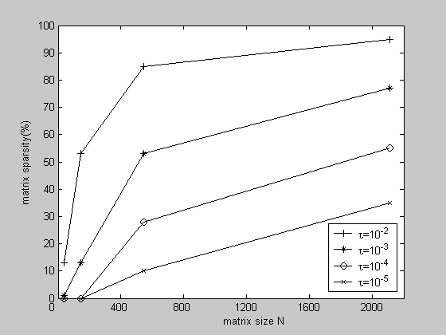
Fig.1. Sparsity Versus Matrix Size and Treshold Level

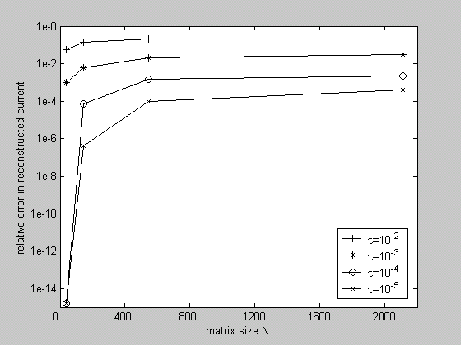
Fig.2. Error Versus Matrix Size and Treshold Level

4. CONCLUSION

The EM scattering from a 3D scattering prob-lem has been analyzed by using the devloped wave-let matrix transform approach. Numerical experi-ments have shown that, especially when the matrix size becomes large, the developed approach does produce very sparse MoM matrices, similar to those obtained by using conventional WMT without increasing the original matrix size, and hence considerably reduces the computation time and memory usage, and yields more accurate results, as compared to conventional WMT.

On the other hand, the proposed method is applicable not only to the EM problems, but also applicable to the applications in which efficient data compression is crucial.

5. REFERENCES

- Goswami, J.C., Chan, A.K., and Chui, C.K., 1995. On Solving First-Kind Integral Equations Using Wavelets on a Bounded Interval. IEEE Trans. Antennas and Propagation, AP-43, 614-622

- Guan, N., Yashiro, K. and Ohkawa, S., 2000. On a Choice of Wavelet Bases in the Wavelet Trans-form Approach. IEEE Trans. Antennas and Pro-pagation, 48(8), 1186-1190

- Kim, H. and Ling, H., 1993. On the Application of Fast Wavelet Transform to the Integral Equation solution of Electromagnetic Scattering Problems. Micro.Opt.Tech.Lett., 6(3), 168-173

- Steinberg, B.Z and Leviatan, Y, 1993. On the Use of Wavelet Expansions in the Method of Mo-ments. IEEE Trans. Antennas and Propagation, AP-41, 610-619

- Sarkar, T.K., Su, C., and et al., 1998. A Tutorial on Wavelets from an Electrical Engineering Perspective, Part I: Discrete Wavelet Techniques. IEEE Trans.on Antennas and Propagation Mag., 40(5), 49-69

- Wagner, R.L.and Chew., W.C., 1995. A study of wavelets for the solution of electromagnetic integral equations. IEEE Trans. on Antennas and Propagation, 43(8), 802-810

- Wang., C.F., 1995. A hybrid wavelet expansion and boundary element analysis of electromagnetic scattering from conducting objects. IEEE Trans. on Antennas and Propagation, 43, 170-178

- Xia, M.Y., Chan, C.H., et al., 2001. Wavelet-based simulations of electromagnetic scattering from large-scale two-dimensional perfectly conducting random rough surfaces. IEEE Trans. on Geoscience and Remote Sensing, 39(4), 718-724

- Xiang, Z and Lu, Y, 1997. An Effective Wavelet Matrix Transform Approach for Efficient Solution of Electromagnetic Integral Equations. IEEE Trans. Antennas and Propagation, 45(8), 1205-1213

