**A Research on the Determination of the Gasification Performance of Grass Pellets**

Çim Peletlerinin Gazlaştırma Performansının Belirlenmesi Üzerine Bir Araştırma

**Bahar DİKEN\***1**, Birol KAYİŞOĞLU**1

**Abstract**

The gasification is the process of converting fuels which mainly contain hydrocarbon such as coal, petroleum, biomass, and solid wastes, into syngas which have combustible gases mixture such as CO, H2, CO2, and CH4 by partial oxidation. In this research, grass pellets were gasified in two different equivalent air coefficients of ER= 0.26 and ER=0.39, and gasification performances of pellets were determined. Gasification was carried out in a micro-scale gasification system in the gasification laboratory of the biosystem engineering department. Performance values as a result of gasification obtained at ER = 0.29 and ER = 0.36 equivalent air ratios are as follows: Biomass fuel consumption rates (FCR) were 8.6 kg/h and 6.5 kg/h. The lower heating values of the syngas were 3831.7 kJ/Nm3 and 3925.5 kJ/Nm3.The gas output rates (GFR) were calculated as 10.01 Nm3/h­ and 9.23 Nm3/ h. The amounts of syngas produced per unit biomass (GMb) were 1.57 Nm3/kg and 1.96 Nm3/kg. The thermal efficiencies of gasification process were 39% and 50%. During the gasification process, the temperature at the core zone varied between 700-800 oC. The performance values obtained as a result of gasification of grass pellet were compared with the performance values obtained from the previous studies on the gasification of biomass. It has been observed that the performance values obtained with 0.36 of equivalent air ratio (ER) are closer to the performance values obtained in previous studies.

**Keywords:** Gasification, biomass, syngas, grass pellet, solid wastes

Öz

Gazlaştırma, esas olarak kömür, petrol, biyokütle ve katı atıklar gibi hidrokarbon içeren yakıtların, kısmi oksidasyon ile CO, H2, CO2 ve CH4 gibi yanıcı gaz karışımlarına sahip olan sentez gaza dönüştürülmesi işlemidir. Bu araştırmada çim peletleri ER=0.26 ve ER= 0.39 olmak üzere iki farklı hava fazlalık katsayısında gazlaştırılmıştır ve gazlaştırma performansları belirlenmiştir. Gazlaştırma işlemleri biyosistem mühendisliği bölümüne ait gazlaştırma laboratuvarında bulunan mikro ölçekli gazlaştırma sisteminde gerçekleştirilmiştir. ER=0.29 ve ER=0.39 hava fazlalık katsayılarıyla gazlaştırma sonucunda elde edilen performans değerleri aşağıdaki gibidir: Biyokütle yakıt tüketim oranları (FCR) sırasıyla 8.6 kg/h ve 6.5 kg/h olarak bulunmuştur. Elde edilen sentez gazların alt ısıl değerleri 3831.7 kJ/Nm3 ve 3925.5 kJ/Nm3 olmuştur. Gaz çıkış oranları (GFR) 10.01 Nm3/h­ ve 9.23 Nm3/h­ olarak hesaplanmıştır. Birim biyokütle (GMb) başına üretilen sentez gaz miktarı 1.57 Nm3/kg ve 1.96 Nm3/kg olmuştur. Gazlaştırma işleminin ısısal verimi % 39 ve % 50 olarak hesaplanmıştır. Gazlaştırma işlemi sırasında kor bölgesindeki sıcaklık 700-800 oC arasında değişmiştir. Çim peletinin gazlaştırılması sonucu elde edilen performans değerleri, biyokütlenin gazlaştırılması ile ilgili olarak daha önce yapılan araştırmalarda elde edilen performans değerleriyle karşılaştırılmıştır. ER =0.36 hava fazlalık katsayısında elde edilen performans değerlerinin önceki çalışmalarda elde edilen performans değerlerine daha yakın olduğu görülmüştür.

**Anahtar Kelimeler:** Gazlaştırma, biyokütle, sentez gaz, çim peleti, katı atıklar

The gasification process takes place in the reactor which is called gasifier and syngas which contains combustible gases such as CO, H2, and CH4 is obtained during this process (Rajvanshi, 1986). Since gasification is carried out by partial oxidation of carbon-containing materials, less oxygen is needed than normal combustion. The equivalent air ratio (ER) varies between 0.2 and 0.5 depending on the type of material used in gasification process (Zhu and Venderbosch, 2005). The gasification efficiency increases when pure oxygen, steam, CO2 or a mixture of these gases with different ratios are used in the gasification process, but because of their high costs, air is generally used (Basu, 2006). The syngas obtained as a result of gasification is usually burned in gas engines to generate electrical energy. When it is used as an energy source in the CHP unit, additional heat energy is provided. The gasification has become prominent among solid waste-based electricity generation process technologies as a clean and environmentally friendly technology for its low emissions, low solid and liquid waste values. In the gasification process, there are less CO2, SO2 and NOx emissions compared to other combustion technologies (Basu, 2010). Although coal is generally used as raw material in large scale gasification plants, it is observed that the residues and wastes originating from biomass have started to be used in order to produce syngas in recent years. At the same time, research on gasification of biomass is also increasing.

The parameters with the greatest impact on the gasification process are the gasification reaction temperature and the equivalent ratio. The control of these parameters ensures that a syngas with an acceptable content of tars and particles is produced and there are no unwanted ash sintering effects caused by high temperatures in the reactor. In addition, the moisture content of the biomass is an important parameter. Furthermore, moisture contents above 15% lead to variations in the concentration of the components of the syngas generated, and therefore in its calorific power, thereby rendering the process unstable (Ruiz et al., 2013). Guangul et al. (2012) investigated the effect of air temperature on performance in the gasification of oil palm fronds. Results showed that preheating the gasifying air improved the volumetric percentage of H2 from 8.47% to 10.53%, CO from 22.87% to 24.94%, CH4 from 2.02% to 2.03%, and higher heating value from 4.66 to 5.31 MJ/Nm3 of the syngas. In the study on gasification of uprooted tea shrub, the specific calorific value and the thermal efficiency of the obtained syngas were found 4.2 MJ/m3 and 65%, respectively (Dutta and Baruah, 2014). In the gasification process of pine and various mixed-hardwood chips at different air speeds, the specific energy of the gas was approximately 6 MJ/m3 (Elder and Groom, 2011). Rubber woods were gasified for tea drying. For this purpose, a downdraft gasifier with a thermal output of 80 KW was used. The average calorific values of obtained syngas changed between 4.18 and 4.62 MJ/m3 (Jayah et al., 2003). Aktaş et al. (2017) have designed and manufactured a laboratory-type micro-scale gasifier. With this gasifier, paddy stalk and 15% coal dust 85% paddy stalk mixture pellets were gasified separately. It has been observed that coal dust increases the thermal value of the gas but reduces the gasification efficiency as it increases the specific gasification rate. A throatless type fixed bed downdraft gasifier prototype has been designed for rice straw gasification and rice straw was pelleted by using different additive materials and these pellet samples were gasified. The highest gasification efficiency was determined using pure rice straw as 64.8 % and the lowest gasification efficiency was determined using 15% coal dust doped pellets as 59.6% (Tuğ, 2016). Coconut shell and palm kernel shell pellets gasified in fixed bed downdraft gasifier at three different temperatures (700, 800 ve 900°C). The lower thermal value (LHV) of the syngas obtained as a result of gasification was found to be 4.01–5.39 MJ/Nm3 (coconut shell) and 3.82–5.09 MJ/ Nm3 (palm kernel shell), respectively. The cold gas efficiency of the coconut shell waste is between 52.2-75.9% and 30.9-56.4% .The cold gas efficiency for palm kernel shell is between 59.0-81.5% and 33.0-57.1% (Yahaya et al., 2019). Fixed bed gasifiers are best suited for small-scale gasification systems. Since the material will move downward by gravity in these gasifiers, the density of the material and the height of the reactor should be sufficiently high. Fixed bed gasifiers are classified into downdraft, updraft and cross draft gasifiers depending on the gas flow direction (Rajvanshi, 1986). Updraft gasifiers are suitable for fuels having high ash content (up to 15%) and moisture content (up to 50%) and the resulting syngas contains a high amount of tar (50-100 g N-1m-3) (Chopra and Jain, 2007).

In this study, grass pellets were gasified by using a micro-scale downdraft and fixed bed gasifier, and gasification performance was determined of pellets at two different airflow rate.

Material and Method

The grass pellets used in the research were obtained from the Agricultural Machinery and Technology Engineering Department of the Faculty of Agriculture of the Akdeniz University. The elemental and chemical analysis results of the grass pellet are given in Table 1 and Table 2.

Table 1. Moisture, ash and volatile matter content of grass pellets (%)

|  |  |  |  |  |
| --- | --- | --- | --- | --- |
| Ash content | Moisture | Volatile Substance | | FC (Fixed Carbon) |
| Original Base | Dry Base | Dry Base |
| 14.91 | 7.98 | 65.78 | 71.85 | 13.24 |

Table 2. Chemical analysis results of grass pellet (% wb)

|  |  |  |  |  |
| --- | --- | --- | --- | --- |
| C | H | N | S | O |
| 40.01 | 5.19 | 2.33 | - | 37.56 |

*Hesaplanarak bulunmuştur (TSE, 1991).

Gasification unit

The gasification unit used in the research is downdraft, fixed bed, and throatless type. The diameter and length of the reactor are 170 mm and 750 mm, respectively. The reactor is manufactured from high temperature and corrosion-resistant stainless steel (AISI 310S) in 5 mm thickness.

There are nozzles and hot air jacket for additional air inlets on the reactor. The additional air intake can be passed through this hot air jacket to the nozzles and from there into the reactor (oxidation zone). In this study, the gasifier used as an open top gasifier by keeping the top opened and keeping the nozzles closed. At the bottom of the reactor, there is a “gas and ash collection unit” where the syngas passing through the grid is delivered to the outlet line and at the same time the ash is collected (Figure 1).

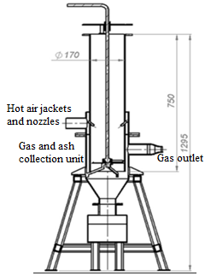

Figure 1. Schematic representation of the gasification reactor and main dimensions (Aktaş et al., 2017)

There is a fixed grid 50 mm above the bottom of the reactor. The grill is supported by the legs on the gas and ash collection unit. A manually controlled stirrer is used for the evacuation of the ash formed under the core zone (Figure 2).

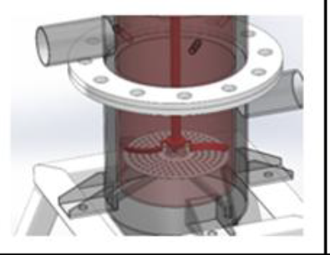

Figure 2. Mixer in the gasification system (Aktaş et al., 2017)

The cyclone in the gas outlet carries out the first stage of gas cleaning. After the cyclone, the syngas passes through the filtration unit in which has stainless steel chips as the retaining material, then into the cooling unit. A second filter after the cooling unit also completes the last step of the gas cleaning process (Figure 3.).

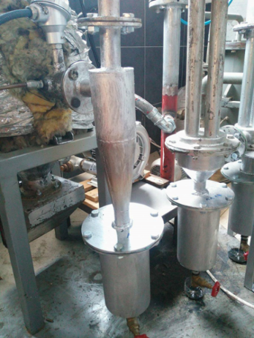

Figure 3. Gas cleaning system (Aktaş et al., 2017)

The flow rate of the obtained gas is measured with the help of an orifice plate and a differential pressure meter. The suction of the syngas in the reactor is provided by a speed controlled vacuum fan. A GREENCO 2RB 210-7AH16 model three-phase vacuum pump provides the discharge of syngas from the reactor. It can operate at 50 Hz (13 kPa) and 60 Hz (11 kPa) frequencies. The maximum airflow rate is 80 m3/h at 50 Hz and is 98 m3/h at 60 Hz. There is a gas sampling plug at the vacuum fan outlet. After sampling, unused gas is burned in a flare which is located outside the laboratory. The flow chart of the gasification unit is shown in Figure 4 (Aktaş et al., 2016).

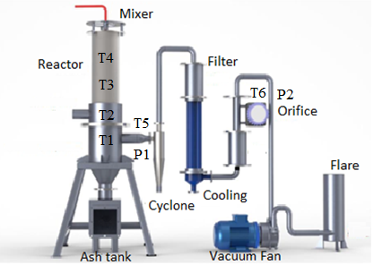

Figure 4. The flow chart of the gasification unit (Dalmış et al., 2018)

**Gas chromatography device**

The chemical composition of syngas produced in the gasification process was measured by AGILENT 7890B model gas chromatograph device. This device measures the volumetric percentages of CO, CO2, H2, CH4 and N2 gases in the syngas.

**Measuring and control equipment**

PLC controlled measurement, control, and automation devices and equipment have been used to control the operation of the gasification system and to display and record the data to be obtained from the gasification unit (Figure 5). The system is equipped with analog and digital input/output channels suitable for structural expansion.

As shown in Figure 6 different temperature measurements and two pressure measurements are made in this developed system. The speed control of the vacuum blower can also be controlled via the HMI panel using the inverter. The measured values can be saved via USB connection without any computer connection. All measured values are shown on the 7 ” TFT display screen on the system.

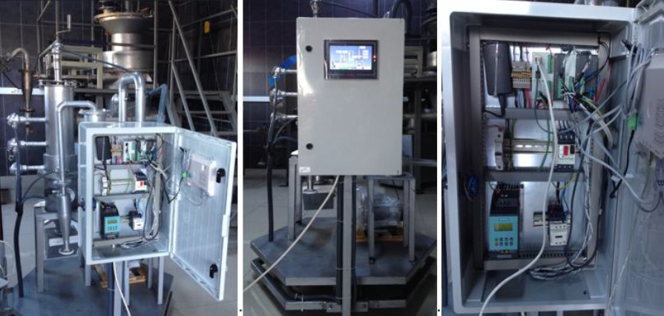

Figure 5. Measurement and control system (Dalmış et al., 2018)

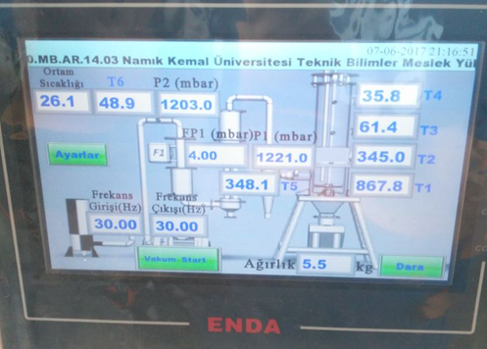

Figure 6. Measurement and control equipment display screen

Analysis of gas components and calculation of heat values

The lower heat value of the syngas was found by taking into account the molar ratios and the energy contents of the gas components in the unit mass of the produced syngas (Waldheim and Nilsson, 2001).

The lower and high heat values of the syngas are calculated by the following equations (Eq. 1,2):

${LHV}_{g}=\left(10,8. \%H_{2}+12,63.\%CO+35,8.\%{CH}_{4}\right)/100$ Eq. (1)

${HHV}_{g}=\left(12,76.\%H_{2}+12,63.\%CO+39,76.\%{CH}_{4}\right)/100$ Eq. (2)

Where, ${LHV}_{g}$ and (MJ/Nm3) are the lower and high heat value of the syngas, respectively. In these equations, molar fractions of gases in the syngas are used.

Gas and Air Flow Measurements

The gas flow measurement was carried out with an orifice type flow meter placed before the gas sample was taken in the gas line. In this study, the orifice plate made of 2mm stainless steel is placed between the flanges and the pipeline (2’’). Orifice diameter is 18mm and flow rate calculations were made according to EN ISO 5761-2 (Tuğ et al., 2017).

The airflow rate was calculated by using the measured gas flow rate and the proportion of N2 in syngas. The amount of nitrogen was assumed as fixed in the air and in the syngas. NOx compounds in syngas are neglected in the calculation of the syngas flow rate. The airflow rate was found by the following equation 3 (Tuğ, 2016).

$AFR=\frac{GFR. N_{2gas}}{N_{2air}}$ Eq. (3)

Where; GFR (Nm3/h) is the syngas flow rate, N2air is the proportion of nitrogen in the air (%), AFR (m3/h) is the airflow rate supplied from the environment, N2gas is the proportion of nitrogen in the syngas (%).

**Calculation of stoichiometric air volume**

The amount of stoichiometric air was calculated with the following equation 4 (Corven, 2002):

$SR=0,31.HHV$ Eq. (4)

Calculation of specific gasification rate (SGR)

The specific gasification rate is the amount of biomass in the unit section of the reactor gasifies per unit time. It is one of the important parameters determining the performance of the reactor (Jain, 2006). For this purpose, the biomass consumption rate (FCR) was calculated primarily based on the amount of biomass consumed by the reactor during the operation time, equation (5).

$FCR=\frac{m_{b}}{t}$ Eq. (5)

Where; FCR (kg/h) is biomass consumption rate, 𝑚𝑏 (kg) is the amount of biomass consumed during operation time (t (h)). Then the specific gasification rate was determined by the following equation 6;

$SGR=\frac{FCR}{A_{R}}$ Eq. (6)

Where; SGR (kg/hm2) is the specific gasification rate and Ar (m2) is the cross-sectional area of the reactor.

**Calculation of equivalence ratio (ER)**

The equivalence ratio (ER) is calculated with the following equation 7 (Reed and Das, 1988):

$ER=\frac{\left(AFR/FCR\right)}{{SR}_{V}}$ Eq. (7)

Where; the ER equivalence ratio; AFR (m3/h) is the rate of air given to the reactor; FCR(kg/h) is the biomass fuel consumption rate and SRv (m3/kg) is the volumetric flow of stoichiometric air required for combustion of 1 kg biomass fuel.

Calculation of specific gas production rate (SGPR)

The amount of gas produced per unit time during gasification (GFR) was found by proportioning the reactor cross-sectional area (Tuğ, 2016). The specific gas production rateratio (SGPR) is calculated with the following equation 8.

$SGPR=\frac{GFR}{A_{R}}$ Eq. (8)

Determination of the amount of gas produced by the unit biomass

The amount of gas produced by the unit biomass **(**𝐺𝑀𝑏, Nm3/kg) was calculated by dividing the specific gas production rate (SGPR) by the specific gasification rate.

Calculation of the gasification efficiency

First, the heat power of the biomass is found with the following equation 9;

$P_{b}=\frac{FCR.{LHV}_{b}}{3600}$ Eq. (9)

Where; Pb (kW) is the heat power of the biomass.

Then the heat power of the produced syngas is found by the following equation 10;

$P_{g}=\frac{GFR.{LHV}_{g}}{3600}$ Eq. (10)

Where; Pg (kW) is the heat power of the produced syngas and GFR (Nm3/h) is the syngas flow rate.

After calculating the thermal powers of the biomass and syngas, the thermal efficiency of the gasification process was found with the following equation 11;

$η_{G}=\frac{P_{g}}{P_{b}}.100$ Eq. (11)

**Results and Discussion**

The amount of stoichiometric air in the pellet sample

The amount of stoichiometric air required for the complete burning of the grass pellet SRm value was calculated as 5.093 kg-air/kg-biomass. Volumetric stoichiometric air at the temperature of 25 °C was calculated as 3.934 m3/kg.

Temperature changes during the gasification process

In the gasification process, the change of the core (T1), reduction (T2), pyrolysis (T3), drying zones (T4) and the temperature of the gas after reactor (T5) after cleaning (T6) are given in Figure 7. The temperature of the core zone reached a maximum level above 900 °C after 30 minutes of gasification. The temperature of the core zone changed between 700 oC and 800 oC. The most recent gas temperature (T6) remained constant at around 50 °C during the gasification process.

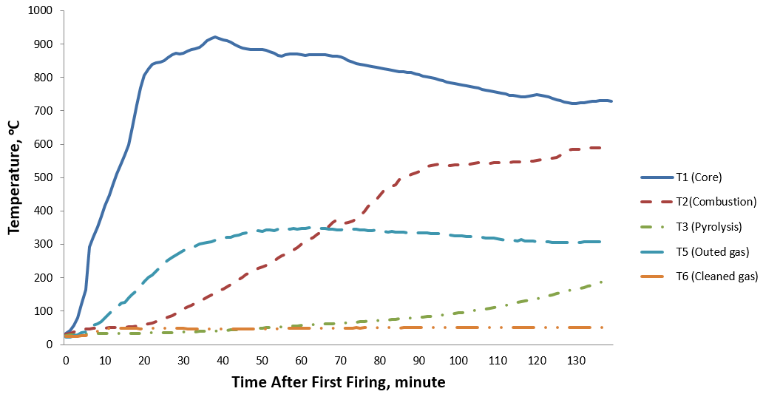

Figure 7. Temperature changes during the gasification process (ER=0.36)

In previous studies on rice pellet gasification, the temperature in the core zone was reported to be around 800 oC (Tuğ, 2016; Manatura et al., 2017). Jangsawang et al. (2015) stated the optimum ER values in core zone temperatures in the model they developed. Upadhyay et al. (2019) stated the temperature in the combustion and reduction zone were found in the range of 535 oC and 915oC respectively with the change in ER from 0.24 to 0.386. Bhoi et al. (2018) for switchgrass gasification, combustion zone temperatures of the reactor were found 724± 154, 734±94, 788±155 and 860±124 oC at the ER of 0.17, 0.22, 0.28 and 0.30, respectively and for redcedar gasification, combustion zone temperatures of the reactor were found 769±163, 772±153, 756±241 and 780± 135 oC at the ER of 0.16, 0.20, 0,24 and 0.29, respectively. Kotyczka et al. (2019), for a variety of biomass samples were found pyrolysis in the temperature range of 250-350 oC. In this study, the temperature of the core-zone was ranged from 700 oC to 800 oC and the temperature of the pyrolysis zone was ranged from 100 oC to 200 oC. The ER levels studied are at optimum levels depending on these temperatures.

Chemical composition and thermal value of the syngas

The experiments were done in two airflow rate. ER was 0.36 in the first airflow rate and 0.29 in the second airflow rate.

The components and the thermal values of the obtained syngas are given in Table 3. The ratio of hydrogen and methane was higher in the syngas obtained at ER=0.36. The lower heating values were found 3925.5 kJ/Nm3 at ER = 0.36 and 3831.7 kJ/Nm3 at ER = 0.29. Susastriawana et al. (2019) stated that lower heating values of the syngas changed between 2690 and 3500 kJ/Nm3 at different equivalence ratios for gasiﬁcation of the rice husk, sawdust, and the mixture.

Table 3. Composition and heating values of syngas

|  |  |  |  |  |  |  |  |
| --- | --- | --- | --- | --- | --- | --- | --- |
| ER | H2 | CO | CH4 | CO2 | N2 | LHV  (kJ/Nm3) | HHV  (kJ/Nm3) |
| 0.36 | 14.56 | 13.78 | 1.72 | 13.33 | 56.61 | 3925.5 | 4283.2 |
| 0.29 | 13.33 | 14.87 | 1.45 | 12.68 | 57.67 | 3831.7 | 4154.7 |



Figure 8. Gas components in the gasification process at ER=0.36 and ER=0.29

Gas components obtained in the gasification process are given in Figure 8. CO, H2, and CH4 which are flammable gases increase the thermal efficiency of the syngas. In this study, the ratio of hydrogen and methane in the syngas at ER=0.36 was found higher than ER=0.29.

Performance values of the gasification process

The biomass feed rate (FCR) at ER = 0.36 was lower, but the amount of gas produced per unit biomass was higher than ER=0.29. The rate of outflow of gas at ER=0.29 was higher (Table 4).

Table 4. Performance values obtained in gasification process

|  |  |  |  |  |  |  |
| --- | --- | --- | --- | --- | --- | --- |
| ER | FCR  (kg/h) | GFR  (Nm3/h) | AFR  (Nm3/h) | SGR  (kg/hm2) | SGPR  (m/h) | GMb  (Nm3/kg) |
| 0.36 | 6.5 | 12.71 | 9.23 | 286.34 | 560.11 | 1.96 |
| 0.29 | 8.6 | 13.54 | 10.01 | 378.85 | 596.40 | 1.57 |

The amount of gas produced per unit biomass mass was found between 1.78 to 1.93 Nm3/kg in the study with rice straw (Tug, 2016). The value of GMb at ER=0.29 is below these values in this study. Simone et al. (2012) found that the specific gasification rate of biomass was between 2.2 and 2.4 Nm3/kg. When we look at previous studies, it is possible to say that the specific gasification rate of grass pellet is slightly lower than other biomass sources.

The thermal efficiency of the gasification process

The thermal efficiency values obtained in the gasification process are given in Table 5. The thermal efficiency at ER=0.36 was higher than ER=0.29. Manatura et al. (2017) were found thermal efficiency between 44-68% in the rice paddy gasification. In the wood sawdust gasification thermal efficiency was between 67% -70% (Simone et al., 2012). Thermal efficiency was 65% in tea branches. Dutta and Baruah (2014) found thermal efficiency 59-64% in their research. Tuğ (2016) stated that thermal efficiency changed between 59-64% in rice straw gasification.

Table 5. The thermal efficiency of the gasification process

|  |  |  |  |
| --- | --- | --- | --- |
| ER | Pb  (kW) | Pg  (kW) | Thermal Efficiency  % |
| 0.36 | 27.71 | 13.86 | 50 |
| 0.29 | 36.66 | 14.41 | 39 |

Optimum ER for switchgrass gasification was in the range of 0.22-0.28 based on the highest gasification efficiencies of 60-64% (Bhoi et al., 2018). In this study, especially in ER = 0.29, the thermal efficiency was very low compared to previous studies. The thermal efficiency of ER = 0.36 was found close to the gasification process with rice straw.

Conclusions and Recommendations

The findings of the research can be summarized as follows;

ER value at the first airflow rate (9,23 m3/h) was 0.36, and 0.29 at the second airflow rate (10.01 m3/h). ER value limits specified between 0.20 and 0.50 in the literature (Tuğ, 2016; Manatura et al., 2017). The ER values obtained in this study were within the determined limits.

The biomass consumption rates (FCR) and the syngas flow rates (GFR) were 6.5 kg/h and 12.71 Nm3/h at ER=0.36, 8.6 kg/h and 13.54 Nm3/h at ER=0.29.

The gas production per unit biomass (GMb) at ER=0.36 and ER=0.29 was found 1.96 Nm3/kg and 1.57 Nm3/kg, respectively. It is possible to say that these values increase in proportion to the ER value.

In this study, thermal efficiencies in gasification were found 50% at ER = 0.36 and 39% at ER = 0.29. In this study, the thermal efficiency was lower than the other biomass gasification studies at both airflow rates.

At the beginning of the gasification, the temperature in the core zone was about 900 °C for 30-40 minutes. After that, it was ranged from 700 to 800 oC. These values are consistent with other biomass gasification values.

According to the results obtained, it is possible to say that the ER = 0.36 level is more suitable for the gasification process of the grass pellet.

Kaynakça/References

Aktaş, T., Dalmış, İ.S., Tuğ, S., Dalmış, F., Kayişoğlu, B. (2017). Çeltik saplarının gazlaştırılması amacıyla laboratuvar tipi bir gazlaştırıcının Geliştirilmesi ve Denenmesi. *Journal of Tekirdag Agricultural Faculty*, 14(02): 119-128.

Bhoi, Prakashbhai R., Huhnke, R. L., Kumar, Ajay., Thapa, Sunil., Indrawan, Natarianto. (2018) . Scale-up of a downdraft gasifier system for commercial scale mobile power generation. *Renewable Energy* 118 25-33.

Basu, P. (2010). Gasification and Pyrolysis. Practical Design and Theory, Canada.

Basu, P. (2006). Combustion and gasification in fluidzed beds. Taylor and Fransic Group LLC, Canada p. 59-101

Chopra, S., Jain, A.(2007). A review of fixed bed gasification systems for biomass. *Agricultural Engineering International:* The CIGR Ejournal, Invited Overview No. 5. Vol. IX:55-60.

Corven, D. (2002). From biomass to diesel—technical and economic evaluation: biomass conversion to diesel by pyrolysis, gasification and Fischer–Tropsch. Graduation report. The University of Twente.

Dutta, PP., Baruah, DC. (2014). Gasification of Tea (Camellia sinensis (L.) Kuntze) Shrubs for Black Tea Manufacturing Process Heat Generation in Assam, İndia. *Biomass and Bioenergy*, 66: 27-38.

Dalmış, F.,Tuğ, S., Dalmış, İS., Aktaş, T., Kayişoğlu, B. (2018). Laboratuvar Tipi Gazlaştırıcılar İçin PLC Tabanlı Prototip Veri Toplama ve Kontrol Sisteminin Geliştirilmesi. *Tekirdağ Ziraat Fakültesi Dergisi*, 15(01):143-156.

Elder, T., Groom, LH. (2011). Pilot-scale gasification of woody biomass. *Biomass and Bioenergy*, 35: 3522-3528.

European Standart EN ISO 5167-2 (2003). Measurement of fluid by means of pressure differential devices inserted in circular cross-section conduits running full – Part 2: Orifice plates (ISO 5167-2:2003).

Guangul, FM., Sulaiman, SA., Ramli, A. (2012). Gasifier selection, design and gasification of oil palm fronds with preheated and unheated gasifying air. *Bioresource Technology*, 126: 224-232.

Jain, AK. (2006). Design parameters for a rice husk throatless gasifier. Agricultural Engineering International: the CIGR Ejournal, Manuscript EE 05 012, Vol VIII: 45-49.

Jangsawang, W., Laohalidanond, K., Kerdsuwan, S. (2015). Optimum equivalance ratio of biomass gasification process based on thermodynamic equilibrum model, *Energy Procedia* 79: 520-527.

Jayah, TH., Aye, L., Fuller, RJ., Stewart, DF. (2003). Computer simulation of a woody downdraft gasifier for tea drying. *Biomass Bioenergy*, 25 :459-69.

Kotyczka, M.,Moranska. (2019). Semi-quantitative and multivariate analysis of the thermal degradation of carbon-oxygen double bonds in biomass *Journal of the Energy Institute* 92: 923-932.

Manatura, K., Lu, JH., Wu, KT., Hsu, HT. (2017). Exergy analysis on torrefied rice husk pellet in fluidized bed gasification, *Applied Thermal Engineering*, 111: 1016-1024.

Rajvanshi, AK. (1986). Alternative energy in Agriculture. CRC Press, Vol II, Chapter 4: 83-102.

Ruiz, JA., Juarez, MC., Morales, MP., Munoz, P., Mendivil, MA. (2013). Biomass gasification for electricity generation: Review of current technology barriers. *Renewable and Sustainable Energy Reviews*, 18: 174-183.

Reed, TB., Das, A. (1988). Gasifier Fabrication and Manufacture. Handbook of Biomass Downdraft Gasifier Engine Systems. Solar Technical Information Program Operated for U.S. Energy Department 38-47, 48-50, Colorado, USA.

Simone, M., Barontini, F., Nicolella, C., Tognotti, L. (2012). Gasification of pelletized biomass in a pilot scale downdraft gasifier, *Bioresource Technology*, 116: 403-412.

Susastriawana A.A.P., Saptoadib, Harwin., Purnomo. (2019). Comparison of the gasiﬁcation performance in the downdraft ﬁxed-bed gasiﬁer fed by diﬀerent feedstocks: Rice husk, sawdust, and their mixture. *Sustainable Energy Technologies and Assessments* 34 (2019) 27-34.

Tuğ, S., Dalmış, F. (2017). Influence of syngas composition on calculations of flow rate measured by using orifice plates. *International Scientific Conference* (UNITECH 2017).

Tuğ, S. (2016). *Çeltik Saplarının Gazlaştırılması İçin Mekanik Karıştırıcılı Aşağı Akışlı Prototip Bir Gazlaştırıcı Tasarımı*. Doktora Tezi, Namık Kemal Üniversitesi Fen Bilimleri Enstitüsü, Tekirdağ.

Upadhyay, Darshit S., Sakhiya, Anil Kumar., Panchal, Krunal., Patel, Amar H., Patel, Rajesh N. (2019). Effect of equivalence ratio on the performance of the downdraft gasifier-An experimental and modelling approach. *Energy* 168: 833-846.

Waldheim, L., Nilsson, T. (2001). Heating value of gases from biomass gasification. Report prepared for: IEA Bioenergy Agreement, Task 20 – Thermal Gasification Process. Report no TPS-01/16 TPS Termiska Processer AB, Studsvik.

Yahaya, AZ., Somalu, MR., Muchtar, A., Sulaiman, AS., Daud, WRW. (2019). Effect of Particle Size and Temperature on Gasification Performance of Coconut and Palm Kernel Shells in Downdraft Fixed Bed Reactor. *Energy*, 175: 931-940.

Zhu, X., Venderbosch, R. (2005). A Correlation Between Stochiometrical Ratio of Fuel and Its Higher Heating Value. *Fuel*, 84, 1007-1010.