Design Approaches of New Buildings Affecting the Historical Texture of Silifke

Meltem AKYÜREK

Abstract
It is an inevitable fact to observe the physical development of the historical cities in the process of urbanization, whose historical past cannot be ignored. In the process of modernization, it is essential to emphasize the necessity of preserving historical values as well as the criteria to form new designs by researching the effects of contemporary buildings on urban fabric. Establishing data and methods for the effort to capture the harmonious integrity of traditional and modern provide the physical heritage and habitable environments that can be passed on to future generations. Developing data and methods for the effort of capturing the harmonious integrity of traditional and modern, constitutes habitable environments by revealing the historical heritage that can be passed on to future generations.
The aim of the study is to develop criticism in the archaeological site of the city center of Silifke by researching new building designs and additions to existing structures in traditional urban texture. In this context, the negative and positive effects of the new structures described in connection with the historical features of the city of Silifke are questioned within the framework of the basic design criteria. Thus, the results of the examinations which were developed considering the old-new relationship provide the designer with the opportunity to analyze the current situation and to develop new methods by analyzing the current situation. Thus, the original projects developed on the basis of the available data that direct the design support the cultural image of the cities.
Key Words:
Silifke, Conservation, Historical Environment, New Building.

Silifke Tarihi Dokusuna Etki Eden Yeni Yapıların Tasarım Yaklaşımları

Özet
Tarihi geçmişi göz ardı edilemeyecek öneme sahip, geleneksel karakterli tarihi çevrelerin, kentleşme sürecindeki fiziksel gelişimlerini gözlemlemek kaçınılmaz bir gerçekliktir. Modernleşme sürecinde, tarihi değerlerin korunması gerekliliğini vurgulamak kadar çağdaş yapıların kent dokusu üzerindeki etkilerini de araştırarak yeni tasarımları oluşturacak kriterleri ortaya koymak esastır. Geleneksel ve modernin uyumlu bütünlüğünü yakalayabilme çabasına yönelik veriler ve yöntemler geliştirmek, gelecek nesillere aktarılabilecek tarihi mirasları ortaya koyarak, yaşanabilir çevreleri oluşturmaktadır.
Çalışmanın amacı, Silifke kent merkezindeki arkeolojik sit alanı içerisinde, geleneksel kent dokusunda bulunan, yeni yapı tasarımlarına ve mevcut yapılara yapılan eklemelere yönelik araştırmalar yaparak eleştiriler geliştirmektir. Bu bağlamda, Silifke kentinin tarihi nitelikleri ile bağdaştırılarak anlatılan yeni yapıların kentte oluşturduğu negatif ve pozitif etkiler, temel tasarım kriterleri çerçevesinde sorgulanmaktadır. Böylelikle eski-yeni birlikteliği göz önünde bulundurularak geliştirilen incelemelerle ortaya konulan sonuçlar tasarımcıya, herhangi bir problemi çözmenin dışında, mevcut durum analizini yaparak, sonuçları değerlendirme ve yeni yöntemler geliştirme imkanı sağlamaktadır. Böylelikle, tasarımı yönlendiren mevcut veriler esas alınarak geliştirilen özgün projeler, kentlerin kültürel imajını desteklemektedir.
Anahtar Kelimeler:
Silifke, Koruma, Tarihi Çevre, Yeni Yapı.

INTRODUCTION
The first major leap in the history of civilization, the agricultural revolution, and the first steps of architecture began to be settled. The second major leap, the industrial revolution, gave impetus to architecture. Within the story of the existence of human beings, architecture has positioned itself at the most important points. People who begin to perceive the concept of space and time have carried the footsteps of the past into the future with an attempt to define the spaces in which they exist. In this context, the architecture, which served as a bridge between past and future, revealed data with concrete facts that we perceive with our senses.
In the formation phase of the cities, the perception of time and space has been mentioned. The fact that the displacements that begin with the concept of time, form the notion of travel, and the commercial developments reveal the necessity of different functions in cities, have formed a large frame on the physical structure of the cities. In different periods, in the cities developing in the direction of different thoughts, the formation of structures serving different purposes at different scales changed the face of the cities. Thus, neighborhoods that provide historical and cultural values ​​to many cities and which create a sense of identity have formed. As time progressed, historical buildings became an integral part of the attraction of cities and played an active role in the image of cities with their visual and functional qualities. In almost every period, the historical structures, which are considered to be the healing elements of identity, have been accepted as concrete values ​​that can make connections between the past and the future.
The environment, which is an ever-changing reality, has been renewed, changed and developed due to the physical variables formed by people and natural reasons and socio-cultural, economic and technological effects. In the process, the physical environment components that affect the social structure and are shaped by mankind have caused the concrete requirements. The city, which is differentiated in accordance with the requirements, has formed records related to different period layers. The explanation of the stains occurring in these layers with the correct methods contributes to many disciplines, especially history, considering the understanding of the physical environment records.

The gaps between the natural environment and the built environment components, how they are to be filled, and which function they serve are among the design problems of the cities. In this context, the aim of the study is to develop a physical examination of the city of Silifke within the boundaries of the urban settlement area and to develop approaches for the correct design of new building components. Discussion of the positive and negative effects of the new structures on the historical texture clarifies the purpose of the research.
The scope of the study consists of new buildings in the historical city center of Silifke, at different points designed around historical buildings. The conceptual explanation and definition of new structures that fill the gaps affects the scope of the study. Before the analysis of the focused structures, some information about the historical, social and cultural structure of the city of Silifke is emphasized and the factors affecting the physical structure of the city are handled by various methods.
The methodology of the research is composed of observations which are qualitative research techniques and the data which are presented by sampling. The observations related to the literature review, the examples and results of the new building design approaches in the historical environment are emphasized in the conclusion part, with the explanation of the steps taken to transfer the historical heritage to the next generations.

1. GEOGRAPHY AND HISTORY OF SİLİFKE
Silifke is located in the south Mediterranean region of Turkey, is one of the districts in the province of Mersin. Silifke, which is located in 13 districts of Mersin Province, is the second in terms of area and the seventh in the population. The district covers 18% of the province with a surface area of 2693 km2, 89% of which is mountainous and 11% is plain. (www.silifke.bel.tr/silifke/ilcemiz/cografi-yapi.html date of access: 10.11.2018)
The city, which has hosted many civilizations over its 6,000-year history, has been exposed to economic, social and physical developments in some periods as a center of some civilizations, and in some periods has been subject to regressions due to wars, exchanges and political conflicts. (www.nufusu.com/il/mersin-nufusu date of access: 15.11.2018)

Although Silifke is a district of Mersin, it has the privilege of being the center of the city in the early years of the Republic. In 1924, Silifke, a new province known as Icel, was established and the districts of Mut, Gülnar and Anamur were connected to Silifke. Until 1933, the status of Silifke as the center of the province of Icel was changed as a district in 1933.

Map 1: Mersin in Turkey, Location of Silifke in Mersin
Reference: Cografya harita (2018).
http://cografyaharita.com/turkiye-cografi-bolge-haritalari2.html
Date of Access: 20.11.2018

It is emphasized that the first group living in Silifke and its vicinity is the community of Luvi, Sumerian origin, which was found in the region before 3000 BC. (Gürtürk, 1990) After the Luwians, BC. In 1750, in the vicinity of Silifke, Arzava (Arzova, Arzawa) Kingdom was founded and it is claimed to have existed for about 1000 years. Later, it is stated that the Ionian kingdom was established in the region and later the Kue kingdom was founded, extending to the western border of Mut and Alanaya. It is mentioned that the city named Timur, which is located in the vicinity of Silifke and surrounding area, is the capital of the Kue Kingdom, and later it is the Assyrian and Iranian sovereignty in the region.
Silifke, which is one of the oldest cities of Cilicia, dates back to Selefkoslar, which was founded as the city. Macedonian King Alexander the Great died in history after his victory in Silifke. The lands of Silifke falling to Selefkos Nikator, one of the generals of Alexander the Great. It was first mentioned in 330 as a city state. The city which has been living for 2300 years is the only one of the 9 silifke cities of Selefkos Nikator. (Taşkıran, 2009)

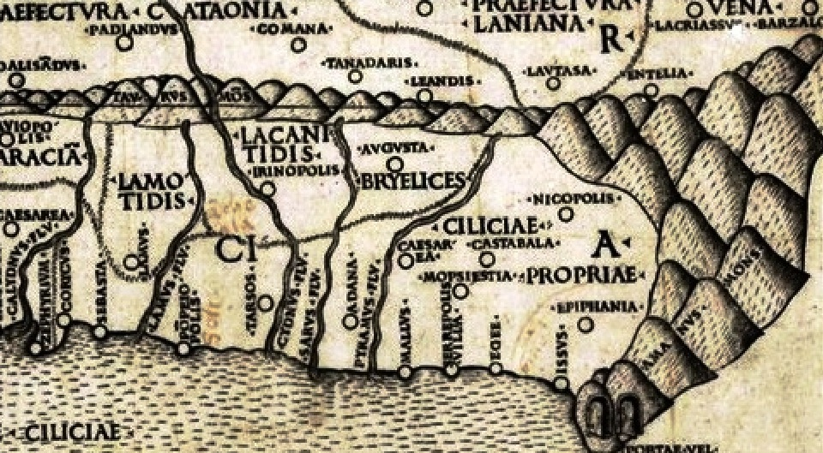
Map 2: Cilicia and surroundings
Reference: Ptoleme haritasında Kilikya ve Mallos (2018).
https://magarss.blogspot.com/2016/08/ptoleme-haritasinda-kilikya-ve-mallos.html
Date of Access: 21.11.2018

After the establishment of Silifke as a city, the civilizations that dominated the region in chronological order from 300 BC to the period of Selefkos (BC 312-64), Roman Period (64 AD 395 BC), Byzantine Period (395-647 AD), Arabs Period (AD 64-1067), the Seljuk Period (1067-1228 AD), Karamanogullari Period (1256-1483 AD), the Ottomans Period (1483-1923) and the Republican Period. (Gürtürk, 1987)

Considering the chronology in question, the architectural character of Silifke, which has created urban layers in temporal continuity, will provide an analysis of the formation and development phases of the urban fabric, the understanding of the architectural character of the city, the solution of important design problems in terms of the spirit of time and urban identity. (Eruzun, 1987)

2. PERCEPTION OF HISTORICAL ENVIRONMENT CONSERVATION
History has been a branch of science that aims to create a world that is transformed into a positive human being by providing input about the past instead of going to the unknown. The historical environment has also been formed by the settlements and ruins of past. The principle of the protection of a single building, beginning with religious reasons, has become a symbol of civilizations over time, protecting the whole of the historical environment. (Erder, 1975)
In this context; The importance of preserving historical environments can be grouped into 3 general objectives:
1. forwarding the historical heritage to future generations,
2. Ensuring the continuity of culture,
3. Providing modern people with new life opportunities with history.

Urban spaces created by societies in various periods have been indicators of the cultural and social structures of societies. The conservation has been carried out with different decisions and applications starting from urban scale up to the historical building and building element scale. While emphasizing the concept of historical environment, it is possible to mention three basic elements. These can be defined as the concept of cultural continuity in the historical environment, the concept of new structure design in the historical environment and the concept of infill. In fact, in general, the interrelations of these three concepts can be observed. The concept of infill, which can be defined as the filling of gaps in the historical environment, is related to the new building design principles in the historical environment and constitutes the data in the cultural continuity.

Within the scope of the study, the data mentioned in considering the concept of historical environment refers to Silifke. However, assuming that an entire historical texture cannot be mentioned, the new structures designed around or near the cultural heritage of various distances are examined together for negative and positive reasons, whether they contribute to the identity of the city or not. Therefore, when talking about new building approaches in the historical environment, two opposite endpoints can be mentioned. In the new building design built near the infill or a single proprietary structure, it develops the method of study to discuss the positive aspects of the structures designed taking into account the various values between imitation and annihilation points.

3. METHOD OF STUDY
Within the framework of the ‘Silifke Conservation Development Plan’, which was organized in 1995, the structures and surroundings of the ancient period such as the Zeus Temple, Tekir warehouse and the ruins were declared as archaeological sites and some of the monumental buildings and traditional houses were registered by the Conservation Council for cultural and natural assets. With the registration decisions taken in the following years, there are 53 registered buildings within the scope of the work area covering Saray district, Say district, Camikebir district, Pazarkaşı district and Mukaddem district in Silifke City Center.

Map 3: Silifke Conservation Development Plan
Reference: Silifke Municipality, edited by the author.
Date of Access: 01.04.2016

The study was developed by qualitative research method, which was determined as the study of the design criteria of the Republican period buildings designed on 5 historical buildings in the city center of Silifke. Based on field surveys and observations, the results of the study were supported by literature surveys and visual analysis. Analysis of the city maps examined from the 1880's gives information about the city's growth and development. However, the determination and formation of the ‘new building’ design stages of cities with historical characteristics with the potential for growth and development are developed within the framework of the regulations and the laws.

Map 4: Silifke city center 3rd degree urbanization boundaries within the archaeological site
Kaynak: http://keos.silifke.bel.tr/keos/
Date of Access: 20.11.2018, edited by the author.

1800 years of urbanization

1950 years of urbanization
2018 years of urbanization

The data and results of the study are analyzed through 5 new buildings designed during the Republican period in the city center of Silifke.
The criteria for the new building designs designed in historical environments are located between the imitation and ignore endpoints. Taking into account the point, it is possible to determine which side of the design is close to it, whether it can provide contextual integrity and contextual continuity with interpretations, and to define the problem open to development. In this context, with the design scale developed, the data of 5 new building design which is examined in Silifke city center is presented.

Design Scale
Reference: Erkartal, 2015

4. EVALUATION AND RESULTS ON SAMPLES
Although there are no consecutive historical textures within the city of Silifke after the battles, immigration, handover, demolitions, distortions and decisions of the governing authorities in the history; The environment should not be ignored. In this context, the Roman temple ruins thought to have been built in the 2nd century BC and the registered building, which is still under restoration in the neighborhood, 2 registered buildings belonging to the Late Ottoman Period and the buildings which were examined around the house used as the Atatürk House Museum built in the late 1914 Ottoman period, by examining the places of the city of Silifke positive and negative aspects are revealed.
Firstly, the Roman (Zeus, Jupiter) Temple (Photo 1) and the registered building (Photo 2) that was restored in 2018 on the adjacent square were examined in the design scale of the new building built in the 2000s. The design of the new building example (Photo 3, 4), which has a physical effect on the temple and its surroundings, which is designated as the first-degree archaeological site, is to be made at a height of approximately 12 meters, indicating that the historic environmental design criteria are taken into consideration. The color and texture used on the exterior of the building makes positive references to the environment. The circular axis formed on the entrance façade of the building does not reduce the visual impact from Inönü Boulevard to the Roman temple. Although the structure is consistent with the scale of the environment, the transformation method, which is a kind of design method, could provide more accurate design results. The building design scale, which emphasizes the construction technique, materials and design criteria used in the construction in the twentieth century, is located at the point where it approaches.

Photo 1: Roman Temple (2018) Photo 2: Registered building during restoration phase (2018)
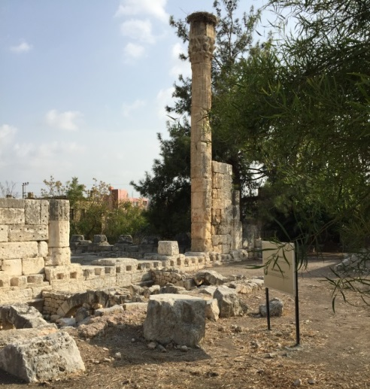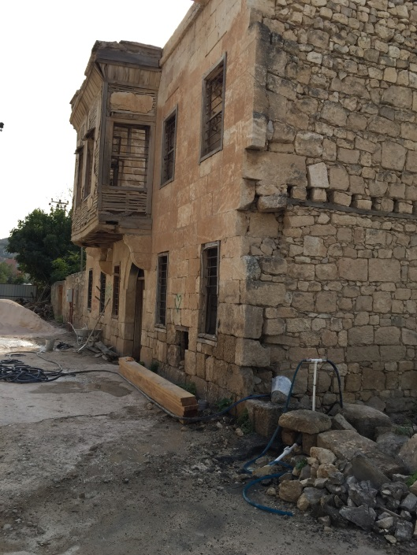

Photo 3: Example 1 Photo 4: Example 1
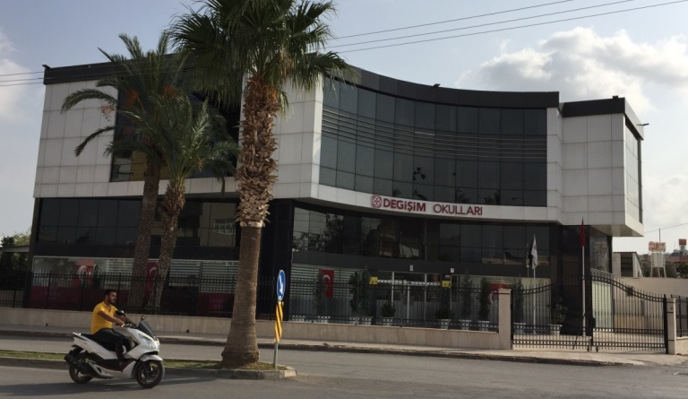
Reference: Photos were taken by the author.
Date of Access: 20.11.2018

The buildings examined in the second, third and fourth examples were built in the continuation of the registered buildings on Cavit Erden Street. The second sample restoration was completed in the 2000s, designed as a registered cafeteria (Photo 5) and near an unregistered proprietary building used as a cafeteria (Photo 6). Although the window ratios are not in rhythm and harmony with registered structures, the building height is compatible with the registered structures around the volumetric clearance rates. The building does not emphasize the design concept of the century in which it was designed, so it finds its place on the design scale near the imitation points. (Photo 7) The third structure is designed on the land located on 2 sides at the corner point in line with the mentioned structures. It does not reflect the characteristics of the period. The mass of the design is unrelated to the environment. The structures in association with each other seem to be imitation of each other. It is a matter of discussion and openness not to think that today will be a date in the present day and not transfer the correct data to the future. Therefore, today's design concept, understanding the social and economic impacts of the design, the styles of the design, the building materials of the region or the external building materials used for the climate, will convey information about the physical structure of the region not only in the field of architecture but also in the different branches of science.

Photo 5: Restored registered building Photo 6: Registered building
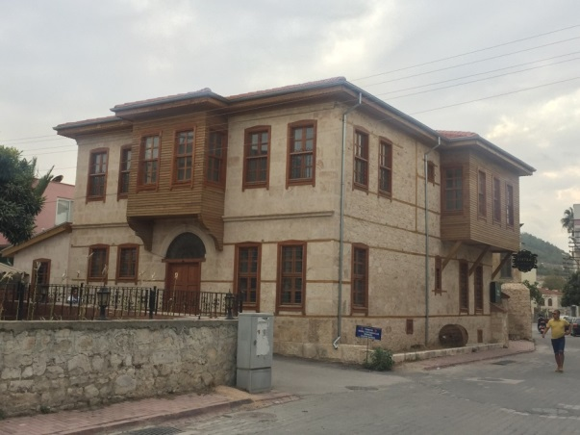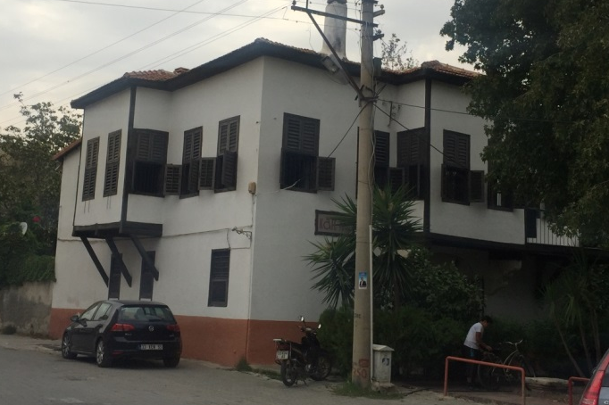

Photo 7: Example 2 Photo 8: Example 3
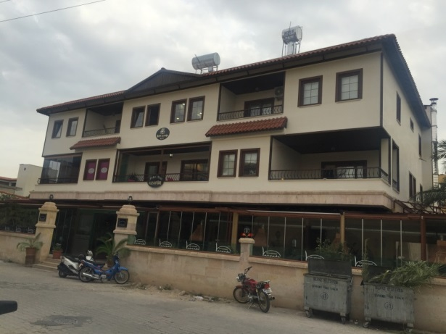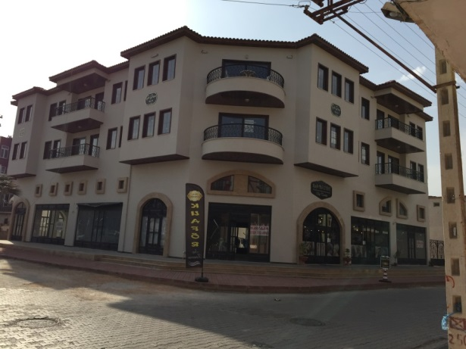
Reference: Photos were taken by the author.
Date of Access: 20.11.2018

The fourth example examined is a structure designed with a relatively different design approach on the same route. Although the mass of the building does not appear entirely in harmony with the environment, it reflects the 21st Century design concept with its ratio and its own proportions. The structure approaching the contrasting side of the scale is noteworthy with the dominance of the hot and cold colors used in the front. With the mass movements and the middle parts of the scale, the building materials pass through the interpretation of the texture and color to the distant points of the scale. (Photo 9, 10)

Photo 9: Example 4 Photo 10: Example 4
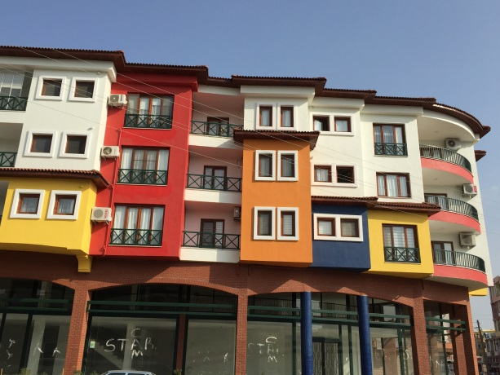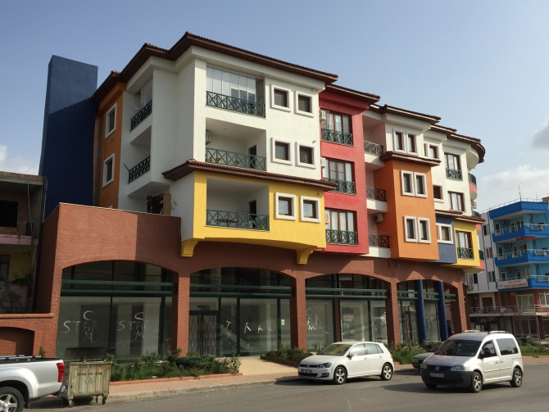
Reference: Photos were taken by the author.
Date of Access: 20.11.2018

The fifth example was built in the 2000's, with a façade facing Ziya Uyghur street, on three sides. The structure is currently being used as a business center. There are registered buildings around the building located in the city center of Silifke, some of which are Atatürk House, Government Mansion, Mazhar Tol business center. When associated with structures around it, its color, height and lack of conformity in terms of building material used on the facade are not ignored. (Photo 11, 12, 13) the lack of contextual integrity and harmony with the environment indicates that the structure, which is close to the point of extinction of the scale, was designed without considering the environmental impacts and data. (Photo 14, 15)

Photo 11: Atatürk House
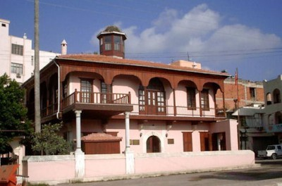
Kaynak: https://www.muze.gov.tr/tr/muzeler/silifke-ataturk-evi-muzesi
Date of Access: 25.11.2018

Photo 12: Silifke Government House Photo 13: Silifke Government House
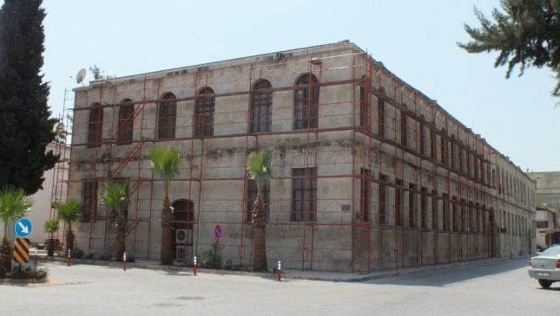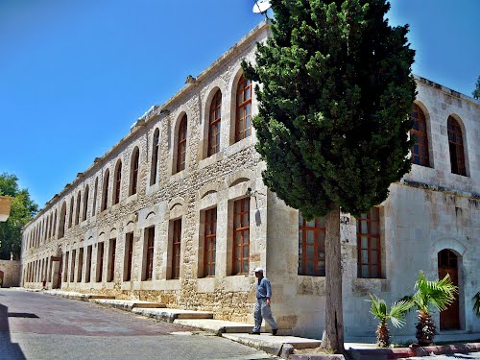
Kaynak: http://www.mersin.web.tr/silifke/silifke-hukumet-konagi
Date of Access: 25.11.2018

Photo 14: Example 5 Photo 15: Example 5
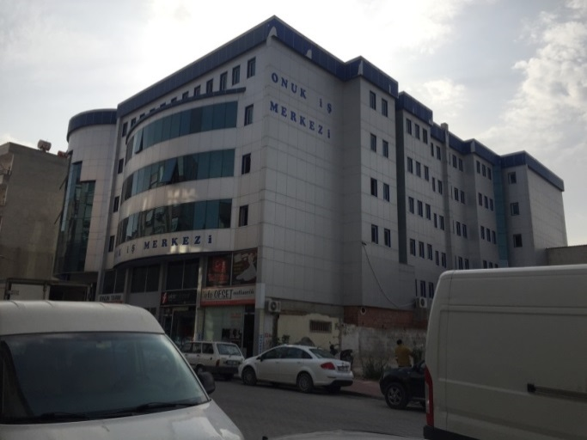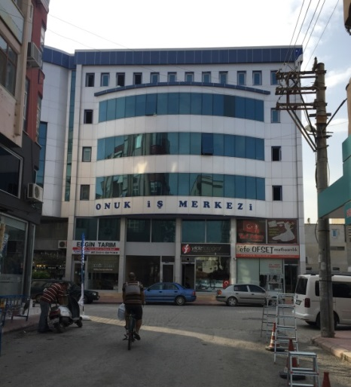
Reference: Photos were taken by the author.
Date of Access: 25.11.2018

As a result, it is stated below at the points at which the design scale of the five new building samples are examined. As we move away from the interpretation part, it is observed that contextual integrity and contextual continuity are not mentioned.

Analysis: Evaluation from Design Scale

It is understood that the purpose of the design is to provide the form, function and economic criteria at maximum efficiency, as well as to act according to environmental values. The design of buildings that bear the marks of the years when they were designed, but also respect the natural and built environment, will be the most important legacy to be transferred to future generations.

REFERENCES
Aslan, İ. (1988). Silifke Tarihi, Adana.
Erder, C. (1975), Tarihi Çevre Bilinci Tarihi Yapılar ve Çevrelerinin Değerlendirilmesi Gelişiminde Örnekleme, Ankara: O.D.T.Ü Mim. Fak. Yayınları, pp: 16-17.
Erkartal, P. Evcil, N. Öymen, Ş. (2015). Fener-Balat Workshop 2015, İstanbul.
Eruzun, C. (1989). Kentsel Sitlerin Korunmasında Yerel Yönetimlerin Önemi, Türkiye 11. Şehircilik Günü Kolokyumu, Tarihi Kentlerde Planlama Düzenleme Sorunları, 6-8 Kasım, Edirne.
Gürtürk, S. (1980). Silifke Tarihi, Taşeli Matbaası.
Mansel, A. M. (1943) Maarif Vekilliği Antikiteler ve Müzeler Direktörlüğü Anıtları Koruma Kurulu, Silifke Klavuzu, Maarif Matbaası, Ankara, Sayı:8.
Taşkıran, C. (2009). Silifke Ulu Kent, SİM Matbaacılık.
Silifke Belediyesi, Silifke Koruma Amaçlı İmar Planı.
http://cografyaharita.com/turkiye-cografi-bolge-haritalari2.html
http://keos.silifke.bel.tr/keos/
https://magarss.blogspot.com/2016/08/ptoleme-haritasinda-kilikya-ve-mallos.html
http://www.mersin.web.tr/silifke/silifke-hukumet-konagi
https://www.muze.gov.tr/tr/muzeler/silifke-ataturk-evi-muzesi
www.nufusu.com/il/mersin-nufusu
www.silifke.bel.tr/silifke/ilcemiz/cografi-yapi.html

Toros Üniversitesi, Güzel Sanatlar Tasarım ve Mimarlık Fakültesi, Mimarlık Bölümü öğretim görevlisi. Adres: Toros Üniversitesi, Güzel Sanatlar Tasarım ve Mimarlık Fakültesi, Mimarlık bölümü, Uray Kampusu, Mersin / TÜRKİYE, Tel: (0324) 325 33 00/ 50 13, E-posta: meltem.akyurek@toros.edu.tr
Bu makale I. Uluslararası Akdeniz Sempozyumunda sözlü olarak sunulan Silifke Tarihi Dokusuna Etki Eden Yeni Yapıların Tasarım Yaklaşımları isimli çalışma esas alınarak hazırlanmıştır.

