Assessment of growing water and food security crises in Afghanistan
Fulya Aydin-Kandemir¹*, Dursun Yıldız²
¹ Antalya Metropolitan Municipality Climate Change and Zero Waste Department, Antalya, Turkey
¹Hydropolitics Association, 06680 Kavaklidere/Ankara, Turkey
E-mail: fulya.aydin.kandemir@hpacenter.org ORCID NO: 0000-0001-5101-6406
² Izmir Institute of Technology, 35430, Izmir, Turkey
²Hydropolitics Association, 06680 Kavaklidere/Ankara, Turkey
E-mail: dursunyildiz@hpacenter.org ORCID NO: 0000-0001-5110-9960
*Corresponding author: fulya.aydin.kandemir@hpacenter.org
Abstract
The gap between Afghanistan's international engagements and the development and management of its national water resources become increasingly pronounced in terms of regional peace and security. Therefore, it is important to understand what would happen if Afghanistan was unable to use its water resources and became cut off from the world. Afghanistan's chances for peace and stability will be limited if food insecurity, water scarcity, and overpopulation persist. Here, the water resources could become the main cause of social unrest, instability, mass migration, and rising conflict among the riparian nations connected by economic, historical, cultural, and environmental ties if they are not improved and managed responsibly. Moreover, the prolonged crisis can make it more difficult for Afghanistan to address issues with food and water insecurity as been in the past. Additionally, the already shaky government structure of the nation further strains by natural disasters. Therefore, the food and water problems in Afghanistan must be taken into account, as well as their effects on local instability and security. Therefore, this study examines the possibilities for water resources in Afghanistan as well as the emergence of droughts. As a result, the final status of the country's food and water security was assessed.
Keywords: Transboundary basin, regional water security, hydropolitics, peace, stability, food security, wheat, data analysis

This article is licensed under a Creative Commons Attribution 4.0 International License.

1. Introduction
The country's possible economic collapse and a humanitarian catastrophe are imminent in Afghanistan. Moreover, the deteriorating environmental circumstances brought on by the continuing consequences of climate change make the situation worse. Therefore, the events that are taking place demand attention, and there is a need to provide some reflections and critical insights on the socio-economic and political risks that arise when characterizing the scope of the refugee crisis and the impacts of climate change as a catalyst on the underlying conflict divisions (Rajmil and others, 2022).
Although Afghanistan has many water resources, and its geography provides significant opportunities for their exploitation (King ve Sturtewagen, 2010), it is an unfortunate nation that cannot utilize its water resources (STIMSON, 2011; Ahmadzai ve McKinna, 2018). The Amu Darya, the ancient Oxus (which runs 1,100 kilometres through Afghanistan and borders Central Asia), the Helmand (1,300 kilometres), the Harirud (650 kilometres through Afghanistan), and the Kabul River are the four main river networks (460 kilometres). Only the Kabul River, which Pakistan's Indus River Basin joins, reaches the ocean. Many streams and rivers drain into the nation's desert regions, depleting themselves via evaporation without refilling the four main networks. Other rivers and streams only flow occasionally. (Blood, 2001). Despite these numerous rivers, river basins, lakes, and desert regions, thirty years of war have damaged the current water infrastructure. This lack of water management capability exacts a great price, worsening food shortages, unemployment, water disputes, and the growth of crops that can rival the production of illegal substances. In addition, existing infrastructure is vulnerable to disastrous seasonal floods and droughts without the ability to retain and redirect water (STIMSON, 2011).
Moreover, almost all of Afghanistan's major rivers flow into neighbouring riparian states due to the country's landlocked natural location. As a result, Afghanistan's borders are experiencing increased transboundary worries (Yıldız, 2017). Afghanistan also has a low electrification rate of only around 30–38%. In addition, the transboundary water management issue remains a crucial obstacle to hydropower potential utilization (Ahmadzai ve McKinna, 2018).
Many people in Afghanistan reside in rural areas, where agriculture and livestock are the country's main economic drivers (Ahmadi and others, 2022). However, the nation is having many difficulties marketing its crops. Some of these obstacles include a lack of local infrastructure, poor market awareness, an absence of industries that utilize crops, a lack of facilities for proper storage, a low on-farm commodity price, the dispersion of yields, and a deficiency of highways for transportation (Khairi and others, 2022). According to Kenyon's report (2021), approximately 80% of Afghans are employed in agriculture in some capacity. In addition, the United Nations estimates that 7 million Afghans are experiencing issues connected to the second drought in four years (Kenyon, 2021).
Three main concerns, including the withdrawal of the USA and its allies, the Taliban seizing power, and the current humanitarian and economic catastrophe, made Afghanistan the focus of media attention in the previous year (2021) (Barlas, 2022). At the global and regional levels, there are significant security worries following the Taliban takeover of Afghanistan on August 15, 2021 (Herd, 2021; Barlas, 2022). The bordering nations worry that Afghan land might be used against them strategically. Despite constructing most of the Durand Line border, Pakistan, which has the longest border with Afghanistan, is worried about potential attacks by the Tehrik-i-Taliban Pakistan (TTP) in the former tribal areas (Khan, 2022), for example. Following the Taliban's seizure of Kabul, tens of thousands of people flocked to Hamed Karzai International Airport as fear and terror increased. According to authoritative sources, international forces helped to evacuate around 124,000 Afghans from Kabul between the middle and end of August 2021. Additionally, nearly 600,000 people relocated to Pakistan and Iran (Barlas, 2022).
In addition to these concerns, the people are apprehensive that the Taliban face various difficulties, including acute food crises, just as the issues with peace and stability (Khan, 2022). The fact that this situation is accompanied by drought puts Afghanistan's agriculture in great difficulty. According to IFRC (2022), the area sown with winter wheat is much below average due to the prolonged drought. According to field reports, near the conclusion of the planting window in December, half of the land typically planted with wheat was fallow. According to the United Nations, hunger is also getting worse in Afghanistan, where 95% of people lack enough to eat nearly every day. Again, for IFRC (2022), La Nina is anticipated to deliver drier-than-average weather in the upcoming months, extending the extreme drought into a second year and making the few crops that were sown vulnerable to harsh conditions.
In Afghanistan, it is essential to assess the chronological development to comprehend the escalating problems in food and water issues. In this context, this study includes research on Afghanistan's key crops, water potential, and the development of droughts. As a result, the nation's food and water security topic was evaluated.
2. Afghanistan: Water Potential
Afghanistan's primary surface water resources are the Amu Darya, the Helmand River, the Kabul River, and the Harirud and Murghab rivers. Afghanistan shares these rivers with Iran, Pakistan, Kyrgyzstan, Tajikistan, Turkmenistan, and Uzbekistan (Ahmadzai and McKinna, 2018). In Figure 1, Afghanistan's domestic and transboundary basins were given via ArcGIS pro v2.19's layout tool. The river basins' data were obtained from the United Nations CEO Water Mandate Interactive Database of the World's River Basins database in shapefile format (see the database: http://riverbasins.wateractionhub.org/). The base map as the "National Geographic Style Map" was also attained from ESRI Living Atlas of the World (to see the base map https://arcg.is/nKiWK).
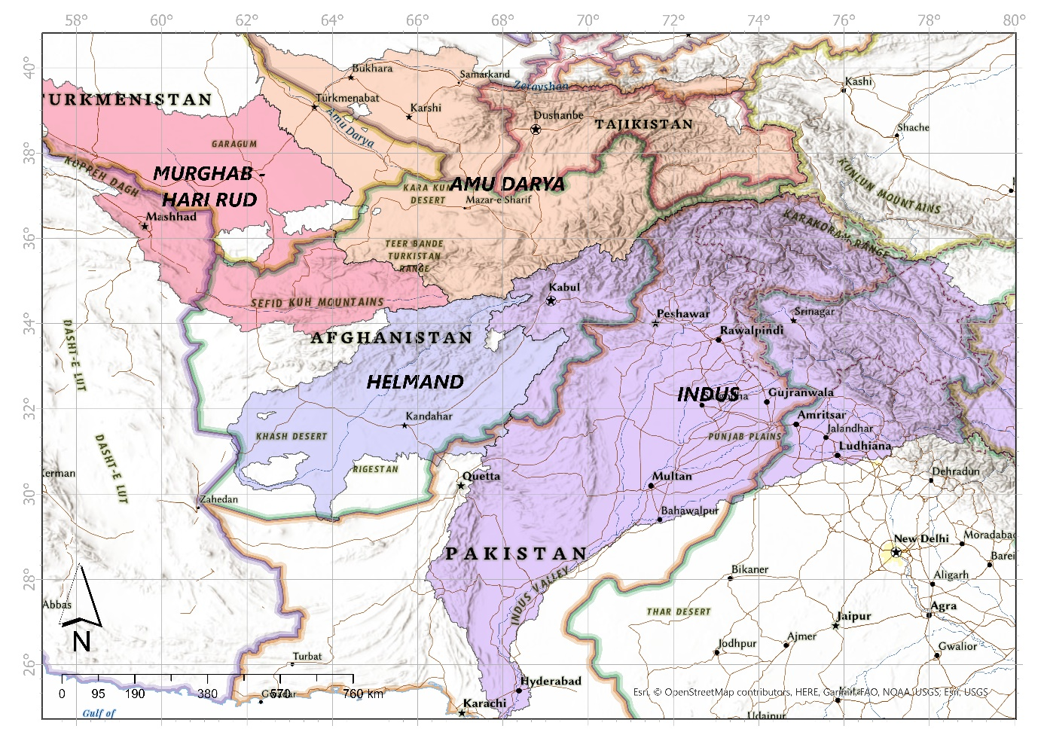
Figure 1. Afghanistan and the country's domestic and transboundary basins.
Afghanistan has an uneven distribution of its water resources. The Amu Darya Basin, which includes the Harirud and Murghab Basins and non-drainage areas, makes up around 37% of Afghanistan's total land area but is responsible for 60% of its water flow. Only 11% of the water flow is contained in the Helmand Basin, despite it being 49 per cent of the total area. With a 12 per cent area coverage, the Kabul-Eastern River Basin holds around 26% of the water flow (Favre ve Kamal, 2004).
Afghanistan has a wealth of water resources, and its terrain offers numerous options to harness them (Ziaie, 2008). However, Afghanistan's capacity and lack of infrastructure restrict its capability to store, effectively manage, and enhance its water resources. At present, about 65 % of the irrigation systems in Afghanistan are operated by the Mirabs. This traditional system, however, has been facing many challenges due to the effects of modern-day economics changing the values and norms of society (Safi and others, 2016). Moreover, despite the need for regional collaboration, there are no official conversation channels or bilateral or multilateral agreements on the region's transboundary waterways (except for the Iran- Afghanistan treaty on the Helmand River) (Ahmadzai ve McKinna, 2018).
Afghanistan's conflicts have always been fueled by resources, with water being the most divisive. According to a 2013 UNEP assessment, 70–80% of Afghans depend directly on agriculture, animal husbandry, and artisanal mining as sources of income and subsistence (Institute for Economics & Peace, 2021). For many generations, violence in Afghanistan has been caused or made worse by access to fertile land and water for agricultural reasons. This conflict also served as a significant motivator for the uprising against the governments of Presidents Hamid Karzai and Ashraf Ghani (Institute for Economics & Peace, 2021). Afghanistan is landlocked; therefore, snowdrifts might provide enough rainfall for all agricultural output if the water were well caught and managed. However, due to conflict, corruption, and general unrest, most of Afghanistan's water is no longer helpful or leaves the nation. Moreover, many people lack easy access to drinking water, even in Afghanistan's largest cities. More than 70% of Kabul's population does not have access to clean drinking water, according to a 2017 report by the Afghan Minister of Urban Development (Institute for Economics & Peace, 2021).
3. Results And Conclusions
3.1. Agriculture, Irrigation and Drought Pattern (1984-2021)
Afghanistan's economy relies heavily on agriculture, which employs a sizable portion of the labour force, accounts for about 60% of all legal exports, and makes up around a quarter of the country's GDP (DeWitt and others, 2022). Afghan agriculture is subject to significant variations depending on the climate and the neighbouring countries' political decisions (Khaliq ve Boz, 2018). In the country, the production of cereals and other annual crops, which makes up an estimated 23% of the agricultural GDP, is vital to the agriculture industry (Khaliq ve Boz, 2018). In Figure 2, the change in the total agricultural area as % of the land area of Afghanistan was given between 1984-2020. (https://data.worldbank.org/indicator/AG.LND.AGRI.ZS?locations=AF).
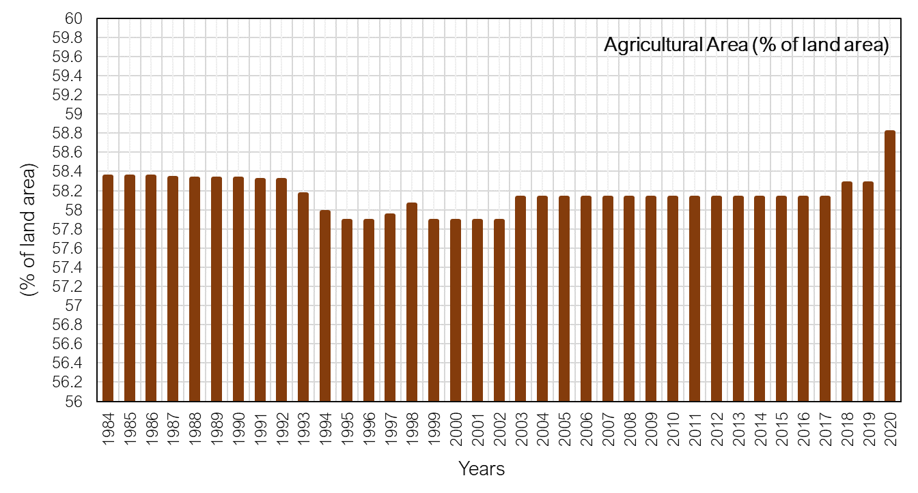
Figure 2. The change of total agricultural area as % of the land area in Afghanistan between 1984 and 2020.
Afghanistan's food security plans heavily rely on the effective use of water and land resources for wheat farming. This is because wheat is an important staple crop in Afghanistan and has a vital cultural significance. A typical Afghan diet contains over 60% of its calories from wheat, compared to 11% from all other grains (Najmuddin and others, 2021). Except for a small portion of Helmand Province, winter grains are farmed mainly in the Northern provinces. The crop is irrigated using snowmelt from the Hindu Kush Mountains (USDA, 2018; Kamil, 2021), accounting for nearly 70% of the yield. However, the remaining winter grains are susceptible to dry conditions (USDA, 2018).
In Figure 3, the wheat production (2017/2018) of Afghanistan was given via using the United States Department of Agriculture (USDA) Foreign Agricultural Service's (FAS) International Production Assessment Division (IPAD) country statistics (source: https://ipad.fas.usda.gov/countrysummary/default.aspx?id=AF&crop=Wheat). In Figure 4, the country's barley, rice, corn and cotton productions were given, respectively.
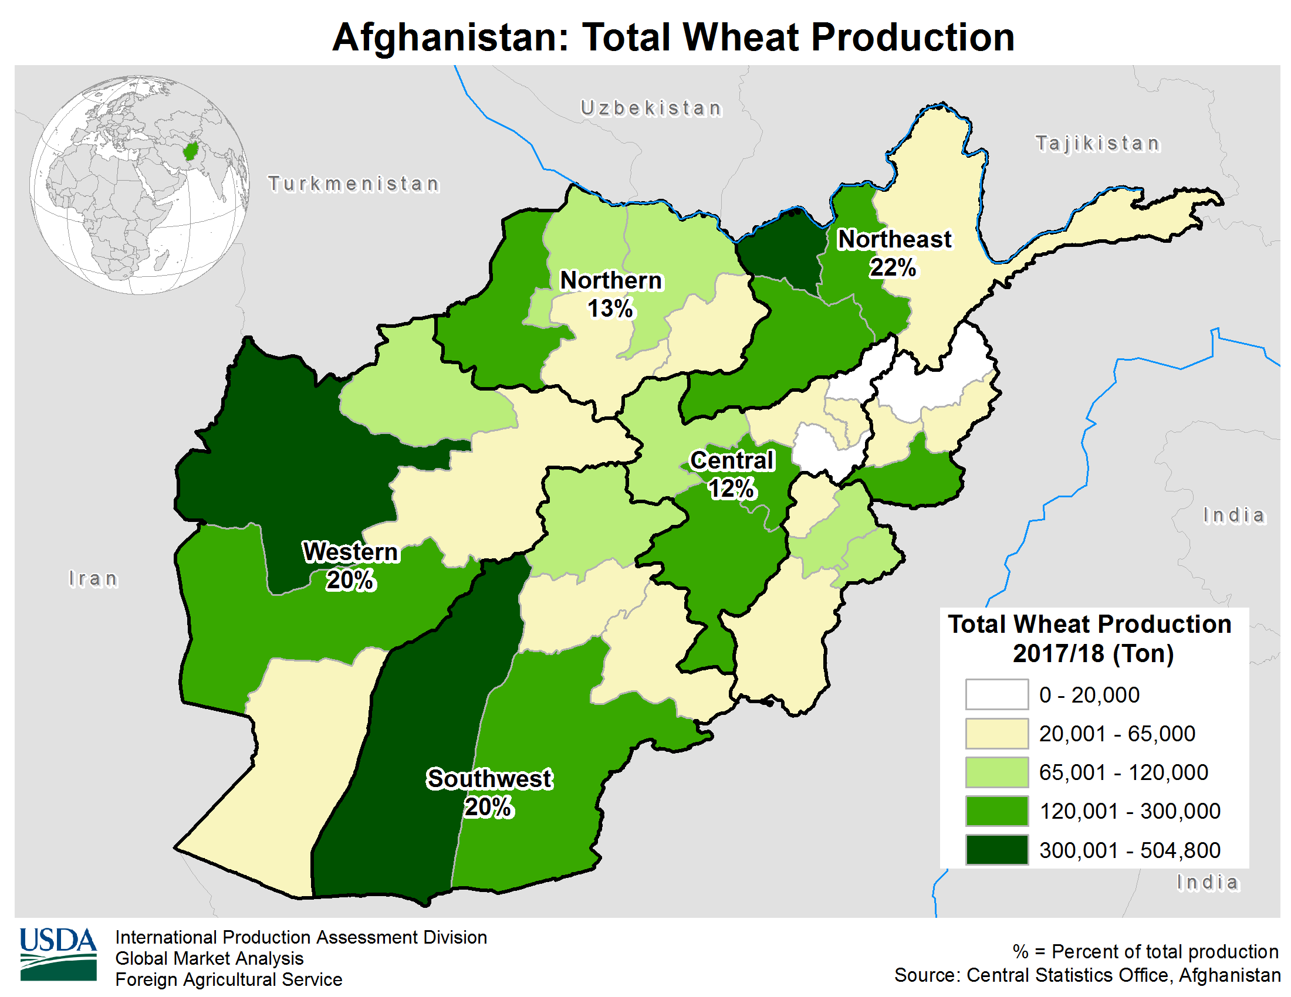
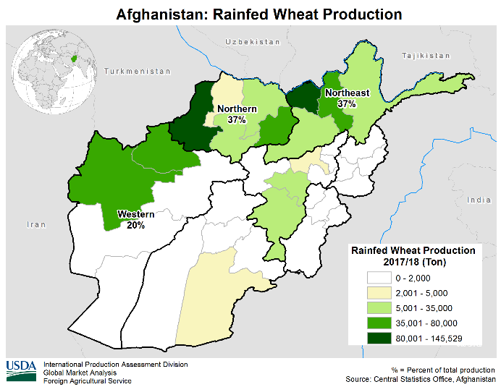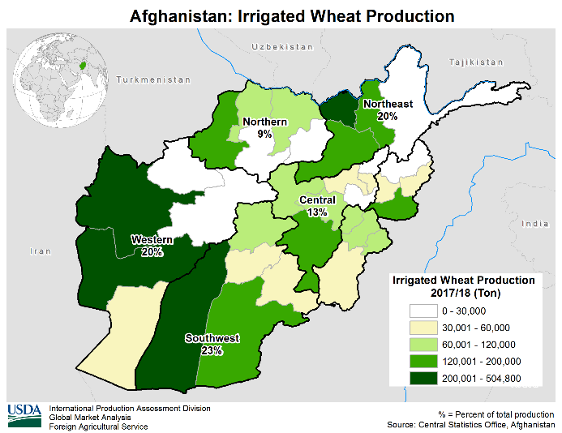
Figure 3. (a) Total wheat production, (b) rainfed and (c) irrigated wheat production in Afghanistan for 2017/2018 (Source: https://ipad.fas.usda.gov/countrysummary/default.aspx?id=AF&crop=Wheat).
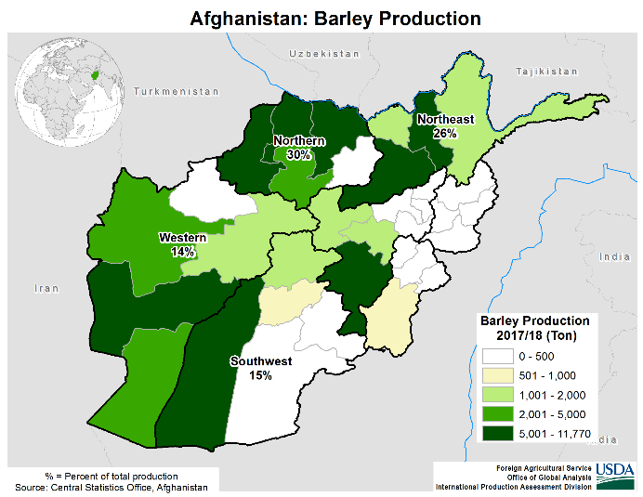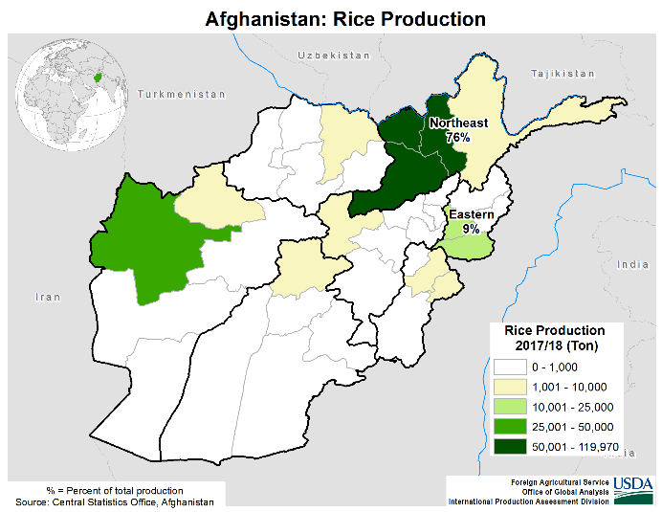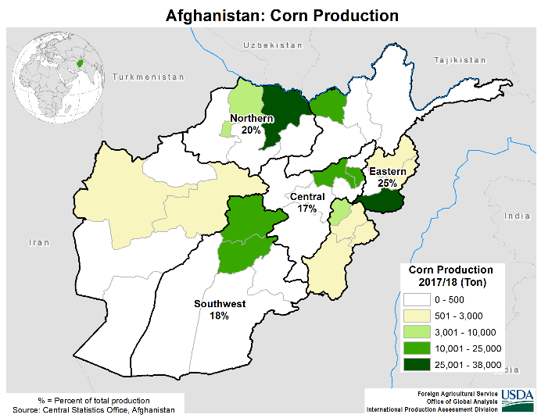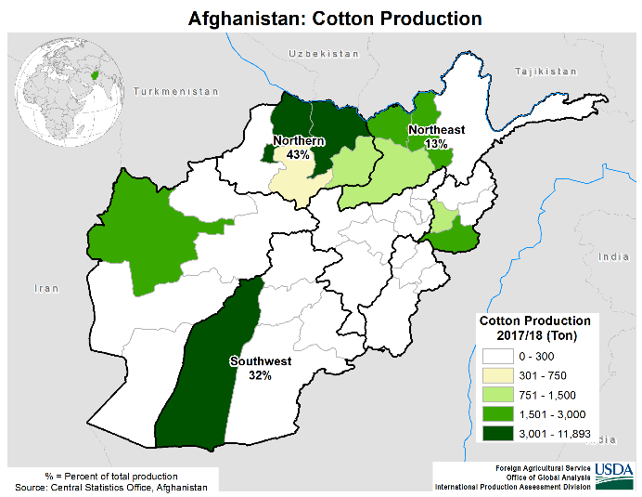
Figure 4. Afghanistan's barley, rice, corn and cotton production for 2017/2018 (Source is available for various crops from this website: https://ipad.fas.usda.gov/countrysummary/default.aspx?id=AF&crop=Wheat).
According to Naimuddin et al. (2021), approximately 2.7 to 3 million hectares of Afghanistan's arable land, or about 80% of the country's total cereal planting area, are dedicated to the production of wheat (Figure 3), which is mainly grown for domestic consumption. Barley and wheat are both grown during the same season and combined are referred to as winter cereals. In terms of production area, barley (in Figure 4) places second to wheat as a rival crop to wheat. Afghan farmers typically choose wheat over barley if they have enough irrigation water and labour (Najmuddin and others, 2021).
In Afghanistan, 90% of agricultural irrigation is also handled through traditional, community-based mirab schemes, which are inefficient and unrelated to larger national or regional frameworks, according to King ve Sturtewagen (2010). For Nengroo (2012), most of Afghanistan's agricultural output comes from its 3 million hectares of irrigated land and gardens. The utilization of 3.5 million more hectares is for non-irrigated production, which is reliant on precipitation. Together, they contribute significantly to the nation's economy, with agriculture making up more than half of the GDP. Similarly, almost 80% of the population works in agriculture, raising cattle. According to Knoema (2022), the total area of Afghanistan that was fitted for irrigation in 2020 was 3,208 thousand hectares. From 2,386 thousand hectares in 1971 to 3,208 thousand hectares in 2020, Afghanistan's total area equipped for irrigation expanded at an average yearly rate of 0.61%. According to Nengroo (2012), over the past 30 years, the overall area that is irrigated has changed. Afghanistan was nearly self-sufficient in food by the middle of the 1970s. About 3.3 million hectares—or around 85% of the nation's total crop production—were cultivated using various irrigation techniques. Due to turmoil and war, droughts, severe flooding, and failure to run and maintain irrigation systems at a local and national level, this has decreased to roughly two million hectares. Figure 5 shows the fluctuations of irrigated agricultural lands as % of the total agricultural area between 2001 and 2020 (to see the source: https://data.worldbank.org/indicator/AG.LND.IRIG.AG.ZS?locations=AF).
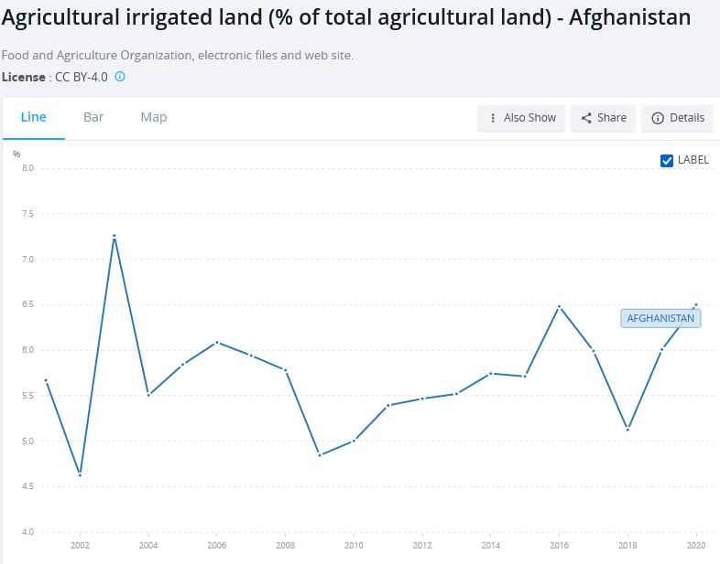
Figure 5. The fluctuations of irrigated agricultural lands as % of the total agricultural area for 2001-2020.
Thirty years of war and unrest have dramatically diminished Afghanistan's water infrastructure and decimated its human capacity in hydrology. Only 1.5 million hectares of agricultural land were irrigated in 2002 (an additional 300,000 hectares have been rehabilitated since), less than half the area irrigated in 1979. Moreover, irrigation schemes are less reliable than in the past. Heavily dependent on seasonal rain and snowfall, Afghanistan's water resources have become unstable. Glacial retreat and early snowmelt have severe effects on seasonal water availability. The country needs new dams to increase storage capacity and improve irrigation efficiency to balance these seasonal shifts. In the near future, Afghanistan will have the region's lowest storage capacity per capita (King ve Sturtewagen, 2010). However, not only wars and internal turmoil have been highly effective in increasing Afghanistan's agricultural stress, but also drought.
Between Figure 6 and Figure 8, the drought intensity for Afghanistan's croplands as an annual summary (1986-2021) was given by using Food and Agriculture Organization (FAO) Global Information and Early Warning System on Food and Agriculture (GIEWS) database. The data are at 1 km resolution for 2007 and after. For 1986-2006, the 1 km data were derived from NOAA-AVHRR (National Oceanic and Atmospheric Administration-Advanced Very-High-Resolution Radiometer) dataset at 16 km resolution (FAO GIEWS, 2022). According to FAO GIEWS's methodology, agricultural droughts are divided into four categories based on severity: Extreme, Severe, Moderate, and Mild. The Weighted Mean Vegetation Health Index, which measures drought severity, shows that the worse the vegetation health, the more intense the drought. Therefore, the user can evaluate the overall severity of the drought for an entire growing season using the Annual summary of Drought Intensity (FAO GIEWS, 2022).
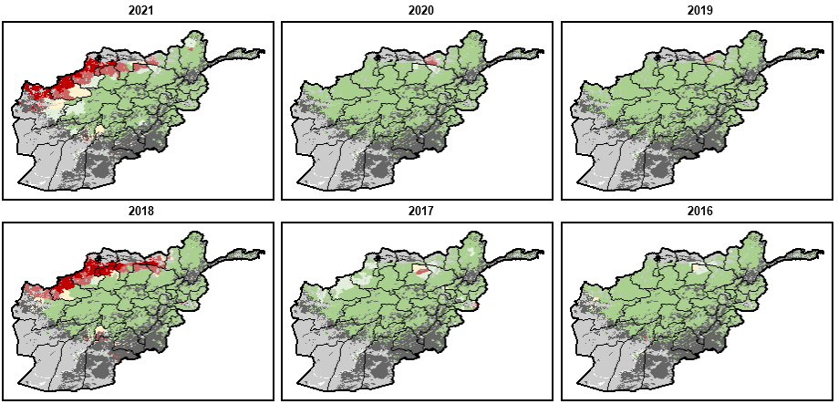
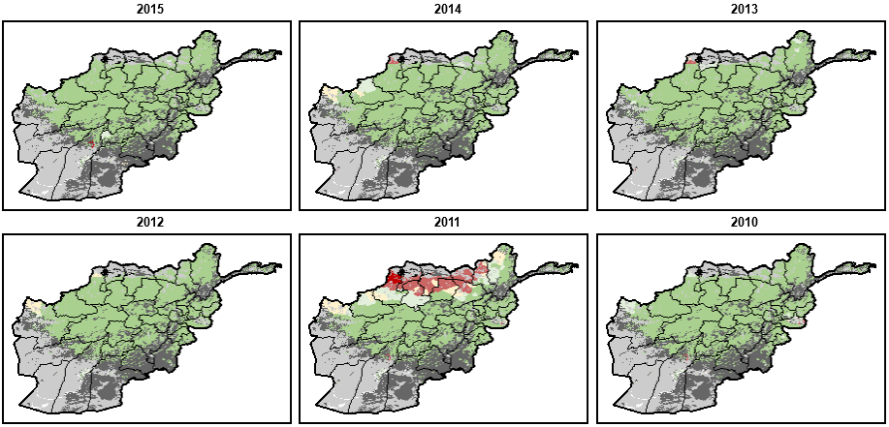
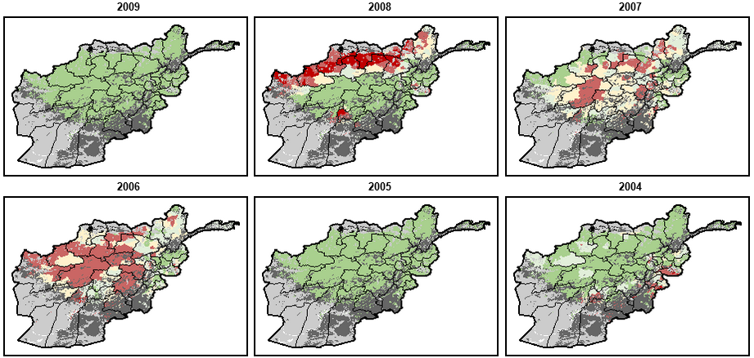
Figure 6. The drought intensity data for 2021/2004 in Afghanistan (data and layout source: FAO GIEWS, 2022).
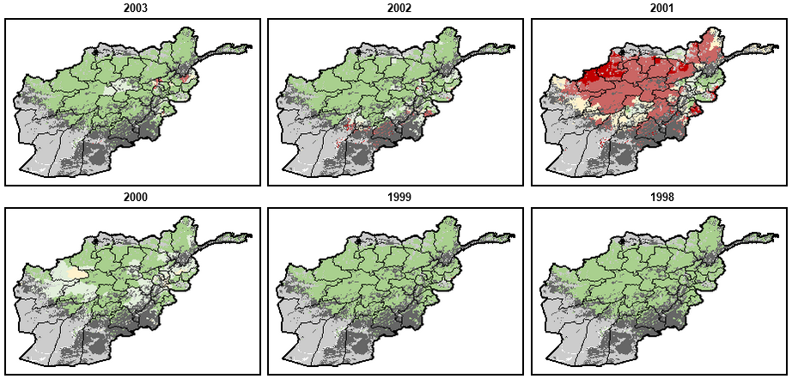
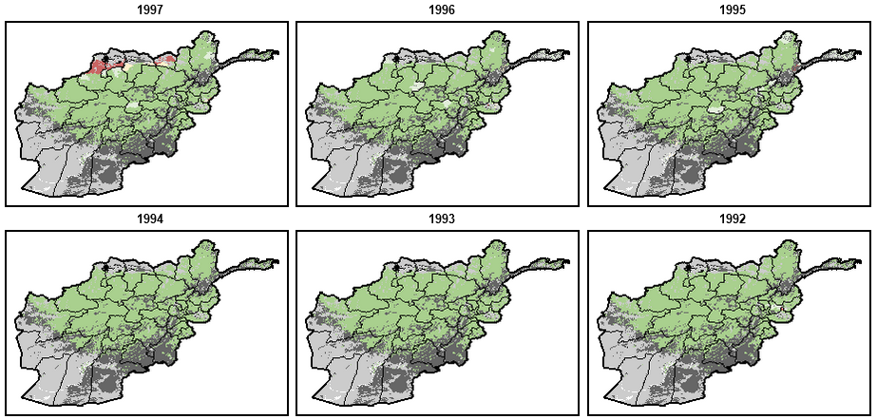
Figure 7. The drought intensity data for 2003/1992 in Afghanistan (data and layout source: FAO GIEWS, 2022).

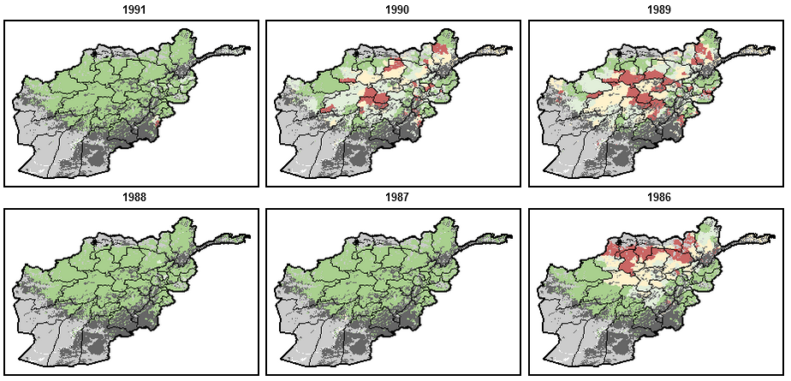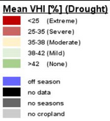
Figure 8. The drought intensity data for 1991/1986 in Afghanistan (data and layout source: FAO GIEWS, 2022).
Looking at the dry years in Afghanistan in 1986, 1989 and 1990, although "extremely arid" regions did not spread to all cropland; generally, the croplands were exposed to drought. Especially the periods of extreme drought are 2001, 2006, 2007 and 2008. In 2011, 2018 and 2021, extremely arid regions remained in the northern croplands. Based on USDA (2018), due to below-average precipitation over north-growing areas, Afghanistan's 2018–19 winter grains crop yield is anticipated to be lower than the previous year. The report's findings are compatible with the present study, which indicated the drought intensity in Figure 8 for 2018. The report (USDA, 2018) states that at 4.0 million metric tons, wheat production in 2018–19 is anticipated to be 20 per cent lower than in 2017. The yield is expected to decline by 18%, and the area is down 2% from the previous year. With a yield predicted to be 1.40 tons per hectare (ton/ha), barley production will be 350,000 metric tons, a decrease of 14% from last year.
In addition to drought, low vegetation health triggers agricultural stress. This can be seen in the Weighted Mean Vegetation Health Index (VHI), which represents vegetation health and is shared by FAO GIEWS (Figure 9). By assessing the health of the vegetation and the impact of temperature on plant conditions, the Annual Weighted Mean Vegetation Health Index (Weighted Mean VHI) enables the user to evaluate the overall severity of drought for a whole growth period. The Annual Weighted Mean VHI evaluates the temporal impact of moisture deficiencies and temperature across the growing season while considering a crop's susceptibility to water stress during its growth period (FAO GIEWS, 2022). The data were obtained from FAO GIEWS in CSV format to analyze the index values. Here, values below 0.25 indicate that the health of vegetation is extremely stressed. Stress is reportedly "reduced" with values of 0.55 and higher, and values indicate "excellent health" near one.
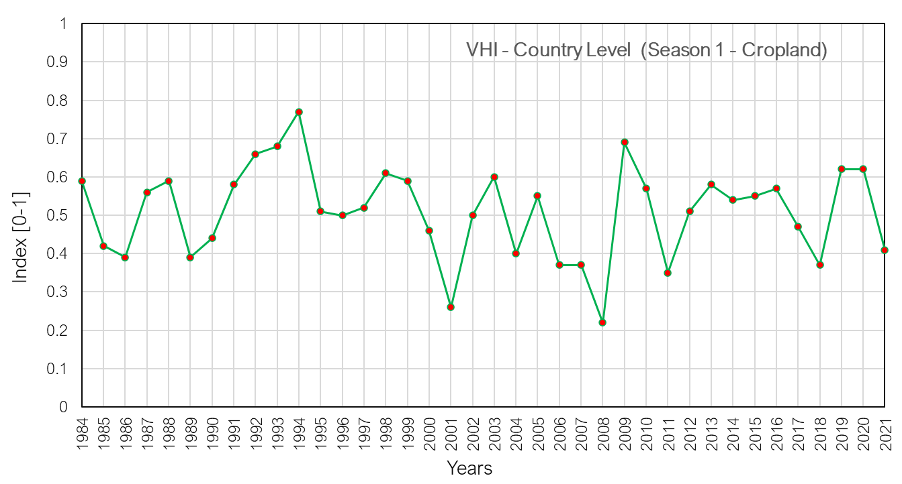
Figure 9. Multi-temporal Vegetation Health Index of croplands in Afghanistan.
According to Figure 9, VHI experienced its lowest level due to drought and water stress in 2008. This year was followed by 2001. The years 1986, 1989 and, 2006, 2007, 2011, 2018, 2021 were also the periods when the index was relatively low, so stress is highly remarkable.
The above explanations are given in which years the VHI values are low due to drought intensity and water stress. These two factors, in particular, directly affect agricultural stress. Agricultural stress in Afghanistan was also determined by the Agricultural Stress Index given by FAO GIEWS (to see the database https://www.fao.org/giews/earthobservation/country/index.jsp?code=AFG&lang=en#). It has been shown that stress increases in similar years because multi-time stress index change is affected by drought and VHI. Significantly, 2001 and 2008 were record-breaking years of agricultural stress (Figure 10).
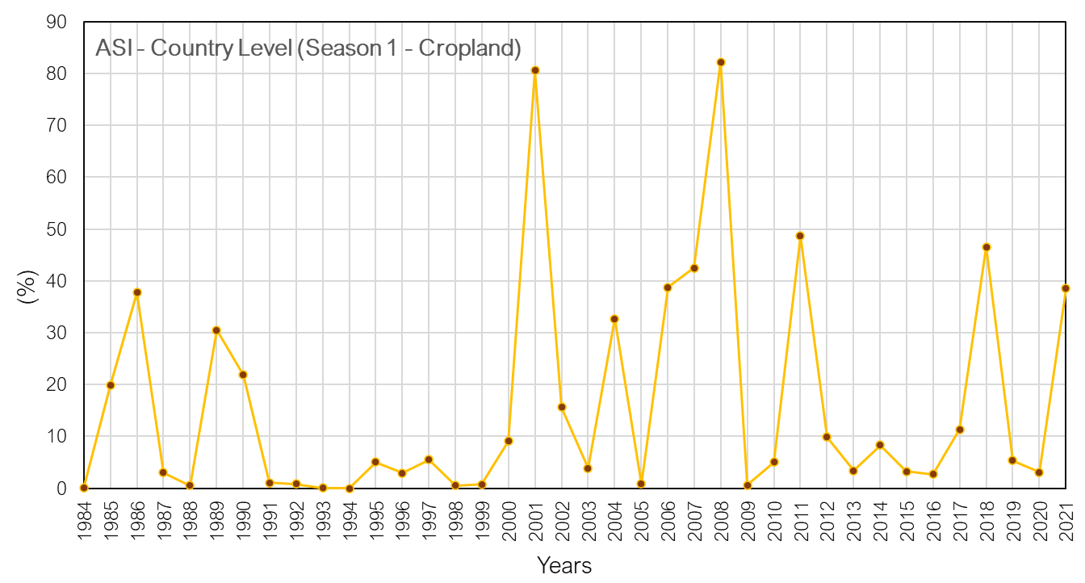
Figure 10. Agricultural Stress Index of Croplands in Afghanistan.
Drought reduced vegetation health and consequent increase in agricultural stress primarily result in an increase in the prices of farm products in the domestic market. In addition, Afghanistan wanted to buy agricultural products from the foreign market during periods of agricultural stress due to both wars and internal turmoil. This situation resulted in an increase in the prices of farm products in the domestic market. In particular, for wheat, the most important agricultural product, the record price increase of the last 12 years was seen in 2008 (Figure 11). Here, multi-temporal wheat price changes were primarily analyzed by FAO Food Price Monitoring and Analysis (FAO FPMA) (to see the dataset https://fpma.fao.org/giews/fpmat4/#/dashboard/tool/domestic) (Figure 11). Subsequently, crisis risks and alarm situations for commodity prices were identified throughout Afghanistan with the Food Price Forecasting and Alert for Price Spikes tool developed by the World Food Programme (the dataset https://dataviz.vam.wfp.org/economic_explorer/price-forecasts-alerts?adm0=1) (Figure 12 and Figure 13).
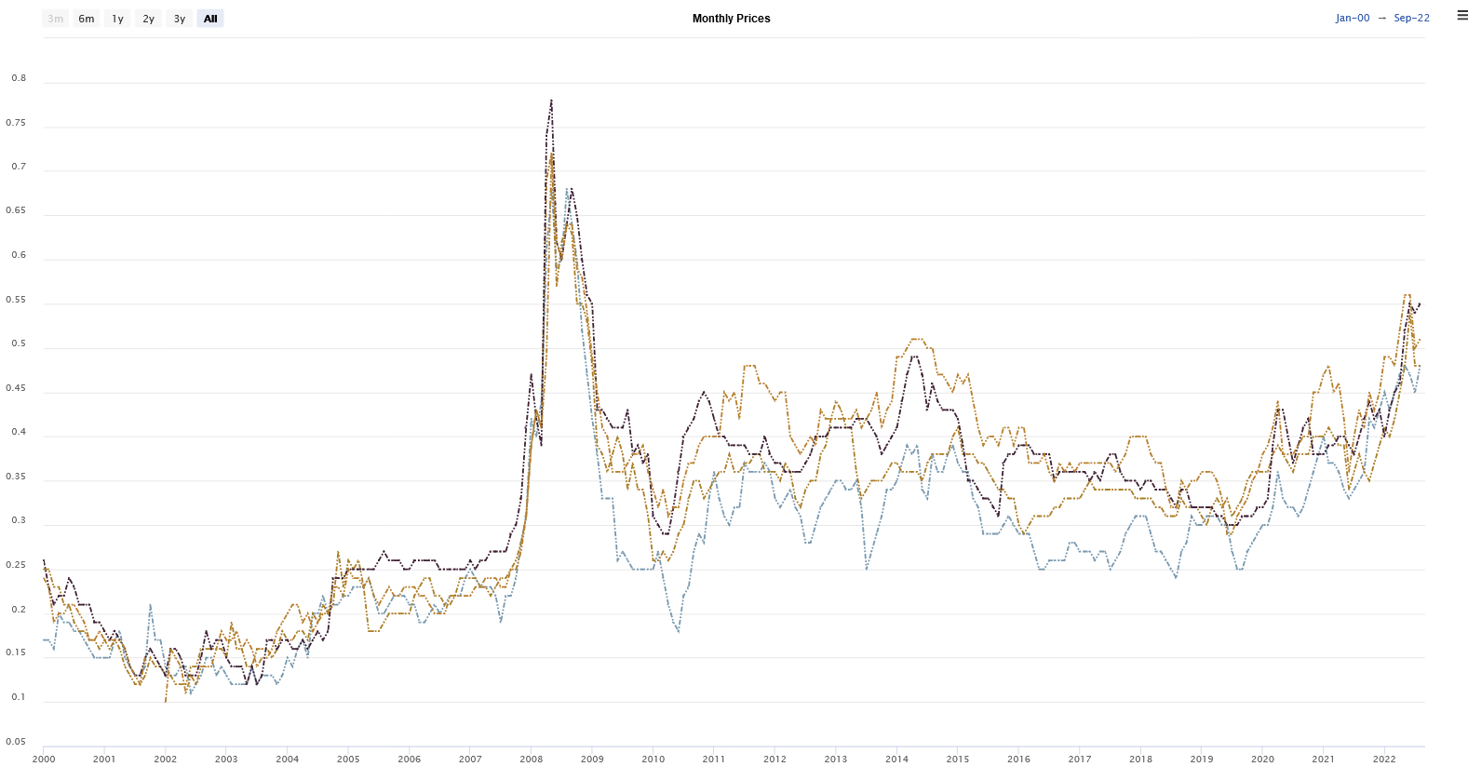
Figure 11. Change in the domestic wheat prices for Afghanistan between 2000 and 2022.
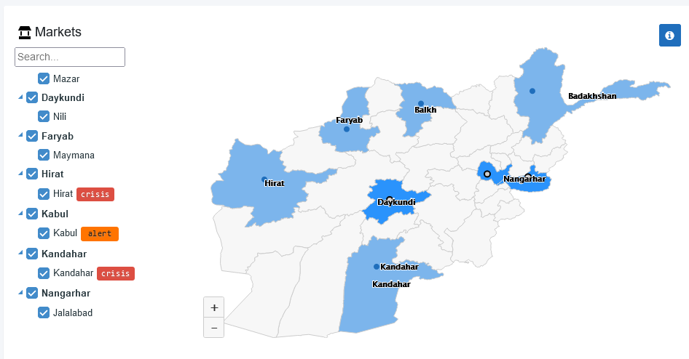
Figure 12. The Food Price Forecasting and Alert for Price Spikes tool's Afghanistan data for crisis and alerts data.
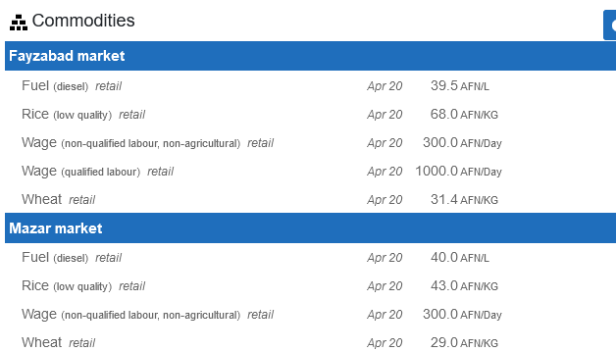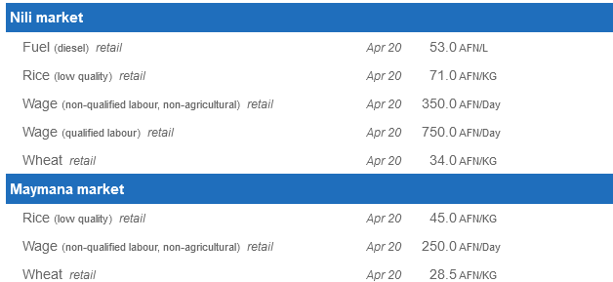
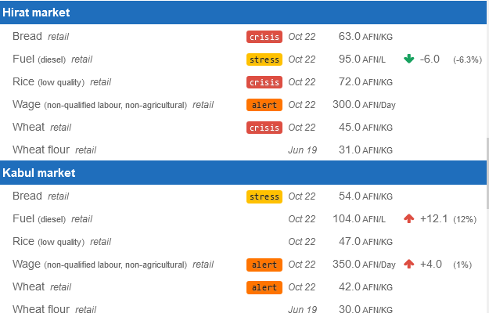
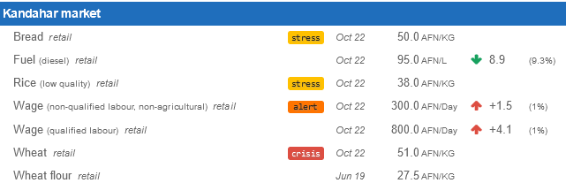
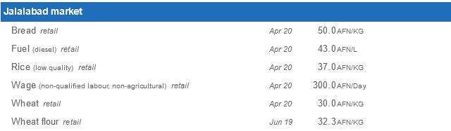
Figure 13. Food Price Forecasting and Alert for Price Spikes data for Afghanistan domestic markets.
As can be seen from here, there is a crisis, stress or alarm in bread and wheat in Herat, Kabul and Kandahar. Herat is located in the western part of Afghanistan. The country's western part accounts for 20% of total wheat production (see Figure 3a) (USDA IPAD, 2022). In the 2018/2018 season, Herat produced approximately 300,000-504,800 tons of wheat. A large part of this production (200,000-504,800 tons) is irrigated production (Figure 3c). Herat is also second in rice production after the northeastern part of the country (25,000-50,000 tons) (Figure 4). However, as seen in Figure 8, 2018, 2021, that is, the extreme drought experienced in the recent period, especially in the west-north sections, has adversely affected production here and brought production to crisis or alarm status. Kabul is located in the central part of the country. Here, bread is in a state of stress, and wheat is on alert. Central Afghanistan accounts for 12% of total wheat production. Production in Kabul is about 20,000 tons (maximum) (Figure 3a). Almost all of this is irrigated production (Figure 3c). Kandahar is located in the southwest part of the country. Here bread and rice are in a state of stress and wheat crisis. The Southwest section has 20% of the country's total wheat production. The total production for Kandahar is between 120,000 and 300,000 tons (Figure 3a). Of this, 120,000-200,000 tons is irrigated production (Figure 3c). This shows that Kandahar also produces wheat primarily through irrigated agriculture. According to WFP VAM data (https://dataviz.vam.wfp.org/version2/ from Armed Conflict Location & Event Data Project (ACLED), daily data; displaying from the last 30 days), there are strategic developments, violence against civilians and battles in Herat. In Kandahar, explosions and remote violence are observed currently. Kabul's conflicts consist of violence against civilians. These conflicts and the alert situation may cause the vulnerability for agricultural activities just as caused by drought.
3.2. No Development, Peace, and Stability In The Short Term Without Water And Food Security
Without significant advancements in the planning and governance of Afghanistan's water resources, the country won't be able to meet its energy, agriculture, or rural and urban development goals. The Afghanistan National Development Strategy 2008-2013 (ANDS), the centrepiece of Afghanistan's development plan, must have these objectives. (Ziaie, 2008). Therefore, water and irrigation are distinct areas of attention in the ANDS under economic and social development. Afghanistan can benefit from the construction of dams and water infrastructure in several ways, including a reduction in its reliance on foreign hydropower and an increase in the water supply for livestock and agriculture. But to engage in water discussions and offer a stage for conversations and signing official agreements with its neighbour countries, this must be supplemented by competent diplomacy (Sayed ve Sadat, 2022). Nevertheless, it is crucial to acknowledge that neither Afghanistan nor its neighbours have made any concerted efforts to join their formalized frameworks of water cooperation.
On the other hand, Afghanistan is not included in the current regional cooperation frameworks for some of the shared water resources. Therefore, the situation of regional water resources and interstate multilateral cooperation will be significantly impacted in the short and long terms by the absence of transboundary water agreements and institutions between Afghanistan and its surrounding nations (Nori, 2020).
3.3. Water and Food Security Crisis Rise in Afghanistan
Afghanistan is landlocked; therefore, snowdrifts might provide enough rainfall for all agricultural output if the water were well caught and managed. However, due to conflict, corruption, and general unrest, most of Afghanistan's water is no longer helpful or escapes the nation. As a result, many people lack easy access to fresh water, even in Afghanistan's largest cities. (Institute for Economics & Peace. Global Peace Index, 2021).
In the 20th and 21st centuries, Afghanistan had several significant wars. Because of these battles, Afghanistan could not develop its water resources, which flowed to its neighbours without being utilized. Although Afghanistan has started to construct projects in both the agricultural and hydroelectric industries during the past ten years, the Taliban overran the nation in 2021 and halted these initiatives (IESS, 2022). Moreover, natural catastrophes and climate change significantly negatively influence Afghanistan and make it more difficult for the country to develop and achieve peace. Afghanistan's natural resources are threatened by climate change, and continued floods and droughts are predicted to affect agricultural productivity and output. The ongoing conflict has also weakened Afghanistan's ability to respond to ecological challenges since natural calamities put further strain on an already ill-equipped system of government. (Institute for Economics & Peace. Global Peace Index, 2021).
Stakeholders in the Food Security and Agriculture Cluster, such as FAO, the World Food Programme (WFP), and other non-governmental organizations, published an analysis of Phase Classification (IPC) in May 2022. (NGOs). According to the most recent Integrated Food Security report, 19.7 million people -nearly half of Afghanistan's population- experience acute hunger, which means they cannot provide for their daily needs (FAO, 2022). Due to the country's crumbling economy and ongoing drought, high levels of severe food insecurity continue to exist throughout Afghanistan. In addition, the fallout from the conflict in Ukraine is making it more challenging to secure adequate food supplies, driving up the price of staples like food and fertilizer while also putting pressure on the nations that provide Afghanistan with wheat to limit food exports and prioritize local consumption (FAO, 2022).
There is no time to waste, U.N. Secretary-General Antonio Guterres declared during his briefing to the U.N. Security Council on January 26, 2022. Antonio Guterres' goal was to remove the barriers to funding humanitarian aid efforts in Afghanistan. Millions of people, according to Guterres, are starving, and he issued a dire warning that there may be a mass exodus from the nation. Guterres asked for important financial transactions to be permitted for humanitarian help, noting that more than 80% of the population lacks access to fresh water (Nicholson ve Landay, 2022). Due to contamination from several sources, including a lack of river basin infrastructure and regulations governing water resource management, as well as a five-year drought (until 2008) and seasonal flooding, the majority of Afghans struggle to access adequate and safe water supplies (Williams-Sether, 2008). In Afghanistan, where there are currently no comprehensive studies about the quality of the country's water supply, groundwater is the primary source of drinking water.
Furthermore, groundwater typically deteriorates naturally or as a result of human activity. According to the research now available, arsenic, boron, fluoride, and sulfate are significant natural variables that impact the quality of the groundwater in Afghanistan and are problems for public health and even agriculture (Institute for Economics & Peace. Global Peace Index, 2021). Agricultural practices, septic tank systems, household waste, and municipal waste are a few anthropogenic variables that might harm groundwater quality. There were high nitrate concentrations in Ghazni, Helmand, Kandahar, Herat, Ghor, Faryab, Kabul, and Nangarhar; Kabul had Escherichia coli; and Farah, Ghazni, Faryab, Kabul, and Nangarhar had fecal coliforms (Institute for Economics & Peace. Global Peace Index, 2021).
3.4. Concern About the Taliban Disrupts Humanitarian Aid
After the United States and NATO left Afghanistan in August 2021, the Taliban seized power. Taliban fighters invaded Kabul, the Afghan capital, on August 15, 2021 (Barlas, 2022), seizing control of the city and the nation. It was the culmination of a military effort by the Taliban that began in May 2021 and led to that group gaining control of most of Afghanistan, including all of the country's main cities (Institute for Economics & Peace. Global Peace Index, 2021).
Few nations have acknowledged the Taliban's new leadership in Afghanistan. The international community ceased providing aid to Afghanistan because it did not want to cooperate with the Taliban. Donor nations have established strict humanitarian assistance standards, such as human rights adherence. They specified that these requirements must be met for help to be released (United Nations, 2022). Taliban and Afghan civil society delegates met in Oslo, Norway, in January 2022, and they spoke directly with representatives of Norway, the USA, France, and the U.K. The Taliban government was not formally acknowledged due to these contacts, as Norwegian Prime Minister Jonas Gahr underlined in the Security Council meeting on Afghanistan / UNAMA on January 26 2022 (Norway in the U.N., 2022).
3.5. The Current State of Afghanistan Adversely Affects Its Water And Land Resources Development Ability
Afghanistan is currently required to implement hydropower and agricultural projects on waterways. However, significant issues are caused by both the Taliban government and the riparian nations. Afghanistan has persevered in the face of tremendous obstacles. Its survival has been significantly aided by international aid. However, the administration faced new difficulties while attempting to use the nation's resources effectively. According to the World Bank, Afghanistan's overall poverty rate increased from 55% to 72% in 2020 due to the country's declining economy. Most Afghans struggle with poor access to water, sanitation, and hygiene. Only around 27% of the population, according to the UNAMA, has access to fresh water (Bertelsmann Stiftung, 2022). According to the United Nations Environment Program, Afghanistan was experiencing one of the world's most severe humanitarian and environmental disasters (UNEP). Natural disasters in Afghanistan in 2020 put the survival of tens of thousands of families in many districts at risk. The lives of Afghans have also recently been impacted by climate change, which has led to forced migration and greater poverty (Bertelsmann Stiftung, 2022; Sayed ve Sadat, 2022). The Taliban's takeover of the government in 2021 further worsened all the unfavourable circumstances previously mentioned.
Transboundary water resources are another issue Afghanistan confronts with all of its neighbours. For example, it has a conflict with Iran concerning the Helmand Waterway. Because Iran implicitly objected to the agreement and did not follow its terms, although it has a contract with Afghanistan (AA, 2021). Since the fall of the Taliban, the Government of the Islamic Republic of Afghanistan (GIRoA)has been actively trying to resume its hydraulic mission that was put on hold in the late 1970s (Thomas and others, 2016). Improving water control through the construction of dams has been described by the GIRoA as a silver bullet for Afghanistan's development, including food security, hydropower production and mitigating the impacts of droughts and floods (Thomas and others, 2016).

4.Conclusions
Afghanistan values water more than any other natural resource or mineral. All of these factors will increase the demand for water due to climate change, including population growth, urbanization, intensified agricultural, and potential mining operations. Any of its neighbours shouldn't hamper the development of Afghanistan's water resources. Long-term instability in Afghanistan and the surrounding area will result from preventing Afghanistan from constructing energy and agricultural projects on its transboundary rivers. Afghanistan is currently facing economic and hydropolitical obstacles in developing its water projects. Innovative hydropolitics are required in this area to solve these issues. However, it can take a while before the Taliban Regime is acknowledged by the international community and formal negotiations between Afghanistan and its neighbours' start. This period's extension will make the area more unstable.
In this situation, the region needs an immediate plan for short-, medium-, and long-term international support for water and food security. Failure to implement this strategy will harm regional peace and stability and exacerbate Afghan mass migration. Concerns around water development and management must be resolved immediately for Afghanistan's food security. Increasing the number of projects on each of Afghanistan's transboundary river basins may be one approach to achieving this goal. Afghanistan and its neighbours must work together to do this, and the international community must provide financial support, which appears to be challenging in the near future. On the other side, failure to accomplish this objective will contribute to increased regional instability and limit opportunities for meeting the fundamental needs of millions of people in the region.
Water-related national policy initiatives of Taliban Governance will not consider the interests of neighbouring nations if the international community is not involved in the problem. This will make the riparian states more politically stressed. Afghanistan can take a while to gain the confidence and trust of the international community and riparian states. This may prevent Afghanistan from fully realizing its water potential and result in major problems with its food and water security. A creative, forward-thinking foreign aid program and a novel, region-specific hydropolitics strategy are needed in this situation.
To prevent more serious water and food crises and mass migration, the international community needs to consider developing Afghanistan's water resources. It should be mentioned that enhanced regional, as opposed to national, initiatives to develop water resources would benefit Afghanistan and the surrounding region. Furthermore, in a country where 90 per cent of the surface water resources are shared with downstream neighbouring countries, transboundary water resources development should be deeply considered in terms of the interactions between the new Taliban Regime and its riparian neighbours.
References
Ahmadi, S., Irfan, M., & Sultanzoy, F. (2022). Impact of social media on Agricultural Extension in Afghanistan – A Case of Ahmad Aba District. International Journal for Research in Applied Sciences and Biotechnology, 9(2), 67-72. https://doi.org/10.31033/ijrasb.9.2.9.
Ahmadzai, S., & McKinna, A. (2018). Afghanistan electrical energy and trans-boundary water systems analyses: Challenges and opportunities. Elsevier Energy Reports 4, 435-469. https://doi.org/10.1016/j.egyr.2018.06.003.
Barlas, A. W. (2022). Population Movements in Afghanistan: A Historical Overview, Migration Trends under the Taliban Regime, and Future Outlooks. Munich Personal RePEc Archive. MPRA Paper No. 114179.
Bertelsmann Stiftung (2022). Afghanistan. https://bti-project.org/en/reports/country-dashboard/AFG. Accessed 10 October 2022.
Blood, P. R. (2001). Afghanistan: A Country Study. Washington: GPO for the Library of Congress.
DeWitt, J. D., Boston, K. M. Alessi, M. A., & Chirico, P. G. (2022). Quantifying and visualizing 32 years of agricultural land use change in Kabul, Afghanistan. Journal of Maps. DOI: 10.1080/17445647.2022.2063079.
FAO, (2022). Afghanistan: Humanitarian assistance averted a food security catastrophe in the harsh winter months, but hunger persists at unprecedented levels. https://www.fao.org/asiapacific/news/detail-events/en/c/1507594/. Accessed 10 October 2022.
FAO GIEWS, (2022). [Dataset] Earth Observation: Afghanistan. https://www.fao.org/giews/earthobservation/country/index.jsp?lang=en&code=AFG. Accessed 10 September 2022.
Favre, R., & Kamal, G. M. (2004). Watershed Atlas of Afghanistan. First Edition. MIWRE, FAO, SDC, AIMS, AREU, Kabul.
Herd, G. (2021). The Causes and the Consequences of Strategic Failure in Afghanistan? George C. Marshall European Center for Security Studies.
IESS, (2022). A look at Afghanistan's Hydro-hegemony Policy. https://www.iess.ir/en/analysis/3114/. Accessed 20 September 2022.
IFRC, (2022). Afghanistan: Food shortages escalate as spring fields remain bare. https://www.ifrc.org/press-release/afghanistan-food-shortages-escalate-spring-fields-remain-bare. Accesseded 04 November 2022.
Institute for Economics & Peace. Global Peace Index, (2021). Measuring Peace in a Complex World, Sydney. https://www.visionofhumanity.org/wp-content/uploads/2021/09/Afghanistan-briefing-2021.pdf. Accessed 05 February 2022.
Kamil, I. (2021). Afghanistan, the Amu Darya Basin and Regional Treaties, Chinese Journal of Environmental Law, 5(1), 37-62. doi: https://doi.org/10.1163/24686042-12340063.
Khairi, M., Safdari, M., & Shahkari, A.S. (2022). An Integrated Investigation into the Socioeconomic Factors Threatening Crop Marketing: A Comparative Study on Faryab Province of Afghanistan and the Sistan Region of Iran. Environmental Energy and Economic Research, 6(2), S036. DOI 10.22097/EEER.2022.276998.1188.
Khaliq, A. J. A., & Boz, I. (2018). The Role of agriculture in the economy of Afghanistan, 2nd International Conference on Food and Agriculture Economics, April 2018, Alanya, Turkey.
Kenyon, P. (2021). How turmoil in Afghanistan has impacted agriculture — a vital part of its livelihood. NPR, https://www.npr.org/2021/10/25/1049092924/how-turmoil-in-afghanistan-has-impacted-agriculture-a-vital-part-of-its-liveliho. Accessed 03 November 2022.
Khan, A. (2022). Current Afghanistan Crisis: The Impact of External Factors on Internal Crisis. Global Regional Review (GRR), 7(1), 118-129.
King, M., & Sturtewagen, B. (2010). Making the Most of Afghanistan's River Basins Opportunities for Regional Cooperation. East West Institute. www.ewi.info.
Knoema (2022). Afghanistan - Total area equipped for irrigation. "https://knoema.com/atlas/Afghanistan/topics/Land-Use/Area/Total-area-equipped-for-irrigation". Accessed 21 October 2022.
Najmuddin, O., Qamer, F. M., Gul, H., Zhuang, W., & Zhang, F. (2021). Cropland use preferences under land, water and labour constraints— implications for wheat self-sufficiency in the Kabul River basin, Afghanistan. Food Security, 13, 955–979. https://doi.org/10.1007/s12571-021-01147-x
Nengroo, I. A. (2012). Irrigation Potential and Levels of Agricultural Development in Afghanistan. University of Kashmir Doctorate Thesis.
Nicholson, M., & Landay, J. (2022). U.N. chief tells Security Council: Afghanistan 'hanging by thread. https://www.reuters.com/world/asia-pacific/un-chief-tells-security-council-afghanistan-hanging-by-thread-2022-01-26/. Accessed 05 October 2022.
Nori, S. M. (2020). Challenges of transboundary water governance in Afghanistan. Central Asian Journal of Water Research. 6(1), 18-38.
Norway in the U.N. (2022). SC: Afghanistan Statement by Prime Minister Jonas Gahr Støre in the Security Council meeting on Afghanistan / UNAMA, https://www.norway.no/en/missions/UN/statements/security-council/2022/sc-afghanistan/. Accessed 20 September 2022.
Rajmil, D., Morales, L., Aira, T., & Valles, M. C. (2022). Afghanistan: A Multidimensional Crisis. Peace Review, 34, 41-50. https://doi.org/10.1080/10402659.2022.2023428.
Safi. I., Payab, H., Sijapati, S., & Asif, M. (2016). Analysis of The Traditional Mırab System and Pointers for Its Preservation in Afghanistan. 2 nd World Irrigation Forum (WIF2) 6-8November 2016, Chiang Mai, Thailand.
Sayed, N., & Sadat, S.H. (2022). Climate Change Compounds Longstanding Displacement in Afghanistan. Migration Information Source, https://www.migrationpolicy.org/article/climate-change-displacement-afghanistan?jr=on. Accessed 29 October 2022.
STIMSON (2011) Transboundary Water Sharing: Iran and Afghanistan. https://www.stimson.org/2011/transboundary-water-sharing-iran-and-afghanistan-0/. Accessed 04 October 2022.
Thomas, V., Azizi, M. A., & Behzad, K. (2016). Developing transboundary water resources: What perspectives for cooperation between Afghanistan, Iran,and Pakistan?. E.U. Afghanistan Research and Evaluation Unit Case Study.
United Nations (2022). Afghanistan's future Depends on Taliban's Engagement with World, But Restrictions on Women Signal Lack of International Commitments, Briefer Warns Security Council. https://press.un.org/en/2022/sc15038.doc.htm. Accessed 02 October 2022.
USDA (2018). Afghanistan: Low Precipitation Results in a Decline in Northern Winter Grains. Commodity Intelligence Report.
USDA IPAD (2022). Country Summary: Afghanistan. https://ipad.fas.usda.gov/countrysummary/default.aspx?id=AF&crop=Wheat. Accessed 20 October 2022.
Yıldız, D. (2017). Afghanistan's Transboundary Rivers and Regional Security. World Water Diplomacy & Science News. Hydropolitics Academy, Ankara. Turkey.
Williams-Sether, T. (2008). Streamflow characteristics of streams in the Helmand Basin, Afghanistan: U.S. Geological Survey Data Series 333-341 pp.
Ziaie (2008). Water Sector Strategy. Afghanistan National Development Strategy, p. 60.

Received: 16 November 2022
Accepted: 09 January 2022

