**Title** *(Book Antiqua,14 pt, Bold, Justified, First Letters Capitalized, 2,0 lines spacing)*

**Author Namea,[1]  , Author Nameb , Author Namec**

*a  Institution, City, Country, email*

*b Institution, City, Country, email*

*c Institution, City, Country, email*

**ABSTRACT** *(Book Antiqua,10 pt, Bold, Justified, Capitalized, 1,15 lines spacing)*

Book Antiqua, 9 pt, justified, 1,15 lines spacing

The summary of the research should not exceed 250 words. It should include the aim, methodology, and key findings of the study.

**Keywords:** There should be at least 3 and at most 5 keywords used.

**Introduction** *(Book Antiqua,12 pt, Bold, Justified, First Letters Capitalized, 1,15 lines spacing)*

*(Book Antiqua, 10 pt, Justified, 1,15 lines spacing)*

In this section, information about the research topic should be provided briefly. The main aim of the study and its sub-aims should be explained. The importance of the research should be explained in detail. In the final part, the originality of the study and the gap it will fill in the relevant literature should be explained.

**Literature Review** *(Book Antiqua,12 pt, Bold, Justified, First Letters Capitalized, 1,15 lines spacing)*

*(Book Antiqua, 10 pt, Justified, 1,15 lines spacing)*

In this section, detailed information about the conceptual framework related to the research topic should be provided. Studies conducted in previous years and their results should be explained, and the hypotheses tested in the study should be presented based on the literature. Subheadings may be used in this section if desired.

Table titles should be placed above the table, while figure titles should be placed below the figure. No coloring or shading should be applied to the cells in tables and figures. **'Table X.'** and **'Figure X.**' parts should be written in bold, while the table and figure titles themselves should not be bold.

***Subheading*** *(Book Antiqua,11 pt, Bold, Italic, Justified, First Letters Capitalized, 1,15 lines spacing)*

*(Book Antiqua, 10 pt, Justified, 1,15 lines spacing)*

**Methodology** *(Book Antiqua,12 pt, Bold, Justified, First Letters Capitalized, 1,15 lines spacing)*

*(Book Antiqua, 10 pt, Justified, 1,15 lines spacing)*

In this section, the population, sample, research model, scales used in the study, and data collection method should be explained. These should be presented in separate paragraphs without using subheadings. The research model should be presented in this section. When describing the population and sample, the type of sample and the sample calculation should be specified. **For studies requiring ethical committee approval, the obtained approval should be mentioned in this section** (e.g., Before starting the study, Ethical Committee Approval was obtained from the xxx University Ethics Committee at the meeting dated 27.05.2021 with the decision number 2021.05).

Table titles should be placed above the table, while figure titles should be placed below the figure. No coloring or shading should be applied to the cells in tables and figures. **'Table X.'** and **'Figure X.**' parts should be written in bold, while the table and figure titles themselves should not be bold.

**Findings** *(Book Antiqua,12 pt, Bold, Justified, First Letters Capitalized, 1,15 lines spacing)*

*(Book Antiqua, 10 pt, Justified, 1,15 lines spacing)*

In this section, validity and reliability analyses of the scales should be provided first, followed by normality tests conducted before starting the analysis process. Subsequently, demographic findings related to the participants, findings from other analyses used in the study, and analyses related to hypothesis testing should be included.

Table titles should be placed above the table, while figure titles should be placed below the figure. No coloring or shading should be applied to the cells in tables and figures. **'Table X.'** and **'Figure X.**' parts should be written in bold, while the table and figure titles themselves should not be bold.

|  |  |  |  |
| --- | --- | --- | --- |
| **Table 1.** Current use of AR marketing in hospitality and tourism | | | |
| **Sector** | **Organization** | **Use case** | **Tourist journey phase** |
| Transport | KLM | Hang baggage size check | Pretrip |
| Destination | City of Magdeburg | Dinosaur tour | During trip |
| Hotels | Best Western Hotel | Meeting Disney characters | During trip |
| Restaurants | Taco Bell | Cinco de Mayo Snapchat lens | Pre-, during and posttrip |
| Museums | Metropolitan Museum of Art | Virtually recreate a Greek sculpture through AR | During trip |
| Events | Coachella Valley Music and Arts Festival 2019 | AR-equipped event stage | Pre-, during and posttrip |
| **Source:** Authors’ own | | | |

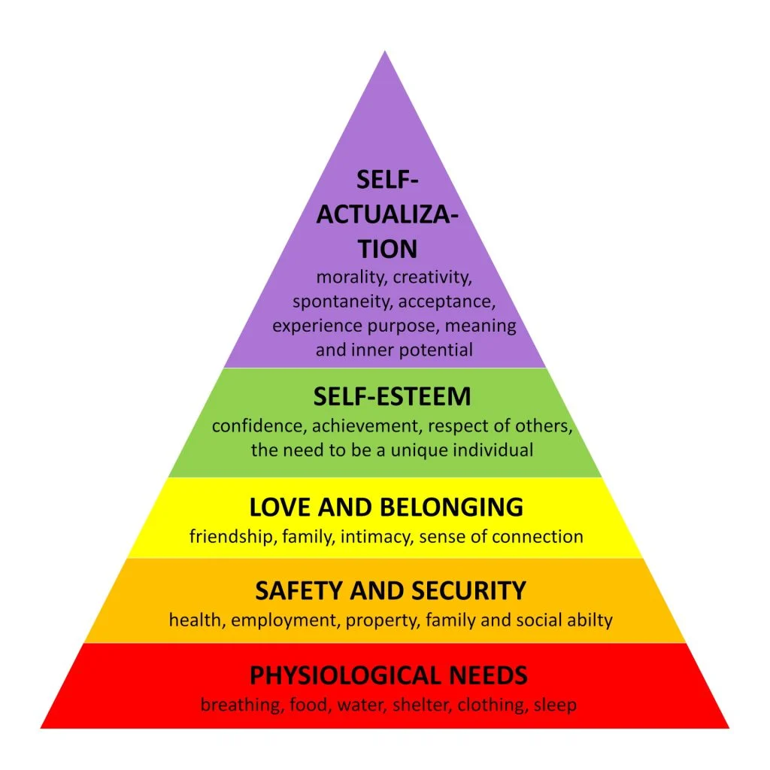

**Figure 1.** Maslow’s hierarchy of needs

**Source:** Authors’ own creation

**Conclusion and Discussion** *(Book Antiqua,12 pt, Bold, Justified, First Letters Capitalized, 1,15 lines spacing)*

*(Book Antiqua, 10 pt, Justified, 1,15 lines spacing)*

In this section, a brief introduction to the aim and process of the study should be provided first. Subsequently, each finding should be discussed by comparing it with the results of previous studies. Additionally, the limitations of the study should be addressed, and suggestions for future research should be provided.

***Conflict of interests:*** The author(s) has (have) no conflict of interest to declare.

***Grant Support:*** The author(s) declared that this study has received no financial support

***Ethics Committee Approval:*** Ethical Committee Approval was obtained from the xxx University Ethics Committee at the meeting dated 27.05.2021 with the decision number 2021.05. In case of any discrepancies, the Journal of Tourism Intelligence and Smartness holds no responsibility, and all liability lies with the author(s) of the work.

If ethics committee permission is not required, the reason should be written.

**References** *(Book Antiqua,12 pt, Bold, Justified, First Letters Capitalized, 1,15 lines spacing)*

*(Book Antiqua, 10 pt, Justified, Hanging – 1,25 cm, 1,15 lines spacing)*

APA 7 style should be used for referencing.

For detailed information on APA 7 citation style referencing: <https://apastyle.apa.org/style-grammar-guidelines/references/examples>

1. *Corresponding* author. *E-mail adress:*