Journal of Physical Chemistry and Functional Materials

Home Page of Journal: https://dergipark.org.tr/jphcfum
A Correlation Assessment of 222Rn Gas Measurements from the East Anatolian Fault Zone
Mücahit Yılmazª*, Mehmet Gürcan^{b} and Yunus Güral^{b}
ªFirat University, Department of Physics, Elazig, Turkey
^{b}Firat University, Department of Statistics, Elazig, Turkey
* Corresponding author: E-mail: muyilmaz@firat.edu.tr
ABSTRACT |  |  | ARTICLE INFO
Factors affecting the diffusion of radon (²²²Rn) gas from the soil to the atmosphere have been examined in many studies. ²²²Rn gas emission depends on the geological structure and meteorological parameters of a given region, and ²²²Rn gas concentration is one of the precursors of earthquakes. In addition, it is an important gas in terms of health, because it can cause lung cancer. In this study, comprehensive statistical analyses of ²²²Rn data was carried out on soil samples obtained from 16 stations located in the East Anatolian Fault Zone (EAFZ) in Turkey, and the ²²²Rn characteristics of the region were investigated. A daily average of the data was taken between 2007 and 2010. The Kruskal-Wallis test was used to determine whether ²²²Rn emissions in the study area varied according to the year and the station. Binary comparisons were made by grouping the ²²²Rn data measured at the stations annually and significant results were obtained. |  |  | Keywords:  ²²²Rn Gas,  Radon Anomaly,  East Anatolian Fault Zone (EAFZ)  Received: XX-XX-2021,  Accepted: XX-XX-2021  ISSN: 2651-3080

INTRODUCTION
Radium (²²⁶Ra), a product of Uranium (²³⁸U) radioactive decay chain, undergoes alpha and gamma decay reactions to become stable. Radon (²²²Rn), formed by the radioactive decay of ²²⁶Ra (in 1600 years), is an invisible, colorless, odorless, radioactive gas. As a result of serial decay, it turns into radioactive elements such as Polonium (²¹⁸Po) and Polonium (²¹⁴Po). The half-life of ²²²Rn gas is 3.82 days and it is an alpha emitter. It is an inert gas located in the noble gas group of the periodic table [1, 2].
²²²Rn is naturally formed by the decay of uranium and radium in soil, rock and water, and it is released to the atmosphere from these sources [2, 3]. For this reason, it exists at different concentration levels depending on the geological structure of the region. Since it is soluble in water, it is also present in different amounts in groundwater and streams.
The diffusion rate of ²²²Rn from soil to air depends on the structure of the soil, the humidity and the geology of the region. In addition, meteorological parameters such as precipitation, temperature and atmospheric pressure also affect the ²²²Rn concentration. Many studies have been conducted on the effects of geological and meteorological factors on the concentration of ²²²Rn [2, 4-7].
Although the alpha emitter ²²²Rn has a carcinogenic structure, it can be utilized for many other useful purposes [3]. ²²²Rn gas in soil is important for geology, seismology and protection from radiation. There are also studies showing that major soil ²²²Rn gas anomalies may be a precursor of oncoming seismic activity (1, 4, 8-16].
In this study, the variation in the data for ²²²Rn gas in the soil from each of the 16 stations observed over the EAFZ for a number of years was investigated. Also, it was checked whether the stations differed in comparison to each other. Consequently, the relationships of the stations to each other and the effects of each station on every other station were determined.

MATERIAL AND METHOD
This study was carried out in the East Anatolian Fault Zone (EAFZ), one of Turkey’s major fault zones. It is known that the EAFZ is 30 km wide and approximately 580 km long; it starts in Karlıova and passes through Bingöl, Palu, Hazar Gölü, Sincik, Çelikhan and Gölbaşı, and it changes direction continuing with the faults forming Hatay Graben and merging with the Ölüdeniz fault. It consists of many left-lateral strike-slip faults that complement each other with different characteristics between Karlıova and Antakya. EAFZ is formed by 6 different segments, the lengths of which vary between 50 km and 145 km. These are the Karlıova-Bingöl segment (65 km), the Palu-Hazar segment (50 km), the Hazar-Sincik segment (85 km), the Çelikhan-Gölbaşı segment (50 km), the Gölbaşı-Türkoğlu segment (90 km) and the Türkoğlu-Antakya segment (145 km).
Since the EAFZ has a high earthquake risk, it is one of the most important fault lines in earthquake studies. Large earthquakes have been observed on this fault line over time. Some of these earthquakes include: December 4, 1905/Pütürge (Malatya) Magnitude scale (Ms) = 6.8, March 20, 1945/Ceyhan (Adana) Ms = 6.0, June 14, 1964/Sincik (Adıyaman) Ms = 6.0, May 22, 1971/Bingöl Ms = 6.8, May 5, 1986/Sürgü (Malatya) Moment magnitude (Mw) = 6.0, June 27, 1998/Yüreğir (Adana) Mw = 6.2, May 1, 2003/Bingöl Mw = 6.3, March 8, 2010/Kovancılar (Elazığ) Mw = 6.1. [17, 18]. Finally, on January 24, 2020, there was a 6.8 magnitude earthquake that lasted for about 40 seconds in the Sivrice district of Elazığ, confirming that the EAFZ has a high earthquake risk.
The study area consisted of 16 stations on and around EAFZ. The locations of these stations are shown in Figure 1.

RESULTS AND DISCUSSIONS
Table 2 shows the Kruskal-Wallis test results that were carried out to check whether there was a difference between the CLIK, DMIR, ERGA, HELI, NURD, KZIL, OSMA, PALU, PTRG and SURG stations over time. Results indicated that significant differences were observed in most of the stations (p value <0.05) by year. In the table, * is used for years with no difference.

Table 1 Locations of the stations in the study area
Station Number | Station Code | Latitude | Longitude | Location
1 | PALU_DR | 38.69131 | 39.93932 | Elazığ (Palu)
2 | HELI_DR | 38.46342 | 39.55242 | Elazığ (Maden)
3 | SGPR_DR | 38.41944 | 39.25726 | Elazığ (Sivrice)
4 | ERGA_DR | 38.33917 | 39.69952 | Diyarbakır (Ergani)
5 | PTRG_DR | 38.18974 | 38.76733 | Malatya (Pötürge)
6 | SURG_DR | 38.04108 | 37.8848 | Malatya (Doğanşehir)
7 | KASI_DR | 37.99086 | 38.15603 | Adıyaman (Kasımlar)
8 | CLIK_DR | 37.70035 | 37.50898 | Adıyaman (Çelikhan)
9 | KZIL_DR | 37.37069 | 36.81721 | Kahramanmaraş (Kızıleniş)
10 | NURD_DR | 37.16434 | 36.70757 | Gaziantep (Nurdağı)
11 | OSMA_DR | 37.08418 | 36.29781 | Osmaniye
12 | YAKA_DR | 36.95122 | 35.62737 | Adana (Yakapınar)
13 | KOZA_DR | 37.44426 | 35.80364 | Adana (Kozan)
14 | CAML_DR | 37.16443 | 34.5706 | Mersin (Çamlıyayla)
15 | YUVA_DR | 36.68707 | 36.45314 | Hatay (Hassa)
16 | DMIR_DR | 36.27637 | 36.35749 | Hatay (Demirköprü)
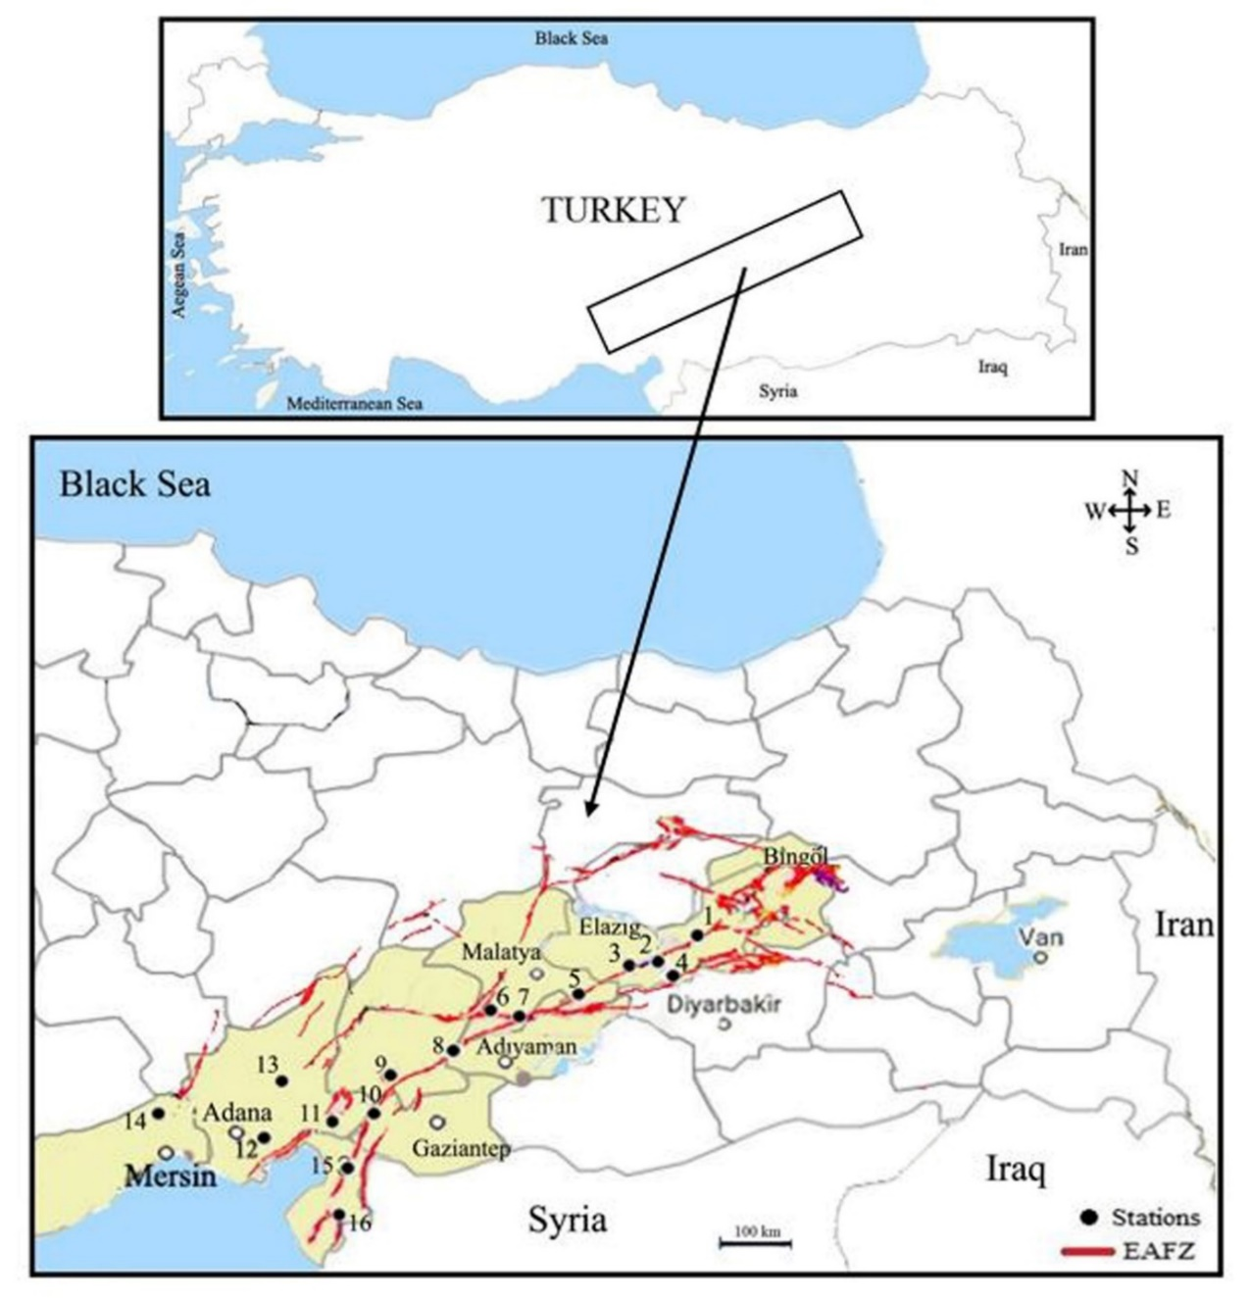
Figure 1 Study area
Table 2 Kruskal-Wallis Test for each station and binary comparisons grouped by years
Station | Kruskal-Wallis H | df | p-value | Binary Comparison
 |  |  |  | Group | Test Statistics | p-value
CLIK | 25.845 | 2 | 0.000 | 2007-2008*  2007-2009  2008-2009 | 49.420  116.797  67.378 | 0.099  0.000  0.007
DMIR | 373.544 | 3 | 0.000 | 2007-2008  2007-2009*  2007-2010  2008-2009  2008-2010  2009-2010 | 325.238  −22.312  462.783  −347.550  137.544  485.095 | 0.000  1.000  0.000  0.000  0.000  0.000
ERGA | 417.839 | 2 | 0.000 | 2007-2008  2007-2009  2008-2009 | −188.497  −467.916  49.420 | 0.000  0.000  0.000
HELI | 103.607 | 3 | 0.000 | 2007-2008  2007-2009  2007-2010  2008-2009  2008-2010  2009-2010* | −154.705  −258.870  −292.059  −104.165  −137.354  −331.189 | 0.000  0.000  0.000  0.003  0.000  1.000
NURD | 62.236 | 3 | 0.000 | 2007-2008  2007-2009*  2007-2010*  2008-2009  2008-2010  2009-2010 | −171.048  −27.317  56.217  143.732  227.226  83.534 | 0.000  1.000  0.439  0.000  0.000  0.032
KZIL | 66.448 | 3 | 0.000 | 2007-2008*  2007-2009  2007-2010  2008-2009  2008-2010  2009-2010 | 7.246  215.379  112.208  208.133  104.962  −103.171 | 1.000  0.000  0.002  0.000  0.003  0.003
OSMA | 20.578 | 3 | 0.000 | 2007-2008  2007-2009  2007-2010  2008-2009*  2008-2010*  2009-2010* | 138.834  100.183  92.293  −38.651  −46.541  −7.890 | 0.000  0.008  0.020  1.000  0.721  1.000
PALU | 246.291 | 3 | 0.000 | 2007-2008  2007-2009  2007-2010  2008-2009*  2008-2010  2009-2010 | 245.906  246.136  491.389  0.229  245.483  245.253 | 0.000  0.000  0.000  1.000  0.000  0.000
PTRG | 168.218 | 3 | 0.000 | 2007-2008  2007-2009  2007-2010  2008-2009*  2008-2010  2009-2010 | 363.587  349.865  233.932  −13.721  −129.654  −115.933 | 0.000  0.000  0.000  1.000  0.000  0.001
SURG | 405.753 | 3 | 0.000 | 2007-2008  2007-2009  2007-2010  2008-2009  2008-2010  2009-2010 | 357.518  −229.010  140.556  −586.528  −216.962  369.566 | 0.000  0.000  0.000  0.000  0.000  0.000

The Kruskal Wallis test was conducted to check whether stations exhibited differences compared to each other in years throughout the time of interest. The results are shown in Table 3.
According to the ²²²Rn concentration results measured at the stations, no significant difference was observed between the stations in 2007, 2008, 2009 and 2010 (p value <0.05). In Figure 2, binary comparisons of ²²²Rn concentrations measured in different years are presented.
Table 3 Kruskal-Wallis test for soil ²²²Rn data by years
Year | 2007 | 2008 | 2009 | 2010
Kruskal-Wallis H | 3015.05 | 2669.14 | 2423.45 | 2440.64
df | 12.00 | 12.00 | 13.00 | 11.00
P Value | 0.00 | 0.00 | 0.00 | 0.00

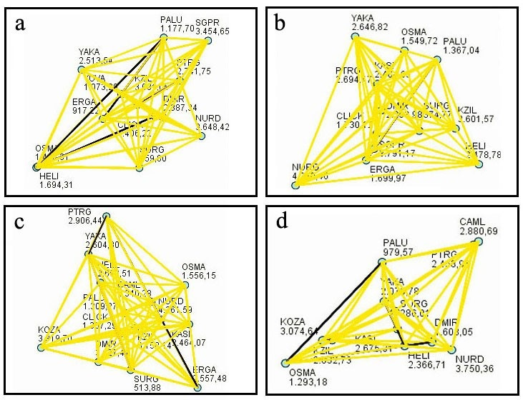
Figure 2 Binary comparisons of ²²²Rn data measured at stations in
(a) 2007 (b) 2008 (c) 2009 (d) 2010

Table 4 Relationships observed between stations for 2007 (* indicates no relationship)
 | 1 | 2 | 3 | 4 | 5 | 6 | 7 | 8 | 9 | 10 | 11 | 12 | 13 | 14 | 15 | 16
1 |  |  |  | * |  | * |  | * |  |  | * |  |  |  | *
2 |  |  |  |  |  | * |  | * |  |  | *
3 |  |  |  |  |  | * |  |  |  | *
4 | * |  |  |  |  | * |  |  |  |  |  |  |  |  | *
5 |  |  |  |  |  | * |  |  | * |  |  | *
6 | * | * | * | * | * | * | * | * | * | * | * | * | * | * | * | *
7 |  |  |  |  |  | *
8 | * | * |  |  |  | * |  |  |  |  | *
9 |  |  |  |  | * | *
10 |  |  | * |  |  | *
11 | * | * |  |  |  | * |  | *
12 |  |  |  |  | * | * |  |  |  |  |  |  |  |  |  | *
13 |  |  |  |  |  | *
14 |  |  |  |  |  | *
15 | * |  |  | * |  | *
16 |  |  |  |  |  | * |  |  |  |  |  | *

Binary comparisons of ²²²Rn gas measured at stations in 2008 are given in Figure 2 (b). It shows that there was a significant difference between the SURG station and every other station. There was a significant difference between the ERGA station and other stations except for the PALU, OSMA and CLIK stations. There was a significant difference between the PALU station and other stations except for the OSMA and ERGA stations. There was a significant difference between the CLIK station and other stations except for the ERGA and OSMA stations. There was a significant difference between the OSMA station and other stations except for the ERGA, PALU and CLIK stations. There was a significant difference between the DMIR station and other stations except for the KASI and HELI stations. There was a significant difference between the KASI station and other stations except for the DMIR, HELI, YAKA and PTRG stations. There was a significant difference between the HELI station and other stations except for the DMIR, KASI, YAKA and PTRG stations. There was a significant difference between the PTRG station and other stations except for the KASI, HELI and YAKA stations. Finally, there was a significant difference between the SGPR station and other stations except for the KZIL station.
Binary comparisons of ²²²Rn gas measured at stations in 2009 are given in Figure 2 (c). According to this figure, there was a significant difference between the SURG station and every other station. There was a significant difference between the ERGA station and other stations except for the KASI, YAKA, HELI and PTRG stations. A significant difference was observed between the PALU station and other stations except for the CLIK and OSMA stations. There was a significant difference between the CLIK station and other stations except for the PALU and OSMA stations. There was a significant difference between the OSMA station and other stations except for the PALU and CLIK stations. There was a significant difference between the DMIR station and other stations except for the PTRG, KZIL and CAML stations. There was a significant difference between the KASI station and other stations except for the ERGA, HELI and YAKA stations. There was a significant difference between the YAKA station and other stations except for the ERGA, KASI, HELI and PTRG stations. There was a significant difference between the HELI station and other stations except for the ERGA, KASI, YAKA and PTRG stations. There was a significant difference between the PTRG station and other stations except for the ERGA, YAKA, HELI, DMIR and KZIL stations. There was a significant difference between the KZIL station and other stations except for the DMIR, PTRG and CAML stations.

Table 5 Binary correlation coefficients of the stations in the study area relative to each other
 | CLIK | DMIR | ERGA | HELI | KZIL | NURD | OSMA | PALU | PTRG | SGPR | SURG | YAKA
CLIK | 1 | −0.388 | −0.312 | 0.375 | 0.114 | 0.118 | 0.162 | 0.063 | −0.129 | 0.065 | −0.234 | −0.010
DMIR | −0.388 | 1 | 0.327 | 0.102 | 0.095 | 0.210 | 0.360 | 0.555 | 0.321 | 0.409 | 0.403 | 0.496
ERGA | −0.312 | 0.327 | 1 | 0.365 | 0.046 | 0.243 | 0.317 | 0.244 | −0.008 | 0.358 | 0.325 | 0.318
HELI | 0.375 | 0.102 | 0.365 | 1 | 0.273 | 0.570 | 0.515 | 0.406 | 0.061 | 0.407 | −0.107 | 0.575
KZIL | 0.114 | 0.095* | 0.046 | 0.273 | 1 | 0.555 | 0.489 | 0.463 | 0.309 | 0.342 | −0.090 | 0.514
NURD | 0.118 | 0.210 | 0.243 | 0.570 | 0.555 | 1 | 0.531 | 0.536 | 0.188 | 0.472 | −0.226 | 0.659
OSMA | 0.162 | 0.360 | 0.317 | 0.515 | 0.489 | 0.531 | 1 | 0.555 | 0.264 | 0.703 | 0.118 | 0.707
PALU | 0.063 | 0.555 | 0.244 | 0.406 | 0.463 | 0.536 | 0.555 | 1 | 0.285 | 0.477 | 0.148 | 0.693
PTRG | −0.129 | 0.321 | −0.008 | 0.061 | 0.309 | 0.188 | 0.264 | 0.285 | 1 | 0.313 | 0.252 | 0.315
SGPR | 0.065 | 0.409 | 0.358 | 0.407 | 0.342 | 0.472 | 0.703 | 0.477 | 0.313 | 1 | 0.154 | 0.575
SURG | −0.234 | 0.403 | 0.325 | −0.107 | −0.090 | −0.226 | 0.118 | 0.148 | 0.252 | 0.154 | 1 | −0.063
YAKA | −0.010 | 0.496 | 0.318 | 0.575 | 0.514 | 0.659 | 0.707 | 0.693 | 0.315 | 0.575 | −0.063 | 1

Binary comparisons of ²²²Rn gas measured at stations in 2010 are given in Figure 2 (d). This figure indicated that there was a significant difference between the SURG station and every other station. There was a significant difference between the PALU station and other stations except for the OSMA station. There was a significant difference between the OSMA station and other stations except for the PALU and DMIR stations. There was a significant difference between the DMIR station and other stations except for the OSMA station. There was a significant difference between the KASI station and other stations except for the HELI, KZIL, PTRG and CAML stations. There was a significant difference between the YAKA station and other stations except for the HELI station. There was a significant difference between the HELI station and other stations except for the KASI, YAKA and PTRG stations. There was a significant difference between the PTRG station and other stations except for the KASI and HELI stations. There was a significant difference between the KZIL station and other stations except for the KASI, KOZA and CAML stations. There was a significant difference between the CAML station and other stations except for the KASI, KZIL and KOZA stations.
In Table 5, calculations of binary correlations for the stations are given as follows:

DISCUSSION
Considering Table 4 with the information given in Figure 2 (a), where the relations between the stations are given, the most interesting finding was that even though there was no significant difference from other stations in 2007 in terms of ²²²Rn gas emission data, there was a significant difference in 2008, 2009 and 2010. If the map of the region is thoroughly examined, it will be noticed that Station 6 in almost in the middle of the other stations. Considering this fact and the geographical location of the region, it is normal that there is no significant difference, but when the fault lines in the region are taken into consideration, the significant difference is normal. The fault line where Station 6 is located and the fault lines passing through the nearby stations are different. Since the fault motion that triggered the release of ²²²Rn gas in 2007 had no effect, no difference was observed with other stations in terms of ²²²Rn gas emission. However, ²²²Rn gas emission showed differences in 2008, 2009 and 2010 due to the mobility of the fault lines in different directions. This finding proves that the emission of ²²²Rn gas is highly affected by the mobility of these fault lines.
Station 7 and Station 6 are located very close to each other. However, Station 7 is located on both fault lines. Therefore, a significant difference is observed in terms of the emission of ²²²Rn gas at Station 7 in other years except 2007. In 2008 and 2009, there was no significant difference between Station 7, and Stations 2 and 12. Although the geographical properties are different from each other, no significant difference was observed in ²²²Rn gas emission due to the mobility of the fault line on which they are located. This situation puts the Gulf region, which includes Hatay, in a very risky situation in terms of fault line mobility.
Although the locations of stations 1, 2, 3 and 5 are all close to each other and on the same fault line, a significant difference was observed in terms of ²²²Rn gas emissions. The reason for this is that there are many fault lines located to the east of Station 1 and in the region, including Bingöl, with different fault ruptures. Moreover, there may be some fault lines that have not yet been detected.
No significant difference was observed between Station 1 and Station 11 in terms of ²²²Rn gas emission in 2007, 2008, 2009 and 2010. It is a striking result that there was no difference between these two stations although the geographical properties are quite different, according to the map. The fault line on both stations affects ²²²Rn gas emission at the same degree. This situation reveals that the area of the gulf where Station 11 is located is the riskiest region in terms of earthquakes. This region is affected by almost all of the mobility of the Eastern Anatolian fault ruptures. Considering the correlation coefficients given in Table 5, the correlation coefficient of Station 1 and Station 11 is 0.555, one of the highest correlations in the table.

Acknowledgement: We would like to thank TÜBİTAK Marmara Research Center for its contribution in obtaining and compiling the data used in this study.

Competing interests

The authors declare that they have no competing interests.

REFERENCES
[1] Durrani, S., A., Ilić, R., 1997. Radon Measurements by Etched Track Detectors, World Scientific, Singapore.
[2] Papachristodoulou, C., Stamoulis, K. & Ioannides, K., 2020. Temporal Variation of Soil Gas Radon Associated with Seismic Activity: A Case Study in NW Greece. Pure Appl. Geophys. 177, 821–836. https://doi.org/10.1007/s00024-019-02339-5
[3] Esan, D.T., Sridhar, M.K.C., Obed, R. et al., 2020. Determination of Residential Soil Gas Radon Risk Indices over the Lithological Units of a Southwestern Nigeria University. Sci Rep 10, 7368. https://doi.org/10.1038/s41598-020-64217-8
[4] Morales-Simfors, N., Wyss, R., A., Bundschuh, J., 2020. Recent progress in radon-based monitoring as seismic and volcanic precursor: A critical review, Critical Reviews in Environmental Science and Technology, 50:10, 979-1012, DOI: 10.1080/10643389.2019.1642833
[5] Kulali, F., Akkurt, I., Özgür, N., 2017. The effect of meteorological parameters on radon concentration in soil gas, Acta Physica Polonica A, 132 (3), pp. 999-1001.
[6] Baldev R. Arora, Arvind Kumar, Vivek Walia, Tsanyao Frank Yang, Ching-Chou Fu, Tsung-Kwei Liu, Kuo-Liang Wen, Cheng-Hong Chen, 2017. Assesment of the response of the meteorological/hydrological parameters on the soil gas radon emission at Hsinchu, northern Taiwan: A prerequisite to identify earthquake precursors, Journal of Asian Earth Sciences, Volume 149, Pages 49-63, ISSN 1367-9120, https://doi.org/10.1016/j.jseaes.2017.06.033.
[7] Ćujić, M., Janković Mandić, L., Petrović, J. et al., 2020. Radon-222: environmental behavior and impact to (human and non-human) biota. International Journal of Biometeorology. https://doi.org/10.1007/s00484-020-01860-w
[8] Okabe, S., 1956. Time Variation of the Atmospheric Radon Content Near the Ground Surface with Relation to Some Geophysical Phenomena. Memoirs of the College of Science, Kyoto Imperial University, Series A, 28, 99-115.
[9] King, C.Y., 1986. Gas Geochemistry Applied to Earthquake prediction: An Overview, Journal of Geophysical Research, 91, 12269–12281.
[10] King, C.Y., Luo, G., 1990. Variations of Electric Resistance and H₂ and Rn Emissions of Concrete Blocks Under Increasing Uniaxial Compression, Pure and Applied Geophysics, 134, 45–56.
[11] King, C. Y., King, B. S., Evans, W. C., 1995, Spatial Radon Anomalies on Active Faults in California, Applied Geochemistry, 11, 497-510.
[12] Ghosh, D., Deb, A., Sengupta, R., 2009. Anomalous radon emission as precursor of earthquake, Journal of Applied Geophysics, 69, pp. 67-81,
[13] Zmazek, B., Vaupotič, J., Živčić, M., Premru, U., Kobal, I., 2020. Radon monitoring for earthquake prediction in Slovenia, Fiz B, 9, pp. 111-118, 0048-9697, https://doi.org/10.1016/j.scitotenv.2020.137857.
[14] Riggio, A., SAntulin, M., 2015. Earthquake forecasting: a review of radon as seismic precursor, Bollettino di Geofisica Teorica ed Applicata, Vol. 56, n. 2, pp. 95-114.
[15] Piersanti, A., Cannelli, V., Galli, G., 2015. Long term continuous radon monitoringin a seismically active area, Annals of Geophysics, 58, 4.
[16] Chen, Z., Li, Y., Liu, Z. et al., 2018. Radon emission from soil gases in the active fault zones in the Capital of China and its environmental effects. Sci Rep 8, 16772. https://doi.org/10.1038/s41598-018-35262-1
[17] Atabey, E., 2000. Deprem, Maden Teknik ve Arama Genel Müdürlüğü, 34, Ankara.
[18] Arpat, E, Şaroğlu, F., 1972. The East Anatolian Fault System; Thoughts on its Development . Bulletin of the Mineral Research and Exploration , 78 (78) , 1-12 .

