Yuzuncu Yil University Journal of Agricultural Sciences, Volume: xx, Issue: x, xx.xx.20xx
 | Yuzuncu Yil University  Journal of Agricultural Sciences  (Yüzüncü Yıl Üniversitesi Tarım Bilimleri Dergisi)  https://dergipark.org.tr/en/pub/yyutbd |  | 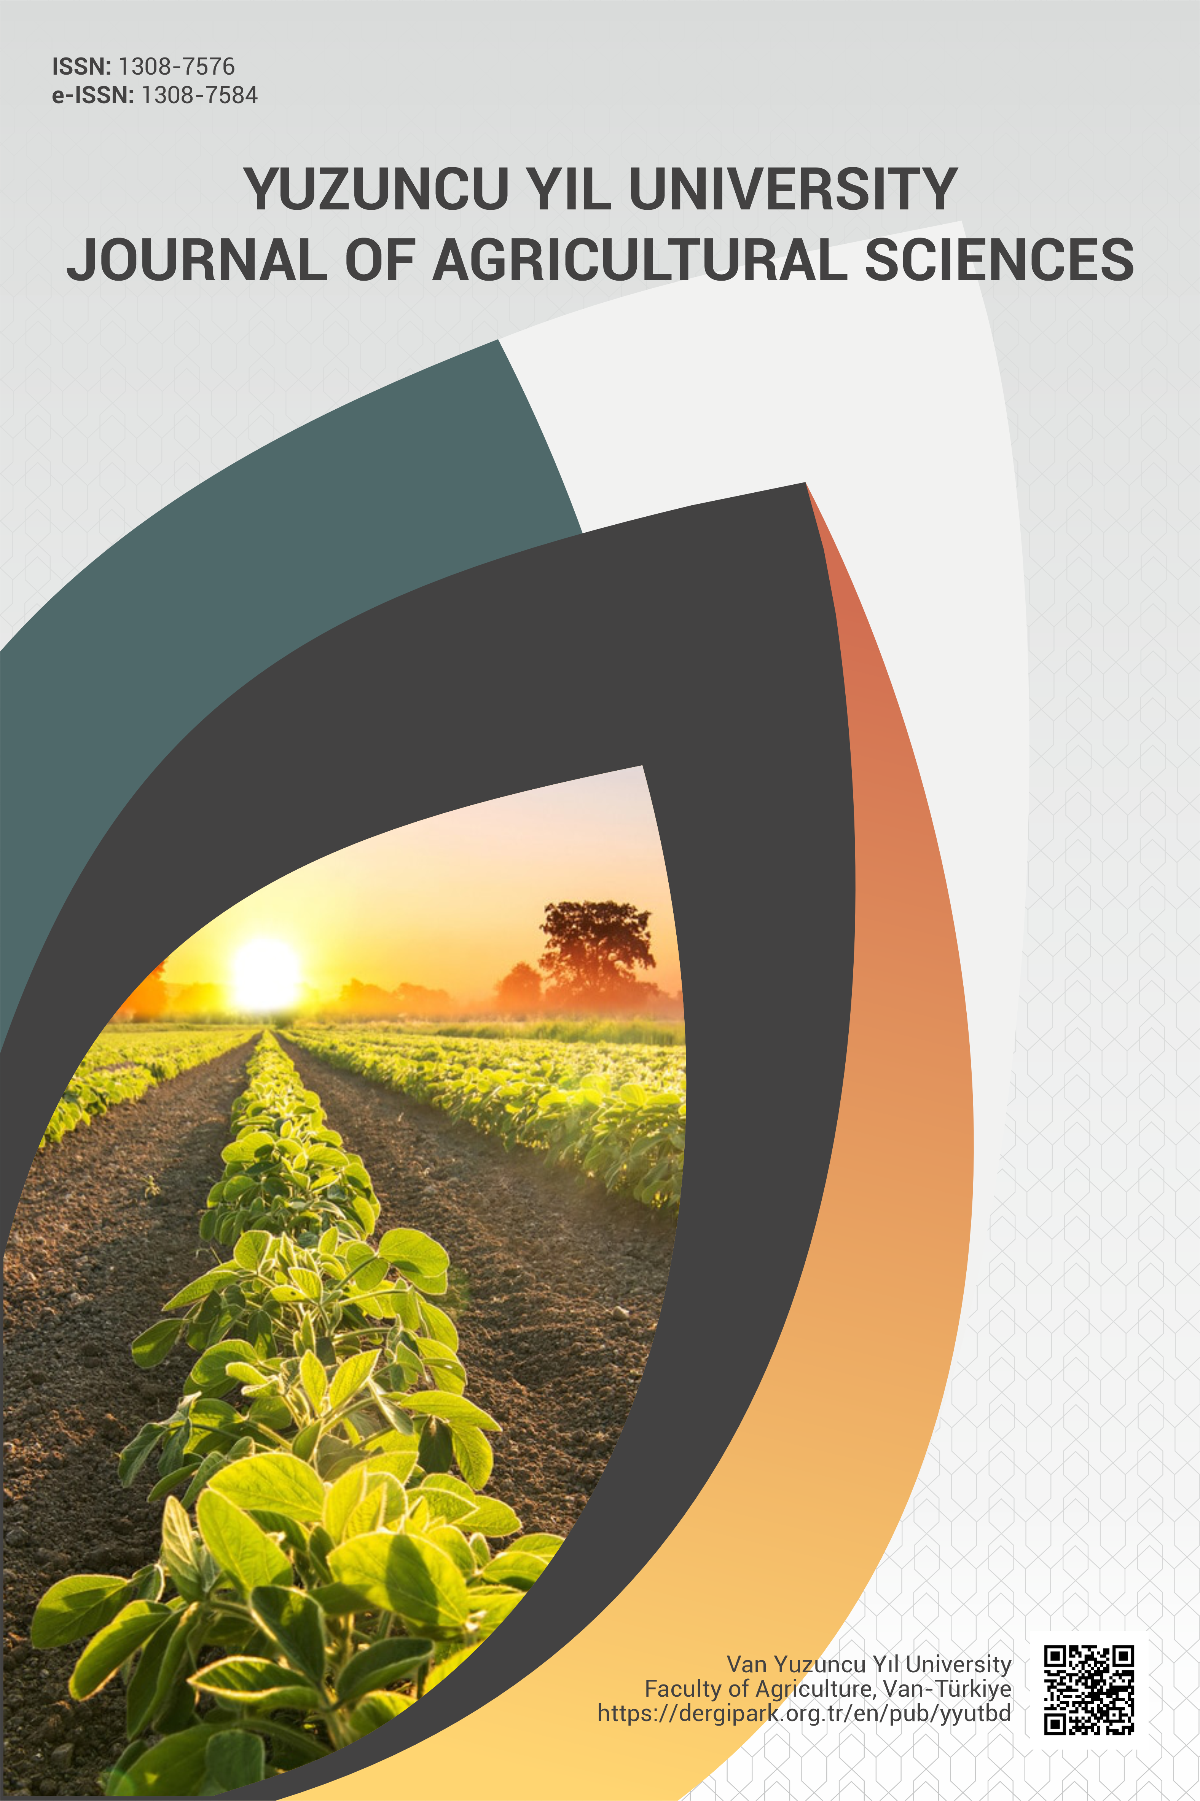
ISSN: 1308-7576 |  | e-ISSN: 1308-7584
Research / Review Article (Type of article should be selected, and the other one must be deleted)
English Title of the Study (The first letter of each word should be added here to be capital (excluding the conjunctions) and “Times New Roman” font with 12 pt) or English title of the manuscript should be written by choosing “Main title” style from the Word Styles menu
Authors’ information must not be added.
Affiliations must not be added.
Orcid Id must not be added.
*Corresponding author e-mail must not be added.

