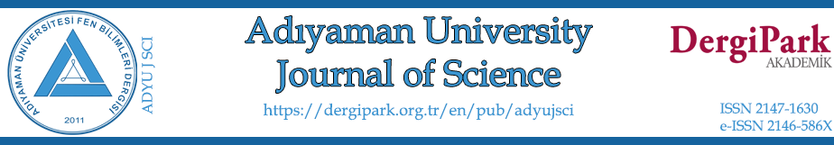 An Example Title of Manuscript for Adıyaman University Journal of Science (ADYU J SCI)
Name FAMILYNAME^{1,}*, Name2 FAMILYNAME2²
¹Name of University, Faculty of XXXXX, Department of YYYYYY, postcode, City, Country
email@uni.edu.tr, ORCID: 0000-0000-0000-0000
²Name of University, Faculty of XXXXX, Department of YYYYYY, postcode, City, Country
email@uni.edu.tr, ORCID: 0000-0000-0000-0000

Received: xx.yy.2022 Accepted: xx.yy.2022 Published: xx.yy.2022

Abstract
In the following an example abstract for the author is given. Vanadium pentaoxide (V₂O₅) doped zinc borate (ZnB) oxide glasses that could be used in fiber optic cable cores in optoelectronics, in laser crystals in solar energy systems have been synthesized successfully. Structural characters of synthesized glasses were determined with differential scanning calorimeter (DSC) and Fourier-Transform infrared spectroscopy (FTIR). Glass transition (T_{g}), crystallization (T_{c}) and melting temperatures (T_{m}), and thermal stabilities (ΔT) of the glasses were determined and also their association with the change in V₂O₅ was explained. Structural units of boron and zinc that form the structure were determined according to FTIR data. As a result, it was determined that boron formed the glass matrix with BO₃, BO₄ and boroxol ring structural units; on the other hand, zinc contributed to the glass matrix with tetrahedral ZnO₄ and octahedral ZnO₆ structural units, and vanadium usually had modifier role in the structure with its VO₄ and VO₅ structural units. V₂O₅’s presence in the structure with increasing amount changes thermal, structural and physical properties. Among the properties that significantly change, the most important one is optical properties. Indirect optical band gaps, Urbach energies, refractive index values of these synthesized samples were determined, and quite clear shifts towards red region were observed in the transmittance and absorption spectra. Optical band gap decreased to 1.24 eV from 2.55 eV with increasing amount of V₂O₅; on the other hand, Urbach energy was determined to increase to 0.630 eV from 0.246 eV. Densities, molar volumes of these synthesized glasses were also examined and commented on.
Keywords: Keyword1; Keyword2; Keyword3; Keyword4; Keyword5; Keyword6.
Adıyaman Üniversitesi Fen Bilimleri Dergisi (ADYU J SCI) Örnek Türkçe Makale Başlığı i
Öz
Bu bir örnek öz. Optoelektronikte fiber optik kablo korlarında, laser kristallerinde ve güneş enerji sistemlerinde kullanılabilecek vanadium pentaoksit (V₂O₅) katkılı çinko borat (ZnB) oksit camlar başarıyla sentezlenmiştir. Sentezlenen camlara ait yapısal karakterler diferansiyel taramalı kalorimetre (DSC) ve Fourier dönüşümlü kızılötesi spektroskopisi (FTIR) ile belirlenmiştir. Camsı geçiş (T_{g}), kristallenme (T_{c}), erime sıcaklıkları (T_{m}) ve termal kararlılıklar (ΔT) belirlenerek V₂O₅ değişimiyle ilgisi açıklanmıştır. FTIR verilerine göre yapıyı oluşturan bor ve çinkonun yapısal birimleri belirlenmiştir. Borun cam matrisini BO₃, BO₄ ve boroksol halka yapısal birimleriyle oluşturduğu, çinkonun ise cam matrisine tetrahedral ZnO₄ ve oktahedral ZnO₆ yapısal birimleri ile katkıda bulunduğu, vanadyumun yapıda çoğunlukla VO₄ ve VO₅ yapısal birimleriyle yer alarak düzenleyici görev üstlendiği belirlenmiştir. V₂O₅ katkısının artması yapının termal, yapısal ve fiziksel özelliklerini değiştirmektedir. Belirgin biçimde değiştirdiği özelliklerin başında optik özellikler gelmektedir. Sentezlenen numunelere ait indirekt optik bant aralığı, Urbach enerjisi, kırılma indisi değerleri belirlenmiş, geçirgenlik ve absorpsiyon spektrumlarında kırmızı dalgaboyuna kaymalar net bir şekilde gözlenmiştir. Optik bant aralığı V₂O₅ artışıyla 2.55 eV dan 1.24 eV’a azalmış, buna karşılık Urbach enerjisi 0.246 eV’dan 0.630 eV’a arttığı belirlenmiştir. Ayrıca, sentezlenen numunelere ait yoğunluk, molar hacim incelenmiş ve yorumlanmıştır.
Anahtar Kelimeler: Kelime1; Kelime2; Kelime3; Kelime4; Kelime5; Kelime6.
1. Introduction
This is an example introduction section. Glass, an amorphous material, has an important place in respect to technology and science. Besides silicon dioxide (SiO₂), phosphorus pentoxide (P₂O₅), boron oxide (B₂O₃), and vanadium pentoxide (V₂O₅) are being used in the synthesis of glasses the most. Among these, B₂O₃ is known to be the best glass former [1, 2]. Borate glasses in which B₂O₃ establishes the glass network are very important optical materials due to their low melting points, high transmittance properties and high thermal stabilities [3]. They are frequently being used in the making of dielectric materials and used as isolation materials. Though they are being used as dielectric materials, the inclusion of transition metal ions in the borate glass network leads to the achievement of semiconductor character or these glasses. Transition metals are nowadays being extensively used in glass science due to their presence in two or more valance states that alters the structural and optical characters [4-10].
It is possible to find examination studies performed on binary zinc-borate structures among transition metal doped borate glasses and also ternary structures and structures having more components in the literature [11-22]. Except for glass systems, it is possible to find zinc-borate ceramic structures, as well [23].
2. Materials and Methods
2.1. Sample preparation
This is an example subsection. ZnO-B₂O₃ glass samples containing V₂O₅ were synthesized from chemicals having 99.5% purity (Alfa Aesar) according to (100-x)(0.6ZnO-0.4B₂O₃). (x)(V₂O₅) (x = 1, 2, 3, 4) composition. The method that was used in the synthesis of the glasses was melt-quenching method. Chemicals were weighed on an analytical scale having accuracy of 0.00001g, and then weighed chemicals were mechanically mixed for approximately 10 min and made uniform.
Prepared powder mixture was left in a porcelain crucible for 60 minutes in a Nabertherm LHT 02/17 LB brand high temperature furnace that was previously heated to 1100 °C for reaction to take place. At the end of the process, molten glass samples were shaped cylindrically in a steel mold and annealed for 60 minutes at 400 °C.
Glass samples synthesized by this way (Fig. 1) were sliced with a Metkon brand Micracut 152 model cutting device with diamond disc for optical measurements having a diameter of 2.5 cm and a thickness of 2 mm; both surfaces of the cut samples were polished with a Metkon brand Forcipol 102 model polishing device. Some of the samples were grounded with a Retsch RM200 brand grinder to study their thermal and structural properties.

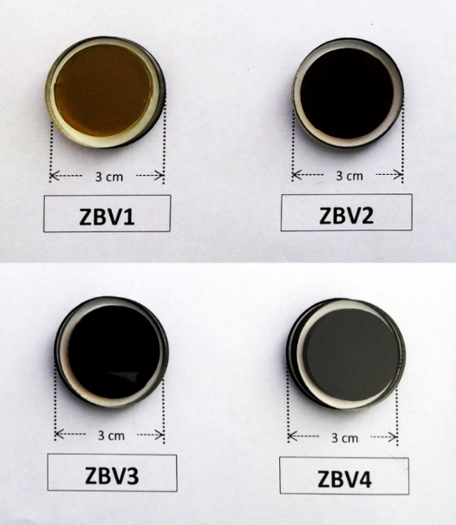
Figure 1: Synthesized ZnO-B₂O₃-V₂O₅ glass samples
2.2. Characterization
This is an example subsection. Densities of glasses were determined with the principle of Archimedes. Samples were first weighed in the air with a KERN brand ABT 100-5m model analytical scale having an accuracy of 0.00001g, and then weighed again in immersion fluid. Ultra-pure water was selected as immersion fluid. By using the measurements taken in the air and in the immersion fluid, densities of the samples were calculated with the below equation [52]:
$$D=\frac{W_{a}}{W_{a}-W_{l}} .ρ_{o}$$ | (1)
In this equation, $W_{a}$is the weight of the sample in the air, $W_{l}$ is the weight of the sample in the fluid and $ρ_{o}$ is the density of immersion fluid (ρ_{o} = 0.998272 g.cm⁻³) at 20 °C. Molar volumes (V_{m}) of glass samples were calculated with the following equation:
$$V_{m}=\frac{\sum{x_{i}M_{i}}}{D}$$ | (2)
Here, $x_{i}$ is the mole ratio of the i.^{th} component, $M_{i}$ is the molecular weight.
Transmittance and absorption spectra of the glasses were determined with Analytik Jena SPECORD 210 UV-Vis Spectrophotometer with steps of 1 nm. In addition, in order to determine the uniformity of the sample, transmittance spectra were determined with scanning attachment of the device by using 1.5 cm piece of the surface. Absorption spectra were used to calculate optical band gaps and Urbach energies of the synthesized samples.
Refractive index due to optical band gap was calculated with the following empirical relation [53]:
$$\frac{\left(n^{2}-1\right)}{\left(n^{2}+2\right)}=1-\sqrt{\frac{E_{0}}{20}}$$ | (3)
$n$, is the refractive index of the samples, $E_{0}$ is optical band gap.
3. Results and Discussion
3.1. Density and molar volume
This is an example subsection. Sample densities and molar volume values calculated with the help of Eqn. (1) are given in Table 1. In addition, sample codes and ratio of components within the glass can also be seen. As you can see in Fig. 2, density values of the samples decreased regularly from 3.392 g.cm⁻³ to 3.329 g.cm⁻³ with increasing amount of V₂O₅. On the other hand, molar volume values increased from 22.910 cm³.mol⁻¹ to 24.289 cm³.mol⁻¹ almost linearly. V₂O₅’s being a more complex molecule led to volume increase, in addition, since masses of shifting vanadium and zinc were close to each other, it resulted in decrease in the molar volume. Similar impact can also be found in the literature [54].
Table 1: Sample codes, % compositions and calculated density and molar volume values of synthesized samples
Sample Code | ZnO | B₂O₃ | V₂O₅ | Density | Molar volume
 | mol % | mol % | mol % | g.cm⁻³ (±0.001) | cm³.mol⁻¹ (±0.005)
ZBV1 | 59.40 | 39.60 | 1.00 | 3.392 | 22.910
ZBV2 | 58.80 | 39.20 | 2.00 | 3.371 | 23.366
ZBV3 | 58.20 | 38.80 | 3.00 | 3.339 | 23.906
ZBV4 | 57.60 | 38.40 | 4.00 | 3.329 | 24.289

3.2. Thermal properties
This is an example subsection. DSC thermograms belonging to synthesized ZBV glass samples are given in Fig. 3, and their glass transition temperatures, crystallization and melting temperatures are given in Table 2. As it can be seen in DSC thermograms, curves belonging to 4 samples are almost identical in respect to their shapes. 3 ambiguous exothermic peaks in the shape of shoulders are followed by 1 endothermic peak. Glass transition temperatures can be seen within the range of 530-550 °C and glass transition temperature has decreased with increasing amount of V₂O₅. First crystallization temperature was around 740 °C; the range of 818-833 °C was the region of second crystallization temperature.
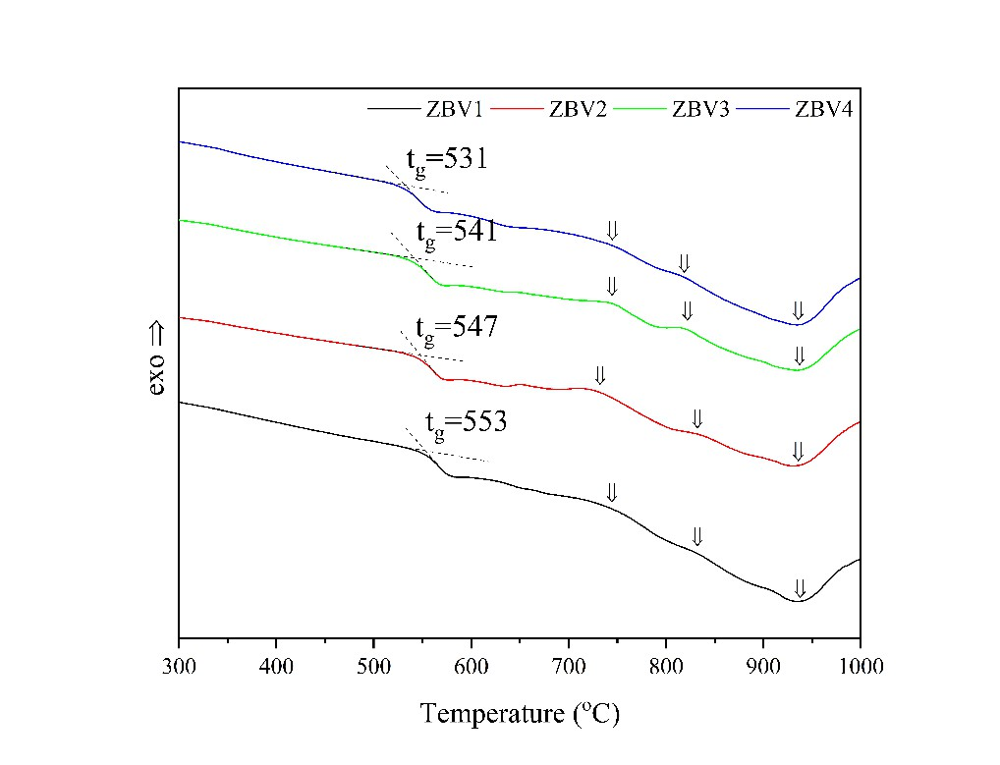
Figure 3: DSC thermograms belonging to samples

Table 2: Glass transition, crystallization, melting temperatures and thermal stabilities of synthesized ZBV glasses
Sample | T_{g} | T_{c1} | T_{c2} | T_{m} | ΔT
Code | (ºC)( ±1) | (ºC)( ±1) | (ºC)( ±1) | (ºC)( ±1) | (ºC)( ±1.2)
ZBV1 | 553 | 743 | 833 | 935 | 190
ZBV2 | 547 | 730 | 831 | 933 | 183
ZBV3 | 541 | 743 | 820 | 935 | 202
ZBV4 | 531 | 743 | 818 | 935 | 212

4. Conclusion
Ternary zinc borate oxide glass samples doped with different ratios of V₂O₅ were synthesized successfully. Physical, structural, thermal, and optical characterization of these synthesized samples were performed. Structural units were determined with FTIR. B₂O₃ was found to be present in the glass network in the structure of the boroxol ring, planar BO₃, tetrahedral BO₄. ZnO, acting as the organizer with its low concentration in the structures in which it is found, was determined to be present in the samples of this study in tetrahedral ZnO₄ and octahedral ZnO₆ structural units; and it was concluded that it might be present in the glass network as a glass former. Vanadium is present in the glass network with VO₄ and VO₅ structural unit. Increase in VO₅ shifted the absorption edge significantly towards the red region and correspondingly decrease optical band gap to 1.24 eV from 2.55 eV and as expected, led to increase in Urbach energy. Increase in Urbach energy proves that V₂O₅ renders the structure nonuniform and unstable. As a result of thermal characterization, V₂O₅ increase was found to decrease glass transition temperature to 531 °C from 553 °C. While density decreased with increasing amount of V₂O₅, molar volume values demonstrated increase, as well. Similar to molar volume, refractive index also increased. High refractive indices increasing to 3.170 from 2.530 showed that synthesized glasses are potential materials that could be used in optical system requiring high refractive index.
Acknowledgements
This study is supported by University Scientific Research Committee with project number XX-YYYY.
References
[1] Kılıç, G., Değişik bileşimli camların hazırlanması, fiziksel ve optik özelliklerinin incelenmesi. PhD Thesis, Eskişehir Osmangazi University, Eskişehir, Turkey, 2006.
[2] Rao, R.B., Veeraiah, N., Study on some physical properties of Li₂O-MO-B₂O₃: V₂O₅ glasses, Physica B: Condensed Matter, 348, 256-271, 2004.
[3] El-Batal, H.A.R., Ezz-El-Din, F.M., Interaction of γ-rays with Some Alkali Alkaline Earth Borate Glasses Containing Chromium, Journal of the American Ceramic Society, 76, 523, 1993.
[4] Abdel-Baki, M., El-Diasty, F., Role of oxygen on the optical properties of borate glass doped with ZnO, Journal of Solid State Chemistry, 184, 2762-2769, 2011.
[5] El-Falaky, G.E., Gaafar, M.S., Abd El-Aal, N.S., Ultrasonic relaxation in Zinc-Borate glasses, Current Applied Physics, 12, 589-596, 2012.
[6] Sumalatha, B., Omkaram, I., Rao, T.R., Raju, Ch. L., Alkaline earth zinc borate glasses doped with Cu²⁺ ions studied by EPR, optical and IR techniques, Journal of Non-Crystalline Solids, 357, 3143-3152, 2011.
[7] Kumar, R.R., Bhatnagar, A.K., Rao, J.L., EPR of vanadyl ions in alkali lead borate glasses, Materials Letters, 57, 178-182, 2002.
[8] Rada, M., Rada, S., Pascuta, P., Culea, E., Structural properties of molybdenum-lead-borate glasses, Spectrochimica Acta A, 77, 832-837, 2010.
[9] Rao, T.R., Reddy, Ch.V., Krishna, Ch.R., Thampy, U.S.U., Raju, R.R., Rao, S., Ravikumar, R.V.S.S.N., Correlation between physical and structural properties of Co²⁺ doped mixed alkali zinc borate glasses, Journal of Non-Crystalline Solids, 357, 3373-3380, 2011.
[10] Singh, G.P., Kaur, S., Kaur, P., Kumar, S., Singh, D.P., Structural and optical properties of WO₃-ZnO-PbO-B₂O₃ glasses, Physica B: Condensed Matter, 406, 1890-1893, 2011.
[11] He, F., Wang, J., Deng, D., Effect of Bi₂O₃ on structure and wetting studies of Bi₂O₃-ZnO-B₂O₃ glasses, Journal of Alloys and Compounds, 509, 6332-6336, 2011.
[12] Lian, Z., Wang, J., Lv, Y., Wang, S., The reduction of Eu³⁺ to Eu²⁺ in air and luminescence properties of Eu²⁺ activated ZnO-B₂O₃-P₂O₅ glasses, Journal of Alloys and Compounds, 430, 257-261, 2007.

