Manuscript title

Author Name Surname
Institution, Department, Province, Country, E-mail
Author Name Surname
Institution, Department, Province, Country, E-mail

Submitted: | XX.XX.202X
Accepted: | XX.XX.202X
Published: | XX.XX.202X
Abstract:
The abstract should be prepared via Segoe UI (Font) and 9 pts, single spaced with 2 cm margins on all sides and align full. The length of Abstract should be between 150 and 200 words. The abstract should be informative by referring study aims, the methodology, the instruments, the major findings and the implications of the study.
Keywords: 3-5 keywords should be given
© 202X Published by peer-reviewed open access scientific journal, CI at DergiPark (https://dergipark.org.tr/tr/pub/ci)

Cite this paper as: | Surname, Name. & Surname, Name. Title of the article, Computers and Informatics, 202X, Volume(Issue), Page Number.

1. INTRODUCTION
In taking a step toward expediting the publication process, Computers and Informatics uses a web-based submission and peer-review. If you have not already create an account, create an account (register) for yourself in the system at the left side of the page: https://dergipark.org.tr/en/pub/ci
To monitor the progress of your manuscript throughout the review process, just login our system periodically and check your status of paper.
The Introduction should contain the literature description on the studied matter. When preparing your manuscript, please use and follow our template. JCS employs an anonymous review policy (i.e., masked review). Therefore, the author's (authors’) name(s) and affiliation and ORCID number should not appear on any part of the article.
Prepare your manuscript and illustrations in appropriate format, according to the instructions given below. Please also be sure that your paper conforms to the scientific and style instructions of the Journal, given below here.
Each article should include an informative, comprehensive abstract of 150 to 200 words with 10 pts. The abstract should explain the critical information related to the paper's aim, methodology, findings, results, and conclusions. Three - five key words should also be given after the abstract.

1.1. General Rules
The manuscript should be typed in using MS Word (6.0 or latest versions), A4 (21x29,7 cm.) paper size, Times New Roman (Font) and 11 pts (excludes, Title and abstract), single spaced with 2 cm margins on all sides and align full.
The Tables and the References should be prepared by using Times New Roman (10 pts).
There should be single space after headings.
The authors should not use any page numbers in their manuscripts.
Appendixes should be placed at the end of the manuscript, after the reference list.

2. CHAPTERS
Chapter titles can be Theory, Experimental Setup, Methodology, Model, Simulation, Results and Discussions, Experimental Findings, Analytical Study, etc. But other titles are also welcome. Uppercase letters should be used in all chapter headings.

2.1. Sub-Headings
Sub-headings should not be numbered and all the first letters should be capitalized.

2.2. Figures, Tables and Equations
Figures, Tables and Equations should be given in the same page (not separate pages). If any of them is long as a whole page, it should be given into the Appendixes.

2.2.1. For figures
Number all figures with Arabic numerals sequentially. The resolution should be sufficient two read in English. The figure names should be given below the Figure and the name “figure” should be italicized. An example is presented below:
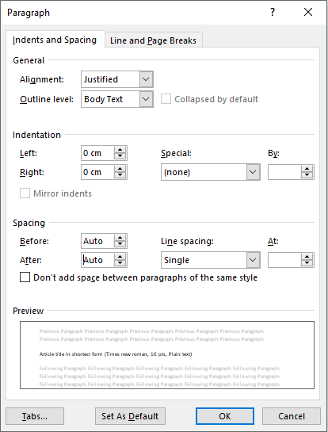
Figure 1. The name of figure
The figure captions should contain short but sufficient info with all parameters. Photos can also be accepted. The figure caption should be at the same page with the figure itself.

2.2.2. For tables
Number all tables with Arabic numerals sequentially. The table names should be placed above the table. There should be the word “Table” and the brief explanation of title should be found and italicized.
Table 1. The name of table
Item no | Item Description | Percentage
1 | Item 1 | N | N | N | N | N
2 | Item 2 | N | N | N | N | N
3 | Item 3 | N | N | N | N | N
The table caption should be at the same page with the figure itself.

2.2.3. For equations
See some examples as:
$$C_{p}=\left[0.73\left(\frac{151}{λ^{'}}\right)-0.002β-13.2\right]exp\left(\frac{-18.4}{λ^{'}}\right)$$ | (1)
After each equation put one blank line. Do not use (x) or (.) for ordinary mathematical product. Put reference to equations as Eq. (1) or multiple references as Eqs. (1,2) or Eqs. (1-3).

Acknowledgment
You can add an acknowledgment and thank to institutions or real people.

REFERENCES
Journal articles
Author, AA, Author, BB, Author, CC. Title of article. Title of Periodical Year, volume number, pages. DOI: http://dx.doi.org/xx.xxx/nnnnnn
[1] Naciri, M, Aggour, M, Ait Ahmed, W. Wind energy storage by pumped hydro station. Journal of Energy Systems 2017; 1: 32-42 <http://dergipark.gov.tr/jes/issue/30882/329315>

Books
Author, AA. Title of work: Capital letter also for subtitle. Location: Publisher, Year.
[2] Kurt E, Kasap R. The Science of Complexity Chaos. Ankara, TURKEY: Nobel Publishing House, 2011.

Chapter in a book
Author, AA, Author, BB. Title of chapter. In AA Editor, BB Editor (Eds.), Title of book, Location: Publisher, Year, pp-pp.
[3] Kurt E, Uzun Y. Nonlinear Problems in Piezoelectric Harvesters under Magnetic Field. In: Bizon N, Tabatabaei NM, Blaabjerg F, Kurt E, editors. Energy Harvesting and Energy Efficiency Technology, Methods, and Applications. Cham, Switzerland: Springer International Publishing, 2017. pp. 107-142.

Thesis/Dissertation
Surname, FN. Title of dissertation (MSc or PhD). Name of Institution, Location, Country, Year.
[4] Kurt E. Pattern Formation in Rotating Fluid Systems under the Influence of Magnetic Fields. PhD, University of Bayreuth, Bayreuth, Germany, 2004.

Conference Papers
Author, AA. Title of contribution. In: Proceedings of the Conference Name, Dates, Publisher, Location: pp. xxx-xxx.
[5] Bizon N, Kurt E, Iana G. Airflow real-time optimization strategy for fuel cell hybrid power sources with fuel flow based on load following. In: ECRES 2017 5. European Conference on Renewable Energy Systems; 27-30 August 2017: Vizyon Publishing House, pp. 222-230.

