 | Amasya Üniversitesi Ekonomi Ticaret ve Pazarlama Dergisi  Amasya University Journal of Economics Trade and Marketing  https://dergipark.org.tr/tr/pub/auetp | 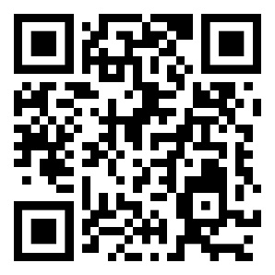

COPYRIGHT TRANSFER FORM
Article Name:
Author(s) Name (in the order in the article):
Corresponding Author's Name and Address:
Email:
Phone/Mobile phone:

Writers;
a) The submitted article is the work of the author(s) and there is no plagiarism in the article;
b) All authors have individually participated in this study and take full responsibility for this study;
c) All authors have seen and approved the final version of the submitted article;
d) The article has not been published or submitted for publication elsewhere;
e) They undertake that the text, figures and documents contained in the article do not violate the Copyrights of other parties.
f) All publishing rights of the article belong to Amasya University Journal of Economics, Trade and Marketing.Sorumlu yazar olarak, telif hakkı ihlali nedeniyle üçüncü şahıslara istenecek hak talebi veya açılacak davalarda "Amasya Üniversitesi Ekonomi Ticaret ve Pazarlama Dergisi" hiçbir sorumluluğunun olmadığını, tüm sorumluluğun sorumlu yazar olarak bana ait olduğunu taahhüt ederim.
Corresponding Author Name and Surname: Signatur:

Name and surname | Date | Signatur
* The Copyright Transfer Form must be signed by all authors. Authors working in different organizations can sign and submit them separately, provided that the Journal Name, Article Name and Author Names sections are filled in the Copyright Transfer Form. All signatures must be wet signatures.

