 | Amasya Üniversitesi Ekonomi Ticaret ve Pazarlama Dergisi  Amasya University Journal of Economics Trade and Marketing  https://dergipark.org.tr/tr/pub/auetp | 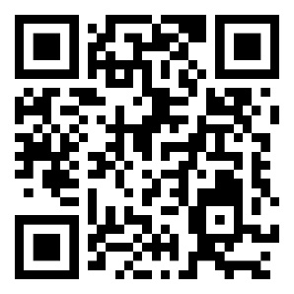

CONFLICT OF INTEREST DECLARATION FORM

Dear Editor,

“……………………………………………………………………………………………………………………………………………………………………………………………………..………………..” there is no financial conflict of interest with any institution, organization or person regarding our article and there is no conflict of interest between the authors.

Author Name Surname | Date | Signature
* All authors must have wet signatures.

In case of a conflict of interest, please explain the scope of the conflict of interest in the field below.

…………………………………………………………………………………………………
…………………………………………………………………………………………………

