http://communications.science.ankara.edu.tr

Commun.Fac.Sci.Univ.Ank.Ser. C Biology
Volume 32, Number 2, Pages xx-xx (2023)
ISSN 1303-6025 E-ISSN 2651-3749
DOI: 10.53447/ communc.1234567
Research Article; Received: March xx, 2023; Accepted: April xx, 2023

MANUSCRIPT TITLE HERE

AUTHORNAME SURNAME¹, AUTHOR², AUTHOR³

¹ Department of XX, Faculty of XX, XX University, City, COUNTRY
² Department of XX, Faculty of XX, XX University, City, COUNTRY

ABSTRACT. The abstract should state briefly the purpose of the research. Please provide an abstract of 250 words or fewer containing the major keywords summarizing the article. The abstract should state briefly the purpose of the research. (9 points, Times New Roman)

1. INTRODUCTION
Clearly outline the goals of this project and establish the relevant background information, without going into extensive reviews of previous research or presenting the final outcomes.

2. MATERIALS AND METHODS
Describe the methods in enough detail that another researcher could replicate the work independently. Summarize established methods with citations, and clearly indicate any modifications or use quotation marks and citations for directly quoted methods.

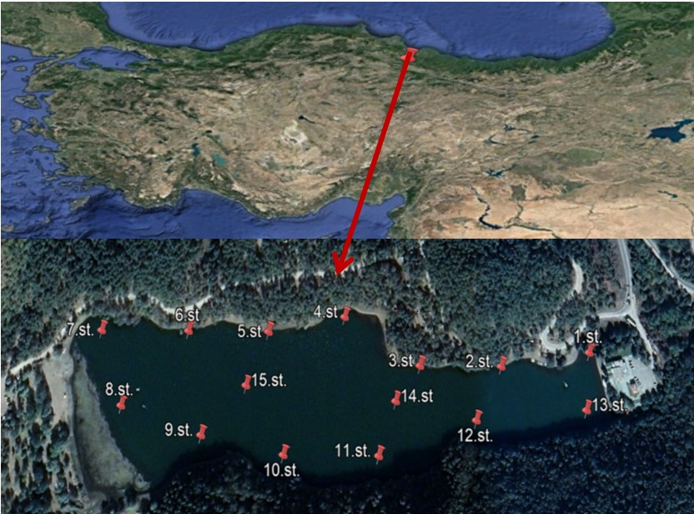
Figure 1. All figures must have numbers (Figure 1) consecutively in accordance with their appearance in the text and a caption (not on the figure itself) below the figure. Required final resolution is 300 dpi for coloured images (RGB), 300–600 dpi for black and white images and 600–1200 dpi for line art.

Table 1. All tables must have numbers (Table 1) consecutively in accordance with their appearance in the text and a legend above the table. Please submit tables as editable text not as images.
Station No | Latitude | Longitude
1 | 40°48'15.53"K | 36° 9'29.03"D
2 | 40°48'15.02"K | 36° 9'24.10"D
3 | 40°48'15.04"K | 36° 9'19.59"D
4 | 40°48'16.84"K | 36° 9'15.41"D
5 | 40°48'16.28"K | 36° 9'11.15"D
6 | 40°48'16.31"K | 36° 9'60.67"D
7 | 40°48'16.33"K | 36° 9'10.81"D
8 | 40°48'13.59"K | 36° 9'30.11"D

- RESULTS AND DISCUSSION
Results should be clear and concise. The discussion should delve into the implications of the findings, not simply restate them. A combined Results and Discussion section can be effective but it is optional. Limit citations and in-depth analysis of existing literature.

4. CONCLUSIONS
The study's key findings can be presented in a brief Conclusions section. This section can be independent or integrated within a larger Discussion or Results and Discussion section.
Acknowledgment Acknowledgements should be given here.
Author Contribution Statements We encourage authors to include a statement in the manuscript that shares and accurately describes the contribution of each author.
Declaration of Competing Interests The authors declare no conflict of interest.
Data availability (if applicable) Optional.

REFERENCES (please check the writing rules here)
- ARTICLE Büyük, İ., İnal, B., İlhan, E., Tanriseven, M., Aras, S., Erayman, M., Genome-wide identification of salinity responsive HSP70 s in common bean. Molecular Biology Reports, 43 (2016), 1251-1266. https://doi.org/10.1007/s11033-016-4057-0
- BOOK Wetzel, R.G., Limnology, Lake and River Ecosystems. Academic Press: London, UK, 2001.
- BOOK Kabata –Pendias, A., Mukherjee, A., Trace Elements from Soil to Human. Springer-Verlag Berlin, Heidelberg, 2007.
- BOOK CHAPTER Tug, G. N., Yaprak, A. E., Vural, M. The Floristical, Ecological, and Syntaxonomical Characteristics of Salt Marshes and Salt Steppes in Turkey. In: Gul, B., Böer, B., Khan, M.A., Clüsener-Godt, M., Hameed, A. Editors. Sabkha Ecosystems. Springer, Cham, (2019), 413-446.

