**PLEASE ADD THE TITLE OF THE ARTICLE HERE WITHOUT IMPROVING THE FORMATTING**

Author Name and Surnamea*, Author Name and Surnameb, Author Name and Surnamec

a University, Country,

ORCID: 0000-0000-0000-0000 / e-mail: [e-mail@anadolu.edu.tr](mailto:e-mail@anadolu.edu.tr)

b University, Country,

ORCID: 0000-0000-0000-0000 / e-mail: [e-mail@anadolu.edu.tr](mailto:e-mail@anadolu.edu.tr)

c University, Country,

ORCID: 0000-0000-0000-0000 / e-mail: [e-mail@anadolu.edu.tr](mailto:e-mail@anadolu.edu.tr)

* Corresponding Author

|  |  |
| --- | --- |
| **Author Name and Surname**  **ORCID: 0000-0000-0000-0000** | |
| CONTACT DETAILS E-mail  Address | BIOGRAPHYshort biography, short biography, short biography, short biography, short biography, short biography, short biography, short biography, short biography, short biography, short biography, short biography, short biography, short biography, short biography, short biography, short biography, short biography, short biography, short biography, short biography, |

|  |  |
| --- | --- |
| **Author Name and Surname**  **ORCID: 0000-0000-0000-0000** | |
| CONTACT DETAILS E-mail  Address | BIOGRAPHYshort biography, short biography, short biography, short biography, short biography, short biography, short biography, short biography, short biography, short biography, short biography, short biography, short biography, short biography, short biography, short biography, short biography, short biography, short biography, short biography, short biography, |

**To complete the bio-sketch section please follow the instructions below.**

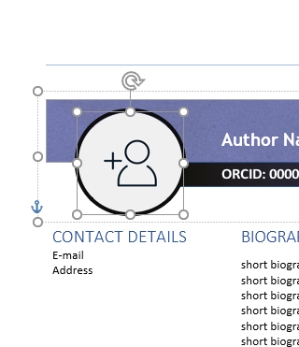

**Copy your profile Picture first. Select the Picture area as shown in the figure above.**

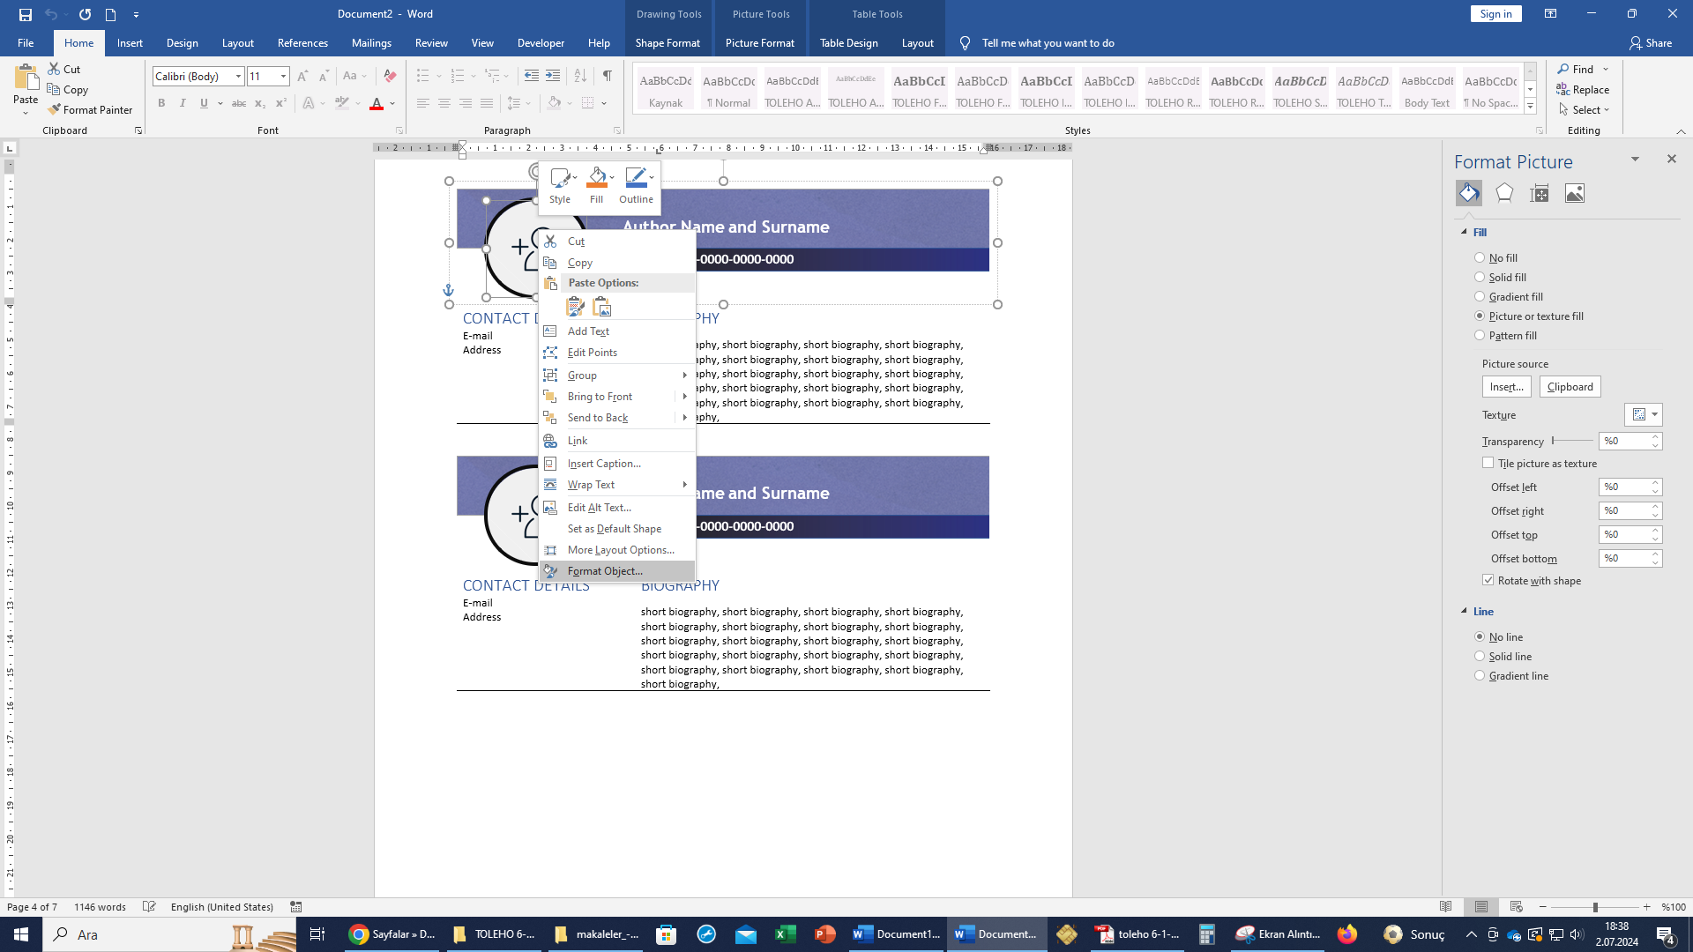

**Then right-click on the ‘Picture’ area and select ‘Format Object’.**

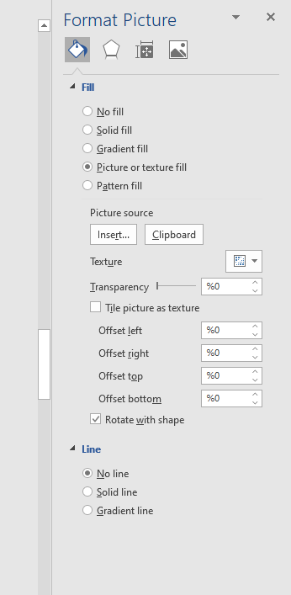

**The ‘Format Object’ box opens on the right side of the screen. Select the ‘Fill’ section and click on the ‘Clipboard’ button to paste your profile Picture.**