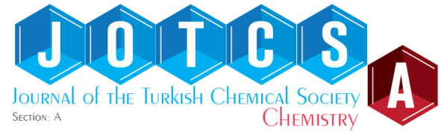

Article Processing Charge (APC) Consent Form
We, with the names and signatures below, accept that the journal will charge 50 United States Dollars (or the equivalent Turkish Liras or Euros) for our article:
Name of Article
Corresponding author (name, signature)
Other authors (name, signature)

The corresponding author and other authors give their consent that when the article is accepted, the APC payment will be made accordingly (the authors are kindly directed to the Journal website of APC, https://dergipark.org.tr/en/pub/jotcsa/price-policy, for proper method of payment). Please scan and send the completed form to jotcsa@turchemsoc.org.
Please note that the APC must be paid after the editor informed you that article has been accepted for publication.
Kind regards,
Mr. Barbaros Akkurt, PhD
Managing editor, JOTCSA

