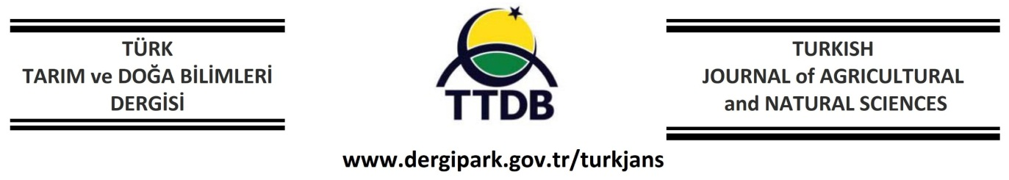**Original Article**

https://doi.org/10.30910/turkjans.xxxxxx

https://doi.org/10.30910/turkjans.738579

**Article Title in English [Calibri 12 bold)**

**ABSTRACT**

(Double spacing, 10-point font, black text].

Abstract should state the purpose of the research, the main methods and results and should not exceed 300 words. It should not contain references. Double spacing, 10-point font, black text.

**Key words:** maximum 6 words, separated by comas. If possible, acronyms should be avoided. Words from the title should not be used.

**Makale Türkçe Başlığı [Calibri 12 bold)**

**ÖZ**

(Double spacing, 10-point font, black text].

Araştırmanın amacını, temel yöntemlerini ve sonuçlarını belirtmeli ve 300 kelimeyi geçmemelidir. Kaynak içermemelidir. Çift satır aralığı, 10 punto ve siyah metin kullanılmalıdır.

**Anahtar kelimeler:** Virgül ile ayrılmış şekilde maksimum 6 kelime olmalıdır. Mümkünse kısaltmalardan kaçınılmalıdır. Başlıktaki kelimeler kullanılmamalıdır.

**INTRODUCTION**

(Double spacing, 10-point font, black text].

Background and significance of the problem by using the most recent publications should be provided.

Discuss how your study connects to existing research without repeating or providing an exhaustive literature review. Clearly and concisely state the research objective and highlight its significance, originality, or contribution to the field. Do not include or summarize your current findings in this section.

When citing sources, use the following formats. If the citation appears at the end of a sentence, list the author and the year in parentheses (First and Second, 2006; First et al., 2007). If referencing the author’s name in the text, follow it with the publication year in parentheses—for example, “according to First et al. (2007) …”. Do not include initials in these citations.

At the end, the aim of the study should be clearly stated.

**MATERIALS AND METHODS**

(Double spacing, 10-point font, black text].

Authors should provide a concise description of experimental site, design, materials and analytical methods and statistical procedures used. This section should be as clear as possible to enable other scientists to repeat the research presented.

**RESULTS AND DISCUSSION**

(Double spacing, 10-point font, black text). This section can be given as two subheadings

**Results** section can be divided into subsections. The numbers from the tables or figures should not be repeated extensively in the text, and long explanations of the tables and figures are not acceptable. The same information given in the table should not be repeated in the figure or vice versa. **Relevant statistical information should be provided in tables and figures. Statistical significance should be clearly indicated where applicable.**

**Table 1.** Table title

**Figure 1.** Include a brief description of the figure, preferably in one or two sentences.

**Discussion**

(Double spacing, 10-point font, black text].

Interpretation of data, related to previous research, should be presented. Results and discussion sections may be combined.

**CONCLUSION(S)**

(Double spacing, 10-point font, black text].

Main significant results of the study should be presented in a clear and concise way and should be numbered.

**Acknowledgements**

(optional) of funds, grants, etc. may be placed.

**Declaration of interests**

The authors declare that they have no known competing financial interests or personal relationships that could have appeared to influence the work reported in this paper

**Author Contributions**

***1st Author* Name-Surname :**Conceptualization; data curation; formal analysis; funding acquisition; investigation; methodology; project administration; software; writing— original draft; writing—review and editing.

**2st Author Name-Surname :**Conceptualization; data curation; formal analysis; funding acquisition; investigation; methodology; project administration; software; writing— original draft; writing—review and editing.

**..**

**ORCID**

**REFERENCES**

The list of references must be written in alphabetical order, following spelling rules, with a 1.0 cm hanging indent, and single line spacing)

Akçura, M. (2011). The relationships of some traits in Turkish winter bread wheat landraces. *Turkish Journal of Agriculture and Forestry*, *35*(2), 115-125. https://doi.org/10.3906/tar-0908-301

Akcura, M., Turan, V., Kokten, K., & Kaplan, M. (2019). Fatty acid and some micro element compositions of cluster bean (*Cyamopsis tetragonoloba*) genotype seeds growing under Mediterranean climate. Industrial Crops and Products, 128, 140-146.

Anonymous (2025). Türkiye Hayvansal üretim istatistikleri. https://data.tuik.gov.tr/Bulten/Index?p=Hayvansal-Uretim-Istatistikleri-2024-53935 (Accessed date: 10.02.2025)

Anonymous, (2019). Food and Agriculture Organization of the United Nations (FAO), http://www.fao.org/site, (Accessed date: 13.11.2018)

Mirik, M. (2005). Biberde bakteriyel leke etmeni Xanthomonas axonopodis pv. vesicatoria’nın tanılanması ve bitki büyüme düzenleyici rizobakteriler ile biyolojik mücadele olanakları. (Ph. D. Thesis) Cukurova University. The Institute of Natural Sciences, Adana, Turkey

Mohsenin, N.N. (1970). Physical Properties of Plant and Animal Materials. Gordon and Breach Science Publishers, New York

Saglam, C., & Tan, F. (2017). An Environmentally Friendly Method of Fertilizer Application in Agriculture; Anhydrous Ammonia Application. International Conference on Environment and Natural Science. (ICENS). 9-10 September, P.7-9. Moscow, Russia.