**Type Title of Paper in Full**

**Abstract**

This is where you will insert the abstract of your paper. The abstract is a very brief summary of your paper. The abstract should be one double-spaced paragraph that is NOT indented. It is usually no more than 150-250 words long. Tell your reader the purpose of your paper in the abstract and describe the main points of your paper. It is usually easiest to write your abstract after you’ve written the rest of your paper.

*Keywords*: word 1, word 2, etc. (Please insert 5 keywords)

**Title in Full**

This will be the body of your paper. Each new paragraph is indented one tab. The entire body of your paper will be double-spaced. This includes the “References” page at the end. Don’t forget that you’ll need to include an in-text citation every time you quote, paraphrase, or summarize an outside source of information. This is very important. Each item that you include an in-text citation for must also be listed in your reference list.

**Type Your Level One Heading Title**

**Type Your Level Two Heading Title**

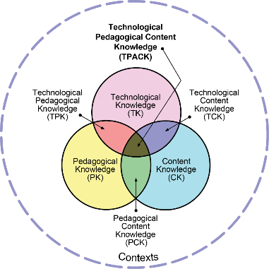

**Figure 1.** The Total PACKage (Koehler & Mishra, 2009)

(Please insert Figures like above example. Figures must be inserted in full-text body. The resolution quality of all images, figures and diagrams used must be in 1080p format. Figures with illegible text cannot be accepted and will be returned to the corresponding author.)

**Method**

**Table 1.** t-test related to the pre-test motivation levels of the experiment and control groups

|  |  |  |  |  |  |  |
| --- | --- | --- | --- | --- | --- | --- |
| Group | N | X | S | Sd | t | p |
| Experiment | 20 | 73.40 | 6.57 | 38 | -0.39 | 0.69 |
| Control | 20 | 74.30 | 7.96 |  |  |  |

(Please insert Tables like above example. Figures must be inserted in full-text body)

**Findings**

**Conclusion**

**Recommendations**

**Ethics and Consent:** Ethical approval for this study was obtained from … (Committee title, approval date and permission of ethics document's number).

**Acknowledgments**

**References**

Author, A. A., Author B. B., & Author, C. C. (year). Title of article. *Title of Journal, volume*(issue), page-page. doi:x.xxxx/xxxx-xxxx.xx.x.xxx

Author, D.D. (year, Month day). Title of article. *Title of Newspaper*, https://newspaper.homepage

Author, E.E., & Author, F.F. (year). *Title of book*. Publisher.

Author, G.G., & Author, H.H. (year, Month day). *Title of document*. https://www.xxxxxxx

Your references will be listed alphabetical by **author’s last name**. They will not be indented the same way as the body of your paper. Each reference will have a “hanging indent,” like this paragraph is written.