 | 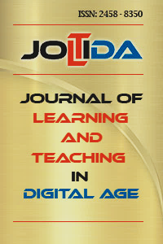  Journal of Learning and Teaching in Digital Age | Author(s) Contribution Form

Title of the Article:

To be an author, a person must have made substantive contributions to the study by fulfilling at least 3 of the criteria presented in the following table. All authors are also expected to fulfil the first 3 criteria stated below:

1. It is mandatory for all authors to prepare the outline of the manuscript or to intellectually review or criticize the content of the manuscript.
2. It is of all authors’ responsibility to approve the final version of the article before publication.
3. Those who do not fulfil the specified number of contributions and conditions are to be mentioned in the final “Acknowledgements” section of the article.
4. The terms set forth herein have been arranged in accordance with the guidelines of the Council of Science Editors (CSE) and International Committee of Medical Journal Editors (ICMJE).
Contribution Type | Contribution Content | Contributors
Idea | Creating ideas or hypotheses for research and / or writing
Design | Planning methods to achieve results
Supervision | Supervision and responsibility of the organization and course of the project and writing
Resources | Provision of “vital” staff, space, financial resources, tools, and equipment for the article
Data Collection and/or Processing | Taking responsibility for conducting experiments, monitoring patients, organizing, and reporting data.
Analysis and/or Interpretation | Taking responsibility for logical explanation and presentation of findings
Literature Review | Taking responsibility for literature review
Writer | Taking responsibility for the creation of the entire article or the main section
Critical Review | Rechecking the article before submission, not only in spelling and grammar, but also in intellectual content.
Materials | Biological materials, reagents and referred patients
Name-Surname of the Author(s) Contributing to the Writing of the Article  1.  2.  3.  4.  5. |  | (Corresponding author):  Signature:  (Date): .. / .. / ....

