Title of the Manuscript

Abstract
The abstract should serve as a concise yet comprehensive summary of the study. It is expected to include the purpose of the research, the research design, details regarding the participants or sample, the instruments used for data collection, the procedure followed, the statistical or analytical methods employed, the key findings, and a concluding sentence emphasizing the study’s contribution. It should be written in a single paragraph, fully justified, and must not exceed 250 words. The abstract must be informative and give readers a clear understanding of the study’s content and relevance without requiring them to read the full article.
Keywords: Keyword, Keywords, Keyword (3-6 words)

Özet
Özet, çalışmanın kısa ancak kapsamlı bir özetini sunmalıdır. Bu bölümde araştırmanın amacı, araştırma deseni, katılımcılar veya çalışma grubuna ait bilgiler, veri toplama araçları, izlenen yöntem veya araştırma tasarımı, kullanılan istatistiksel veya analitik teknikler, temel bulgular ve çalışmanın katkısını vurgulayan sonuç cümlesine yer verilmesi beklenir. Öz tek bir paragraf halinde, iki yana yaslı olarak yazılmalı ve 250 kelimeyi aşmamalıdır. Okuyucuların çalışmanın tamamını okumalarına gerek kalmadan, içeriği ve önemi hakkında açık ve bilgilendirici bir fikir vermelidir.
Anahtar kelimeler: Anahtar kelime, Anahtar kelime, Anahtar kelime (3-6 kelime)

Introduction
In this section, the problem and the theoretical or conceptual framework of the research should be presented with their justifications. Introduction should clearly state the study’s purpose, importance and scope. This section should orient the reader to the article’s content and provide an understanding of the importance of the research. Furthermore, the main questions or hypotheses of the research should be stated and explain to the reader what problems it aims to solve and which gap in the literature it fills.
In-text citation examples to be used in relevant literature should be cited in accordance with the Publication Manual of the American Psychological Association, Seventh Edition (APA style 7th edition). You can also easily create your citations and references using the EndNote patch file specially prepared for our journal.

Method
Research Design
The Research Design or Experimental Approach section should clearly outline the overall methodological framework adopted to address the research question. This includes a detailed description of the study type (e.g., experimental, quasi-experimental, cross-sectional, longitudinal), the rationale for the chosen design, and the procedures implemented to ensure internal and external validity. Key elements such as the intervention or experimental manipulation (if applicable), control conditions, randomization methods, and timing or duration of data collection should be specified. Furthermore, this section should provide sufficient information to allow replication of the study and demonstrate that the chosen approach is appropriate for testing the stated hypotheses or research objectives.
Research Group
The participants of the study should be explained in this part. In this section, research participants should be identified. Demographic information (age, gender, education level, etc.) of the participants should be provided in this section. In addition, information on adherence to ethical rules and ethics committee approval for research involving humans or animals should be included in this section.
Procedures
The Procedures or Data Collection Instruments section should concisely describe the tools and methods used to collect data, including standardized tests, questionnaires, observations, interviews, or experimental setups. Validity and reliability information must be provided, along with data collection conditions (e.g., setting, duration), the qualifications of data collectors, and the procedural steps followed. If validated tools from prior research were used, citations should be included; for newly developed instruments, the development process should be briefly explained.
Data Analysis
This section should clearly describe how the data were processed and analysed, including the statistical methods used (e.g., descriptive statistics, ANOVA, regression) and the software employed (e.g., SPSS, R, JASP, NVivo). The choice of analyses should be justified based on the research questions and data types. If assumption tests (e.g., normality, homogeneity) were conducted, their procedures and outcomes should be reported. For qualitative data, the analysis method (e.g., content or thematic analysis) and coding process should be outlined.

Findings
The findings of the study should be clearly and systematically presented in this section. All outcome-related data, including up to six tables and figures, must be included and cited in-text in numerical order. In addition, each table and figure should be referenced in the text. Tables should not contain vertical lines, and horizontal lines must conform to APA style 7th edition formatting standards. Figure numbers and titles should be placed below the figures. If the figures were not created by the authors, the source from which they were obtained must be clearly cited. Authors should emphasize results that are central to the research questions and highlight any outcomes that diverge from expected patterns or offer novel insights.

Table 1. MANOVA analysis of job satisfaction and organizational socialization based on gender
Dimensions | Gender | Sd | $$\overline{X}$$ | N | F | p
International Relationship | Women | 4,04 | ,54 | 108 | ,015 | ,902
 | Men | 4,03 | ,67 | 97
Organizational Policy | Women | 3,81 | ,66 | 108 | ,530 | ,467
 | Men | 3,87 | ,63 | 97
Professional Competence | Women | 4,20 | ,56 | 108 | ,641 | ,424
 | Men | 4,14 | ,56 | 97
Alignments with Goals and Values | Women | 4,14 | ,57 | 108 | ,072 | ,789
 | Men | 4,11 | ,65 | 97
Organizational Language and History | Women | 4,21 | ,72 | 108 | 8,927 | ,003*
 | Men | 3,85 | ,96 | 97
Organizational Socialization | Women | 4,08 | ,44 | 108 | ,943 | ,333
 | Men | 4,01 | ,56 | 97
Job Satisfaction | Women | 3,98 | ,52 | 108 | 1,267 | ,262
 | Men | 4,07 | ,52 | 97
p<0,05*

Table 2. Linear regression analysis carried out to assess the impact of organizational socialization on job satisfaction
Independent Variables | Dependent Variables | B | t | p | F | R2 | Durbin Watson
Constant | Interpersonal Relationships | 1,343 | 6,060 | ,000* | 36,817 | ,467 | 1,905
Job Satisfaction | Organizational Policy | ,352 | 4,710 | ,000*
 | Professional Competence | ,298 | 2,716 | ,007*
 | Alignment with Goals and Values | ,170 | 1,947 | ,053
 | Organizational Language and History | ,011 | ,178 | ,859
 | Organizational Socialization | -,164 | -,668 | ,505
*p<0,05*

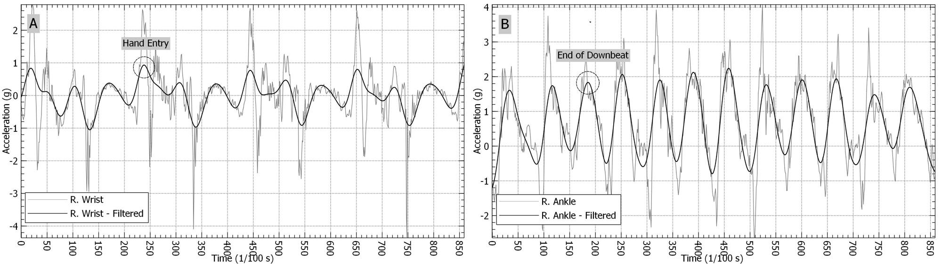
A = Arm-strokes of right arm; B = Kicks of right leg
Figure 1. Raw and filtered acceleration data of freestyle arm-strokes and kicks

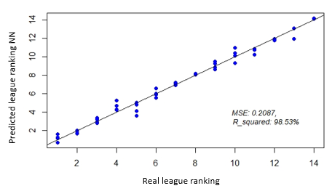  (a) Training set | 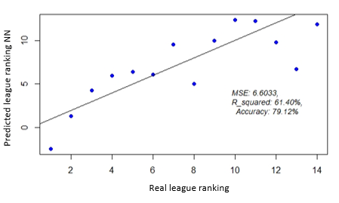  (b) Test set
Figure 2. The Training and Test Set results of 10*1 model (Efeler League)

Discussion

This section should offer an in-depth analysis of the research findings in relation to the current body of knowledge. Authors are encouraged to situate their results within the framework of prior empirical and theoretical work, drawing attention to the most salient contributions of the study. Any deviations from established literature or internal contradictions within the findings must be critically addressed and rigorously interpreted. Moreover, comparisons between distinct participant groups or correlations among variables should be substantiated through relevant academic sources and methodological justification.

Limitation
If the study includes any methodological or contextual limitations, these should be addressed transparently at this section to offer a balanced perspective and inform future investigations. Authors are expected to clearly articulate the limitations of their study. These may include methodological constraints, sample-related issues, measurement limitations, or contextual factors that may affect the generalizability or interpretation of the findings. Authors should demonstrate critical reflection by acknowledging these limitations transparently, while also suggesting how future research could address them or build upon the current study’s scope.

Conclusion

This section should provide a well-structured and scholarly conclusion, offering a critical synthesis of the study’s primary findings. Emphasis should be placed on the theoretical and practical significance of the results, highlighting their contributions to the field. Moreover, the conclusion should delineate practical implications where appropriate, and present well-reasoned suggestions for future research endeavours.

Practical Implications
This section should present a clear and concise conclusion of the study, reflecting the key outcomes derived from the research. The major results should be synthesized, with emphasis on their broader implications within the relevant academic and practical domains. Authors are encouraged to interpret their findings considering existing literature and theoretical frameworks. Furthermore, this section may incorporate implications for practice, and it is advisable to propose directions for future research.

References
References should be written in APA style 7th edition.
Altundağ, E., & Soylu, Ç. (2025). Predictive Models of Hamstring Performance in Adolescent Athletes.
Gazi Journal of Physical Education and Sport Sciences, 30(1), 27-35.

